

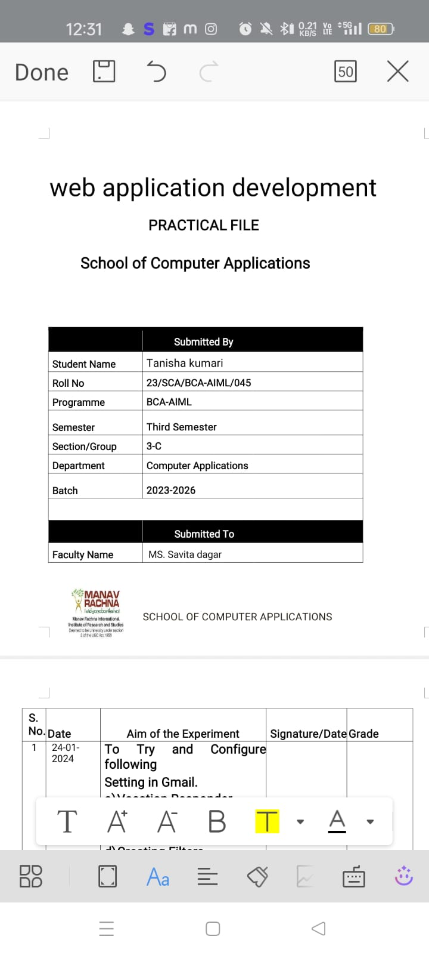

1.Create a simple HTML page using basic tags.

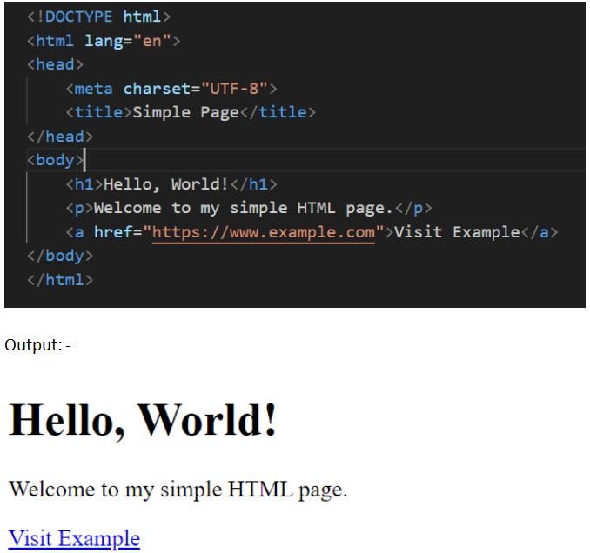

2.Create a web page that displays your name to the screen.

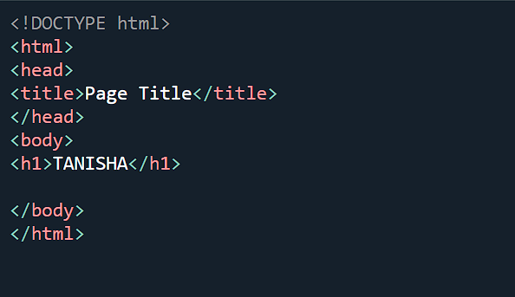

Output;-



3.Create a web page and show the output from 1 to 10 in separate lines.

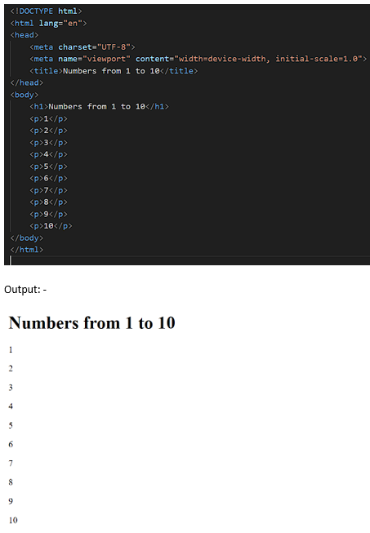

4.Create a web page and show the output from 1 to 10 in separate lines, each number being in different colour

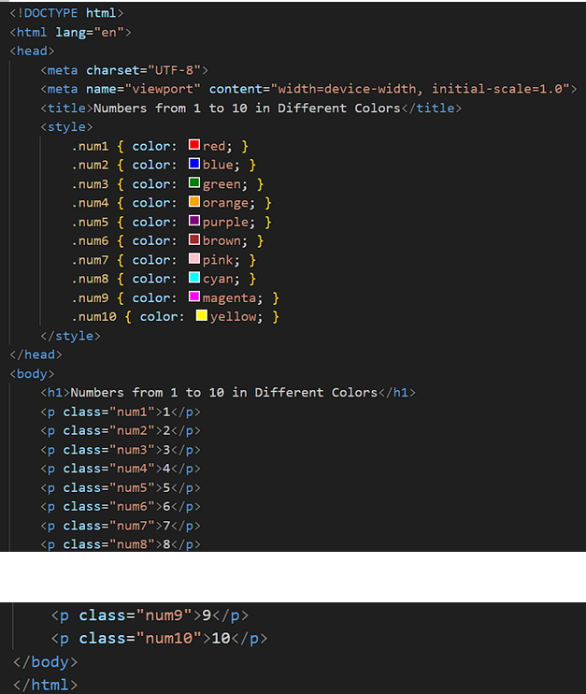

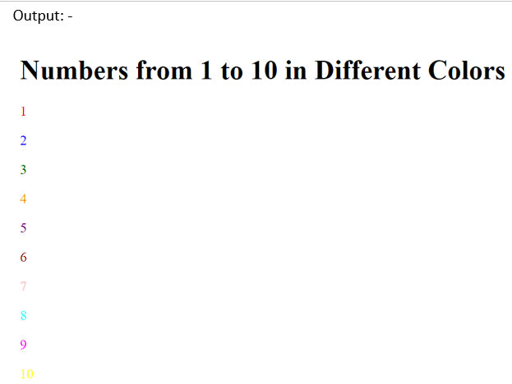

5.Create a web page to print a paragraph with 4-5 sentences, each sentence shall have a different font.

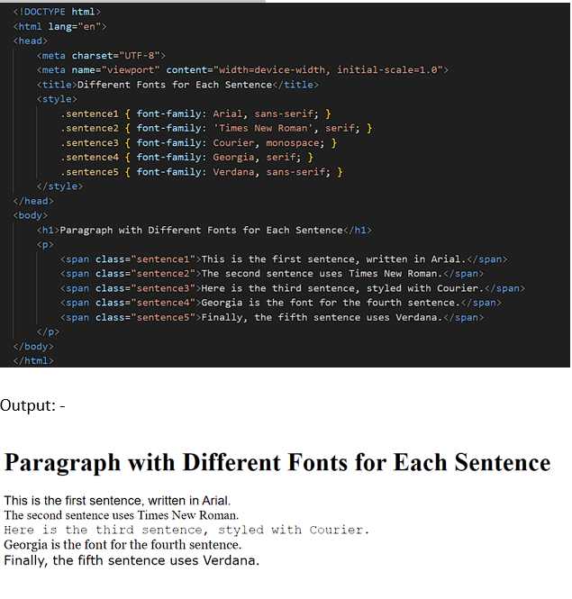

6.Write HTML code to print a paragraph that is description of a book, it shall include the title of the book, its author name; name and title should be underlined and all adjectives shall be bold and Italics.

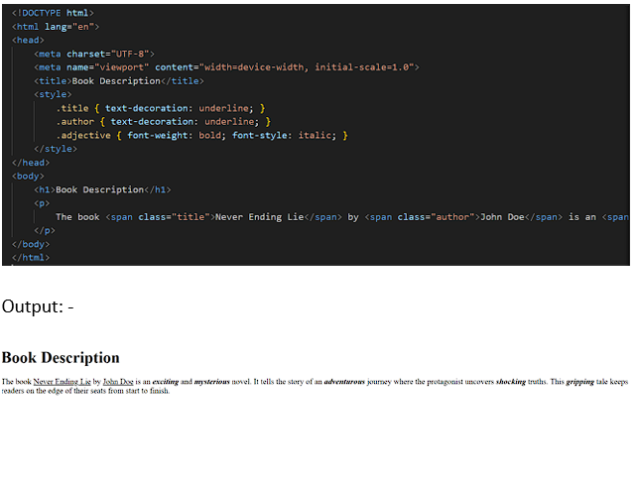

7.Write HTML code to print your name using Heading tag, every letter shall be of different heading size

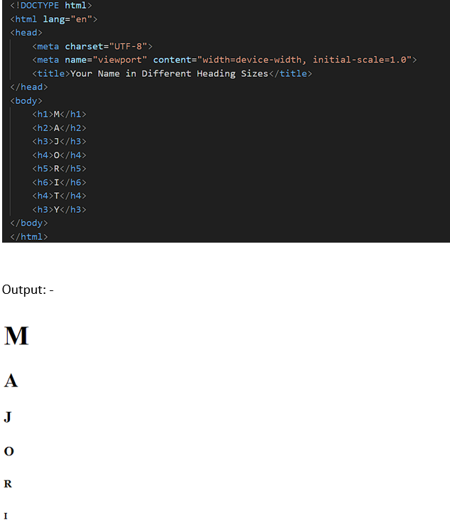

8. Write HTML code to print the sequence of numbers 1-20. Each number shall be in different line with number 2 next to it as subscript, an equal sign and the result.

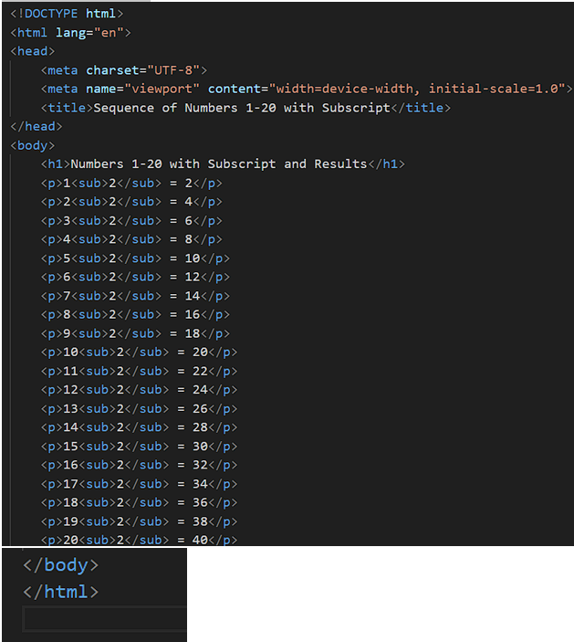

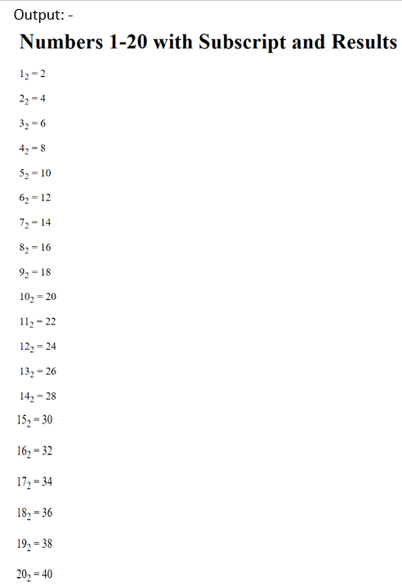

9. Write HTML code to display an image with border of size with width 200, height 200 pixels, leaving Hspace and Vspace of your choice with image hanging in the right side on the screen

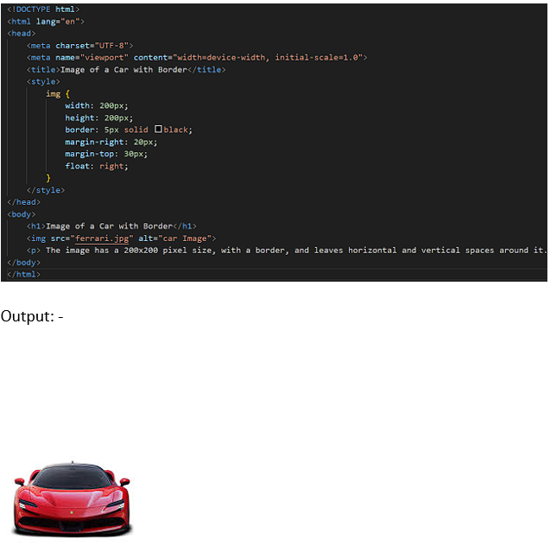

10.Write HTML code to create a web page with heading. The heading shall be displayed at the top-center of the page and the image shall be at the center, just below the heading.

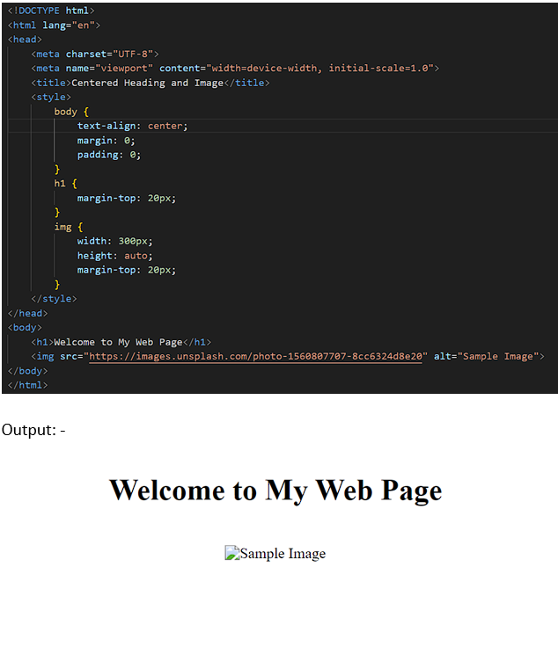

1. Write HTML code using Multimedia tags.

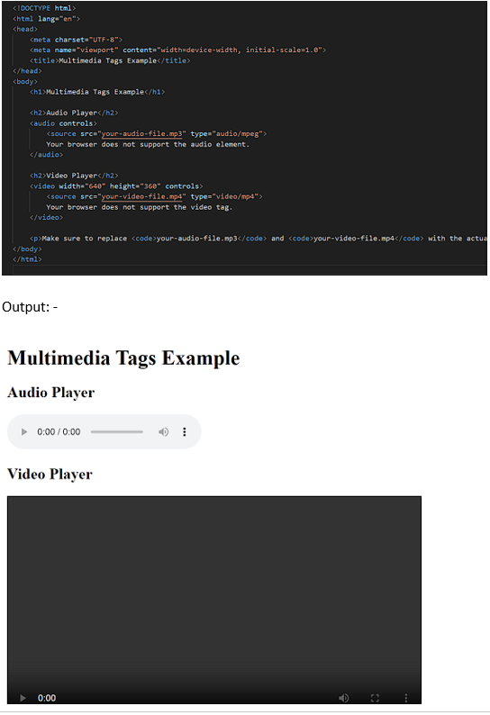

1. A table using rowspan and colspan taking example of student record.

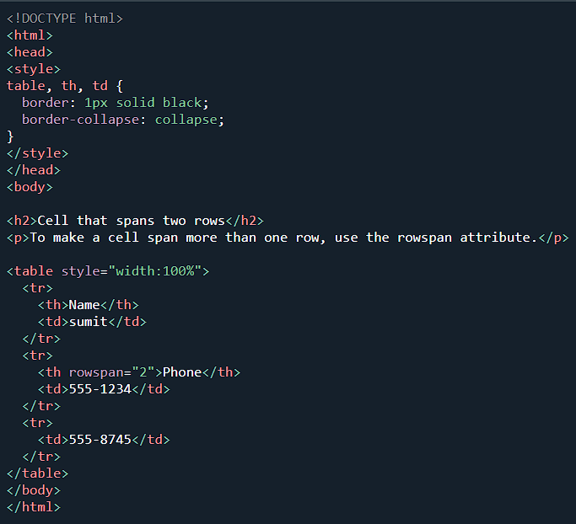

Output:-

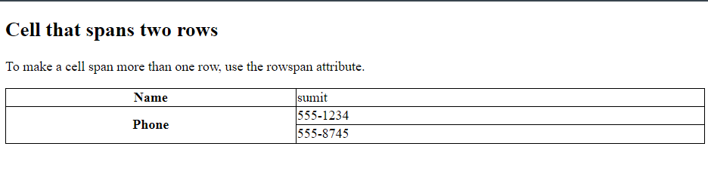

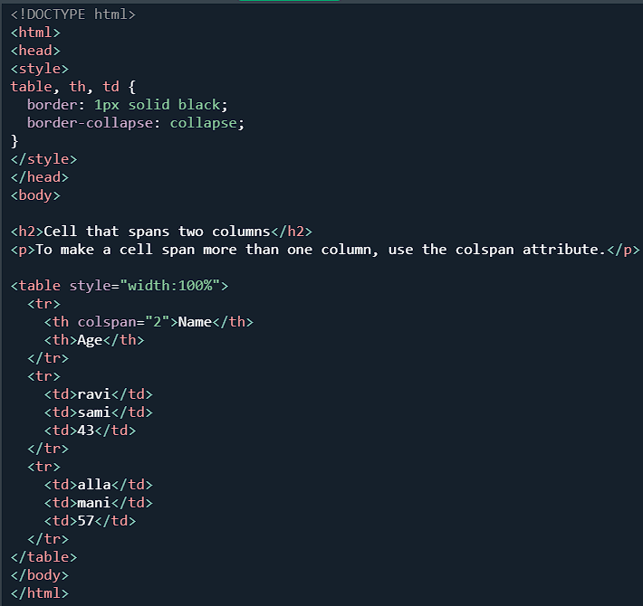

Output:-

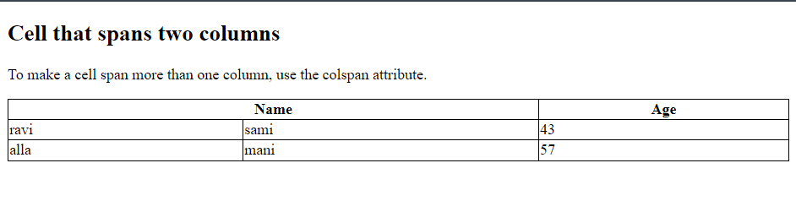

13.write html code using table tag <table> and cellpadding and cellspacing as its attributes

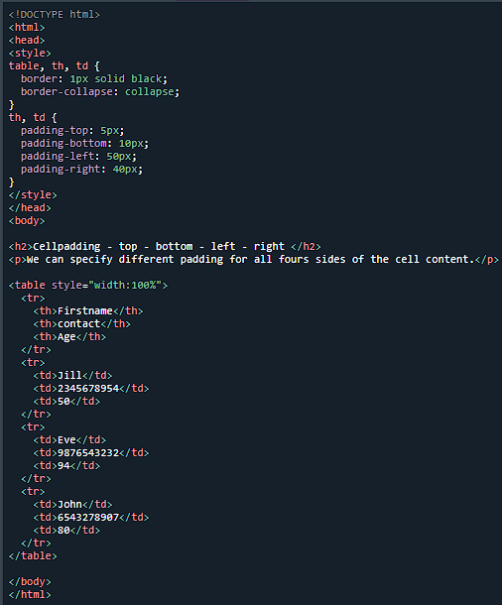

Output:-

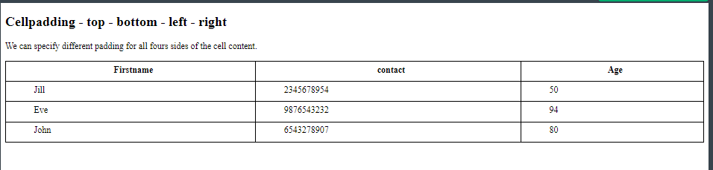

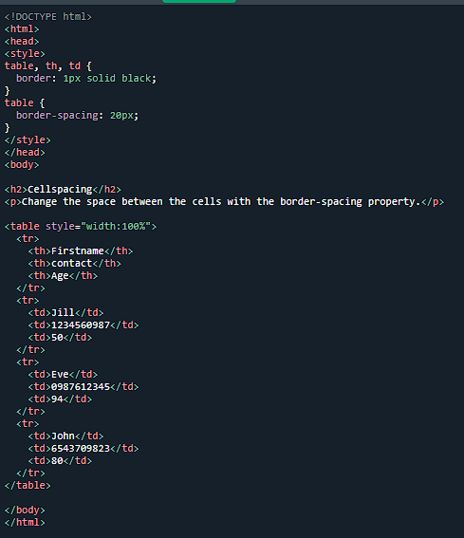

Output:-

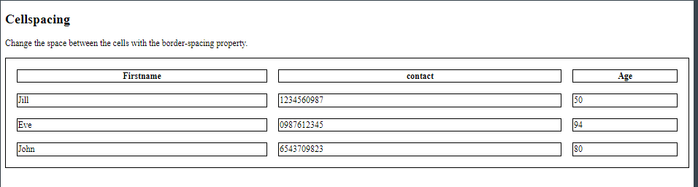

14.create unorderd,orderd and definition list taking example of your subjects in bca 1st ,llnd and lllrd semester

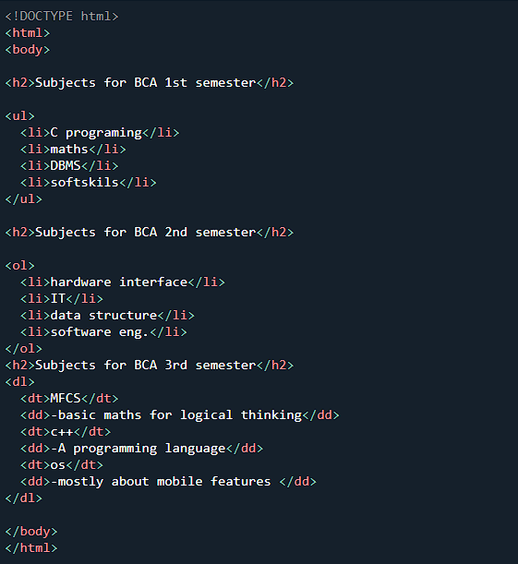

Output:-

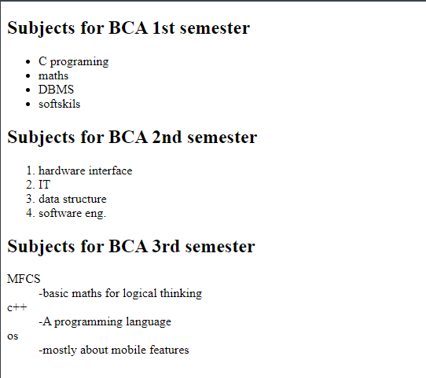

15.write html code using <frameset> and <frame> tag with all its attribute

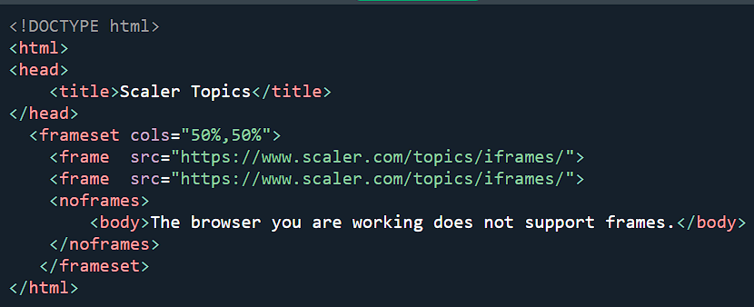

Output:-

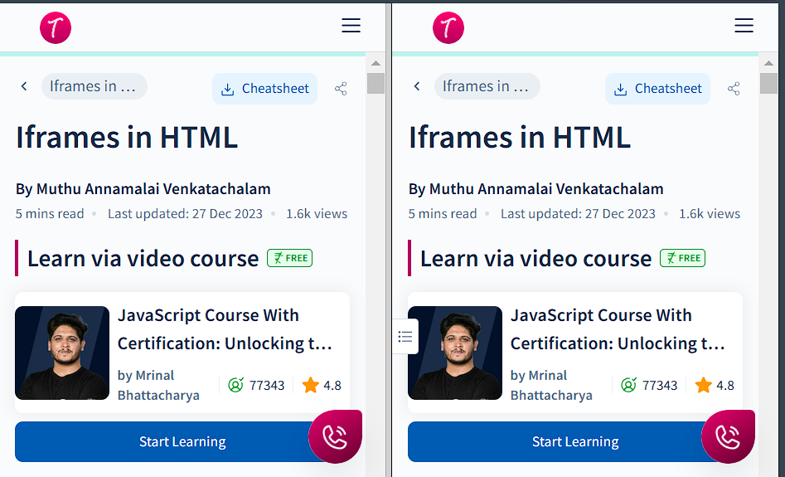

16.write html code to degine a form in html using controls and buttons such as text box, text area,submitte button etc

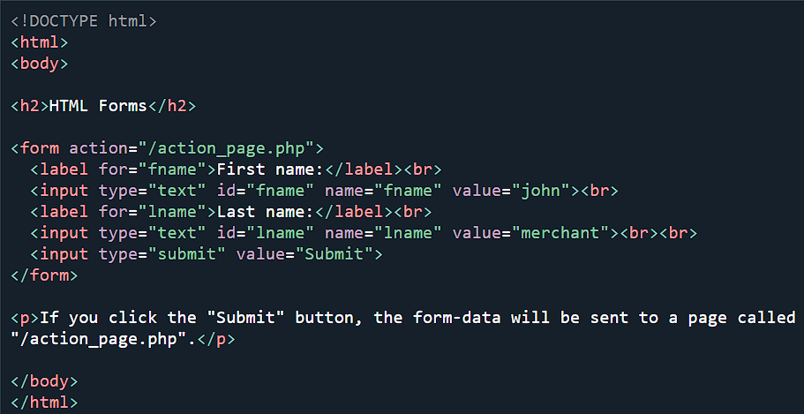

Output:-

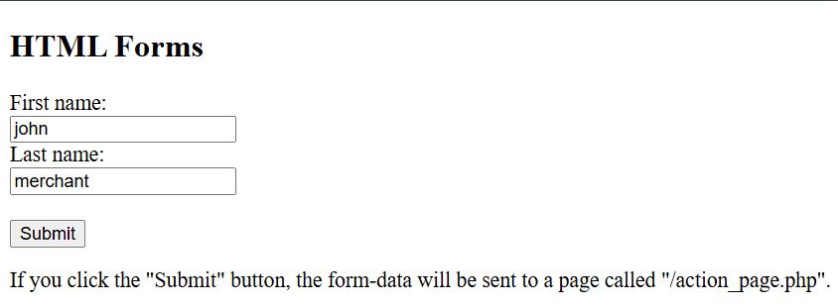

17.write html code to degine a registration form in html

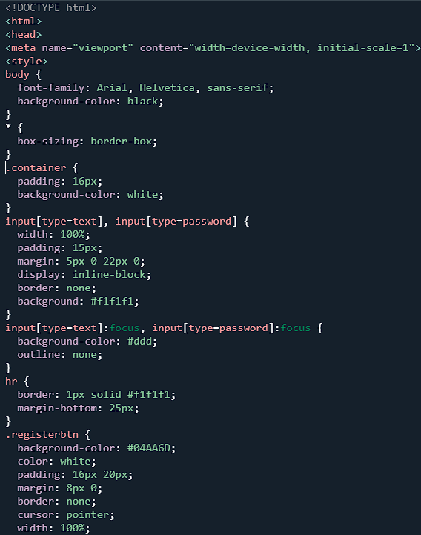

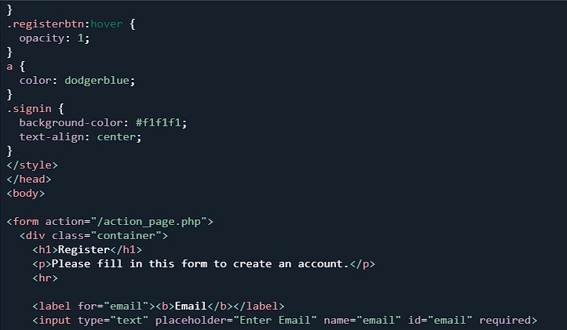

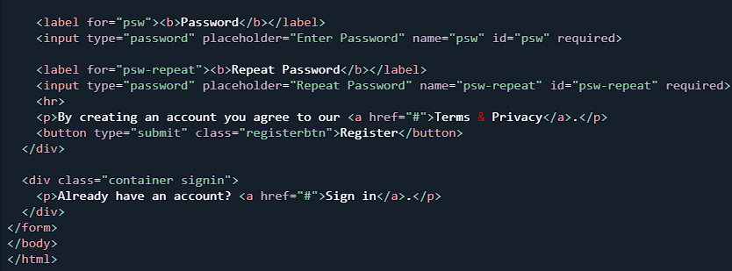

Output:-

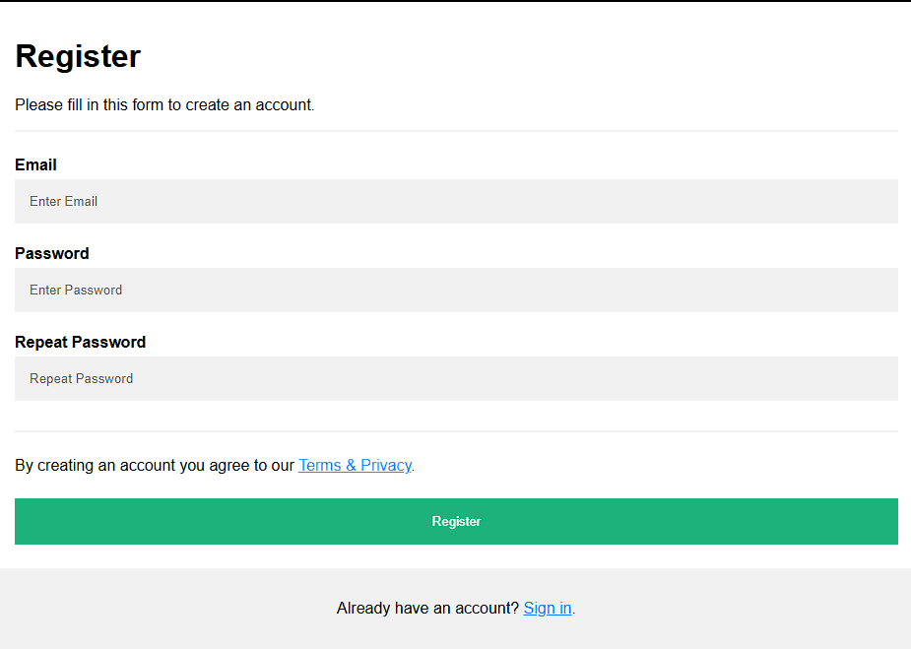

18.create a proper home page using an components and style

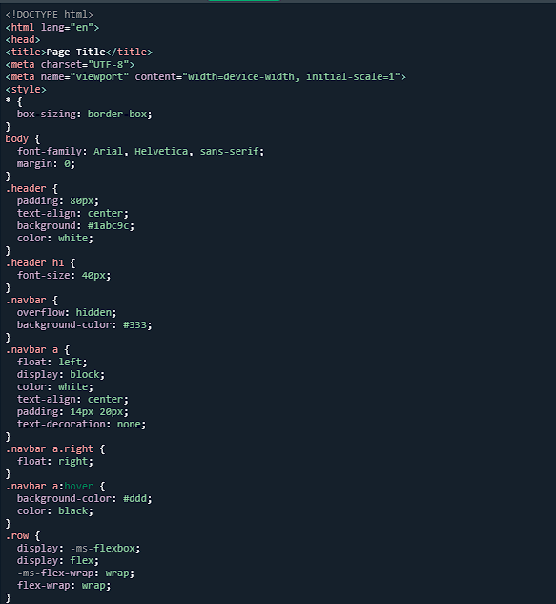

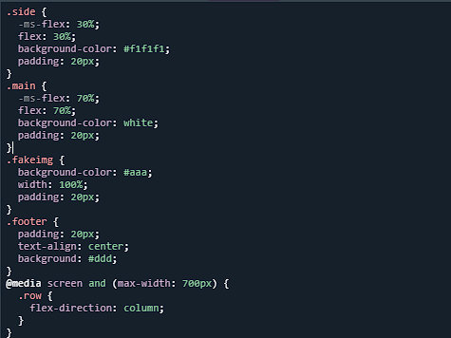

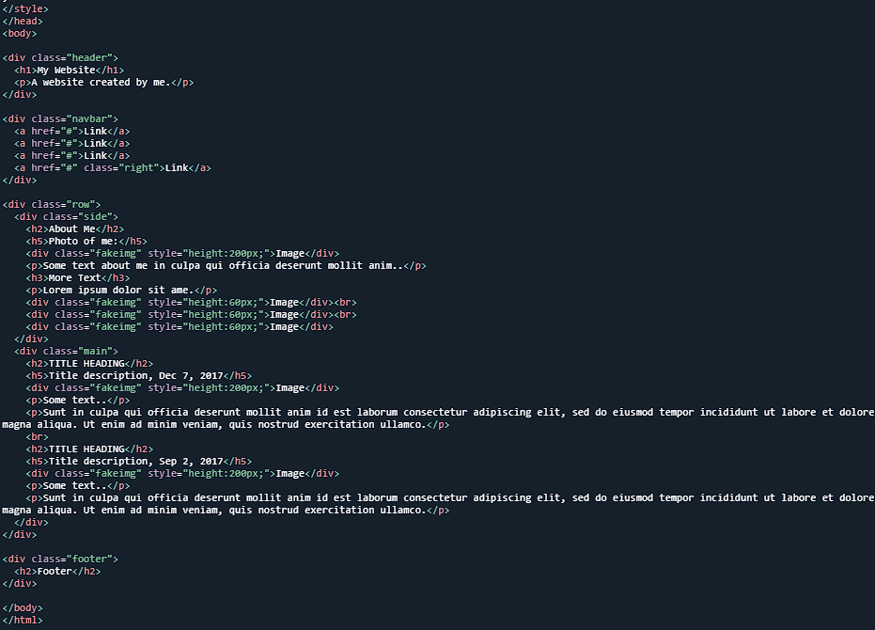

Output:-

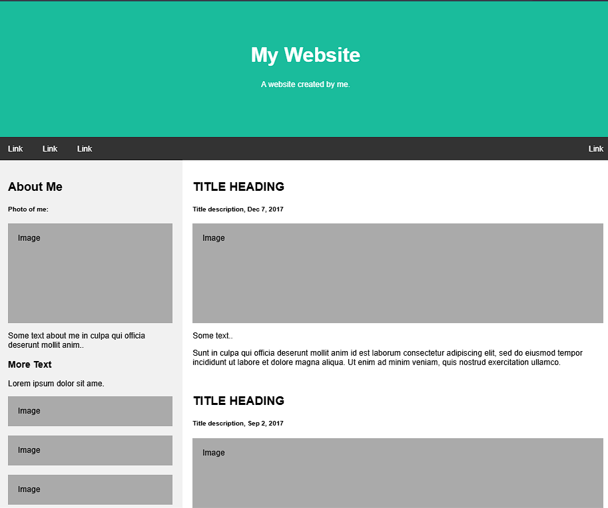

19.write a html code for including local hyperlink in a webpage

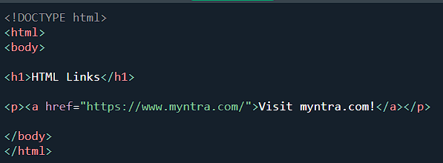

Output:-



20.write a html code for including inter hyperlink in a webpage

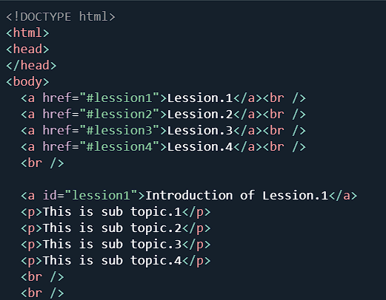

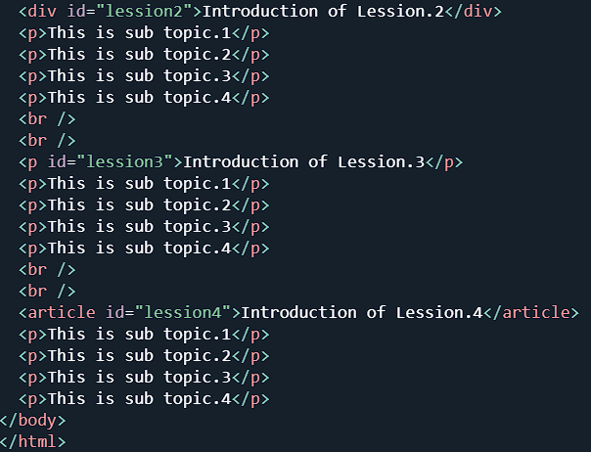

Output:-

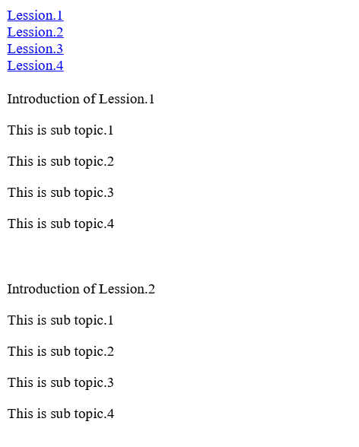

20.write a code to show external css with html code

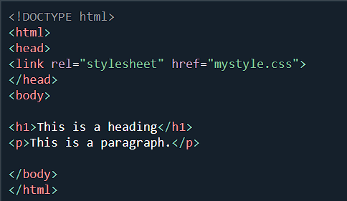

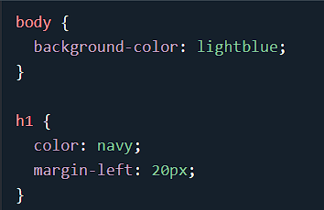

Output:-



21.write a code to show internal css with html code

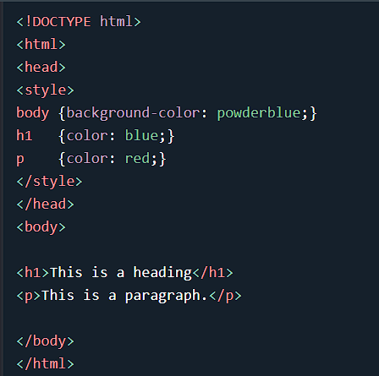

Output:-



22.write a code to show inline css with html code

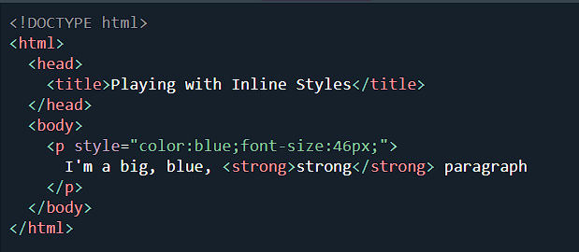

Output:-



23.write a program to add two numbers using froms in javascript

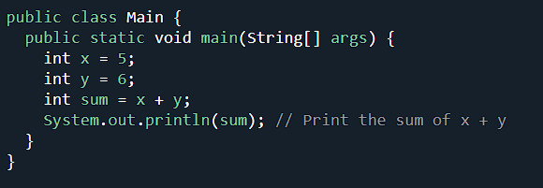

Output:-



24.write a simple javascript program to short an array.

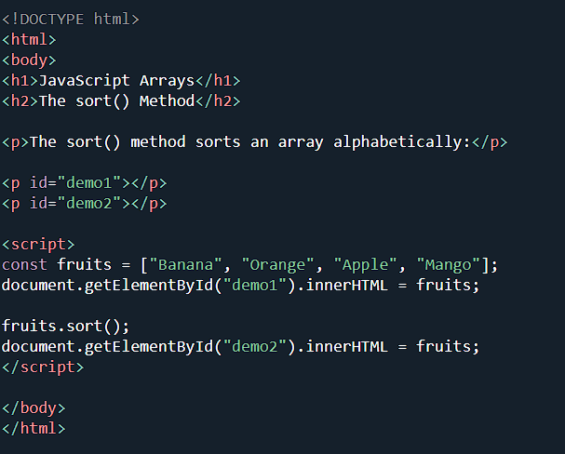

Output:-

