INSTITUTE OF ENGINEERING AND MANAGEMENT
DEPARTMENT OF CSE AI
CAPSTONE ASSIGNMENT – 2
SELENIUM PYTHON FRAMEWORK DEVELOPMENT -(Unittest + PyTest + Page Object Model)

PROJECT TITLE
E-COMMERCE LOGIN AND PRODUCT SEARCH
AUTOMATION USING SELENIUM PYTHON
Submitted By
TANISHA DEBNATH
Enrollment No.: 12023052020012
Program: CSE AI
Course
PYTHON AUTOMATION

1. Introduction
This project develops a Selenium-based Python automation framework for an e-commerce demonstration application. The framework was built as part of the Wipro Python Automation Capstone Assignment – 2 and automates end-to-end functional scenarios on the TutorialsNinja Demo storefront.
The framework automates the following scenarios:
• Valid Login
• Invalid Login
• Product Search
• Data-driven Product Search
• Unittest Login
It is built using Selenium WebDriver, PyTest, Python's built-in Unittest module, the Page Object Model design pattern, reusable utility classes, centralised configuration management, CSV-driven test data, PyTest fixtures, automatic screenshot capture on failure, and HTML test reporting.

2. Problem Statement
Manual testing of web applications is repetitive, time-consuming, and prone to human error, especially when the same scenarios (login, search) must be verified repeatedly across builds and releases.
This project addresses that problem by creating an automated Selenium framework that can repeatedly execute login and product-search scenarios while keeping page logic, test logic, configuration, test data, utilities, and reports cleanly separated from one another for long-term maintainability.

3. Objectives
1. To learn Selenium WebDriver automation using Python.
2. To automate e-commerce login functionality.
3. To automate product search functionality.
4. To implement the Page Object Model.
5. To use PyTest as the primary test runner.
6. To demonstrate Python Unittest.
7. To use PyTest fixtures.
8. To implement CSV-based test data.
9. To implement data-driven testing.
10. To implement configuration management.
11. To capture screenshots on test failure.
12. To generate HTML reports.
13. To create a modular and maintainable automation framework.

4. Application Under Test
Application: TutorialsNinja Demo
URL: https://tutorialsninja.com/demo/
Application type: E-commerce demonstration website.
Automated functionality:
• Login
• Invalid Login
• Product Search

5. Tools and Technologies
Technology | Purpose
Python | Programming language
Selenium | Browser automation
PyTest | Test execution
Unittest | Python testing framework
Page Object Model | Framework design
CSV | Test data
ConfigParser | Configuration
pytest-html | HTML reporting
Google Chrome | Browser
Visual Studio Code | Development environment
Environment
• Operating System: Windows 11
• Python: 3.14.7
• PyTest: 9.1.1
• pytest-html: 4.2.0
• Browser: Google Chrome

6. System Requirements
Hardware
• Laptop / Computer
• Minimum 4 GB RAM
• Internet connection
Software
• Python 3.x
• Google Chrome
• Visual Studio Code
• Selenium
• PyTest
• pytest-html

7. Project Structure
The framework follows a modular directory layout that separates configuration, test data, page objects, tests, utilities, screenshots, and reports:
Wipro_Selenium_Capstone/
│
├── config/
│ └── config.ini
│
├── data/
│ └── test_data.csv
│
├── pages/
│ ├── home_page.py
│ ├── login_page.py
│ └── search_page.py
│
├── tests/
│ ├── test_login.py
│ ├── test_search.py
│ └── test_unittest_login.py
│
├── utilities/
│ ├── config_reader.py
│ ├── csv_reader.py
│ ├── driver_factory.py
│ └── screenshot_util.py
│
├── screenshots/
│
├── reports/
│ └── report.html
│
├── conftest.py
├── pytest.ini
├── requirements.txt
├── .gitignore
└── README.md

Figure 1: Project structure of the Selenium Python automation framework.

8. Framework Architecture
The framework follows a layered architecture in which test cases drive page objects, which in turn drive the Selenium WebDriver against the application under test:
Test Cases
↓
Page Objects
↓
Selenium WebDriver
↓
TutorialsNinja Application
Supporting components
• Configuration → config.ini
• Test Data → CSV
• Driver → DriverFactory
• Browser Setup → PyTest Fixture
• Failure Evidence → Screenshot Utility / Hook
• Reporting → pytest-html

9. Page Object Model
The Page Object Model (POM) is a design pattern that represents each web page as a class. Element locators and page-specific actions live inside that class, while test scripts call the class's methods instead of interacting with the page directly.
HomePage
• My Account
• Login
• Search
LoginPage
• Email
• Password
• Login button
• Warning message
SearchPage
• Search heading
• Search results
Advantages
• Maintainability
• Reusability
• Readability
• Separation of concerns
• Reduced duplication

10. Utility Classes
ConfigReader
Reads config.ini and exposes configuration values to the rest of the framework.
CSVReader
Reads test data from the CSV file for data-driven testing.
DriverFactory
Creates and configures the browser driver based on the configured browser value.
ScreenshotUtil
Captures and saves screenshots to the screenshots/ directory.
conftest.py holds the shared PyTest fixture that creates and tears down the driver, and the hook that automatically captures a screenshot whenever a test fails.

11. Configuration Management
The project uses config/config.ini to centralise environment and credential values so they are never hard-coded inside test scripts:
[DEFAULT]
base_url = https://tutorialsninja.com/demo/
browser = chrome

[LOGIN]
email = <configured email>
password = <configured password>
The real email and password values are never displayed in this report; they are represented here as placeholders for security. Configuration is kept separate from test code so that environment, browser, and credential values can be changed without touching any test logic, and so config.ini itself can be excluded from version control.

12. Test Data Handling
Test data is stored in data/test_data.csv:
product
MacBook
iPhone
Canon
CSVReader reads the list of products from this file, and PyTest's parametrize decorator runs the same test function once for each product — MacBook, iPhone, and Canon — without duplicating test code. This is the data-driven testing approach used for the product search scenario.

13. Complete Source Code
The complete, unmodified implementation of the framework is listed below, file by file.
13.1 requirements.txt
selenium
pytest
pytest-html

13.2 config/config.ini
[DEFAULT]
base_url = https://tutorialsninja.com/demo/
browser = chrome

[LOGIN]
email = <configured email>
password = <configured password>

13.3 data/test_data.csv
product
MacBook
iPhone
Canon

13.4 utilities/config_reader.py
import configparser

class ConfigReader:

@staticmethod
def get_config():

config = configparser.ConfigParser()

config.read("config/config.ini")

return config

13.5 utilities/driver_factory.py
from selenium import webdriver
from utilities.config_reader import ConfigReader

class DriverFactory:

@staticmethod
def get_driver():

config = ConfigReader.get_config()

browser = config["DEFAULT"]["browser"].lower()

if browser == "chrome":
driver = webdriver.Chrome()

elif browser == "edge":
driver = webdriver.Edge()

elif browser == "firefox":
driver = webdriver.Firefox()

else:
raise ValueError(
f"Unsupported browser: {browser}"
)

driver.maximize_window()

return driver

13.6 utilities/csv_reader.py
import csv

class CSVReader:

@staticmethod
def read_products(file_path):

products = []

with open(
file_path,
"r",
newline="",
encoding="utf-8"
) as file:

reader = csv.DictReader(file)

for row in reader:
products.append(row["product"])

return products

13.7 utilities/screenshot_util.py
import os
from datetime import datetime

class ScreenshotUtil:

@staticmethod
def take_screenshot(driver, test_name):

os.makedirs("screenshots", exist_ok=True)

timestamp = datetime.now().strftime("%Y%m%d_%H%M%S")

file_name = f"{test_name}_{timestamp}.png"

file_path = os.path.join(
"screenshots",
file_name
)

driver.save_screenshot(file_path)

print(f"\nScreenshot saved: {file_path}")

return file_path

13.8 pages/home_page.py
from selenium.webdriver.common.by import By

class HomePage:

def __init__(self, driver):
self.driver = driver

my_account = (
By.XPATH,
"//span[text()='My Account']"
)

login_link = (
By.LINK_TEXT,
"Login"
)

search_box = (
By.NAME,
"search"
)

search_button = (
By.CSS_SELECTOR,
"button.btn.btn-default.btn-lg"
)

def click_my_account(self):
self.driver.find_element(*self.my_account).click()

def click_login(self):
self.driver.find_element(*self.login_link).click()

def search_product(self, product):
self.driver.find_element(*self.search_box).clear()
self.driver.find_element(*self.search_box).send_keys(product)
self.driver.find_element(*self.search_button).click()

13.9 pages/login_page.py
from selenium.webdriver.common.by import By

class LoginPage:

def __init__(self, driver):
self.driver = driver

email = (By.ID, "input-email")
password = (By.ID, "input-password")
login_button = (
By.CSS_SELECTOR,
"input.btn.btn-primary"
)
warning_message = (
By.CSS_SELECTOR,
".alert.alert-danger"
)

def enter_email(self, email):
self.driver.find_element(*self.email).send_keys(email)

def enter_password(self, password):
self.driver.find_element(*self.password).send_keys(password)

def click_login(self):
self.driver.find_element(*self.login_button).click()

def get_warning_message(self):
return self.driver.find_element(
*self.warning_message
).text

13.10 pages/search_page.py
from selenium.webdriver.common.by import By

class SearchPage:

def __init__(self, driver):
self.driver = driver

search_heading = (
By.XPATH,
"//h1[contains(text(), 'Search')]"
)

search_results = (
By.CSS_SELECTOR,
".product-thumb"
)

def get_search_heading(self):
return self.driver.find_element(
*self.search_heading
).text

def get_search_result_count(self):
return len(
self.driver.find_elements(
*self.search_results
)
)

13.11 tests/test_login.py
from pages.home_page import HomePage
from pages.login_page import LoginPage
from utilities.config_reader import ConfigReader

config = ConfigReader.get_config()

def test_valid_login(driver):

driver.get(
config["DEFAULT"]["base_url"]
)

home_page = HomePage(driver)
login_page = LoginPage(driver)

home_page.click_my_account()
home_page.click_login()

login_email = config["LOGIN"]["email"]
login_password = config["LOGIN"]["password"]

login_page.enter_email(login_email)
login_page.enter_password(login_password)

login_page.click_login()

assert "My Account" in driver.title

def test_invalid_login(driver):

driver.get(
config["DEFAULT"]["base_url"]
)

home_page = HomePage(driver)
login_page = LoginPage(driver)

home_page.click_my_account()
home_page.click_login()

login_page.enter_email(
"wrong@example.com"
)

login_page.enter_password(
"wrongpassword"
)

login_page.click_login()

message = login_page.get_warning_message()

assert "Warning" in message

13.12 tests/test_search.py
import pytest

from pages.home_page import HomePage
from pages.search_page import SearchPage
from utilities.csv_reader import CSVReader
from utilities.config_reader import ConfigReader

config = ConfigReader.get_config()

products = CSVReader.read_products(
"data/test_data.csv"
)

@pytest.mark.parametrize(
"product",
products
)
def test_product_search(driver, product):

driver.get(
config["DEFAULT"]["base_url"]
)

home_page = HomePage(driver)
search_page = SearchPage(driver)

home_page.search_product(product)

heading = search_page.get_search_heading()

result_count = (
search_page.get_search_result_count()
)

assert "Search" in heading

assert result_count > 0

13.13 tests/test_unittest_login.py
import unittest

from selenium import webdriver

from pages.home_page import HomePage
from pages.login_page import LoginPage
from utilities.config_reader import ConfigReader

class LoginUnittest(unittest.TestCase):

@classmethod
def setUpClass(cls):

config = ConfigReader.get_config()

cls.base_url = config["DEFAULT"]["base_url"]
cls.email = config["LOGIN"]["email"]
cls.password = config["LOGIN"]["password"]

cls.driver = webdriver.Chrome()
cls.driver.maximize_window()

def test_login_page(self):

self.driver.get(self.base_url)

home_page = HomePage(self.driver)
login_page = LoginPage(self.driver)

home_page.click_my_account()
home_page.click_login()

login_page.enter_email(self.email)
login_page.enter_password(self.password)

login_page.click_login()

self.assertIn(
"My Account",
self.driver.title
)

@classmethod
def tearDownClass(cls):

cls.driver.quit()

if __name__ == "__main__":
unittest.main()

13.14 conftest.py
import os
import pytest

from utilities.driver_factory import DriverFactory

@pytest.fixture
def driver():

driver = DriverFactory.get_driver()

yield driver

driver.quit()

@pytest.hookimpl(hookwrapper=True)
def pytest_runtest_makereport(item, call):

outcome = yield

report = outcome.get_result()

if report.when == "call" and report.failed:

driver = item.funcargs.get("driver")

if driver:

os.makedirs(
"screenshots",
exist_ok=True
)

screenshot_name = (
f"{item.name}.png"
)

screenshot_path = os.path.join(
"screenshots",
screenshot_name
)

driver.save_screenshot(
screenshot_path
)

print(
f"\nScreenshot saved: "
f"{screenshot_path}"
)

13.15 pytest.ini
[pytest]
addopts = -v
testpaths = tests
python_files = test_*.py
python_functions = test_*

13.16 .gitignore
venv/
__pycache__/
.pytest_cache/

screenshots/
reports/

config/config.ini

*.pyc

14. Test Cases
ID | Test Case | Input | Expected Result | Actual Result | Status
TC01 | Valid Login | Valid configured credentials | User logs in successfully | Passed | PASS
TC02 | Invalid Login | Invalid credentials | Warning displayed | Passed | PASS
TC03 | MacBook Search | MacBook | Search results displayed | Passed | PASS
TC04 | iPhone Search | iPhone | Search results displayed | Passed | PASS
TC05 | Canon Search | Canon | Search results displayed | Passed | PASS
TC06 | Unittest Login | Valid configured credentials | Login test passes | Passed | PASS

15. Valid Login Output
Steps:
1. Open TutorialsNinja.
2. Click My Account.
3. Click Login.
4. Enter configured credentials.
5. Click Login.
6. Validate title.
Expected: Successful login. Actual: PASSED.
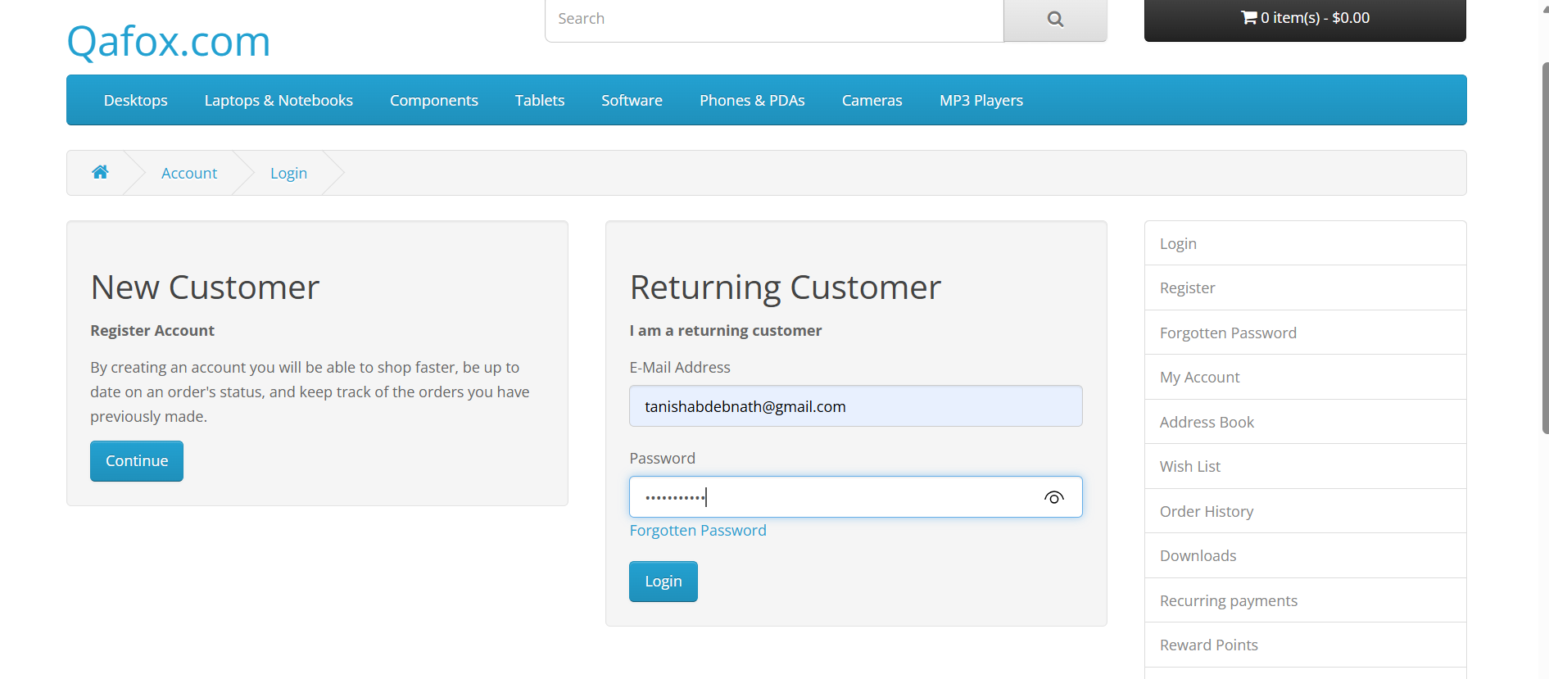

Figure 2: Successful login automation using valid credentials.

16. Invalid Login Output
This negative test intentionally submits invalid credentials and verifies that the application responds with the expected warning message:
“Warning: No match for E-Mail Address and/or Password.”
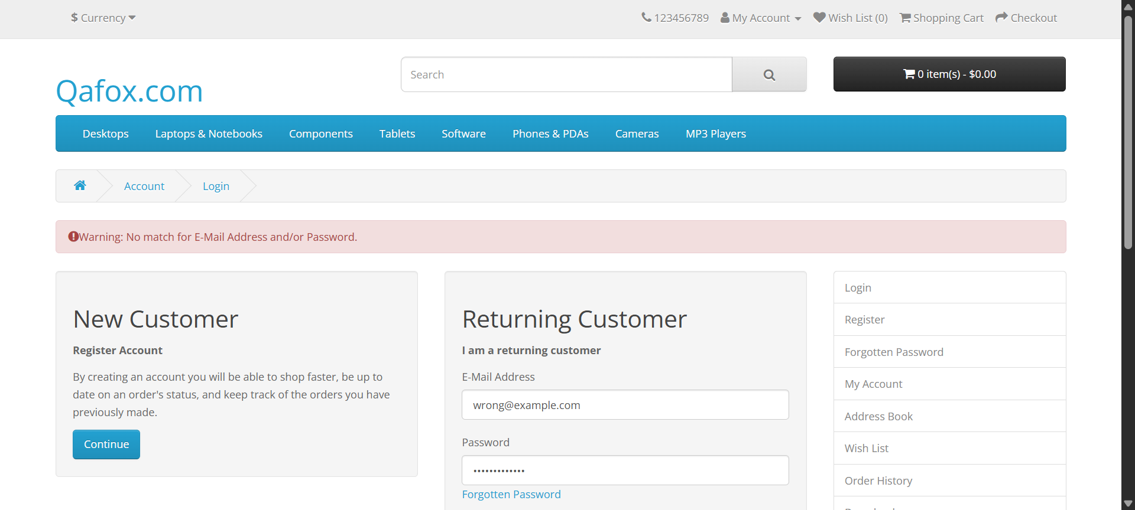
Figure 3: Invalid login scenario displaying the expected warning message.

17. Product Search Outputs

17.1 MacBook
Search term: MacBook
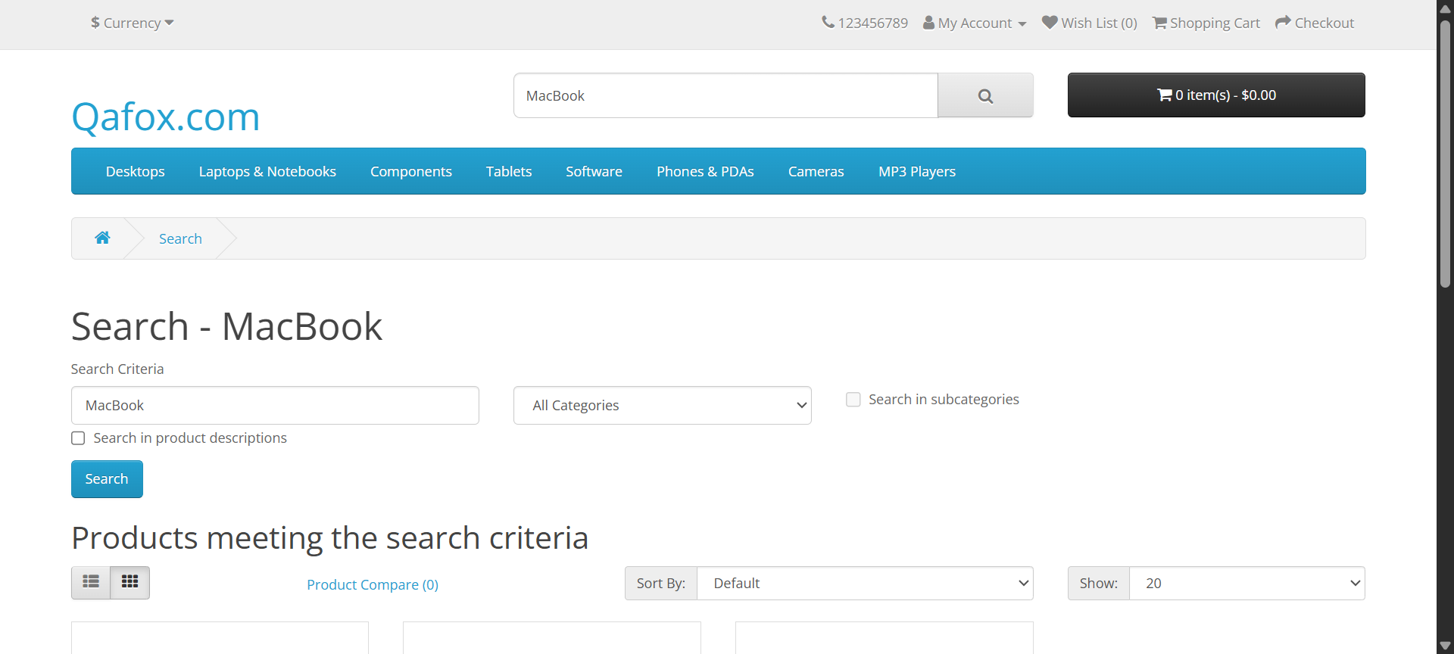
Figure 4: MacBook product search result.

17.2 iPhone
Search term: iPhone
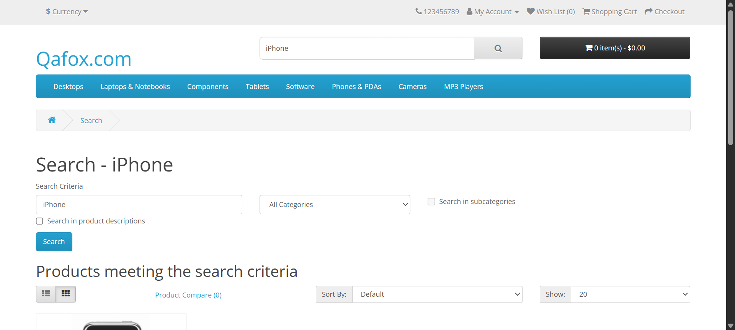
Figure 5: iPhone product search result.

17.3 Canon
Search term: Canon
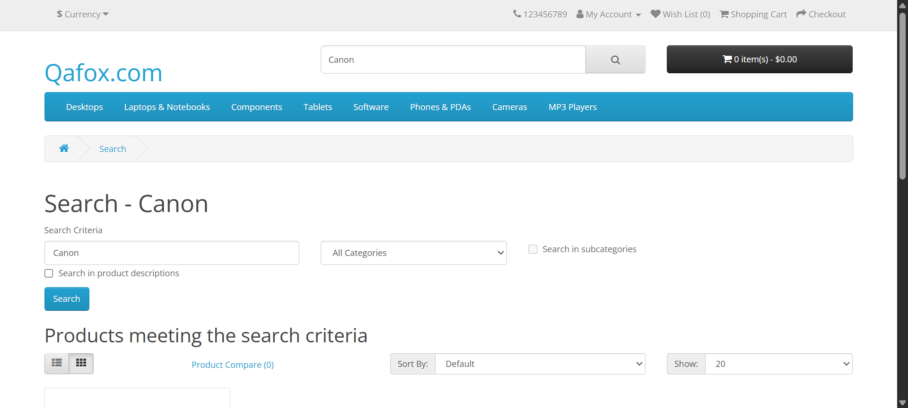
Figure 6: Canon product search result.

18. Screenshot-on-Failure Proof
Screenshot-on-failure was verified during an actual run in which a login test failed. The conftest.py hook detected the failure and automatically saved a PNG screenshot to the screenshots/ directory, named after the failing test (test_valid_login.png), exactly as implemented in the hook.
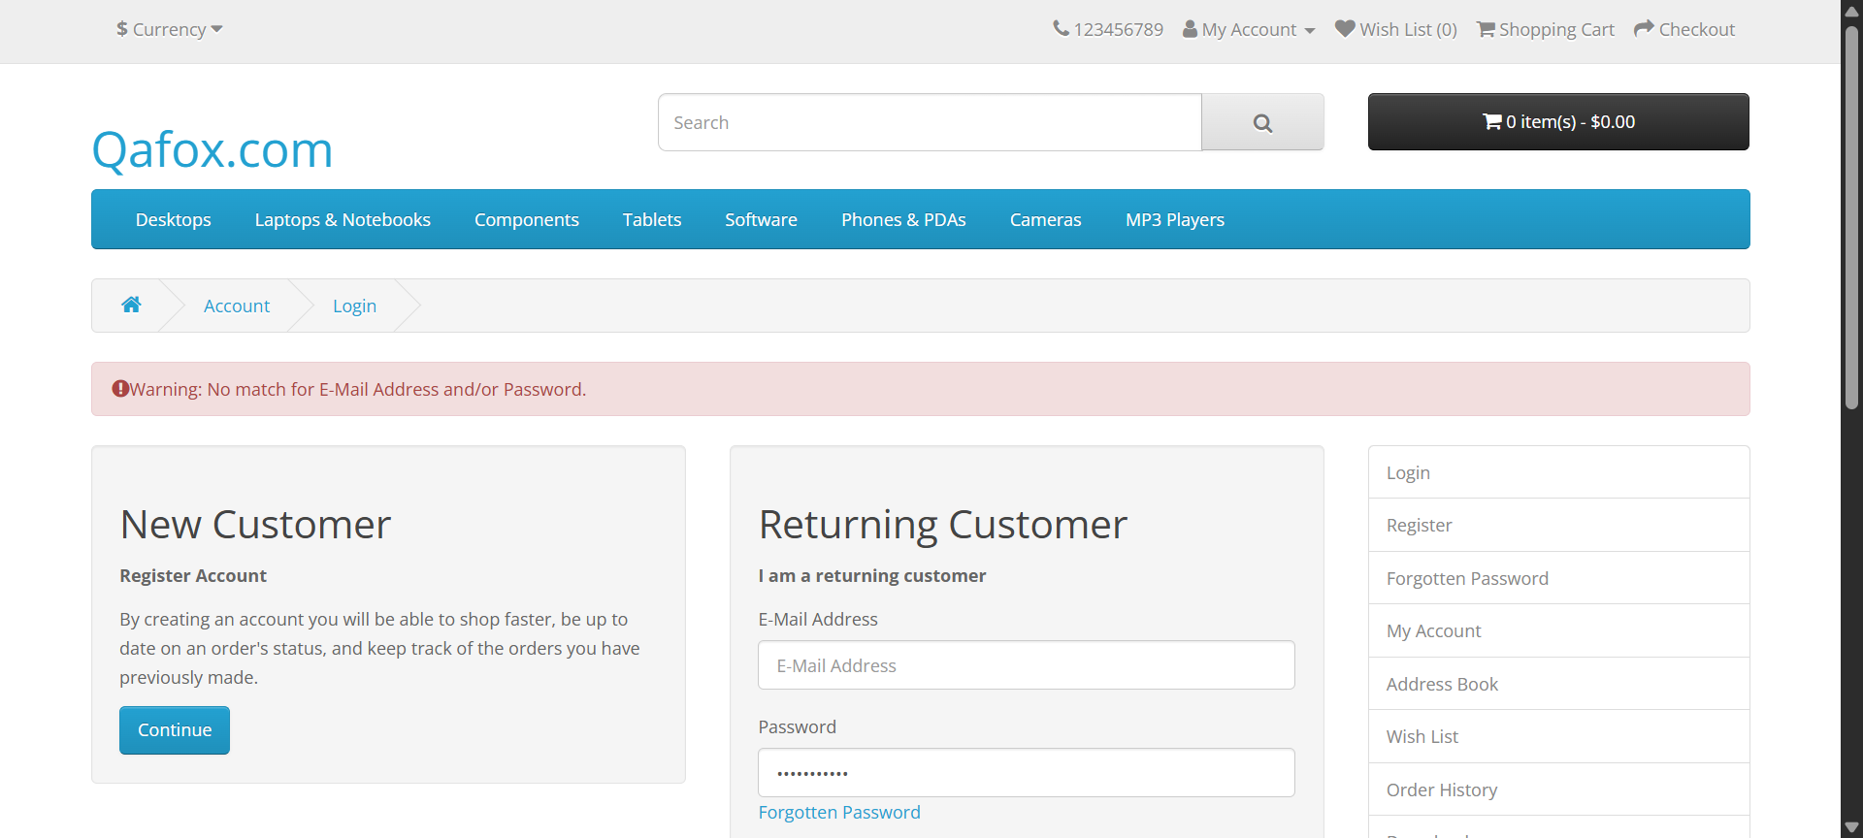
Figure 8: Automatic screenshot captured after test failure.
This mechanism is intended for failure diagnostics only — it does not capture screenshots for successful tests unless explicitly programmed to do so.

19. Unittest Output
Command:
pytest tests/test_unittest_login.py -v
Actual result: 1 passed in 23.51s

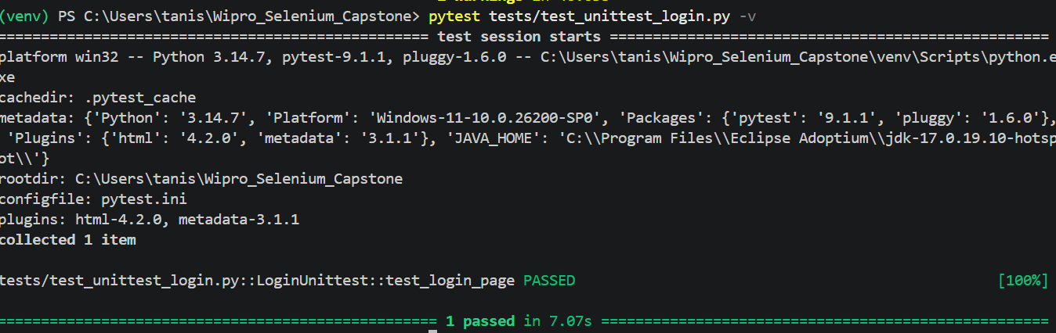
Figure 7: Successful Python Unittest execution.

20. Final PyTest Output
Full-suite run, showing all six tests:
collected 6 items

tests/test_login.py::test_valid_login PASSED
tests/test_login.py::test_invalid_login PASSED
tests/test_search.py::test_product_search[MacBook] PASSED
tests/test_search.py::test_product_search[iPhone] PASSED
tests/test_search.py::test_product_search[Canon] PASSED
tests/test_unittest_login.py::LoginUnittest::test_login_page PASSED

6 passed in 54.66s

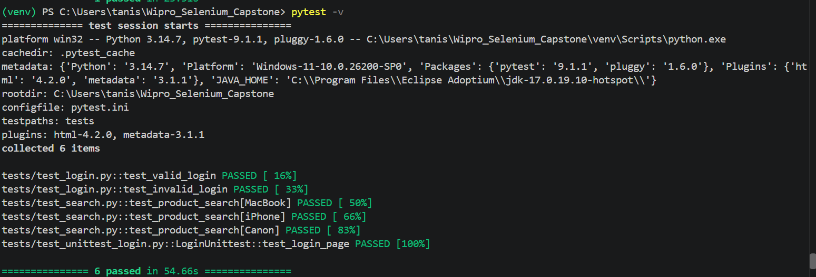
Figure 9: Complete PyTest execution showing all six tests passed.

21. Final HTML Report Output
Command:
pytest -v --html=reports/report.html --self-contained-html
The HTML report shows 6 tests completed in approximately 00:00:47, with 0 Failed, 6 Passed, 0 Skipped, 0 Expected failures, 0 Unexpected passes, 0 Errors, 0 Reruns and 0 Retried. All six tests below are marked Passed:
• tests/test_login.py::test_valid_login
• tests/test_login.py::test_invalid_login
• tests/test_search.py::test_product_search[MacBook]
• tests/test_search.py::test_product_search[iPhone]
• tests/test_search.py::test_product_search[Canon]
• tests/test_unittest_login.py::LoginUnittest::test_login_page

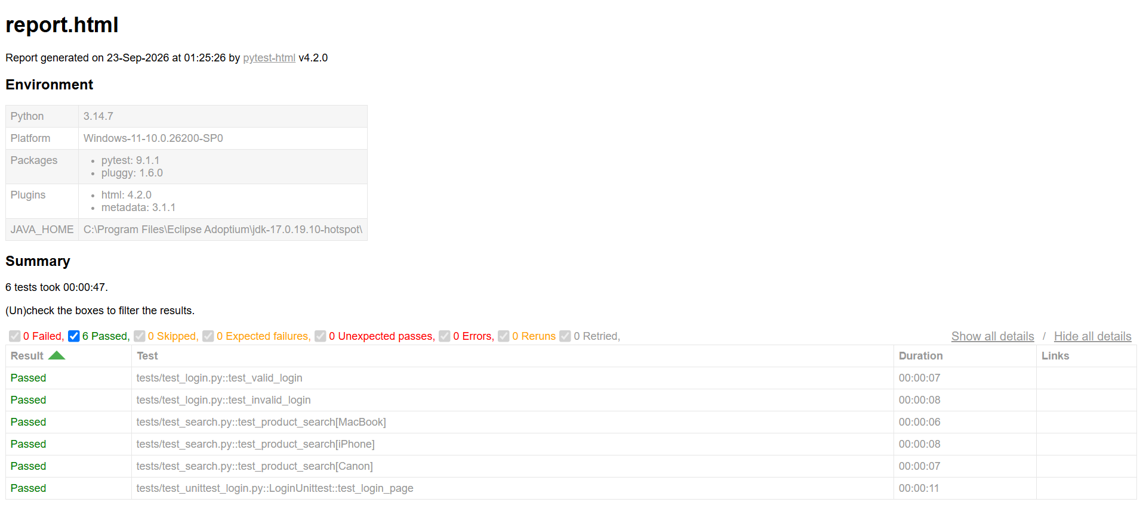
Figure 10: Final HTML test execution report showing six passed tests.

22. Execution Command Output
The following commands were executed to produce the evidence in this report:
• pytest -v — shown in Figure 9
• pytest -v --html=reports/report.html --self-contained-html — shown below
• pytest tests/test_unittest_login.py -v — referenced in Figure 7 (Section 19)
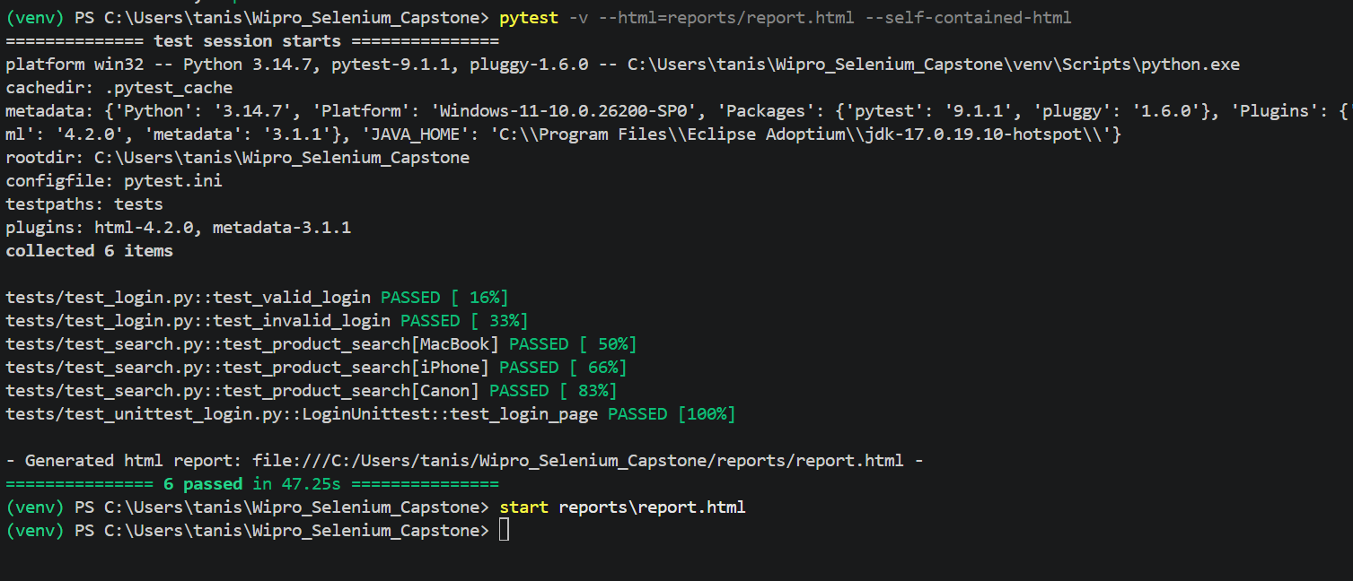
Terminal output — pytest -v --html=reports/report.html --self-contained-html

23. Final Test Result Summary
Metric | Result
Total Tests | 6
Passed | 6
Failed | 0
Skipped | 0
Errors | 0
Overall Result | All automated test cases passed successfully
Actual full-suite execution: 6 passed in 54.66s

24. HTML Report Summary
Metric | Result
Total Tests | 6
Passed | 6
Failed | 0
Skipped | 0
Errors | 0
The HTML report was generated using pytest-html and stored at reports/report.html.

25. Challenges and Solutions
Challenge | Solution
Repeated locators | Page Object Model
Repeated browser setup | PyTest fixture
Multiple product inputs | CSV + parameterization
Configuration values | config.ini + ConfigReader
Failure debugging | Screenshot-on-failure hook
Execution reporting | pytest-html
Multiple testing frameworks | PyTest + Unittest

26. Learning Outcomes
This project provided practical, hands-on understanding of:
• Selenium WebDriver
• Python automation
• PyTest
• Unittest
• Page Object Model
• Fixtures
• Parameterization
• CSV data handling
• Configuration management
• Utility classes
• Screenshot capture
• HTML reporting
• Framework organisation

27. Conclusion
The Selenium Python automation framework successfully automated the Login and Product Search functionalities of the TutorialsNinja Demo e-commerce application. The project was designed as a modular and reusable automation framework rather than a collection of standalone scripts.
The framework demonstrates the practical implementation of several important automation concepts, including Selenium WebDriver, PyTest, Unittest, Page Object Model (POM), utility classes, configuration management, CSV-based test data handling, data-driven testing, screenshot capture on test failure, and HTML test reporting. Each component has been separated according to its responsibility, making the framework easier to understand, maintain, debug, and extend.
The Page Object Model was used to separate web-page locators and actions from the actual test cases. This improves code reusability and reduces duplication. Configuration values such as the application URL, browser, and login details are managed separately, while product search data is maintained in a CSV file. PyTest parameterization enables the same search test to be executed for multiple products without duplicating test code.
The framework also incorporates positive and negative testing. The valid login scenario verifies successful authentication, while the invalid login scenario verifies that the application displays the appropriate warning message for incorrect credentials. Product search automation validates searches for multiple products and verifies that the corresponding search page and product results are displayed.
To improve debugging and test analysis, the framework includes automatic screenshot capture for failed tests. In addition, the pytest-html plugin is used to generate a detailed HTML execution report containing the overall test results.
During the final execution, 6 test executions were performed and all 6 passed successfully, with 0 failures, 0 errors, and 0 skipped tests. This confirms that the implemented automation scenarios and framework components worked successfully together.
Overall, this project provided practical experience in developing a structured Selenium Python automation framework and demonstrated how different automation techniques can be integrated into a single maintainable testing solution. The framework can also be extended in the future by adding more application modules, additional test scenarios, browser configurations, larger test-data sets, explicit waits, logging, and continuous integration support.

Appendix

Appendix A – Complete Project Structure
See Section 7 (Project Structure) for the full directory layout.

Appendix B – CSV Test Data
See Section 12 (Test Data Handling) for the complete contents of data/test_data.csv.

Appendix C – Complete Source Code
See Section 13 (Complete Source Code) for every implemented file, listed in full.

Appendix D – Test Execution Evidence
See Sections 15–21 for the login, search, unittest, PyTest, and HTML report evidence and figures.

Appendix E – Important Commands
Create virtual environment:
python -m venv venv

Activate:
.\venv\Scripts\Activate.ps1

Install dependencies:
pip install -r requirements.txt

Run all tests:
pytest -v

Run login tests:
pytest tests/test_login.py -v

Run search tests:
pytest tests/test_search.py -v

Run Unittest:
pytest tests/test_unittest_login.py -v

Generate HTML report:
pytest -v --html=reports/report.html --self-contained-html

Open report:
start reports\report.html

