

1. Executive Summary
F1 Performance Hub is an interactive Power BI report designed to explore motorsport performance through several connected views: an overall qualifying baseline, driver-level comparisons, constructor-level comparisons, season-to-season patterns, and lap-time behaviour by lap number. The goal is not to rank an entity from one number alone, but to compare different performance dimensions together.
The qualifying table contains 11,120 records across 556 race-round combinations, 20 driver identifiers, and 10 constructor identifiers for the 2000–2026 analysis period. The lap-time table contains 77,840 records. The overall average qualifying position is 10.48, Q3 reach is approximately 50.0%, the standard deviation of qualifying position is 5.78, and the fastest recorded Q3 time in the analysis table is 76.219 seconds.
The dashboard’s main value is its ability to connect these metrics. Average qualifying position provides a broad reference point; Q3 reach indicates how often an entry advances into the final qualifying segment; spread indicates variation; and lap-time analysis adds a sequential view. Each metric answers a different question, so the results should be interpreted together.

Main takeaways
- Use average qualifying position as a baseline, not as a complete performance score.
- Compare Q3 reach and position spread to understand advancement and consistency separately.
- Driver and constructor comparisons reveal differences that an overall average can hide.
- Season averages remain within a relatively narrow range, while individual year patterns still vary.
- Mean lap time rises from approximately 94.46 seconds on lap 1 to 97.48 seconds on lap 7; the pattern is descriptive and does not, by itself, explain why lap times change.
Data interpretation note: the workbook is an analytical practice dataset, not an official historical FIA/F1 results archive. The dashboard is therefore best presented as a demonstration of data modelling, visual analytics, and interpretation methods rather than as verified claims about real-world Formula 1 history.

2. Project Objectives
Objective | How the dashboard addresses it | Why it matters
Establish a baseline | Summary KPI cards for qualifying position, Q3 reach, spread, and best Q3 time. | Creates a common reference before entity comparisons.
Compare drivers | Driver-level qualifying position and qualifying-edge views. | Shows differences between individual identifiers across multiple indicators.
Compare constructors | Constructor-level edge, Q3 reach, and seasonal trend visuals. | Moves from individual results to group-level performance patterns.
Explore time-based behaviour | Season trends and lap-time analysis. | Separates between-season variation from within-session lap patterns.
Enable interactive exploration | Page navigation, slicers, and linked visuals. | Lets users narrow the view without maintaining separate static reports.
Communicate responsibly | Interpretation notes and limitations. | Prevents descriptive patterns from being mistaken for causal or official conclusions.

3. Tools and Analytical Workflow
Tool: Microsoft Power BI Desktop. The report is organized into four analytical pages: Overview, Drivers, Constructors, and Season Trends.
Stage | Work performed | Output
1. Data preparation | Load qualifying and lap-time tables; review field types and available keys. | Two related analytical tables.
2. Model alignment | Use year, round, race key, driver key, and constructor key to maintain context between records. | Consistent dimensions for comparison.
3. Measure design | Aggregate position, Q3 availability, spread, fastest Q3 time, and mean lap time. | Comparable KPIs.
4. Visual selection | Use KPI cards, bar charts, line charts, and scatter-style comparisons. | Different views for ranking, distribution, and change over time.
5. Interpretation | Compare the baseline with driver/team and time-based views. | Findings with explicit limits.

The workbook’s qualifying table has 10 fields and the lap-time table has 9 fields. The race key and entity keys support joining or filtering the data at the relevant level. The report should be read with the dashboard’s active slicers in mind, because filter selections can change the displayed values.

4. Dataset Profile
Data element | Value | Interpretation
Analysis period | 2000–2026 | Year coverage used for the dashboard analysis.
Qualifying records | 11,120 | Rows in the qualifying table.
Lap-time records | 77,840 | Rows in the lap-time table.
Race-round combinations | 556 | Distinct race keys represented in the qualifying table.
Driver identifiers | 20 | Distinct driver keys in the analysis data.
Constructor identifiers | 10 | Distinct constructor keys in the analysis data.
Average qualifying position | 10.48 | Mean position across qualifying records; lower values indicate better grid position.
Position spread (standard deviation) | 5.78 | Shows how widely qualifying positions vary around their mean.
Q3 reach rate | 50.0% | Share of qualifying records with a Q3 time available.
Best Q3 time | 76.219 seconds | Minimum recorded Q3 time in the analysis table.

Data fields and their role
- Year and round identify the time period and round sequence.
- Race key supports grouping records belonging to the same race-round combination.
- Driver and constructor keys support comparisons at individual and team level.
- Qualifying position is an ordinal result: a smaller number represents a better starting position.
- Q1, Q2, and Q3 time fields represent qualifying-session timing fields; Q2/Q3 values are not expected to be present for every record.
- Lap number and lap time enable comparison of average time by sequential lap.
Before presenting a live demonstration, clear slicers to show the full report, then apply one filter at a time. When comparing two entities, keep the year range and other filters consistent.

5. Dashboard Overview and Navigation
The dashboard is divided into four pages so that each page answers a distinct analytical question instead of crowding all visuals into one canvas.
Page | Main question | Typical visuals / measures
Overview | What does the overall qualifying dataset look like? | KPI cards, qualifying-position trend, Q3 reach, and baseline comparisons.
Drivers | How do driver identifiers differ? | Driver ranking, qualifying-edge comparison, Q3 reach, and spread.
Constructors | How do constructor identifiers differ? | Constructor edge, reach/consistency comparisons, and seasonal team trends.
Season Trends | How does performance vary over time and by lap? | Season average position, Q3 reach over years, and average lap time by lap number.

Recommended reading order: begin with Overview to understand the baseline; use Drivers and Constructors to locate differences; then use Season Trends to check whether the patterns persist or vary across time. Return to Overview when a filtered result needs to be compared with the full dataset.

Dashboard screenshots
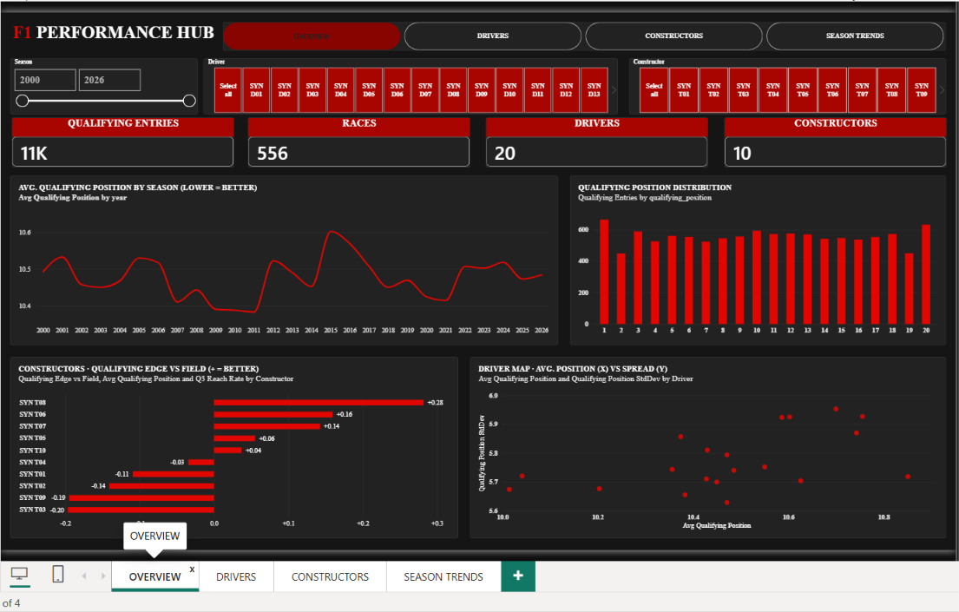
Figure 1. Overview page — The baseline view summarises qualifying performance and gives context for later comparisons.
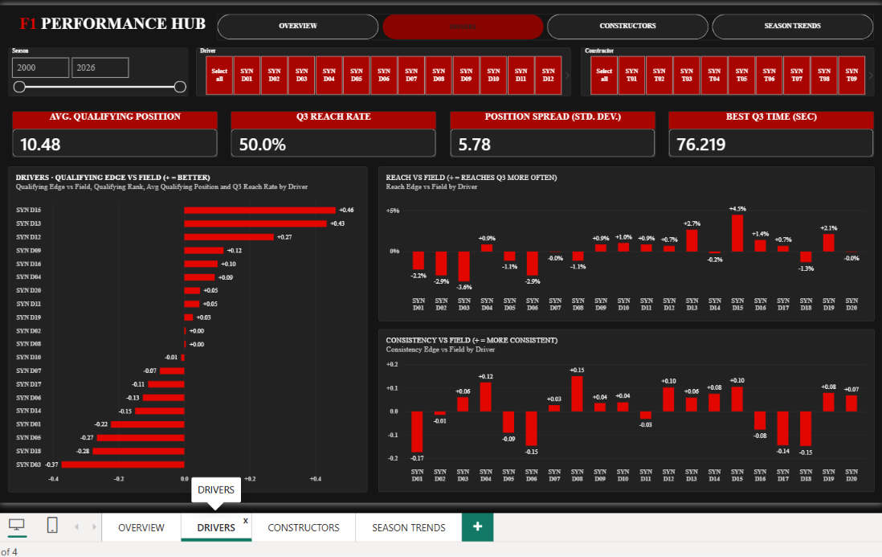
Figure 2. Drivers page — The driver page compares qualifying-position outcomes and related performance indicators.
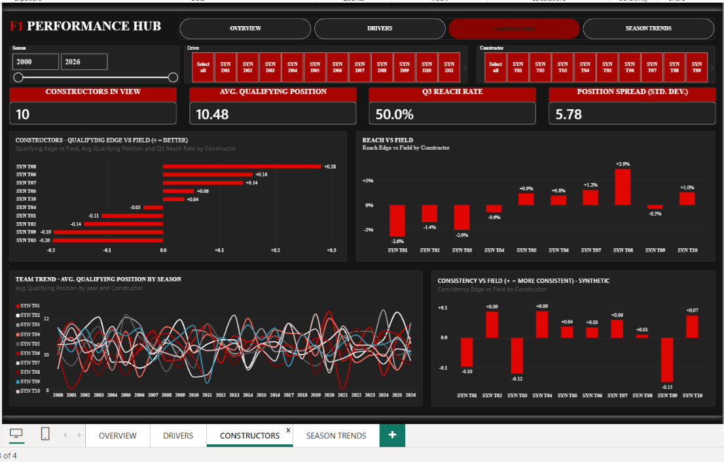
Figure 3. Constructors page — The constructor page shifts the analysis from individual entries to team-level patterns.
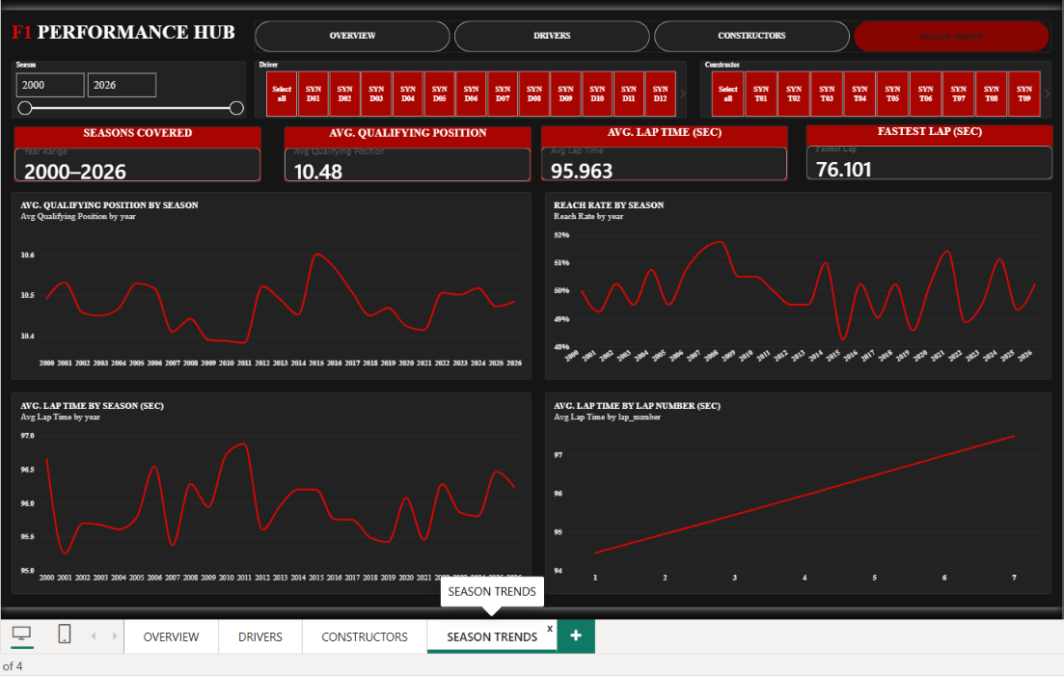
Figure 4. Season Trends page — The season page explores changes over time and the relationship between lap number and mean lap time.

6. Page One — Overview: Establishing the Baseline

6.1 KPI cards
KPI | Observed value | What it tells the viewer
Average qualifying position | 10.48 | The mean qualifying position is around the middle of a 20-entry field. It is a baseline, not a standalone judgement of performance.
Q3 reach rate | 50.0% | About half of the qualifying records have a Q3 time available. This measures advancement into the final qualifying segment.
Position spread | 5.78 | The standard deviation indicates meaningful variation in qualifying position across records.
Best Q3 time | 76.219 s | The fastest Q3 time recorded in the analysis table; it should be interpreted in the context of the dataset and conditions represented.

6.2 Why the baseline matters
The baseline gives the audience a common point of reference. Without it, a driver or constructor comparison can show a high or low value without explaining whether that value is unusual relative to the wider dataset. The average position and spread should be read together: the mean describes central tendency, while spread describes variability.
Q3 reach answers a different question from average position. A record may contribute to a respectable average position while still failing to reach Q3 frequently, or may reach Q3 often but show variation in final position. For this reason, the dashboard keeps these indicators separate rather than collapsing them into one composite score.

7. Page Two — Driver Analysis
The driver page compares driver identifiers across qualifying outcomes. Its purpose is to show how the ranking changes when the viewer moves beyond a single average and considers the qualifying-edge measure, Q3 reach, and spread.

7.1 Qualifying-edge observations
Driver identifier | Reported qualifying edge | Interpretation
SYN D15 | +0.46 | Positive value under the dashboard’s edge convention; interpret with the measure definition and comparison baseline.
SYN D13 | +0.43 | Also positive under the displayed convention. The difference from D15 is small enough that it should not be over-interpreted without uncertainty or sample-size context.
SYN D10 | −0.37 | Negative under the same convention, indicating a different result relative to the dashboard’s reference.

Important: the plus/minus sign must be interpreted according to the exact DAX measure definition. The report should not claim that positive always means faster or better until the measure’s direction and reference group have been confirmed.

7.2 How to read driver visuals
- Ranking bars are useful for comparing average qualifying position; lower average position is better.
- Q3 reach indicates how often an identifier reaches the final qualifying segment, not how fast it is when it reaches Q3.
- Position spread indicates variability. A low spread may suggest more stable results, but it does not necessarily mean the driver is the fastest.
- Scatter plots can help identify combinations of average position and spread that a ranking alone cannot show.
- Use the same season and other filters when comparing two drivers to avoid comparing different data subsets.

7.3 What can and cannot be concluded
The dashboard can identify differences among the driver identifiers represented in the table. It cannot, by itself, attribute those differences to driving skill, car performance, strategy, track characteristics, weather, or regulation changes. Those explanations require additional variables and a suitable study design.

8. Page Three — Constructor Analysis
The constructor page aggregates the analysis at team level. This matters because driver-level outcomes may be influenced by the broader team context, while constructor-level summaries can reveal patterns shared across entries.
Constructor identifier | Reported qualifying edge | Interpretation
SYN T08 | +0.28 | Positive value under the dashboard’s edge convention.
SYN T06 | +0.16 | Positive but smaller reported edge than T08.
SYN T07 | +0.14 | Close to T06; avoid treating the small gap as meaningful without uncertainty analysis.
SYN T03 | −0.20 | Negative under the same displayed convention.

How constructor comparisons add value
- They summarise patterns across the driver entries associated with each constructor identifier.
- Q3 reach helps distinguish teams that advance regularly from teams that do so less often.
- Consistency/spread adds a measure of stability to the average-position comparison.
- Seasonal trend lines show whether a team-level pattern remains stable or varies over the period.
- Small differences should be treated cautiously if sample sizes or represented seasons differ.
The dashboard is descriptive. It can highlight where further investigation is useful, but it cannot establish that a constructor’s technical package caused a particular result. A stronger explanation would require car, circuit, weather, tyre, regulation, and session-level context.

9. Page Four — Season Trends
The season page moves from comparing entities to comparing periods. It helps answer whether the overall qualifying baseline changes materially over time and whether lap-time averages differ by lap number.
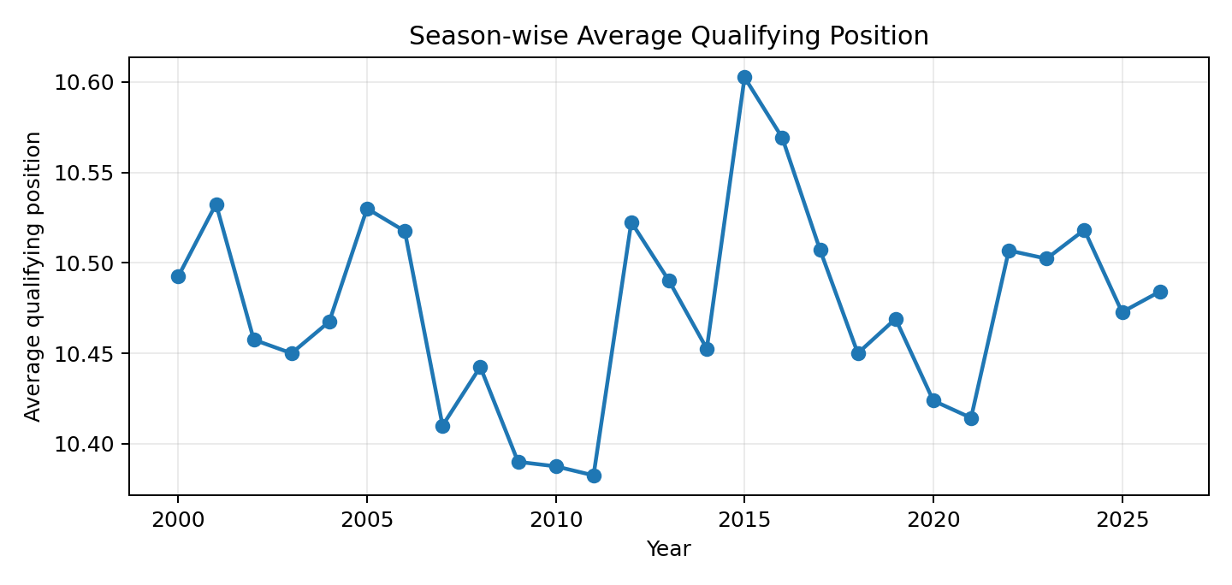
Figure 5. Average qualifying position by year, calculated from the provided qualifying table.
Seasonal average qualifying position lies approximately within the 10.38–10.60 range. The lowest average is around 2011 and the highest around 2015 in the reported dashboard view. The range is relatively narrow, so the main message is broad stability in the overall mean alongside year-to-year variation.
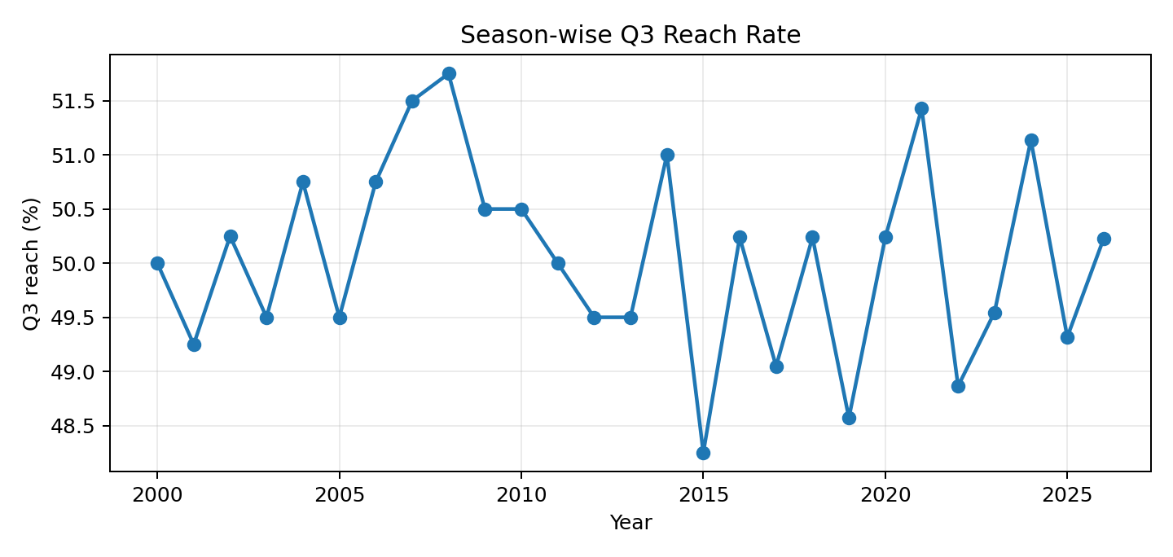
Figure 6. Q3 reach rate by year, calculated as the share of qualifying rows with a Q3 time.
Q3 reach changes across years and complements the average-position trend. A stable mean does not guarantee that the same share of entries reaches Q3 each year; the two indicators capture different aspects of the qualifying distribution.

9.1 Interpreting trends responsibly
- Yearly aggregates can hide changes among individual drivers or constructors.
- The number and composition of records per year should be checked before comparing years.
- Trend lines show association and movement over time, not the reason for a change.
- The 2000–2026 period should be treated as the workbook’s analysis coverage, not as a verified official race calendar.

10. Lap-Time Analysis
Lap-time analysis adds a sequential perspective to the qualifying-focused views. Instead of comparing grid positions or entities, it compares mean lap time across lap numbers.
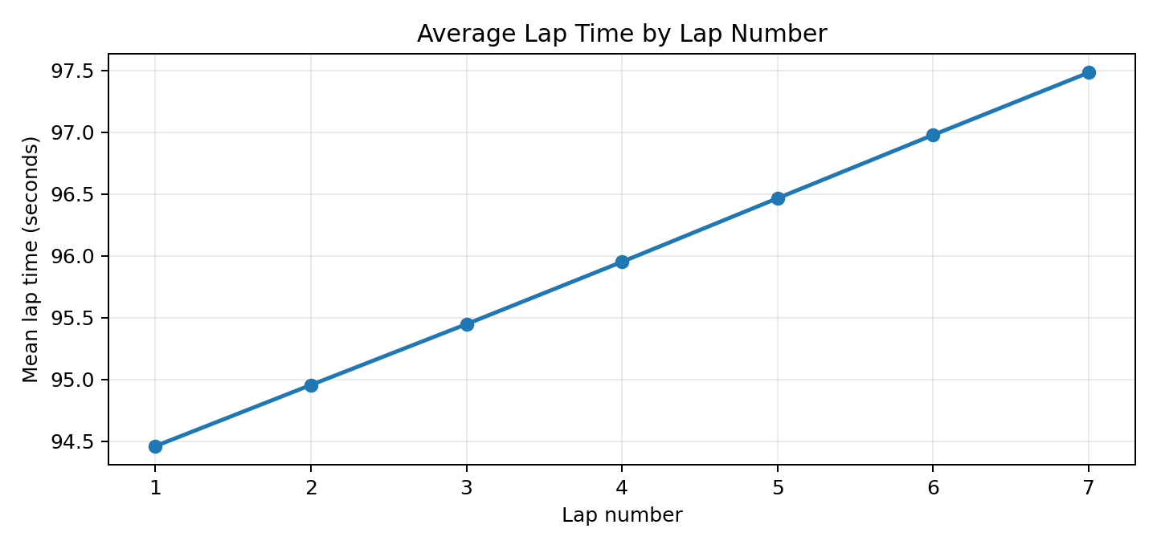
Figure 7. Mean lap time by lap number, calculated from the provided lap-time table.
Lap number | Mean lap time
Lap 1 | 94.46 seconds
Lap 2 | 94.96 seconds
Lap 3 | 95.45 seconds
Lap 4 | 95.95 seconds
Lap 5 | 96.47 seconds
Lap 6 | 96.98 seconds
Lap 7 | 97.48 seconds

Mean lap time rises from approximately 94.46 seconds on lap 1 to 97.48 seconds on lap 7, a difference of about 3.02 seconds. This is a pattern in the supplied records. The graph alone does not identify the cause: tyre wear, fuel load, track conditions, traffic, circuit mix, and other variables are not isolated by this chart.

Why this visual is useful
It demonstrates how a sequence-based measure can reveal a trend that would not be visible in qualifying position alone. To deepen the analysis, the next iteration could compare lap-time distributions by circuit, driver, constructor, stint, and track conditions, where those fields are available and validated.

11. Integrated Findings
Finding | Evidence in the dashboard | Practical interpretation
A single average is insufficient | Average qualifying position is 10.48, while Q3 reach is about 50.0%. | Use multiple indicators to describe performance rather than one score.
Variability matters | Position spread is 5.78. | An average should be accompanied by a measure of dispersion.
Driver and constructor views answer different questions | The dashboard provides both entity-level and team-level comparisons. | Separate individual patterns from group-level patterns.
The overall seasonal mean is broadly stable | Seasonal average position is roughly 10.38–10.60. | Inspect year-by-year and entity-level variation instead of assuming no change.
Lap-time averages rise by lap number | About 94.46 seconds at lap 1 and 97.48 seconds at lap 7. | Investigate the pattern further; do not claim a cause from this chart alone.
Data context limits interpretation | The analytical workbook does not verify official historical F1 results. | Present findings as a demonstration of analytical workflow, not as official sport statistics.

12. Limitations and Validation Notes
- The analysis data are prepared for dashboard development and are not a verified official historical Formula 1 dataset. Results should not be presented as official race statistics.
- Driver and constructor identifiers are coded identifiers, so they should not be mapped to real people or teams without a verified mapping.
- Qualifying position is ordinal. Differences between positions should not automatically be treated as equal-sized performance gaps.
- Q3 reach depends on whether a Q3 time is available; confirm that the field is used consistently as the intended indicator.
- The qualifying-edge values depend on the dashboard measure’s exact formula and reference direction. Document the measure definition alongside the report.
- Season comparisons can be affected by differences in record counts and entity composition.
- Lap-time changes cannot be causally explained without additional variables such as circuit, tyre, weather, stint, and track conditions.
- Before submission, clear unintended slicers, verify that each visual uses the correct aggregation, and ensure titles include units where needed.

13. Recommendations and Future Scope
- Add a data dictionary that defines each KPI, its unit, aggregation, and interpretation.
- Display the sample size behind each driver, constructor, and season result.
- Add tooltip definitions for qualifying edge, position spread, and Q3 reach.
- Add confidence intervals or distribution plots where comparisons need uncertainty context.
- Introduce additional validated fields—such as circuit, session conditions, tyre/stint information, and weather—if deeper explanatory analysis is required.
- Add a reset-filters button and a visible filter-state summary to improve dashboard usability.
- Validate all joins and check for duplicate keys before using the dashboard for formal reporting.
- If the project is extended with official data, document the source, version, licence, and data-cleaning steps, then rerun the same measures for a like-for-like comparison.

14. Conclusion
F1 Performance Hub demonstrates an end-to-end Power BI workflow for turning structured performance tables into an interactive analytical report. Its strength is the combination of an overall baseline, driver and constructor comparisons, seasonal patterns, and lap-time behaviour. The metrics are most useful when interpreted together: average position describes the centre, Q3 reach describes advancement, spread describes variability, and lap-time analysis describes a separate time-based pattern.
The project also highlights an important analytics principle: a chart is only as reliable as its data, measure definition, and context. Clearly documenting those elements makes the dashboard easier to explain, validate, and extend.

Appendix A — KPI glossary
Term | Definition
KPI | Key Performance Indicator: a headline measure used to summarise a specific aspect of performance.
Average qualifying position | Arithmetic mean of the qualifying-position field; lower values indicate better positions.
Q3 reach rate | Share of qualifying records with a Q3 time present, used here as a proxy for reaching Q3.
Position spread | Standard deviation of qualifying positions; indicates how dispersed the positions are.
Best Q3 time | Minimum recorded Q3 time in the analysis table.
Slicer | An interactive filter that changes the records included in one or more visuals.
Filter context | The subset of records included after slicers and visual filters are applied.

Appendix B — Source and project notes
Project tool: Microsoft Power BI Desktop. Analysis workbook: F1_Synthetic_Qualifying_LapTime_AddOn_80Kplus.xlsx. The workbook README identifies the qualifying and lap-time tables as generated practice records rather than verified historical race records.
Dataset attribution: insert the exact source title, creator, and URL if the qualifying data were adapted from a separate public source. Do not add a source citation unless it has been verified.

