**CA 3: Experiential Learning**

**Group Members:**

| **Sr. No.** | **PRN** | **Name of Student** | **Mail Id** |
| --- | --- | --- | --- |
| 1 | 22070122186 | Satviki Budhia | satviki.budhia.btech2022@sitpine.edu.in |
| 2 | 22070122232 | Tanisha Vyas | tanisha.vyas.btech2022@sitpune.edu.in |

**Problem Statement:**

The objective of this code is to create a simple text-based virtual assistant that can interact with the user through a command-line interface in order to provide them with a simple way to interact with it. This virtual assistant can perform various tasks based on user input, including opening web pages, searching the internet, greeting the user, and responding to specific commands.

**Explanation:**

It is the aim of the project to develop a basic virtual assistant that can assist the user with a limited set of tasks through text-based interaction with the assistant. There are various tasks that the virtual assistant can perform, including answering specific textual commands, providing greetings, opening websites, and performing basic web searches for the user.

**Key Components:**

* **Voice and Text-to-Speech:**
  + This project includes a voice component for converting text into speech. To enable the assistant to speak aloud, it uses a simple Text-to-Speech (TTS) approach.
  + The **Voice** class serves as the base class, and **TextToSpeech** is an implementation of voice functionality. It generates a VBScript file (**speak.vbs**) and uses SAPI (Speech Application Programming Interface) to produce speech.
* **Assistant Classes:**There are two main assistant classes:
  + **GreetingAssistant**: This assistant is specialized for providing greetings based on the time of day.
  + **CommandAssistant**: This assistant is responsible for processing user commands entered via text input.
* **User Interaction**
  + User input is collected using the **gets** function, which reads text input from the command line.
  + The assistant interacts with the user by both speaking the responses using TTS and displaying text on the console.
* **Functionality**:TONI can perform various tasks like
  + opening browsers
  + opening application
  + conducting web searches on Google and Youtube
  + Informing date and time
  + Basic chat like “who are you” and “how are you”

**Class Diagram:**

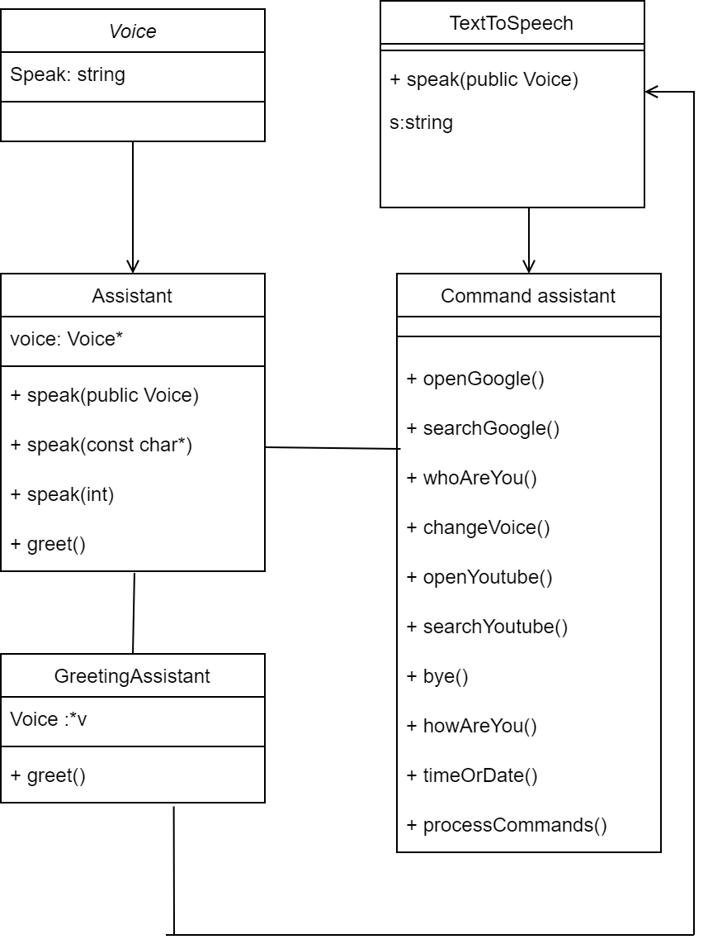

**Code Snippets:**

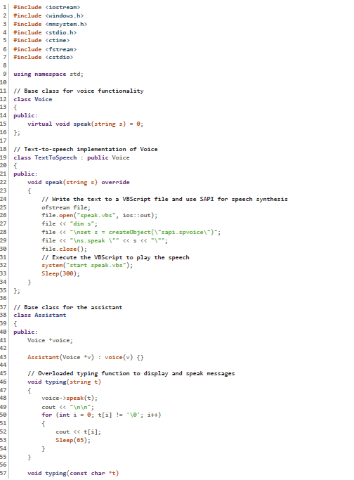

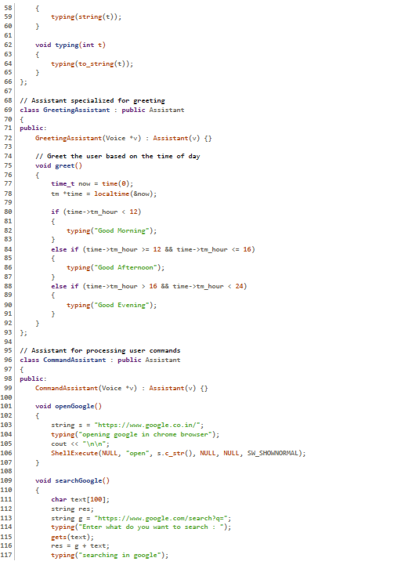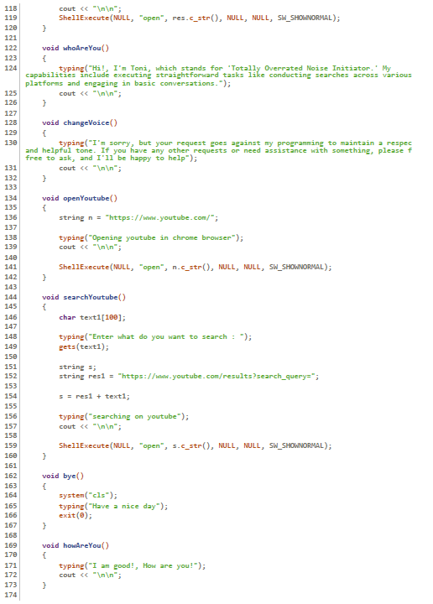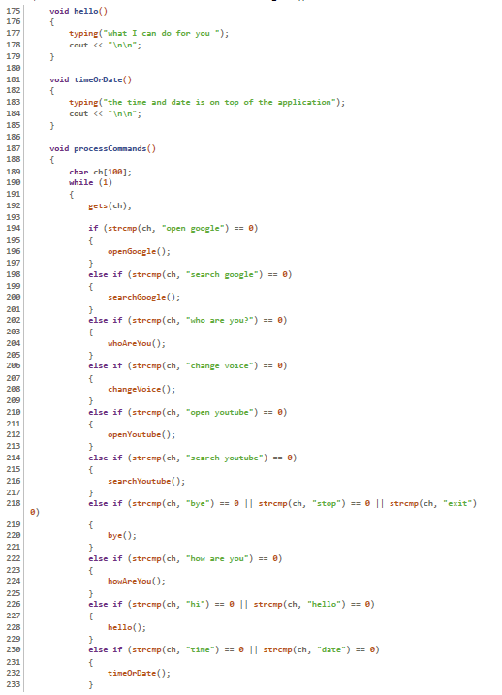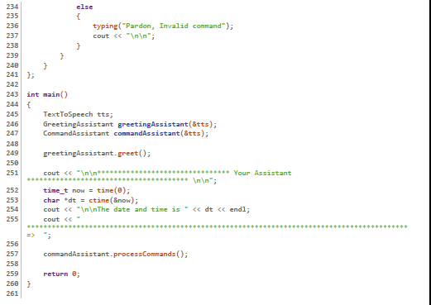

**Input/Output:**

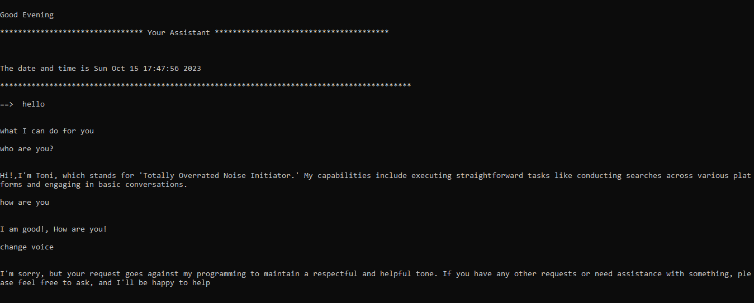

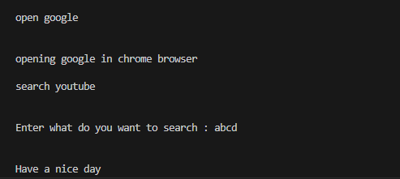

**Github repository link**

[**https://github.com/TanishaVyas/Voice_Assistant_TONI_Cpp**](https://github.com/TanishaVyas/Voice_Assistant_TONI_Cpp)