TRANSCRIBE

A

Project Report

Submitted in partial fulfillment of the requirement for the award of degree of

#### Bachelor of Technology

In

#### Computer Science & Engineering

Submitted to

#### RAJIV GANDHI PROUDYOGIKI VISHWAVIDYALAYA, BHOPAL (M.P.)



**Guided by Submitted By**

Mr. Ajay Khatri Tanisha Singhai(0827CS181223)

Srashti Gupta(0827CS181215)

Shruti Kanungo(0827CS181201)

Vaishnavi Tiwari(0827CS181230

#### DEPARTMENT OF COMPUTER SCIENCE & ENGINEERING ACROPOLIS INSTITUTE OF TECHNOLOGY AND RESEARCH, INDORE (M.P.) 452001

**2021-2022**

**Declaration**

I hereby declared that the work, which is being presented in the project entitled “**Transcribe**” partial fulfilment of the requirement for the award of the degree of **Bachelor of Technology**, submitted in the Department of Computer Science & Engineering at **Acropolis Institute of Technology and Research, Indore** is an authentic record of my own work carried under the supervision of “**Mr. Ajay Khatri** ”. I have not submitted the matter embodied in this report for award of any other degree.

Tanisha Singhai(0827CS181223)

Srashti Gupta(0827CS181215)

Shruti Kanungo(0827CS181201)

VaishnaviTiwari(0827CS181230)

# Project Approval Form

I hereby recommend, that the project prepared under my supervision titled by **“Transcribe”** be accepted in partial fulfilment of the requirement for the degree of Bachelor of Technology in Computer Science & Engineering.

Ms. Khushboo Pawar

Supervisor

Recommendation concurred in

Prof. Ajay Khatri

#### Project Coordinator

**Acropolis Technical Campus Department of Computer Science & Engineering**

**Certificate**

The project work entitled “**Transcribe**” submitted by Tanisha Singhai (0827CS181223), Shruti Kanungo(0827CS181201), Srashti Gupta(0827CS181215), Vaishnavi Tiwari(0827CS181230) is approved as partial fulfillment for the award of the degree of Bachelor of Technology in Computer Science & Engineering by Rajiv Gandhi Proudyogiki Vishwavidyalaya, Bhopal (M.P.).

#### Internal Examiner External Examiner

Name:………………. Name: ……………..

Date: …./…/……….. Date: …./…/………..

# Acknowledgement

With boundless love and appreciation, we/I would like to extend our/my heartfelt gratitude and appreciation to the people who helped us/me to bring this work in reality. We/I would like to have some space of acknowledgement for them.

Foremost, our/I would like to express our/ my sincere gratitude to our/my supervisor, Ms. Khushboo Pawar whose expertise, consistent guidance, ample time spent and consistent advices that helped us/me to bring this study into success.

To the project coordinator **Prof. Ajay Khatri**, for their constructive comments, suggestions, and critiquing even in hardship.

Finally, I/we would like to pay my/our thanks to faculty members and staff of Department of Computer Science & Engineering for their timely help and support.

We/I also like to pay thanks to our/my **parents** for their eternal love, support and prayers. Without them it is not possible.

Tanisha Singhai(0827CS181223)

Srashti Gupta(0827CS181215)

Shruti Kanungo(0827CS181201)

VaishnaviTiwari(0827CS181230)

)

# Abstract

In our day to day life the people are facing many problems in understand the languages. For example, if the people move from one state to the other they don’t understand their language at that time this Mobile Application will help them. Existing system, having a separate application for each and every process like camera, Google translator and Optical Character Recognition(OCR) text scanner. But, people expect the application consists of all the three facilities together. So this proposed application provides a new idea to the people to translate the other language text into their known language. This application contains three steps. 1.Take a photo image of the unknown language text which you want to translate(either handwritten or printed material), 2.Tessaract is an open source Optical Character Recognition (OCR) technology, which is used to extract the text from the image then Google API and YANDEX API is used for translation of language. People travelling to different places find it difficult to communicate with local people as they do not know the language. They are unable to interpret the words written on any board or banner. So there is a need to develop text information extraction systems that can identify and recognize text that is contained in the images. The project was selected keeping in mind the need to develop an Android App which will extract the text from images in cases where the user cannot manually enter the characters. After the method of text extraction, the characters are translated in the user understandable language. Thus the user will have faster access to the unknown language and will be able to interpret it.

# Table of Content

Chapter 1: Introduction 1

* 1. Rationale 1
  2. Goal 2
  3. Objective 2
  4. Methodology 2
  5. Role 3
  6. Contribution of Project 3
     1. Market Potential 4
     2. Innovativeness 4
     3. Usefulness 4
  7. Report Organization 5

Chapter 2: Requirement Engineering 6

* 1. Requirement Collection Error! Bookmark not defined.
     1. <Collection Type 1> Error! Bookmark not defined.
     2. <Collection Type N> Error! Bookmark not defined.
  2. Requirements Error! Bookmark not defined.

Chapter 3: Analsis & Design 11

* 1. Use-case Diagrams 11
  2. Activity Diagrams 12
  3. Sequence Diagrams 13
  4. Class Diagrams 14
  5. ER Diagrams 14
  6. Data Design Error! Bookmark not defined.
     1. Schema Definitions Error! Bookmark not defined.
     2. Integrity Constraints Error! Bookmark not defined.
  7. System Architecture 15

Chapter 4: Construction 16

* 1. Implementation Error! Bookmark not defined.
     1. Implementation Details Error! Bookmark not defined.
  2. Testing Error! Bookmark not defined.
     1. White Box Testing Error! Bookmark not defined.
     2. Black Box Testing Error! Bookmark not defined.

Conclusion & Future Works…………

Appendix A

# List of Tables

### Page No.

1. White Box Testing 17
2. Black Box Testing 18

**List of Figures**

### Page No.

1. Use-Case Diagram 11
2. Activity Diagram 12
3. Sequence Diagram 13
4. Class Diagram 14
5. System Architecture 15

# Chapter 1 Introduction

TRANSCRIBE is an application which will be used to convert text from one language to another. This application is made to solve a real world problem. The problem recognized was that people do not know all the languages that they may hear or read. To solve this problem we searched for exisiting solutions. We found solutions but they could be better. Hence we tried to come up with a better solution.

TRANSCRIBE is an android based application which is capable of scanning the image either from the gallery or from the camera. It converts the text from the image into the required language. It can also covert the text we type into different language and produce the output into a voice form. It is also used to give input in a voice form and produce output through speaker i.e. speech to text translation.

This application can be used by any common man whose requirement is to convert text from one language to another. There is a basic requirement to this application which an android mobile along with android version 4.0.

People who love travelling can use this application evrytime they visit a new place. Labour class people can use this application to see the requirements they need to fill the form. People who want to converse with other person not knowing even single language in common can use this application. This application is user friendly, efficient and beneficial for people.

1

## Rationale

There were few language converts available which were online. These were inefficient as there are different sites for every single language converter. User must visit a diverse site every time he/she wants to convert text into various languages. This made the google online translator inefficient. To overcome this problem we selected this project. Aim of our project TRANSCRIBE is to make this application user friendly and efficient. This application can be used by anyone who has an android device and fulfills the basic requirements.

## Goal

The goal of the project is to put in place new solutions for language conversion as per the end user expectations; so that the <accuracy, speedup, digitalization> of the system will be enhanced. To do this:

* + - Provide an efficient system for image to text conversion along with text to speech and speech to text conversion.
    - Provide effective solutions and make them available at a single platform.
    - Provide simpler version of the converter.
    - Provide acuurate solution of the exsisting problem.

## Objective

The objective of the works is to propose options for better iamge to text conversion, speech to text conversion and text to speech conversion. To do this it requires to:

* + - Review and study different online convertor systems.
    - Find out difference between the existing convertors and our implementation of the same.
    - Propose a faster solution of the conversion system.
    - Propose solution for the systems and make three converts available in a single application so as to make it user friendly.

## Methodology

The fesiablity of the system is anyalized by comparing following factors of existing system with proposed system :

1. Effort :

As compared with the existing system the proposed system will require less effort and better environment.

1. Time :

It is less time consuming due to the limit which is fixed in the proposed system.

1. Result Generation :

In this system the result is generated easily and quickly.

## Role

Our team members actively participated and worked as a team. Ruchika Gandhe did back end coding in java. Sakshi Choudhary and Yuktika Mishra took over the designing part. Pragati Rathore computed the documentation part.

## Contribution of Project

Language translator using image processing is an android application which will do the task of extracting text from the captured image and will convert the extracted text into the language understood by the user. Many people face the language barrier while travelling to different places. They cannot communicate because they don’t know how to speak the local language. So they end up annoyed as their work is not done. Also there are many language translator android applications wherein user has to type the text he wants to interpret. But if he doesn’t understand the language at all, that application would be of no use. The user will take image of the text which he is unable to interpret. Then the characters will be extracted from the image. Then the extracted text will be translated in the user understandable language.

#### Market Potential

Transcribe is an application which will be used to convert text from one language to another.This application is made to solve a real world problem.The term going global used to be a buzz word a few years back but it has now become more like a way of life. This is because the access to communication is faster, cheaper and readily available, enabling people all over the world to communicate directly with each other. Every day, more and more people are unwittingly participating in the global economy, as some may drive a car that has been made in South Korea, filled with petrol from a country in the Middle East; drink coffee that probably came from South America or Africa, watch programs on a television made in Japan or use laptops that are made in China.

#### Innovativeness

If the people move from one state to the other they don’t understand their language at that time this Mobile Application will help them. Existing system, having a separate application for each and every process like camera, Google translator and Optical Character Recognition(OCR) text scanner.But, people expect the application consists of all the three facilities together. So this proposed application provides a wide a to the people to translate the other language text into their known language.

#### Usefulness

Transcribe is an android based application which is capable of scanning the image either from the gallery or from the camera. It converts the text from the image into the required language.It can also convert the text we type into different language and produce the output into a voice form. It is also usedto give input in a voice form and produce output through speaker i.e. speech to text translation.

This application can be used by any commonman whose requirement is to convert text from one language to another.

## Report Organization

The remaining section of the report is structured as follows.

**Chapter 2:-** provides detailed business and technical requirements. Different steps taken for information collection are also discussed in this chapter.

**Chapter 3 :-** provides details analysis and design part of the project.

**Chapter 4 :-** provides details about the implementation and testing part of the project.

# Chapter 2

**Requirement Engineering**

Requirements engineering is the process of conforming engineering designs to a set of core software requirements. This is critically important for creating accurate results in software engineering. Requirements engineering is also known as requirements analysis. Elements of requirements engineering include: Requirements solicitation, whereas software company gets the requirements from a client Requirements analysis, Requirements specification, Requirements verification, where engineers confirm that the requirements are accurate Requirements management, which matches processes to their requirements.

## 2.1 Requirement

#### Interface Requirements

**User**: must use an Android mobile phone. He/she will take a picture of the desired text or choose one from the phone's directory. The OCR will ignore the non textual region of the picture and will print only the text. Also, the user has to follow the required steps in order to avoid any error while using the application.

The application will work as follow:



With a simple click, the user can take advantage of this application and perform many actions in few minutes. By using the mobile's camera, different text images can be scanned, copied, and save.

#### Functional Requirements:

* + - 1. Speech to text Functional Requirements
      2. Text to Speech Functional Requirements
      3. Image to Text functional Requirements

#### Speech to text Functional Requirements:

The speech recognition engine takes audio as input and turns into text form a gives the text as input. The speech recognition process has a front end and a back end. The front end processes the audio, isolates it into segments of sound and converts it into numeric values. This value is used to categorize the vocal sound in signal.The Android Speech yandex translation API used for voice recognition,which is translation of spoken language into desired language .

#### Text to Speech Functional Requirements:

Text to speech, abbreviated as TTS, is a form of speech synthesis that converts text into spoken voice output. TTS should not be confused with voice response systems. Voice response systems synthe size speech by concatenating sentences from a database.

#### Image to Text functional Requirements:

We have classified these functional requirements as follow:

1. Taking/ choosing the desired text image.
2. Recognition of the text.
3. Copying the text for different uses.

#### Taking/ choosing the desired text image:

The most important thing here is the use of an Android mobile phone and its

camera. The user can take a picture of a text image or choose one from the mobile's directory.

ra of typical resolution and take a picture of a text image or choose one from existing ones in his phone.





#### Recognition of the text:

The text will be recognized from the image taken by the mobile's camera or from any chosen image from the phone directory.





#### Copying the text for different uses:

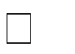**Description**:

Once the text is recognized and ready to be used, the user will be able to copy, edit, and modify it. He/she may also be able to retrieve the data from the image and store it directly on the phone such as the contact information taken from a Business Card.



phone.



#### Non- Functional Requirements

After the functional requirements, My teammate and I have been able to classify the non- functional requirements as follows:

#### Product Requirements:

* + - * 1. **Usability Requirements:**

The application shall be used friendly and doesn't require any guidance to be used. In other words, the application has to be as simple as possible, so its users shall use it easily. Actually, the interface is quite simple and straight forward so that anyone can understand it. The user should only click on the take or pick picture button and then directly click on the button extract text without any complications.

#### Reliability Requirements:

The application should not have any unexpected failure. In order to avoid any failure's

occurrence, the specifications have been respected and followed correctly. The only problem that may occur in some cases is that the application do not get 100% of the characters in the picture.

#### Efficiency Requirements 2.1.3.1.3.1. Performance:

The application response time shall be adequate and sufficient enough, that's why the time required for this application to response to its user's actions has to been managed and controlled. But in order to maintain the performance of the application, the user has to follow the required steps to get the desired result.

#### 2.1.3.1.3.2 Portability Requirements:

The application should be compatible with different version of Android, so if the version of Android is upgraded, the application should be upgraded as well.

#### Organizational Requirements:

* + - * 1. **Delivery Requirements**:

I agreed with my client, to deliver the mobile based application by the beginning of june, and exactly on june 4th, 2019.

#### Implementation Requirements:

I used Java as a programming language for the implementation of the project.

#### Standards Requirements:

The application shall follow the AUI standard form.

#### External Requirements:

* + - * 1. **Ethical Requirements**:

This application should protect the confidentiality of the user's personal information and any personal data stored on his\her mobile phone.

#### Legislative Requirements:

**Security**:

The security signature and certificate of the application is required as in any mobile application.

#### 2.1.3.3.2.2. Privacy:

The application shall protect the user's data and make sure to keep it confidential. The device can be protected by a pin code or finger prints in orderto ensure the privacy.

# Chapter 3

**Analysis & Desig****n**

* 1. **Use-case Diagrams**

Use case diagrams are used to gather the requirements of a system including internal and external influences. These requirements are mostly design requirements. Hence, when a system is analyzed to gather its functionalities, use cases are prepared and actors are identified.

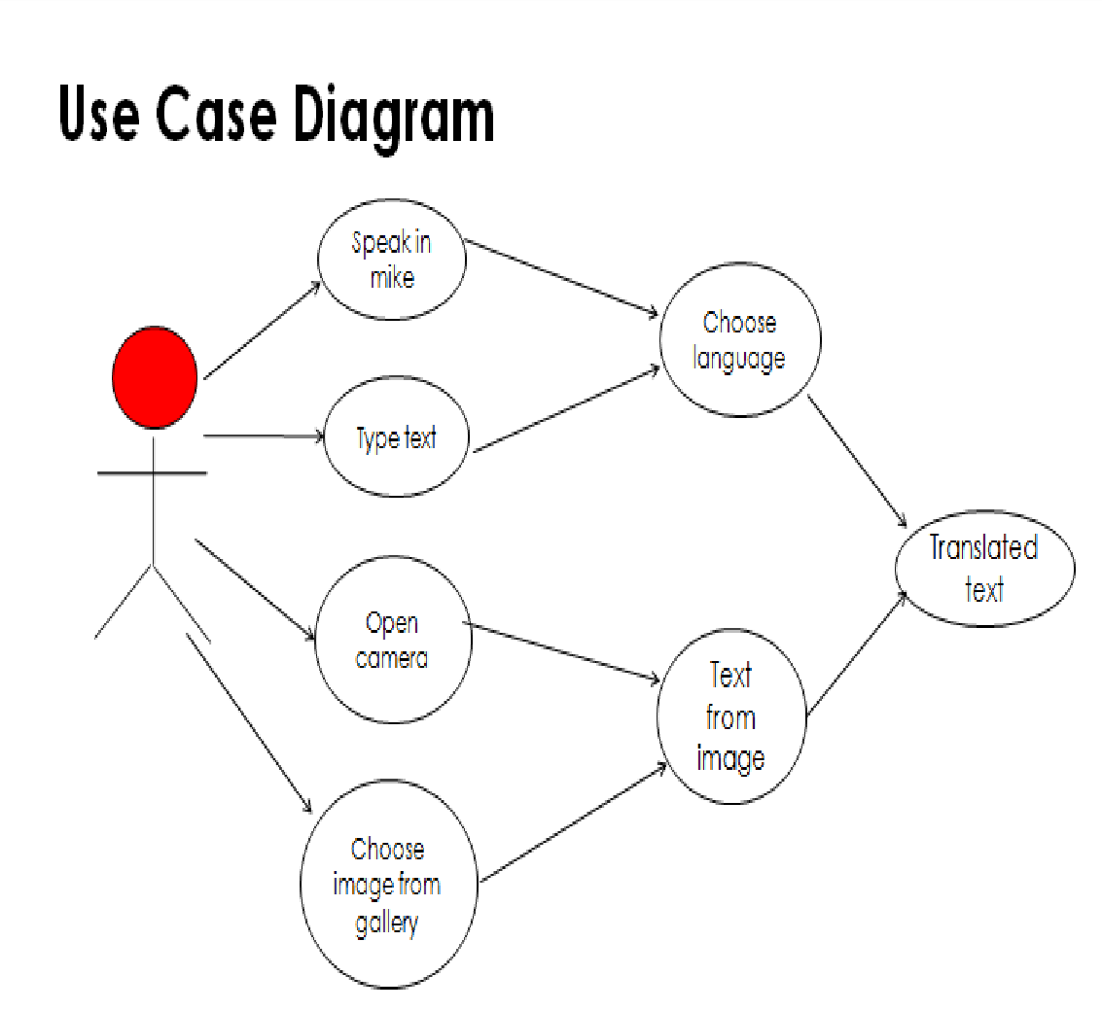

**Figure 3.1: Use-case Diagram of Transcribe**

#### Fig 3.1 use case diagram

## Activity Diagrams

Activity diagram is basically a flowchart to represent the flow from one activity to another activity. The activity can be described as an operation of the system. The control flow is drawn from one operation to another. This flow can be sequential, branched,or concurrent**.**

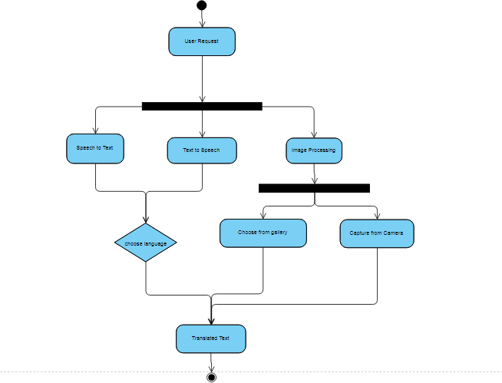

#### Figure 3.2: Activity Diagram of the Transcribe

## Sequence Diagrams

A sequence diagram shows object interactions arranged in time sequence. It depicts the objects and classes involved in the scenario and the sequence of messages exchanged between the objects needed to carry out the functionality of the scenario.

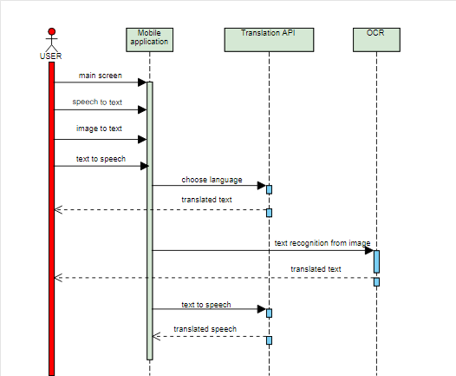

#### Figure 3.3: Sequence Diagram of the Transcribe

## Class Diagrams

Class diagram is a static diagram. It represents the static view of an application. Class diagram is not only used for visualizing, describing, and documenting different aspects of a system but also for constructing executable code of the software application.

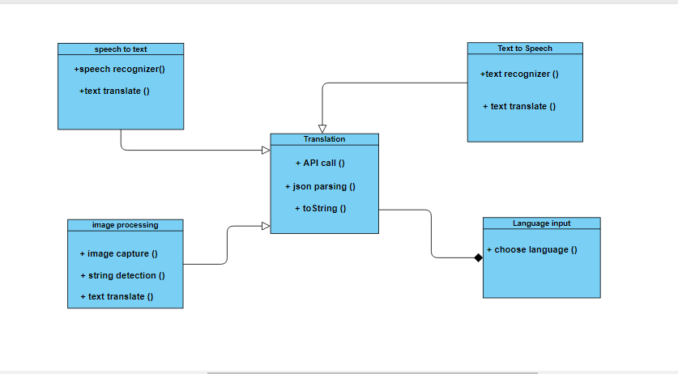

#### Fig 3.4 class diagram

* 1. **System Architecture**

A system architecture or systems architecture is the conceptual model that defines the structure, behavior, and more views of a system. An architecture description is a formal description and representation of a system, organized in a way that supports reasoning about the structures and behaviors of the system. The fundamental organization of a system, embodied in its components, their relationships to each other and to the environment, and the principles governing its design and evolution. A representation of a system, including a mapping of functionality onto hardware and software components, a mapping of the software architecture onto the hardware architecture, and human interaction with these components.

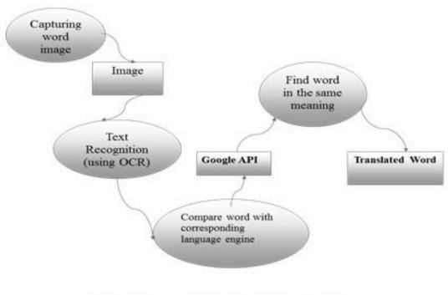An allocated arrangement of physical elements which provides the design solution for a consumer product or life-cycle process intended to satisfy the requirements of the functional architecture and the requirements baseline.

#### Fig 3.5 System architecture

# Chapter 4 Construction

* 1. **Implementation**

The implementation details include all the software and hardware details which are required to successfully secure your Android handheld system’s installed application and personal notes.

#### Implementation Details

The implementation details include all the software and hardware details which are required to successfully secure your Android handheld system’s installed application and personal notes.

#### Software Details

The software requirements needed for implementing our project are as follows: -

Operating System : Windows 7

Android Studio : 3.0.1

SDK : version 28

Language : Java

Database : SQLite

Translation API : YANDEX

Design Part : XML

#### Hardware Details

The hardware requirements needed for implementing our project are as follows: -

RAM : 8 GB

Hard disk : 32 GB

Processor : i3

Windows : 7/10

* 1. **Testing**

#### White Box Testing

White box testing considers system to be like a white box, which means that everything about the system is known to us. We know that different programs and procedures used in the system, inputs supplied and the output produced by it. White box testing requires access to source code. Though white box testing can be performed any time in life cycle after the code is developed, it is good practice to perform white box testing during the unit testing face.

User Verification

|  |  |  |  |  |  |  |  |
| --- | --- | --- | --- | --- | --- | --- | --- |
| Test  Id | Description | Input | Expected  Outcome | Actual  Outcome | Result  (Pass/Fail) | Path | Review |
| Case 1 | Open Application | User opens a app | Options should be come to select one | The optional screen is displayed | PASS |  | User can now enter to the app |
| Case 2 | Enter into image translation | Enter the language | The choosed image should be  open | The image is opened | PASS |  | User can see translation on choosen  language |
| Case 3 | Enter into speech translation | Enter the language | The speech should be translated | The speech is translated | PASS |  | User can see translation on choosen  language |
| Case 4 | Enter into text translation | Enter the language | The text should be translated | The text is tranlated | PASS |  | User can see translation on choosen  language |

#### Black Box Testing

The end users carry out black box testing. This testing can be performed by selecting some persons of the organization who have to operate the system, so that they know what inputs are to be given in the system for different option and what should be the output thus generated by the system for those values. They can then evaluate whether the system is working as per the user requirements.

Translation

|  |  |  |  |  |  |  |  |
| --- | --- | --- | --- | --- | --- | --- | --- |
| Test  Id | Description | Input | Expected  Outcome | Actual  Outcome | Result  (Pass/Fail) | Path | Review |
| Case 1 | Open Application | User opens a app | Options should be come to select one | The optional screen is displayed | PASS |  | User can now enter to the app |
| Case 2 | Enter into image translation | Enter the language | The choosed image should be  open | The image is opened | PASS |  | User can see translation on choosen  language |
| Case 3 | Enter into speech translation | Enter the language | The speech should be translated | The speech is translated | PASS |  | User can see translation on choosen  language |
| Case 4 | Enter into text translation | Enter the language | The text should be translated | The text is tranlated | PASS |  | User can see translation on choosen  language |

# Conclusion & Future Works

It was a wonderful and learning experience for us while working on this project. This project took us through the various phases of project development and gave us real insight into the world of software engineering. The joy of working and tackling the various problems and challenges gave us a feel of a developer in the industry. It was due to this project we came to know how professional software’s are designed.

We enjoyed each and every bit of work we had put into this project.

The project is further extendable and we aim to include Personal chat box with voice chatting and text chatting .This application can also describe the traffic sign boards.

**Appendix A** <<Snapshots of the project>>

#### App icon-



**Transcribe**

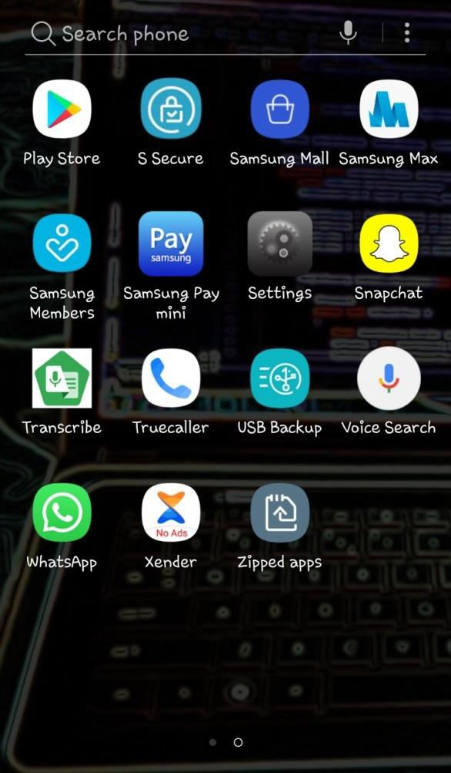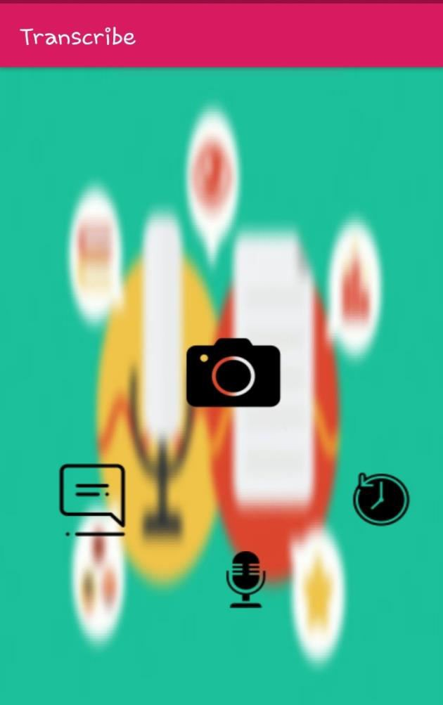

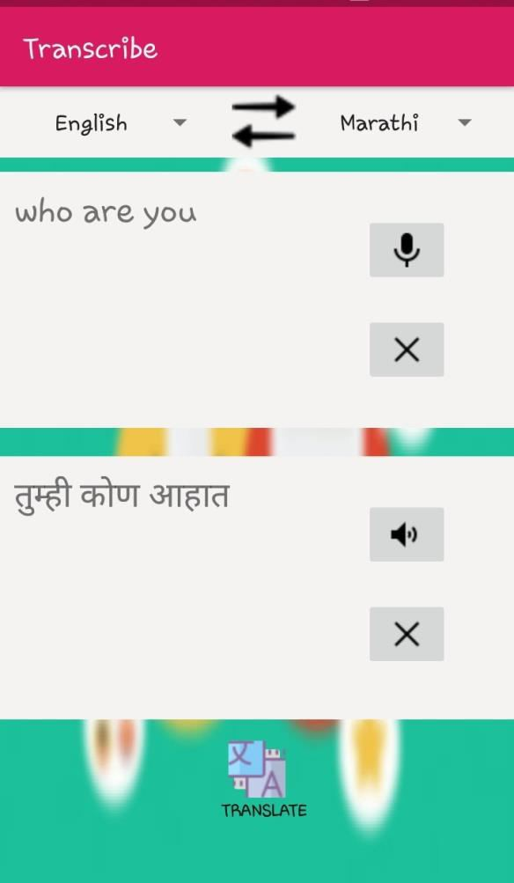 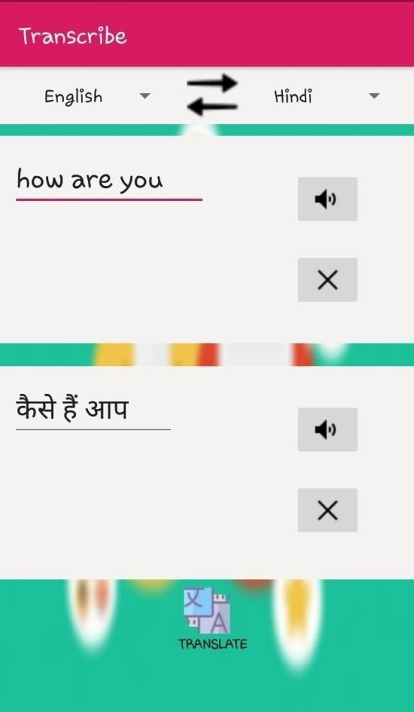

**Speech to text Text to Speech**

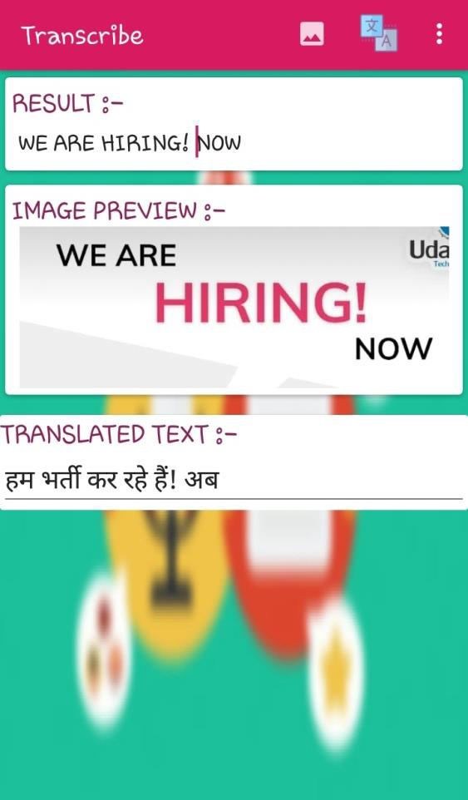

**Image Translation**