Transcribe
A Major Project Synopsis Submitted to

Rajiv Gandhi Proudyogiki Vishwavidhyalaya, Bhopal
Towards Partial Fulfillment for the Award of

Bachelor of Technology
(Computer Science and Engineering)

Submitted By:
Tanisha Singhai(0827CS181223)
Shruti Kanungo(0827CS181201)
Vaishnavi Tiwari (0827CS181230)
Srashti Gupta(0827CS181215)
CS4 IV YEAR

Supervised By: Guided by:
Mr. Anurag Punde Prof. Ajay Khatri


Department of Computer Science and Engineering
Acropolis Institute of Technology and Research, Indore
July 2021 - June 2022
CONTENT
S. NO. | TOPIC | PAGE NO. | REMARK
1. | Title | 1
2. | introduction | 1
 | 2.1 project benefits | 1
 | 2.2 project scope | 1
3. | problem statement | 2
4. | objectives | 2
5. | intented user | 2
6. | exixting system | 2-3
 | 6.1 process flow | 3
 | 6.2 limitations | 3
7. | proposed system | 3-5
 | 7.1 system features | 3
 | 7.2 process flow | 4
 | 7.3 hardware requirements | 4
 | 7.4 software requirements | 5
8. | expected outcomes | 5
9. | conclusion | 5
 | 9.1 limitations | 5
 | 9.2 future enhancements | 5
10. | references | 5

SYNOPSIS
1. TITLE
Transcribe
2. INTRODUCTION
TRANSCRIBE is an application which will be used to convert text from one language to another. This application is made to solve a real world problem. The problem recognized was that people do not know all the languages that they may hear or read. To solve this problem we searched for existing solutions. We found solutions but they could be better. Hence we tried to come up with a better solution.
TRANSCRIBE is an android based application which is capable of scanning the image either from the gallery or from the camera. It converts the text from the image into the required language. It can also covert the text we type into different language and produce the output into a voice form. It is also used to give input in a voice form and produce output through speaker i.e. speech to text translation.
2.1 PROJECT BENEFITS
- While travelling to a place whose native language is unknown to us this application can be beneficial to communicate with local people.
- While passing through a banner or hoarding if we do not understand the language we can use this application.
- If an illiterate person is applying for bank account (or any other official work), they can use this application to see the requirements for filling the form.

SCOPE
The scopes of this project are:
This software package can be readily used by non-programming personal avoiding human handled chance of error. This project is used by any common man, student and faculties.

3. PROBLEM STATEMENT
- Problem Identification:
People travelling to different places find it difficult to communicate with local people as they do not know the language. They are unable to interpret the words on any board or banner. So there is a need to develop text extraction system.
- Problem in Existing System:
Existing text extraction systems are available online which do not recognise all the characters properly. If the image resolution is low these systems do not recognise the characters. Already exsisting system needs to be more effective.
4. OBJECTIVE
The objective of the works is to propose options for better image to text conversion, speech to text conversion and text to speech conversion. To do this it requires to:
- Review and study different online convertor systems.
- Find out difference between the existing convertors and our implementation of the same.
- Propose a faster solution of the conversion system.
- Propose solution for the systems and make three converts available in a single application so as to make it user friendly.

5. INTENDED USER
The intended users of this system are the people who travel to different cities for studying, work and need to understand the local languages.
6. EXISTING SYSTEM
Existing text extraction systems are available online which do not recognise all the characters properly. If the image resolution is low these systems do not recognise the characters. Already exsisting system needs to be more effective.

6.1 PROCESS FLOW
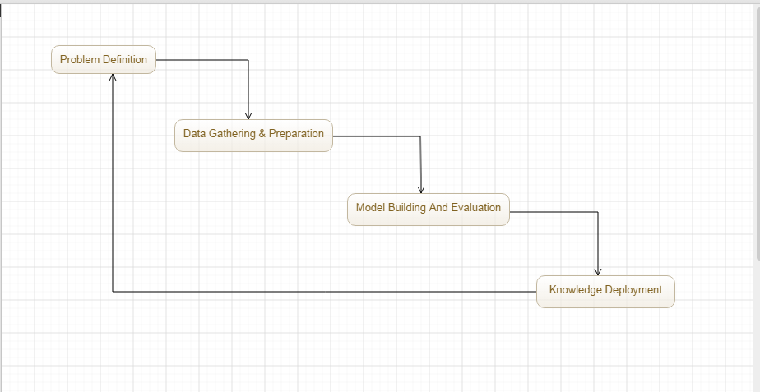
Figure 6.1: Process Flow of Existing System
6.2 LIMITATIONS
Some limitations of the existing system are:
- Doesn’t understand all characters properly
- Low image resolutions
7. PROPOSED SYSTEM
7.1 SYSTEM FEATURES
As the objective of the system of to analyze data sets of temperatures of past hundred years, its features includes: -
- Effective translation into different languages
- No special hardware is required.
- Fault tolerant.

7.3 HARDWARE REQUIREMENT
Any modern computer system with:
- Intel core i3 or i5, Dual core processor.
  - SOFTWARE REQUIREMENT
- Windows 7 OS, Android system
- Android, XML.
- Java and SQLite.

8. EXPECTED OUTCOMES
The expected outcome is:
- It will be able to translate text to speech and speech to text effectively.
9. CONCLUSION
This is to conclude that the project that we undertook was worked upon with a sincere effort. Most of the requirements have been fulfilled up to the mark and the requirements which have been remaining, can be completed with a short extension.
Our project is only a humble venture to satisfy the needs of a discussion forum at college level. Several user friendly coding have also adopted. This package shall prove to be a powerful package in satisfying all the requirements of the organization.
10. REFERENCES
- https://developer.android.com/reference

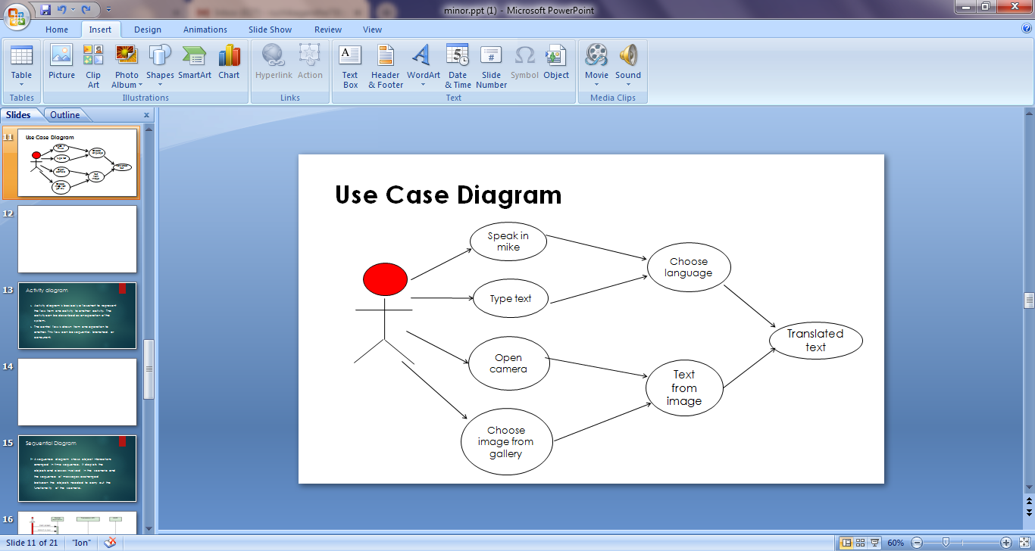
USE CASE DIAGRAM:

Figure: Use Case Diagram

