Breast Cancer Tumor Classification Using Machine Learning

1. Introduction
Breast cancer is one of the most common and serious diseases worldwide. Early detection is key to improving survival rates. This project uses machine learning techniques to classify tumor as malignant (cancerous) or benign (non-cancerous) based on medical data.

2. Dataset Description
The dataset used is the Breast Cancer dataset found in scikit-learn.
- Total samples: 569
- Features: 30 numerical features (e.g., radius, texture, smoothness)
- Target variable:
  - 0 → Malignant
  - 1 → Benign

This dataset is widely used for binary classification tasks in healthcare.

3. Data Preprocessing
The following steps were done:

- Loaded the dataset into a Pandas DataFrame
- Checked for missing values (none found)
- Split the dataset into training (80%) and testing (20%)
- Applied feature scaling using StandardScaler to normalize the data

4. Exploratory Data Analysis (EDA)

- Visualized feature distributions with histograms
- Created a correlation matrix to understand relationships between features
- Noted that some features strongly influence tumor classification

5. Model Building

5.1 Logistic Regression
Logistic Regression served as the baseline model due to its simplicity and effectiveness in binary classification.
- Accuracy: 0.9737 (97.37%)
5.2 Random Forest Classifier
Random Forest, an ensemble learning method, captured complex patterns in the data.
- Accuracy: 0.9649 (96.49%)

6. Model Evaluation

Models were evaluated using:
- Accuracy score
- Confusion matrix
- Classification report (precision, recall, F1-score)
Comparison Table
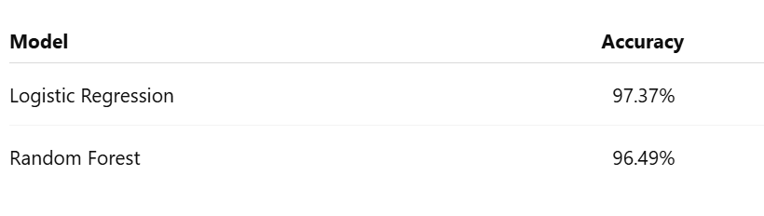
Analysis

- Logistic Regression performed slightly better than Random Forest
- The high accuracy shows strong predictive capability
- In medical diagnosis, minimizing false negatives is especially important

7. Results

- The Logistic Regression model achieved the highest accuracy
- Both models did well, showing the dataset is well-structured
- The system can effectively classify tumors with high reliability

8. Conclusion

This project shows how machine learning can be applied in medical diagnosis. Logistic Regression and Random Forest models were implemented and compared. Logistic Regression had the best performance with an accuracy of 97.37%.

These models can help doctors with early detection of breast cancer, improving decision-making and patient outcomes.

9. Future Improvements

- Use larger and more real-world medical datasets
- Apply more advanced models like Support Vector Machines or Neural Networks
- Deploy the model using a web interface, such as Streamlit
- Perform hyperparameter tuning for better accuracy

10. References

- scikit-learn documentation
- Machine Learning textbooks and online resources

