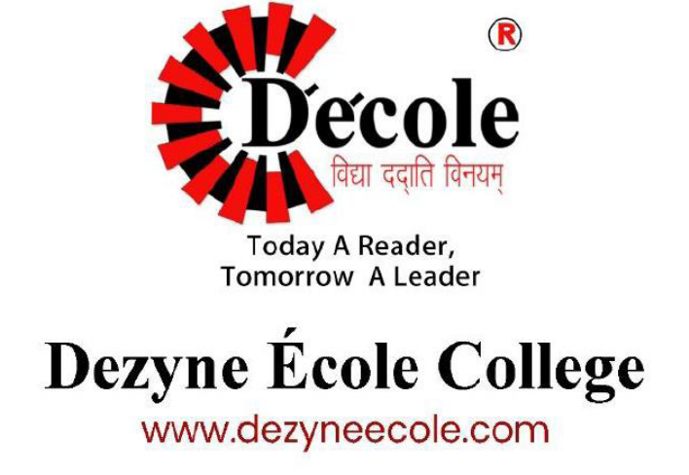
Identity 2026
Hackathon
Process Sheet of the Project Website on SS Spices

Submitted By
Tanishk Bansal
Department – Bachelor of Computer Application Semester 1st

CLIENT DETAILS — SS SPICES
Client Business Name: Sarda Traders
Business Type: Spice and grocery products business
Business Location : Sharda Traders Paroa Ajmer, Rajasthan
Project Objective:*To create a simple, user-friendly website that helps the business showcase its products online and makes it easier for customers to explore product categories and contact the business.
Target Audience: Customers interested in purchasing spices, seeds, pulses, and pickles.
5 Client Questions & Answers
Q1. What products do you sell?
Answer: We sell different types of spices, seeds, pulses, and pickles.
Q2. Why do you need a website?
Answer: We need a website to show our products online and help more customers find our business.
Q3. What is your best selling products?
Answer: Jeera & Aathana mirchi.
Q4. What features do you want on your website?
Answer: We want product details, information about our business, and contact options such as WhatsApp.
Q5. How should customers contact you for purchases?
Answer: Customers can contact us through WhatsApp to ask questions and place orders.
Website Pages: Home, About Us, Products, and Contact Us.
Key Features:
- Product categories for Seeds, Spices, Pulses, and Pickle.
- Business information through the About Us page.
- Contact information through the Contact Us page.
- WhatsApp purchase links, where implemented and tested.
- HTML and CSS-based website design.

Reason for Choosing the Colour Palette
I selected a warm, spice-inspired colour palette for the SS Spices website to reflect the nature of the business.
Deep brown represents an earthy and traditional feel, while spice red adds warmth and visual strength. Turmeric gold creates highlights that draw attention to important elements. The warm cream background keeps the overall design light and comfortable to view.
I used these colours to create a consistent visual identity that suits a spice business. I also considered readability and contrast when combining text and background colours.
Wire Frame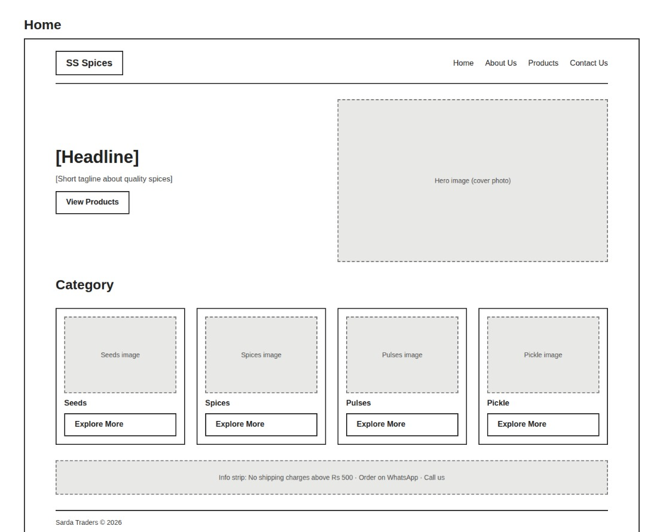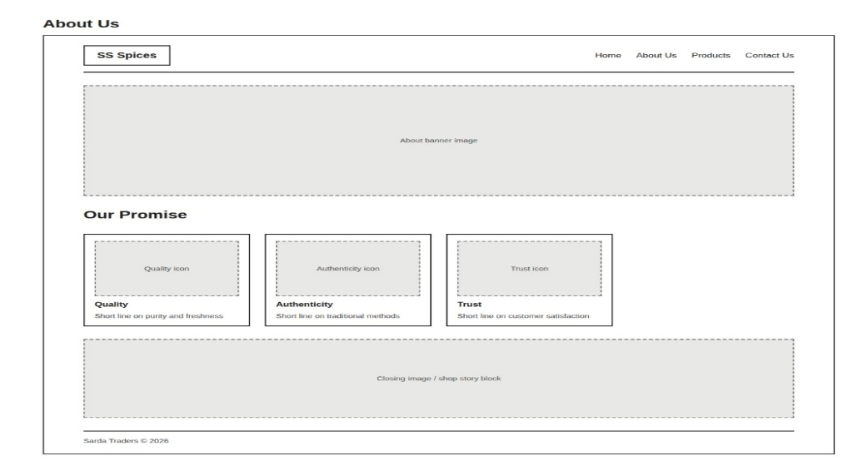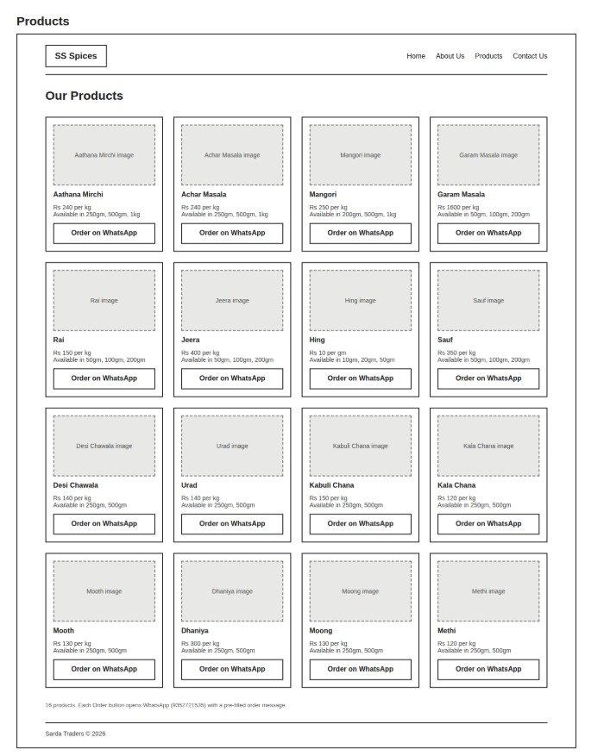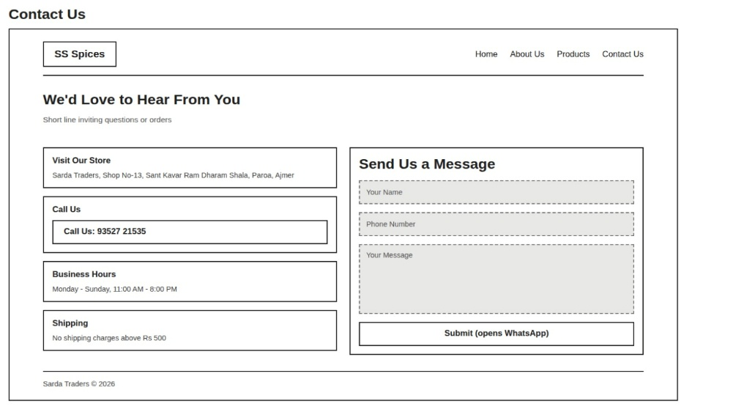

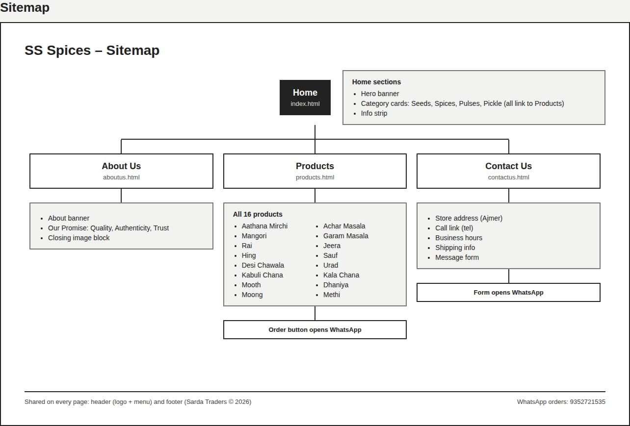
Validator
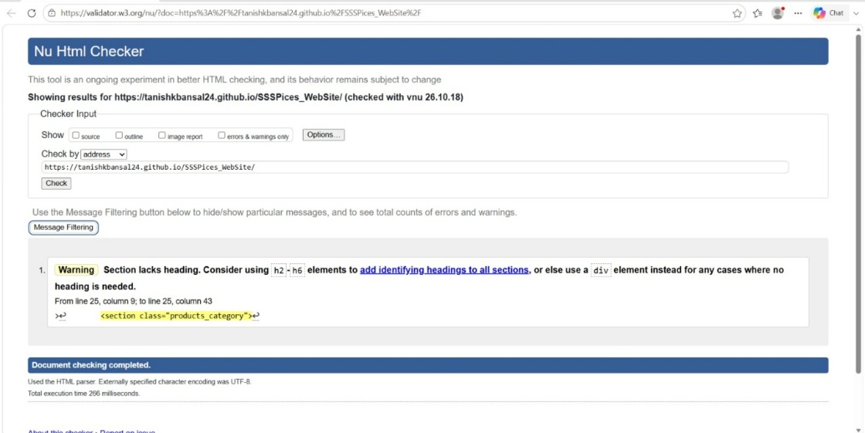
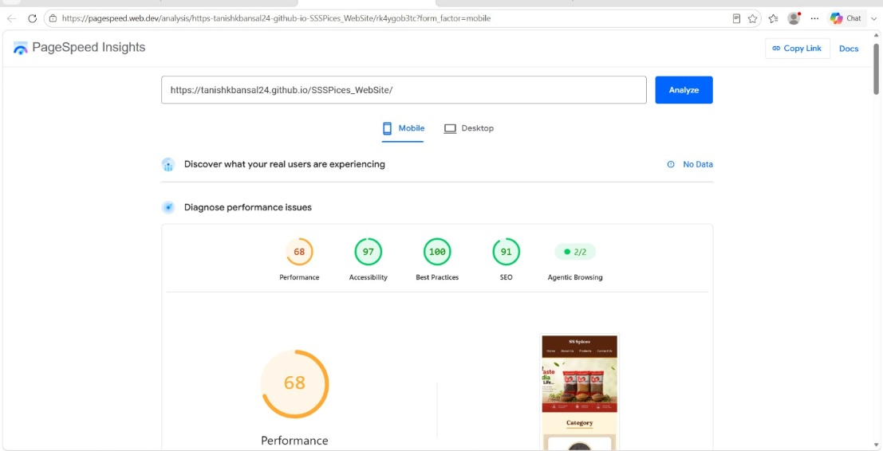

Shop Owner Consent Letter
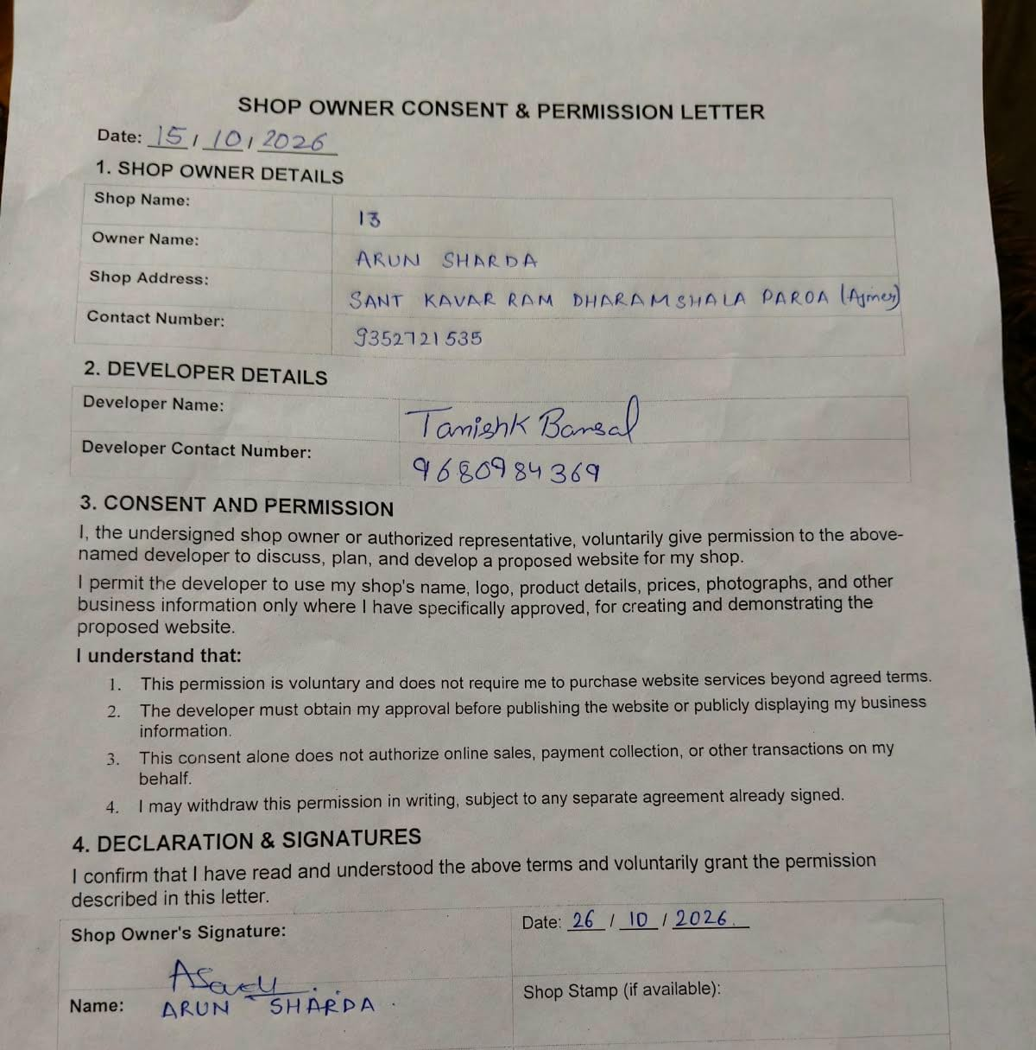
AI Use Declaration
