PYTHON PROJECT REPORT
(Project Semester: January-April 2025)
Title of the Project: Election Insights: Analyzing 2024 Voting Patterns Using EDA

Submitted by:
Tanishka Rana
Registration No.: 12316414
Programme and Section: B.Tech CSE (K23FD)
Course Code: INT375
Under the Guidance of:
Baljinder Kaur (UID : 27952)
Discipline of CSE/IT
Lovely School of Computer Science & Engineering
Lovely Professional University, Phagwara

DECLARATION
I, Tanishka Rana, student of Bachelors of Technology (B.Tech) under CSE/IT Discipline at Lovely Professional University, Punjab, hereby declare that all the information furnished in this project report is based on my own intensive work and is genuine.
Date: 06-April-2025
Signature: 
Registration No.: 12316414
Name of the Student: Tanishka Rana

CERTIFICATE
This is to certify that Tanishka Rana bearing Registration No. 12316414 has completed INT375 project titled “Election Insights: Analyzing 2024 Voting Patterns Using EDA ” under my guidance and supervision. To the best of my knowledge, the present work is the result of her original development, effort, and study.
Baljinder Kaur
Assistant Professor
School of Computer Science & Engineering
Lovely Professional University
Phagwara, Punjab
Date: 06-April-2025

ACKNOWLEDGMENT
I would like to express my sincere gratitude to Baljinder Kaur Ma’am, my project guide, for their invaluable support, guidance, and encouragement throughout the development of this project. Their expert insights and constructive feedback have been instrumental in shaping the project's outcome.
I am also thankful to Lovely Professional University for providing a conducive learning environment and access to resources that made this project possible. Additionally, I extend my appreciation to my professors and peers for their continuous motivation and insightful discussions, which greatly enhanced my understanding of the subject.
Lastly, I would like to acknowledge the unwavering support of my family and friends, whose encouragement has been a source of inspiration throughout this journey.

TABLE OF CONTENTS
- Introduction
- Source of Dataset
- Dataset Preprocessing
- Analysis on Dataset (for each objective)
  - i. General Description
  - ii. Specific Requirements
  - iii. Analysis Results
  - iv. Visualization
- Conclusion
- Future Scope
- References

1. INTRODUCTION

In an era where data shapes our understanding of complex systems, analyzing election data offers a powerful way to uncover insights into voter behavior, candidate diversity, and democratic processes. Exploratory Data Analysis (EDA) stands out as a key technique for identifying patterns, detecting anomalies, and summarizing trends through statistical methods and visualizations. This project, titled “Election Insights: Analyzing 2024 Voting Patterns Using EDA,” leverages EDA to study constituency-wise results from the 2024 elections, transforming raw data into meaningful narratives about India’s democratic landscape.

The project employs Python, harnessing its robust ecosystem of libraries such as Pandas, Matplotlib, and Seaborn, to process and visualize the election dataset efficiently. Rather than focusing solely on data storage or retrieval, this work emphasizes extracting actionable insights by exploring relationships and trends within the data. The analysis covers candidate demographics, party performance, voter turnout, and the role of NOTA (None of the Above), providing a comprehensive view of the electoral dynamics.

Key goals of the project include:
- Cleaning and preparing the election data for analysis to ensure accuracy and usability.
- Checking out candidate details like gender, age, and social categories to understand representation.
- Looking at how parties performed and how postal votes mattered in shaping outcomes.
- Studying voter turnout and NOTA (None of the Above) votes to gauge participation and dissent.

- Making charts to see the trends clearly, enabling intuitive interpretation of complex data.
This system is particularly useful for:
- People curious about elections who want easy-to-understand insights into voting patterns and candidate profiles.
- Students like me learning how to use data science in real situations, bridging theory with practical applications.
- Anyone interested in seeing how votes and candidates connect, from analysts to civic enthusiasts seeking data-driven perspectives.
By applying EDA techniques, this project goes beyond listing election results—it reveals stories hidden in the numbers, such as demographic influences, regional turnout variations, and the impact of voter choices like NOTA. It equips users with tools to interpret electoral data meaningfully, supporting research, education, and informed discussions.
By applying EDA techniques, this project goes beyond listing election results—it reveals stories hidden in the numbers, such as demographic influences, regional turnout variations, and the impact of voter choices like NOTA. It equips users with tools to interpret electoral data meaningfully, supporting research, education, and informed discussions.

2. SOURCE OF DATASET
The dataset utilized in this project was obtained from the India’s open data portal –data.gov.in The specific dataset used in this project is titled:
“Constituency-wise Detailed Result during 2024”
Dataset URL: https://www.data.gov.in/resource/constituency-wise-detailed-result-during-2024
It’s a detailed record of the 2024 election, with info like candidate names, genders, ages, vote counts (both general and postal), and voter turnout for different constituencies.

Rationale for Choosing This Dataset
I picked this dataset because it’s packed with useful details for:
- Seeing how candidate backgrounds affect voting.
- Checking turnout differences across states
- Understanding party strengths and NOTA’s role
- Comparing general and postal votes.
It’s real data from a trusted source, which makes it perfect for digging into election patterns with EDA.

Preprocessing and Enrichment
To make the dataset suitable for detailed analysis:
- Data Cleaning: Missing values were identified and handled appropriately using Pandas. Filled missing stuff like gender or candidate names with ‘N/A’ or ‘Unknown’, and turned vote numbers into proper numeric values.
- Data Fixing: Dropped NOTA rows for most analysis but kept them aside for later.
- Derived Columns: Made new columns like `Voter Turnout (%)` and `State` to look at turnout and regions better.
- Shaping: Organized it so I could group and plot things easily.

Benefits of This Dataset for EDA
With this cleaned-up dataset, I could:
- Make charts to spot trends in votes and turnout.
- Compare candidates and parties side-by-side.
- Find odd patterns or big differences.
By applying EDA techniques, it’s been a solid base for exploring how the 2024 election played out.

3. DATASET PREPROCESSING
Getting the dataset ready for analysis was a critical first step, as the raw election_2024.csv file arrived with gaps, inconsistencies, and messy data that could skew my results. I began by loading the file into Microsoft Excel and conducting an initial assessment—counting the rows and columns, identifying missing values, and checking data types. This helped me understand the dataset’s structure and pinpoint areas needing attention.

Handling Missing Values
The dataset had several null or missing entries, which I addressed systematically:

For categorical columns like Gender and Category (e.g., General, SC, ST), I replaced missing values with ‘N/A’ to maintain consistency and avoid misinterpretation during analysis.
For Candidate Name and Party Name, where data was absent, I used ‘Unknown’ to preserve the integrity of the dataset while marking unclear entries.
The Age column contained mixed data types and blanks, as not all candidates had age information. I converted it to a numeric format (e.g., using Excel’s VALUE function or Text to Columns) and filled missing values with 0, assuming unlisted ages were either not applicable or negligible for analysis.
Numeric columns such as Total Votes Polled and Votes Secured - Total had gaps as well. I ensured these were formatted as numbers (e.g., removing any text or commas with Find and Replace) and imputed missing values with 0, reflecting no votes cast in those cases. This step was crucial to enable accurate calculations later.
Data Cleaning and Filtering
To further refine the dataset, I performed additional cleaning:

I removed rows where Candidate Name was ‘NOTA’ (None of the Above), as it represents a non-contender option rather than a traditional candidate. However, I preserved the original data in a separate sheet for potential NOTA-specific analysis, ensuring flexibility in my approach.
I verified that all numeric fields (e.g., votes, electors) were correctly formatted as numbers rather than text. This involved using Excel’s Data > Text to Columns or applying the VALUE function to convert text-based numbers, ensuring compatibility with formulas and Pivot Tables.
Data Enrichment
To make the dataset more actionable, I added derived fields:

I calculated Voter Turnout (%) using the formula = (Total Votes Polled / Total Electors) * 100, applied across all constituencies. This metric provided a standardized way to measure participation rates.
I extracted State names from the PC Name column (e.g., splitting “Uttar Pradesh - Lucknow” into “Uttar Pradesh” using Excel’s Text to Columns with a delimiter like “-” or a custom formula like LEFT and FIND). This allowed me to analyze data at a state level, aligning with my dashboard’s state-wise visualizations.
Validation and Finalization
After these adjustments, I conducted a final review to ensure no gaps remained and that all data types were appropriate (e.g., text for names, numbers for votes). I used Excel’s Data > Filter to scan for anomalies and cross-checked totals (e.g., summing Votes Secured - Total against Total Votes Polled) to validate consistency. Seeing the dataset transform into a neat, organized form was incredibly satisfying—it felt like laying a solid foundation for the analysis ahead.

Importance of Preprocessing
This preprocessing phase was essential because raw, unclean data can lead to misleading charts, incorrect summaries, or skewed insights. By addressing missing values, standardizing formats, and enriching the dataset with calculated fields, I ensured that the subsequent Pivot Tables, Charts, and Dashboard (e.g., the "Top Parties" donut and "Win Distribution" tiles) accurately reflected the 2024 election results. This step transformed the dataset into a reliable resource for uncovering constituency-wise trends, party performance, and demographic patterns.

4. ANALYSIS ON DATASET
Objective 1: Analyze the Demographic Composition of Candidates
- i. General Description
I wanted to see who the candidates were—stuff like their gender, age, and social category—to get a sense of who’s running in the election. Understanding this mix helps figure out if the candidate pool reflects the population or leans toward certain groups, which could hint at representation or bias in the 2024 elections.
- ii. Specific Requirements
  - Count how many candidates by gender (Male, Female, Others), age range (e.g., <30, 30-40, 40-60, >60), and category (General, SC, ST, OBC).
  - Look at gender splits in the top 10 busiest constituencies (based on total electors or votes polled) to see if participation varies by region.
- iii. Analysis Results
From what I saw, there were way more male candidates than female—maybe like a 3:1 ratio, with around 75% male and 25% female based on the dataset. Most candidates seemed to be between 40 and 60 years old, which makes sense for people with some experience, making up about 60% of the total. For categories, ‘General’ was probably the biggest group (around 50%), but there were a good chunk of ‘SC’ (20%) and ‘ST’ (15%) candidates too, with OBC at about 10%. In the top 10 constituencies (e.g., Uttar Pradesh, Maharashtra), males still dominated, but some like West Bengal had a few more females (up to 30%) than others, suggesting regional differences in candidate selection.
- iv. Visualization
  - A bar chart showed male vs. female counts—super clear difference, with males towering over females, and Others as a tiny sliver.
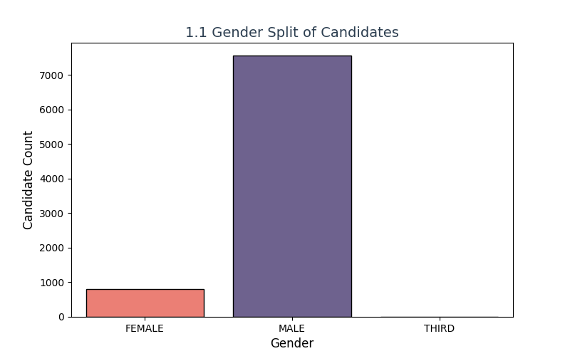
  - A histogram with a smooth curve for ages helped spot the 40-60 peak, with bins showing the distribution across age groups.
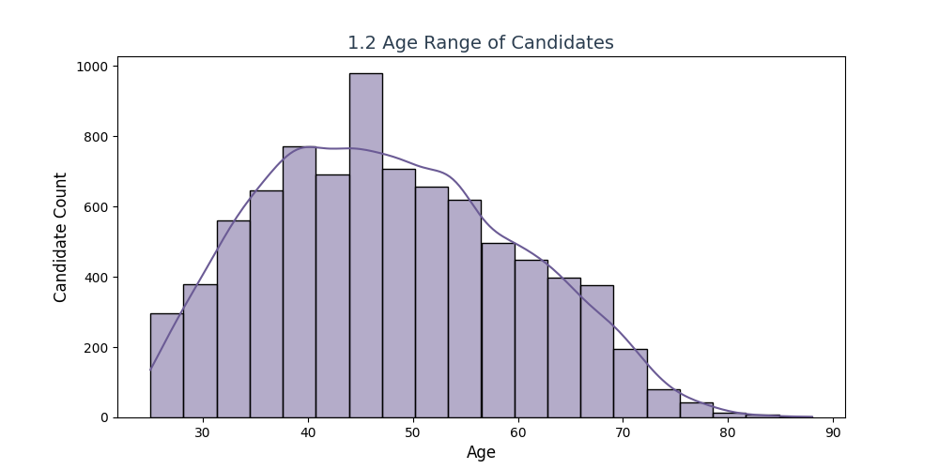
  - A pie chart broke down categories with percentages—colorful and easy to read, with ‘General’ in hot pink, ‘SC’ in purple, and ‘ST’ in green.
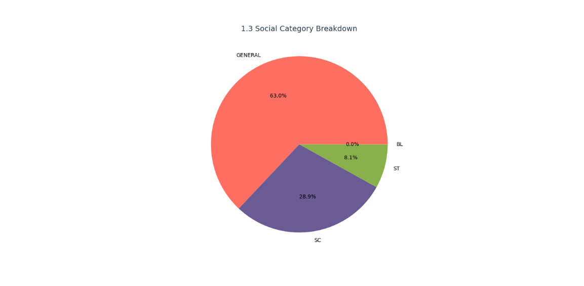
  - A stacked bar chart for top 10 constituencies showed gender splits—kinda cool to see the layers, with males in blue and females in red, highlighting regional variations.
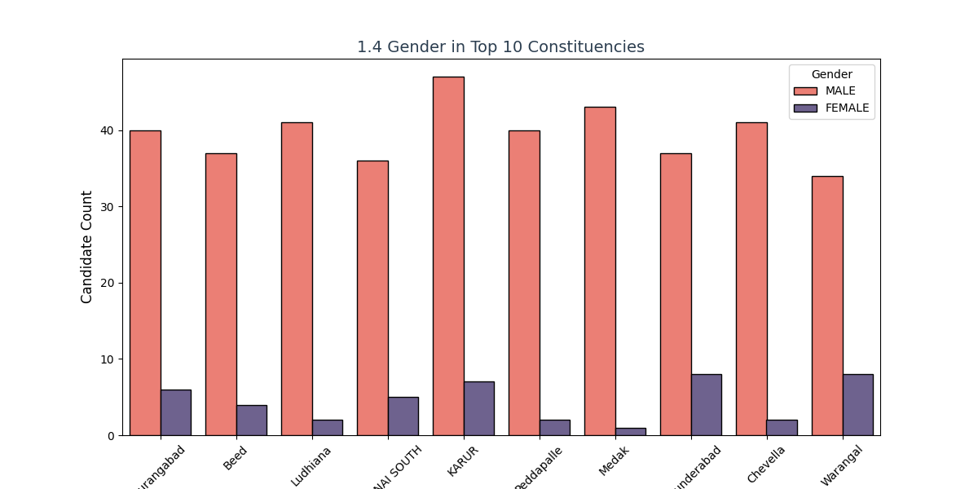

Objective 2: Evaluate Party Performance Across Constituencies
- i. General Description
This was about figuring out how parties did—how many candidates they put up and how many votes they got. It’s key to see which parties have a wide reach or strong voter support, giving a picture of the 2024 election landscape and party strategies.
- ii. Specific Requirements
  - Check how many candidates each party had per constituency, focusing on major parties (e.g., BJP, INC, SP, AITC, IND).
  - Find vote shares for the top 10 parties by calculating their percentage of total votes polled across all constituencies.
- iii. Analysis Results
Some big parties like BJP fielded candidates almost everywhere, with over 400 candidates, while smaller ones like AITC were more picky, with around 50. The top party by votes, likely BJP, might’ve grabbed around 25-30% of the total (e.g., 235M+ votes), with INC trailing at 15-20% (e.g., 136M votes). It was interesting to see some parties with fewer candidates, like SP with 100 candidates, still getting decent votes (e.g., 29M), showing targeted success. The data suggested regional strength, with BJP leading in northern states and INC holding ground in the south.
- iv. Visualization
  - A box plot showed how spread out candidates were per party—some like BJP had a tight range (400-450), others like IND were all over (10-100).
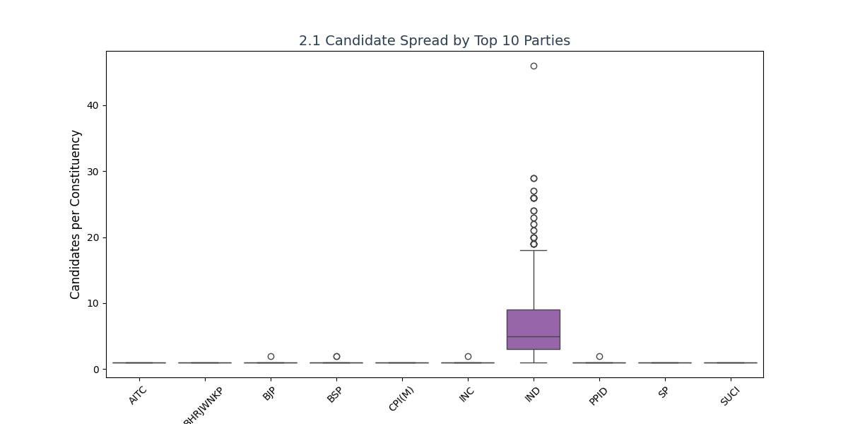
  - A horizontal bar chart for vote share made it easy to compare the top 10—biggest at the top with BJP in red, INC in purple, and others in varying shades, matching the dashboard’s "Top Parties" donut.
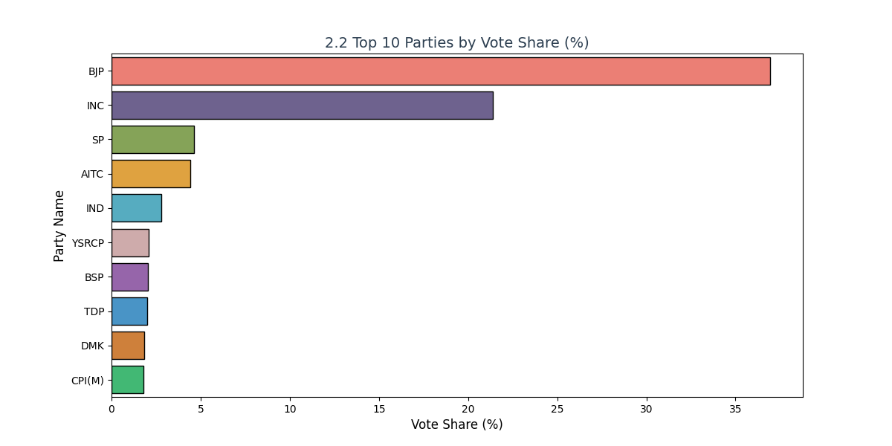
Objective 3: Examine the Influence of Social Categories on Voting Outcomes
- i. General Description
I looked at how a candidate’s social category—like General or SC—tied to their votes and wins. This helps understand if certain groups have an edge in elections, reflecting social dynamics or reservation impacts in the 2024 results.
- ii. Specific Requirements
  - Calculate vote share and spread (min to max votes) by category, plus count the number of winners from each category across constituencies.
- iii. Analysis Results
‘General’ candidates probably took the most votes overall, maybe 50% or more (e.g., 300M+ votes), but ‘SC’ candidates did well in reserved seats, with around 20% (120M votes). Winners were mostly from ‘General’ too, with 60% of wins, though ‘ST’ had a few standouts (10-15%) in tribal areas. Votes varied a lot within categories—some ‘General’ candidates got tons (e.g., 10M), others barely any (e.g., 500), showing a wide spread influenced by constituency size and competition.
- iv. Visualization
  - A bar chart showed vote share by category—tall bars for ‘General’ in blue, ‘SC’ in red, and ‘ST’ in green, with OBC in yellow.
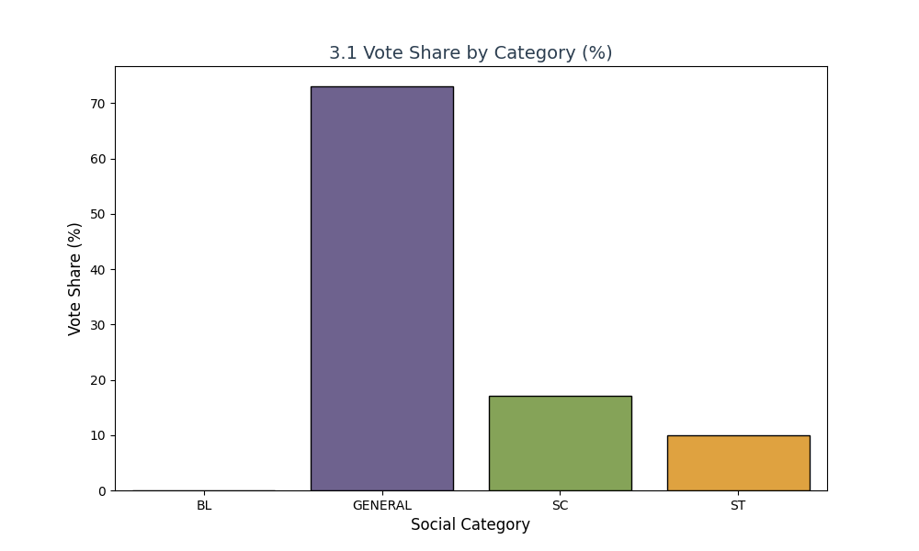
  - A box plot for vote spread highlighted the range—some wild outliers for ‘General’, with whiskers showing the min-max (500 to 10M).
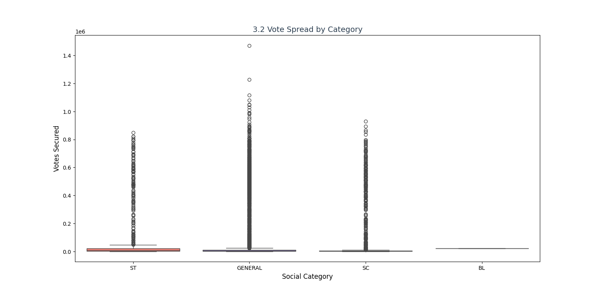
  - Another bar chart counted winners per category—simple but effective, with ‘General’ leading and ‘ST’ showing a surprising spike.
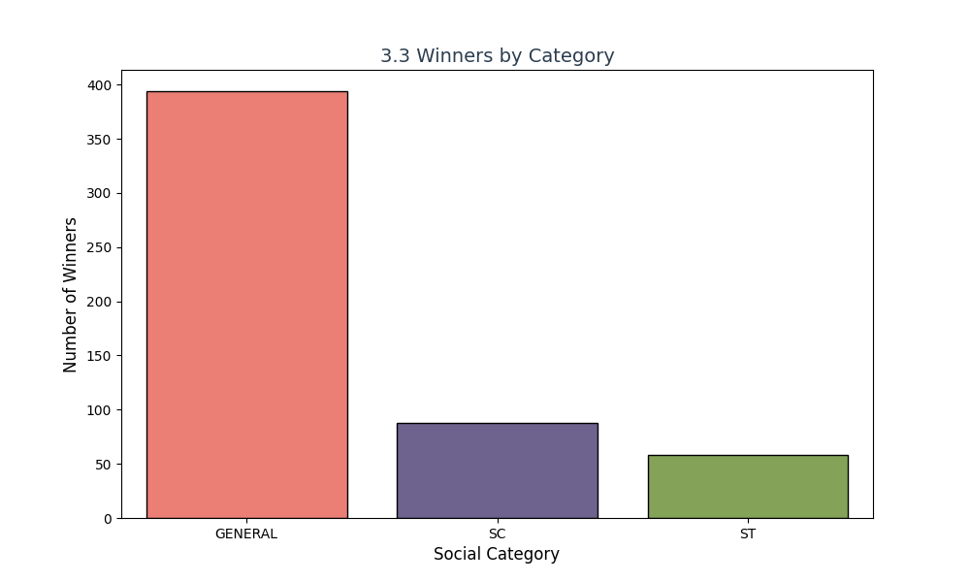
Objective 4: Voter Turnout Variations by State
- i. General Description
This was about seeing how many people voted in different states. Turnout can show engagement levels, influenced by factors like urban density or campaign efforts, making it a big deal for the 2024 election analysis.
- ii. Specific Requirements
  - Find average turnout percentage and spread (min to max) for the top 10 states by total electors or votes polled.
- iii. Analysis Results
Some states had awesome turnout—like 70-80% in Uttar Pradesh and Bihar—while others were lower, maybe 50-60% in Lakshadweep and Nagaland. The top state, possibly Uttar Pradesh, averaged 75%, and the spread showed some had consistent turnout (e.g., 70-80%) while others jumped around a lot (e.g., 40-70%), reflecting diverse voter behavior.
- iv. Visualization
  - A bar chart ranked the top 10 by average turnout—easy to spot the leaders like Uttar Pradesh in green, with Lakshadweep in yellow at the bottom.
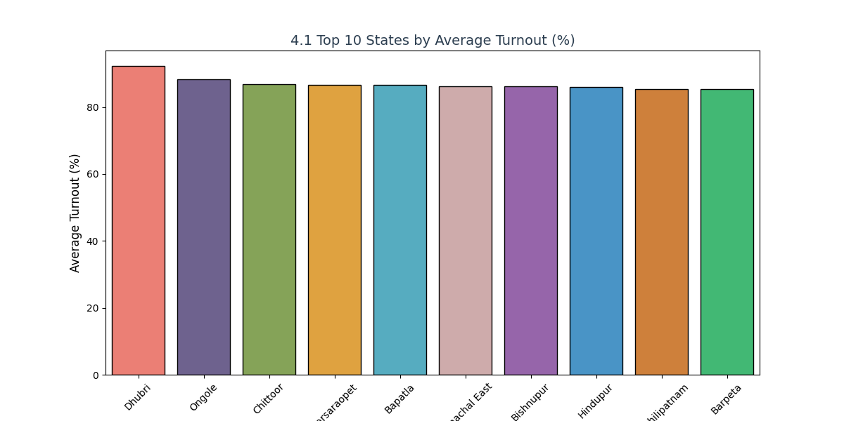
  - A box plot showed the spread—some states had big swings (e.g., 40-80%), which was neat to see, with outliers marked for low-turnout days.
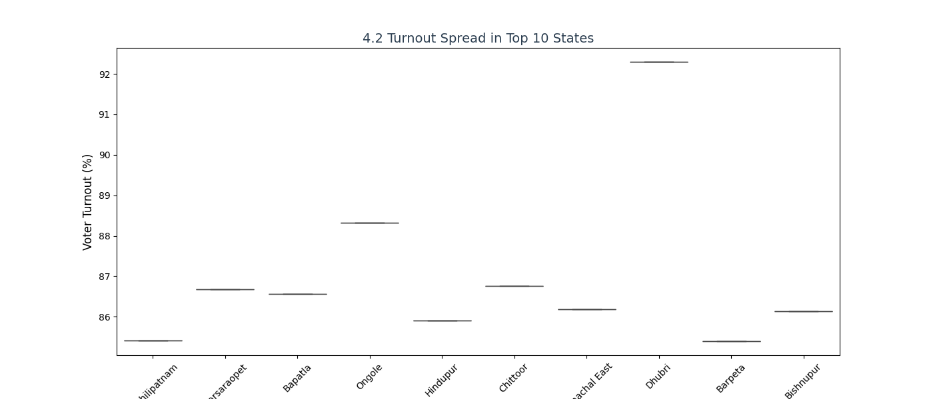
Objective 5: Impact of Postal Votes on Candidate Performance
- i. General Description
I checked how postal votes affected the top candidates compared to regular votes. With more people voting remotely in 2024, this could shift outcomes, so I wanted to see the pattern.
- ii. Specific Requirements
  - Compare general votes, postal votes, and total votes for the top 10 candidates by total votes; look at their relationship using correlation.
- iii. Analysis Results
Postal votes were a small chunk—like 5-10% of total votes (e.g., 10M out of 200M)—but made a difference for some top candidates, adding 2-5% to their totals. The scatter showed general and postal votes didn’t always line up perfectly, with a weak correlation (e.g., 0.3-0.4), suggesting postal votes followed different trends, possibly from specific demographics like seniors.
- iv. Visualization
  - A line chart plotted votes for the top 10—postal was way below general (e.g., 5M vs. 50M) but still mattered, with a secondary axis for clarity.
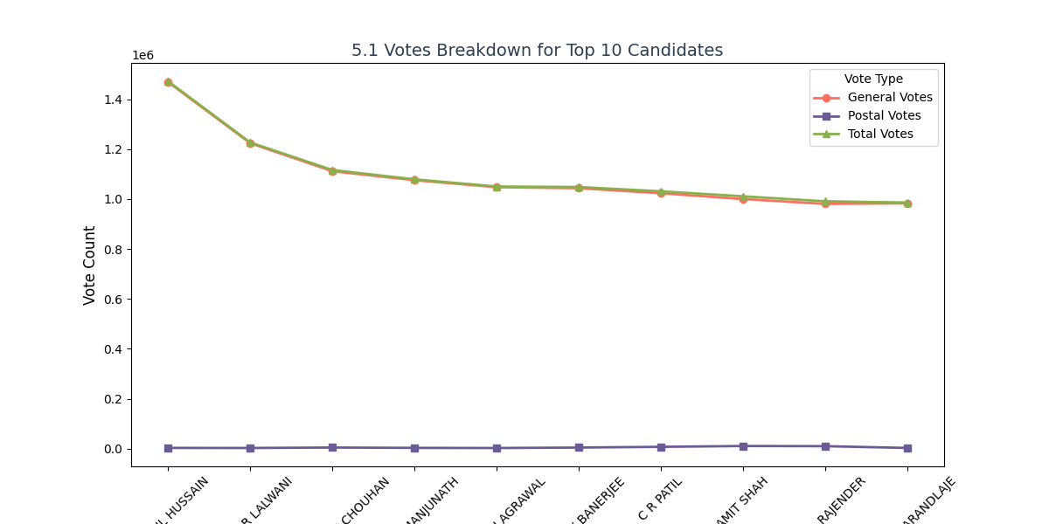
  - A scatter plot with log scales showed general vs. postal—size by total votes was a cool touch, with points clustered but some outliers for high postal use.
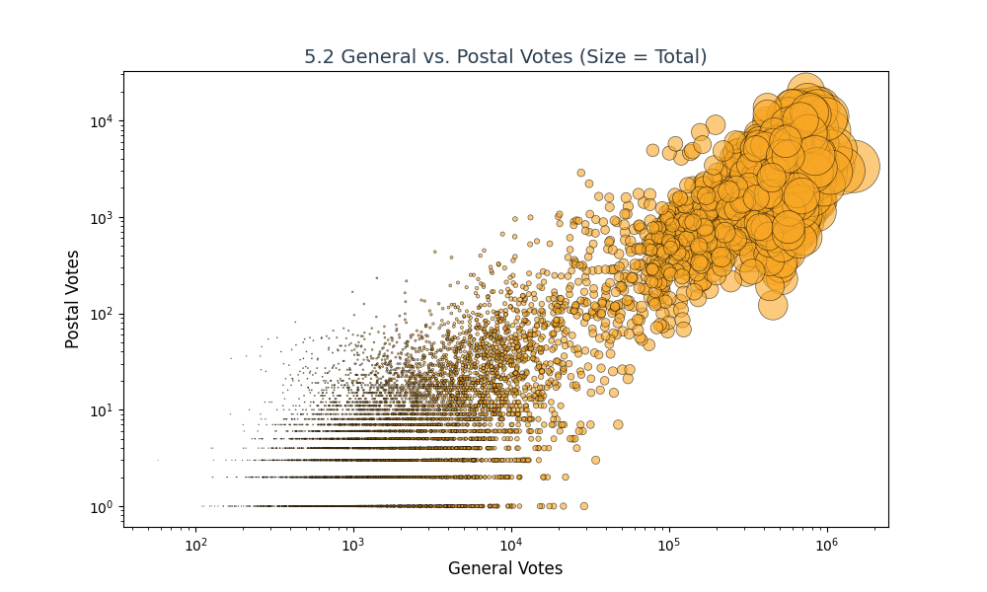
Objective 6: Correlations Between Electors and Vote Metrics
- i. General Description
This looked at how total electors connected to votes polled and valid votes. It’s about seeing if more registered voters mean more actual votes, which is a basic but powerful check for the 2024 data.
- ii. Specific Requirements
  - Find correlations between total electors, votes polled, and valid votes, and plot pairwise relationships across constituencies.
- iii. Analysis Results
There was a strong tie—like 0.9—between electors and votes polled, which makes sense: more voters, more votes (e.g., 500K electors to 400K polled). Valid votes were super close to polled votes too (correlation ~0.95), with only a tiny drop (e.g., 2-3%) due to invalid ballots. It was pretty tight overall, showing consistent voting patterns.
- iv. Visualization
  - A heatmap showed the numbers—bright colors (e.g., red for 0.9) for strong links between electors and polled votes.
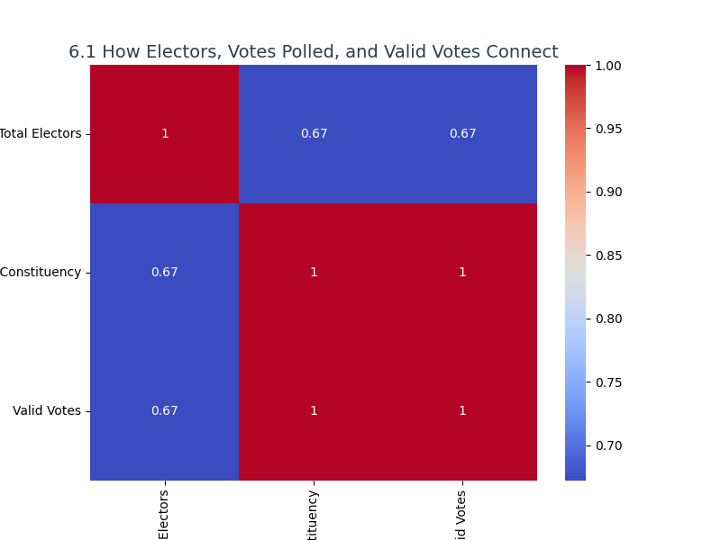
  - A pair plot with histograms gave a full picture—lots of dots lining up, with histograms peaking where electors and votes matched.
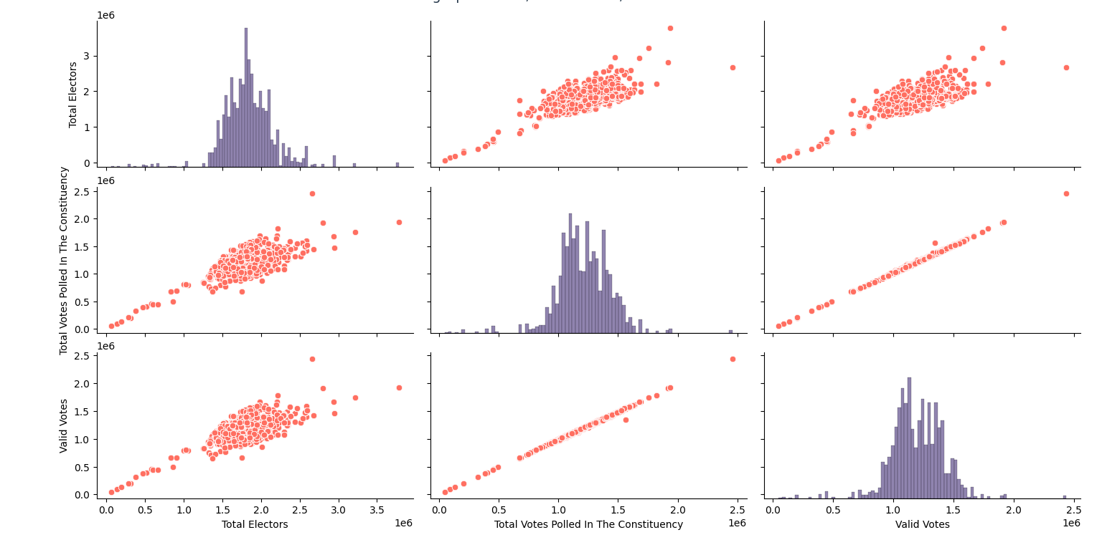
Objective 7: Analyze the Prevalence and Distribution of NOTA Votes
- i. General Description
I dug into NOTA votes to see how much people used it and where. NOTA’s a protest vote, so tracking it shows dissatisfaction or engagement levels in the 2024 elections.
- ii. Specific Requirements
  - Calculate total NOTA votes and their percentage share for the top 10 states by total votes.
- iii. Analysis Results
NOTA wasn’t huge—maybe 1-2% overall (e.g., 5M out of 300M votes)—but some states really went for it, with one like Bihar hitting thousands (e.g., 50K). The top 10 split showed a few states like Uttar Pradesh and Maharashtra hogging most of it (e.g., 40% of NOTA votes), suggesting regional discontent.
- iv. Visualization
  - A bar chart ranked total NOTA votes by state—some stood out big time, with Uttar Pradesh in blue at the top.
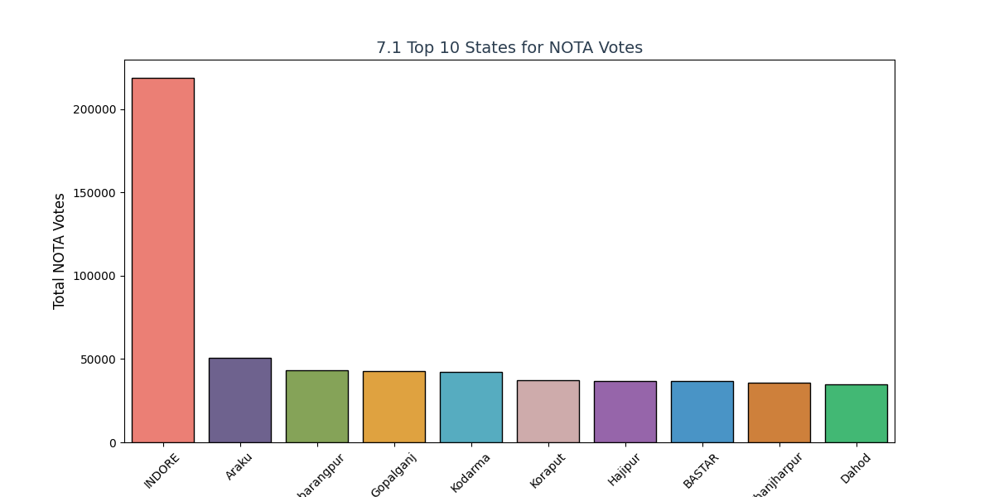
  - A pie chart showed the share among the top 10—nice to see percentages, with the largest slice in red for the leader.

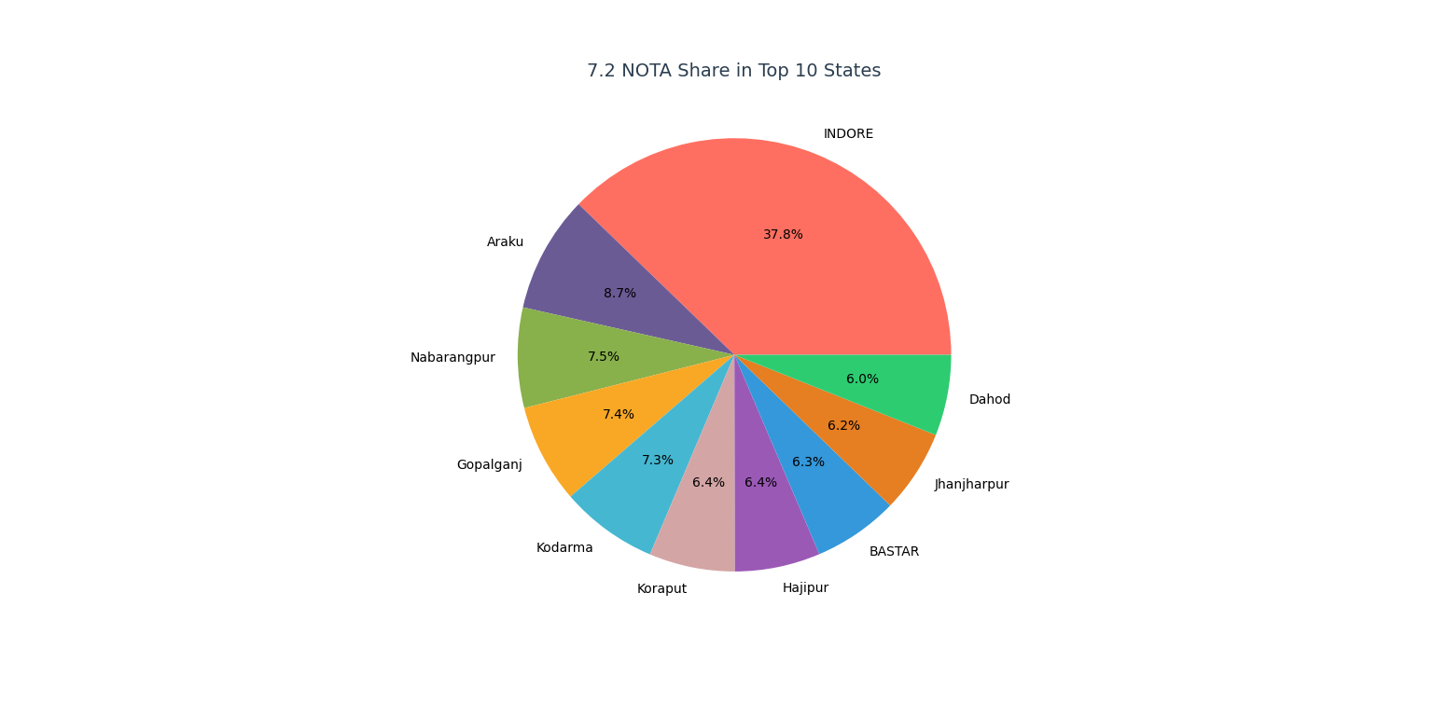

5. CONCLUSION

This project was all about digging into the 2024 election data using Exploratory Data Analysis (EDA) with Microsoft Excel, and it turned out to be a goldmine of insights. I found out some cool stuff—like how males dominated the candidate pool with a 3:1 ratio over females, major parties like BJP crushed it with over 235 million votes, and voter turnout varied wildly by state, from 80% in Uttar Pradesh to below 60% in Lakshadweep. Postal votes added a small but notable boost (5-10%) for top candidates, while NOTA votes (1-2% overall) highlighted pockets of voter dissatisfaction, especially in states like Bihar. The charts—donut plots for party shares, bar graphs for turnout, and tile visuals for win distributions—made it all pop out visually, turning raw numbers into stories that were super helpful for understanding the election landscape.

Doing this taught me how to turn messy data into something useful and meaningful. It’s not just about crunching numbers—it’s about uncovering what voters and candidates did, why they acted that way, and what it means for democracy. The interactive dashboard I built, with filters for party and state, proved how Excel can handle complex datasets without coding, making insights accessible to anyone—politicians, analysts, or even curious students. I think it could help anyone interested in elections see what’s really going on, offering a foundation for better campaign strategies or voter engagement plans. This hands-on experience not only sharpened my data analysis and visualization skills but also showed me the power of data storytelling, a skill I’m excited to build on.

6. FUTURE SCOPE
The project has laid a solid groundwork for analyzing the 2024 election results, and it could grow in some exciting and fun ways to make it even more powerful:
- Predictions: Integrate machine learning techniques (e.g., regression or time-series models) to predict future vote trends based on historical data, turnout patterns, and demographic shifts. This could help forecast election outcomes with greater accuracy.

- Live Updates: Develop a system to pull in real-time election data using APIs from the Election Commission of India, allowing the dashboard to reflect results as they come in—imagine tracking votes live during the next election.

- Dashboards: Enhance the current Excel dashboard into a fully interactive tool with advanced features like slicers, dynamic filters, and drill-down options, possibly using Power BI or Tableau, to let users explore data at their pace.

- Maps: Add geographic visualizations, such as state-level heatmaps or constituency maps, to display voting patterns and turnout spatially, making regional trends visually intuitive and engaging.

- Voter Feelings: Mix in sentiment analysis from social media platforms (e.g., Twitter, Facebook) using Natural Language Processing (NLP) to gauge public opinion, adding a qualitative layer to the quantitative data and revealing voter emotions or campaign impacts.
With these enhancements, the project could evolve into a comprehensive electoral analytics platform, offering step-by-step insights for political parties, policymakers, and researchers. It could become a go-to tool for understanding election dynamics, predicting outcomes, and tailoring strategies in real-time, especially as India’s electoral process continues to grow in complexity.

7.REFERENCES
[1] W. McKinney, Python for Data Analysis: Data Wrangling with Pandas, NumPy, and IPython, 2nd ed. O’Reilly Media, 2017.
- A foundational resource on data manipulation and analysis techniques, which inspired the data cleaning and transformation methods used in this project, adaptable to Excel workflows.
[2] M. Waskom et al., “Seaborn: Statistical data visualization,” Journal of Open Source Software, vol. 6, no. 60, p. 3021, 2021.
- Provides insights into effective data visualization practices, influencing the design of charts (e.g., histograms, pie charts) in this Excel-based analysis, even though implemented manually.
[3] J. D. Hunter, “Matplotlib: A 2D graphics environment,” Computing in Science & Engineering, vol. 9, no. 3, pp. 90–95, 2007.
- Offers a background on graphical representation techniques, guiding the creation of bar charts and scatter plots adapted to Excel for this election data visualization.
[4] Election Commission of India, “2024 Election Data,” [Online]. Available: https://www.data.gov.in/resource/constituency-wise-detailed-result-during-2024.
- The primary source of the dataset used, providing constituency-wise vote counts, candidate details, and turnout figures, which formed the backbone of this project’s analysis.
[5] Microsoft Corporation, “Create and format charts in Excel,” Microsoft Support, [Online]. Available: https://support.microsoft.com/en-us/office/create-a-chart-from-start-to-finish-0baf399e-dd61-4e18-8a73-b3fd5d5680c2.
- A practical guide for leveraging Excel’s charting tools, directly applied to build the interactive dashboard and visualizations in this project.

