“POWERPULSE: A DATA-DRIVEN APPROACH TO FORECASTING ELECTRICITY DEMAND”
A
Major Project Report
Submitted
In partial fulfillment
For the award of the degree of
Bachelor of Technology
In Department of Computer Science Engineering


Project Coordinator Submitted By:
Prof. (Dr.) Om Prakash Sharma Tanishka Dabas (0201220096)
Project Guide Varish Jamal (0201220141)
Dr. Raghunandan Hada Syed Irfan (0201230803)
Prof., CSE

Faculty of Engineering & Technology
Department of Computer Science and Engineering
Jagan Nath University, Jaipur
Session 2025-26

Faculty of Engineering & Technology
Department of Computer Science and Engineering

CERTIFICATE
This is to certify that the major project report entitled “POWERPULSE: A DATA-DRIVEN APPROACH TO FORECASTING ELECTRICITY DEMAND” submitted by Tanishka Dabas for the award of degree of Bachelor of Technology in the department of Computer Science and Engineering of Jagannath University Jaipur is record of authentic work carried out by her under our guidance.
The matter embodies in this major project report is the original work of the candidate and has not been submitted for the award of any other degree. It is further certified that she has worked with me for the required period in the Department of Computer Science Engineering, Faculty of Engineering and Technology of Jagannath University Jaipur.

Project Guide Project Coordinator
Dr. Raghunandan Hada Prof. (Dr.) Om Prakash Sharma
Prof., CSE Signature ……………………….. Signature ………………………


Faculty of Engineering & Technology
Department of Computer Science and Engineering

CERTIFICATE
This is to certify that the major project report entitled “POWERPULSE: A DATA-DRIVEN APPROACH TO FORECASTING ELECTRICITY DEMAND” submitted by Varish Jamal for the award of degree of Bachelor of Technology in the department of Computer Science and Engineering of Jagannath University Jaipur is record of authentic work carried out by him under our guidance.
The matter embodies in this major project report is the original work of the candidate and has not been submitted for the award of any other degree. It is further certified that he has worked with me for the required period in the Department of Computer Science Engineering, Faculty of Engineering and Technology of Jagannath University Jaipur.

Project Guide Project Coordinator
Dr. Raghunandan Hada Prof. (Dr.) Om Prakash Sharma
Prof., CSE Signature ……………………….. Signature ………………………


Faculty of Engineering & Technology
Department of Computer Science and Engineering

CERTIFICATE
This is to certify that the major project report entitled “POWERPULSE: A DATA-DRIVEN APPROACH TO FORECASTING ELECTRICITY DEMAND” submitted by Syed Irfan for the award of degree of Bachelor of Technology in the department of Computer Science and Engineering of Jagannath University Jaipur is record of authentic work carried out by him under our guidance.
The matter embodies in this major project report is the original work of the candidate and has not been submitted for the award of any other degree. It is further certified that he has worked with me for the required period in the Department of Computer Science Engineering, Faculty of Engineering and Technology of Jagannath University Jaipur.

Project Guide Project Coordinator
Dr. Raghunandan Hada Prof. (Dr.) Om Prakash Sharma
Prof., CSE Signature ……………………….. Signature ………………………


Faculty of Engineering & Technology
Department of Computer Science and Engineering
CANDIDATE DECLARATION
We hereby declare that the major project titled “POWERPULSE: A DATA-DRIVEN APPROACH TO FORECASTING ELECTRICITY DEMAND” submitted for the partial fulfillment of the requirements for the Bachelor of Computer Science and Engineering at Jagannath University is our original work and has not been submitted previously at any other university or institution for any other degree or diploma.
We further declare that the work presented in this major project report is the result of our own investigations, except where explicitly stated otherwise. Any references to the work of other researchers have been duly cited/acknowledged.
We also declare that We have adhered to the ethical guidelines and research standards set by Faculty of Engineering and technology of Jagannath University and have obtained all necessary permissions for the use of data, software, and other resources.
We extend Our gratitude to Project Coordinator Prof. (Dr.) Om Prakash Sharma and Guide Dr. Raghunandan Hada for their invaluable guidance and support throughout the course of this major project.

TANISHKA DABAS (0201220096) Signature

VARISH JAMAL (0201220141) Signature

SYED IRFAN (0201230803) Signature


Faculty of Engineering & Technology
Department of Computer Science and Engineering
ACKNOWLEDGEMENTS
We would like to express our sincere gratitude to all those who have supported and guided us throughout the course of this major project.
First and foremost, We are deeply indebted to Major Project Coordinator Prof. (Dr.) Om Prakash Sharma and Guide Dr. Raghunandan Hada, for their invaluable guidance, encouragement, and insightful feedback. Their expertise and support were crucial in shaping the direction and outcome of this project.
Our heartfelt thanks go to our peers and colleagues, especially Garlapati Harshitha, Sooraj Santhosh for their collaboration, support, and the stimulating discussions that enriched this major project.
We are grateful to Faculty of Engineering and Jagannath University for providing us necessary resources and facilities that enabled us to carry out this research. This project has been a valuable learning experience that enhanced my technical, analytical, and problem-solving skills, which were instrumental in the development of the sign language recognition model.
Finally, We extend our deepest gratitude to our family and friends for their unwavering support, patience, and encouragement throughout our academic journey.

TANISHKA DABAS (0201220096)

VARISH JAMAL (0201220141)

SYED IRFAN (0201230803)

ABSTRACT

Accurate electricity demand forecasting is essential for efficient energy management and planning. The primary problem addressed in this project is predicting future electricity consumption for major Indian cities, where demand fluctuates due to weather conditions, population behavior, and seasonal patterns. The objective of this project is to develop a reliable predictive model that can estimate electricity demand and support better decision-making for energy distribution.
The primary objective of this project is to develop a reliable electricity demand forecasting system using machine learning and data analytics techniques. Historical electricity consumption data along with environmental factors such as temperature and humidity were collected and analyzed to identify patterns influencing electricity usage. Data preprocessing and Exploratory Data Analysis (EDA) were performed to improve data quality and extract meaningful insights.
To achieve this, historical electricity consumption data along with weather-related parameters such as temperature and humidity were collected and preprocessed. Exploratory Data Analysis (EDA) was performed to identify trends, patterns, and correlations among variables. A machine learning approach was then applied using regression techniques to build the forecasting model. Model performance was evaluated using metrics such as Mean Absolute Error (MAE) to ensure accuracy and reliability.
The project was implemented using tools and technologies including Python, Google Colab, Pandas, NumPy, Matplotlib, and Scikit-learn, while Power BI was used for interactive dashboard visualization. The final outcome demonstrates a reasonably accurate forecasting model along with a dynamic dashboard that provides actionable insights into electricity consumption trends, enabling improved energy planning and management.
The proposed system highlights the importance of machine learning in modern energy management and demonstrates how predictive analytics can support efficient planning, decision-making, and optimization of electricity distribution systems.

CONTENTS
LIST OF FIGURES 11
LIST OF TABLES 11
CHAPTER 1
Introduction 12-16
  - Background of Study 12
  - Literature Review 13
    - Challenges in Electricity Demand Forecasting 14
    - Types of Electricity Demand Forecasting 14
  - Objectives of the Study 15
  - Problem Statement 15
  - Scope of the Study 15
  - Advantages of Electricity Demand Forecasting 16

CHAPTER -2
Methodology 17-22
2.1 Data Collection 17
2.2 Data Preprocessing 17
2.2.1 Data Cleaning Techniques 17
2.3 Exploratory Data Analysis (EDA) 18
2.4 Model Building 20
2.4.1 Algorithms Used 20
2.4.2 Why we chose it 20
2.5 Model Evaluation 21
2.6 System Architecture 21
2.7 Feature Engineering 22

CHAPTER -3
Dataset & Tools Used 24-26
3.1 Dataset Description 24
3.2 Features Used 24
3.3 Tools and Technologies 25
3.3.1 Python & Libraries 25
3.3.2 Google Colab 25
3.3.3 Power BI 25
3.3.4 Benefits of Using Power BI 26

CHAPTER- 4
Results and Discussion 27-30
4.1 Model Performance 27
4.2 Actual vs Predicted Electricity Demand 28
4.3 Correlation Analysis 28
4.4 Temperature vs Electricity Demand 29
4.5 City-wise Electricity Demand Analysis 29
4.6 Dashboard Visualization Using Power BI 29
4.7 Discussion 30

CHAPTER- 5
Conclusion & Future Scope 31-32
5.1 Conclusion 31
5.2 Applications of Electricity Demand Forecasting 31
5.3 Future Scope 32
5.4 Limitations 32

CHAPTER- 6
Applications and Industry impact 33-35
6.1 Applications of Electricity Demand Forecasting 33
6.1.1 Smart grid Management 33
6.1.2 Energy Distribution Planning 33
6.1.3 Renewable Energy Integration 33
6.1.4 Industrial Energy Management 34
6.1.5 Smart Cities and Urban Planning 34
6.2 Industry Impact 34
6.3 Future Industrial Opportunities 35

REFERENCES 36

LIST OF FIGURES
Figure No. | Title | Page No.
Figure 1.1 | Electricity Consumption Trends Across States | 03
Figure 2.1 | Methodology Workflow for Electricity Demand Forecasting | 09
Figure 2.2 | Electricity Demand Trend Over Time | 11
Figure 2.3 | Correlation Matrix of Features | 12
Figure 2.4 | Temperature vs Electricity Demand | 13
Figure 2.5 | City-wise Electricity Demand | 14
Figure 3.1 | Sample Dataset Used for Forecasting | 16
Figure 4.1 | Actual vs Predicted Electricity Demand | 18
Figure 4.2 | Power BI Dashboard for Electricity Forecasting | 20

LIST OF TABLES
Table No. | Title | Page No.
Table 3.1 | Features Used in the Dataset | 15
Table 3.2 | Tools and Technologies Used | 17
Table 4.1 | Performance Evaluation of Forecasting Model | 18

CHAPTER-1
INTRODUCTION
Electricity demand forecasting plays a critical role in modern energy management systems, particularly in rapidly growing urban environments. With increasing population density, industrial expansion, and changing consumption patterns, the need for accurate and reliable prediction of electricity usage has become more important than ever. Inefficient forecasting can lead to serious challenges such as power shortages, excessive generation costs, and poor resource allocation.
In recent years, the integration of data analytics and machine learning has significantly transformed the way forecasting problems are approached. Unlike traditional statistical methods, modern techniques are capable of analyzing large volumes of data and identifying complex relationships between variables such as temperature, humidity, seasonal variations, and electricity consumption. This enables the development of more precise and adaptive predictive models.
This project focuses on forecasting electricity demand for selected Indian cities by utilizing historical consumption data along with relevant environmental factors. The study involves data preprocessing, exploratory data analysis, and the application of machine learning algorithms to build a predictive model. Furthermore, an interactive dashboard has been developed using Power BI to visualize key insights and trends in a user-friendly manner.
The overall aim of this project is to demonstrate how data-driven approaches can enhance forecasting accuracy and support better decision-making in the field of energy management.

1.1 BACKGROUND OF THE STUDY
Electricity is a fundamental resource that drives economic growth, industrial development, and daily life activities. With rapid urbanization and increasing population in cities such as Delhi, Jaipur, Noida, and Ajmer, the demand for electricity has shown significant variability over time. This variability is influenced by multiple factors, including weather conditions, seasonal trends, and human consumption patterns.
Accurate forecasting of electricity demand has become essential for efficient energy management and planning. Traditional methods often struggle to capture the dynamic and non-linear relationships present in real-world data. With the advancement of data analytics and machine learning techniques, it is now possible to develop predictive models that can analyze historical data and generate reliable forecasts.
This study focuses on leveraging data-driven approaches to predict electricity consumption patterns, enabling better decision-making for energy distribution and resource optimization.

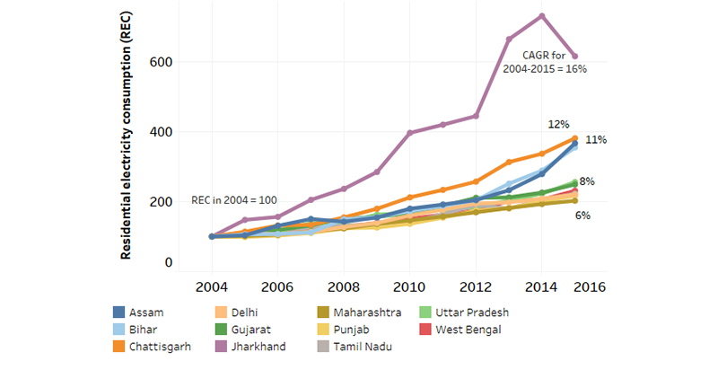
Figure 1.1: Electricity Research Trends Across States
(Source: Centre for Policy Research)

The above figure illustrates the increasing trend in electricity consumption across various states, highlighting the growing demand and the need for accurate forecasting models.

1.2 LITERATURE REVIEW
Previous studies in the domain of electricity demand forecasting have explored a variety of statistical and machine learning approaches. Traditional techniques such as time series analysis and regression models have been widely used due to their simplicity and interpretability. However, these methods often face limitations when dealing with complex and high-dimensional datasets.
Recent advancements have introduced machine learning algorithms, including linear regression, decision trees, and neural networks, which have demonstrated improved performance in capturing non-linear relationships between variables. Additionally, the integration of weather parameters such as temperature and humidity has been shown to significantly enhance forecasting accuracy.
Despite these advancements, many existing models lack proper visualization and real-time interpretability. This highlights the need for an integrated approach that combines predictive modeling with interactive dashboards for better insight generation.

1.2.1 Challenges in Electricity Demand Forecasting
Electricity demand forecasting is a complex task due to the influence of multiple dynamic factors. Consumption patterns continuously change based on weather conditions, human behavior, industrial activity, and seasonal variations.
Some common challenges include:
- Sudden fluctuations in weather conditions
- Incomplete or inconsistent historical data
- Rapid urbanization and changing population behavior
- Difficulty in capturing non-linear relationships between variables
- Real-time processing and scalability issues
These challenges highlight the need for advanced machine learning techniques capable of handling complex and high-dimensional datasets.

1.2.2 Types of Electricity Demand Forecasting
Electricity demand forecasting can generally be classified into three categories:

Short-Term Forecasting
Used for predicting electricity demand over a few hours or days. It is useful for daily load management and operational planning.

Medium-Term Forecasting
Used for forecasting demand over weeks or months. It assists in maintenance scheduling and resource allocation.

Long-Term Forecasting
Used for predicting future electricity requirements over several years. It supports infrastructure planning and policy development.
In this project, short-term forecasting techniques were primarily utilized to analyze and predict electricity consumption patterns.

  - OBJECTIVES OF THE STUDY
The primary objectives of this project are as follows:
- To analyze historical electricity consumption data and identify key patterns and trends.
- To develop a predictive model for forecasting electricity demand using machine learning techniques.
- To evaluate the performance of the model using appropriate metrics such as Mean Absolute Error (MAE).
- To design an interactive dashboard for visualizing electricity consumption trends and predictions.
- To provide actionable insights that can support efficient energy planning and management.

  - PROBLEM STATEMENT
Electricity demand is highly dynamic and influenced by multiple external factors, making it difficult to predict accurately using conventional approaches. Inconsistent forecasting can lead to issues such as energy shortages, overproduction, and inefficient resource allocation.
The problem addressed in this project is to develop a reliable and data-driven model that can accurately forecast electricity consumption based on historical and environmental data. The model should be capable of capturing underlying patterns and providing meaningful insights to improve decision-making in energy management systems.

  - SCOPE OF THE STUDY
This study focuses on forecasting electricity demand for selected Indian cities using historical consumption and weather-related data. The analysis includes data preprocessing, exploratory data analysis, and the application of machine learning techniques for prediction.
The project also involves the development of an interactive dashboard using Power BI to present insights in a user-friendly manner. However, the scope is limited to the available dataset and selected features, and does not include real-time data integration or large-scale deployment.
Future enhancements can include the use of advanced algorithms, incorporation of additional influencing factors, and real-time forecasting capabilities.

1.6 ADVANTAGES OF ELECTRICITY DEMAND FORECASTING
Electricity demand forecasting offers several advantages in modern energy management systems. Accurate forecasting helps power distribution companies optimize electricity generation and reduce operational costs. It also minimizes the risk of energy shortages and overproduction.
Some major advantages include:
- Efficient utilization of energy resources
- Improved load management and grid stability
- Reduction in energy wastage
- Better planning for future electricity requirements
- Support for smart city and smart grid development
Forecasting systems also assist government agencies and utility providers in making data-driven decisions related to infrastructure development and sustainable energy management.

CHAPTER -2
METHODOLOGY
The methodology of this project outlines the systematic approach followed to forecast electricity consumption using data analytics and machine learning techniques. It includes data collection, preprocessing, exploratory analysis, model development, and evaluation, followed by visualization of results. Each step is designed to ensure accuracy, reliability, and meaningful interpretation of the data.

2.1 DATA COLLECTION
The data used in this project was collected from publicly available sources containing historical electricity consumption records along with weather-related parameters for selected cities such as Delhi, Jaipur, Noida, and Ajmer. The dataset includes key variables such as temperature, humidity, and electricity usage, which are essential for analyzing consumption patterns.
The collected data serves as the foundation for building predictive models and generating insights related to electricity demand.

2.2 DATA PREPROCESSING
Raw data often contains inconsistencies such as missing values, duplicate entries, and formatting issues. Therefore, data preprocessing was performed to ensure data quality and consistency.
The preprocessing steps included:
- Handling missing values using appropriate techniques
- Removing duplicate records
- Converting data into suitable formats
- Normalizing and cleaning the dataset
These steps improved the reliability of the dataset and prepared it for further analysis.

2.2.1 Data Cleaning Techniques
Data cleaning is an essential step in preprocessing to improve the quality and reliability of the dataset. Various techniques were used to clean and prepare the data before analysis.
The cleaning process included:
- Identification and removal of duplicate records
- Handling null or missing values
- Detection of outliers using statistical methods
- Standardization of column formats
- Verification of data consistency
These techniques ensured that the dataset was suitable for machine learning and minimized the possibility of inaccurate predictions.

2.3 EXPLORATORY DATA ANALYSIS
Exploratory Data Analysis was conducted to understand the underlying patterns, trends, and relationships within the dataset. Various statistical and visualization techniques were used to analyze the data.
Key activities included:
- Identifying trends in electricity consumption over time
- Analyzing the relationship between temperature and electricity usage
- Detecting outliers and anomalies
- Visualizing data using graphs such as line charts and heatmaps
EDA helped in gaining insights into the data and guided the model-building process.
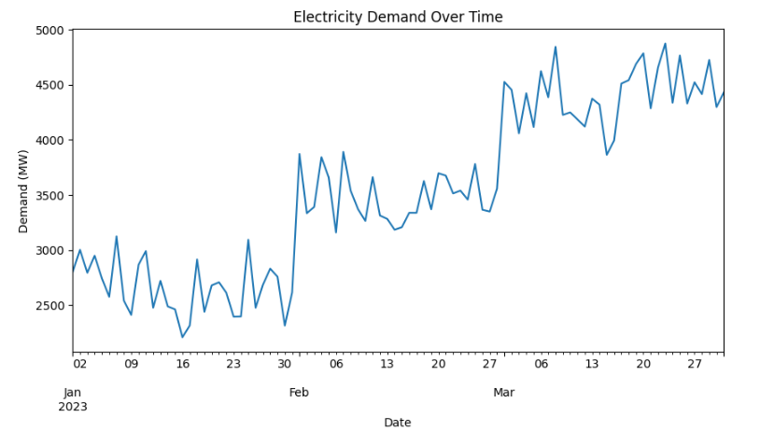

Figure 2.1: Electricity Demand Over Time
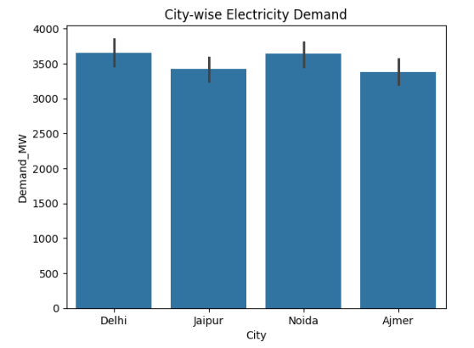

Figure 2.2: City-wise Demand

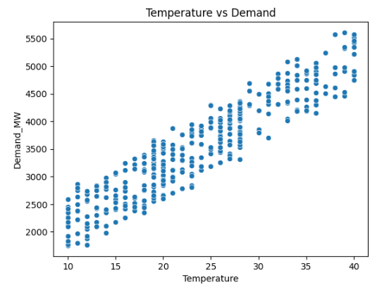

Figure 2.3: Temperature vs Demand

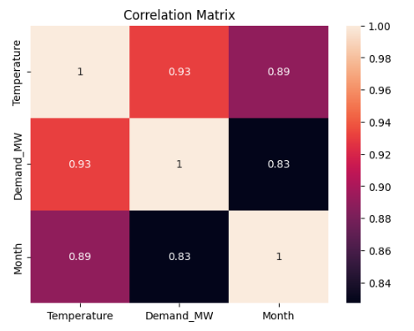

Figure 2.4: Correlation Heatmap
The insights obtained from exploratory data analysis helped in identifying key influencing factors such as temperature and seasonal trends, which were further utilized in building an effective predictive model.

2.4 MODEL BUILDING
A machine learning approach was used to develop a predictive model for electricity demand forecasting. Regression techniques were applied to model the relationship between input variables (such as temperature and humidity) and electricity consumption.
The dataset was divided into training and testing sets to evaluate the model’s performance. The model was trained using the training data and then tested on unseen data to assess its predictive capability.

2.4.1 ALGORITHM USED
In this project, the Linear Regression Algorithm was used for electricity demand forecasting.
Linear Regression is a supervised machine learning algorithm used to predict continuous numerical values by establishing a relationship between dependent and independent variables. The algorithm attempts to fit a linear equation that best represents the relationship between input features such as temperature and humidity and the target variable, electricity demand.
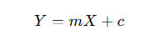
The general equation of Linear Regression is:

Where:
- Y = Predicted value
- X = Input feature
- m = Slope of the line
- c = Intercept
The algorithm predicts electricity demand based on the influence of selected features.

2.4.2 WHY WE CHOSE IT
Linear Regression was selected for this project due to its simplicity, efficiency, and effectiveness in handling continuous numerical prediction problems.
The following reasons justify the use of Linear Regression:
- It is suitable for forecasting numerical values such as electricity demand
- It provides fast training and prediction
- It is easy to interpret and implement
- It performs well when strong relationships exist between variables
- It helps in understanding the influence of individual features on electricity consumption
Since the dataset showed a significant correlation between temperature and electricity demand, Linear Regression proved to be an appropriate choice for predictive modeling.

2.5 MODEL EVALUATION
The performance of the model was evaluated using appropriate metrics to ensure its accuracy and reliability. One of the primary evaluation metrics used in this project is:
- Mean Absolute Error (MAE): Measures the average difference between actual and predicted values.
A lower MAE value indicates better model performance. The evaluation process helps in validating the effectiveness of the model and identifying areas for improvement.

2.6 SYSTEM ARCHITECTURE
The overall workflow of the project follows a structured pipeline, starting from data collection to final visualization
.

( Data Collection )
↓
[ Data Preprocessing ]
↓
[ Exploratory Data Analysis ]
↓
[ Feature Engineering ]
↓
[ Model Building ]
↓
[ Model Evaluation ]
↓
[ Dashboard Visualization ]

Figure 2.5: Methodology Workflow for Electricity Demand Forecasting

Flow of the system:
Data Collection → Data Preprocessing → Exploratory Data Analysis → Model Building → Model Evaluation → Dashboard Visualization
This architecture ensures a logical and organized approach to solving the forecasting problem.

2.7 FEATURE ENGINEERING
Feature engineering involves creating and selecting relevant features that improve the performance of the machine learning model.
In this project:
- Important features such as temperature and humidity were selected
- Data transformations were applied where necessary
- Irrelevant or redundant features were removed
Effective feature engineering enhances the predictive power of the model and contributes to better forecasting accuracy.

CHAPTER -3
DATASET AND TOOLS USED
Plastic This chapter provides an overview of the dataset used in the project along with the tools and technologies employed for data analysis, model development, and visualization.

3.1 DATASET DESCRIPTION
The dataset used in this project consists of historical electricity consumption data along with relevant weather parameters for selected cities, including Delhi, Jaipur, Noida, and Ajmer. The data captures variations in electricity demand influenced by environmental and temporal factors.
Key attributes in the dataset include:
- Temperature (°C)
- Humidity (%)
- Electricity Demand (MW)
- Date/Time Information
- City
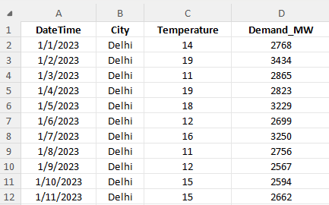
Figure 3.1: Sample Dataset Used for Electricity Demand Forecasting
The dataset provides a comprehensive view of how electricity consumption changes over time and across different locations. It serves as the foundation for performing exploratory analysis and building predictive models.

3.2 FEATURES USED
Feature selection plays a crucial role in improving model performance. In this project, the following features were selected based on their relevance and correlation with electricity demand:
- Temperature – A major factor affecting electricity usage, especially due to cooling needs
- Humidity – Influences weather conditions and indirectly impacts consumption
- Month/Time – Captures seasonal variations
- City – Represents geographical differences
The target variable for prediction is:
- Electricity Demand (MW)
These features were used to train the machine learning model for accurate forecasting.

3.3 TOOLS AND TECHNOLOGIES USED
Various tools and technologies were used throughout the project for data processing, analysis, modeling, and visualization.

3.3.1 Python
Python was used as the primary programming language for data analysis and model development due to its simplicity and powerful libraries.

3.3.2 Libraries Used
- Pandas – For data manipulation and preprocessing
- NumPy – For numerical computations
- Matplotlib & Seaborn – For data visualization
- Scikit-learn – For implementing machine learning models and evaluation

3.3.3 Google Colab
Google Colab was used as the development environment for executing Python code. It provides cloud-based execution, making it easy to run and manage the project without requiring local setup.

3.3.4 Power BI
Power BI was used to create an interactive dashboard for visualizing electricity consumption trends and model insights. It enables users to explore data dynamically and supports better decision-making.
Tool | Purpose
Python | Data analysis & modeling
Pandas | Data preprocessing
Matplotlib | Visualization
Scikit-learn | Machine learning model
Power BI | Dashboard visualization
Table 3.1: Purpose of Tools Used

3.3.5 Benefits of Using Power BI
Power BI provides an efficient platform for transforming raw data into meaningful visual insights. It enables interactive visualization and supports dynamic data exploration through charts, filters, and dashboards.
Major benefits include:
- Interactive and user-friendly dashboards
- Real-time visualization capabilities
- Easy integration with multiple data sources
- Better interpretation of forecasting results
- Enhanced decision-making support
The use of Power BI significantly improved the presentation and accessibility of electricity consumption insights in this project.

CHAPTER -4
RESULTS AND DISCUSSION
This chapter presents the results obtained from the machine learning model developed for electricity demand forecasting. The performance of the model was evaluated using standard evaluation metrics and visual analysis techniques. The findings provide insights into the effectiveness of the predictive model and the factors influencing electricity consumption.

4.1 MODEL PERFORMANCE
After preprocessing and analyzing the dataset, a regression-based machine learning model was developed to forecast electricity demand. The model was trained using historical electricity consumption and weather-related parameters such as temperature and humidity.
The performance of the model was evaluated using the Mean Absolute Error (MAE) metric.

Mean Absolute Error (MAE)
Mean Absolute Error (MAE) is one of the most commonly used evaluation metrics for regression-based machine learning models. It measures the average absolute difference between the actual and predicted values generated by the model.
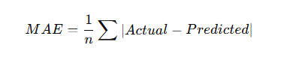
The formula for MAE is:

Where:
- Actual represents the real electricity demand values
- Predicted represents the forecasted values generated by the model
- n is the total number of observations
In this project, the obtained MAE value is:

MAE = 302.5650
This value indicates that the model predictions differ from the actual electricity demand values by an average of approximately 302 units. Considering the scale and variability of electricity consumption data, the model demonstrates satisfactory forecasting performance.
A lower MAE value generally indicates better prediction accuracy. The obtained result shows that the machine learning model is capable of capturing the overall demand trends and producing reasonably accurate forecasts.
The obtained MAE value indicates the average difference between the actual and predicted electricity demand values. An MAE of approximately 302 suggests that the model predictions are reasonably close to the actual demand values.

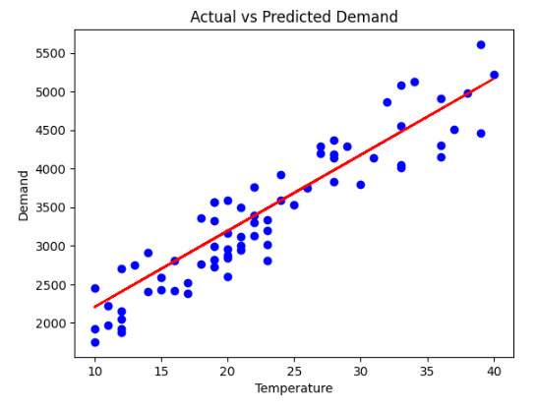
4.2 ACTUAL VS PREDICTED ELECTRICITY DEMAND

Figure 4.1: Actual vs Predicted Electricity Demand

✍ Explanation:
The above graph compares the actual electricity demand values with the values predicted by the machine learning model. The linear trend observed in the graph indicates that the predicted values closely follow the actual demand pattern.
Although slight deviations are present, the model successfully captures the general trend and fluctuations in electricity consumption. This demonstrates the capability of the model to perform reliable forecasting based on historical and environmental data.


4.3 CORRELATION ANALYSIS

Figure 4.2: Correlation Matrix of Features

✍ Explanation:
The heatmap illustrates the correlation between different variables used in the dataset. A strong positive correlation is observed between temperature and electricity demand, indicating that electricity usage increases significantly with rising temperature.

The month variable also shows a high correlation with demand, highlighting the influence of seasonal variations on electricity consumption patterns.

4.4 TEMPERATURE VS ELECTRICITY DEMAND

Figure 4.3: Temperature vs Electricity Demand

✍ Explanation:
The scatter plot demonstrates the relationship between temperature and electricity demand. It can be observed that higher temperatures generally correspond to higher electricity usage.

This pattern suggests that temperature is one of the most influential factors affecting electricity demand, primarily due to increased usage of cooling appliances during warmer conditions.

4.5 CITY-WISE ELECTRICITY DEMAND ANALYSIS

Figure 4.4: City-wise Electricity Demand

✍ Explanation:
The bar chart compares electricity demand across different cities included in the dataset. Variations in demand can be observed among Delhi, Jaipur, Noida, and Ajmer.

These differences may be influenced by population density, climatic conditions, urban infrastructure, and consumption behavior. The analysis helps in understanding regional demand variations and supports location-specific forecasting.

4.6 DASHBOARD VISUALIZATION USING POWER BI

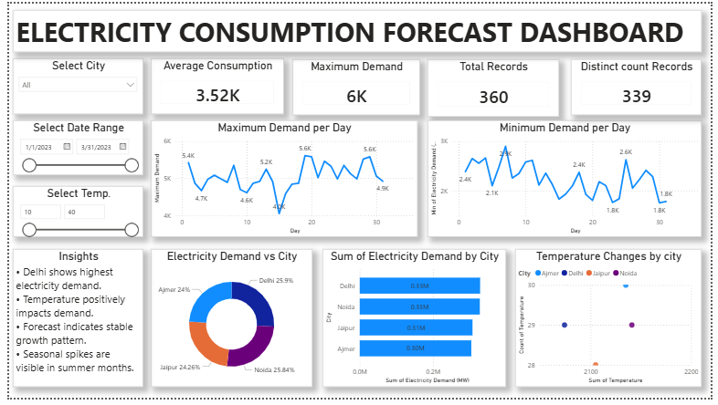
Figure 4.5: Power BI Dashboard for Electricity Demand Forecasting

✍ Explanation:
An interactive dashboard was developed using Power BI to visualize electricity consumption trends, model outputs, and comparative analysis across cities. The dashboard enables dynamic exploration of data through charts, filters, and graphical representations.
The visualization improves interpretability and helps users identify trends, patterns, and forecasting insights more effectively.

4.7 DISCUSSION
The results obtained from the forecasting model indicate that machine learning techniques can effectively predict electricity demand using historical and environmental data. Temperature and seasonal factors were identified as major contributors influencing electricity consumption.
The model achieved a satisfactory level of accuracy with an MAE of 302.5650, demonstrating its capability to capture demand patterns and provide reliable predictions. The integration of Power BI further enhanced the project by enabling interactive visualization and improved interpretation of results.
Overall, the project successfully demonstrates the application of data analytics and machine learning in energy demand forecasting and highlights the importance of data-driven decision-making in modern energy management systems.

CHAPTER-5
CONCLUSION AND FUTURE SCOPE

5.1 CONCLUSION
This project successfully demonstrates the application of data analytics and machine learning techniques in forecasting electricity demand. By utilizing historical electricity consumption data along with environmental factors such as temperature and humidity, the developed model was able to identify meaningful patterns and generate reliable predictions.
The project involved multiple stages including data preprocessing, exploratory data analysis, feature selection, model building, and performance evaluation. The obtained results indicate that the model performs satisfactorily in predicting electricity demand, achieving a Mean Absolute Error (MAE) value of 302.5650.
The visualizations and interactive Power BI dashboard further enhanced the interpretability of the analysis by providing clear insights into consumption trends, city-wise comparisons, and prediction outcomes. The project highlights the importance of data-driven approaches in improving energy planning and decision-making processes.
Overall, the study demonstrates that machine learning can serve as an effective tool for electricity demand forecasting and can contribute toward efficient energy management systems.

5.2 Applications of Electricity Demand Forecasting
Electricity demand forecasting has numerous real-world applications in the energy and utility sector. Accurate forecasting enables organizations to improve operational efficiency and maintain energy stability.
Applications include:
- Smart grid management
- Energy distribution planning
- Industrial power consumption analysis
- Renewable energy integration
- Load balancing and peak demand management
Forecasting systems are increasingly being adopted in smart cities and intelligent energy management systems for sustainable development.

5.3 FUTURE SCOPE
Although the developed model provides satisfactory forecasting performance, there are several opportunities for further improvement and expansion.
Future enhancements may include:
- Integration of real-time electricity consumption data
- Implementation of advanced machine learning and deep learning algorithms such as LSTM and Random Forest
- Inclusion of additional influencing factors such as population growth, industrial activity, and holidays
- Development of automated forecasting systems for smart grid applications
- Deployment of cloud-based dashboards for real-time monitoring and analytics
These improvements can increase prediction accuracy and make the system more suitable for large-scale practical applications in the energy sector.

5.4 LIMITATIONS
Despite achieving satisfactory results, the project has certain limitations. The forecasting model was developed using a limited dataset and selected features, which may affect prediction accuracy under highly dynamic conditions.
Some limitations of the project include:
- Dependence on historical data availability and quality
- Limited number of influencing variables considered
- Absence of real-time data integration
- Forecasting performance may vary for unseen or extreme conditions
Addressing these limitations in future work can further improve the robustness and scalability of the forecasting system.
.

CHAPTER-6
APPLICATIONS AND INDUSTRY IMPACT

6.1 Applications of Electricity Demand Forecasting
Electricity demand forecasting has become an essential component of modern energy management systems. Accurate forecasting enables utility providers, industries, and governments to optimize electricity generation, distribution, and consumption. Machine learning-based forecasting systems help improve operational efficiency while reducing energy wastage and costs.
The following are some major applications of electricity demand forecasting:

6.1.1 Smart Grid Management
Smart grids rely heavily on demand forecasting to balance electricity generation and consumption efficiently. Forecasting models help utility providers monitor load fluctuations and maintain grid stability in real time.
Benefits include:
- Improved load balancing
- Reduced transmission losses
- Better fault detection and management
- Enhanced energy efficiency

6.1.2 Energy Distribution Planning
Electricity forecasting assists power distribution companies in planning energy allocation more effectively. Accurate prediction of future demand helps avoid overproduction and power shortages.
This contributes to:
- Efficient utilization of energy resources
- Reduced operational costs
- Improved reliability of electricity supply

6.1.3 Renewable Energy Integration
Renewable energy sources such as solar and wind power are highly dependent on environmental conditions. Forecasting systems help integrate renewable energy into existing power grids by predicting demand and balancing supply accordingly.
This supports:
- Sustainable energy management
- Better utilization of renewable resources
- Reduction in dependency on fossil fuels

6.1.4 Industrial Energy Management
Industries consume a significant portion of electricity resources. Forecasting systems help industries analyze consumption patterns and optimize energy usage during peak demand periods.
Applications include:
- Cost reduction through optimized power usage
- Efficient production planning
- Monitoring of energy-intensive operations

6.1.5 Smart Cities and Urban Planning
With rapid urbanization, smart cities require intelligent systems for managing electricity demand. Forecasting models support city planners in designing sustainable infrastructure and improving resource allocation.
Electricity forecasting contributes to:
- Smart infrastructure development
- Efficient public utility management
- Sustainable urban growth

6.2 Industry Impact
The implementation of machine learning and data analytics in electricity forecasting has significantly transformed the energy sector. Traditional forecasting approaches are gradually being replaced by intelligent predictive systems capable of handling large-scale and dynamic datasets.
Major industry impacts include:
- Increased forecasting accuracy using machine learning models
- Improved operational efficiency for power utilities
- Better customer demand management
- Reduction in energy wastage and operational risks
- Enhanced decision-making through data visualization tools such as Power BI
The integration of predictive analytics into energy systems is also supporting the transition toward smart grids, automated monitoring systems, and sustainable energy management practices.

6.3 Future Industrial Opportunities
The future of electricity demand forecasting is closely connected with advancements in Artificial Intelligence (AI), Internet of Things (IoT), and cloud computing technologies.
Future opportunities include:
- Real-time forecasting using IoT sensors
- AI-driven automated energy management systems
- Cloud-based analytics platforms for large-scale monitoring
- Integration with smart home technologies
- Advanced deep learning models for highly accurate predictions
These developments are expected to play a major role in shaping next-generation intelligent energy systems.

REFRENCES
[1] A. Géron, Hands-On Machine Learning with Scikit-Learn, Keras, and TensorFlow, 2nd ed. California, USA: O’Reilly Media, 2019.
[2] J. Han, M. Kamber, and J. Pei, Data Mining: Concepts and Techniques, 3rd ed. Waltham, MA, USA: Morgan Kaufmann Publishers, 2011.
[3] F. Pedregosa et al., “Scikit-learn: Machine Learning in Python,” Journal of Machine Learning Research, vol. 12, pp. 2825–2830, 2011.
[4] Python Official Documentation
[5] Pandas Documentation
[6] NumPy Documentation
[7] Matplotlib Documentation
[8] Scikit-learn Documentation
[9] Google Colab Documentation
[10] Microsoft Power BI Documentation
[11] Kaggle Dataset Repository
[12] S. Makridakis, E. Spiliotis, and V. Assimakopoulos, “Statistical and Machine Learning Forecasting Methods: Concerns and Ways Forward,” PLOS ONE, vol. 13, no. 3, pp. 1–26, 2018.
[13] H. L. Willis and W. G. Scott, Distributed Power Generation: Planning and Evaluation. New York, USA: Marcel Dekker Inc., 2000.

