Game Design Document

Fill up the following document

1. Write the title of your project.

Rover rush

1. What is the goal of the game?

We just have to reach the checkpoint

1. Write a brief story of your game.

There is a boy he finds a treasure map and he has to find the treasure. And he then goes out in his car to find the treasure that is our checkpoint over here but there are many obstacles and enemy cars coming from the opposite side.will he be able to reach the checkpoint or will he drop dead in the middle of the road

1. Which are the playing characters of this game?

* Playing characters are the ones who respond to the user based on the input from the user.
* Cars, monkeys, dinos, wizards, etc., are the playing characters in the game.

|  |  |  |
| --- | --- | --- |
| Number | Character Name | What can this character do? |
| 1 | car | To reach the checkpoint |
| 2 |  |  |
| 3 |  |  |
| 4 |  |  |
| 5 |  |  |
| 6 |  |  |
| 7 |  |  |
| 8 |  |  |

1. Which are the Non-Playing Characters of this game?

* Non-Playing characters are the ones that don't have an action or behavior when the user interacts with the game.
* Hurdles, stones, bananas, coins, etc., are non-playing characters in the game.

|  |  |  |
| --- | --- | --- |
| Number | Character Name | What can this character do? |
| 1 | Enemy cars | It hinders the movement of our main car and to defeat it |
| 2 | obstacles | It hinders the movement of our main car |
| 3 |  |  |
| 4 |  |  |
| 5 |  |  |
| 6 |  |  |
| 7 |  |  |
| 8 |  |  |

Draw your imagination of this game. What does this game look like?

* Draw the game either on your computer or on paper.
* Add images of the game scenes to show each of the playing and non-playing characters at least once.

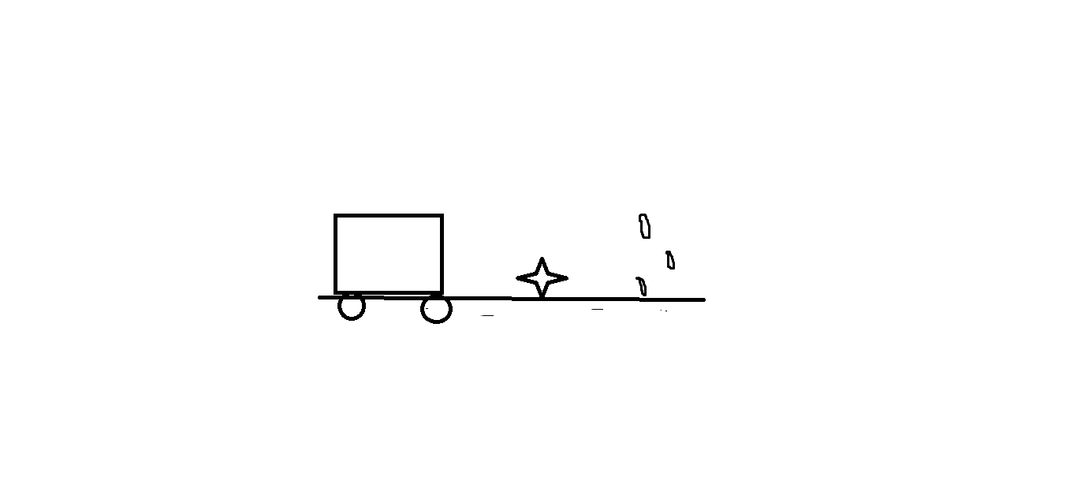

How do you plan to make your game engaging?

I would like to add great visuals and soothing background music with intreasting game sounds.