STUDENT DECLARATION

Project Title | AutoDoc AI — AUTOSAR HLD Document Analysis Assistant
Student Name | Tanishka Kadam
PRN | 124B2D001
Programme / Institute | - Tech. Computer Engineering(Regional Language)  Pimpri Chinchwad College of Engineering (PCCOE), Pune
Submission | Tata Technologies TechPulse Case Study — Digital / Applied AI/ML

I hereby declare that the AutoDoc AI case study submitted by me has been prepared for academic evaluation. I have reviewed the project implementation, documentation, and evaluation results to the best of my knowledge. I understand that AI tools and external libraries were used during development and that their use has been documented where required.
I confirm that the reported results reflect the tests performed and that the limitations of the prototype have been acknowledged. The application has not been validated for safety-critical automotive engineering use.
I accept responsibility for the accuracy of the submitted information and for complying with the applicable academic and project submission guidelines.

Student Signature: 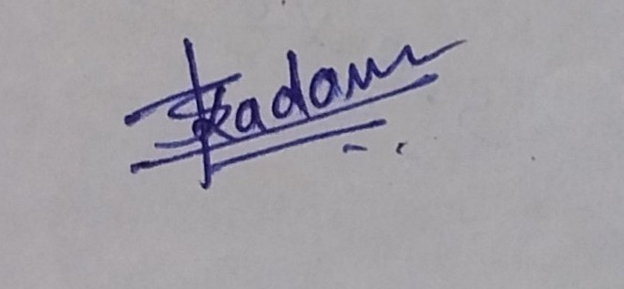
Date: 10/10/2026

