TATA TECHNOLOGIES LTD.
TECH PULSE FY-26 | AI/ML Capstone Project
TECHNICAL REPORT
Field | Details
Institute / University | Pimpri Chinchwad College of Engineering (PCCOE), Pune
Programme / Batch | B.Tech. Computer Engineering(Regional Language) / Final Year
Student Name | Tanishka Kadam
PRN | 124B2D001
Case Study ID (CS1–CS5) | CS1
Project Title | AutoDoc AI — AUTOSAR HLD Document Analysis Assistant

Problem Statement and Intended Users

Problem Statement
Automotive High-Level Design (HLD) documents contain important technical information about system components, interfaces, message flows, and component responsibilities. Manually searching these documents to find specific information can be time-consuming, particularly when users ask questions in natural language rather than using the exact terms found in the document.
AutoDoc AI addresses this problem by providing a document question-answering assistant that combines semantic search with a Large Language Model (LLM). It extracts text from uploaded PDF documents, retrieves relevant passages using embeddings and a vector database, and generates answers using the retrieved evidence. The application also displays source passages and page references to help users verify the answers and identify information that is not specified in the document.
The current prototype is demonstrated using a synthetic automotive HLD document describing an obstacle detection and automatic braking support system. It is intended for educational demonstration and is not validated for safety-critical automotive engineering decisions.

Intended Users
- Automotive software engineers: To locate component responsibilities, interfaces, and message-related information in HLD documents.
- System architects and design reviewers: To find relevant design details and verify answers against source passages.
- Engineering students and researchers: To explore technical-document analysis and retrieval-augmented question answering.
- Technical documentation teams: To support document navigation and information retrieval.
The current implementation is a prototype. These users represent its intended audience; the system has not yet been validated for production use.

2. Input Data / Knowledge Base
Item | Description
Sources | Synthetic educational automotive HLD PDF created for prototype testing. It describes an obstacle detection and automatic braking support system. It is not an official AUTOSAR/OEM specification.
Size and format | One text-based PDF, 3 pages. Synthetic sample, contains component responsibilities, message relationships, and predefined test questions.
Preprocessing / EDA done | PDF text extracted page-by-page using PyMuPDF. Page metadata retained for citations. Text divided into smaller passages and converted into embeddings. OCR/scanned-PDF processing is not claimed.
Chunking strategy | The extracted PDF text is divided into smaller passages (chunks), with page metadata retained for source identification. The passages are converted into embeddings and stored in ChromaDB for semantic retrieval. The exact chunk size and overlap should be documented according to the implemented configuration.

3. Solution Architecture
Component | Choice (name, version, hosting)
Pre-trained model | Google Gemini API — gemini-3.8-flash
Embedding model | Sentence Transformers: all-MiniLM-L6-v2; creates embeddings for document passages and user questions.
Vector store (FAISS / ChromaDB) | ChromaDB persistent vector store; stores passage text, embeddings, and page metadata.
RAG pipeline / AI-agent design | RAG-style workflow: PDF extraction → chunking → embeddings/indexing → semantic top-k retrieval → Gemini answer generation using retrieved evidence → answer and source-page display. No separate autonomous agent is claimed.
Service layer and UI | Python + Streamlit local web application. Launch command: python -m streamlit run Code/app.py.
Tools / deterministic rules | PyMuPDF is used for PDF text extraction, Sentence Transformers (all-MiniLM-L6-v2) for embedding generation, ChromaDB for semantic retrieval, and the Google Gemini API (gemini-3.8-flash) for answer generation. The prompt instructs the model to answer using the retrieved document evidence and acknowledge when the available evidence does not specify an answer. Source-page references are displayed to support manual verification.

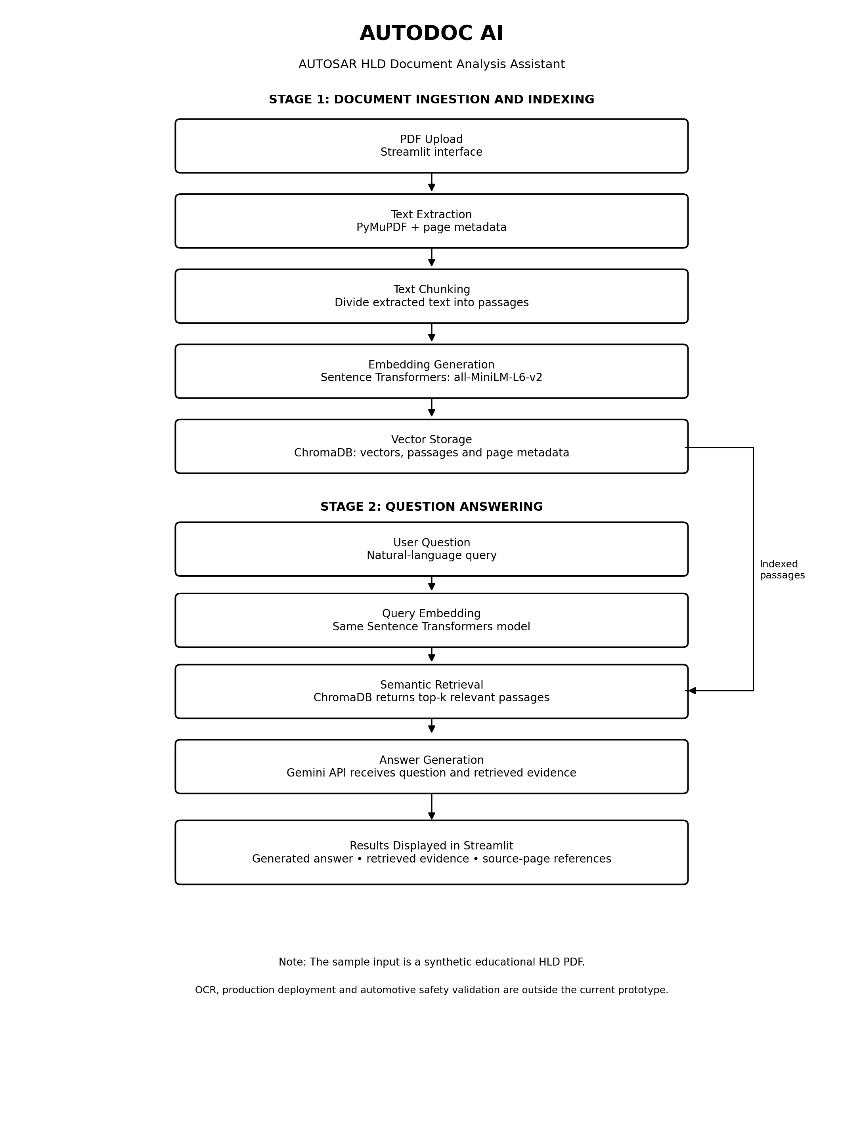

4. Implementation and Configuration

4.1 Development Environment
The AutoDoc AI prototype was developed using Python and Streamlit. The application was developed and tested locally in Visual Studio Code using a Python virtual environment.
Technologies and tools used:
- Programming language: Python
- User interface: Streamlit
- PDF text extraction: PyMuPDF
- Embedding model: Sentence Transformers — all-MiniLM-L6-v2
- Vector database: ChromaDB
- Answer generation: Google Gemini API gemini-3.8-flash
- Development environment: Visual Studio Code

4.2 Document Ingestion and Processing
The user uploads an automotive High-Level Design (HLD) PDF through the Streamlit interface. PyMuPDF extracts the document text and associated page information. The extracted text is divided into smaller passages to support efficient retrieval. Page metadata is retained so that relevant passages can be associated with their source pages.

4.3 Embedding Generation and Vector Storage
The Sentence Transformers model all-MiniLM-L6-v2 converts document passages into numerical vector embeddings. These embeddings, along with the corresponding text and metadata, are stored in ChromaDB. This enables semantic retrieval based on the meaning of a question rather than relying only on exact keyword matches.

4.4 Question Processing and Answer Generation
When a user submits a natural-language question, the application generates an embedding for the query and retrieves the configured number of relevant passages from ChromaDB. The retrieved evidence and the question are then sent to the Google Gemini API to generate an answer. The application displays the generated answer, retrieved source passages, and associated page references.
The intended prompting approach is to keep answers grounded in the retrieved evidence and indicate when the document does not provide sufficient information. The exact prompt and Gemini model identifier should be documented from the working source code.

4.5 User Interface and Output
The Streamlit interface provides document upload, semantic-search preparation, a question input field, a control for selecting the number of passages to retrieve, and a search button. The results section displays the generated answer and retrieved evidence to help users verify the response against the original PDF.

4.6 Configuration and Execution
The application uses a Python virtual environment and a dependency list maintained in requirements.txt. The Gemini API key is configured through environment settings and must not be hard-coded into the application or included in a public repository.
From the project root, the application can be launched using:
python -m streamlit run Code/app.py
The local URL displayed in the terminal can then be opened in a web browser.

4.7 Implementation Limitations
The current implementation was evaluated using a synthetic three-page automotive HLD PDF. The prototype has not been validated for production automotive engineering or safety-critical decisions. OCR for scanned documents and production deployment should not be considered implemented unless separately verified.

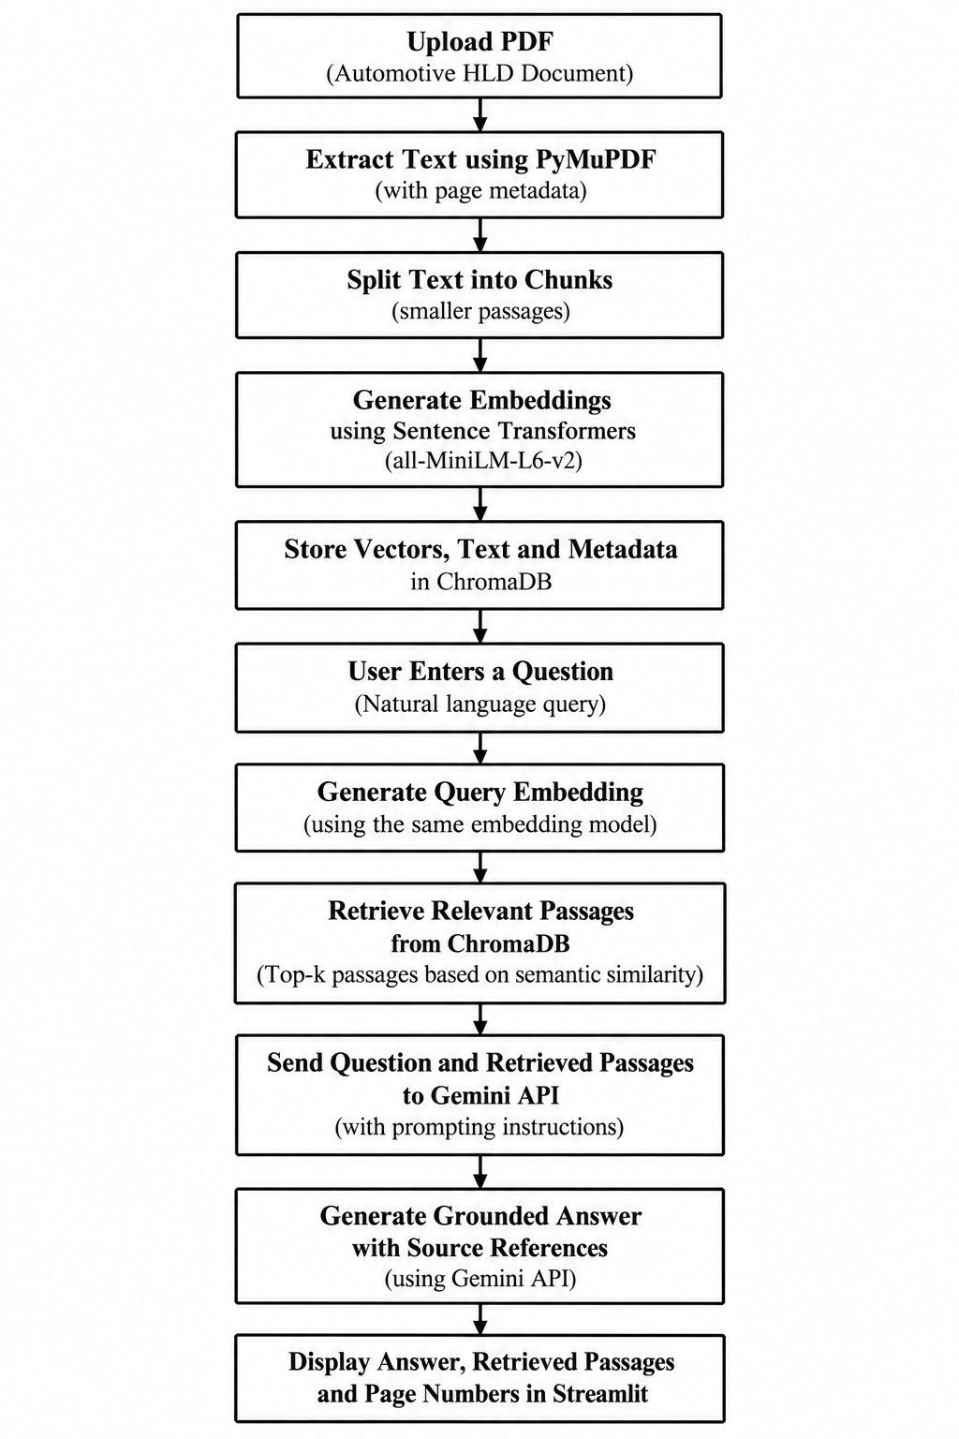

5. Evaluation Steps and Results
Semantic retrieval allows natural-language questions instead of relying only on exact keyword matching.
# | Test question / scenario | Expected answer / behaviour | Result (Pass/Fail, notes)
1 | Which component evaluates the obstacle detection message? | Driver Assistance Controller | Pass* — expected answer displayed; pages 2 and 3 cited. Verify citation support manually.
2 | What is the exact braking distance threshold? | The document does not specify a real threshold. | Pass* — system reported threshold unspecified and cited page 3.
3 | Which component produces ObstacleDetectionMessage? | Obstacle Sensor | Pass* — expected answer displayed; pages 2 and 3 cited. Verify citation support manually.
4 | Which interface receives BrakeRequestMessage? | Brake Control Interface | Pass* — expected answer displayed; pages 2 and 3 cited. Verify citation support manually.
5 | Which component displays the system warning? | Driver Display | Pass* — expected answer returned after retry; pages 2 and 3 cited. A Gemini 503 error occurred on an earlier attempt.

Metric | Score / observation
e.g. Answer relevance / faithfulness | Observed functional answer match: 5/5 questions (100% on this small predefined test set only; not a general accuracy estimate).
e.g. Retrieval hit rate / citation accuracy | Retrieval passages and page citations are displayed. Citation correctness / retrieval hit rate has not yet been independently scored; verify each citation against the PDF.
e.g. Latency | Latency was not systematically measured. Record response time for each test if required, Gemini API temporarily returned 503 UNAVAILABLE once, then retry succeeded.

Missing-information test checks whether the application avoids inventing an exact braking threshold when the sample document does not specify one.
Area | Measure adopted in this project
Grounding and citations | Answer generation uses retrieved document passages; source passages and page numbers are displayed for human verification. The system should say when information is not specified.
Privacy | Use synthetic educational input for demonstration. Do not upload confidential OEM, personal, or restricted documents without authorization.
Security | Keep Gemini API key in environment configuration; never hard-code it or commit .env to GitHub. Add .env to .gitignore.
Human oversight / review | Users must verify answers and cited pages. This prototype is not validated for safety-critical automotive engineering decisions.

7. Innovation Highlights
Semantic Search for Technical Documents: AutoDoc AI uses the Sentence Transformers model (all-MiniLM-L6-v2) to retrieve relevant passages based on the meaning of a user's question rather than relying only on exact keyword matching.
Retrieval-Augmented Generation (RAG): The system combines semantic retrieval through ChromaDB with answer generation using the Google Gemini API, allowing responses to be generated using relevant passages from the uploaded document.
Source-Based Answer Verification: The application displays retrieved evidence and PDF page references alongside generated answers, helping users cross-check responses against the original document.
Handling Missing Information: The prototype was tested with a question about an exact braking-distance threshold that was not specified in the sample document. The application correctly reported that the threshold was not specified, demonstrating an important check against unsupported answers in this test.
Interactive Document Analysis Interface: The Streamlit interface combines PDF upload, semantic-search preparation, configurable passage retrieval, question input, and answer display in one application.
Automotive HLD-Focused Demonstration: The prototype demonstrates how document question answering can be applied to automotive High-Level Design documents using a synthetic obstacle detection and automatic braking support system.
Modular and Extensible Architecture: The use of separate components for PDF extraction, embeddings, vector storage, retrieval, and answer generation makes it possible to improve individual stages independently in future development.

8. Screenshots, Logs and Evidence
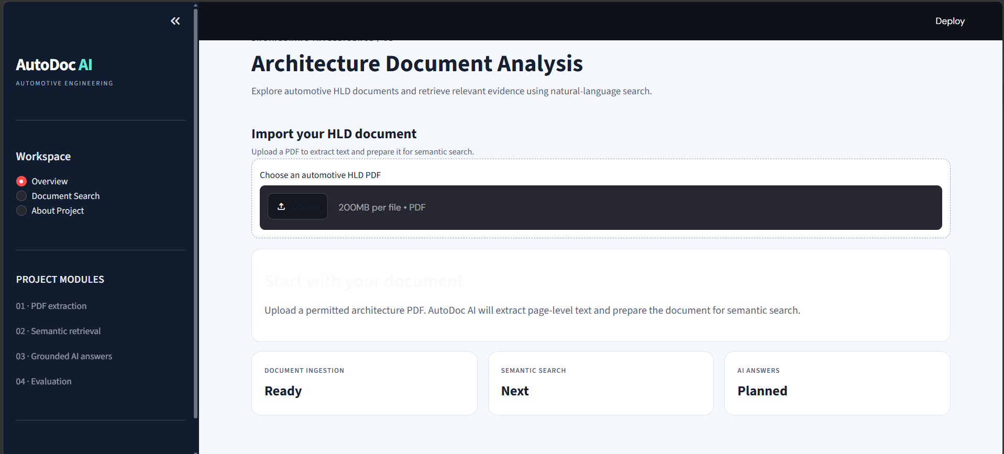
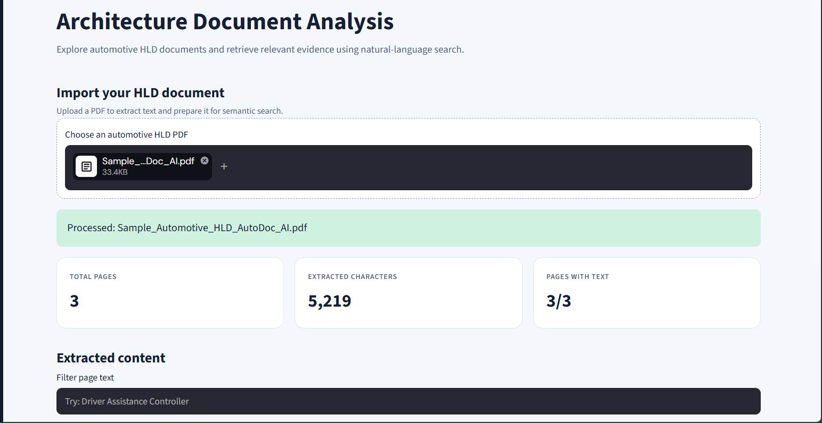
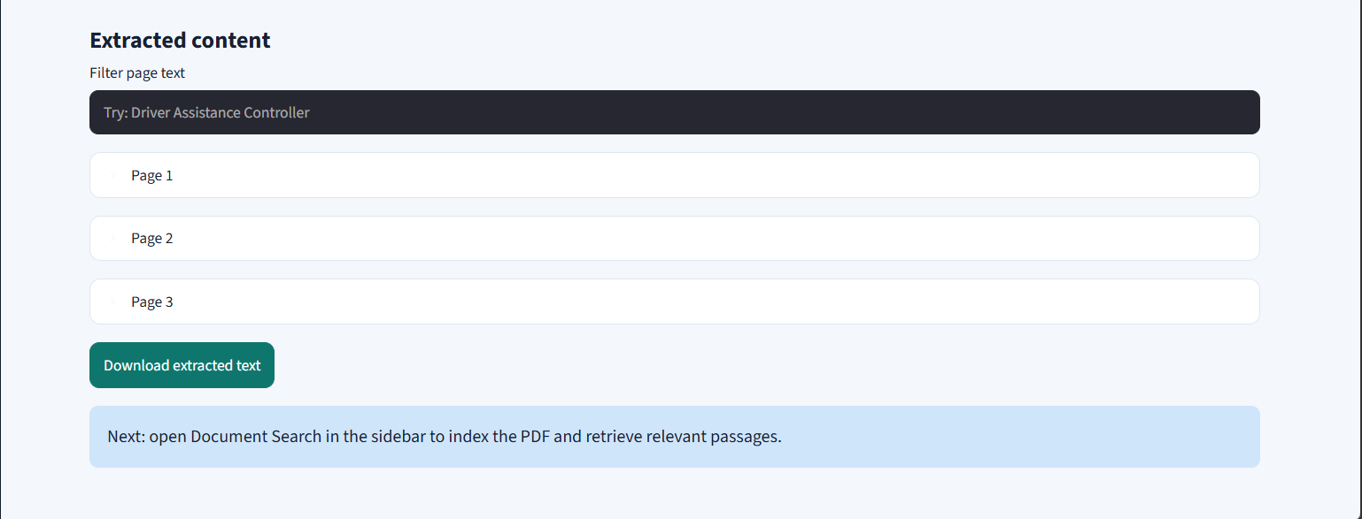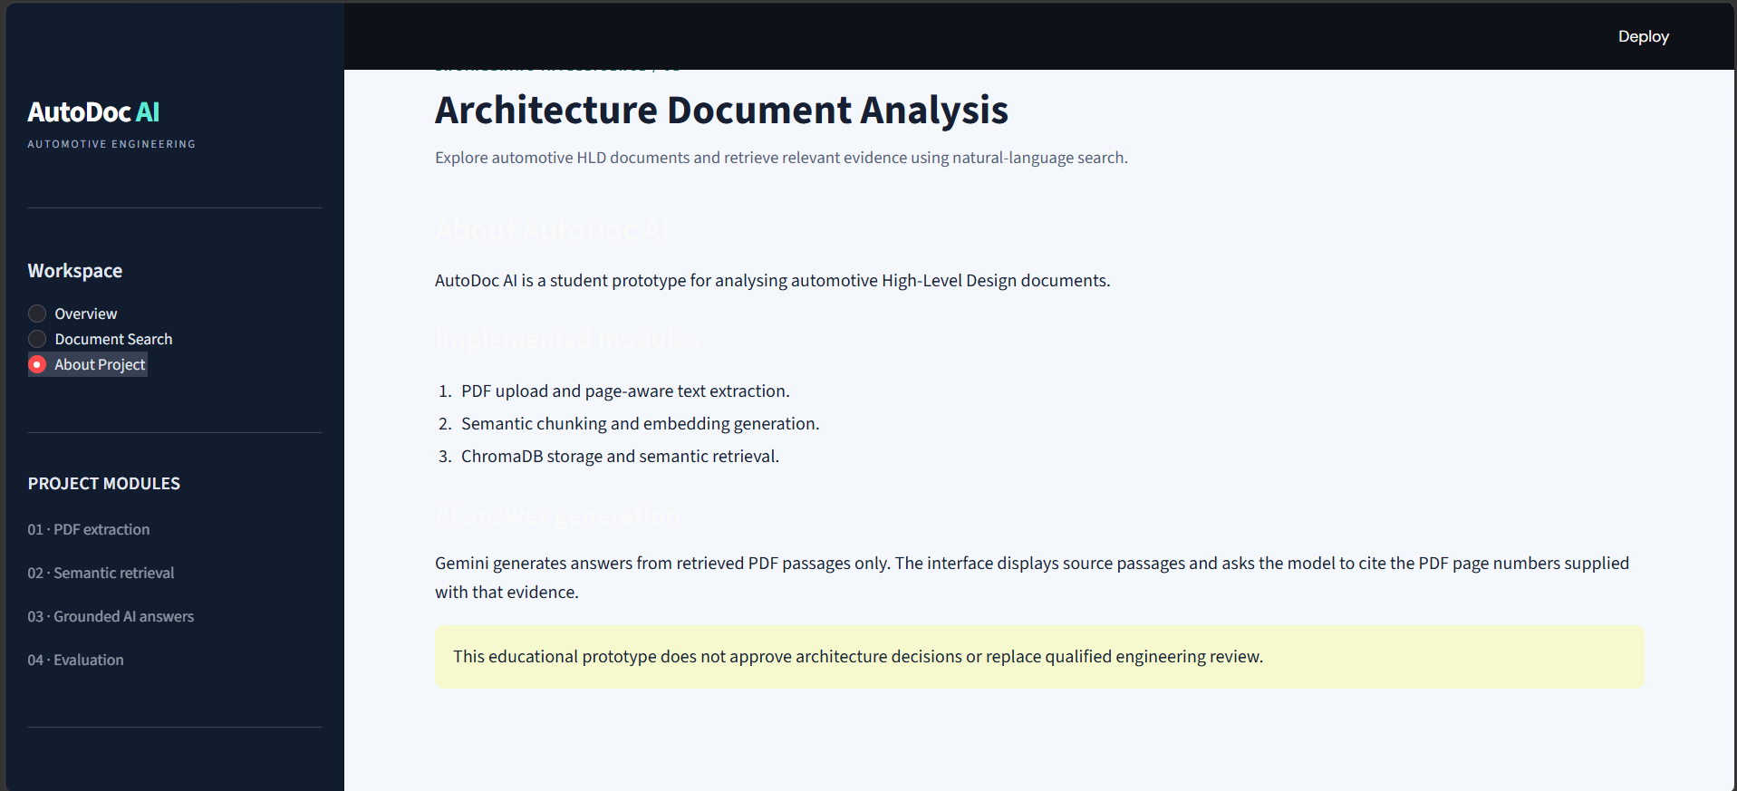Figure 1. DashBoard

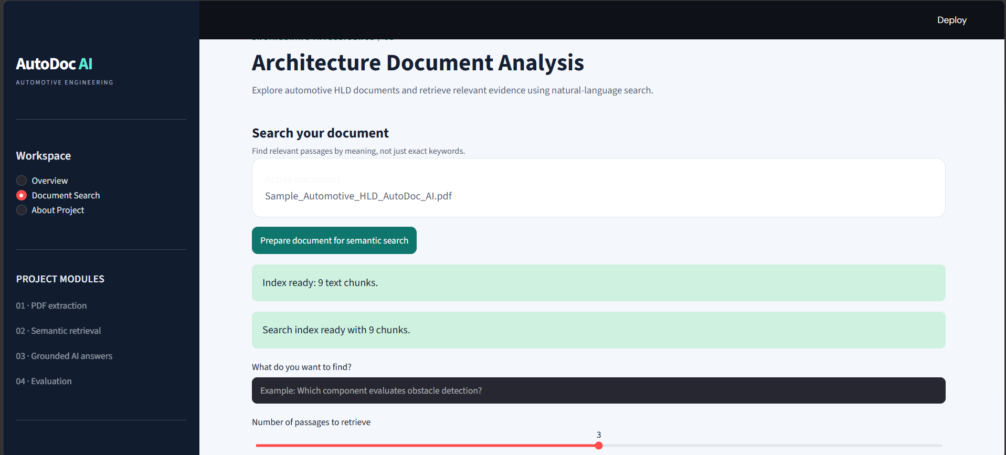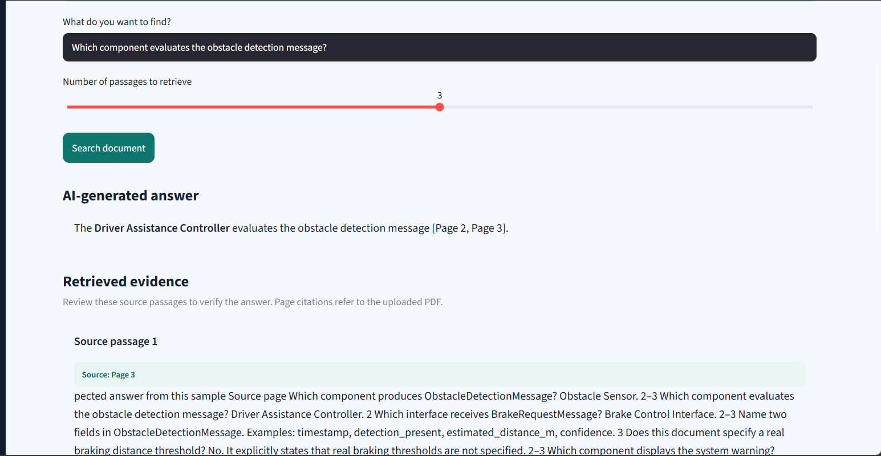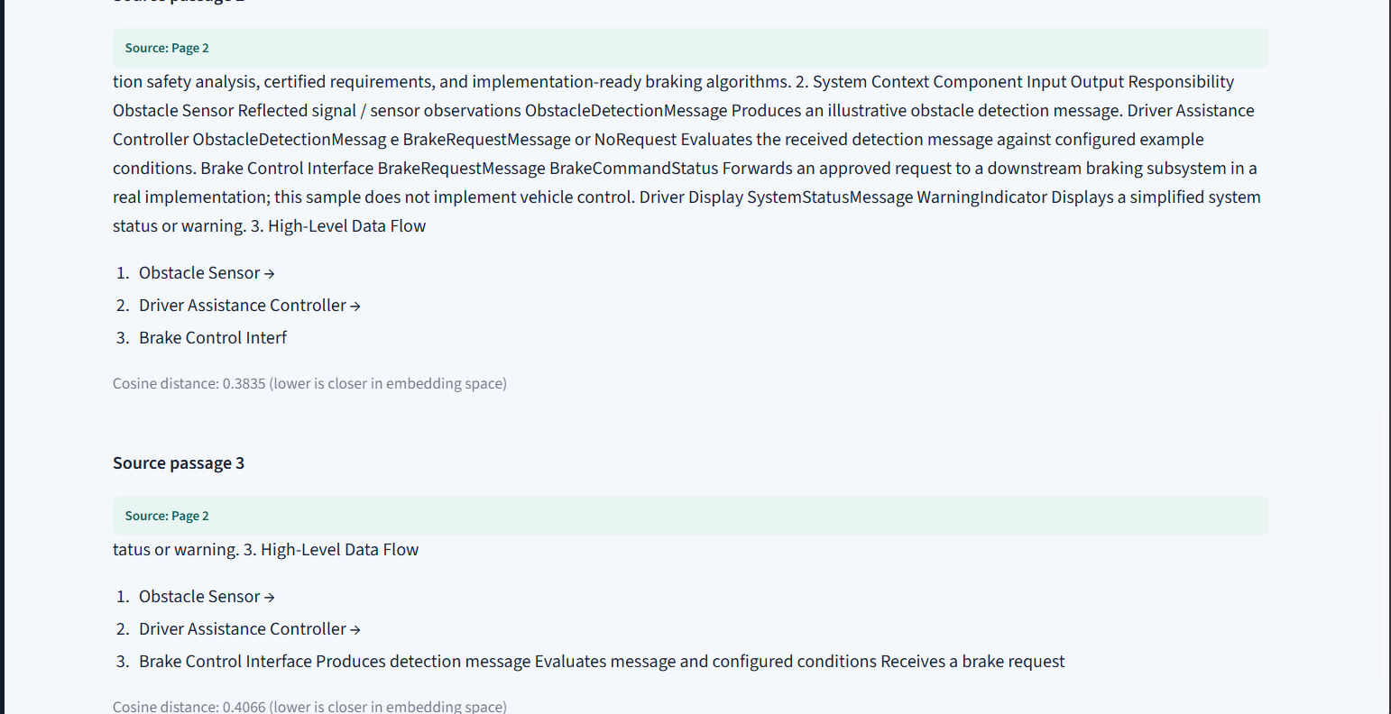Figure 2. Document Searching

9. Reflection and Conclusions

Reflection:-

Developing AutoDoc AI helped me understand semantic search, embeddings, vector databases, and RAG-based question answering. Testing five questions improved my understanding of answer verification and highlighted the need for better retrieval evaluation and citation accuracy.

Conclusion:-

AutoDoc AI successfully demonstrated document-based question answering using Sentence Transformers, ChromaDB, and the Gemini API. All five tested questions produced the expected answers. Further testing is needed to validate citation accuracy and improve reliability before broader use.

10. AI-Tool Usage Declaration
AI tool / model | Purpose | Artifact affected | Verified by Student (Y/N)
ChatGPT / OpenAI | Development guidance, debugging support, and help drafting project documentation. | Code assistance, synopsis/report wording, README and configuration documentation; student reviewed and must verify all content. | Yes — only after personally reviewing and verifying each item
Google Gemini API gemini-3.8-flash | Generate answers from retrieved evidence within the application. | AutoDoc AI answer-generation component and displayed responses. | Yes — student must validate answers and citations

11. Student Declaration
I confirm that this report represents my own understanding and contribution, that the work follows the approved case-study scope, and that I can explain every significant part of the implementation.

Signature: | 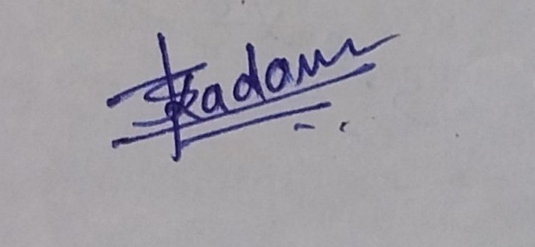 | Date: | 10/10/2026
Name: | Tanishka Kadam | PRN: | 124B2D001

