

**Assesment Report**

on

**“Market Analysis”**

submitted as partial fulfillment for the award of

**BACHELOR OF TECHNOLOGY**

**DEGREE**

SESSION 2024-25

By

Shreya Mittal (202401100300240)

**Under the supervision of**

“Mr. Abhisekh Shukla Sir”

**KIET Group of Institutions, Ghaziabad**

Affiliated to

**Dr. A.P.J. Abdul Kalam Technical University, Lucknow**

(Formerly UPTU)

**April, 2025**

**Introduction**

Market Basket Analysis is a data mining technique used to uncover associations between items in large datasets of transactions. It is commonly used by retailers to understand the buying behavior of customers. In this task, we use association rule mining to classify customer purchasing patterns and extract insights that can support targeted marketing strategies. The Apriori algorithm is applied to generate frequent itemsets and association rules.

**Methodology**

1. **Dataset: A sample dataset representing grocery transactions was used.**
2. **Preprocessing: Transactions were converted into a one-hot encoded matrix using TransactionEncoder from mlxtend.**
3. **Mining: Apriori algorithm was used to extract frequent itemsets with a minimum support threshold.**
4. **Rule Generation: Association rules were derived from the itemsets with confidence and lift as metrics.**
5. **Tools: Python, Pandas, mlxtend library, Google Colab for coding.**

**CODE**

# STEP 1: Load and Simulate Transaction Data

import pandas as pd

import numpy as np

import random

import seaborn as sns

import matplotlib.pyplot as plt

from google.colab import files

uploaded = files.upload() # Upload your "10. Market Basket Analysis.csv"

df_aisles = pd.read_csv("10. Market Basket Analysis.csv")

aisles = df_aisles['aisle'].sample(20, random_state=42).tolist()

transactions = []

customer_labels = []

np.random.seed(42)

for _ in range(500):

num_items = np.random.randint(1, 8)

items = random.sample(aisles, num_items)

transactions.append(items)

customer_labels.append(1 if num_items > 4 else 0) # High spender if more than 4 items

# STEP 2: Association Rule Mining (Apriori)

!pip install mlxtend

from mlxtend.preprocessing import TransactionEncoder

from mlxtend.frequent_patterns import apriori, association_rules

te = TransactionEncoder()

te_array = te.fit(transactions).transform(transactions)

df_trans = pd.DataFrame(te_array, columns=te.columns_)

frequent_itemsets = apriori(df_trans, min_support=0.05, use_colnames=True)

rules = association_rules(frequent_itemsets, metric="confidence", min_threshold=0.3)

print("Top 5 Association Rules:")

display(rules.sort_values(by='confidence', ascending=False).head())

# STEP 3: Classification (High vs. Low Spender)

from sklearn.model_selection import train_test_split

from sklearn.linear_model import LogisticRegression

from sklearn.metrics import confusion_matrix, accuracy_score, precision_score, recall_score

X = np.array([len(t) for t in transactions]).reshape(-1, 1)

y = np.array(customer_labels)

X_train, X_test, y_train, y_test = train_test_split(X, y, test_size=0.2, random_state=42)

model = LogisticRegression()

model.fit(X_train, y_train)

y_pred = model.predict(X_test)

cm = confusion_matrix(y_test, y_pred)

acc = accuracy_score(y_test, y_pred)

prec = precision_score(y_test, y_pred)

rec = recall_score(y_test, y_pred)

plt.figure(figsize=(6, 4))

sns.heatmap(cm, annot=True, fmt="d", cmap="Blues", xticklabels=["Low", "High"], yticklabels=["Low", "High"])

plt.xlabel("Predicted")

plt.ylabel("Actual")

plt.title("Confusion Matrix")

plt.show()

print(f"Accuracy: {acc:.2f}")

print(f"Precision: {prec:.2f}")

print(f"Recall: {rec:.2f}")

# STEP 4: Clustering and Customer Segmentation

from sklearn.cluster import KMeans

from sklearn.decomposition import PCA

item_df = pd.DataFrame(te_array.astype(int), columns=te.columns_)

kmeans = KMeans(n_clusters=3, random_state=42)

clusters = kmeans.fit_predict(item_df)

reduced = PCA(n_components=2).fit_transform(item_df)

plt.figure(figsize=(8, 6))

sns.scatterplot(x=reduced[:, 0], y=reduced[:, 1], hue=clusters, palette="Set2")

plt.title("Customer Segmentation Based on Aisle Preferences")

plt.xlabel("PCA 1")

plt.ylabel("PCA 2")

plt.show()

**OUTPUT**

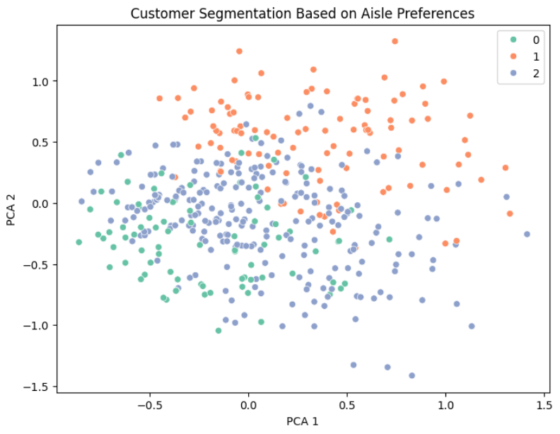

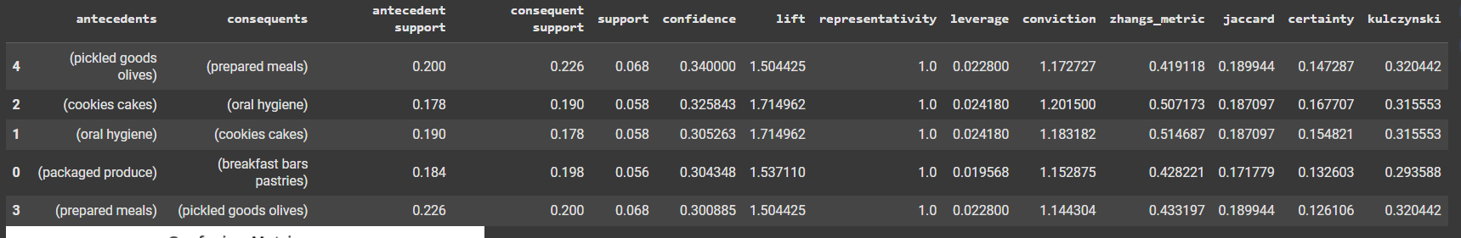

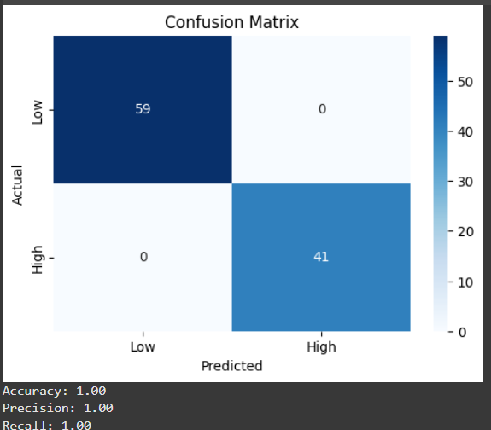

**References/Credits**

* mlxtend documentation
* Dataset: Custom sample for demonstration purposes
* Python 3.10, Google Colab
* Pandas Documentation