**DATA EXPLORATION AND ANALYSIS OF CAR DEKHO APP**

**TANISHQ CHERUKURI**

**12/03/2022**

**DESCRIPTION:-**

Project is about description and visualization of “CAR DEKHO” app related to used car details.

Data link: <https://www.kaggle.com/datasets/akshaydattatraykhare/car-details-dataset>

The data set consist of 4340 Rows and 8 Columns.

**DATA OVERVIEW AND TRANSFORMATION:-**

As we know that data has 4340 Rows and 8 columns, looking into the columns, below is the column information provided from data source.

Following details of cars are included in the dataset they are Car name, Year, Selling price **,**Kms driven , Fuel , Selling price ,Transmission ,Owner:-

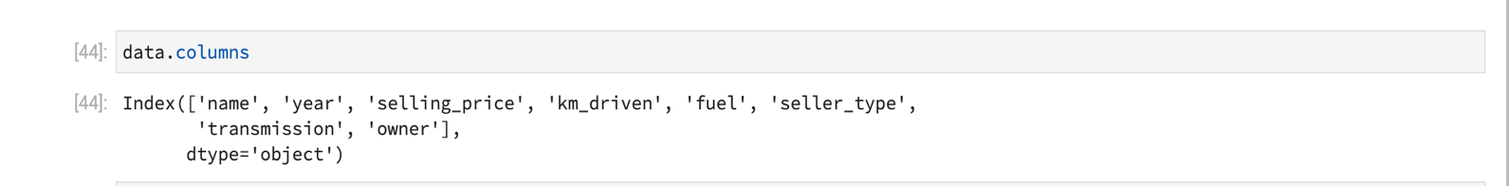

The number of cars sold according to their brands are:-

The number of cars sold by fuel type are:-

**DESCRITIVE AND VISUALIZATION:-**

The pie-chart shows the cars owner data ,most of them are buying cars sold by first hand owners only and least is test driver cars.

The pie-chart shows the car transmission type, most of the people are preferring manual cars compared to automatic.

The bar graph shows the selling price of different car companies.

The bar graph shows the kms driven by different car companies.

**CONCLUSION:-**

Maruti Suzuki has high margin compare to all cars. Diesel and Petrol cars are almost sold equally and the least is electric cars. First owner cars are sold highest by 65.25% and test drive cars are sold least by 0.39% . Manual transmission cars are sold highest by 89.68% and automatic by 10.32%. KIA, FORCE ISUZU cars are list sold.