# 

# **WORK REPORT**

## 

## SUBMITTED BY:

TANISHQ BHAKAR

VIPS B.TECH(CSE)

CONTACT NO.-8595776138

## **INTRODUCTION**

This report presents a comprehensive analysis of datasets from Smart India Hackathon (SIH), focusing on teams participating in the Grand Finale and Wildcard Selection, including the winning entries. The dataset comprises factors such as cities, states, themes, organizations, problem statements, college names, and college codes. The objective of this analysis is to uncover key trends and insights into team distribution, thematic preferences, problem-solving strategies, and institutional representation. By systematically evaluating these aspects, the report highlights patterns and actionable observations that distinguish successful teams, offering valuable guidance for organizers and participants to enhance strategies for future editions of SIH.

## This report is based on the analysis of three datasets provided:

* Grand Finale Selection Teams Dataset
* Wildcard Selection Teams Dataset
* Winning Teams Dataset
* Problem Statement Dataset

# **EDA and Visualization of the Grand Finale Selection Teams Dataset:**

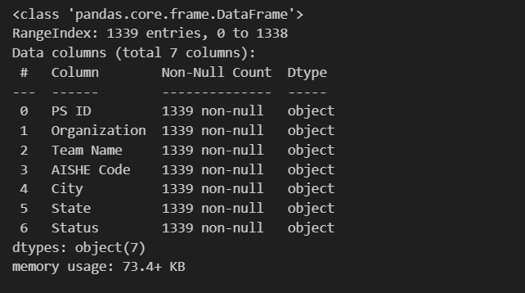

## **INFERENCE:**

* Total Number of Teams selected through Grand Finale are:1339 Teams

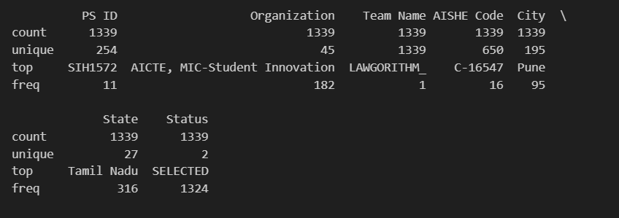

INFERENCE:

* Total Number of Problem Statement ID represented in the Grand Finale are: 254
* Total Number of States represented in the Grand Finale are: 27
* Total Number of Cities represented in the Grand Finale are: 195
* Total Number of Colleges represented in the Grand Finale are: 650
* Total Number of Organization represented in the Grand Finale are: 45

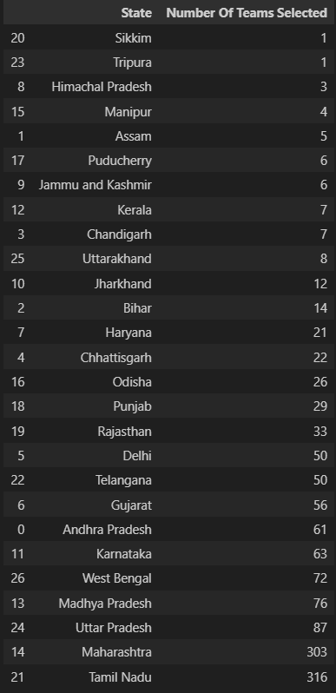

INFERENCE:

* State with the maximum number of Teams Selected is Tamil Nadu with 316 Teams selected.
* States with the minimum number of Teams Selected are Tripura and Sikkim with only 1 Team selected.
* Top 5 States(On the basis of Team Selected)

1. Tamil Nadu with 316 teams selected.
2. Maharashtra with 303 teams selected.
3. Uttar Pradesh with 87 teams selected.
4. Madhya Pradesh with 76 teams selected.
5. West Bengal with 72 teams selected.

* STATES(With More than 50 Teams Selected)

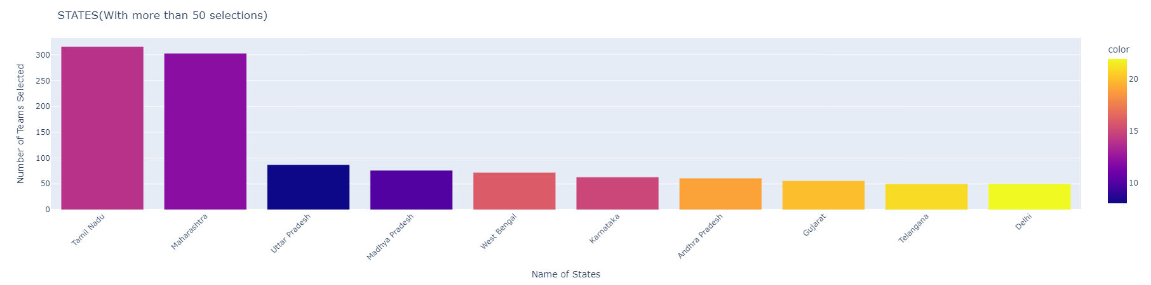

* STATES(With Less than 50 Teams Selected)

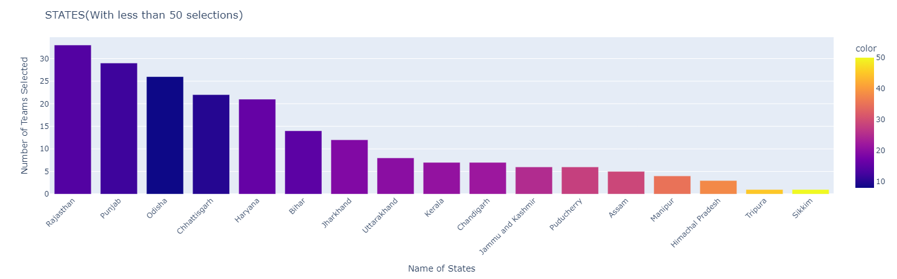

* DISTRIBUTION OF TOP 3 CITIES FOR STATES(With Max. No. Of Selections)

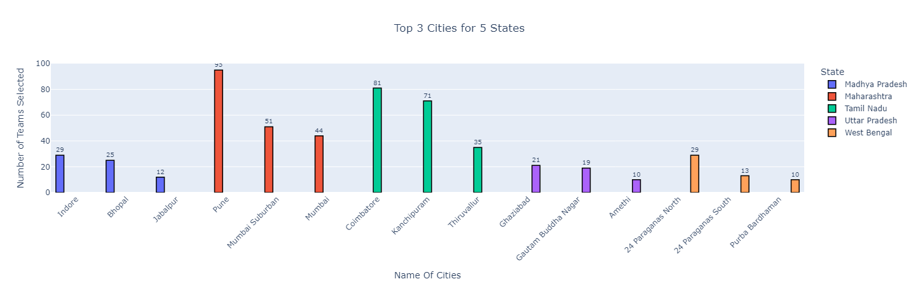

INFERENCE:

* In Tamil Nadu

1. Coimbatore has 81 No. of Teams Selected.
2. Kanchipuram has 71 No. of Teams Selected.
3. Thiruvallur has 35 No. of Teams Selected.

* In Madhya Pradesh

1. Indore has 29 No. of Teams Selected.
2. Bhopal has 25 No. of Teams Selected.
3. Jabalpur has 12 No. of Teams Selected.

* In Maharashtra

1. Pune has 95 No. of Teams Selected.
2. Mumbai Suburban has 51 No. of Teams Selected.
3. Mumbai has 44 No. of Teams Selected.

* In Uttar Pradesh

1. Ghaziabad has 21 No. of Teams Selected.
2. Gautam Buddha Nagar has 19 No. of Teams Selected.
3. Amethi has 10 No. of Teams Selected.

* In West Bengal

1. 24 Paraganas North has 21 No. of Teams Selected.
2. 24 Paraganas South has 21 No. of Teams Selected.
3. Purba Bardhaman has 21 No. of Teams Selected.

* DISTRIBUTION OF STATES AND ORGANIZATION

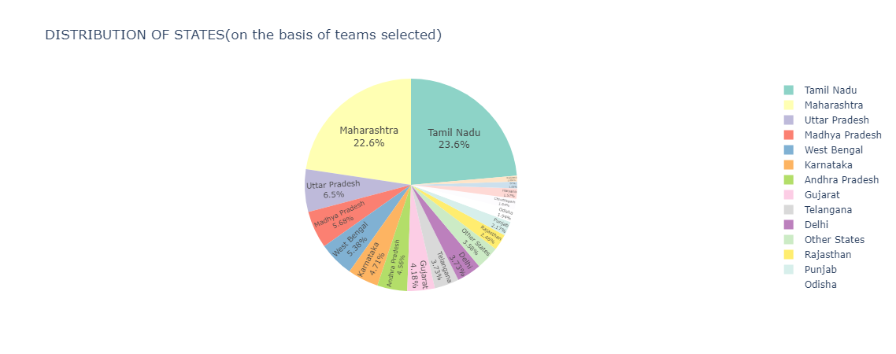

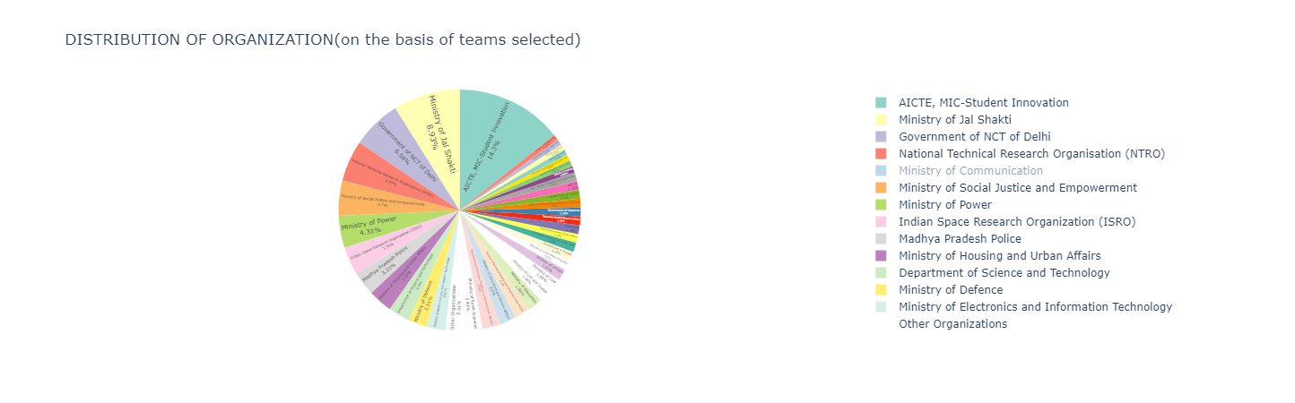

* TOP 10 INSTITUTES(On the Basis Of Teams Selected)

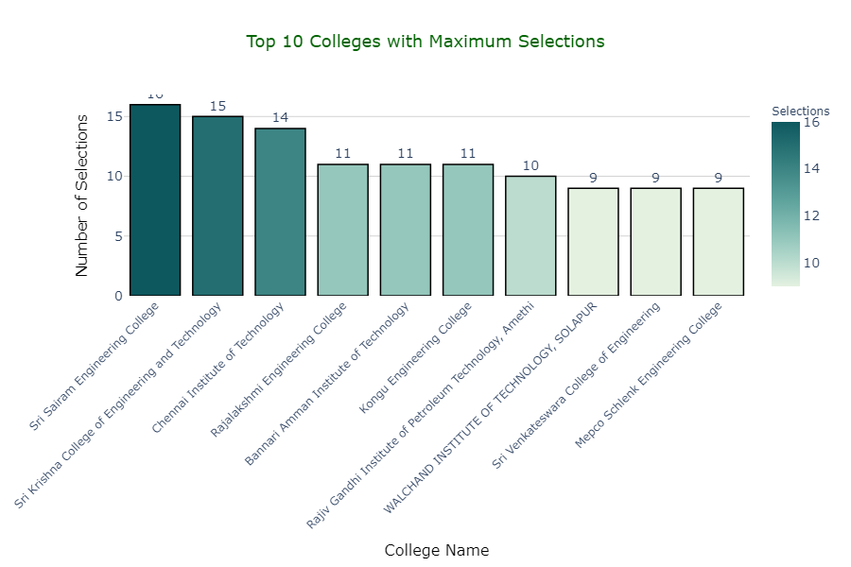

* LIST OF TOP 10 INSTITUTES

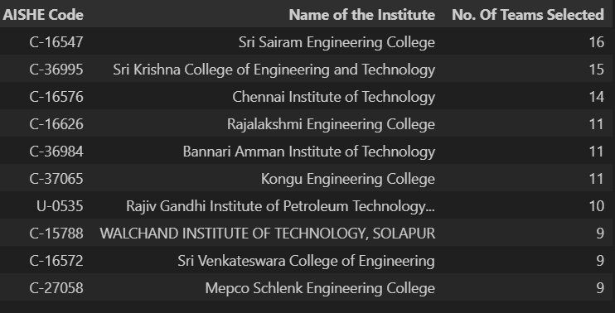

# **EDA and Visualization of the Grand Finale Selection Teams Dataset:**

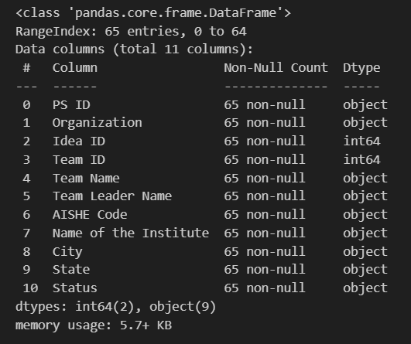

INFERENCE:

* Total Number of Teams selected through Wildcard are: 65 Teams

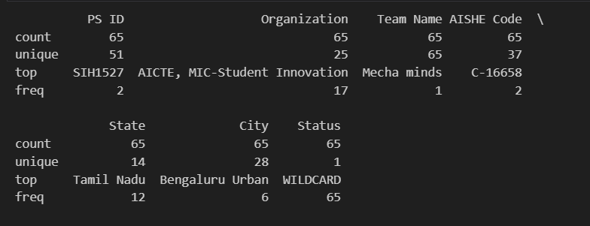

INFERENCE:

* Total Number of Problem Statement ID represented in the Wildcard are: 51
* Total Number of States represented in the Wildcard are: 14
* Total Number of Cities represented in the Wildcard are: 28
* Total Number of Colleges represented in the Wildcard are: 37
* Total Number of Organization represented in the Wildcard are: 25

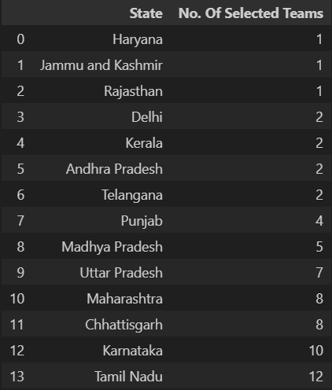

INFERENCE:

* State with the maximum number of Teams Selected through WIldcard is Tamil Nadu with 12 Teams selected.
* States with the minimum number of Teams Selected are Haryana , Jammu & Kashmir and Rajisthan with only 1 Team selected.
* Top 5 States(On the basis of Team Selected through Wildcard)

1. Tamil Nadu with 12 teams selected.
2. Karnataka with 10 teams selected.
3. Chhattisgarh and Maharashtra with 8 teams selected.
4. Uttar Pradesh with 7 teams selected.
5. Madhya Pradesh with 5 teams selected.

* DISTRIBUTION OF STATES

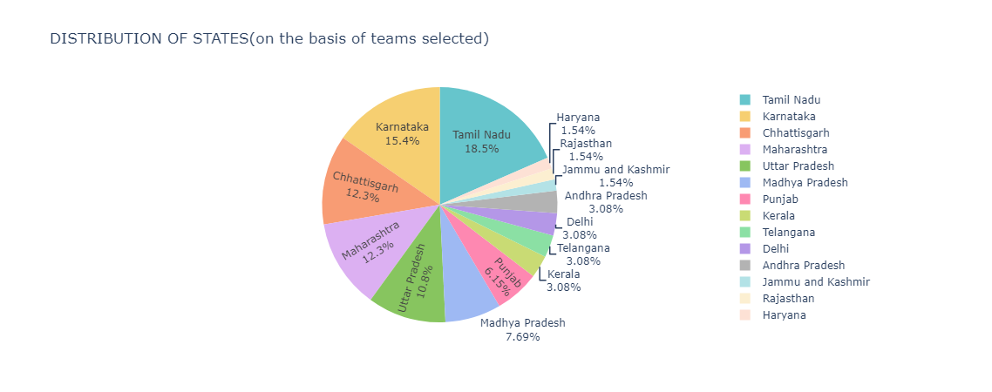

* DISTRIBUTION OF TOP 3 CITIES FOR STATES(With Max. No. Of Selections)
* 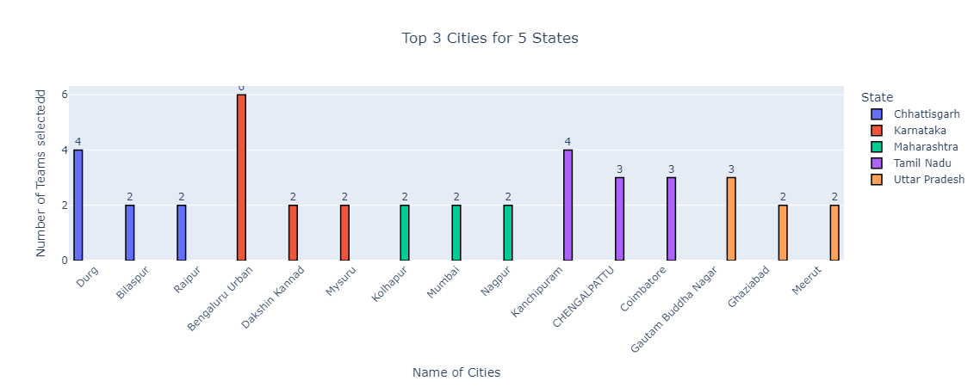

INFERENCE:

* In Tamil Nadu

1. Kanchipuram has 4 No. of Teams Selected.
2. CHENGALPATTU has 3 No. of Teams Selected.
3. Coimbatore has 3 No. of Teams Selected.

* In Chattisgarh

1. Durg has 4 No. of Teams Selected.
2. Bilaspur has 2 No. of Teams Selected.
3. Raipur has 2 No. of Teams Selected.

* In Maharashtra

1. Kolhapur has 2 No. of Teams Selected.
2. Mumbai has 2 No. of Teams Selected.
3. Nagpur has 2 No. of Teams Selected.

* In Uttar Pradesh

1. Gautam Buddha Nagar has 3No. of Teams Selected.
2. Ghaziabad has 2 No. of Teams Selected.
3. Meerut has 2 No. of Teams Selected.

* In Karnataka

1. Bengaluru Urban has 4 No. of Teams Selected.
2. Mysuru has 2 No. of Teams Selected.
3. Dakshin Kannad has 2 No. of Teams Selected.

* DISTRIBUTION OF ORGANIZATIONS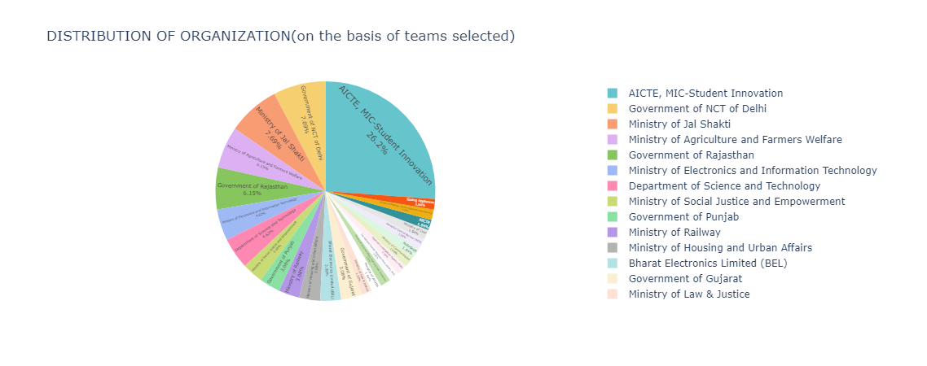

# **EDA AND VISUALIZATION OF THE PROBLEM STATEMENT DATASET**

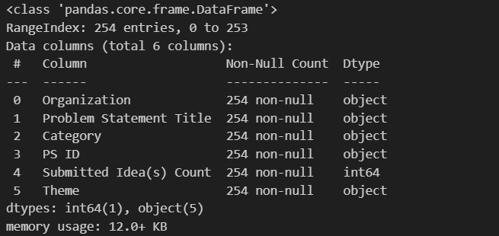

**INFERENCE:**

* Total Number of Problem Statements are: 254 PS ID’s

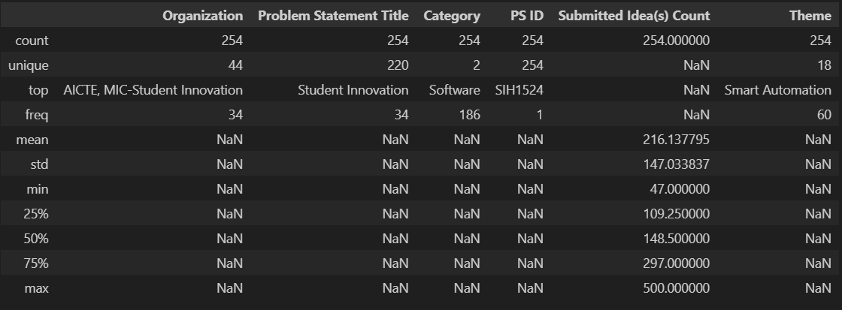

**INFERENCE:**

* Total Number of Organizations represented in the Grand Finale are: 44
* Total Number of Themes represented in the Grand Finale are: 18
* **VISUALIZATIONS THROUGH GRAPHS**
* 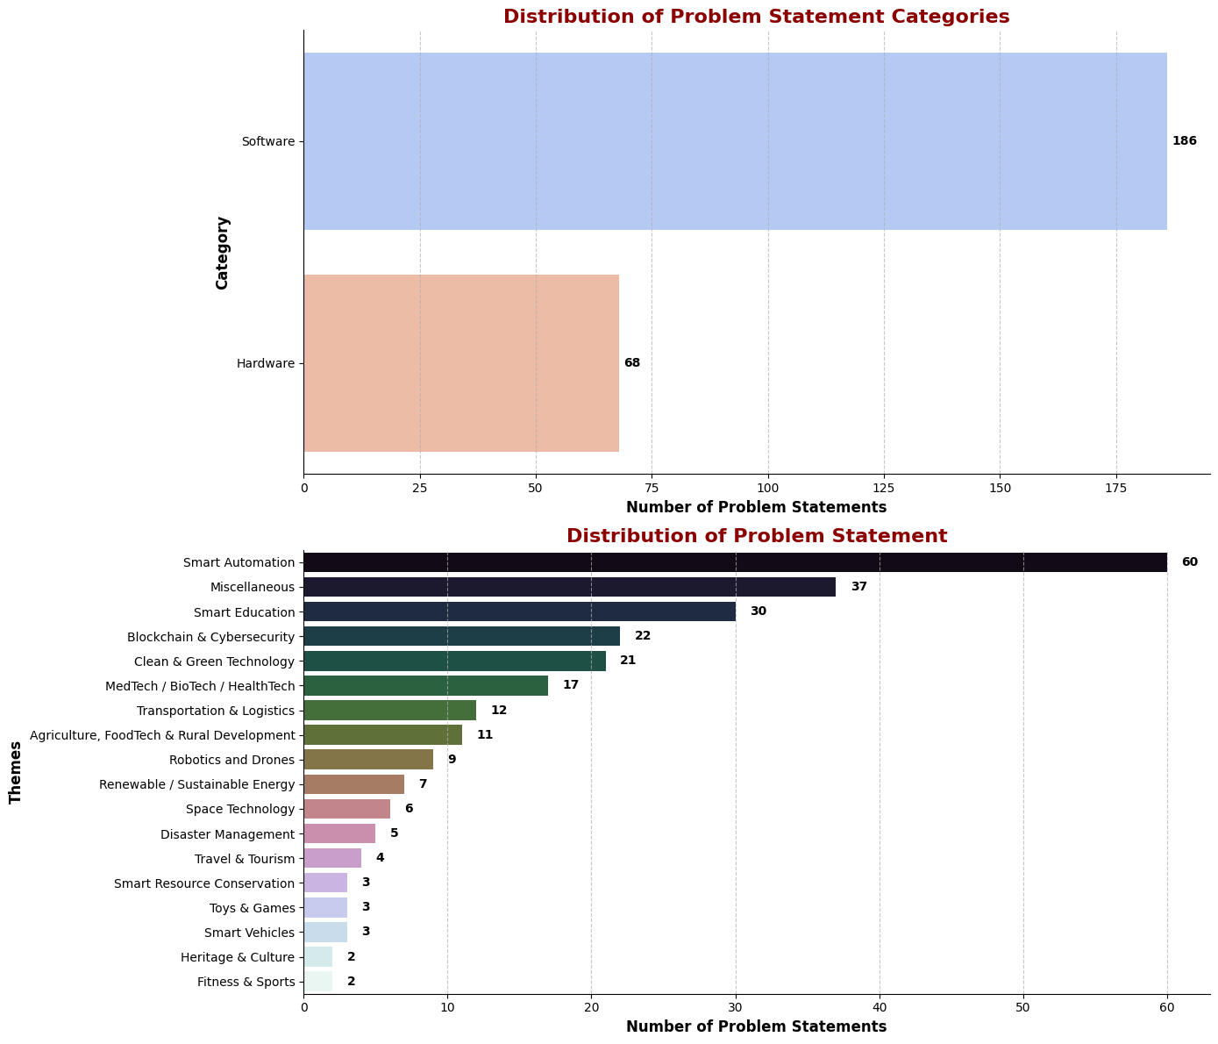

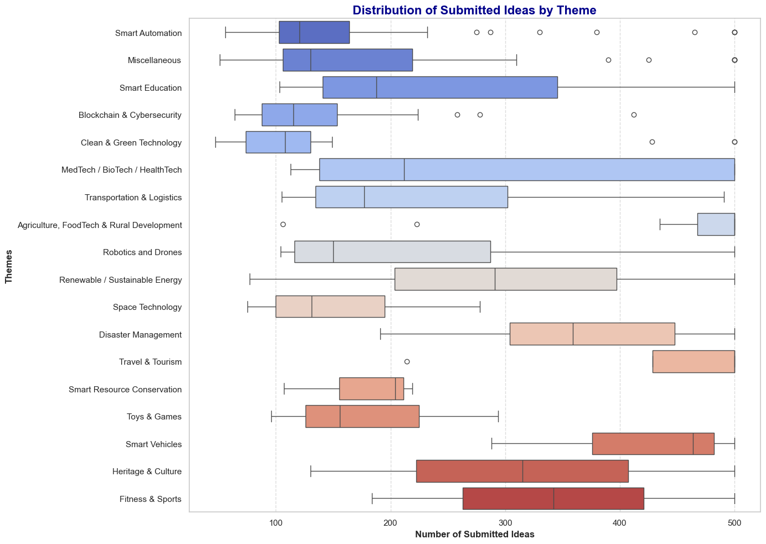

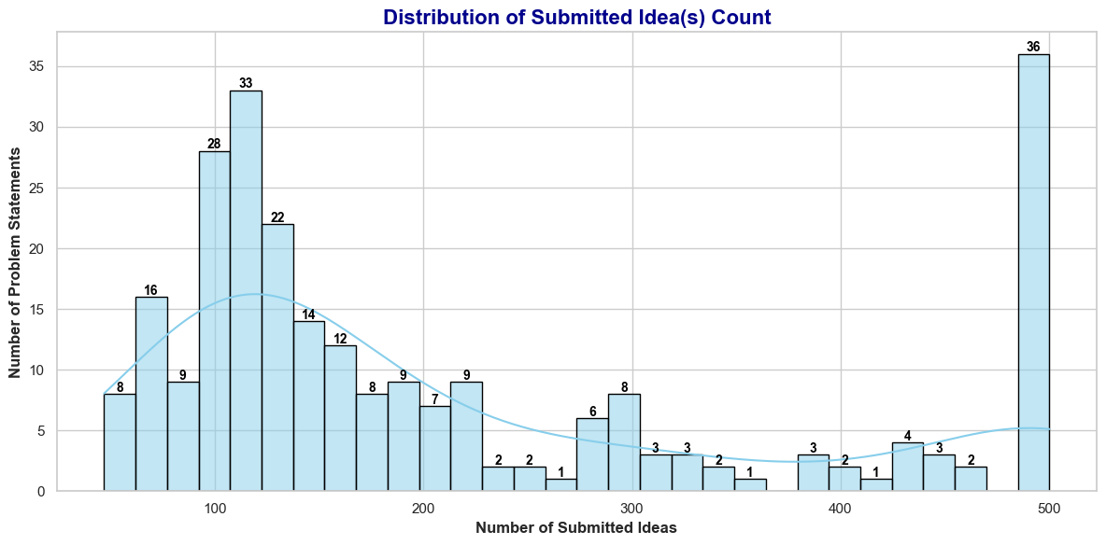

# **Visualization of the Winning Teams Dataset**

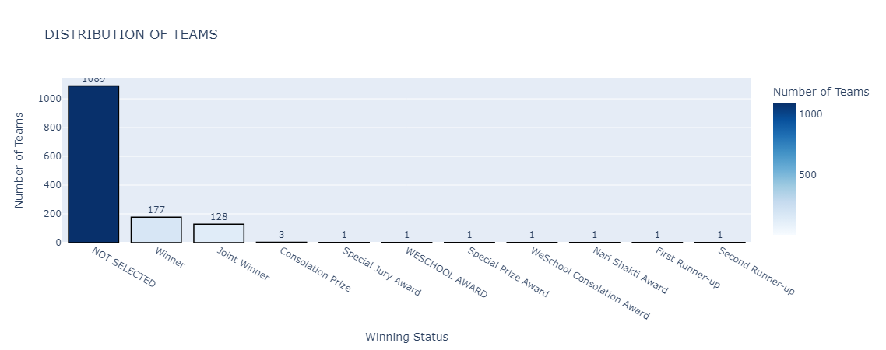

INFERENCE

* Total Number Of Teams Selected through Grand Finale are:
* Total Number Of Teams Selected through WILDCARD are:
* Total Number Of Winning Teams are: 177
* Total Number Of Joint Winner are: 128
* Total Number Of Consolation Prize are: 3
* Total Number Of Special Jury Award are 1:
* Total Number Of Weschool Award are: 1
* Total Number Of Special Prize Award are: 1
* Total Number Of Weschool Consolation Award are: 1
* Total Number Of Nari Shakti Award are: 1
* Total Number Of First-Runner Up are: 1
* Total Number Of Second-Runner Up are: 1

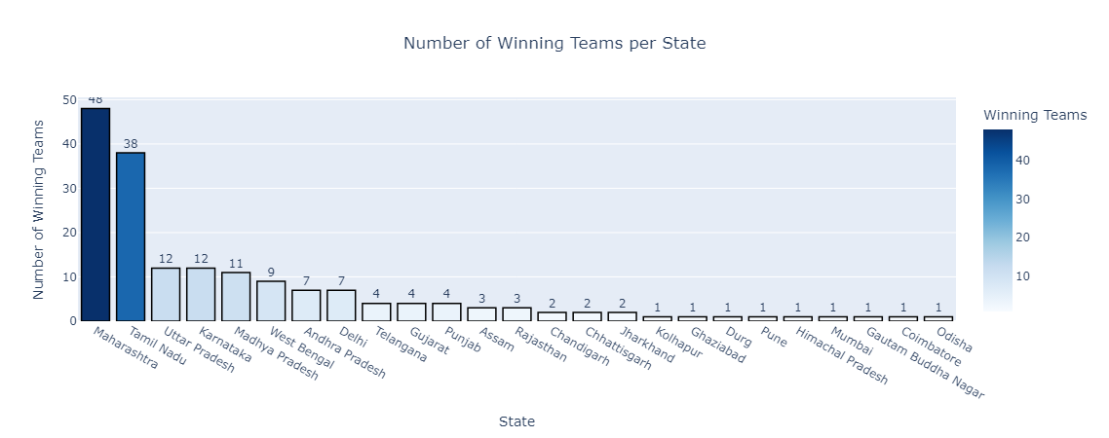

INFERENCE

* Maximum Number of Winning Teams are from Maharashtra and Tamil Nadu.
* Not more than 50 Teams have won from a single State.

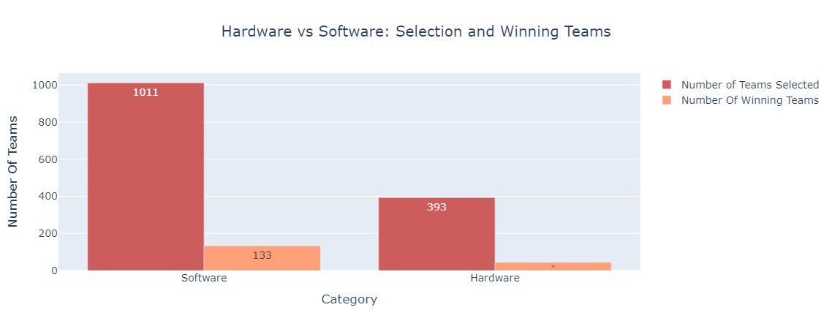]

INFERENCE

* Total Number of Teams selected in Software Category is: 1011
* Total Number of Winning Teams in Software Category is: 133
* Total Number of Teams selected in Hardware Category is: 393
* Total Number of Winning Teams in Hardware Category is: 44

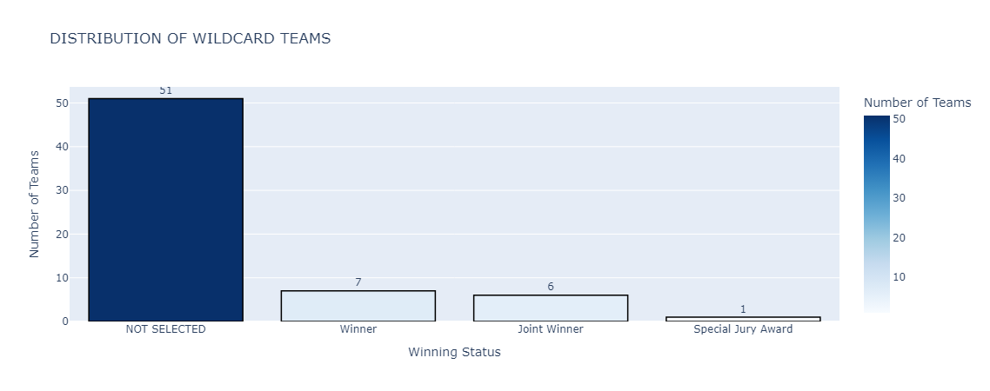

INFERENCE

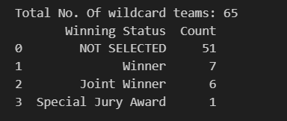

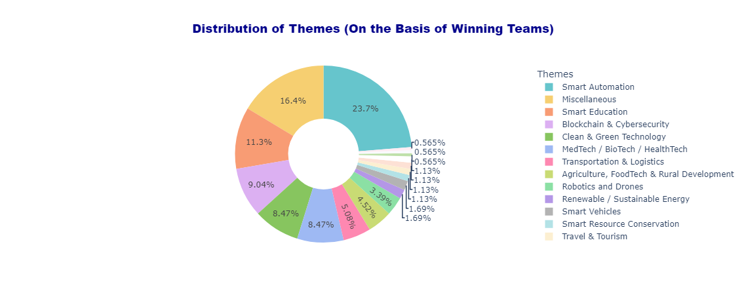

INFERENCE

* Maximum Number of Winning Teams are from Smart Automation, miscellaneous and Smart Education Theme.

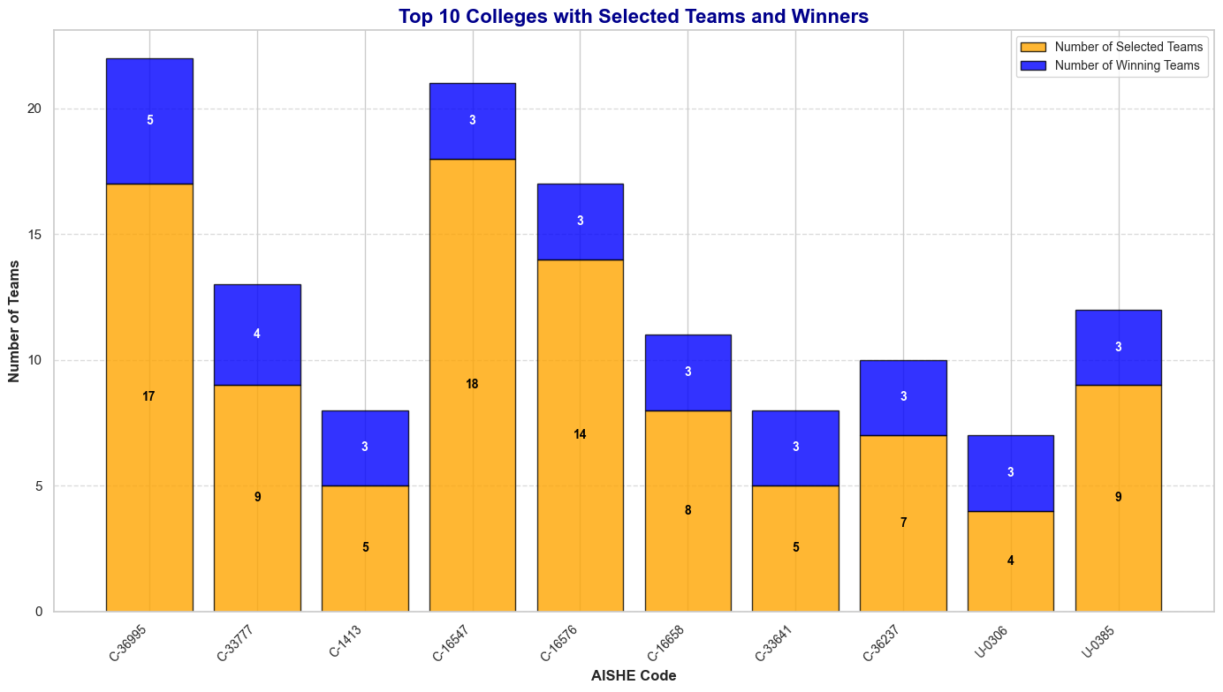

INFERENCE

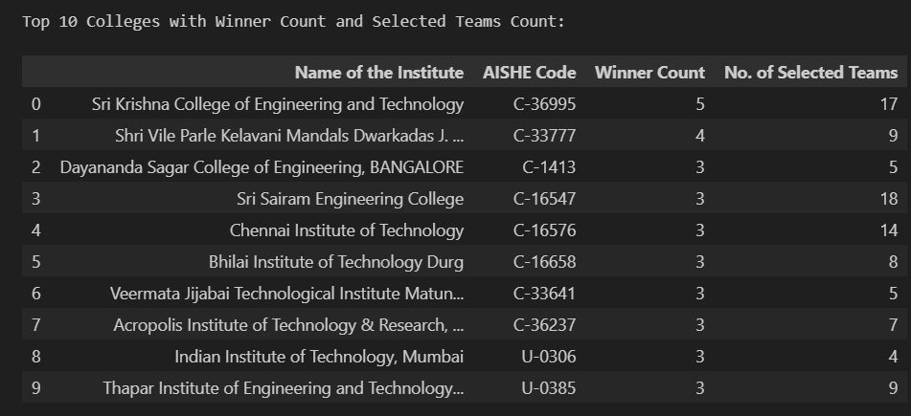

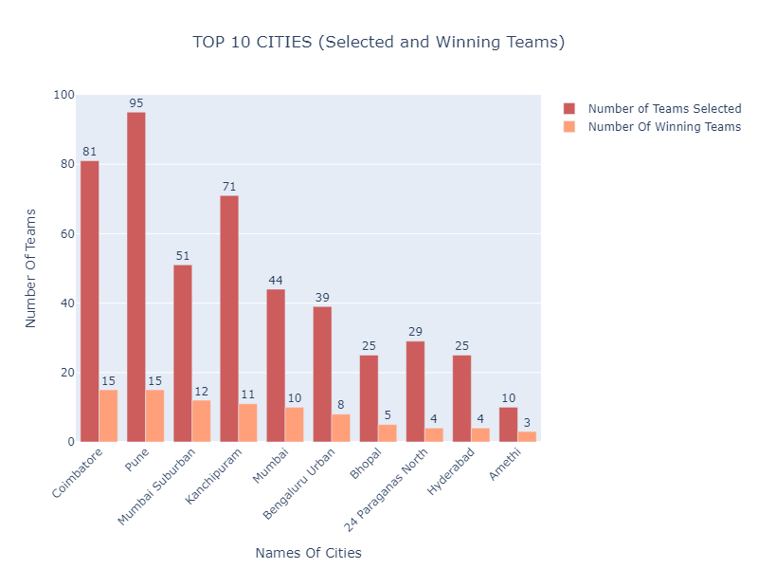

INFERENCE

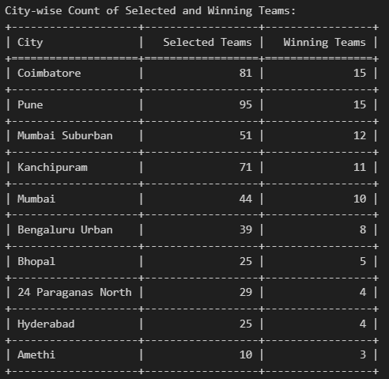

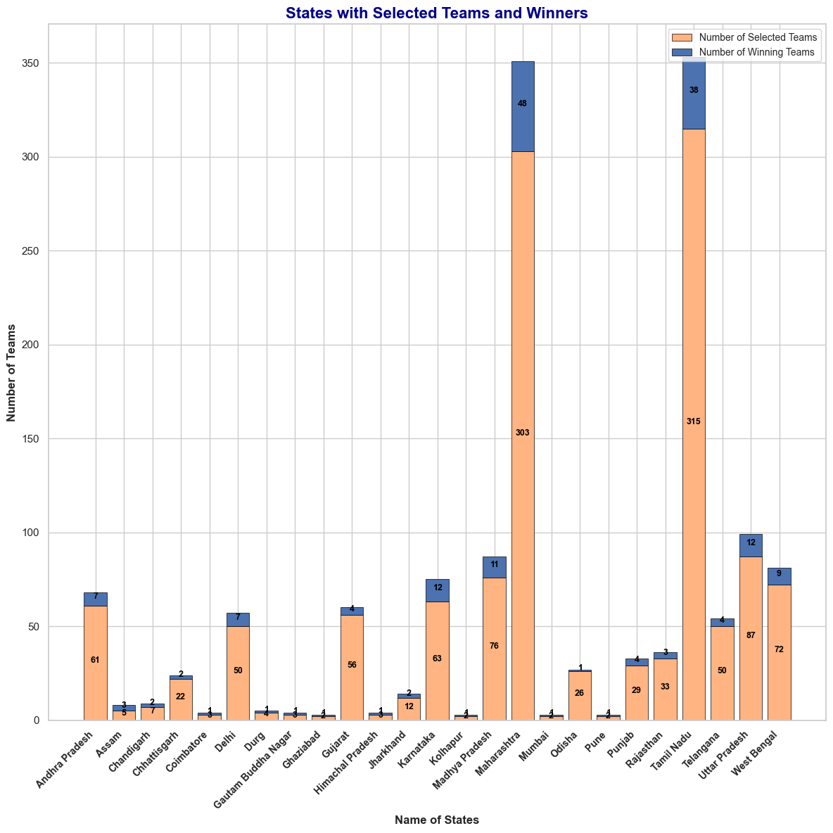

INFERENCE

