**Choosing the Right Memory IC:**

* For ***Small Non-Volatile Data Storage***:

**EEPROM**: AT24C256 (256 Kbit), easy to interface with I2C.

* For ***Larger Non-Volatile Storage:***

**Flash Memory**: W25Q64 (64 Mbit), interfaced using SPI.

* For ***Large Volatile Storage***:

**SRAM**: 23LC1024 (1 Mbit), interfaced using SPI.

* For ***Very Large Storage*** Needs:

**SD Card Module**: Supports up to several gigabytes, interfaced using SPI.

**Hardware Requirements and Connections:**

**1. External EEPROM (AT24C256)**

**Components:**

AT24C256 EEPROM

[AT24C256 Robu.com 256 Kbit](https://roboticsdna.in/product/at24c256-i2c-interface-eeprom-memory-module/?src=google&kwd=&adgroup=%7badgroup%7d&device=c&campaign=%7bcampaign%7d&adgroup=%7badgroup%7d&keyword=&matchtype=&gad_source=1&gclid=CjwKCAjwy8i0BhAkEiwAdFaeGKUgUEEAV3kYBeUwZzJo7Zm6516ksPo4N5ZMNLxrNq9T5dfIzm4-JhoCWrUQAvD_BwE) (No 1 Mbit option available)

Arduino Uno

Pull-up resistors (typically 10kΩ)

Connecting wires

Breadboard

**Wiring:**

SDA (EEPROM) -> A4 (Arduino)

SCL (EEPROM) -> A5 (Arduino)

VCC (EEPROM) -> 5V (Arduino)

GND (EEPROM) -> GND (Arduino)

WP (EEPROM) -> GND (Arduino)

Pull-up resistors between SDA and VCC, and SCL and VCC

**2. External Flash Memory (W25Q64)**

**Components:**

W25Q64 Flash Memory

[WQ25 RoboCraze.com Module 64 Mbit](https://robocraze.com/products/w25q64-norflash-storage-module-64mbit?variant=40193051951257&currency=INR&utm_medium=product_sync&utm_source=google&utm_content=sag_organic&utm_campaign=sag_organic&utm_source=google&utm_medium=cpc&utm_campaign=BL+%7C+Pmax+%7C+Feed+Only+%7C+Raspberry+Pi+Other+Categories+%7C+12%2F06&utm_source=googleads&utm_medium=ppc&utm_campaign=21377582366&utm_content=_&utm_term=&campaignid=21377582366&adgroupid=&campaign=21377582366&gad_source=1&gclid=CjwKCAjwy8i0BhAkEiwAdFaeGK2MRkuPvDXwl9BmpnfUzOz2JXTwItUGtnWs4y9eum-oJI2xqbXoDBoC3okQAvD_BwE)

[Flash Module Robu Buy link](https://robu.in/product/w25q128-large-capacity-flash-storage-module/?gad_source=1&gclid=CjwKCAjwy8i0BhAkEiwAdFaeGDraiTw3SMoxzeRkHcl5JuYFkDTctCAWoZ4u568rnnx4NEMF2gAOARoC5fMQAvD_BwE) (W25Q128 8Mbit)

Arduino Uno

Pull-up resistors (typically 10kΩ for CS, optional for other SPI lines)

Connecting wires

Breadboard

**Wiring:**

MISO (Flash) -> 12 (Arduino)

MOSI (Flash) -> 11 (Arduino)

SCK (Flash) -> 13 (Arduino)

CS (Flash) -> 10 (Arduino)

VCC (Flash) -> 3.3V (Arduino)

GND (Flash) -> GND (Arduino)

**3. External SRAM (23LC1024)**

**Components:**

23LC1024 SRAM

[23LC1024 1 Mbit Arrow Price](https://www.arrow.com/en/products/23lc1024-isn/microchip-technology)

Arduino Uno

Pull-up resistors

Connecting wires

Breadboard

**Wiring:**

MISO (SRAM) -> 12 (Arduino)

MOSI (SRAM) -> 11 (Arduino)

SCK (SRAM) -> 13 (Arduino)

CS (SRAM) -> 10 (Arduino)

VCC (SRAM) -> 5V (Arduino)

GND (SRAM) -> GND (Arduino)

**4. SD Card Module**

**Components:**

SD Card Module

[UNO Rev3 with built in SD Card Module](https://robu.in/product/original-arduino-uno-wifi-rev2/)

MicroSD Card

Arduino Uno

Connecting wires

Breadboard

**Wiring:**

MISO (SD Module) -> 12 (Arduino)

MOSI (SD Module) -> 11 (Arduino)

SCK (SD Module) -> 13 (Arduino)

CS (SD Module) -> 10 (Arduino)

VCC (SD Module) -> 5V (Arduino)

GND (SD Module) -> GND (Arduino)

**Comparison:**

Price: Flash < EEPROM < SRAM < SD_Card_Module

Storage availability: SD_Card_Module> (Flash = SRAM)> EEPROM

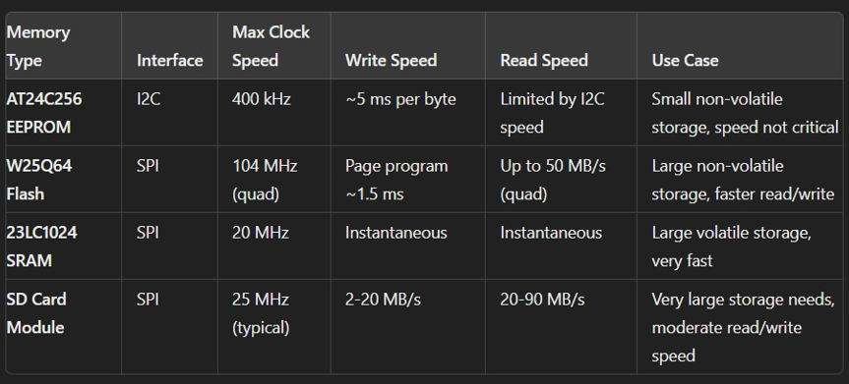

So, considering these parameters we can conclude that flash memory will be the best option as external memory.