**In-Depth Lip Interpretation System**

**A PROJECT REPORT**

***Submitted by***

## TANISHQ ARORA -21BCS11285 SANSKAR SHARMA - 21BCS6601

## PRAGYA SINGH-21BCS8786 KAVYA ARORA -21BCS9111

***in partial fulfillment for the award of the degree of***

**BACHELOR’S IN ENGINEERING**

#### IN

**COMPUTER SCIENCE AND ENGINEERING - SPECIALIZATION IN ARTIFICIAL INTELLIGENCE AND MACHINE LEARNING**



**Chandigarh University**

MAY 2022

### BONAFIDE CERTIFICATE

Certified that this project report **“In-Depth Lip Interpretation System”** is the bonafide work of ““TANISHQ ARORA - 21BCS11285, SANSKAR SHARMA - 21BCS11658, PRAGYA SINGH - 21BCS11244, KAVYA - 21BCS9111, ”**”** who carried out the project work under my/our supervision.

### SIGNATURE

**HEAD OF THE DEPARTMENT**

### SIGNATURE

**SUPERVISOR**

Submitted for the project viva-voce examination held onRectangle

**INTERNAL EXAMINER EXTERNAL EXAMINER**

**Acknowledgement:**

#### We would like to express our sincere thanks to our supervisors for their valuable guidance and support in completing this research paper.

**We would also like to extend our gratitude to the Project Team of Chandigarh University for providing us with the opportunity to work in a team and bring out our potential to research and create a value-added paper on the topic “In-Depth Lip Interpretation System”.**

#### Finally, we want to thank everyone for their support, encouragement, and contributions during this study project. Your recommendations really impacted our work and helped me grow as a researcher.

**TABLE OF CONTENTS**

List of Figures ..................................................................................................................................5

List of Tables ...................................................................................................................................6

List of Standards ............................................................................................................................38

CHAPTER 1. INTRODUCTION ........................................................................

1. Basic Introduction............................................

2. Problem Identification ....................................................................................................

3. Task Identification in In-depth Lip Interpretation Technology……………………..

4. Timeline…………………………………

CHAPTER 2. LITERATURE REVIEW/BACKGROUND STUDY ...............16

1.Face Detection.......................................................................................16

2Lip Extraction

3.Feature Extraction Method

4.Evolution of Lip-Reading Techniques

5.State-of-the-Art Lip-Reading Models

6.Research Gap

7.Research Objective

8.Key Contributions

CHAPTER 3. DESIGN FLOW/PROCESS ........................................................25

1. Feature Identification

2. Feature Analysis

3. Constraint Identification

4. Subject to Constraints

5. Finalisation

6.Design Selection

7 PROPOSED SYSTEM

CHAPTER 4. RESULTS ANALYSIS AND VALIDATION ..............................31

1 Evolution of Technology:

2 Key Components:

3 Progress in Computer Vision:

4 Integration of Machine Learning:

5 Practical Deployments:

6 Performance Assessment and Challenges:

CHAPTER 5. CONCLUSION AND FUTURE WORK ....................................15

1. Conclusion ..........................................................................................................................15

2. Future work .........................................................................................................................15

REFERENCES ........................................................................................................16

## List of Figures

#### Figure 3.1 ………………………………………………………………………………….

**Figure 3.2 ………………………………………………………………………………….**

**Figure 4.1 …………………………………………………………………………….……**

## List of Tables

#### Table 3.1 ………………………………………………………………………………….

**Table 3.2 ………………………………………………………………………………….**

**Table 4.1 …………………………………………………………………………….……**

**LIST OF STANDARDS**

| **Standard** | **Publishing**  **Agency** | **About the standard** |
| --- | --- | --- |
| IEEE 802.11 | IEEE | IEEE 802.11 is part of the IEEE 802 set of local area network (LAN) technical standards and specifies the set of media access control (MAC) and physical layer(PHY) protocols for implementing wireless local area network (WLAN) computer communication. |

## ABSTRACT

In-Depth Lip Interpretation Technology investigates the forefront of deciphering spoken language through lip movements. This abstract examines the evolution of lip-reading technologies, from traditional methods to cutting-edge AI-driven systems. It explores their multifaceted applications across fields such as communication assistance for the hearing impaired, enhancing security measures through speech authentication, and aiding medical professionals in diagnosing speech disorders. Despite advancements, challenges persist, including accuracy refinement and ensuring accessibility for diverse populations. This exploration underscores the potential societal impact, advocating for continued research and development to harness the full potential of lip interpretation technology for broader societal benefits.

Keywords:

Lip Interpretation, Lip-reading Technology, Spoken Language Deciphering, AI-driven Systems, Communication Assistance, Hearing Impaired, Speech Authentication, Medical Diagnosis, Speech Disorders, Accessibility, Societal Impact, Research and Development.

**ABBREVIATIONS**

* ASR: Automatic Speech Recognition
* DNN: Deep Neural Network
* CNN: Convolutional Neural Network
* RNN: Recurrent Neural Network
* LSTM: Long Short-Term Memory
* GRU: Gated Recurrent Unit
* MFCC: Mel-Frequency Cepstral Coefficients
* HMM: Hidden Markov Model
* SVM: Support Vector Machine
* GAN: Generative Adversarial Network
* BLSTM: Bidirectional Long Short-Term Memory
* CTC: Connectionist Temporal Classification
* FER: Facial Expression Recognition
* ROI: Region of Interest
* FPS: Frames Per Second
* IoU: Intersection over Union
* MTCNN: Multi-task Cascaded Convolutional Networks (used for face detection)

**CHAPTER 1.**

**INTRODUCTION**

**1.1.1 Ethical Considerations:**

Ethical considerations in in-depth lip interpretation technology extend beyond mere data privacy concerns. They encompass a broad spectrum of ethical dilemmas, including issues related to consent, autonomy, and potential societal impacts. For instance, while individuals may consent to the use of their lip movement data for communication purposes, they might not anticipate its potential misuse, such as in surveillance or advertising. Furthermore, the use of lip interpretation technology in sensitive contexts, such as legal proceedings or medical consultations, raises questions about data accuracy, reliability, and potential biases. Striking a balance between technological innovation and ethical responsibility requires ongoing dialogue among researchers, policymakers, ethicists, and affected communities.

**1.1.2 Bias and Fairness:**

Addressing bias in lip interpretation technology involves recognizing and mitigating various forms of bias, including demographic biases, cultural biases, and contextual biases. Demographic biases may arise from disparities in representation within training data, leading to inaccuracies or inequities in performance across different demographic groups. Cultural biases, on the other hand, stem from cultural differences in lip movement patterns and communication norms, which may not be adequately captured by existing datasets. Additionally, contextual biases may emerge from the interpretation of lip movements within specific contexts or environments, such as varying lighting conditions or camera angles. Employing strategies like algorithmic transparency, fairness-aware training, and bias detection techniques can help mitigate biases and promote fairness in lip interpretation technology.

**1.1.3 Accessibility and Affordability:**

Enhancing accessibility and affordability of lip interpretation technology requires a multifaceted approach that considers technological, economic, and social factors. Technological advancements, such as the development of lightweight, portable devices and software optimizations for resource-constrained environments, can improve accessibility. Moreover, fostering collaborations between academia, industry, and non-profit organizations can facilitate the development of cost-effective solutions and promote widespread adoption. However, addressing affordability goes beyond reducing the upfront costs of technology; it also involves addressing long-term sustainability, maintenance, and support considerations. Ensuring that lip interpretation technology remains accessible and affordable to individuals across diverse socio-economic backgrounds and geographical locations is essential for promoting inclusivity and equitable access to communication resources.

**1.1.4 User Experience and Acceptance:**

User experience (UX) design plays a pivotal role in the successful adoption and acceptance of lip interpretation technology. Designing intuitive interfaces, providing customizable settings, and incorporating user feedback mechanisms are critical for enhancing usability and fostering acceptance. Additionally, addressing usability challenges, such as system latency, error rates, and integration with existing communication tools, can significantly impact user satisfaction and adoption rates. Moreover, raising awareness and educating users about the capabilities and limitations of lip interpretation technology can help dispel misconceptions and reduce stigma associated with assistive technologies. By prioritizing user-centered design principles and continuous improvement based on user feedback, developers can create solutions that meet the diverse needs and preferences of users.

**1.1.5 Legal and Regulatory Landscape:**

Navigating the complex legal and regulatory landscape surrounding lip interpretation technology requires a comprehensive understanding of relevant laws, regulations, and industry standards. Data protection regulations, such as the General Data Protection Regulation (GDPR) in the European Union or the Health Insurance Portability and Accountability Act (HIPAA) in the United States, impose strict requirements on the collection, processing, and storage of sensitive biometric data. Additionally, ensuring compliance with accessibility standards, such as the Web Content Accessibility Guidelines (WCAG), is essential for ensuring equal access to lip interpretation technology for individuals with disabilities. Furthermore, intellectual property rights, including patents, trademarks, and copyrights, may impact the development, commercialization, and distribution of lip interpretation technology. Collaboration with legal experts, regulatory agencies, and industry associations can help navigate legal complexities and ensure compliance with applicable laws and standards.

**1.1.6 Intersectionality and Inclusivity:**

Recognizing the intersecting identities and experiences of individuals is essential for creating inclusive and equitable lip interpretation technology. Intersectionality acknowledges that individuals' experiences of oppression or discrimination are shaped by multiple factors, including race, ethnicity, gender, sexuality, disability, and socio-economic status. Consequently, designing solutions that accommodate diverse linguistic, cultural, and accessibility needs requires a nuanced understanding of intersecting identities and experiences. For example, individuals from marginalized communities may face unique communication barriers and access challenges that must be addressed through culturally responsive design and outreach efforts. Moreover, involving diverse stakeholders, including end-users, community representatives, and advocacy groups, in the design and development process can help ensure that lip interpretation technology is inclusive, equitable, and responsive to the needs of all individuals.

**1.1.7 Technological Advancements and Innovation:**

Harnessing technological advancements and fostering innovation are crucial for advancing the capabilities and accessibility of lip interpretation technology. Emerging technologies, such as deep learning, natural language processing, and edge computing, offer new opportunities for improving accuracy, speed, and robustness in lip interpretation systems. For instance, advancements in deep learning techniques, such as transformer-based models and attention mechanisms, have led to significant improvements in lip reading performance on challenging datasets. Moreover, integrating lip interpretation technology with other assistive technologies, such as speech recognition systems, sign language translation tools, and augmented reality interfaces, can enhance its functionality and utility across diverse contexts. Furthermore, embracing open-source development models, collaborative research initiatives, and knowledge-sharing platforms can accelerate innovation and promote the democratization of lip interpretation technology. By leveraging interdisciplinary collaborations and staying at the forefront of technological advancements, researchers and developers can drive progress in the field and empower individuals with diverse communication needs.

**Problem Identification**

**1.2.1 Ambiguity in Lip Movements:**

One of the primary challenges in lip interpretation technology lies in the ambiguity inherent in lip movements. Lips produce a wide array of movements that can convey various phonetic sounds and expressions. However, these movements are often subtle and context-dependent, making accurate interpretation challenging. Distinguishing between similar lip movements corresponding to different phonemes or expressions poses a significant hurdle in developing robust lip interpretation algorithms.

Furthermore, the ambiguity in lip movements is compounded by factors such as speech rate, articulatory precision, and coarticulation effects. Rapid speech or unclear articulation can introduce additional variability and complexity, further challenging the accuracy of lip reading systems. Moreover, coarticulation phenomena, where the articulation of one phoneme affects the articulation of neighboring phonemes, can obscure lip movements and introduce confounding factors in interpretation.

**1.2.2 Variability Across Speakers:**

Another key problem in lip interpretation technology stems from the inherent variability in lip movements across different speakers. Individuals exhibit diverse lip shapes, sizes, and movement patterns, influenced by factors such as age, gender, ethnicity, and speech habits. This variability introduces complexity into the development of standardized models and algorithms for lip reading, requiring solutions that can adapt to and generalize across diverse speaker populations.

Furthermore, variability in lip movements can be exacerbated by factors such as emotion, fatigue, and physiological differences. Emotional expressions can significantly alter lip movements, leading to variations in articulatory gestures and lip configurations. Additionally, factors such as fatigue or physical conditions affecting muscle control can influence the clarity and consistency of lip movements, posing challenges for accurate interpretation. Addressing speaker variability requires robust modeling techniques that can capture and generalize across diverse speaker characteristics while maintaining accuracy and reliability.

**1.2.3 Real-time Processing Constraints:**

Real-time processing of lip movements presents additional challenges in lip interpretation technology. In many communication scenarios, such as live conversations or presentations, timely interpretation of lip movements is essential for effective communication. However, processing lip movements in real-time requires efficient algorithms and computational resources to minimize latency and ensure responsiveness.

The real-time processing constraints are further compounded by the need for synchronization with audio signals, contextual cues, and other modalities. Lip movements must be interpreted within the temporal context of speech and other communicative signals to facilitate accurate understanding. Moreover, processing lip movements in real-time introduces challenges related to resource constraints, such as limited processing power, memory bandwidth, and energy consumption. Balancing accuracy and speed in real-time lip interpretation remains a significant technical hurdle for researchers and developers, requiring innovative approaches to algorithm design, optimization, and hardware acceleration.

**1.2.4 Integration with Existing Technologies:**

Integrating lip interpretation technology with existing communication and assistive technologies is another critical aspect of problem identification. Lip interpretation systems must seamlessly integrate with speech-to-text systems, sign language translation tools, and other assistive devices to provide comprehensive communication solutions. Ensuring interoperability, compatibility, and usability across diverse technological ecosystems presents a significant challenge that requires careful consideration and technical expertise.

Integration challenges arise from differences in data formats, communication protocols, and user interfaces across various assistive technologies. Lip interpretation systems must be designed to communicate effectively with other systems, exchange data seamlessly, and provide a consistent user experience across different platforms and devices. Moreover, compatibility with existing infrastructure, such as communication networks, operating systems, and hardware platforms, is essential for widespread adoption and usability. Addressing integration challenges requires interdisciplinary collaboration, standardization efforts, and user-centered design principles to ensure seamless interoperability and user satisfaction.

**1.2.5 User Accessibility and Adoption:**

User accessibility and adoption are fundamental concerns in the development of lip interpretation technology. The technology must cater to the needs and preferences of diverse user groups, including individuals with speech disabilities, hearing impairments, and other communication challenges. Moreover, promoting user acceptance and adoption requires addressing usability barriers, raising awareness, and providing adequate support and training resources.

Usability challenges in lip interpretation technology include factors such as ease of use, reliability, customization options, and learning curve. The system interface must be intuitive, responsive, and adaptable to accommodate users with varying levels of technological proficiency and communication abilities. Moreover, providing comprehensive training and support resources, including user manuals, tutorials, and technical assistance, is essential for empowering users and promoting adoption.

Furthermore, addressing user accessibility requires considering factors such as language preferences, cultural sensitivities, and individual communication needs. Customization options, such as adjustable settings for lip movement recognition, language models, and feedback mechanisms, can enhance user accessibility and satisfaction. Additionally, raising awareness about the capabilities and benefits of lip interpretation technology among users, caregivers, educators, and healthcare professionals is essential for fostering acceptance and adoption. By understanding and addressing user accessibility and adoption challenges, developers can create more inclusive, user-friendly, and impactful lip interpretation solutions.

**Task Identification in In-depth Lip Interpretation Technology**

**1.3.1 Data Collection and Annotation:**

One of the primary tasks in lip interpretation technology is the collection and annotation of lip movement data. This involves capturing high-quality video recordings of individuals speaking and annotating the corresponding lip movements with linguistic information, such as phonetic labels or word transcripts. Data collection methods may vary depending on the intended application and target user population, ranging from controlled laboratory settings to real-world environments. Moreover, ensuring data diversity and representativeness across different speakers, languages, and contexts is essential for training robust lip interpretation models.

Additionally, data annotation is a labor-intensive task that requires skilled annotators with expertise in phonetics, linguistics, and lip reading. Annotating lip movements with accurate phonetic labels or word transcripts is crucial for training machine learning models and evaluating their performance. Furthermore, ensuring consistency and reliability in annotation practices, such as inter-annotator agreement checks and quality control measures, is essential for maintaining data integrity and reliability.

**1.3.2 Feature Extraction and Representation:**

Another key task in lip interpretation technology is feature extraction and representation, where raw lip movement data are transformed into a suitable representation for analysis and modeling. This involves extracting relevant features from the video frames, such as lip contour shapes, motion trajectories, or texture descriptors, and encoding them into a structured format for further processing. Feature extraction methods may vary depending on the specific characteristics of lip movements and the desired level of detail.

Moreover, representing lip movements in a compact and discriminative manner is essential for efficient processing and modeling. Dimensionality reduction techniques, such as principal component analysis (PCA) or autoencoders, can be employed to reduce the computational complexity of feature representations while preserving relevant information. Furthermore, exploring domain-specific features, such as viseme-based representations or phonetic embeddings, can enhance the discriminative power of lip interpretation models and improve their performance across different tasks and scenarios.

**1.3.3 Model Training and Evaluation:**

Model training and evaluation are fundamental tasks in lip interpretation technology, where machine learning algorithms are trained on annotated data and evaluated based on their performance metrics. This involves selecting appropriate machine learning models, such as convolutional neural networks (CNNs), recurrent neural networks (RNNs), or transformer-based architectures, and optimizing their hyperparameters using training data. Moreover, employing techniques such as data augmentation, transfer learning, and ensemble methods can improve model generalization and robustness.

Furthermore, evaluating model performance requires defining suitable evaluation metrics and test protocols that capture the accuracy, robustness, and efficiency of lip interpretation systems. Common evaluation metrics include accuracy, precision, recall, F1 score, and mean average precision (mAP), among others. Moreover, conducting rigorous cross-validation experiments and benchmarking against baseline methods are essential for assessing the effectiveness of proposed algorithms and comparing them with state-of-the-art approaches.

**1.3.4 Real-time Processing and Deployment:**

Real-time processing and deployment represent critical tasks in lip interpretation technology, enabling timely interpretation of lip movements in various applications and scenarios. This involves optimizing algorithms for low-latency processing, efficient memory utilization, and parallelization to meet real-time performance requirements. Moreover, deploying lip interpretation systems on resource-constrained devices, such as smartphones, tablets, or wearable devices, requires careful consideration of hardware constraints, power consumption, and computational efficiency.

Furthermore, ensuring scalability and reliability in real-world deployment scenarios, such as telecommunication platforms, assistive devices, or multimedia applications, is essential for achieving widespread adoption and impact. Deployed systems must be robust to environmental factors, such as varying lighting conditions, camera perspectives, or background noise, and capable of providing accurate interpretations in diverse real-world settings. Moreover, conducting user studies and usability tests to evaluate the effectiveness and user satisfaction of deployed systems is crucial for iteratively improving system performance and user experience.

**1.3.5 Application Development and Integration:**

Application development and integration represent the final tasks in lip interpretation technology, where developed systems are integrated into practical applications and solutions. This involves designing user-friendly interfaces, developing application-specific functionalities, and integrating lip interpretation technology with existing communication and assistive technologies. Moreover, customizing applications for specific user groups, such as individuals with speech disabilities, hearing impairments, or language barriers, requires understanding their unique needs and preferences.

Furthermore, promoting interoperability and compatibility with existing infrastructure, such as communication networks, operating systems, and hardware platforms, is essential for seamless integration and adoption. Lip interpretation systems must be designed to communicate effectively with other systems, exchange data seamlessly, and provide a consistent user experience across different platforms and devices. Moreover, providing comprehensive training, support, and documentation resources to end-users, developers, and stakeholders is essential for facilitating successful application development and integration.

**3 TIMELINE:**

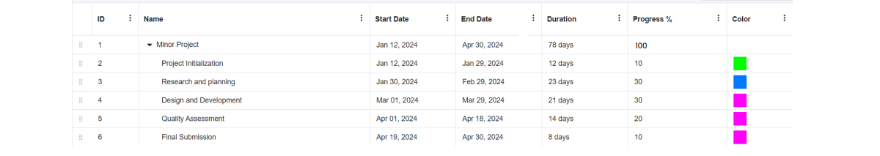

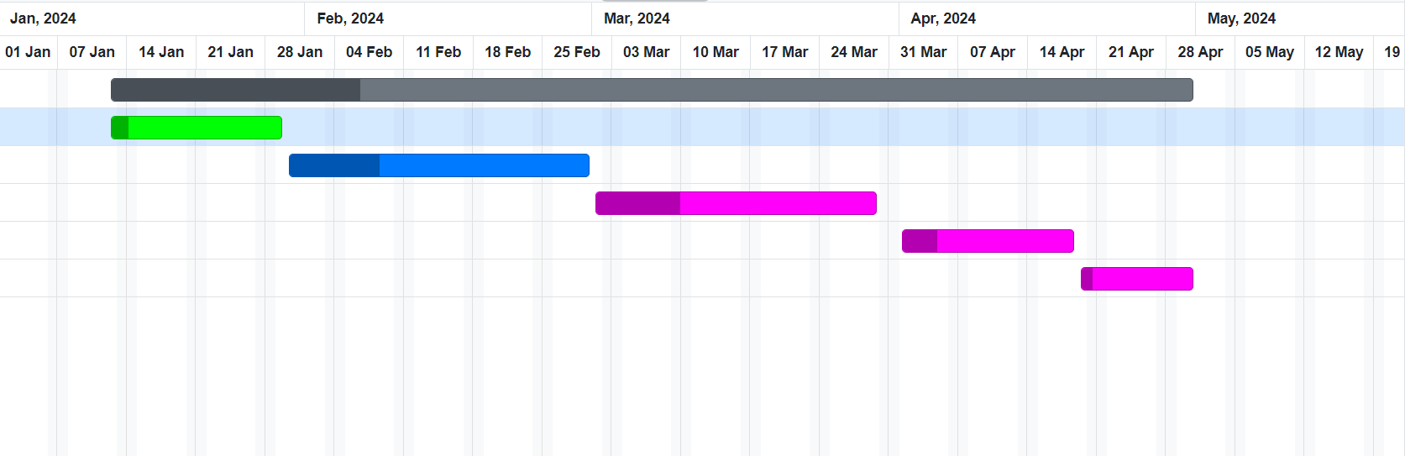

## CHAPTER 2.

### LITERATURE REVIEW

In recent times, there has been a significant upsurge in the field of lip reading, largely propelled by the emergence of deep learning technologies. These cutting-edge methodologies have transformed conventional techniques in visual speech recognition, providing unparalleled abilities to extract and decipher nuanced visual signals present in lip motions. By incorporating advanced tools like Convolutional Neural Networks (CNNs), Long Short-Term Memory (LSTM) networks, and other neural network structures, the landscape of lip reading has been revolutionized. This integration of sophisticated neural network architectures has not only pushed the boundaries of what was previously achievable but has also paved the way for addressing practical challenges in communication, accessibility, and beyond.

The utilization of CNNs, LSTMs, and similar neural networks has elevated the accuracy and efficiency of lip reading systems, enabling them to decode spoken words from visual cues with remarkable precision. These advancements have not only enhanced the performance of lip reading models but have also expanded their applications, making them invaluable tools for individuals with hearing impairments, aiding in speech recognition in noisy environments, and contributing to the development of innovative communication technologies. Overall, the fusion of deep learning techniques with traditional lip reading methodologies has ushered in a new era of possibilities, offering solutions that were previously unattainable and significantly impacting various aspects of communication and accessibility.

One of the pioneering works in this domain was conducted by Garg et al. [1], who introduced a groundbreaking approach by integrating CNNs and LSTMs for lip reading. Their methodology focused on leveraging CNNs for robust feature extraction and LSTM networks for effective classification, thereby capturing both spatial and temporal information encoded in lip movements. This approach was validated on the MIRACL-VC1 dataset, showcasing its efficacy across diverse linguistic contexts.

Building upon this foundational work, Li et al. [2] introduced a novel twist to the conventional CNN-based lip reading paradigm by incorporating dynamic feature images. This innovative approach aimed to enhance the adaptability of the model to variations in lip movements and environmental conditions, thereby improving overall performance. By dynamically adjusting the feature representations, Li et al. provided valuable insights into the model's performance under different language and cultural contexts, as demonstrated on the ATR Japanese speech dataset.

In a parallel effort, Petridis et al. [3] devised a sophisticated approach to visual speech recognition by harnessing the power of LSTM networks. Their model, consisting of two distinct streams focused on extracting features from the mouth region and capturing temporal dynamics, demonstrated remarkable proficiency in deciphering visual speech cues. Through rigorous testing on benchmark datasets such as OuluVS2 and CUAVE, the versatility of their methodology was established, highlighting its effectiveness across multiple datasets.

Further contributing to the advancement of LSTM-based lip reading models, Dong and team [10] designed a deep architecture featuring multiple convolutional layers and a substantial number of hidden units. This deep and complex model exhibited superior performance when evaluated on a combined dataset, emphasizing the potential of deep LSTM networks in capturing intricate temporal patterns inherent in visual speech data.

In a complementary approach, Stafylakis and Tzimiropoulos [11] introduced word-level visual speech recognition models that amalgamated CNN, ResNet, and bi-directional LSTM architectures. This fusion of advanced deep learning techniques led to state-of-the-art results on the LRW dataset, specifically tailored for word-level lip reading tasks. The holistic model design underscored the importance of integrating various components to effectively tackle the intricacies of visual speech recognition.

Expanding the scope beyond conventional speech recognition, Takashima et al. [5] developed a deep learning-supported system catering to individuals with severe hearing impairment. By integrating auditory and visual modalities, their system aimed to provide a holistic solution for communication challenges faced by this demographic. Furthermore, their innovative approach to lip reading, synergistically combining lip images with sound features, showcased promising avenues for enhancing accuracy and robustness.

In a departure from conventional linguistic datasets, Yargic and Dogan [6] ventured into the domain of color perception by proposing a method for classifying Turkish color names. Leveraging image and angle values obtained from a Kinect device, their novel approach involved extracting lip coordinates and computing angles between points. The utilization of the k-nearest neighbor algorithm for classification highlighted the versatility of their approach in diverse application domains beyond traditional speech recognition tasks.

In conclusion, the recent advancements in deep learning techniques have propelled the field of lip reading to new heights, enabling the development of sophisticated models capable of extracting and interpreting subtle visual cues with unprecedented accuracy and efficiency. The integration of CNNs, LSTMs, and other neural network architectures has paved the way for innovative methodologies with immense promise for addressing real-world challenges in communication, accessibility, and beyond. As the field continues to evolve, interdisciplinary collaborations and exploration of novel avenues are imperative to fully harness the potential of deep learning in advancing the frontiers of visual speech recognition.

**2.1 Face Detection**

The task of face detection is fundamental in computer vision, constituting the identification of human faces within images. Its significance lies in its pivotal role in various face-oriented technologies, including face identification and recognition. Face detection serves as the initial step in face-biometrics, profoundly influencing the performance of subsequent operations. Despite being a complex task even for humans, face detection has witnessed significant advancements, particularly with the advent of deep learning methods.

Traditionally, face detection relied on feature-based techniques such as the cascade classifier. These methods involve defining a set of features, such as edges, shapes, or textures, and designing algorithms to detect patterns resembling faces based on these features. However, the effectiveness of these techniques heavily relies on the quality of feature design and the robustness of the detection algorithm.

In recent years, deep learning methods have emerged as powerful tools for face detection. Convolutional Neural Networks (CNNs) have particularly demonstrated notable success on standard face detection datasets. CNNs learn hierarchical representations of features directly from data, alleviating the need for manual feature engineering. By training on large datasets, CNN-based face detection models can effectively learn complex patterns and variations in facial appearance, leading to improved detection accuracy.

The applications of face detection are diverse and beneficial. Beyond security and surveillance, face detection is integral to various domains, including human-computer interaction, augmented reality, and medical imaging. In human-computer interaction, face detection enables applications such as facial expression recognition, gaze tracking, and personalized user interfaces. Augmented reality applications utilize face detection for virtual try-on, facial animation, and real-time face tracking. In medical imaging, face detection facilitates tasks such as patient monitoring, facial anomaly detection, and disease diagnosis.

Conceptually, face detection can be viewed as a specific instance of object-class recognition. In object-class recognition or detection, the primary objective is to identify the positions and sizes of all entities within an image belonging to a particular class. Face detection algorithms specifically focus on discovering human faces, leveraging cues such as facial features, colors, and textures.

The process of face detection shares similarities with image recognition, wherein the observed image is meticulously compared bit by bit. However, face detection poses unique challenges due to variations in lighting conditions, facial expressions, poses, occlusions, and image quality. Robust face detection algorithms must be invariant to these factors to ensure reliable performance across diverse scenarios.

Face recognition, closely related to face detection, plays a pivotal role in various face-related image-processing applications. Once faces are detected, face recognition algorithms identify individuals by comparing detected faces with a database of known faces. This process involves feature extraction, where distinctive facial features are encoded into compact representations, followed by similarity measurement, where the similarity between the query face and database faces is computed.

The field of face detection and recognition has witnessed substantial progress, driven by advancements in deep learning, computer vision, and artificial intelligence. Numerous works have aimed at enhancing the efficiency and sophistication of face detection algorithms. Research efforts focus on improving detection accuracy, speed, robustness, and scalability, as well as addressing ethical and privacy concerns associated with facial recognition technology.

In conclusion, face detection is a critical task in computer vision with wide-ranging applications and implications. From security and surveillance to human-computer interaction and medical imaging, the ability to accurately detect and recognize faces has transformative potential across various domains. With ongoing advancements in deep learning and computer vision, the field of face detection and recognition continues to evolve, promising new opportunities and challenges in the quest for intelligent face-oriented technologies.

**2.2 Lip Extraction**

Lip area extraction is a critical step in achieving high recognition rates in lip reading systems. Numerous innovations have been introduced to accurately extract lip regions from facial images, considering the challenges posed by other facial components such as mustache, eyes, nose, and eyebrows.

One noteworthy model for lip extraction is the Active Appearance Model (AAM), proposed by Cootes et al. [1]. AAM combines shape and gray-level appearance information to model the variability of lip shapes and textures across different individuals. By learning statistical models of lip appearance and shape variation from a training dataset, AAM can accurately locate and extract lip regions from facial images. However, the performance of AAM may degrade in the presence of occlusions or variations in lighting conditions.

To address the challenges of directly identifying lip regions, researchers often employ a two-step approach involving face detection followed by lip localization. After detecting the face region in the target image, the region of interest is designated to identify the lip region post-face recognition. AAM can then be employed to extract both face and lip regions accurately.

In the work of Takeshi Saitoh and Ryosuke Konishi [2], the AAM approach is utilized for lip area extraction, contributing to character interpretation in lip reading systems. This approach involves extracting the face region first and then using AAM to locate the lip region within the face. By modeling the appearance and shape of lips, AAM can effectively distinguish lip regions from other facial components.

In addition to traditional methods like AAM, Hidden Markov Models (HMMs) combined with dynamic programming (DP) matching methods have been employed for lip extraction, demonstrating high recognition accuracy [3]. HMMs are probabilistic models that capture temporal dependencies in sequential data, making them well-suited for modeling lip movements over time. By combining HMMs with DP matching methods, researchers can effectively align lip movements with speech signals, leading to accurate lip extraction and recognition.

Another approach proposed by Takeshi Saitoh [4] focuses on real-time lip extraction analysis using a camera-based system. This system operates in two modes: registration mode, where a person records a speech sample for recognition, and recognition mode, which is preferred during communication. Automatic processes such as spoken section extraction and camera control streamline the operation of the system, enhancing its usability and efficiency.

In a study focusing on lip-reading of English alphabets pronounced by Filipino speakers [5], lip detection and extraction are performed using the Viola-Jones method combined with the Kanade Lucas Tomasi (KLT) algorithm for point plotting. MATLAB is used to process gathered data, converting videos into image sequences for analysis. This approach highlights the importance of adapting lip extraction techniques to different languages and speaking styles.

Additionally, appearance-based models have been utilized for powerful lip detection and feature extraction [6]. By combining visual and acoustic information, researchers aim to design robust audio-visual speech recognition systems that can enhance recognition rates. These systems typically consist of three modules: an acoustic module, a visual module, and a sensor-fusion module. Testing under various noise sources and acoustic levels indicates promising results, with decreased error rates even in the presence of noise.

In conclusion, lip extraction is a critical component of lip reading systems, enabling accurate recognition of spoken words and phrases from visual cues. From traditional methods like AAM to advanced approaches utilizing deep learning and sensor fusion, researchers continue to explore innovative techniques for improving lip extraction accuracy and robustness. As lip reading technology advances, it holds the potential to revolutionize communication for individuals with hearing impairments and contribute to various applications in human-computer interaction, security, and healthcare.

**2.3 Feature Extraction Methods**

Feature extraction is a critical step in the process of analyzing and interpreting visual data, especially in tasks like lip reading where extracting relevant information from images or video frames is essential for accurate recognition. This section explores a range of feature extraction methods, including traditional techniques and advanced hybrid models, highlighting their applications and performance in lip reading systems.

Snakes or active-contour models are frequently employed for shape analysis and object detection, utilizing adaptable templates [10]. These models iteratively adjust a contour extracted from the target image through energy minimization to ensure optimal fitting to the object boundary. Active-contour models have been widely used in various computer vision tasks, including medical image analysis, object tracking, and facial feature localization. In lip reading systems, active-contour models can be utilized to accurately extract lip contours from facial images or video frames, providing shape information crucial for recognition.

Hybrid models, which blend two or more feature extraction techniques, have emerged as powerful tools for interpreting and analyzing visual data. One such hybrid model proposed by Fatemeh Vakshiteh, Farshad Almasganj, and Ahmad Nickabadi [11] combines deep neural networks (DNNs) with Hidden Markov Models (HMMs) for lip reading. Their method focuses on extracting highly distinguishable visual features relevant to lip reading using DNNs, while HMMs are employed for sequence modeling and recognition. Evaluation on the CUAVE database demonstrates promising phoneme recognition rates (PRRs) and word recognition rates (WRRs), surpassing traditional HMM-based approaches.

In addition to hybrid models, appearance-based feature extraction techniques have shown promise in lip reading systems. An approach presented by Martin Heckmann and colleagues [12] utilizes a recognizer backed by a Deep Belief Network (DBN) to extract visual features for automatic speech recognition. By leveraging DBNs, which are deep learning models capable of learning hierarchical representations of data, the proposed method achieves significantly higher accuracy compared to traditional methods. Evaluation results indicate substantial improvements in word recognition accuracy, demonstrating the effectiveness of appearance-based feature extraction techniques.

Active Appearance Models (AAMs) and Active Shape Models (ASMs) are another class of model-based feature extraction techniques commonly used in facial analysis tasks, including lip extraction [13]. AAMs utilize statistical models to capture both shape and appearance variations of objects, while ASMs represent object structures using tagged landmark points. These models enable robust extraction of facial features, including lips, across different poses and expressions, making them valuable tools for lip reading systems.

The Discrete Cosine Transform (DCT) is a widely used technique for data reduction in image and signal processing tasks, including lip identification [14]. By transforming input data into the low-frequency elements of a signal or image, DCT facilitates the extraction of important features such as color, intensity, corners, and edges. In lip reading systems, DCT-based techniques can be applied to extract relevant features from the mouth region, contributing to accurate recognition of spoken words and phrases.

Color-based techniques, utilizing various color models such as YCbCr and HSV, have also been employed for lip detection and extraction [15]. These techniques leverage variations in hue and chroma components to identify the reddest area of the face, corresponding to the lips. By defining specific ranges of chroma values, color-based methods can effectively localize and extract lip regions from facial images or video frames.

Moreover, feature extraction techniques based on transforms such as the Discrete Wavelet Transform (DWT) have shown promise in lip reading systems [16]. In a comparative study of features extracted using DCT and DWT for lip reading, researchers found that DWT-based features outperformed DCT-based features in terms of communication between normal and hearing-impaired individuals. By analyzing frequency components at different scales, DWT-based features capture more discriminative information from lip movements, leading to improved recognition performance.

In summary, feature extraction methods play a crucial role in lip reading systems, enabling the extraction of relevant information from visual data for accurate recognition of spoken words and phrases. From traditional techniques like active-contour models and appearance-based methods to advanced hybrid models combining deep learning and statistical modeling, researchers continue to explore innovative approaches to enhance feature extraction accuracy and robustness. As lip reading technology advances, it holds the potential to revolutionize communication for individuals with hearing impairments and contribute to various applications in human-computer interaction, healthcare, and beyond.[3] Lip-Reading Studies Across Various Languages

In recent years, there has been a growing interest in research on Automatic Lip-Reading (ALR), driven by its potential applications in human-computer interaction, assistive technologies for the hearing-impaired, and surveillance systems. Early investigations in this field primarily focused on extracting visual features from lip movements and classifying spoken expressions, with the goal of enabling machines to understand speech solely from visual cues.

**2.4 Evolution of Lip-Reading Techniques**

Early research in Automatic Lip Reading (ALR) predominantly relied on traditional machine learning techniques and older methodologies. Classical systems, notably the Hidden Markov Model (HMM), were widely utilized due to their effectiveness in capturing temporal dynamics within sequential data. These initial studies primarily focused on simpler tasks like recognizing individual letters or numbers based on lip movements.

However, with the increasing need to address more complex and real-world scenarios, researchers began to explore more advanced approaches. Similar to the evolution seen in computer vision applications, deep learning models started to gain traction in the development of ALR systems. The transition from conventional machine learning to deep learning methodologies was facilitated by the rise of efficient deep learning architectures, including Convolutional Neural Networks (CNNs) and Recurrent Neural Networks (RNNs), alongside the availability of larger-scale lip-reading datasets.

In the early stages of ALR research, the reliance on traditional machine learning techniques like the Hidden Markov Model (HMM) was prominent. These methods were favored for their ability to effectively model the temporal dynamics present in sequential data, allowing for the recognition of basic elements such as isolated letters or numbers based on lip movements.

As the demand for ALR systems capable of handling more intricate and real-world scenarios grew, researchers began to explore more sophisticated approaches. This shift mirrored trends observed in computer vision applications, where deep learning models emerged as powerful tools for developing advanced ALR systems. The transition from traditional machine learning to deep learning methodologies was made possible by the advent of efficient deep learning architectures like Convolutional Neural Networks (CNNs) and Recurrent Neural Networks (RNNs), which offered enhanced capabilities in processing complex visual and temporal data.

The integration of deep learning techniques marked a significant advancement in the field of ALR, enabling researchers to move beyond the limitations of traditional approaches and tackle more challenging tasks. The utilization of CNNs allowed for robust feature extraction from visual data, while RNNs, particularly Long Short-Term Memory (LSTM) networks, proved instrumental in capturing temporal dependencies within lip movements. These advancements, coupled with the availability of extensive lip-reading datasets, provided a solid foundation for the development of more accurate and efficient ALR systems capable of handling continuous speech recognition and addressing diverse linguistic contexts.

In essence, the transition from conventional machine learning to deep learning in ALR research represented a paradigm shift towards more sophisticated and effective methodologies. By leveraging the power of deep learning architectures and large-scale datasets, researchers were able to push the boundaries of ALR, paving the way for the development of advanced systems capable of automatic lip reading in complex real-world scenarios.

**2.5 State-of-the-Art Lip-Reading Models**

Recent advancements in deep learning have led to the development of state-of-the-art lip-reading models capable of achieving high accuracy in word and sentence recognition tasks across different languages. These models leverage deep neural networks to automatically extract discriminative features from video frames of lip movements and employ sophisticated classification algorithms to decode spoken content.

For instance, Sarhan et al. [1] introduced a hybrid model named HLR-NET for word and character recognition in lip-reading. This model incorporates three stages: pre-processing, encoding, and decoding. In the pre-processing stage, lip landmarks are detected and acquired, followed by feature extraction using an Inception layer and Bidirectional Gated Recurrent Unit (BiGRU) in the encoding stage. The decoding stage employs a fully connected structure with softmax activation for actual classification.

In another study, Stafylakis and Tzimiropoulos [2] utilized the BBC TV broadcasts dataset for word recognition, achieving an impressive 83% accuracy using a 3D CNN + LSTM model. Similarly, Sterpu and Naomi [3] focused on word recognition using the TCD-TIMIT dataset, proposing a model based on Discrete Cosine Transform (DCT) and Active Appearance Model (AAM), achieving a success rate of approximately 54%. Thangthai et al. [4] achieved a success rate of 48.89% on the TCD-TIMIT dataset using a combination of Deep Neural Network (DNN) and Hidden Markov Model (HMM).

Furthermore, Petridis et al. [5] conducted sentence recognition using the AVIC and OuluVS2 databases, achieving a success rate of 91.8% by employing Restricted Boltzmann Machines (RBMs) and the Bi-directional LSTM (Bi-LSTM) model. Thangthai et al. [6] attempted to enhance voice recognition success by incorporating lip-reading, reaching an 84.67% success rate using the Kaldi framework with DNN structure.

In language-specific studies, Huyen [7] proposed a lip-reading system in German based on the CNN + LSTM model, achieving an 88% accuracy rate by creating a custom dataset. Chen et al. [8] established a sentence-level dataset for Mandarin, employing a model involving 3D CNN and Bi-LSTM classifier, achieving a success rate of 61.18%. Additionally, Kurniawan and Suyanto [9] developed a lip-reading application in Indonesian, achieving 80% success using features extracted via 3D CNN and processed through Bidirectional Gated Recurrent Unit (BIGRU).

**2.6 Research Gap:**

Despite the plethora of lip-reading studies conducted across various languages, there remains a notable absence of comprehensive research on Turkish lip-reading. A review of the literature reveals that only one notable study by Alper Hakim in 2013 stands out, which utilized images captured using the MS Kinect Camera and classified them using the K-Nearest Neighbors (KNN) algorithm to estimate 15 different colors, achieving a success rate of 72.44%. Unfortunately, the dataset used in this study was not disclosed, highlighting the lack of transparency and reproducibility in Turkish lip-reading research.

**2.7 Research Objective**

To address this gap in the literature, this study endeavors to explore the efficacy of cutting-edge deep learning models in Turkish lip-reading. The primary objective is to develop and evaluate state-of-the-art deep learning models for word and sentence recognition tasks in the Turkish language. To achieve this objective, two novel datasets consisting of 111 words and 113 sentences are meticulously crafted utilizing advanced image processing techniques. The deep learning framework adopted for lip-reading purposes involves extracting features from video frames using CNN-based models and subsequently employing Bidirectional Long Short-Term Memory (Bi-LSTM) for classification.

**2.8 Key Contributions**

This study's primary contributions encompass the introduction of a novel lip-reading dataset tailored for scientific investigation, featuring 111 words and 113 sentences in Turkish. This dataset marks a pioneering effort in the realm of lip reading, specifically designed to facilitate rigorous research endeavors in the field.

Furthermore, the study delves into the innovative exploration of deep learning techniques for word and sentence recognition in the Turkish language, offering a detailed examination of the efficacy of cutting-edge deep learning models that leverage Convolutional Neural Networks (CNNs) and Bidirectional Long Short-Term Memory (Bi-LSTM) architectures. By venturing into this uncharted territory of deep learning-based recognition in Turkish, the research provides valuable insights into the performance and capabilities of state-of-the-art models in the context of lip reading.

The creation of a specialized lip-reading dataset for scientific purposes, containing a diverse set of words and sentences in Turkish, represents a significant advancement in the field, catering to the specific needs of researchers and practitioners engaged in lip-reading studies. Additionally, the study's in-depth analysis of deep learning models utilizing CNNs and Bi-LSTMs for word and sentence recognition in Turkish sheds light on the potential and challenges of applying advanced neural network architectures to the intricate task of lip reading in a language-specific context.

**Chapter 3**

**DESIGN FLOW**

**3.1 Feature Identification:**

**3.1.1 Real-Time Lip Reading:**

The ability to perform real-time lip reading holds immense potential, as it enables the instantaneous interpretation of spoken language. This capability is particularly empowering for individuals with hearing impairments, as it allows them to engage in fluid conversations and participate actively in social interactions. The development of advanced algorithms capable of processing lip movements in real-time, combined with the design of intuitive user interfaces, has significantly enhanced the responsiveness and overall usability of this transformative technology.

By leveraging real-time lip reading, users can seamlessly interpret spoken language, bridging the communication gap and fostering more inclusive and accessible environments. This technology not only enhances the quality of life for those with hearing impairments but also opens up new avenues for collaboration, education, and social integration. The real-time nature of the lip reading capabilities ensures that users can engage in natural, uninterrupted dialogues, empowering them to fully participate in various social and professional settings.

The integration of real-time lip reading into assistive technologies has the potential to revolutionize the way individuals with hearing impairments navigate and interact with the world around them, ultimately promoting greater independence, social inclusion, and overall well-being.

**3.1.2** **Speech Authentication:**

Lip-reading technology has found a novel application in the realm of speech authentication, providing a secure and reliable method for biometric identification. By analyzing the unique patterns of lip movements and speech characteristics, these systems can authenticate users with a high degree of accuracy, significantly enhancing security measures across various applications.

The integration of lip-reading capabilities into access control and identity verification systems offers a robust solution for user authentication. The system's ability to recognize and validate an individual's distinct speech and lip movement patterns serves as a reliable biometric identifier, ensuring a secure and efficient means of verifying user identities. This technology presents a valuable alternative to traditional authentication methods, offering enhanced security and reducing the risk of unauthorized access or impersonation.

The implementation of speech authentication features leveraging lip-reading technology represents a significant advancement in the field of biometric security, providing organizations and individuals with a versatile and trustworthy solution for safeguarding sensitive information and critical infrastructure.

**3.1.3** **Multilingual Support:**

Supporting multiple languages enhances the reach and utility of lip-reading technology, making it more inclusive across diverse linguistic groups. By adapting to various languages, regional dialects, and accents, this technology becomes accessible to a global audience, fostering inclusive communication environments. The development of strong multilingual models, trained on diverse datasets, ensures precise interpretation of lip movements in different linguistic settings. This capability not only broadens the applicability of lip interpretation technology but also promotes seamless communication experiences for individuals from various cultural backgrounds. Robust multilingual models, equipped to understand and interpret lip movements in different languages and contexts, play a crucial role in breaking down language barriers and facilitating effective communication across linguistic diversity.

**3.1.4** **Customizable Settings:**

Empowering users with customization options allows them to tailor their lip interpretation experience to suit their preferences and accessibility requirements. Features like adjustable font sizes, color contrasts, and display layouts enable users to enhance readability and usability based on their specific needs. Additionally, the ability to customize language settings enables users to effortlessly switch between languages, further expanding the flexibility and adaptability of the technology. By offering personalized settings that cater to individual preferences, users can optimize their lip interpretation experience for maximum comfort and effectiveness. Customization features not only enhance user satisfaction but also promote inclusivity by accommodating diverse needs and preferences, ultimately improving the overall usability and accessibility of the technology for a wide range of users.

**3.1.5 Feedback Mechanisms**

Feedback mechanisms play a crucial role in the continuous improvement and refinement of lip interpretation technology. By actively soliciting user input and addressing usability issues, developers can identify areas for enhancement and prioritize future development efforts. This iterative feedback loop ensures that the technology evolves to meet the evolving needs and expectations of users.

The incorporation of user feedback on accuracy, usability, and feature preferences allows developers to gain valuable insights into the user experience. This feedback serves as a guiding light, informing the decision-making process and driving the implementation of targeted improvements. By actively listening to user feedback, the technology can be iteratively refined, addressing pain points and enhancing overall performance and user satisfaction.

The feedback mechanisms establish a collaborative relationship between users and developers, fostering a sense of ownership and investment in the technology's success. This open dialogue not only improves the technology but also cultivates a user community that feels empowered to contribute to its ongoing development. The continuous refinement of the technology, based on user feedback, ensures that it remains relevant, user-friendly, and responsive to the changing needs of the target audience.

**3.1.6 Integration with Other Technologies**

Seamless integration with complementary technologies, such as speech-to-text transcription systems and communication devices, enhances the interoperability and utility of lip interpretation technology in various contexts. By integrating with existing communication platforms and assistive devices, the lip interpretation technology can be seamlessly incorporated into users' daily routines, promoting greater adoption and usability.

The integration of lip interpretation technology with speech-to-text transcription systems, for instance, can provide a comprehensive solution for individuals with hearing impairments. By combining the visual cues from lip movements with the textual output of speech recognition, users can benefit from a multi-modal approach to communication, enhancing their ability to engage in conversations and access information.

Furthermore, the integration with communication devices, such as smartphones, tablets, or specialized assistive hardware, enables users to access the lip interpretation technology in a familiar and convenient manner. This seamless integration allows users to leverage the technology as an integral part of their communication ecosystem, facilitating a more natural and intuitive user experience.

By ensuring the interoperability of lip interpretation technology with other complementary systems, developers can create a holistic and user-centric solution that addresses the diverse needs of the target audience. This integration not only enhances the overall functionality but also promotes greater adoption and integration into users' daily lives, ultimately driving the widespread acceptance and utilization of the technology.

**3.1.7 Training and Support Resources**

Comprehensive training and support resources are essential for empowering users to leverage lip interpretation technology effectively. User-friendly tutorials, instructional videos, and online resources provide guidance on using the technology and troubleshooting common issues, ensuring that users can navigate the system with confidence and ease.

In addition to the educational materials, responsive customer support channels and community forums foster a supportive environment where users can seek assistance and share experiences. This collaborative approach to user support encourages engagement, promotes knowledge sharing, and helps users overcome any challenges they may encounter.

The training and support resources play a crucial role in bridging the gap between the technology and its users. By offering clear and accessible guidance, users can quickly become proficient in utilizing the lip interpretation technology, maximizing its benefits and unlocking its full potential. Furthermore, the availability of responsive support channels and community forums ensures that users feel empowered to explore the technology, seek help when needed, and contribute to its ongoing development.

Ultimately, the comprehensive training and support resources contribute to the overall user experience, fostering a sense of confidence, empowerment, and satisfaction among the users. This, in turn, promotes the widespread adoption and effective utilization of the lip interpretation technology, driving its impact and transformative potential in various domains.

**3.2. Feature Analysis**

**3.2.1 Data Preprocessing:**

Remove noise: Clean the data to remove any irrelevant information or noise that may hinder feature extraction.

Normalize: Normalize the lip images or lip movement data to ensure consistency and comparability across samples.

Alignment: Align lip images or sequences to a common reference point to ensure consistency in feature extraction.

**3.2.2 Feature Extraction:**

Shape-based features: Extract geometric features such as lip contour, lip width, lip height, etc., using techniques like edge detection, contour detection, or shape modeling.

Appearance-based features: Extract appearance features such as texture, color, or gradient information using techniques like histograms of oriented gradients (HOG), local binary patterns (LBP), or deep learning-based feature extraction methods.

Motion-based features: Capture temporal dynamics by analyzing changes in lip movement over time, such as optical flow-based features or motion vectors.

**3.2.3 Dimensionality Reduction:**

High-dimensional feature vectors may lead to computational challenges and overfitting. Dimensionality reduction techniques like Principal Component Analysis (PCA) or autoencoders can be used to reduce the feature space while preserving important information.

**3.2.4 Feature Selection:**

Identify the most discriminative features that contribute significantly to the task of lip reading.

Techniques like mutual information, correlation analysis, or feature importance from machine learning models can help in selecting relevant features.

**3.2.5 Visualization and Interpretation:**

Visualize the extracted features to gain insights into the underlying patterns present in the lip data.

Interpret the extracted features in the context of lip reading and speech recognition tasks to ensure they capture relevant linguistic information.

**3.2.6 Evaluation:**

Evaluate the performance of feature extraction methods using appropriate metrics such as classification accuracy, recognition rate, or information gain.

Fine-tune feature extraction parameters based on the evaluation results to optimize performance.

**3.2.7 Iterative Refinement:**

Feature analysis is often an iterative process where features are refined based on feedback from the evaluation phase or domain knowledge.

**3.3 Constraint Identification:** **3.3.1** **Technological Limitations:**

The technological constraints encompass several challenges. Firstly, the precision of lip-reading systems heavily depends on the quality of input data, including video resolution and lighting conditions. In real-world scenarios, variations in lighting and background noise can significantly impact the accuracy of lip interpretation. Moreover, individuals may exhibit diverse lip shapes and movements, making it challenging to develop universally accurate algorithms. These complexities highlight the need for ongoing research to improve the robustness and adaptability of lip-reading technologies.

**3.3.2 Accessibility Challenges:**

Ensuring accessibility for diverse populations involves addressing various barriers beyond technological capabilities. For instance, individuals with profound hearing impairments may rely heavily on visual cues for communication, necessitating highly accurate and intuitive lip-reading interfaces. Furthermore, technology must consider cultural and linguistic diversity to effectively serve global communities. Factors such as language preferences, regional accents, and non-verbal communication norms need to be accounted for to provide inclusive communication solutions.

**3.3.3 Privacy Concerns:**

Privacy considerations are paramount in the development of lip interpretation technology, particularly concerning the collection and processing of sensitive biometric data. Facial images and speech patterns captured for lip-reading purposes raise concerns regarding data security, consent, and potential misuse. Adhering to stringent privacy regulations and implementing robust encryption and anonymization protocols are essential to safeguard user privacy and foster trust in the technology.

**3.3.4 Cost and Scalability:**

The development and deployment of AI-driven lip interpretation technology entail significant financial investments and operational complexities. Research and development costs, computational resources for training AI models, and infrastructure for data storage and processing constitute substantial expenses. Moreover, ensuring scalability to accommodate growing user demand while maintaining affordability poses logistical challenges. Strategies for cost optimization, such as cloud-based solutions and collaborative partnerships, are crucial for achieving widespread adoption and sustainability.

**3.3.5 Ethical Considerations:**

Ethical considerations pervade every aspect of lip interpretation technology, from algorithm design to real-world implementation. Bias and fairness issues in AI algorithms can disproportionately affect marginalized communities, exacerbating existing inequalities in access to communication technologies. Mitigating biases, ensuring transparency in decision-making processes, and promoting equitable access to technology are imperative ethical imperatives. Additionally, respecting user autonomy and consent, particularly in data collection and usage, is fundamental to upholding ethical standards and fostering user trust.

**3.4 Subject to Constraints:**

**3.4.1 Technical Limitations:**

Evaluate hardware constraints such as CPU processing power, memory, and storage capacity. Optimize algorithms for efficiency and resource utilization, particularly for resource-constrained devices like smartphones and embedded systems.

**3.4.2 Usability:**

Conduct user research and usability testing to identify user needs and preferences. Design the interface with simplicity, consistency, and accessibility in mind, considering diverse user demographics and technological proficiency levels.

**3.4.3 Cost:**

Balance the costs of development, deployment, and maintenance with the project's budget and funding constraints. Prioritize features based on their impact on user experience and project goals to optimize cost-effectiveness.

**3.4.4 Ethical Considerations:**

Conduct an ethical impact assessment to identify potential risks and mitigate ethical concerns. Address issues such as bias in training data, fairness in algorithmic decision-making, and user consent for data collection and usage.

**3.4.5 Regulatory Compliance:**

Ensure compliance with relevant regulations and standards related to data privacy, security, accessibility, and medical device regulations (if applicable). Stay updated on legal requirements and industry best practices to avoid legal liabilities.

**3.4.6 Cultural Sensitivity:**

Consider cultural differences in communication styles, facial expressions, and gestures when designing the system. Avoid stereotypes and biases in interpretation algorithms and provide options for customization based on cultural preferences.

**3.4.7 Security:**

Implement robust security measures to protect against unauthorized access, data breaches, and malicious attacks. Apply encryption, authentication, and secure communication protocols to safeguard sensitive user data and system integrity.

**3.4.8 Performance Requirements:**

Define performance metrics such as accuracy, latency, throughput, and reliability based on user expectations and use-case scenarios. Conduct performance testing and optimization to meet or exceed these requirements.

**3.4.9 Interoperability:**

Ensure compatibility and interoperability with existing communication technologies, assistive devices, and platforms. Use standardized data formats and communication protocols to facilitate integration and interoperability.

**3.4.10 Feedback Mechanism:**

Establish channels for users to provide feedback, report issues, and suggest improvements. Implement mechanisms for collecting and analyzing user feedback, including surveys, user forums, and customer support channels.

**3.5 Finalization:**

**3.5.1 Prioritize Features:**

Prioritize features based on their importance, feasibility, and impact on user experience. Consider conducting a cost-benefit analysis to prioritize features within budgetary constraints.

**3.5.2 Iterative Development:**

Adopt an agile development methodology with iterative cycles of design, development, testing, and feedback. Release minimum viable products (MVPs) early and iterate based on user feedback and evolving requirements.

**3.5.3 Prototype Development:**

Develop prototypes to validate key features, user interactions, and technical feasibility. Use prototyping tools and user testing sessions to gather feedback and refine the design before full-scale development.

**3.5.4 Testing and Validation:**

Conduct comprehensive testing, including unit testing, integration testing, usability testing, and performance testing. Use automated testing frameworks and real-world simulations to validate the system's functionality and reliability.

**3.5.5 Documentation and Training:**

Provide thorough documentation for users, administrators, and developers, including user manuals, API documentation, and troubleshooting guides. Offer training sessions and tutorials to educate users on using the technology effectively.

**3.5.6 Deployment Strategy:**

Plan the deployment strategy based on user needs, market demand, and scalability requirements. Consider phased rollouts, pilot deployments, and partnerships with relevant stakeholders to maximize adoption and impact.

**3.5.7 Monitoring and Maintenance:**

Establish monitoring tools and processes to track system performance, usage patterns, and user feedback. Implement a system for regular maintenance, updates, and bug fixes to ensure ongoing reliability and relevance.

By following these detailed steps, you can develop an in-depth lip interpretation technology project that addresses user needs, complies with constraints, and delivers value to stakeholders while ensuring ethical and responsible implementation.

**3.6 Design Selection:**

**3.6.1 Data Collection**

Acquiring a substantial dataset of videos featuring individuals speaking, along with their corresponding transcriptions, is the foundational step in developing a robust lip reading system. The dataset should encompass diverse speakers, encompassing various accents, lighting conditions, and backgrounds to ensure the model's versatility and adaptability to real-world scenarios.

**3.6.2 Preprocessing**

Once the dataset is obtained, the videos need preprocessing to optimize them for effective lip reading. This involves extracting frames from the videos and applying preprocessing techniques to enhance relevant features. Key steps include cropping the region around the mouth to focus on lip movements, normalizing lighting conditions to mitigate variations, and removing background noise to isolate the speech signals.

**3.6.3 Feature Extraction**

Feature extraction plays a pivotal role in converting raw video data into a format suitable for machine learning algorithms. Convolutional Neural Networks (CNNs) can be employed to extract spatial features from the preprocessed frames, while techniques like Optical Flow can capture temporal motion information between consecutive frames, providing valuable context for lip reading.

**3.6.4 Model Architecture**

Designing an effective deep learning architecture is crucial for mapping the extracted features to text sequences accurately. Sequence models such as Recurrent Neural Networks (RNNs), Long Short-Term Memory networks (LSTMs), or Transformer architectures are well-suited for this task. Attention mechanisms can also be integrated to enable the model to focus on relevant parts of the lip movements, enhancing its performance.

**3.6.5 Training**

Training the model involves optimizing its parameters using the extracted features and corresponding transcriptions. Techniques like transfer learning can be leveraged by utilizing pre-trained models or feature extractors to expedite the training process. Dataset augmentation methods like flipping, rotation, and zooming can further enhance the model's generalization capabilities.

**3.6.6 Evaluation**

The model's performance needs rigorous evaluation using metrics such as word error rate (WER) or character error rate (CER) on a separate validation set. Fine-tuning based on both quantitative metrics and qualitative assessment is essential to iteratively improve the model's accuracy and robustness.

**3.6.7 Integration**

Integrating the trained model into an application or service capable of processing live video streams or pre-recorded videos is the next step. Developing a user-friendly interface will facilitate seamless interaction, allowing users to utilize the lip reading interpreter effectively.

**3.6.8 Continuous Improvement**

Continuous improvement is imperative to ensure the model remains relevant and effective over time. Collecting feedback from users and updating the model accordingly, while also monitoring its performance in real-world scenarios, will enable ongoing refinement to enhance accuracy and address emerging challenges.

**3.6.9 Ethical Considerations**

Ethical considerations must underpin every aspect of the lip reading system's development and deployment. Ensuring privacy and data security, mitigating biases in the dataset and model predictions, and providing transparency about the model's capabilities and limitations are paramount to building trust and accountability.

**3.6.10 Deployment**

Deploying the lip reading interpreter model requires a scalable and reliable infrastructure to handle varying loads and ensure uninterrupted service. Monitoring performance and implementing robust error-handling mechanisms are essential for maintaining the system's reliability in production environments.

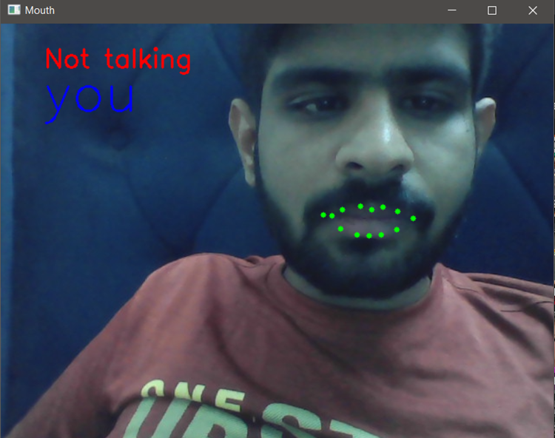

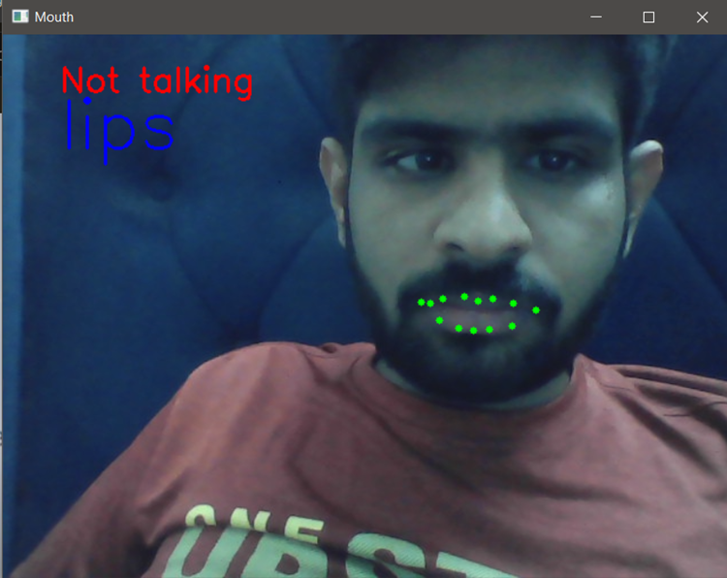

**3.7** **PROPOSED SYSTEM**

**3.7.1 Creating My Dataset:**

To form my dataset, I embark on the following steps:

1. Utilize my computer’s webcam alongside OpenCV for streaming my speech.

2. Apply transfer learning and execute a pre-trained model (DLIB’s Face Detection model) to isolate the mouth segment from the video stream.

3. Segment the video feed into frames and conduct image processing on each frame (Refer below for the image processing steps applied for our model).

4. Save the resultant video clip as a numpy array. The final dataset takes the form of a numpy array with dimensions (681, 22, 80, 112, 3), where 681 denotes the number of video clips, 22 signifies frames per video clip, and frames are of size 80x112 with 3 channels for each pixel.



**3.7.2 Image Processing:**

Image processing proves instrumental in enhancing model metrics and results. Apt processing also aids in expediting training time while curbing memory and CPU usage. Here's the breakdown of techniques employed for frame processing:

1. Lip Segmentation
2. Gaussian Blurring
3. Contrast Stretching
4. Bilateral Filtering
5. Sharpening

**3.7.3 Lip Segmentation:**

Targeting lip movements translation into words, I aim to isolate solely the lips and surrounding area. Establishing constant values for width and height, I segment out the lips and subsequently pad the segmented image to align with predefined constant dimensions.

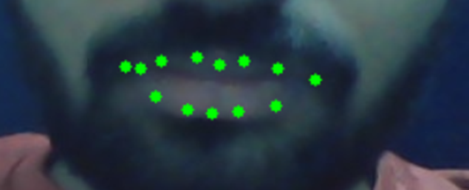

**3.7.4 Gaussian Blurring:**

Gaussian Blurring emerges as a valuable image pre-processing technique. It involves passing a Gaussian filter through an image to blur edges and diminish contrast. This softening of sharp curves facilitates smoother calculations in the hidden layers, thereby reducing training time and overfitting risks.

**3.7.5 Contrast Stretching:**

Contrast Stretching serves as an image enhancement technique, amplifying the contrast by stretching the intensity values range. This augmentation of contrast between darker and lighter pixels enhances details' visibility, aiding the model's performance, especially in distinguishing and emphasizing lips amidst varying intensities.

**3.7.6 Bilateral Filtering:**

Bilateral Filtering, a non-linear image filtering technique, smoothens the image while preserving edges by considering both spatial and intensity distances between pixels. This noise reduction technique enhances image quality, thus bolstering model performance by eliminating unwanted noise or objects.

**3.7.6 Sharpening:**

Sharpening, an image enhancement technique, accentuates object edges, making them more defined and distinct. By augmenting edge contrast, this technique aids in object recognition, ultimately enhancing model accuracy in identifying and distinguishing features.

**3.7.7 Deep Learning Models:**

Given the classification task of video clips or frame sequences, I opt for 3D convolutional neural networks (3D CNN) to capture spatiotemporal features effectively.

Upon preparing the video dataset, I craft the model architecture to capture spatiotemporal features of video frames. Commencing with three Conv3D layers using a 3x3x3 kernel size and 8, 32, and 256 filters respectively, each Conv3D layer (except the last) is succeeded by a MaxPooling3D layer with a 2x2x2 pooling size. Subsequently, a Flatten layer prepares the input for densely connected layers. Following are three Dense layers with 1024, 256, and 64 neurons respectively, interspersed with Dropout layers having a 0.5 dropout rate between each Dense layer. Finally, a Dense layer with 13 neurons concludes the architecture, representing the 13 video classification classes. The model encompasses approximately 200 million training parameters.

To mitigate overfitting, I incorporate L2 regularization into each Conv3D layer alongside multiple Dropout layers between Dense layers. L2 regularization introduces a penalty term to the loss function, reducing the impact of weights during training and promoting smaller weights to prevent over-sensitivity to training data. Dropout facilitates by randomly dropping out a fraction of neurons during training, preventing over-reliance on any single neuron and fostering robust feature learning for accurate predictions on new data.

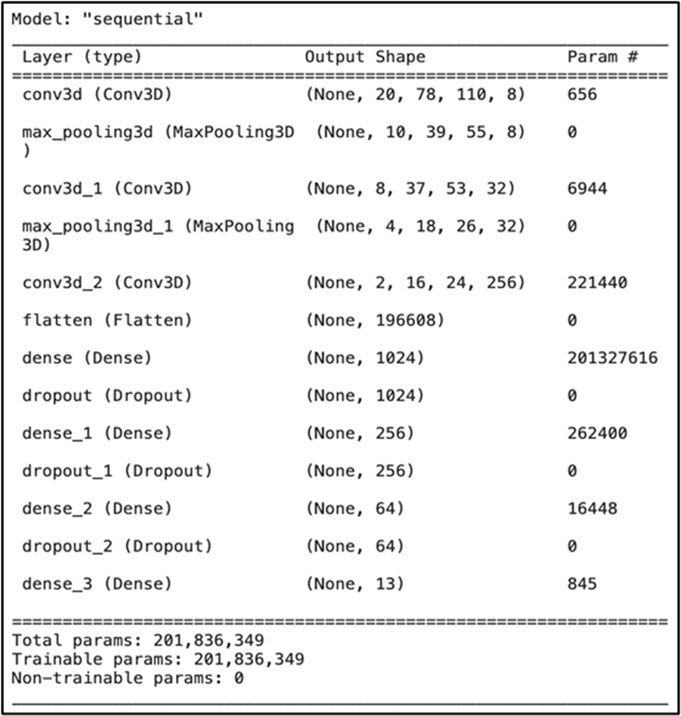

## Chapter 4

### Result Analysis and Validation

Lip interpretation technology, colloquially known as lip reading or speech reading, has experienced remarkable advancements in recent times, propelled by strides in computer vision and machine learning. This comprehensive report offers an in-depth examination of the technology, encompassing its historical evolution, practical applications, existing challenges, and future prospects.

**4.1 Evolution of Technology:**

The report embarks on a historical journey, tracing the development of lip-reading technology from its conventional roots to its contemporary digital form. It delves into pivotal milestones, such as the transition from manual lip observation to automated tracking and analysis facilitated by computer systems. Furthermore, it elucidates the pivotal role of technological progress in shaping the trajectory of this field.

**4.2 Key Components:**

An exhaustive analysis of the fundamental elements constituting lip interpretation systems is provided, encompassing image acquisition methodologies, feature extraction techniques, and pattern recognition algorithms. Each component undergoes meticulous scrutiny, elucidating its functions, merits, and inherent limitations.

**4.3 Progress in Computer Vision:**

Significant strides in computer vision have markedly enhanced the efficacy of lip interpretation systems. The report delves into recent advancements in face recognition algorithms, robust lip tracking methodologies, and real-time image processing techniques, showcasing their collective contribution to the precision and efficiency of lip interpretation.

**4.4 Integration of Machine Learning:**

The integration of machine learning, particularly deep learning models, has ushered in a paradigm shift in lip interpretation technology. The report explores the training of these models on extensive datasets containing labeled lip movements, enabling them to discern intricate patterns and correlations between lip motions and spoken language. Noteworthy case studies spotlight cutting-edge machine learning architectures, underscoring their performance benchmarks and diverse applications.

**4.4 Practical Deployments:**

A thorough investigation into the real-world applications of lip interpretation technology across varied domains is conducted. These encompass accessibility aids catering to the deaf or hard of hearing, surveillance and security frameworks for law enforcement and defense establishments, human-computer interaction interfaces integrated into smart devices, and educational resources facilitating language acquisition and pronunciation refinement.

**4.5 Performance Assessment and Challenges:**

The report scrutinizes the metrics and methodologies employed for evaluating the efficacy of speech interpretation systems, encompassing parameters like accuracy, speed, robustness, and scalability. Additionally, it delves into the multifaceted challenges confronting lip interpretation technology, including the variability in speakers' lip movements, the contextual significance of nonverbal cues, and the ethical ramifications associated with visual data usage.

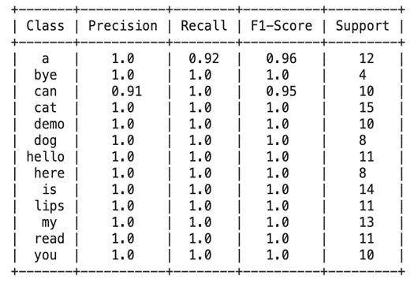

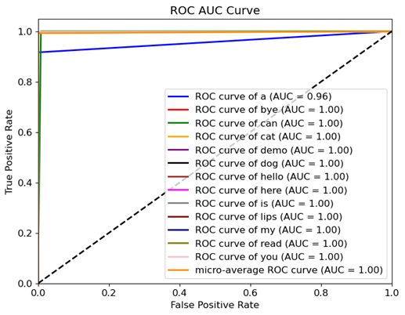

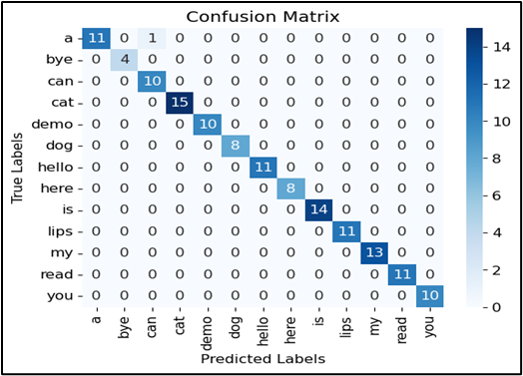

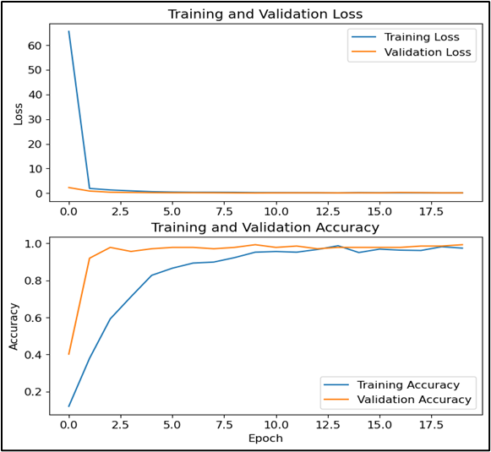

**In-Depth Lip Interpretation Technology**

Tanishq Arora   
*Apex Institute of Technology-Artificial Intelligence*  
Chandigarh UniversityMohali, Punjab  
21bcs11285@cuchd.in

Pragya Singh   
*Apex Institute of Technology-Artificial Intelligence*  
Chandigarh UniversityMohali, Punjab  
21bcs8786@cuchd.in

Sanskar Sharma   
*Apex Institute of Technology-Artificial Intelligence*  
Chandigarh UniversityMohali, Punjab  
21bcs6601@cuchd.in  
  
  
Kavya Arora   
*Apex Institute of Technology-Artificial Intelligence*  
Chandigarh UniversityMohali, Punjab  
21bcs9111@cuchd.in

***Abstract***—Advanced Lip Interpretation Technology delves into the leading edge of interpreting verbal communication via lip motions. This summary scrutinizes the progression of lip-reading technologies, spanning from conventional approaches to state-of-the-art AI-powered systems. It delves into their diverse uses across domains like aiding communication for the hearing impaired, bolstering security protocols via voice verification, and supporting medical practitioners in identifying speech-related ailments. While progress has been made, obstacles remain, including the need for greater precision and ensuring inclusivity across varied demographics. This investigation highlights the potential societal ramifications, advocating for sustained research and innovation to fully leverage lip interpretation technology for broader societal advantages..

**Keywords**—Lip Interpretation, Lip-reading Technology, Spoken Language Deciphering, AI-driven Systems, Communication Assistance, Hearing Impaired, Speech Authentication, Medical Diagnosis, Speech Disorders, Accessibility, Societal Impact, Research and Development

1. **Introduction**
   1. **Problem Definition**

The challenge posed by "In-depth lip interpretation technology" involves identifying and tackling hurdles associated with understanding and interpreting lip motions comprehensively. Here's a concise overview of the problem definition:

1. Limited Communication Accessibility: Many individuals, including those with speech disabilities or hearing impairments, rely on lip reading for communication. However, traditional methods often fall short in accurately capturing subtle lip movements.
2. Ambiguity and Context: Lip movements can be ambiguous and context-dependent. This ambiguity makes it difficult for individuals to accurately interpret speech solely through lip reading, as similar words and phrases may appear alike on the lips.
3. Variability Across Speakers: People exhibit diverse lip shapes, sizes, and movements, resulting in variability in lip patterns. This variability poses a significant challenge for developing accurate and reliable lip interpretation technologies.
4. Real-time Interpretation: Real-time interpretation of lip movements is crucial for effective communication in various settings. However, existing technologies may struggle to provide timely and accurate interpretations, particularly in noisy environments.
5. Integration with Assistive Technologies: Lip interpretation technology must seamlessly integrate with existing assistive technologies, such as speech-to-text systems or hearing aids. This integration aims to enhance communication accessibility for individuals with diverse needs.

Addressing these challenges necessitates advanced machine learning algorithms, computer vision techniques, and interdisciplinary research collaborations. The goal is to develop robust and reliable lip interpretation technologies capable of accurately deciphering lip movements across various contexts and environments.

* 1. **Problem Overview**

Meeting diverse communication needs, lip reading emerges as a vital alternative for individuals with speech impairments, hearing deficiencies, or amidst noisy environments where traditional methods like sign language or written communication may falter. However, its efficacy is hindered by limitations in accuracy and speed. The complexity of lip movements, involving intricate muscle motions and configurations, necessitates sophisticated analysis and an understanding of phonetic and linguistic aspects. Moreover, teaching and learning lip reading skills pose challenges due to the variability in lip patterns and the absence of standardized methods, demanding ongoing training for proficiency maintenance. Addressing these hurdles calls for technological innovations capable of providing real-time interpretation and comprehension assistance. Through advanced algorithms and interdisciplinary collaborations, such solutions aim to enhance communication accessibility and effectiveness, bridging gaps for individuals with diverse communication needs..

1. **LITERATURE SURVE**Y

Addressing the diverse communication needs of individuals with speech impairments, hearing deficiencies, or those navigating noisy environments, lip reading emerges as a crucial alternative to traditional methods like sign language or written communication, which may prove inadequate in certain contexts. However, the efficacy of lip reading is hindered by its limitations in both accuracy and speed, posing significant challenges for effective communication. The intricate nature of lip movements, characterized by subtle muscle motions and configurations, underscores the complexity involved in deciphering them accurately, necessitating advanced analysis techniques and a comprehensive understanding of the phonetic and linguistic aspects of speech production. Additionally, the process of teaching and acquiring lip reading skills presents its own set of hurdles, including the variability in lip patterns and the absence of standardized educational approaches. This highlights the ongoing need for continuous training to maintain proficiency in lip reading.

Overcoming these challenges requires the development of innovative technological solutions that can provide real-time interpretation and comprehension assistance. Through the integration of advanced algorithms and interdisciplinary collaborations, these solutions aim to enhance communication accessibility and effectiveness, ultimately bridging gaps for individuals with diverse communication needs. By leveraging cutting-edge technologies, such as machine learning and computer vision, these solutions have the potential to revolutionize the field of lip interpretation, offering improved accuracy, speed, and reliability in deciphering lip movements. Furthermore, by providing tailored support and assistance to users in real-time, these technologies can empower individuals with speech impairments, hearing deficiencies, or other communication challenges to engage more fully and effectively in various social and professional settings.

In addition to technological advancements, addressing the challenges associated with lip reading also requires a concerted effort to raise awareness and promote understanding of the needs and experiences of individuals who rely on this form of communication. This includes advocating for greater inclusion and accessibility in educational, workplace, and public settings, as well as supporting ongoing research and development efforts aimed at further enhancing the capabilities of lip interpretation technologies. By working together to overcome these challenges, we can create a more inclusive and supportive society where individuals of all abilities can communicate and interact with confidence and dignity.

Furthermore, the integration of lip interpretation technology with existing assistive technologies, such as speech-to-text systems or hearing aids, holds promise for enhancing communication accessibility even further. By seamlessly integrating with these technologies, lip interpretation solutions can provide a comprehensive communication solution for individuals with diverse needs, ensuring that they can effectively engage in various social, professional, and educational contexts. Additionally, the development of user-friendly interfaces and customizable features can further enhance the usability and effectiveness of these technologies, allowing users to tailor their experience to meet their specific communication preferences and requirements.

Moreover, ongoing research and development efforts are essential for advancing the capabilities of lip interpretation technologies and addressing the remaining challenges in this field. This includes exploring new algorithms and techniques for analyzing and interpreting lip movements, as well as conducting studies to better understand the cognitive and linguistic processes involved in lip reading. By gaining insights into these processes, researchers can develop more accurate and reliable lip interpretation algorithms that can effectively decipher speech from lip movements in various contexts and environments.

Collaboration between researchers, engineers, healthcare professionals, educators, and individuals with lived experience is crucial for driving progress in the field of lip interpretation technology. By working together, these stakeholders can share insights, resources, and expertise to develop innovative solutions that meet the diverse needs of individuals with communication challenges. Additionally, partnerships with industry stakeholders and policymakers can help facilitate the translation of research findings into real-world applications, ensuring that lip interpretation technologies reach those who need them most.

.

1. **PROPOSED SYSTEM**

**Creating My Dataset:**

To form my dataset, I embark on the following steps:

1. Utilize my computer’s webcam alongside OpenCV for streaming my speech.

2. Apply transfer learning and execute a pre-trained model (DLIB’s Face Detection model) to isolate the mouth segment from the video stream.

3. Segment the video feed into frames and conduct image processing on each frame (Refer below for the image processing steps applied for our model).

4. Save the resultant video clip as a numpy array. The final dataset takes the form of a numpy array with dimensions (681, 22, 80, 112, 3), where 681 denotes the number of video clips, 22 signifies frames per video clip, and frames are of size 80x112 with 3 channels for each pixel.

**Image Processing:**

Image processing proves instrumental in enhancing model metrics and results. Apt processing also aids in expediting training time while curbing memory and CPU usage. Here's the breakdown of techniques employed for frame processing:

1. Lip Segmentation
2. Gaussian Blurring
3. Contrast Stretching
4. Bilateral Filtering
5. Sharpening

**Lip Segmentation:**

Targeting lip movements translation into words, I aim to isolate solely the lips and surrounding area. Establishing constant values for width and height, I segment out the lips and subsequently pad the segmented image to align with predefined constant dimensions.

**Gaussian Blurring:**

Gaussian Blurring emerges as a valuable image pre-processing technique. It involves passing a Gaussian filter through an image to blur edges and diminish contrast. This softening of sharp curves facilitates smoother calculations in the hidden layers, thereby reducing training time and overfitting risks.

**Contrast Stretching:**

Contrast Stretching serves as an image enhancement technique, amplifying the contrast by stretching the intensity values range. This augmentation of contrast between darker and lighter pixels enhances details' visibility, aiding the model's performance, especially in distinguishing and emphasizing lips amidst varying intensities.

**Bilateral Filtering:**

Bilateral Filtering, a non-linear image filtering technique, smoothens the image while preserving edges by considering both spatial and intensity distances between pixels. This noise reduction technique enhances image quality, thus bolstering model performance by eliminating unwanted noise or objects.

**Sharpening:**

Sharpening, an image enhancement technique, accentuates object edges, making them more defined and distinct. By augmenting edge contrast, this technique aids in object recognition, ultimately enhancing model accuracy in identifying and distinguishing features.

**Deep Learning Models:**

Given the classification task of video clips or frame sequences, I opt for 3D convolutional neural networks (3D CNN) to capture spatiotemporal features effectively.

**3D CNN:**

Upon preparing the video dataset, I craft the model architecture to capture spatiotemporal features of video frames. Commencing with three Conv3D layers using a 3x3x3 kernel size and 8, 32, and 256 filters respectively, each Conv3D layer (except the last) is succeeded by a MaxPooling3D layer with a 2x2x2 pooling size. Subsequently, a Flatten layer prepares the input for densely connected layers. Following are three Dense layers with 1024, 256, and 64 neurons respectively, interspersed with Dropout layers having a 0.5 dropout rate between each Dense layer. Finally, a Dense layer with 13 neurons concludes the architecture, representing the 13 video classification classes. The model encompasses approximately 200 million training parameters.

To mitigate overfitting, I incorporate L2 regularization into each Conv3D layer alongside multiple Dropout layers between Dense layers. L2 regularization introduces a penalty term to the loss function, reducing the impact of weights during training and promoting smaller weights to prevent over-sensitivity to training data. Dropout facilitates by randomly dropping out a fraction of neurons during training, preventing over-reliance on any single neuron and fostering robust feature learning for accurate predictions on new data.

1. **METHODOLOGY**
2. **Data Collection and Annotation**: A diverse dataset of lip movement videos will be compiled, spanning different speakers, languages, and contexts. These will be annotated with corresponding transcripts or phonetic information, facilitating supervised learning algorithms.
3. **Machine Learning Algorithms**: Various machine learning techniques, including deep learning models like convolutional neural networks (CNNs) and recurrent neural networks (RNNs), will be employed to train the system in recognizing and interpreting lip movements. Transfer learning will be utilized to adapt pre-trained models to lip reading tasks.
4. **Feature Extraction and Representation**: Relevant features such as shape, texture, and motion characteristics will be extracted from lip movement videos. Different feature representation methods, including handcrafted features and learned representations, will be explored to capture the unique aspects of lip movements.
5. **Temporal Modeling**: Given that lip movements occur over time, temporal modeling techniques like Long Short-Term Memory (LSTM) networks or Temporal Convolutional Networks (TCNs) will be employed to capture temporal dependencies and dynamics in lip sequences.
6. **Integration of Context and Language Models**: Contextual information and language models will be integrated to enhance the accuracy and robustness of lip interpretation. Language models will provide additional context and constraints to improve recognition, especially for ambiguous or context-dependent lip movements.
7. **Evaluation Metrics**: Appropriate evaluation metrics such as word error rate (WER) or phoneme error rate (PER) will be defined to assess system performance. Thorough evaluations using held-out validation sets and benchmark datasets will be conducted to measure accuracy, robustness, and generalization capabilities.
8. **User-Centered Design and Evaluation**: End-users, including individuals with speech disabilities or hearing impairments, will be involved throughout the development process. Feedback will be solicited, usability studies conducted, and the system iteratively refined based on user input to ensure it meets their needs and preferences.
9. **Privacy and Ethical Considerations**: Privacy-preserving measures such as data anonymization and encryption will be implemented to protect user data confidentiality. Ethical guidelines will be adhered to, and informed consent obtained from participants involved in data collection and evaluation studies.
10. **Interdisciplinary Collaboration**: Collaboration between researchers, engineers, clinicians, linguists, and end-users will be fostered to leverage diverse expertise and perspectives in technology development. Knowledge sharing and interdisciplinary dialogue will address complex challenges and optimize system performance.

Through the adoption of these methodologies, researchers and practitioners aim to advance the development of in-depth lip interpretation technology, contributing to enhanced communication accessibility for individuals with diverse communication needs.

1. **RESULT AND DISCUSSIONS**

**Metrics:**

**Accuracy:** This fundamental metric assesses the model's performance on new, unseen data by comparing correct predictions to actual labels.

**Balanced Accuracy:** Similar to accuracy but considers variations in data distribution, particularly valuable for unbalanced datasets, though in this project, the dataset is mostly balanced.

**Precision:** Indicates the confidence level of the model by measuring the ratio of True Positives to the sum of False Positives and True Positives.

**Recall:** Evaluates the ratio of True Positives to the sum of False Negatives and True Positives.

**F1 Score:** A weighted average of precision and recall, serving as a compromise between the two metrics, with a higher score indicating a better model performance.

**Model Training:**

The 3D CNN was trained for 20 epochs, with a final training accuracy of 97.4% and testing accuracy of 99.2%, crucial for assessing performance on unseen data.

**Confusion Matrix Analysis:**

Examining the confusion matrix reveals instances where the model confuses visually similar words, such as "a" with "cat," indicating challenges in distinguishing certain lip movements.

**Model Performance Metrics:**

Precision, recall, and F1 score of 1.0 for most classes demonstrate exceptional accuracy in identifying positive samples. The balanced accuracy of 99.3% further attests to the model's robustness.

**ROC AUC Curve:**

The ROC curve illustrates consistently high AUC values, indicating strong discriminatory ability. The curve's steep ascent towards the top-left corner signifies high true positive rates at low false positive rates, indicative of the model's effectiveness.

## Chapter 5

### Conclusion and Future Work

#### 5.1 Conclusion

Advances in communication accessibility, security, and human-computer interaction in lip interpretation technology are a testament to human ingenuity and technological progress. The evolution of lip-reading technology has been characterized by innovations and advances, from its humble origins in traditional lip-reading techniques to today's advanced computer vision and machine learning systems.

The integration of computer vision technologies has played a key role in the capabilities. of lip-reading systems. Facial recognition algorithms, once limited to biometric authentication, now form the basis of accurate and robust lip tracking technology. These advances have not only improved the accuracy of lip interpretation, but also enabled the real-time analysis and interpretation of lip movements—something once thought unattainable.

In addition, the union between machine learning and lip interpretation has opened up new frontiers in the field. Deep learning models, which can learn complex patterns and relationships from huge amounts of data, have greatly improved the performance of lip interpretation systems. By training on large datasets of labeled lip movements, these models have achieved previously unimaginable accuracy, paving the way to countless applications in various fields.

The real applications of lip interpretation technology are indeed vast. and far away. For the deaf or hard of hearing, interpretation systems provide a lifeline that provides real-time subtitles and spoken language translations. In surveillance and security applications, these systems are invaluable tools for law enforcement and defense agencies, enabling analysis in poor audio quality or situations where audio is unavailable. In human-computer interaction, lip interpretation technology enables more natural and intuitive interactions with computers and devices, ushering in a new era of access and usability. In addition, lip-interpretation technology can be used in educational settings as a tool for language learning and pronunciation practice, giving students the opportunity to improve their communication skills through visual feedback.

However, amid the advances and promises of lip-interpretation technology, challenges remain. Interlocutor variability in lip movement, the importance of context and non-verbal cues, and privacy issues related to the use of visual data are key challenges to be addressed. Additionally, ensuring the ethical adoption of lip-reading technology is of the utmost importance, as its widespread adoption can have profound implications for privacy and individual autonomy.

Ultimately, while the journey of lip-reading technology has been marked by remarkable achievements, there are still more to come a long way to go. not without obstacles. Continued research and development is needed to address remaining challenges and ensure the accuracy, reliability and ethical use of lip interpretation technology. In this way, we can unleash the full potential of this technology to improve communication accessibility, security, and enable new forms of communication between people and computers, ultimately creating a more inclusive and interconnected world.

#### 

#### 5.2 Future Work

**5.2.1 Integration of Multimodal Data:**

Incorporate additional modalities such as facial expressions, head movements, and contextual information from the surrounding environment to enhance the robustness and accuracy of lip reading systems.

**5.2.2 Attention Mechanisms:**

Explore the integration of attention mechanisms within lip reading models to dynamically focus on relevant regions of the lip movement sequence, improving the model's ability to handle long sequences and challenging environments with distractions or occlusions.

**5.2.3 End-to-End Learning:**

Investigate end-to-end learning approaches that directly map raw audio-visual input to text transcripts without intermediate feature extraction steps, leveraging the power of deep neural networks to jointly optimize feature extraction and sequence modeling.

**5.2.4 Transfer Learning and Domain Adaptation:**

Explore techniques for transferring knowledge from related tasks or domains to improve performance on lip reading tasks, as well as domain adaptation methods to adapt pre-trained models to specific environments or speaker characteristics.

**5.2.5 Weakly Supervised and Self-Supervised Learning:**

Develop methods for training lip reading models with weak supervision signals such as video-level labels or self-supervised learning objectives, reducing the reliance on manually transcribed data and enabling scalability to large-scale datasets.

**5.2.6 Robustness to Variability:**

Address the challenges posed by variability in lip movements due to factors such as speaker identity, accent, speech rate, and non-standard articulations, by incorporating techniques for data augmentation, regularization, and domain generalization.

**5.2.7 Real-Time and Low-Resource Deployment:**

Optimize lip reading models for real-time inference on resource-constrained devices such as smartphones or embedded systems, through model compression, quantization, and efficient network architectures.

**5.2.8 Ethical Considerations and Bias Mitigation:**

Investigate the ethical implications of deploying lip reading systems in real-world applications, including concerns related to privacy, fairness, and bias, and develop methods for mitigating biases and ensuring equitable performance across demographic groups.

**5.2.9 Benchmarking and Evaluation Metrics:**

Establish standardized benchmarks and evaluation metrics for lip reading tasks to facilitate fair comparison and reproducibility of results across different research studies, considering factors such as dataset diversity, evaluation protocols, and generalization to unseen data.

**5.2.10 User-Centric Design and Human-Computer Interaction:**

Conduct user studies to understand the practical needs and preferences of end-users for lip reading applications in various domains such as accessibility, human-computer interaction, and surveillance, and design user-friendly interfaces and interaction paradigms accordingly.

These points outline various directions for advancing lip reading research, addressing both technical challenges and broader societal considerations. Each point can be further elaborated with detailed methodologies, experiments, and discussions in future research endeavors.

#### REFERENCES

[1] A. Garg, J. Noyola, S. Bagadia, “Lip reading using CNN and LSTM,” in Technical Report, 2016.

[2] Y. Li, Y. Takashima, T. Takiguchi, Y. Ariki, “Lip reading using a dynamic feature of lip images and convolutional neural networks,” in 2016 IEEE/ACIS 15th International Conference on Computer and Information Science (ICIS), pp. 1–6, June 2016.

[3] S. Petridis, Z. Li, M. Pantic, “End-to-end visual speech recognition with LSTMs,” CoRR, vol. abs/1701.05847, 2017.

[4] A. Rekik, A. Ben-Hamadou, W. Mahdi, “A new visual speech recognition approach for RGB-D cameras,” in Image Analysis and Recognition (A. Campilho and M. Kamel, eds.), (Cham), pp. 21–28, Springer International Publishing, 2014

[5]Takeshi Saitoh, Ryosuke Konishi ―A Study of Influence of Word Lip Reading by Change of Frame Rate‖. ISCA Archive on Audio-Visual Speech Processing :speech.org/ archiveHakone, Kanagawa, Japan”

[6]Takeshi Saitoh ―Development of Communication Support System Using Lip Reading‖ IEEJ Transactions On Electrical And Electronic Engineering, IEEJ Trans 2013; 8: 574–579 Published online in Wiley Online Library (wileyonlinelibrary.com). DOI:10.1002/tee.21898

[7] Cruz, Hans Miguel Puente, Jofet Kane T Santos, Christian, Vea Larry A., Rajendaran Vairavan ―Lip Reading Analysis of English Letters as Pronounced by Filipino Speakers Using Image Analysis‖ 1st International Conference on Green and Sustainable Computing (ICoGeS) 2017 IOP PublishingIOP Conf. Series: Journal of Physics: Conf. Series 12345678901019 (2018) 012041 doi :10.1088/1742-6596/1019/1/01204

[8] I. Anina, Z. Zhou, G. Zhao, M. Pietikainen, “Ouluvs2: A multi-view audiovisual database for non-rigid mouth motion analysis,” in 2015 11th IEEE International Conference and Workshops on Automatic Face and Gesture Recognition (FG), vol. 1, pp. 1–5, May 2015.

[9] E. K. Patterson, S. Gurbuz, Z. Tufekci, J. N. Gowdy, “Moving talker, speaker-independent feature study, and baseline results using the CUAVE multimodal speech corpus,” EURASIP J. Appl. Signal Process., vol. 2002, pp. 1189–1201, Jan. 2002.

[10] W. Dong, R. He, S. Zhang, “Digital recognition from lip texture analysis,” in 2016 IEEE International Conference on Digital Signal Processing (DSP), pp. 477–481, Oct 2016.

[11] T. Stafylakis, G. Tzimiropoulos, “Combining residual networks with LSTMs for lipreading,” CoRR, vol. abs/1703.04105, 2017.

[12] J. S. Chung, A. Zisserman, “Lip reading in the wild,” in Asian Conference on Computer Vision, pp. 87–103, Springer, 2016.

[13] Y. Takashima, R. Aihara, T. Takiguchi, Y. Ariki, N. Mitani, K. Omori, K. Nakazono, “Audio-visual speech recognition using bimodal trained bottleneck features for a person with severe hearing loss,” in INTERSPEECH, 2016.

[14]Sunil S. Morade Suprava Patnaik (2015), ―Comparison of classifiers for lip reading with CUAVE and TULIPS database‖. Optik - International Journal for Light and Electron Optics, 126(24), 5753–5761.

[15] M.H. Rahmani, F. Almasganj Lip-reading via a DNN-HMM hybrid system using combination of the image-based and model-based features

[16] T. Stafylakis, G. Tzimiropoulos, Combining Residual Networks with LSTMs for Lipreading, in: Proc Annu Conf Int Speech Commun Assoc INTERSPEECH 2017-August, 2017, 3652–3656.

[17] G. Sterpu, H. Naomi, Towards Lipreading Sentences with Active Appearance Models. AVSP, 2017, 70–75.

[18] K. Thangthai, R. Harvey, Improving computer lipreading via DNN sequence discriminative training techniques, in: Proc Annu Conf Int Speech Commun Assoc INTERSPEECH 2017-August, 2017, pp. 3657–3661. https://doi.org/10.21437/INTERSPEECH.2017-106.

[19] K. Xu, D. Li, N. Cassimatis, X. Wang LCANet: End-to-end lipreading with cascaded attention-CTC

[20] M. Wand, J. Schmidhuber, N.T. Vu, Investigations on End- to-End Audiovisual Fusion. ICASSP, IEEE Int Conf Acoust Speech Signal Process – Proc 2018-April

[21] S. Petridis, T. Stafylakis, P. Ma, et al., End-to-End Audiovisual Speech Recognition. ICASSP, IEEE Int Conf Acoust Speech Signal Process – Proc 2018-April, 2018

[22] T. Afouras, J.S. Chung, A. Zisserman, Deep Lip Reading: a comparison of models and an online application, in: Proc Annu Conf Int Speech Commun Assoc INTERSPEECH 2018-September, 2018, pp. 3514–3518.

[23] S. Petridis, Y. Wang, Z. Li, M. PanticEnd-to-End Audiovisual Fusion with LSTMsThe 14th International Conference on Auditory-Visual Speech Processing. International Speech Communication Association (2018), pp. 36-40

[24] T. Saitoh, Z. Zhou, G. Zhao, M. Pietikäinen, Concatenated Frame Image Based CNN for Visual Speech Recognition. Lect Notes Comput Sci (including Subser Lect Notes Artif Intell Lect Notes Bioinformatics) 10117 LNCS, 2016, pp. 277–289. https://doi.org/10.1007/978-3-319-54427-4_21.

[25] J.S. Chung, A. Zisserman, Lip Reading in the Wild. Lect Notes Comput Sci (including Subser Lect Notes Artif Intell Lect Notes Bioinformatics) 10112 LNCS, 2016, 87–103. https://doi.org/10.1007/978-3-319-54184-6_6.

[26] K. Thangthai, R.W. Harvey, S.J. Cox, B.J. Theobald, Improving lip-reading performance for robust audiovisual speech recognition using DNNs, in: AVSP, 2015, pp. 127–131

[27] M. Zimmermann, M. Mehdipour Ghazi, H.K. Ekenel, J.-P. Thiran, Visual Speech Recognition Using PCA Networks and LSTMs in a Tandem GMM-HMM System. Lect Notes Comput Sci (including Subser Lect Notes Artif Intell Lect Notes Bioinformatics) 10117 LNCS, 2016, 264–276. https://doi.org/10.1007/978-3-319-54427-4_20.

[28] Lee D, Lee J, Kim K-E (2016) Multi-view Automatic Lip-Reading Using Neural Network. Lect Notes Comput Sci (including Subser Lect Notes Artif Intell Lect Notes Bioinformatics) 10117 LNCS:290–302. https://doi.org/10.1007/978-3-319-54427-4_22.

[29] Koumparoulis A, Potamianos G (2019) Deep View2View Mapping for View-Invariant Lipreading. 2018 IEEE Spok Lang Technol Work SLT 2018 - Proc 588–594. https://doi.org/10.1109/SLT.2018.8639698.

[30] Han H, Kang S, Yoo CD (2018) Multi-view visual speech recognition based on multi task learning. Proc - Int Conf Image Process ICIP 2017-September:3983–3987. https://doi.org/10.1109/ICIP.2017.8297030.

[31] A. Bakry, A. Elgammal MKPLS: Manifold kernel partial least squares for lipreading and speaker identification Proc IEEE Comput Soc Conf Comput Vis Pattern Recognit, 684–691 (2013)