**In-Depth Lip Interpretation Technology**

**A Project Work Synopsis**

*Submitted in the partial fulfillment for the award of the degree of*

**BACHELOR OF ENGINEERING**

**IN**

**COMPUTER SCIENCE WITH SPECIALIZATION IN**

**ARTIFICIAL INTELLIGENCE AND MACHINE LEARNING**

**Submitted by:**

21BCS9111 Kavya Arora

21BCS8786 Pragya Singh

21BCS6601 Sanskar Sharma

21BCS11285 Tanishq Arora

**Under the Supervision of:**

**Mr. Jaswinder Singh**



**CHANDIGARH UNIVERSITY, GHARUAN, MOHALI - 140413,**

**PUNJAB**

**Abstract**

In-Depth Lip Interpretation Technology investigates the forefront of deciphering spoken language through lip movements. This abstract examines the evolution of lip-reading technologies, from traditional methods to cutting-edge AI-driven systems. It explores their multifaceted applications across fields such as communication assistance for the hearing impaired, enhancing security measures through speech authentication, and aiding medical professionals in diagnosing speech disorders. Despite advancements, challenges persist, including accuracy refinement and ensuring accessibility for diverse populations. This exploration underscores the potential societal impact, advocating for continued research and development to harness the full potential of lip interpretation technology for broader societal benefits.

Keywords:

Lip Interpretation, Lip-reading Technology, Spoken Language Deciphering, AI-driven Systems, Communication Assistance, Hearing Impaired, Speech Authentication, Medical Diagnosis, Speech Disorders, Accessibility, Societal Impact, Research and Development.

**Table of Contents**

| Title Page | i |
| --- | --- |
| Abstract | ii |
| 1.    Introduction |  |
| 1.1           Problem Definition |  |
| 1.2 Project Overview |  |
| 2.    Literature Survey  3. Feature Identification  4. Feature Analysis  5. Constraint Identification  6. Subject to Constraints  7. Finalization |  |
| 8.    Problem Formulation  9. Design selection |  |
| 10.    Research Objective |  |
| 11.    Methodologies |  |
| 12.    Reference |  |

**1. INTRODUCTION**

## 1.1 Problem Definition

The problem definition of "In-depth lip interpretation technology," involves identifying and addressing challenges related to understanding and interpreting lip movements comprehensively. Here's a brief outline of the problem definition:

1. **Limited Communication Accessibility:** Many individuals, such as those with speech disabilities or hearing impairments, rely on lip reading as a means of communication. However, traditional lip reading methods have limitations in accurately capturing nuanced lip movements.
2. **Ambiguity and Context:** Lip movements can be ambiguous and context-dependent. Different words and phrases may appear similar on the lips, making it challenging for individuals to accurately interpret speech solely through lip reading**.**
3. **Variability Across Speakers:** People have different lip shapes, sizes, and movements, leading to variability in lip patterns. This variability presents a significant challenge for developing accurate and reliable lip interpretation technologies**.**
4. **Real-time Interpretation:** Real-time interpretation of lip movements is crucial for effective communication in various settings, such as during conversations, presentations, or in noisy environments. However, existing technologies may struggle to provide timely and accurate interpretations.
5. **Integration with Assistive Technologies:** Lip interpretation technology needs to integrate seamlessly with existing assistive technologies, such as speech-to-text systems or hearing aids, to enhance communication accessibility for individuals with diverse needs.

Addressing these challenges requires advanced machine learning algorithms, computer vision techniques, and interdisciplinary research collaborations to develop robust and reliable lip interpretation technologies that can accurately decipher lip movements in various contexts and environments

## 1.2 Problem Overview

**1. Diverse User Needs:** Individuals with speech disabilities, hearing impairments, or those in noisy environments have diverse communication needs. Traditional methods like sign language or written communication may not always be feasible or efficient, making lip reading a critical alternative. However, its limitations in accuracy and speed hinder effective communication for many.

**2. Complexity of Lip Movements:** Lip movements are intricate and dynamic, involving subtle muscle movements and configurations. Deciphering these movements accurately requires sophisticated analysis and interpretation, as well as an understanding of the phonetic and linguistic aspects of speech production.

**3. Challenges in Training and Education:** Teaching and learning lip reading skills can be challenging due to the variability in lip patterns and the lack of standardized methods. Moreover, individuals may require ongoing training to maintain proficiency, highlighting the need for technological solutions that can assist in real-time interpretation and comprehension.

**4. Accessibility in Digital Communication:** With the increasing prevalence of digital communication platforms, ensuring accessibility for individuals with speech disabilities or hearing impairments becomes even more crucial. Lip interpretation technologies can bridge this gap by enabling real-time interpretation of video calls, online lectures, and multimedia content.

1. **Inclusion in Education and Employment**: Access to effective communication tools is essential for inclusive education and employment opportunities. Lip interpretation technology can empower individuals with diverse communication needs to participate more fully in academic settings, professional environments, and social interactions.
2. **Cultural and Linguistic Considerations:** Different languages and cultures may have unique lip movement patterns and communication norms. Developing lip interpretation technologies that are adaptable and customizable to diverse linguistic and cultural contexts is essential for their widespread adoption and effectiveness.

By addressing these multifaceted challenges through innovative research, technology development, and collaboration with stakeholders, in-depth lip interpretation technology has the potential to significantly enhance communication accessibility and inclusivity for individuals with diverse communication needs across various contexts and settings.

**2. LITERATURE SURVEY**

Garg et al. [1] integrated CNN and LSTM deep learning techniques for lip reading, employing CNN for feature extraction and LSTM for classification. The model underwent testing on the MIRACL-VC1 [4] dataset, encompassing words and phrases. Li et al. [2] conducted classification using CNN with dynamic feature images instead of the original ones, evaluating the model with the ATR Japanese speech dataset. Petridis et al. [3] developed an LSTM-supported approach to visual speech recognition, consisting of two streams: the first focused on mouth-based feature extraction, while the second emphasized changes between images, and LSTM captured the temporal dynamics of each stream. The proposed method was tested on OuluVS2 [8] and CUAVE [9] datasets.

Dong and team [10] designed a model with LSTM, featuring 5 convolution layers and 256 hidden units. Their method's performance was assessed by combining two datasets. Stafylakis and Tzimiropoulos [1] introduced word-level visual speech recognition models utilizing deep learning, combining CNN, ResNet, and bi-directional LSTM. The model was tested on the LRW [12] dataset, and experimental results were presented.

Takashima et al. [5] developed a deep learning-supported speech recognition system for individuals with severe hearing loss, incorporating both voice and visual data. Another work by Takashima et al. [13] proposed a novel approach to lip reading, combining lip images and sound features using deep learning, with testing conducted on the ATR Japanese speech dataset. Yargic and Dogan [6] proposed a method classifying a dataset of Turkish color names, utilizing image and angle values from a Kinect device. The authors extracted lip coordinates from the Kinect camera, calculated angles between points, and classified them using the k-nearest neighbor search algorithm.

**2.1 Face Detection**

The task of face detection is commonly viewed as a computer vision challenge, involving the identification of faces within images. It serves as a pivotal step in face-biometrics, significantly influencing the performance of subsequent operations. Given its complexity, humans often find face detection challenging, leading to the development of feature-based techniques such as the cascade classifier. Currently, deep learning methods have demonstrated notable success on standard face detection datasets.

Face detection is generally acknowledged as the initial stage for various face-oriented technologies, including face identification and recognition. Its applications are diverse and beneficial. Conceptually, face detection can be considered a specific instance of object-class recognition. In object-class recognition or detection, the primary objective is to identify the positions and sizes of all entities within an image belonging to a particular class. Face detection algorithms specifically focus on discovering human faces.

The process of face detection shares similarities with image recognition, wherein the observed image is meticulously compared bit by bit. It's crucial to note that any changes in face-related features within the database can compromise the validity of the comparison. Face recognition plays a pivotal role in various face-related image-processing applications. The field of face detection and recognition has seen substantial progress, with numerous works aimed at enhancing its efficiency and sophistication.

**2.2 Lip Extraction**

Lip area extraction stands out as a crucial aspect of achieving a high recognition rate. Numerous innovations have been introduced to extract facial images from the overall face structure. The active appearance model (AAM) is a noteworthy model that determines both the shape and grey-level appearance (displaying only shades of grey without other colors). Identifying or recognizing lip regions directly proves challenging due to the presence of

other facial components such as mustache, eyes, nose, eyebrows, and the overall body in the target image.

Figure 2 illustrates the process of face detection and lip localization, emphasizing lip region extraction observed for the CUAVE database [14]. Takeshi Saitoh and Ryosuke Konishi [5] proposed the active-appearance model (AAM) to extract lip areas, offering insights into how this extraction contributes to character interpretation. Given the difficulty in directly identifying lip regions, the approach involves first extracting the face region from the target image. Subsequently, the region of interest is designated to identify the lip-region post-face recognition. AAM is employed for extracting both face and lip regions.

In this work, Hidden Markov models, combined with dynamic programming (DP) matching methods, demonstrate high recognition accuracy. Takeshi Saitoh [6] proposed an enhanced real-time lip extraction analysis, capturing changing lip movement videos using a camera and developing a database. The system operates in two modes: registration, where a person records a speech sample before recognition, and recognition, preferred during communication. The paper introduces two automatic processes: automatic spoken section extraction and camera control to streamline operations.

The automatic-spoken section extraction focuses on phrase recognition, analyzing lip shapes (closed) before and after a letter is spoken. The camera control method employs the camera to capture images, where the initial mode considers a rectangular area of 80×80 pixels within a 320×240-pixel image. Lip-reading studies of English alphabets pronounced by Filipino speakers, utilizing image analysis, are presented [7]. MATLAB processes the gathered data, converting videos into image sequences. Lip detection and extraction employ the Viola-Jones method, with the KLT (Kanade Lucas Tomasi) algorithm for point-plotting.

Another approach for powerful lip detection and feature extraction, utilizing appearance-based models, is explained [3]. This method combines visual and acoustic information to design an audio-visual speech recognition system, aiming to enhance recognition rates. The system is divided into three modules: an acoustic module, a visual module, and a sensor-fusion module. Testing under various noise sources and acoustic levels indicates a decreased error rate in the presence of noise, even when powerful noise-related acoustic features are considered.

**2.3 Feature Extraction Methods**

Snakes or active-contour models are frequently utilized for shape analysis and detecting objects, employing adaptable templates [10]. The contour extracted from the target is adjusted through energy minimization to ensure optimal fitting. Table 1 outlines the comparison between methods based on pixels and those based on models for feature extraction [41], highlighting key feature extraction techniques.

Hybrid models blend two or more methods to interpret and analyze data, yielding more precise results with increased accuracy rates. Hidden Markov models (HMM) serve as crucial statistical tools for categorizing continuous sequences, including tasks like speech recognition, dynamic hand-gesture identification, and recognizing facial expressions.

Fatemeh Vakshiteh, Farshad Almasganj, and Ahmad Nickabadi put out a method for lip reading that makes use of hybrid visual characteristics in deep neural networks (DNN). Their method focused on creating processing blocks to identify highly distinguishable visual features pertinent to lip reading, employing DBN-HMM hybrid models for feature extraction. They highlighted how their model used a structured recognizer aimed toward Deep Belief Networks (DBNs).

Phoneme recognition rates (PRRs) were evaluated using speaker-independent (SI) and multi-speaker (MS) tests on the CUAVE database. PRRs of 73.40% and 77.65%, respectively, were attained. For both SI and MS tests, the best word recognition rates (WRRs) were found to be 76.91% and 80.25%, respectively. These outcomes show how well the suggested method works to get over some of the drawbacks that traditional Hidden Markov Models (HMMs) have.

Outperforming HMM baseline recognizers, a new appearance-based feature extraction technique [1] was presented that makes use of a recognizer backed by the Deep Belief Network (DBN). A baseline accuracy of 29.8% was obtained by extracting visual-based features in automatic speech recognition systems. Interestingly, the top DBN design achieved 45.63% accuracy by employing visual features as inputs.

A hybrid ANN-HMM model was used in the continuous Audio-Visual Speech Recognition (AVSR) system that Martin Heckmann and associates suggested [1]. In this system, RASTA-PLP was used for audio extraction, and chroma-keying was used for video extraction. To facilitate real-time extraction and simpler identification, the lips were colored blue. Continuous word recognition performance was improved by the hybrid model over pure HMM systems.

The hybrid approach known as AAM (Active Appearance Model) combines model-based and pixel-based methods. Using extracted lip data, this model is able to recognize words from any position or perspective. It uses a set of model variables to detect lips and defines how an object's gray level varies.

Active Shape Models (ASM) are numerical depictions of object structures that specify object shapes by means of tagged landmark points. Statistical shape models are constructed using principal component analysis using trained sets of reference objects.

Because of its capabilities for data reduction, the Discrete Cosine Transform (DCT) is frequently employed in image and signal processing. It converts input into the low-frequency elements of a picture, identifying characteristics like the color, intensity, corners, and edges of each pixel. For lip identification, color-based techniques use the RGB model, high-pass filters, and binary image conversion.

Lips are also located using several color models, such as YCbCr and HSV, which rely on variations in hue and chroma components. The reddest area of the face, the lips, can be recognized by particular chroma value ranges.

Features retrieved from the mouth region using the Direct Cosine Transform (DCT) and Discrete Wavelet Transform (DWT) were compared in a lip reading system that used HMM. The main goal of the study was to improve communication between normal and hearing-impaired people. The results indicated that HMM with DWT-related characteristics outperformed DCT-related features, obtaining a 97% performance compared to 91% with DCT.

In recent years, there has been a growing interest in research on Automatic Lip-Reading. Early investigations in this field focused on extracting visual features and classifying spoken expressions, employing various methods for recognition across different languages. Initially, conventional machine learning techniques and older methodologies predominated. Consequently, classical systems such as the Hidden Markov Model, leveraging contextual information to model temporal dynamics in sequential data, were widely adopted. These early studies primarily tackled simple tasks like recognizing letters or numbers. However, over time, the demand for addressing more intricate and real-world scenarios gradually surfaced. Similar to trends in computer vision applications, deep learning models have gained prominence in developing automatic lip-reading systems, replacing traditional machine learning approaches to handle complex tasks more effectively. This shift has been facilitated by the emergence of efficient deep learning architectures and the availability of larger-scale lip-reading datasets.

For instance, Sarhan et al. introduced a hybrid model named HLR-NET for word and character recognition in lip-reading. This model comprises three stages: pre-processing, encoder, and decoder. The preprocessing stage involves detecting and acquiring lip landmarks, followed by the utilization of the Inception layer and BiGRU in the encoder stage. In the decoder stage, which involves actual classification, a fully connected structure employing softmax activation function is employed. Additionally, Stafylakis and Tzimiropoulos utilized the BBC TV broadcasts dataset for word recognition, achieving 83% accuracy using the 3D CNN + LSTM model. Similarly, Sterpu and Naomi focused on word recognition using the TCD-TIMIT dataset, proposing a model based on Discrete Cosine Transform and Active Appearance Model, achieving a success rate of approximately 54%. Thangthai et al. attained a 48.89% success rate on the TCD-TIMIT dataset using a combination of deep neural network (DNN) and Hidden Markov Model (HMM).

Furthermore, Petridis et al. conducted sentence recognition using AVIC and OuluVS2 databases, achieving a success rate of 91.8% by employing Restricted Boltzmann Machines and the Bi-LSTM model. Thangthai et al. attempted to enhance voice recognition success by incorporating lip-reading, reaching an 84.67% success rate using the Kaldi framework with DNN structure. Huyen proposed a lip-reading system in German based on the CNN + LSTM model, achieving an 88% accuracy rate by creating a custom dataset. Chen et al. established a sentence-level dataset for Mandarin, employing a model involving 3D CNN and Bi-LSTM classifier, achieving a success rate of 61.18%. Additionally, Kurniawan and Suyanto developed a lip-reading application in Indonesian, achieving 80% success using features extracted via 3D CNN and processed through Bidirectional Gated Recurrent Unit (BIGRU).

However, when examining studies specifically on lip-reading in Turkish, only one notable study by Alper Hakim in 2013 stands out. This study utilized images captured using the MS Kinect Camera and classified them using KNN to estimate 15 different colors, achieving a success rate of 72.44%. Unfortunately, the dataset used in this study was not disclosed. Further details regarding study outcomes in different languages and datasets are provided in Table 1.

Table 1. Previous studies and models.

| **Ref.** | **Dataset** | **Dataset Type** | **Accuracy** |
| --- | --- | --- | --- |
| Rahmani [[15]](https://www.sciencedirect.com/science/article/pii/S221509862200115X#b0255) | CUAVE | Digit | 56% |
| Stafylakis [[16]](https://www.sciencedirect.com/science/article/pii/S221509862200115X#b0160) | LRW | Word | 84% |
| Sterpu [[17]](https://www.sciencedirect.com/science/article/pii/S221509862200115X#b0165) | TCD-TIMIT | Sentence | 31.59% |
| Thangthai [[18]](https://www.sciencedirect.com/science/article/pii/S221509862200115X#b0170) | TCD-TIMIT | Sentence | 43.61% |
| Xu [[19]](https://www.sciencedirect.com/science/article/pii/S221509862200115X#b0260) | GRID | Sentence | 97.10% |
| Wand [[20]](https://www.sciencedirect.com/science/article/pii/S221509862200115X#b0265) | GRID | Sentence | 84.70% |
| Petridis [[21]](https://www.sciencedirect.com/science/article/pii/S221509862200115X#b0270) | LRW | Word | 82% |
| Afouras [[22]](https://www.sciencedirect.com/science/article/pii/S221509862200115X#b0275) | LRS | Sentence | 50% |
| Petridis [[23]](https://www.sciencedirect.com/science/article/pii/S221509862200115X#b0175) | OuluVS2 | Sentence | 91.80% |
| Saitoh [[24]](https://www.sciencedirect.com/science/article/pii/S221509862200115X#b0280) | OuluVS2 | Sentence | 82.80% |
| Chung [[25]](https://www.sciencedirect.com/science/article/pii/S221509862200115X#b0285) | LRW | Word | 61.10% |
| Chung [[25]](https://www.sciencedirect.com/science/article/pii/S221509862200115X#b0285) | OuluVS | Sentence | 91.40% |
| Thangthai [[26]](https://www.sciencedirect.com/science/article/pii/S221509862200115X#b0180) | RM-3000 | Sentence | 84.67% |
| Zimmermann [[27]](https://www.sciencedirect.com/science/article/pii/S221509862200115X#b0290) | OuluVS2 | Sentence | 74.1% |
| Lee [[28]](https://www.sciencedirect.com/science/article/pii/S221509862200115X#b0295) | OuluVS2 | Sentence | 81.1% |
| Koumparoulis [[29]](https://www.sciencedirect.com/science/article/pii/S221509862200115X#b0300) | OuluVS2 | Sentence | 90% |
| Han [[30]](https://www.sciencedirect.com/science/article/pii/S221509862200115X#b0305) | OuluVS2 | Sentence | 95% |
| Bakry [[31]](https://www.sciencedirect.com/science/article/pii/S221509862200115X#b0310) | AVLetters | Letter | 65.3% |

In the literature review, it is evident that while numerous lip-reading studies have been conducted across various languages, the majority have focused on English, with a notable absence of comprehensive research on Turkish. To address this gap, this study endeavors to explore the efficacy of cutting-edge deep learning models in Turkish lip-reading. To achieve this objective, two novel datasets consisting of 111 words and 113 sentences are meticulously crafted utilizing advanced image processing techniques. The deep learning framework adopted for lip-reading purposes involves extracting features from video frames using CNN-based models and subsequently employing Bidirectional Long Short-Term Memory (Bi-LSTM) for classification. In summary, the key contributions of this study are highlighted as follows:

Introducing the first lip-reading dataset specifically designed for scientific research, comprising 111 words and 113 sentences in Turkish.

Pioneering the exploration of deep learning-based word and sentence recognition in the Turkish language, providing a comprehensive analysis of the performance of state-of-the-art deep learning models leveraging CNN and Bi-LSTM architectures.

**3. Feature Identification:**

**3.1Real-Time Lip Reading:**

Real-time lip reading capability enables instantaneous interpretation of spoken language, empowering individuals with hearing impairments to engage in fluid conversations and participate actively in social interactions. Advanced algorithms that can process lip movements in real-time, coupled with intuitive user interfaces, enhance the responsiveness and usability of the technology.

**3.2** **Speech Authentication:**

Speech authentication features leverage lip-reading technology for biometric identification, offering a secure and reliable method for verifying speaker identities. By analyzing unique lip movements and speech patterns, the system can authenticate users with a high degree of accuracy, thereby enhancing security measures in various applications, including access control and identity verification systems.

**3.3** **Multilingual Support:**

Multilingual support broadens the accessibility and applicability of lip interpretation technology across diverse linguistic communities. By accommodating different languages, dialects, and accents, the technology can cater to a global user base and promote inclusive communication experiences. Robust multilingual models trained on diverse datasets enable accurate interpretation of lip movements in various linguistic contexts.

**3.3** **Customizable Settings:**

Customization features empower users to personalize their lip interpretation experience according to their preferences and accessibility needs. Adjustable settings such as font size, color contrast, and display layout enable users to optimize readability and usability based on their individual preferences. Moreover, customizable language settings allow users to switch between languages seamlessly, enhancing the versatility of the technology.

**3.4** **Feedback Mechanisms:**

Feedback mechanisms facilitate continuous improvement and refinement of lip interpretation technology by soliciting user input and addressing usability issues. User feedback on accuracy, usability, and feature preferences helps developers identify areas for enhancement and prioritize future development efforts. Iterative feedback loops ensure that the technology evolves iteratively to meet the evolving needs and expectations of users.

**3.5 Integration with Other Technologies:**

Seamless integration with complementary technologies, such as speech-to-text transcription systems and communication devices, enhances the interoperability and utility of lip interpretation technology in various contexts. Integration with existing communication platforms and assistive devices enables seamless integration into users' daily routines, promoting greater adoption and usability.

**3.6 Training and Support Resources:**

Comprehensive training and support resources are essential for empowering users to leverage lip interpretation technology effectively. User-friendly tutorials, instructional videos, and online resources provide guidance on using the technology and troubleshooting common issues. Additionally, responsive customer support channels and community forums foster a supportive environment where users can seek assistance and share experiences, promoting user engagement and satisfaction.

**4. Feature Analysis**

**4.1 Data Preprocessing:**

Remove noise: Clean the data to remove any irrelevant information or noise that may hinder feature extraction.

Normalize: Normalize the lip images or lip movement data to ensure consistency and comparability across samples.

Alignment: Align lip images or sequences to a common reference point to ensure consistency in feature extraction.

**4.2 Feature Extraction:**

Shape-based features: Extract geometric features such as lip contour, lip width, lip height, etc., using techniques like edge detection, contour detection, or shape modeling.

Appearance-based features: Extract appearance features such as texture, color, or gradient information using techniques like histograms of oriented gradients (HOG), local binary patterns (LBP), or deep learning-based feature extraction methods.

Motion-based features: Capture temporal dynamics by analyzing changes in lip movement over time, such as optical flow-based features or motion vectors.

**4.3 Dimensionality Reduction:**

High-dimensional feature vectors may lead to computational challenges and overfitting. Dimensionality reduction techniques like Principal Component Analysis (PCA) or autoencoders can be used to reduce the feature space while preserving important information.

**4.4 Feature Selection:**

Identify the most discriminative features that contribute significantly to the task of lip reading.

Techniques like mutual information, correlation analysis, or feature importance from machine learning models can help in selecting relevant features.

**4.5 Visualization and Interpretation:**

Visualize the extracted features to gain insights into the underlying patterns present in the lip data.

Interpret the extracted features in the context of lip reading and speech recognition tasks to ensure they capture relevant linguistic information.

**4.6 Evaluation:**

Evaluate the performance of feature extraction methods using appropriate metrics such as classification accuracy, recognition rate, or information gain.

Fine-tune feature extraction parameters based on the evaluation results to optimize performance.

**4.7 Iterative Refinement:**

Feature analysis is often an iterative process where features are refined based on feedback from the evaluation phase or domain knowledge.

**5. Constraint Identification:**  
  
 **5.1** **Technological Limitations:**

The technological constraints encompass several challenges. Firstly, the precision of lip-reading systems heavily depends on the quality of input data, including video resolution and lighting conditions. In real-world scenarios, variations in lighting and background noise can significantly impact the accuracy of lip interpretation. Moreover, individuals may exhibit diverse lip shapes and movements, making it challenging to develop universally accurate algorithms. These complexities highlight the need for ongoing research to improve the robustness and adaptability of lip-reading technologies.

**5.2 Accessibility Challenges:**

Ensuring accessibility for diverse populations involves addressing various barriers beyond technological capabilities. For instance, individuals with profound hearing impairments may rely heavily on visual cues for communication, necessitating highly accurate and intuitive lip-reading interfaces. Furthermore, technology must consider cultural and linguistic diversity to effectively serve global communities. Factors such as language preferences, regional accents, and non-verbal communication norms need to be accounted for to provide inclusive communication solutions.

**5.3 Privacy Concerns:**

Privacy considerations are paramount in the development of lip interpretation technology, particularly concerning the collection and processing of sensitive biometric data. Facial images and speech patterns captured for lip-reading purposes raise concerns regarding data security, consent, and potential misuse. Adhering to stringent privacy regulations and implementing robust encryption and anonymization protocols are essential to safeguard user privacy and foster trust in the technology.

**4.4 Cost and Scalability:**

The development and deployment of AI-driven lip interpretation technology entail significant financial investments and operational complexities. Research and development costs, computational resources for training AI models, and infrastructure for data storage and processing constitute substantial expenses. Moreover, ensuring scalability to accommodate growing user demand while maintaining affordability poses logistical challenges. Strategies for cost optimization, such as cloud-based solutions and collaborative partnerships, are crucial for achieving widespread adoption and sustainability.

**5.5 Ethical Considerations:**

Ethical considerations pervade every aspect of lip interpretation technology, from algorithm design to real-world implementation. Bias and fairness issues in AI algorithms can disproportionately affect marginalized communities, exacerbating existing inequalities in access to communication technologies. Mitigating biases, ensuring transparency in decision-making processes, and promoting equitable access to technology are imperative ethical imperatives. Additionally, respecting user autonomy and consent, particularly in data collection and usage, is fundamental to upholding ethical standards and fostering user trust.

**6. Subject to Constraints:**

**1. Technical Limitations:**

Evaluate hardware constraints such as CPU processing power, memory, and storage capacity. Optimize algorithms for efficiency and resource utilization, particularly for resource-constrained devices like smartphones and embedded systems.

**2. Usability:**

Conduct user research and usability testing to identify user needs and preferences. Design the interface with simplicity, consistency, and accessibility in mind, considering diverse user demographics and technological proficiency levels.

**3. Cost:**

Balance the costs of development, deployment, and maintenance with the project's budget and funding constraints. Prioritize features based on their impact on user experience and project goals to optimize cost-effectiveness.

**4. Ethical Considerations:**

Conduct an ethical impact assessment to identify potential risks and mitigate ethical concerns. Address issues such as bias in training data, fairness in algorithmic decision-making, and user consent for data collection and usage.

**5. Regulatory Compliance:**

Ensure compliance with relevant regulations and standards related to data privacy, security, accessibility, and medical device regulations (if applicable). Stay updated on legal requirements and industry best practices to avoid legal liabilities.

**6. Cultural Sensitivity:**

Consider cultural differences in communication styles, facial expressions, and gestures when designing the system. Avoid stereotypes and biases in interpretation algorithms and provide options for customization based on cultural preferences.

**7. Security:**

Implement robust security measures to protect against unauthorized access, data breaches, and malicious attacks. Apply encryption, authentication, and secure communication protocols to safeguard sensitive user data and system integrity.

**8. Performance Requirements:**

Define performance metrics such as accuracy, latency, throughput, and reliability based on user expectations and use-case scenarios. Conduct performance testing and optimization to meet or exceed these requirements.

**9. Interoperability:**

Ensure compatibility and interoperability with existing communication technologies, assistive devices, and platforms. Use standardized data formats and communication protocols to facilitate integration and interoperability.

**10. Feedback Mechanism:**

Establish channels for users to provide feedback, report issues, and suggest improvements. Implement mechanisms for collecting and analyzing user feedback, including surveys, user forums, and customer support channels.

**7. Finalization:**

**1. Prioritize Features:**

Prioritize features based on their importance, feasibility, and impact on user experience. Consider conducting a cost-benefit analysis to prioritize features within budgetary constraints.

**2. Iterative Development:**

Adopt an agile development methodology with iterative cycles of design, development, testing, and feedback. Release minimum viable products (MVPs) early and iterate based on user feedback and evolving requirements.

**3. Prototype Development:**

Develop prototypes to validate key features, user interactions, and technical feasibility. Use prototyping tools and user testing sessions to gather feedback and refine the design before full-scale development.

**4. Testing and Validation:**

Conduct comprehensive testing, including unit testing, integration testing, usability testing, and performance testing. Use automated testing frameworks and real-world simulations to validate the system's functionality and reliability.

**5. Documentation and Training:**

Provide thorough documentation for users, administrators, and developers, including user manuals, API documentation, and troubleshooting guides. Offer training sessions and tutorials to educate users on using the technology effectively.

**6. Deployment Strategy:**

Plan the deployment strategy based on user needs, market demand, and scalability requirements. Consider phased rollouts, pilot deployments, and partnerships with relevant stakeholders to maximize adoption and impact.

**7. Monitoring and Maintenance:**

Establish monitoring tools and processes to track system performance, usage patterns, and user feedback. Implement a system for regular maintenance, updates, and bug fixes to ensure ongoing reliability and relevance.

By following these detailed steps, you can develop an in-depth lip interpretation technology project that addresses user needs, complies with constraints, and delivers value to stakeholders while ensuring ethical and responsible implementation.

**8. PROBLEM FORMULATION**

**1. Identification of Lip Movements:**

The primary challenge is to accurately identify and segment lip movements from input visual data, which may vary in quality, resolution, and lighting conditions.

Formulate algorithms to detect and extract lip regions from images or videos, accounting for variations in lip shapes, sizes, and orientations.

**2. Feature Extraction and Representation:**

Develop techniques for feature extraction from lip images or sequences, capturing relevant information such as lip shape, texture, motion, and dynamics.

Explore methods to represent lip features in a meaningful and discriminative manner for subsequent analysis and interpretation.

**3. Lip Movement Analysis:**

Formulate algorithms to analyze lip movements and gestures, including lip opening, closure, protrusion, and articulation of phonemes.

Address challenges related to subtle variations in lip movements across different languages, dialects, and speaking styles.

**4. Speech and Emotion Recognition:**

Integrate lip interpretation with speech recognition algorithms to enhance accuracy and robustness in understanding spoken language.

Develop techniques to infer emotions and intentions from lip movements, including cues such as facial expressions, lip configurations, and timing.

**5. Noise and Environmental Variability:**

Mitigate the impact of noise, occlusions, and environmental factors on lip interpretation accuracy.

Develop algorithms that are resilient to variations in background noise, lighting conditions, facial hair, and other visual artifacts.

**6. Real-Time Processing and Efficiency:**

Design efficient algorithms and computational models capable of real time lip interpretation, suitable for applications requiring low latency responses.

Optimize resource utilization and processing speed to enable deployment on resource constrained devices.

**7. Accessibility and Inclusivity**

Ensure that the lip interpretation system is accessible and inclusive, catering to diverse user populations, including individuals with hearing impairments or speech disabilities.

Consider user interface design, language support, and assistive technologies to accommodate different user needs and preferences.

By addressing these key challenges and considerations in the problem formulation, the indepth lip interpretation system aims to provide a robust, accurate, and versatile platform for analyzing and understanding lip movements and expressions in various contexts and applications.

**9. Design Selection:**

**1. Data Collection:**

Obtain a large dataset of videos containing people speaking and corresponding transcriptions. The videos should cover a wide range of speakers, accents, lighting conditions, and backgrounds.

**2. Preprocessing:**

Extract frames from the videos.

Preprocess frames to enhance features relevant for lip reading, such as cropping the region around the mouth, normalizing lighting conditions, and removing background noise.

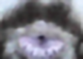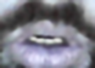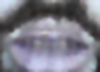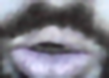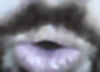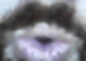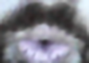

**3. Feature Extraction:**

Use techniques like Convolutional Neural Networks (CNNs) to extract features from the preprocessed frames.

Consider methods like Optical Flow to capture motion information between consecutive frames.

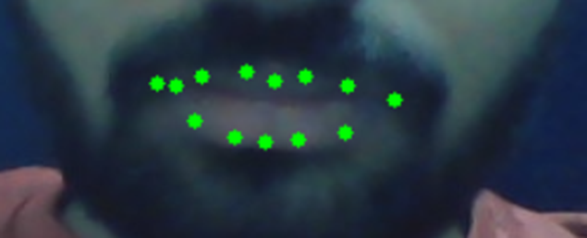

**4. Model Architecture:**

Design a deep learning architecture to map the extracted features to text sequences.

Sequence models like Recurrent Neural Networks (RNNs), Long Short-Term Memory networks (LSTM), or Transformer architectures can be suitable for this task.

You might also explore attention mechanisms to focus on relevant parts of the lip movements.

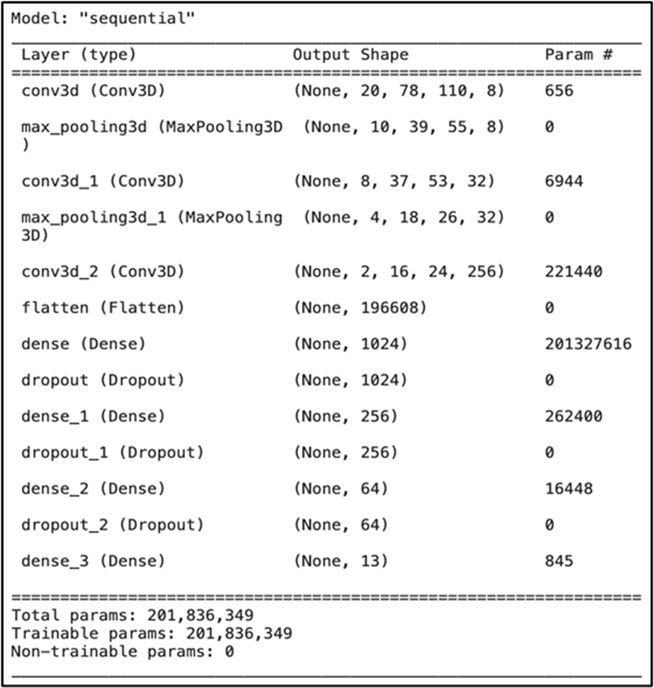

**5. Training:**

Train the model using the extracted features and corresponding transcriptions.

Utilize techniques like transfer learning if you have access to pre-trained models or feature extractors.

Augment the dataset with techniques like flipping, rotation, and zooming to improve generalization.

**6. Evaluation:**

Evaluate the model's performance using metrics such as word error rate (WER) or character error rate (CER) on a separate validation set.

Fine-tune the model based on performance metrics and qualitative assessment.

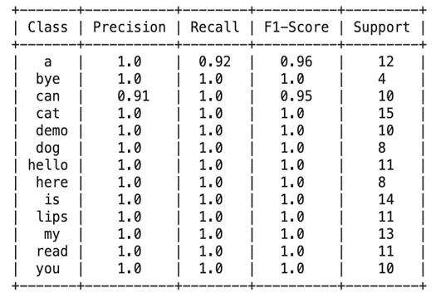

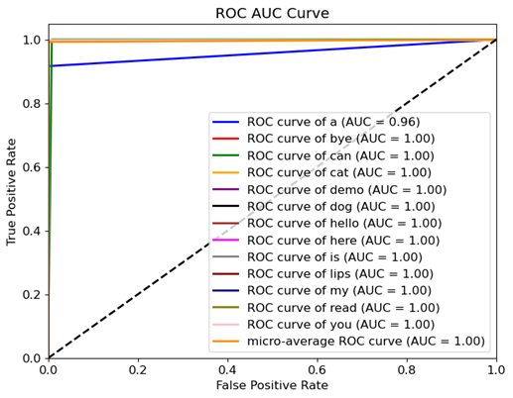

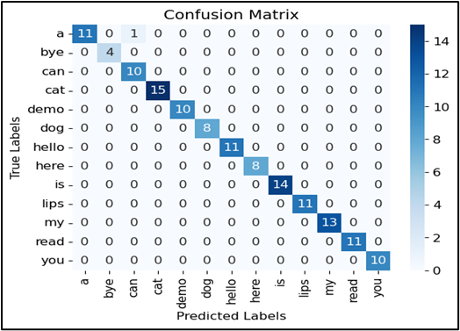

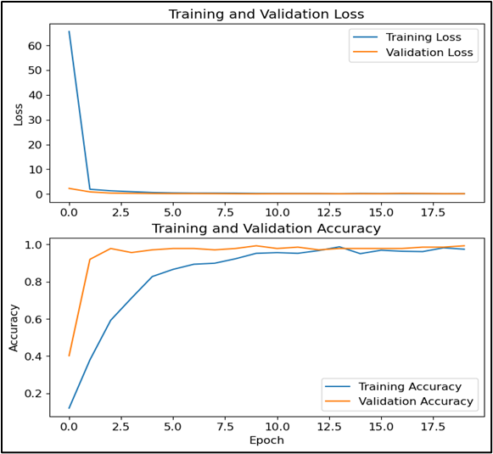

**7. Integration:**

Integrate the model into an application or service that can process live video streams or pre recorded videos.

Develop a user-friendly interface for users to interact with the lip reading interpreter.

**8. Continuous Improvement:**

Collect feedback from users and continuously update the model to improve its accuracy and robustness.

Monitor the performance of the model in real-world scenarios and refine it accordingly.

**9. Ethical Considerations:**

Ensure the model respects privacy and data security.

Address potential biases in the dataset and model predictions.

Provide transparency about the model's capabilities and limitations.

**10. Deployment:**

Deploy the lip reading interpreter model in a scalable and reliable infrastructure.

Monitor performance and handle errors gracefully in production environments.

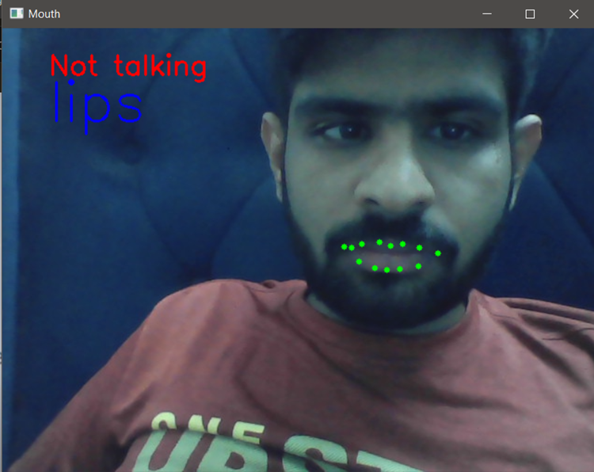

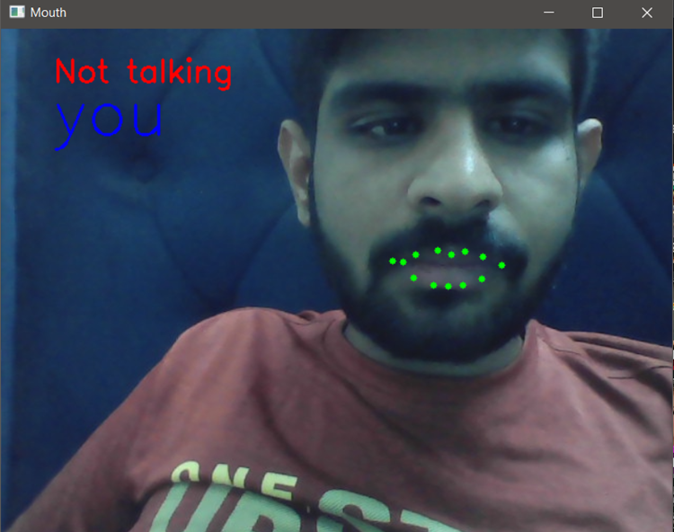

**10. OBJECTIVES**

The primary goal of an extensive project on lip interpretation is to establish a sophisticated system proficient in analyzing and comprehending lip movements and patterns with exceptional precision and dependability. This initiative is geared towards crafting advanced algorithms and models tailored to deciphering lip movements, gestures, and expressions, with the intention of application in speech recognition, emotion detection, and communication assistance. By harnessing cutting-edge technology, the system aims to elevate human-computer interaction, foster improved comprehension of spoken language among individuals with hearing impairments, and bolster the efficacy of speech recognition systems, particularly in environments characterized by high levels of noise.

The overarching objective of this endeavor is to develop a robust infrastructure capable of interpreting lip cues with utmost accuracy and reliability, thereby unlocking a myriad of potential applications across various domains. Through the integration of innovative methodologies and computational techniques, the system endeavors to bridge gaps in communication barriers, empower individuals with hearing impairments, and optimize the performance of speech recognition technologies under adverse conditions. Ultimately, the project seeks to revolutionize the landscape of human-machine interaction by leveraging the intricate nuances of lip movements to enhance communication and accessibility for diverse populations.

**11. METHODOLOGY**

**1.Data Collection and Annotation:** Gather a diverse dataset of lip movement videos across different speakers, languages, and contexts. Annotate the data with corresponding transcripts or phonetic information to facilitate supervised learning algorithms.

**2.Machine Learning Algorithms:** Employ machine learning techniques, such as deep learning models (e.g., convolutional neural networks - CNNs, recurrent neural networks - RNNs), to train the system to recognize and interpret lip movements. Transfer learning approaches can be utilized to leverage pre-trained models and adapt them to lip reading tasks.

**3.Feature Extraction and Representation:** Extract relevant features from lip movement videos, such as shape, texture, and motion characteristics. Explore different feature representation methods, including handcrafted features and learned representations, to capture the unique aspects of lip movements.

**4.Temporal Modeling:** Since lip movements unfold over time, employ temporal modeling techniques, such as Long Short-Term Memory (LSTM) networks or Temporal Convolutional Networks (TCNs), to capture temporal dependencies and dynamics in lip sequences.

**5.Integration of Context and Language Models:** Incorporate contextual information and language models to enhance the accuracy and robustness of lip interpretation. Language models can provide additional context and constraints to improve the recognition of ambiguous or context-dependent lip movements.

**6.Evaluation Metrics:** Define appropriate evaluation metrics, such as word error rate (WER) or phoneme error rate (PER), to assess the performance of the lip interpretation system. Conduct thorough evaluations using held-out validation sets and benchmark datasets to measure accuracy, robustness, and generalization capabilities.

**7.User-Centered Design and Evaluation:** Involve end-users, including individuals with speech disabilities or hearing impairments, throughout the development process. Solicit feedback, conduct usability studies, and iteratively refine the system based on user input to ensure it meets their needs and preferences.

**8.Privacy and Ethical Considerations:** Implement privacy-preserving measures, such as data anonymization and encryption, to protect the confidentiality of user data and ensure compliance with relevant privacy regulations. Adhere to ethical guidelines and obtain informed consent from participants involved in data collection and evaluation studies.

**9.Interdisciplinary Collaboration:** Foster collaboration between researchers, engineers, clinicians, linguists, and end-users to leverage diverse expertise and perspectives in the development of lip interpretation technology. Engage in knowledge sharing and interdisciplinary dialogue to address complex challenges and optimize system performance.

By adopting these methodologies, researchers and practitioners can advance the development of in-depth lip interpretation technology and contribute to enhancing communication accessibility for individuals with diverse communication needs.

## 12. REFERENCES

[1] A. Garg, J. Noyola, S. Bagadia, “Lip reading using CNN and LSTM,” in Technical Report, 2016.

[2] Y. Li, Y. Takashima, T. Takiguchi, Y. Ariki, “Lip reading using a dynamic feature of lip images and convolutional neural networks,” in 2016 IEEE/ACIS 15th International Conference on Computer and Information Science (ICIS), pp. 1–6, June 2016.

[3] S. Petridis, Z. Li, M. Pantic, “End-to-end visual speech recognition with LSTMs,” CoRR, vol. abs/1701.05847, 2017.

[4] A. Rekik, A. Ben-Hamadou, W. Mahdi, “A new visual speech recognition approach for RGB-D cameras,” in Image Analysis and Recognition (A. Campilho and M. Kamel, eds.), (Cham), pp. 21–28, Springer International Publishing, 2014

[5]Takeshi Saitoh, Ryosuke Konishi ―A Study of Influence of Word Lip Reading by Change of Frame Rate‖. ISCA Archive on Audio-Visual Speech Processing :speech.org/ archiveHakone, Kanagawa, Japan”

[6]Takeshi Saitoh ―Development of Communication Support System Using Lip Reading‖ IEEJ Transactions On Electrical And Electronic Engineering, IEEJ Trans 2013; 8: 574–579 Published online in Wiley Online Library (wileyonlinelibrary.com). DOI:10.1002/tee.21898

[7] Cruz, Hans Miguel Puente, Jofet Kane T Santos, Christian, Vea Larry A., Rajendaran Vairavan ―Lip Reading Analysis of English Letters as Pronounced by Filipino Speakers Using Image Analysis‖ 1st International Conference on Green and Sustainable Computing (ICoGeS) 2017 IOP PublishingIOP Conf. Series: Journal of Physics: Conf. Series 12345678901019 (2018) 012041 doi :10.1088/1742-6596/1019/1/01204

[8] I. Anina, Z. Zhou, G. Zhao, M. Pietikainen, “Ouluvs2: A multi-view audiovisual database for non-rigid mouth motion analysis,” in 2015 11th IEEE International Conference and Workshops on Automatic Face and Gesture Recognition (FG), vol. 1, pp. 1–5, May 2015.

[9] E. K. Patterson, S. Gurbuz, Z. Tufekci, J. N. Gowdy, “Moving talker, speaker-independent feature study, and baseline results using the CUAVE multimodal speech corpus,” EURASIP J. Appl. Signal Process., vol. 2002, pp. 1189–1201, Jan. 2002.

[10] W. Dong, R. He, S. Zhang, “Digital recognition from lip texture analysis,” in 2016 IEEE International Conference on Digital Signal Processing (DSP), pp. 477–481, Oct 2016.

[11] T. Stafylakis, G. Tzimiropoulos, “Combining residual networks with LSTMs for lipreading,” CoRR, vol. abs/1703.04105, 2017.

[12] J. S. Chung, A. Zisserman, “Lip reading in the wild,” in Asian Conference on Computer Vision, pp. 87–103, Springer, 2016.

[13] Y. Takashima, R. Aihara, T. Takiguchi, Y. Ariki, N. Mitani, K. Omori, K. Nakazono, “Audio-visual speech recognition using bimodal trained bottleneck features for a person with severe hearing loss,” in INTERSPEECH, 2016.

[14]Sunil S. Morade Suprava Patnaik (2015), ―Comparison of classifiers for lip reading with CUAVE and TULIPS database‖. Optik - International Journal for Light and Electron Optics, 126(24), 5753–5761.

[15] M.H. Rahmani, F. Almasganj Lip-reading via a DNN-HMM hybrid system using combination of the image-based and model-based features

[16] T. Stafylakis, G. Tzimiropoulos, Combining Residual Networks with LSTMs for Lipreading, in: Proc Annu Conf Int Speech Commun Assoc INTERSPEECH 2017-August, 2017, 3652–3656.

[17] G. Sterpu, H. Naomi, Towards Lipreading Sentences with Active Appearance Models. AVSP, 2017, 70–75.

[18] K. Thangthai, R. Harvey, Improving computer lipreading via DNN sequence discriminative training techniques, in: Proc Annu Conf Int Speech Commun Assoc INTERSPEECH 2017-August, 2017, pp. 3657–3661. https://doi.org/10.21437/INTERSPEECH.2017-106.

[19] K. Xu, D. Li, N. Cassimatis, X. Wang LCANet: End-to-end lipreading with cascaded attention-CTC

[20] M. Wand, J. Schmidhuber, N.T. Vu, Investigations on End- to-End Audiovisual Fusion. ICASSP, IEEE Int Conf Acoust Speech Signal Process – Proc 2018-April

[21] S. Petridis, T. Stafylakis, P. Ma, et al., End-to-End Audiovisual Speech Recognition. ICASSP, IEEE Int Conf Acoust Speech Signal Process – Proc 2018-April, 2018

[22] T. Afouras, J.S. Chung, A. Zisserman, Deep Lip Reading: a comparison of models and an online application, in: Proc Annu Conf Int Speech Commun Assoc INTERSPEECH 2018-September, 2018, pp. 3514–3518.

[23] S. Petridis, Y. Wang, Z. Li, M. PanticEnd-to-End Audiovisual Fusion with LSTMsThe 14th International Conference on Auditory-Visual Speech Processing. International Speech Communication Association (2018), pp. 36-40

[24] T. Saitoh, Z. Zhou, G. Zhao, M. Pietikäinen, Concatenated Frame Image Based CNN for Visual Speech Recognition. Lect Notes Comput Sci (including Subser Lect Notes Artif Intell Lect Notes Bioinformatics) 10117 LNCS, 2016, pp. 277–289. https://doi.org/10.1007/978-3-319-54427-4_21.

[25] J.S. Chung, A. Zisserman, Lip Reading in the Wild. Lect Notes Comput Sci (including Subser Lect Notes Artif Intell Lect Notes Bioinformatics) 10112 LNCS, 2016, 87–103. https://doi.org/10.1007/978-3-319-54184-6_6.

[26] K. Thangthai, R.W. Harvey, S.J. Cox, B.J. Theobald, Improving lip-reading performance for robust audiovisual speech recognition using DNNs, in: AVSP, 2015, pp. 127–131

[27] M. Zimmermann, M. Mehdipour Ghazi, H.K. Ekenel, J.-P. Thiran, Visual Speech Recognition Using PCA Networks and LSTMs in a Tandem GMM-HMM System. Lect Notes Comput Sci (including Subser Lect Notes Artif Intell Lect Notes Bioinformatics) 10117 LNCS, 2016, 264–276. https://doi.org/10.1007/978-3-319-54427-4_20.

[28] Lee D, Lee J, Kim K-E (2016) Multi-view Automatic Lip-Reading Using Neural Network. Lect Notes Comput Sci (including Subser Lect Notes Artif Intell Lect Notes Bioinformatics) 10117 LNCS:290–302. https://doi.org/10.1007/978-3-319-54427-4_22.

[29] Koumparoulis A, Potamianos G (2019) Deep View2View Mapping for View-Invariant Lipreading. 2018 IEEE Spok Lang Technol Work SLT 2018 - Proc 588–594. https://doi.org/10.1109/SLT.2018.8639698.

[30] Han H, Kang S, Yoo CD (2018) Multi-view visual speech recognition based on multi task learning. Proc - Int Conf Image Process ICIP 2017-September:3983–3987. https://doi.org/10.1109/ICIP.2017.8297030.

[31] A. Bakry, A. Elgammal MKPLS: Manifold kernel partial least squares for lipreading and speaker identification Proc IEEE Comput Soc Conf Comput Vis Pattern Recognit, 684–691 (2013)