Image Enhancement Techniques : A Review

A Project report submitted in partial fulfillment of the requirements of the award of the degree of

Bachelor of Technology

in

Computer Science Engineering (AI)

by

Tanishq Maharshi , Reg No: PCE21CA054

Tanishq Gupta , Reg No: PCE21CA053

Astha Gothi , Reg No: PCE21CA012

under the guidance of

Ms. Reena Sharma, Assistance professor, Poornima college of Engineering,Jaipur



(Session 2022-23)

Department of Advance Computing

# Poornima College of Engineering

ISI-6, RIICO Institutional Area, Sitapura, Jaipur – 302022

December, 2022

Table of contents

|  |  |  |  |
| --- | --- | --- | --- |
| S. No. | Title | Chapter Name | Page No. |
| 1 | Chapter 1 | Introduction | 4 |
| 2 | Chapter 2 | Problem Statement &  Objective | 6 |
| 3 | Chapter 3 | Literature Review | 7 |
| 4 | Chapter 4 | Proposed Approach | 17 |
| 5 | Chapter 5 | Conclusion & Future Scope | 18 |
| 6 |  | References | 20 |

Abstract

A crucial aspect of image research is image enhancement. Image enhancement techniques can be used to improve the image's quality and aesthetic appeal in order to more accurately convey a transform. In general, multiple types of photos, including satellite images, medical images, and photographs taken in real life, are impacted by low contrast and unique noise. A picture can be enhanced or modified using the filtering process. For instance, you may filter an image to highlight some elements while removing others. Filtering is used to accomplish image processing operations including edge enhancement, sharpening, and smoothing.

## CHAPTER 1

INTRODUCTION

Image enhancement is the technique of enhancing the original data's quality and information content before processing. Typical techniques include FCC, spatial filtering, density slicing, and contrast augmentation. By applying a linear transformation, the original range of grey levels is expanded, resulting in contrast enhancement or stretching. The naturally occurring linear features, such as fault, shear zones, and lineaments, are improved by spatial filtering. Through a process called density slicing, distinct features are represented by a sequence of density intervals, each of which is denoted by a different colour or symbol.

The fundamental objective of image enhancement is to improve the dark areas of a picture and adjust its edges. The result is more suitable than the original image for some specialised needs. There are numerous traits that make them more suited to a certain purpose and viewer. One or more picture characteristics are changed throughout this operation. A provided job determines the qualities to be used and how they are updated.

To achieve the best results, each linear or nonlinear filter would be applied to the regions of the image where it would result in the most significant results. Nevertheless, this method requires a system to select the best filter from a variety of choices for each point in the image.

To make images simpler for people to understand or see or to give other automated image processing algorithms "better" input, images are enhanced. Image enhancement methods can be divided into two broad categories:

1. Methods based on pixels that operate in space.
2. Frequency domain techniques that utilise the Fourier transform of a picture.

The area of signal processing in mathematics and electrical engineering is concerned with analysing and processing analogue and digital signals, as well as storing, filtering, and other operations on signals. These signals include speech, sound, and image signals in addition to transmission signals. Out of all these signals, image processing is the field that works with the kind of signals where the input is an image and the output is also an image. It deals with the processing of photographs, as its name would imply.

A Although the field of digital image processing is extensive and frequently requires mathematically challenging processes, its core concept is actually rather straightforwardUsing the information in the image is the ultimate goal of image processing.To give the system the ability to comprehend, recognise, and interpret the information that has been processed from the visual pattern. Image enhancement techniques are typically used to reveal details that are hidden or to draw attention to specific characteristics in an image. One or more image properties may be changed throughout the image enhancement process. Several branches of research and engineering can benefit from image improvement. The clarity of images is also impacted by outside noises and environmental disturbances such changes in temperature and atmospheric pressure. Image enhancement (IE) has helped develop research in many different domains. methods for improving images with poor contrast include stretching histograms over an acceptable dynamic range.

Areas where image enhancement used:

Here are listed a few of the locations where IE is widely used .

1. For meteorological observations, image enhancement in atmospheric sciences is employed to lessen the impacts of haze, fog, and turbulent weather. In environment sensing, image augmentation aids in identifying the shape and structure of distant objects. Noise is removed from satellite photos by image enhancement and restoration.
2. Image enhancement is utilised in forensics for surveillance, evidence collecting, and identification. Pictures from crime scene investigations, security video analysis, and fingerprint detection are upgraded for use in prosecuting offenders and protecting victims.
3. Light and noise pollution pose problems for astrophotography, but IE can help.
4. Image analysis in oceanography offers intriguing features such as sediment concentration, water flow, geomorphology, and bathymetric patterns, to mention a few. Images that have been digitally improved to address the issues of moving targets, insufficient light, and obfuscated backgrounds make these elements easier to see.

Other IE techniques are useful in many different domains, including as bacteriology, microbiology, biomedicine, and law enforcement. These advantages apply to regular users who use IE to aesthetically improve and repair their photographs as well as professional research and enterprises.

## CHAPTER 2

PROBLEM STATEMENT & OBJECTIVE

Since a normal image is not clear and it may not show some useful information or its brightness level seems inappropriate, then to get rid of such problems, we perform image enhancement to get a better and clearer image.To gain deeper knowledge of contrast enhancement.To implement & understand the concepts of signals & system in the context of image processing. The main objective of image processing is to transform an image into digital form and perform certain operations on it in order to obtain specific models or to extract useful information from the image. The image enhancement technique is to make the digital picture more appealing to our eyes, for example, making the images smooth or sharp. This is an important topic in digital image processing. It can help humans and computer vision algorithms obtain accurate information from the enhanced images.

Picture enhancement techniques are a collection of tactics designed to improve a picture's visual appeal or transform it into a format better suited for computer or human analysis. The primary objective of picture upgrade enhancement procedures is to transform a photo such that the final product is better suited than the original photo for a given use.

It is frequently employed to increase complexity in images that are noticeably light or drab.

Image enhancement entails either operations to alter a picture to an organisation better suited to machine preparation or operations to improve the appearance to a human viewer.

## CHAPTER 3

LITERATURE REVIEW

### Paper 1

[1] A.Rosenfeld and A.C.K ak, Digital Picture processing, computer science and Applied mathematics, Academic Press, 1982.

Summary: This book is part of the Selected Symposia Series of the American Association for the

Advancement of Science (AAAS). It is based on a symposium that was held at the 1980 AAAS National Annual Meeting in San Francisco. The format is designed to provide for rapid dissemination of information, so the papers are not typeset but are reproduced directly from the camera-copy submitted by the authors. However, upon closer inspection, it is revealed that six of the ten papers in this book are well-known papers that have already been "widely disseminated" in an even more permanent form.

Donald W. Davies' collection of papers The Security of Data in Networks, 1981, #U366, is a much better value than the book under review, Digital Picture Processing, 2nd ed., A. Rosenfeld and A. Kak (New York: Academic, 1982, Vol. 1: xiii + 435 pp., Vol. 2: vii + 349 pp.). The book is now in two volumes, the first volume presenting introductory fundamentals and image processing tech- niques such as coding, restoration, and reconstruction, and the second volume dedicated to image analysis techniques. The introduction is included in both volumes.

Chapters 1 through 7 are revised and ex- panded versions of the corresponding chapters in the first edition, while Chapter 8, on reconstruction, is new. Chapter 2 covers the basics of linear processing of pictures and random field models, while Chapter 3 presents a number of properties of the human visual system applicable to image processing. Chapter 4 discusses the issues of sampling and quanti- zation of pictures, while Chapter 5 discusses the topic of nonorthogonal sampling lattices. This chapter discusses subjectively optimal quantization of pictures, source coding, transform coding, block truncation coding, error-free compression, image enhancement and restoration, illumination effects, and visual fidelity criterion. This chapter discusses the advantages and disadvantages of various image reconstruc- tion methods, including the maximum aposteriori method and the maximum entropy method. It also provides a detailed description of the techniques of recon- struction from parallel projections and fan projections, as well as alge- braic reconstruction techniques.

### Paper 2

[2] Cheng Lei, and Lv Weijie, “A Fast Algorithm for foggy image contrast enhancement” International conference on TMEE, 2011.

Summary: To improve the visual quality of low contrast images, contrast enhancement technology is widely used, such as Histogram Equalization (HE). GHE is the most basic HE technology, while local histogram equalization is a complex method that applies HE over a block and then sliding block over all the image pixels sequentially. To overcome these problems, researchers have proposed Dynamic Histogram equalization (DHE) algorithm, which improves image contrast but noise is also enhanced at the same time. This paper discusses the use of a proposed algorithm to improve the visual quality of low contrast gray images

It is based on Histogram Equalization (HE), which is divided into two categories: global and local. Global HE uses cumulative distribution function which uniformly distributes gray level, while local HE applies HE over a block and then sliding blocks over all the image pixels sequentially. Results are satisfactory and open the scope for use of this algorithm in many real life scenarios. Researchers have proposed a Dynamic histogram equalization (DHE) algorithm to improve the visual quality of low contrast gray images, but it is not suitable for real time requirements. This paper proposes an integrated approach of Contrast-Limited Adaptive Histogram Equalization (CLAHE) and NoBlackPixel Constraint (NBPC) to improve image enhancement in foggy and hazy weather conditions.

Results are satisfactory and open the scope for use in many real life scenarios. Dense fog has both pros and cons. It is good for rubber tree growth and production of tea, but can be dangerous for navigation, highway driving, and aircraft take-off and landing. It has two effects: the luminance of the atmospheric veil

Ls(1−e−kl(i,j)), which is an increasing function of the object, and the metrological visibility distance lm=-ln (0.05)/k. Visibilty is better in clean air than polluted air, and visibility distance is used to quantify the difference between smoke, fog, haze and mist.

### Paper 3

[3] Lan GE Xin-Yu Zhangan and Tian-Fu Wang, “Entropy based Local Histogram

Equalization for Medical Ultrasound Image Enhancement”, IEEE 2008

Summary: This paper examines the use of intensity exposure in histogram segmentation and its performance in histogram equalization. Two techniques are proposed: mean-based bi-histogram equalization plateau limit (mean-BHEPL) or median-based BHEPL (median-bHEPL) and ABHE, which perform comparably to the conventional BHEPL technique. ABHE exhibits excellent performance in image quality, naturalness, and mean brightness preservation, but is slightly inferior in image detail preservation.

10 | P a g e

Poornima College of Engineering, Jaipur, B. Tech., Department of Advance Computing

### Paper 4

[4] Raman Maini and Himanshu Aggarwal , “A Comprehensive Review of Image

Enhancement Techniques” ,JOURNAL OF COMPUTING, VOLUME 2, ISSUE 3, MARCH 2010, ISSN 2151-9617

Summary: Image enhancement is used to improve the quality of images in many areas, such as forensics, Astrophotography, Fingerprint matching, and e-learning. It is implemented in MATLAB R2016a tool with algorithms such as Contrast Stretching, Logarithmic, Negative Image, Power-law transformation, Histogram processing, Histogram Equalization, Spatial Filtering, Linear spatial filtering, Laplacian filter, Diagonal filter, Sobel operator.

### Paper 5

[5] R. C. Gonzales, R. E. Woods, Digital Image Processing, Reading, MA: AddisonWesley, 1995

Summary: Improved gray-scale (IGS) quantization is a method for re-quantizing digital gray-scale images for data compression while producing halftones. This paper reveals the capability of conserving a DC signal level of a source image through the quantization, as well as a complete procedure for producing a multilevel halftone image by IGS quantization. The performance of the multi-level IGS halftoning is evaluated by experiments conducted on 8-bit gray-scale test images in comparison with the halftoning by error diffusion. The experimental result demonstrates that a signal level to be quantized varies more randomly than that in the error diffusion halftoning, but not entirely randomly. Additionally, visual quality of the resulting halftone images was measured by subjective evaluations of viewers. The result indicates that for 3 or more-bit, in other words, 8- level halftones, the IGS Halftoning achieves image quality comparable to that by the error diffusion.

### Paper 6

[6] F. Catte et al., Image selective smoothing and edge detection by nonlinear diffusion,

SIAM J. Numer. Anal., 29: 182- 193, 19

Summary: This paper proposes and studies a class of nonlinear parabolic differential equations for image processing of the following kind: au Du (1) -= g(jG * Du1)j Duj div ID u(0, x, y) = u0(x, y). The terms of the equation are as follows: Au - D2u(Du, Du)/lIDuI2 represents a degen- erate diffusion term, which diffuses u in the direction orthogonal to its gradient Du and does not diffuse at all in the direction of Du. G * Du is a local estimate of Du for noise elimination, and g(s) is a nonincreasing real function which tends to zero as s -> oo. The term g(lG * Dul) is used for the "enhancement" of the edges, and controls the speed of the diffusion. The proposed model is a selective smoothing of the image, where the "edges" are relatively enhanced and preserved as much as possible. It has the minimal number of parameters required by any image processing.

This text discusses the proposed model DAJA45-88-C-0009, a partial differential equation (PDE) model for image smoothing and edge detection, which is at the frontier of the stable models which preserve L' norms of the image and can be associated with efficient numerical schemes. It presents a new aspect of the model, the degenerate diffusion, and discusses its relation to the classical models of image processing. It also presents an approximate model whose numerical analysis will be easier, and proves the mathematical validity of the model and of its approximated one. Finally, it explains how g(lG * Dul) controls the speed of the diffusion: if Du has a small mean in a neighborhood of a point x, x is considered an edge point and the diffusion spread is lowered, since g(s) is small for large s. This work has been partially supported by U.S.

Army contract DAJA45-88-C-0009. It presents a degenerate diffusion model that generalizes or specializes most of the models that have been proposed for image smoothing and edge detection. The model is at the frontier of the stable models which preserve L' norms of the image and can be associated with efficient numerical schemes. It also presents an approximate model whose numerical analysis will be easier. Finally, it proves the mathematical validity of the model and of its approximated one.

### Comparison Table

|  |  |  |  |  |  |
| --- | --- | --- | --- | --- | --- |
| S.no. | Author’s name | Year | Approach used | Merits | Demerits |
| 1. | A.Rosenfeld  and A.C.K  ak | 1982 | Digital  picture processing | Images are made better for human interpretation as a result. Images can be analysed, and data can be extracted for automated interpretation. Any desired density and contrast can be achieved by manipulating the image's pixels. Pictures can coveniently stored and accessed. | It takes a great deal of time.  The price varies greatly depending on the system. Useful people can be found. |
| 2. | Cheng Lei, and  Lv  Weijie | 2011 | A fast  algorithm for foggy image contrast enhancement | We omitted refinement steps like soft matting or other filtering techniques and still got finer transmission than he  original approach. The processing time of the method is roughly three to four times faster than the traditional algorithm. | The calculatio ns of algorithm is very tough. |
| 3. | TianFu Wang | 2008 | Entropy based local histogram equalisation for  medical  ultrasound image enhancement. | It is a reasonably simple method with an invertible operator that adapts to the input image. So, in theory, the original histogram can be obtained if the histogram equalisatio n function is known. The computation doesn't require a lot of processing power | This method has a number of disadvantages, such that it distorts the signal, increases background contrast, and adds noise to the resulting image. |
| 4. | Raman Maini and Himanshu Aggarwal | 2010 | A comprehensive review of image enhancement techniques | The images are improved for human interpretat ion.  Data can be taken from images and used for automated interpretat ion. The pixels in the image can be changed to produce any desired density and contrast. It is simple to access and store pictures. | This is a review paper so demerits cannot be defined. |

|  |  |  |  |  |  |  |
| --- | --- | --- | --- | --- | --- | --- |
| 5. | F. Catte et al | 1995 | Image selective  smoothing and edge detection by  nonline ar diffusion. | The method's most significant benefit is that it makes the visual data to be processed simpler. | The signal to noise ratio was a drawback.  Justification: The estimated gradient calculation is what gives the Sobel operator  its simplicity. |  |
| 6. | R . C .  Gonzales, R .  E. Woods | 1995 | Digital  Image  processing and enhancing using filters. | It is used to get clearity in pixels of images. | It is basically use for black and white images not for colourful images. |  |

‘

## Chapter-4

Proposed Approach

Due to the imaging limitations of existing equipment, in the natural environment, various weather conditions often have an adverse impact on the image acquisition equipment, resulting in the acquisition of low-quality natural images. In this paper, we know that the imaging principle of the camera is through the reflected light of the object. However, in the evening or dark conditions, due to the lack of light, the light that the scene can reflect to the sensor is limited, and the scene information is seriously lost. The above three scenarios analyzed in this paper all have the problem of low quality of acquired natural images due to environmental factors, so how to improve the quality of these images becomes the focus of this paper. Deep learning is in the training data or test data of a deep neural network. At present, high visibility images, clear images, and images or videos with high feature density are used in image recognition or other computer vision tests, and the computer vision tasks under these images or videos with obvious features and in line with aesthetics have achieved exciting results. The problems of image enhancement and reconstruction cover a wide range, involving many application problems such as image smoothing and denoising, image deblurring, image defogging, rain and snow, image superresolution, image inpainting, detail enhancement, and high dynamic range tone mapping. When the input image is a degraded image, the common goal of both is to improve the visual quality of the image and obtain an improved image in a sense. In contrast, image enhancement does not seek the original appearance of the image, but selectively highlights some interesting parts and useful information, suppresses or weakens some uninterested parts, and obtains the enhancement results with strong expressiveness, obvious characteristics, and rich effective information.

## CHAPTER 5

CONCLUSION & FUTURE SCOPE

A broad range of methods for changing photos to produce aesthetically appealing images are available through image enhancement algorithms. The exact task, picture content, observer characteristics, and viewing circumstances all play a role in the technique selection. The most basic yet necessary image processing processes are the point processing techniques, which are mostly employed for contrast amplification. Image Negative has uses in medical imaging and is suitable for highlighting white detail embedded in dark regions. In general, contrast manipulation can benefit from power-law transformations. For a dark image, a power-law transformation with a fractional exponent is used to expand the range of grey levels.The higher-level values of the log transformation are useful for increasing features in the darker areas of the image at the price of detail in the brighter areas. A powerlaw transformation with higher than 1 is used to produce a compression of grey levels for a picture that has a washed-out appearance. An image's histogram, which is a depiction of the grayscale frequencies, contains crucial details about an image's contrast. A technique called histogram equalisation increases contrast by equally spreading the values of the grey levels. The only fully automated process that can be used is the global histogram equalisation. Although it was not covered in this article, the computational cost of enhancement algorithms may be a key factor in selecting an approach for real-time applications.

Despite the fact that each of these algorithms works well when used alone, in reality, one has to combine many of these techniques to improve images.

With image enhancement algorithms, a variety of techniques for modifying photos to create visually pleasing images are accessible. The choice of technique depends on the precise task, visual content, observer characteristics, and viewing environment. The point processing techniques, which are mostly used for contrast amplification, are the most fundamental yet essential image processing steps. Image Negative is useful for showing white detail contained in dark areas and has applications in medical imaging. Power-law transformations are generally advantageous for contrast manipulation. A power-law transformation with a fractional exponent is used to increase the range of grey levels for a dark image. For the price of boosting features in the darker portions of the image, the higherlevel values of the log transformation are advantageous.

This essay examines a few fields related to image enhancement. The most significant methods for picture enhancement in digital image processing for grey scale images are discussed in this work.

The computing cost of enhancement approaches was not covered in this paper, but it may be a key factor when selecting a strategy for real-time applications. Although each of these algorithms works well when used alone, in order to get more effective image enhancement, one must combine these techniques.

Image Enhancement Techniques : A Review

References

1. A.Rosenfeld and A.C.K ak, Digital Picture processing, computer science and Applied mathematics, Academic Press, 1982.
2. Cheng Lei, and Lv Weijie, “A Fast Algorithm for foggy image contrast enhancement” International conference on TMEE, 2011.
3. Lan GE Xin-Yu Zhangan and Tian-Fu Wang, “Entropy based Local Histogram Equalization for Medical Ultrasound Image Enhancement”, IEEE 2008
4. Raman Maini and Himanshu Aggarwal , “A Comprehensive Review of Image

Enhancement Techniques” ,JOURNAL OF COMPUTING, VOLUME 2, ISSUE 3, MARCH

2010, ISSN 2151-9617

1. R. C. Gonzales, R. E. Woods, Digital Image Processing, Reading, MA: AddisonWesley, 1995
2. F. Catte et al., Image selective smoothing and edge detection by nonlinear diffusion, SIAM J. Numer. Anal., 29: 182- 193, 19

20 | P a g e

Poornima College of Engineering, Jaipur, B. Tech., Department of Advance Computing



### Department Certificate

This is to certify that Mr. Tanishq Maharshi, registration no. PCE21CA054 of the Computer Science and Engineering(AI), Department of Advance Computing, has submitted this project report entitled “ Image Enhancement Techniques : A Review

“under the supervision of Ms. Reena Sharma , working as Assistance Professor in Department of Advance Computing as per the requirements of the Bachelor of Technology program of Poornima College of Engineering, Jaipur.

Dr. Kamlesh Gautam Mr.Shirish Mohan Dubey

Dy. Head, Dept. of Advance Computing Coordinator-Project

### Department Certificate

This is to certify that Ms.Astha Gothi, registration no. PCE21CA012 of the Computer Science and Engineering(AI), Department of Advance Computing, has submitted this project report entitled “ Image Enhancement Techniques : A Review“ under the supervision of Ms. Reena Sharma , working as Assistance Professor in Department of Advance Computing as per the requirements of the Bachelor of Technology program of Poornima College of Engineering, Jaipur.

Dr. Kamlesh Gautam Mr.Shirish Mohan Dubey

Dy. Head, Dept. of Advance Computing Coordinator-Project

### Department Certificate

This is to certify that Mr. Tanishq Gupta, registration no. PCE21CA053 of the Computer Science and Engineering(AI), Department of Advance Computing, has submitted this project report entitled “ Image Enhancement Techniques : A Review

“under the supervision of Ms. Reena Sharma , working as Assistance Professor in

Department of Advance Computing as per the requirements of the Bachelor of Technology program of Poornima College of Engineering, Jaipur.

Dr. Kamlesh Gautam Mr.Shirish Mohan Dubey

Dy. Head, Dept. of Advance Computing Coordinator-Project

### CANDIDATE’S DECLARATION

I hereby declare that the work which is being presented in this project report entitled “Image

Enhancement Techniques :A Review ” in the partial fulfilment for the award of the Degree of Bachelor of Technology in (Computer & Engineering(AI)), submitted in the Department of Advance Computing, Poornima College of Engineering, Jaipur, is an authentic record of my own work done during the period from July 2022 to Dec 2022 under the supervision and guidance of Ms.Reena Sharma.

I have not submitted the matter embodied in this project report for the award of any other degree.

|  |  |
| --- | --- |
| Signature | Signature |
| Name of Candidate:------------------ Registration no.:-------------------- | Name of Candidate:---- Registration no.:---  - |
| Signature | Signature |
| Name of Candidate:-------------- Registration no.:------------- | Name of Candidate:--------- Registration no.:------------ |

Dated: -

Place: Jaipur

SUPERVISOR’S CERTIFICATE

This is to certify that the above statement made by the candidate is correct to the best of my knowledge.

Dated: Ms. Reena Sharma

Place: Jaipur Assistance Professor,

Poornima College of Engineering

ACKNOWLEDGEMENT

I would like to convey my profound sense of reverence and admiration to my supervisor

Ms. Reena Sharma, Department of Advance Computing, Poornima College of Engineering, for his intense concern, attention, priceless direction, guidance and encouragement throughout this research work.

I am grateful to Dr. Mahesh Bundele, Director of Poornima College of Engineering for his helping attitude with a keen interest in completing this dissertation in time.

I extend my heartiest gratitude to all the teachers, who extended their cooperation to steer the topic towards its successful completion. I am also thankful to non-teaching staff of the department to support in preparation of this dissertation work.

My special heartfelt gratitude goes to Dr. Mithlesh Arya, Dy. Head, Department of

Advance Computing, Ms. Archika Jain, Project Coordinator, Department of Advance Computing, Poornima College of Engineering, for unvarying support, guidance and motivation during the course of this research.

I would like to express my deep sense of gratitude towards management of Poornima College of Engineering including Dr. S. M. Seth, Chairman Emeritus, Poornima Group and former Director NIH, Roorkee, Shri Shashikant Singhi, Chairman, Poornima Group, Mr. M. K. M. Shah, Director Admin & Finance, Poornima Group and Ar. Rahul Singhi, Director Poornima Group for establishment of institute and providing facilties my studies.

I would like to take the opportunity of expressing my thanks to all faculty members of the Department, for their kind support, technical guidance, and inspiration throughout the course.

I am deeply thankful to my parents and all other family members for their blessings and inspiration. At last but not least I would like to give special thanks to God who enabled me to complete my dissertation on time.

TANISHQ MAHARSHI, Department of Advance Computing, 54

TANISHQ GUPTA, Department of Advance Computing, 53

ASTHA GOTHI, Department of Advance Computing, 12

Image Enhancement Techniques : A Review

Astha Gothi

Tanishq Maharshi Dept of Advance Computing

Dept of Advance Computing Poornima College of Engineering

Poornima College of Engineering 2021pcecaastha012@poornim.org

2021pcecatanishq054@poornima.org

Reena Sharma

Tanishq Gupta Dept of Advance Computing

Dept of Advance Computing Poornima College of Engineering

Poornima College of Engineering Reena.sharma@poornima.org 2021pcecatanishq053@poornima.org

Abstract – A crucial aspect of image research is image enhancement. Image enhancement techniques can be used to improve the image's quality and aesthetic appeal in order to more accurately convey a transform. In general, multiple types of photos, including satellite images, medical images, and photographs taken in real life, are impacted by low contrast and unique noise. A picture can be enhanced or modified using the filtering process. For instance, you may filter an image to highlight some elements while removing others. Filtering is used to accomplish image processing operations including edge enhancement, sharpening, and smoothing. Keywords- Image enhancement, modifying, filtering , edge enhancement,

I. INTRODUCTION

Picture processing used to highlight a certain element of an image is known as image enhancement. Image enhancement fundamentally involves making pictures easier for humans to understand or interpret while also giving other automated image processing methods better input. The main goal enhancement is to change a picture's characteristics so that they are more suited to a certain purpose and viewer. One or more picture characteristics are changed throughout this operation. A provided job determines the qualities to be used and how they are updated. The choice of picture augmentation techniques will also be very subjective due to observer-specific elements, including the human visual system and the observer's experience.The following scenarios involve the use of image enhancement: removing the image's noise the highlighting of object edges and improvement of the dark picture. For certain specialised uses, the outcome is better suited than the original image. There are many different kinds of filtering techniques that we may apply to improve photos. A single, specialised image enhancement filter may not give the optimum quality throughout a complicated image in many situations. In order to eliminate Gaussian noise from smooth areas of a picture, for instance, a filter would often seek to blur edge detail. Alternatively, a non-linear filter meant to maintain edge detail could result in unfavourable artefacts in smooth, noisy parts of a picture.

In a perfect world, each linear or nonlinear filter would be applied to the areas of the picture where it would produce the greatest results in order to produce the best possible outcome. This strategy calls for a mechanism, nevertheless, to choose the optimum filter from a range of options for each point in the image.

30 | P a g e

#### II. Histogram Equalization Techniques

Globalisation Of Histograms when a low-contrast picture with grey levels ranging from 0 to L-1 is used as the input, the likelihood of a pixel having the intensity value k is given by

Pk = nk/N (1)

Where N is the total number of pixels in a picture, k is the intensity value ranging from 0 to L-1, and nk is the number of instances of the kth intensity in the image. Formula for expressing the cumulative distribution function (CDF) in terms of the probability distribution function

Cdf = P1+P2……..PL-1 (2)

The problem with GHE is that it over-enhances pixels with high probability while under-enhances pixels with low probability, which might decrease the quality of the target item in the picture [2].

Equalization Of The Local Histogram The global information of the image is the foundation for global histogram equalisation

(GHE). First, a window is taken into consideration for the input picture I in Local Histogram Equalization (LHE) under Block Overlapped Histogram Equalization [3]. (i,j). Beginning with the first pixel of the image, traversing begins with the window's centre point. Equalize the centre point and move the window to the neighbouring pixel to perform equalisation. This process is performed for each pixel in the input picture, pixel by pixel. The input image is transformed into the high contrast image after LHE. But LHE is also not the best technique since the image is over-enhanced and this process becomes more difficult as the image size grows.

III. EXPERIMENTAL RESULTS AND

COMPARISON

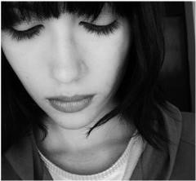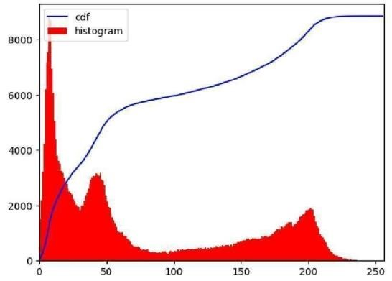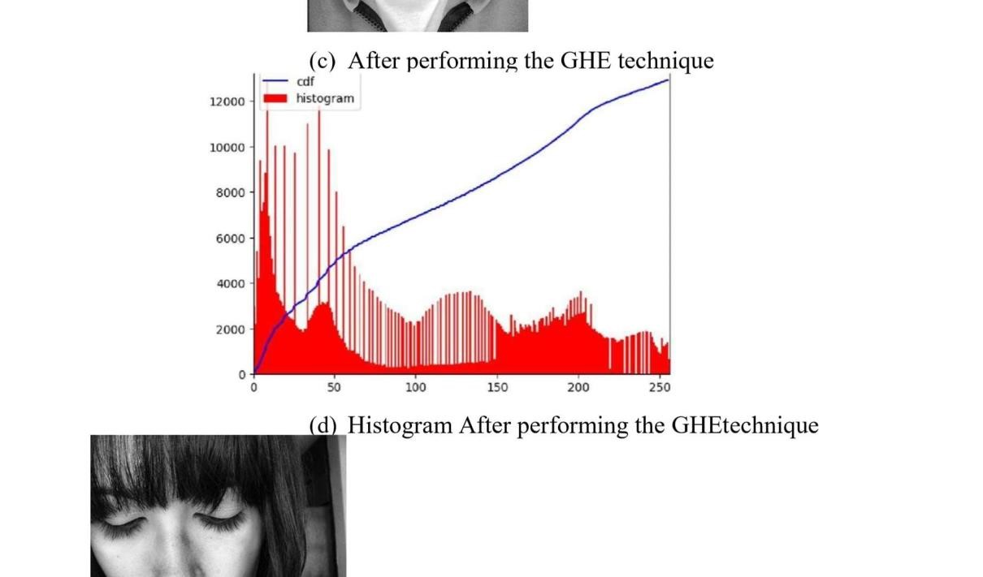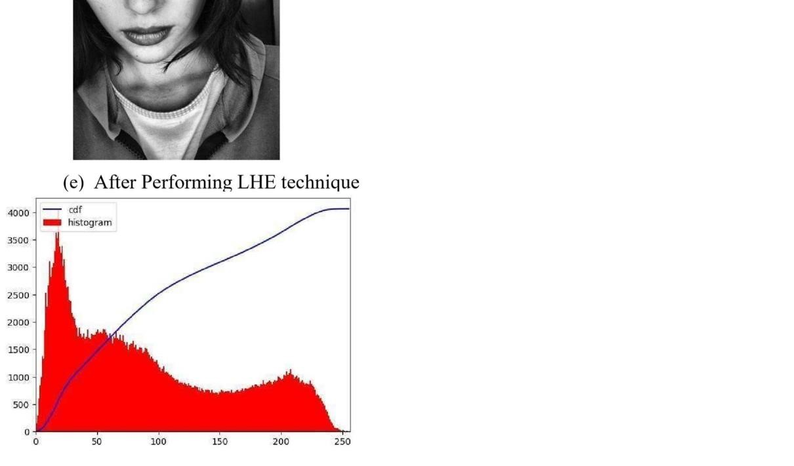

(f) Histogram After Performing The LHE onoriginal image IV.

Conclusion

A broad range of methods for changing photos to produce aesthetically appealing images are available through image enhancement algorithms. The exact task, picture content, observer characteristics, and viewing circumstances all play a role in the technique selection. The most basic yet necessary image processing processes are the point processing techniques, which are mostly employed for contrast amplification. Image Negative has uses in medical imaging and is suitable for highlighting white detail embedded in dark regions. In general, contrast manipulation can benefit from power-law transformations. For a dark image, a power-law transformation with a fractional exponent is used to expand the range of grey levels.The higher-level values of the log transformation are useful for increasing features in the darker areas of the image at the price of detail in the brighter areas. A power-law transformation with higher than 1 is used to produce a compression of grey levels for a picture that has a washed-out appearance. An image's histogram, which is a depiction of the grayscale frequencies, contains crucial details about an image's contrast. A technique called histogram equalisation increases contrast by equally spreading the values of the grey levels. The only fully automated process that can be used is the global histogram equalisation. Although it was not covered in this article, the computational cost of enhancement algorithms may be a key factor in selecting an approach for real-time applications.

Despite the fact that each of these algorithms works well when used alone, in reality, one has to combine many of these techniques to improve images.

References

1. A.Rosenfeld and A.C.K ak, Digital Picture processing, computer science and Applied mathematics, Academic Press, 1982.
2. Cheng Lei, and Lv Weijie, “A Fast Algorithm for foggy image contrast enhancement” International conference on TMEE, 2011.
3. Lan GE Xin-Yu Zhangan and Tian-Fu Wang, “Entropy based Local Histogram Equalization for Medical Ultrasound Image Enhancement”, IEEE 2008
4. Raman Maini and Himanshu Aggarwal , “A Comprehensive Review of Image

Enhancement Techniques” ,JOURNAL OF COMPUTING, VOLUME 2, ISSUE 3, MARCH 2010, ISSN 2151-9617

ORIGINALITY REPORT

18% 6% 18% 4%

PRIMARY SOURCES



##### SIMILARITY INDEX INTERNET SOURCES PUBLICATIONS STUDENT PAPERS

Robust Image Watermarking Based on Hybrid Domain", 2022

7th International Conference on

Intelligent Computing and Signal Processing (ICSP),

2022

Publication

# www.semanticscholar.org

|  |
| --- |
| 2 |

Internet Source 2%

2%

Mianjie Li, Xiaochen Yuan, Hai Chen, Jianqing 3

Li. "Quaternion Discrete Fourier Transform

Based Color Image Watermarking Method

Using Quaternion QR Decomposition", IEEE

Access, 2020

Publication

1%

Lan Zhang, Xiang-Yang Li, Kebin Liu, Cihang

1. and

Liu, Xuan Ding, Yunhao Liu. "Cloak of

Invisibility: Privacy-Friendly Photo Capturing Sharing System", IEEE Transactions on Mobile

Computing, 2019

Publication

Vishal Choudhary, Malay Kishore Dutta,

1. 1%

Abhilasha Singh. "Reversible Watermarking scheme for

Authentication and integrity control in Biometric

Images", 2019 4th International Conference on

Information

Systems and Computer Networks (ISCON), 2019

Publication

Ashish Sinha, Jeebananda Panda. "A Secure 1

%

6

Wavelet based Watermarking Approach using

Psycho-Visual Redundancy in Image", 2021

7th International Conference on Advanced

Computing and Communication Systems

(ICACCS), 2021

Publication

Bibek Ranjan Ghosh, Siddhartha Banerjee, 1%

7

Jyotsna Kumar Mandal. "Watermark based

Image Authentication using Integer Wavelet

Transform", 2022 International Conference on

Inventive Computation Technologies (ICICT), 2022

Publication

cps-vo.org

8

Internet Source1%

Mustafa Ali Mir, Farheen Qazi, Muhammad

9

1%

Naseem, S. Saood Zia, Dur-e-Shawar Agha, Tauseef Mubeen. "Invisibility Cloak using

Color Extraction and Image Segmentation with

OpenCV", 2022 Global Conference on

Wireless and Optical Technologies

(GCWOT), 2022

Publication



10



1%

Ying Yu, Yue Qiao, Caiyin Wang, Chao Li,

Xiaojuan Shi. "A robust digital watermarking method for textile image", 2021 6th

International Conference on Intelligent

Computing and Signal Processing (ICSP), 2021

Publication



11



1%

"Table of Contents", 2022 10th International

Conference on Emerging Trends in

Engineering and Technology - Signal and

Information Processing (ICETET-SIP-22), 2022

Publication



12



1%

Nicolae Luca Iacobici, Mihaela Frigura-Iliasa,

Hannelore Elfride Filipescu, Madlena Nen et al.

"Digital Imaging Processing and

Reconstruction for General Applications", 2020 IEEE

18th World Symposium on Applied

Machine Intelligence and Informatics (SAMI), 2020

Publication

researchr.org

|  |
| --- |
| 13 |

Internet Source 1%

14 Internet Source %

15

labs.imaginea.com 1

coek.info

I n t e r

n e

t

S o

u

r c e

1

%

Submitted to Nanyang Technological

16

1

%University

Student Paper

Exclude quotes On Exclude matches < 1%

Exclude bibliography On