A Project Report
ON
99Care OS – AI-Powered Healthcare OperationsManagement System with Integrated CRM, HR & Billing
99 Care
Project Report Submitted in the Partial Fulfillment for the Degree of
Bachelor of Science
IN
Information Technology(BSc IT)
Submitted
BY
Tanishq Kachiwala212023042 2023–26
Under the Guidance of
Dr. Sunil Kumar


Certificate of Undertaking
(Declaration)
I, Tanishq Kachiwala, Enrollment No. 212023042, hereby declare that the project
entitled “99Care OS – AI-Powered Healthcare Operations Management System with Integrated
CRM, HR & Billing”, undertaken at the School of Information Technology, is submitted
in partial fulfillment of the requirements for the degree of Bachelor of Science in Information
Technology.
I further declare that this project is my original work and has not been submitted, either in
part or in full, for the award of any other degree, diploma, associate ship, fellowship, or any
other similar title in AURO University or any other University/Institution.
Date: _______________
Place: _______________
Signature of the Student
Tanishq Kachiwala
Enrollment No.: 212023042

School of Information Technology
Certificate
This is to certify that the project entitled “99Care OS – AI-Powered Healthcare Operations
Management System with Integrated CRM, HR & Billing” has been successfully carried out by
the following student(s) under my guidance in the partial fulfilment of the requirements for
the degree of Bachelor of Science in Information Technology of AURO University, Surat,
during the academic year 2023–26 (Semester VI).
Student(s):
212023042 – Tanishq Kachiwala
Date: _______________
Place: Surat
Dr. Sunil Kumar
Project Guide / Supervisor
Dr. Anurag Dixit
Head, School of Information Technology

ACKNOWLEDGEMENT
I would like to express my sincere gratitude to all those who have contributed to the successful completion of this project.
First and foremost, I am deeply thankful to my internal faculty guide, Dr. Sunil Kumar, for his invaluable guidance, continuous support, and constructive feedback throughout the project development process. His expertise and mentorship have been instrumental in shaping this project.
I extend my heartfelt thanks to Dr. Anurag Dixit, Head of the School of Information Technology, AURO University, Surat, for providing the necessary infrastructure and academic environment that facilitated this work.
I am especially grateful to Mr. Divyesh Patel, Director of 99 Care, for giving me the opportunity to work on a real-world healthcare operations management system. His domain expertise in the healthcare industry provided crucial insights into the business requirements that shaped the system's architecture.
I also wish to thank the entire team at 99 Care for their cooperation, timely feedback, and for providing access to the necessary resources and APIs that made this project possible.
Finally, I would like to thank my family and friends for their unwavering encouragement and moral support throughout this journey.
Tanishq Kachiwala
212023042
BSc IT, Semester VI
AURO University, Surat

TABLE OF CONTENTS
Chapter | Title | Page No.
 | NOC / NDC Certificate
 | Certificate of Undertaking (Declaration)
 | Certificate from Institute
 | Certificate from Company
 | Acknowledgement
 | Table of Contents
 | List of Figures
 | List of Tables
 | List of Abbreviations
1 | Preliminary Pages
2 | Introduction of the Project
3 | Software/System Requirement Study
4 | Objective of the Software
5 | Feasibility Study
6 | System Analysis
7 | Software/System Design
8 | Front-End Screens
9 | Database Design
10 | Back-End Description
11 | Implementation
12 | Source Code
13 | Testing and Implementation
14 | Results and Discussion
15 | Limitations
16 | Future Enhancements
17 | Conclusion
18 | Bibliography / References
19 | Appendix
(Page numbers to be filled after final formatting)

LIST OF FIGURES
Fig. No. | Title | Page No.
7.1 | System Flowchart
7.2 | Data Flow Diagram – Level 0 (Context Diagram)
7.3 | Data Flow Diagram – Level 1
7.4 | Entity Relationship Diagram (ERD)
7.5 | Use Case Diagram
7.6 | Class Diagram
7.7 | Sequence Diagram – Lead Intake Flow
7.8 | Sequence Diagram – Worker Assignment Flow
8.1 | Public Website – Home Page
8.2 | Public Website – Services Page
8.3 | Public Website – Appointment Booking
8.4 | Login Screen
8.5 | Admin Dashboard
8.6 | CRM – Kanban Pipeline View
8.7 | CRM – Call Logs with AI Summary
8.8 | HR – Available Workers Tab
8.9 | HR – Active Deployments Tab
8.10 | HR – Employee Directory
8.11 | HR – Attendance Matrix
8.12 | HR – Worker Assignment Dialog
8.13 | HR – Digital ID Card Preview
8.14 | Billing Module
8.15 | Access Control / Settings
9.1 | Database Schema Diagram
(Page numbers to be filled after final formatting)

LIST OF TABLES
Table No. | Title | Page No.
3.1 | Hardware Requirements
3.2 | Software Requirements
3.3 | Tools and Technologies
6.1 | Functional Requirements
6.2 | Non-Functional Requirements
9.1 | employees Table Structure
9.2 | crm_leads Table Structure
9.3 | worker_assignments Table Structure
9.4 | id_card_links Table Structure
9.5 | clients Table Structure
9.6 | attendance Table Structure
9.7 | payroll Table Structure
9.8 | call_transcripts Table Structure
13.1 | Test Cases – CRM Module
13.2 | Test Cases – HR Module
13.3 | Test Cases – Authentication
13.4 | Test Cases – Public Website
(Page numbers to be filled after final formatting)

LIST OF ABBREVIATIONS
Abbreviation | Full Form
AI | Artificial Intelligence
API | Application Programming Interface
BaaS | Backend as a Service
CRUD | Create, Read, Update, Delete
CRM | Customer Relationship Management
CSS | Cascading Style Sheets
DFD | Data Flow Diagram
ERD | Entity Relationship Diagram
HR | Human Resource Management
HTML | HyperText Markup Language
HTTP | HyperText Transfer Protocol
JSON | JavaScript Object Notation
JWT | JSON Web Token
NDC | Non-Disclosure Compliance
OS | Operations System
PDF | Portable Document Format
PK | Primary Key
FK | Foreign Key
PWA | Progressive Web Application
RBAC | Role-Based Access Control
REST | Representational State Transfer
RLS | Row Level Security
SEO | Search Engine Optimization
SQL | Structured Query Language
TSX | TypeScript JSX
UAT | User Acceptance Testing
UI | User Interface
URL | Uniform Resource Locator
UUID | Universally Unique Identifier

CHAPTER 2: INTRODUCTION OF THE PROJECT

2.1 Background of the Project
The healthcare industry in India is undergoing a significant digital transformation. Home healthcare services, in particular, have seen tremendous growth in recent years, driven by an aging population, increasing chronic diseases, and the convenience of receiving medical care at home. However, many home healthcare companies still rely on manual processes for managing their operations — from tracking patient inquiries and assigning healthcare workers, to managing attendance, billing, and client communication.
99 Care is a home healthcare services provider based in Surat, Gujarat, that offers a wide range of services including elderly care, post-surgical care, baby care, physiotherapy, nursing, and more. Before the development of this system, the company relied on a fragmented set of tools — phone calls, spreadsheets, WhatsApp messages, and manual record-keeping — to manage their day-to-day operations.
The need for a centralized, intelligent, and automated operations management system became increasingly apparent as the company scaled its workforce and client base. This project was undertaken to address this critical gap by building 99Care OS — a comprehensive, AI-powered healthcare operations management platform.
The system was developed as a full-stack web application using modern technologies including React, TypeScript, Supabase (PostgreSQL), and integrated with third-party AI services such as ElevenLabs for conversational AI voice agents and Meta's WhatsApp Cloud API for automated client communication.

2.2 Problem Statement
Home healthcare companies face several operational challenges that hinder their growth and efficiency:
- Fragmented Lead Management: Incoming patient/client inquiries arrive through multiple channels — phone calls, WhatsApp messages, website forms — with no centralized system to track, prioritize, or follow up on them. Leads are frequently lost or delayed due to manual handling.
- Inefficient Workforce Allocation: Assigning healthcare workers (nurses, attendants, therapists) to clients involves checking availability, matching skills, and managing schedules — all done manually through phone calls and spreadsheets, leading to delays and double-bookings.
- Lack of Communication Automation: Post-inquiry follow-ups, appointment confirmations, staff assignment notifications, and review requests are all handled manually via individual WhatsApp messages, consuming significant staff time and leading to inconsistencies.
- No Digital Identity Management: Healthcare workers visiting client homes had no standardized identity verification system. Paper-based ID cards were easily misplaced or forged, creating trust and safety concerns for clients.
- Manual Attendance and Payroll: Tracking daily attendance of field workers and calculating their pay based on different rate structures (hourly, daily, monthly) was done through paper registers, resulting in errors and disputes.
- No Data-Driven Decision Making: Without a centralized system, the company had no visibility into key metrics like lead conversion rates, worker utilization, revenue trends, or operational bottlenecks.

2.3 Need and Significance of the System
The significance of the 99Care OS system can be understood from the following perspectives:

For the Business (99 Care)
- Operational Efficiency: Automating lead capture, worker assignment, attendance tracking, and billing reduces the time and effort required to manage daily operations by an estimated 60–70%.
- Revenue Growth: AI-powered call handling and automated WhatsApp follow-ups ensure no lead is missed, directly impacting conversion rates and revenue.
- Scalability: The cloud-based architecture allows the company to scale from managing 10 workers to 100+ without proportional increases in administrative overhead.
- Data Visibility: Real-time dashboards provide management with actionable insights into pipeline health, workforce utilization, and financial performance.

For Clients (Patients and Families)
- Trust and Safety: Digital ID cards with shareable links allow clients to verify the identity and credentials of healthcare workers assigned to their home, enhancing trust and safety.
- Better Communication: Automated WhatsApp notifications keep clients informed about staff assignments, schedule changes, and service updates in real-time.
- Convenient Booking: The public-facing website allows clients to book appointments, explore services, and contact the company without the need for phone calls.

For Healthcare Workers
- Digital Identity: Professional digital ID cards with unique shareable links provide workers with a verifiable identity that enhances their professional image.
- Transparent Payroll: Automated attendance tracking and payroll calculation ensure accurate and timely compensation.
- Clear Assignments: Workers receive clear assignment details including client information and service requirements through the system.

Academic Significance
- This project demonstrates the practical application of modern web development technologies (React, TypeScript, Supabase) combined with AI services (ElevenLabs, Meta WhatsApp API) to solve real-world business problems.
- It showcases the integration of multiple complex subsystems — CRM, HR, billing, and communication — into a cohesive, production-ready application.
- The project provides hands-on experience with industry-standard tools and practices including version control (Git/GitHub), cloud hosting (Vercel), serverless functions, and real-time databases.

CHAPTER 3: SOFTWARE/SYSTEM REQUIREMENT STUDY

3.1 Hardware Requirements
The system is a cloud-hosted web application and does not require specialized hardware for deployment. However, the following hardware specifications are recommended for development and end-user access:
Component | Minimum Requirement
Processor | Intel Core i5 / Apple M1 or equivalent
RAM | 8 GB (16 GB recommended)
Storage | 256 GB SSD
Display | 13-inch, 1920×1080 resolution
Internet | Broadband with minimum 10 Mbps speed
Component | Minimum Requirement
Device | Desktop, Laptop, Tablet, or Smartphone
Browser | Google Chrome 90+, Safari 15+, Firefox 88+, Edge 90+
Internet | Broadband or 4G/5G mobile data
Screen Resolution | Minimum 1024×768 (responsive design supports all sizes)
Component | Specification
Cloud Provider | Supabase (PostgreSQL 15, hosted on AWS)
Frontend Hosting | Vercel (Edge Network, Global CDN)
Storage | Supabase Storage (S3-compatible object storage)
Edge Functions | Supabase Edge Functions (Deno runtime)

3.2 Software Requirements
Software | Version | Purpose
Node.js | 20.x LTS | JavaScript runtime for development tooling
npm | 10.x | Package manager
Visual Studio Code | Latest | Primary code editor / IDE
Git | 2.x | Version control system
GitHub | — | Remote repository hosting
Supabase CLI | Latest | Local development and migration management
OS | Supported Versions
Windows | Windows 10 / 11
macOS | macOS 12 (Monterey) or later
Linux | Ubuntu 20.04 LTS or later
Mobile | Android 10+ / iOS 15+ (via browser)

3.3 Tools and Technologies Used
Category | Technology | Version | Purpose
Frontend Framework | React | 19.2 | Component-based UI library for building interactive user interfaces
Language | TypeScript | 5.9 | Strongly-typed superset of JavaScript for type safety and developer experience
Build Tool | Vite | 7.x | Next-generation frontend build tool with fast HMR (Hot Module Replacement)
CSS Framework | Tailwind CSS | 3.4 | Utility-first CSS framework for rapid UI development
UI Components | shadcn/ui (Radix) | Latest | Accessible, customizable component library built on Radix UI primitives
Icons | Lucide React | 0.562 | Modern, consistent icon library with 1000+ icons
Animations | Framer Motion | 12.x | Production-ready motion library for React animations
Charts | Recharts | 2.15 | Composable charting library built on React and D3
Routing | React Router DOM | 7.x | Client-side routing for single-page application navigation
State Management | TanStack React Query | 5.x | Data fetching and server state management library
Backend (BaaS) | Supabase | 2.97 | Open-source Firebase alternative: PostgreSQL database, auth, real-time subscriptions, storage, and edge functions

Category | Technology | Version | Purpose
Database | PostgreSQL | 15 | Enterprise-grade relational database (managed by Supabase)
Authentication | Supabase Auth | — | JWT-based authentication with Row Level Security (RLS)
File Storage | Supabase Storage | — | S3-compatible object storage for employee photos and documents
Serverless Functions | Supabase Edge Functions | — | Deno-based serverless functions for backend logic (webhooks, API integrations)
AI Voice Agent | ElevenLabs | — | Conversational AI platform for voice-based lead intake and customer interaction
Messaging API | Meta WhatsApp Cloud API | — | Official WhatsApp Business API for automated template messages and notifications
PDF Generation | jsPDF + AutoTable | 4.x | Client-side PDF generation for invoices and reports
Form Validation | Zod + React Hook Form | 4.x / 7.x | Schema-based form validation and management
Hosting | Vercel | — | Frontend hosting with global edge network, automatic deployments from GitHub
Version Control | Git + GitHub | — | Source code versioning and collaboration
PWA | Vite PWA Plugin | 1.2 | Progressive Web App support for mobile installability and offline capabilities

CHAPTER 4: OBJECTIVE OF THE SOFTWARE

4.1 Primary Objectives
The primary objectives of the 99Care OS system are:
- To design and develop a centralized healthcare operations management platform that consolidates all critical business functions — CRM, HR, billing, and client communication — into a single, unified web application accessible from any device.
- To automate the lead management lifecycle from initial inquiry (via phone call, WhatsApp, or website form) through qualification, staff assignment, and conversion to an active client, using AI-powered voice agents and automated messaging.
- To build an intelligent workforce allocation system that enables administrators to manage healthcare worker profiles, track availability, assign workers to clients, and generate verifiable digital identity cards with secure shareable links.
- To implement automated client communication via the WhatsApp Business API, enabling the system to send greeting messages, appointment confirmations, staff assignment notifications, and ID card links without manual intervention.
- To develop a comprehensive attendance and payroll management module that tracks daily worker attendance, supports multiple payment structures (hourly, daily, monthly), and automates payroll calculations.

4.2 Secondary Objectives
- To create a professional public-facing website for 99 Care that showcases services, enables online appointment booking, and serves as a marketing and SEO presence for the business.
- To implement role-based access control (RBAC) that allows the system administrator to create staff accounts with specific module-level permissions, ensuring data security and operational segregation.
- To integrate AI-powered voice interaction using ElevenLabs' Conversational AI platform, enabling the system to handle inbound phone calls, extract lead information (name, service needed, budget), and auto-populate the CRM pipeline.
- To ensure data security and privacy through Supabase's Row Level Security (RLS) policies, JWT-based authentication, and secure token-based access for public-facing resources (ID cards).
- To build the system as a Progressive Web App (PWA) that can be installed on mobile devices for quick access, providing a near-native app experience without requiring app store distribution.
- To design the system architecture for scalability, using cloud-hosted infrastructure (Supabase + Vercel) with serverless edge functions that can scale automatically based on demand.

4.3 Expected Outcomes
Upon successful completion and deployment, the system is expected to deliver the following outcomes:
# | Expected Outcome | Measurement
1 | Reduction in lead response time from hours to seconds through automated AI call handling and WhatsApp greetings | < 30 seconds for automated first contact
2 | Elimination of manual spreadsheet-based worker tracking with a digital directory supporting search, filter, and real-time status updates | 100% digital workforce management
3 | Automated staff assignment workflow including client notification via WhatsApp with digital ID card link | < 2 minutes per assignment vs. 15–20 minutes manual
4 | Accurate payroll calculation with configurable rate structures and automatic attendance-based computation | Zero calculation errors
5 | Professional online presence with a modern, responsive, SEO-optimized public website | Accessible on all devices
6 | Digital identity verification for healthcare workers through secure, shareable ID card links | Unique token per assignment
7 | Centralized data visibility through a real-time admin dashboard displaying key business metrics | Single source of truth
8 | Reduced administrative overhead enabling the company to manage a larger workforce without proportional staff increase | 60–70% reduction in manual effort

CHAPTER 5: FEASIBILITY STUDY
A feasibility study was conducted to evaluate whether the proposed system is practical, achievable, and worthwhile from technical, economic, and operational perspectives.

5.1 Technical Feasibility
Technical feasibility assesses whether the required technology, tools, and expertise are available to build and deploy the system.
Assessment: FEASIBLE ✓
Factor | Analysis
Frontend Technology | React 19 with TypeScript is a mature, widely-adopted technology with extensive community support, comprehensive documentation, and a rich ecosystem of libraries. The developer has prior experience with React development.
Backend Infrastructure | Supabase provides a fully managed PostgreSQL database, authentication, file storage, and serverless edge functions — eliminating the need to set up and maintain a custom backend server, significantly reducing technical complexity and development time.
AI Integration | ElevenLabs provides well-documented REST APIs and webhook-based integration for conversational AI. The integration involves receiving webhook callbacks and making API calls, which is standard web development practice.
WhatsApp Integration | Meta's WhatsApp Cloud API provides official, documented endpoints for sending template messages. The integration uses Supabase Edge Functions as a middleware layer, which is a proven pattern.
Deployment | Vercel provides zero-configuration deployment for React/Vite applications with automatic builds from GitHub pushes. Supabase handles all backend infrastructure. No DevOps expertise is required.
Development Tools | All tools used (VS Code, Git, npm, Node.js) are free, open-source, and cross-platform. No proprietary or expensive development tools are needed.
Skills Available | The developer possesses working knowledge of JavaScript/TypeScript, React, SQL, REST APIs, and Git — all essential skills for this project.
Conclusion: The project is technically feasible. All required technologies are mature, well-documented, and within the developer's skill set. The use of Supabase as a BaaS significantly reduces backend complexity.

5.2 Economic Feasibility
Economic feasibility evaluates whether the project can be developed and maintained within a reasonable budget.
Assessment: FEASIBLE ✓
Item | Cost | Notes
Development Hardware | ₹0 | Existing laptop used for development
IDE / Code Editor | ₹0 | VS Code is free and open-source
Supabase (Free Tier) | ₹0 | Free tier: 500 MB database, 1 GB storage, 50,000 MAU
Vercel (Free Tier) | ₹0 | Free tier: 100 GB bandwidth, automatic HTTPS, global CDN
GitHub (Free Tier) | ₹0 | Free for public and private repositories
Domain Name | ₹800/year | For the public website — borne by the company
ElevenLabs API | Usage-based | Free tier available; production costs borne by the company
WhatsApp Cloud API | Usage-based | First 1,000 conversations/month free; costs borne by the company
Total Development Cost | ₹0 | All tools used are free/open-source
Item | Estimated Cost | Notes
Supabase Pro Plan | ₹2,100/mo (~$25) | 8 GB DB, 100 GB storage, production features
Vercel Pro | ₹1,680/mo (~$20) | Commercial use and team features
ElevenLabs API | ₹4,000–8,000/mo | Based on 200–500 calls/month estimated volume
WhatsApp API | ₹1,000–3,000/mo | Based on message volume
Total Monthly | ~₹9,000–15,000/mo | Borne entirely by 99 Care
Conclusion: The project is economically feasible. Development cost is effectively zero due to free and open-source tools. Operational costs are modest; ROI is expected within 2–3 months through reduced administrative costs and increased lead conversion.

5.3 Operational Feasibility
Operational feasibility evaluates whether the system can be successfully adopted and used by target users in the organization.
Assessment: FEASIBLE ✓
Factor | Analysis
User Interface | Clean, modern UI with intuitive navigation (sidebar menu, tab-based views, card layouts). No specialized training required — users familiar with web-based tools can operate the system.
Accessibility | Accessible from any device with a modern browser — desktop, laptop, tablet, or smartphone. No software installation required.
Learning Curve | Designed with a low learning curve. Common patterns (search bars, dropdown menus, form inputs, buttons) follow standard web conventions already familiar to users.
Data Migration | Existing data (worker records, client lists) can be imported through the Supabase database interface or the application's built-in forms.
Support & Maintenance | Modular architecture with clear separation of concerns makes it straightforward for a developer to maintain, debug, and extend the system in the future.
Organizational Readiness | 99 Care's management is committed to digital transformation and actively participated in defining requirements and providing feedback during development.
Backup & Recovery | Supabase provides automatic daily backups of the PostgreSQL database. Point-in-time recovery is available on the Pro plan, ensuring data safety.
Conclusion: The project is operationally feasible. The web-based architecture ensures universal accessibility, and the intuitive UI design minimizes the need for user training. The company's management is supportive and engaged in the adoption process.

Overall Feasibility Summary
Dimension | Status | Remarks
Technical | ✓ Feasible | Mature tech stack, developer has required skills
Economic | ✓ Feasible | Zero development cost, modest operational costs
Operational | ✓ Feasible | Intuitive UI, universal access, management support
The project has been determined to be feasible across all three dimensions and is approved for development.

CHAPTER 6: SYSTEM ANALYSIS

6.1 Functional Requirements
Functional requirements define the specific behavior and functions that the system must perform. The following tables categorize the functional requirements by module:
FR ID | Requirement | Priority
FR-01 | The system shall display a responsive home page with service highlights, testimonials, and call-to-action buttons. | High
FR-02 | The system shall provide a detailed services page listing all healthcare services offered by 99 Care. | High
FR-03 | The system shall allow visitors to book appointments through an online form, capturing name, phone, email, preferred date/time, and service type. | High
FR-04 | The system shall display a confirmation page after successful appointment booking. | Medium
FR-05 | The system shall provide a public-facing digital ID card page accessible via a unique shareable token URL. | High
FR-06 | The system shall include About, Contact, Blog, Privacy Policy, and Terms pages. | Medium
FR-07 | The system shall be installable as a PWA on mobile devices. | Low
FR ID | Requirement | Priority
FR-08 | The system shall provide a login page with username and password authentication. | High
FR-09 | The system shall support role-based access control (RBAC) with module-level permissions (CRM, HR, Clients, Finance). | High
FR-10 | The system shall redirect unauthenticated users to the login page when accessing admin routes. | High
FR-11 | The system shall allow administrators to create, edit, and delete staff accounts with specific module access. | High

FR ID | Requirement | Priority
FR-12 | The system shall display leads in a Kanban-style pipeline board with draggable cards across configurable stages. | High
FR-13 | The system shall allow manual creation of new leads with name, phone, email, service interest, and estimated value. | High
FR-14 | The system shall integrate with ElevenLabs to receive AI voice call data (transcripts, summaries, caller info) via webhooks. | High
FR-15 | The system shall display call logs with audio playback, AI-generated summaries, and captured lead data. | High
FR-16 | The system shall auto-capture leads from AI voice calls and add them to the pipeline. | High
FR-17 | The system shall send automated WhatsApp greeting messages to new leads. | High
FR-18 | The system shall allow assigning healthcare workers to leads directly from the CRM. | High
FR-19 | The system shall support lead stage transitions with automatic status updates and notifications. | Medium
FR-20 | The system shall track call transcripts linked to specific leads. | Medium
FR ID | Requirement | Priority
FR-21 | The system shall allow adding new employees with profile details (name, job title, photo, phone, Aadhaar, address, DOB, services, payment type, rates, documents). | High
FR-22 | The system shall display available workers in a card-based grid view with search and filter capabilities. | High
FR-23 | The system shall support assigning workers to clients, generating a digital ID card link, and sending it via WhatsApp. | High
FR-24 | The system shall display active deployments (assignments) in a table with actions for ID card preview, link resend, release, and terminate. | High
FR-25 | The system shall provide a full employee directory with status filters (All, Available, Assigned, Inactive). | High
FR-26 | The system shall display a confirmation warning when changing an assigned worker's status to available. | High
FR-27 | The system shall support soft-delete with a recycle bin for deleted employees. | Medium
FR-28 | The system shall track daily attendance with bulk mark-present functionality. | High
FR-29 | The system shall generate digital ID cards with employee details, photo, and company branding. | High
FR-30 | The system shall allow editing employee details (job title, phone, address, payment rates). | Medium

FR ID | Requirement | Priority
FR-31 | The system shall calculate payroll based on attendance records and configured payment rates. | High
FR-32 | The system shall generate PDF invoices for client billing. | Medium
FR-33 | The system shall display financial summaries and reports. | Medium

6.2 Non-Functional Requirements
Non-functional requirements define the quality attributes and constraints of the system.
NFR ID | Category | Requirement
NFR-01 | Performance | The system shall load any page within 3 seconds on a standard broadband connection.
NFR-02 | Performance | The system shall support at least 50 concurrent admin users without degradation.
NFR-03 | Security | All data transmission shall be encrypted using HTTPS/TLS.
NFR-04 | Security | User authentication shall use JWT tokens with session expiration.
NFR-05 | Security | Database access shall be controlled through Row Level Security (RLS) policies.
NFR-06 | Security | Public ID card links shall use cryptographically secure random tokens (32-byte hex).
NFR-07 | Usability | The system shall have a responsive design supporting screen sizes from 320px (mobile) to 4K (desktop).
NFR-08 | Usability | The system shall follow consistent design patterns using the shadcn/ui component library.
NFR-09 | Reliability | The system shall have 99.9% uptime, ensured by Supabase and Vercel's SLA guarantees.
NFR-10 | Reliability | The database shall have automatic daily backups with point-in-time recovery.
NFR-11 | Scalability | The system architecture shall support horizontal scaling through Vercel's edge network and Supabase's managed PostgreSQL.
NFR-12 | Maintainability | The codebase shall use TypeScript for type safety and shall follow a modular component architecture.
NFR-13 | Compatibility | The system shall be compatible with the latest two versions of Chrome, Safari, Firefox, and Edge browsers.
NFR-14 | SEO | The public-facing website shall implement SEO best practices including meta tags, semantic HTML, and proper heading hierarchy.

6.3 Existing System Overview
Before the development of 99Care OS, the company operated using the following manual and fragmented processes:
Function | Existing Method | Limitations
Lead Tracking | Phone calls noted in a notebook; WhatsApp messages saved in chat | Leads lost, no prioritization, no follow-up tracking
Worker Management | Excel spreadsheet with names, phone numbers, and status | No real-time updates, no photo/document management, prone to errors
Worker Assignment | Manual phone calls to check availability, then inform client via WhatsApp | Time-consuming (15–20 min per assignment), no audit trail
Identity Verification | Paper ID cards (sometimes none) | Easily lost/forged, no digital verification for clients
Attendance | Paper register maintained by the worker or client | Unreliable, disputes about presence, no centralized record
Payroll | Manual calculation in Excel based on attendance register | Errors, delays, disputes, no support for multiple rate types
Client Communication | Individual WhatsApp messages from personal phones | Inconsistent tone, no templates, missed follow-ups
Website | Basic WordPress site with limited functionality | No appointment booking, no integration with operations
The proposed system addresses all the limitations listed above by providing a unified, automated, and intelligent platform that replaces fragmented manual processes with a single, cloud-based operations management solution.

CHAPTER 7: SOFTWARE/SYSTEM DESIGN

7.1 System Flowchart
The system flowchart is presented across four figures. Figure 7.1a shows the entry and authentication flow. Figure 7.1b shows the public website module. Figure 7.1c shows the admin dashboard modules. Figure 7.1d shows the worker assignment sub-flow.
Figure 7.1a — System entry and authentication flow
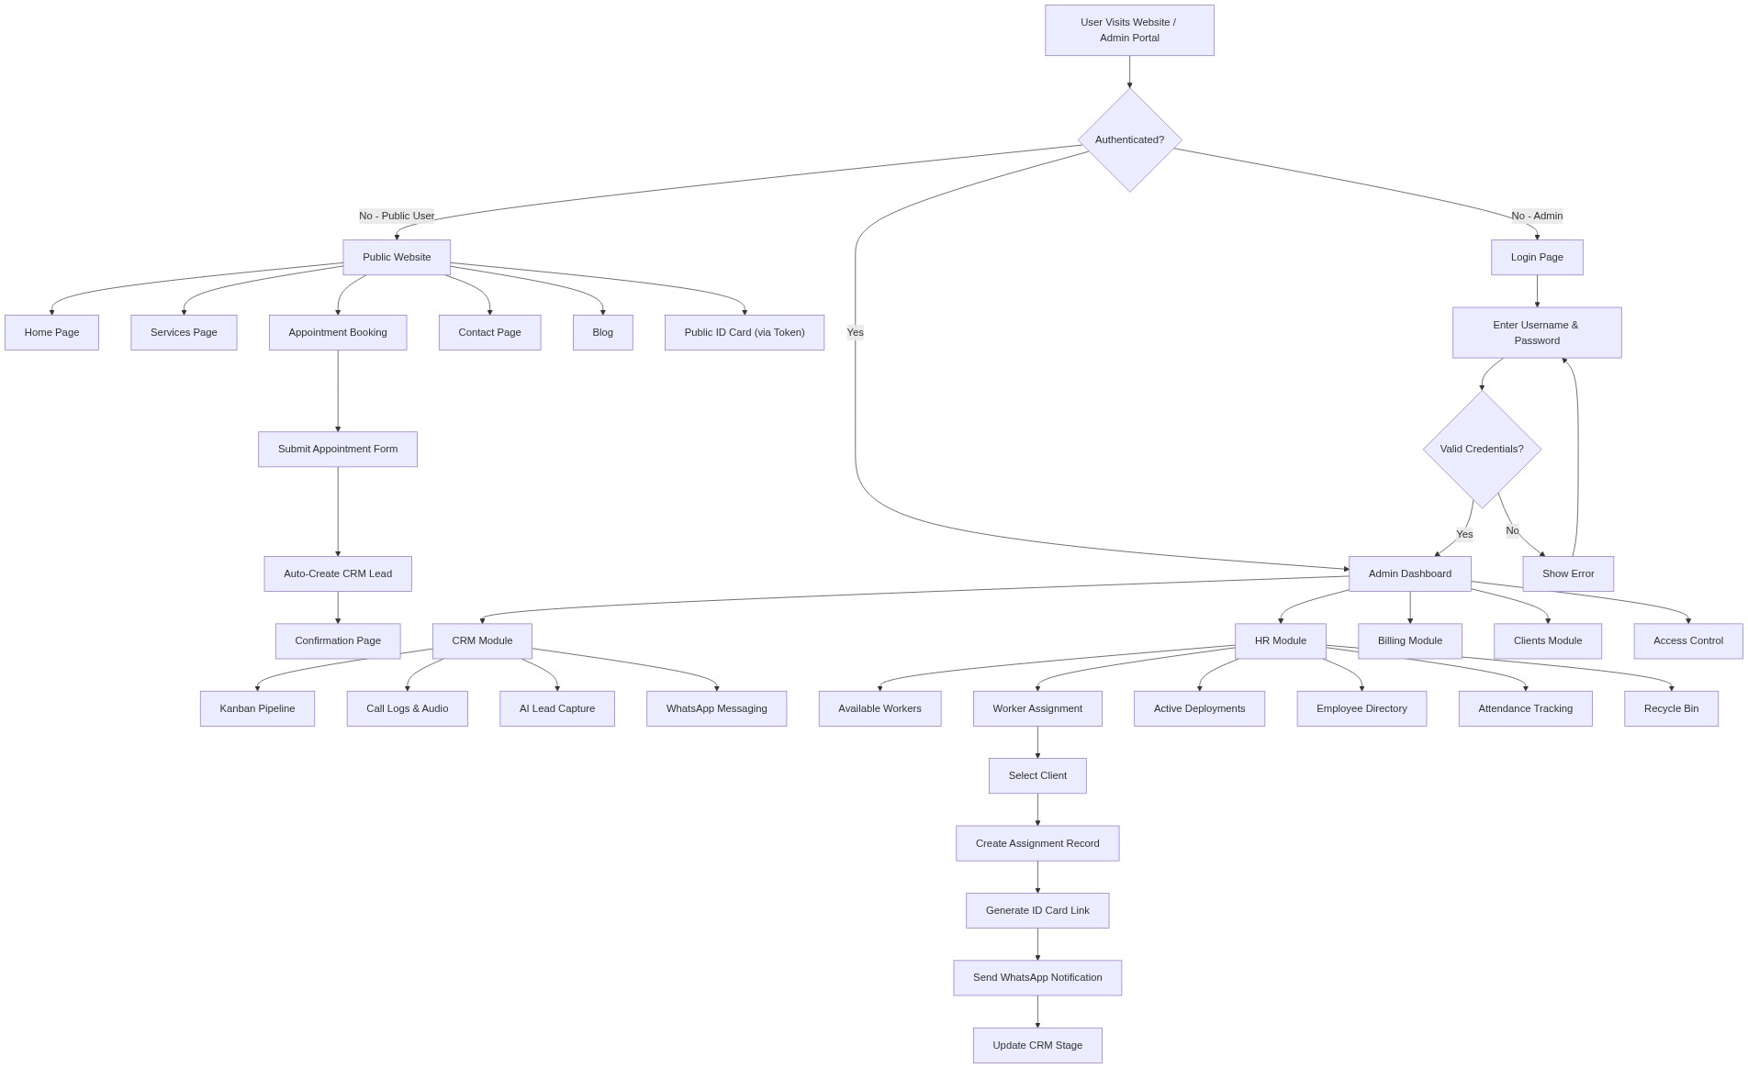

Figure 7.1b — Public website module and appointment booking sub-flow
Figure 7.1c — Admin dashboard module overview and sub-functions

Figure 7.1d — Worker assignment sub-flow within the HR module

7.2 Data Flow Diagram — Level 0 (Context Diagram)
The context diagram shows the entire 99Care OS as a single central process. All five external entities and their bidirectional data flows are shown.
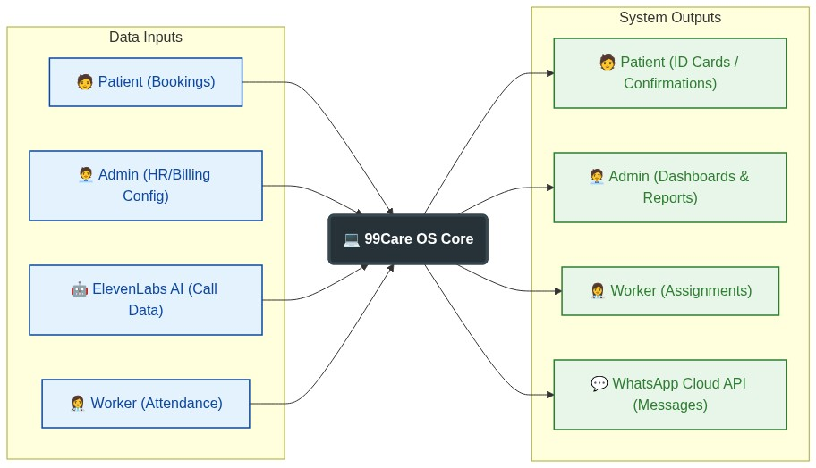
Figure 7.2 — DFD Level 0: Context diagram showing 99Care OS and all external entities

7.3 Data Flow Diagram — Level 1
Six major processes are shown with external entities on the left, data stores on the right, and clearly labelled data flows between them.
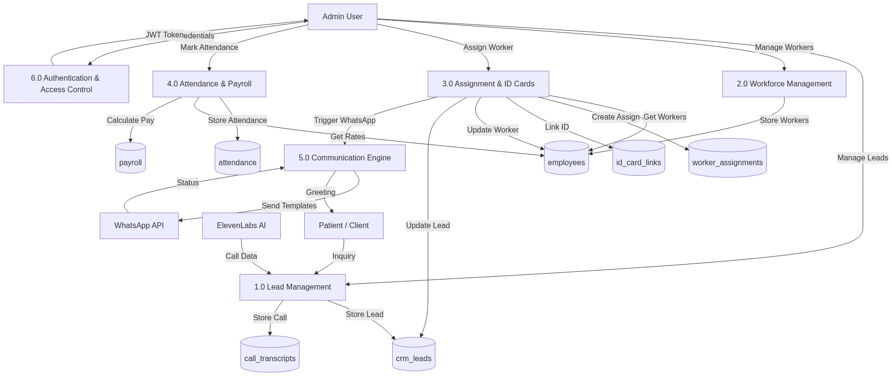
Figure 7.3 — DFD Level 1: Six major processes, external entities, and seven data stores

7.4 Entity Relationship Diagram (ERD)
Nine database entities are shown with their key fields. Relationship labels show cardinality (1 = one, * = many). PK = Primary Key, FK = Foreign Key, UK = Unique Key.
Figure 7.4 — Entity Relationship Diagram showing all nine database tables and their relationships
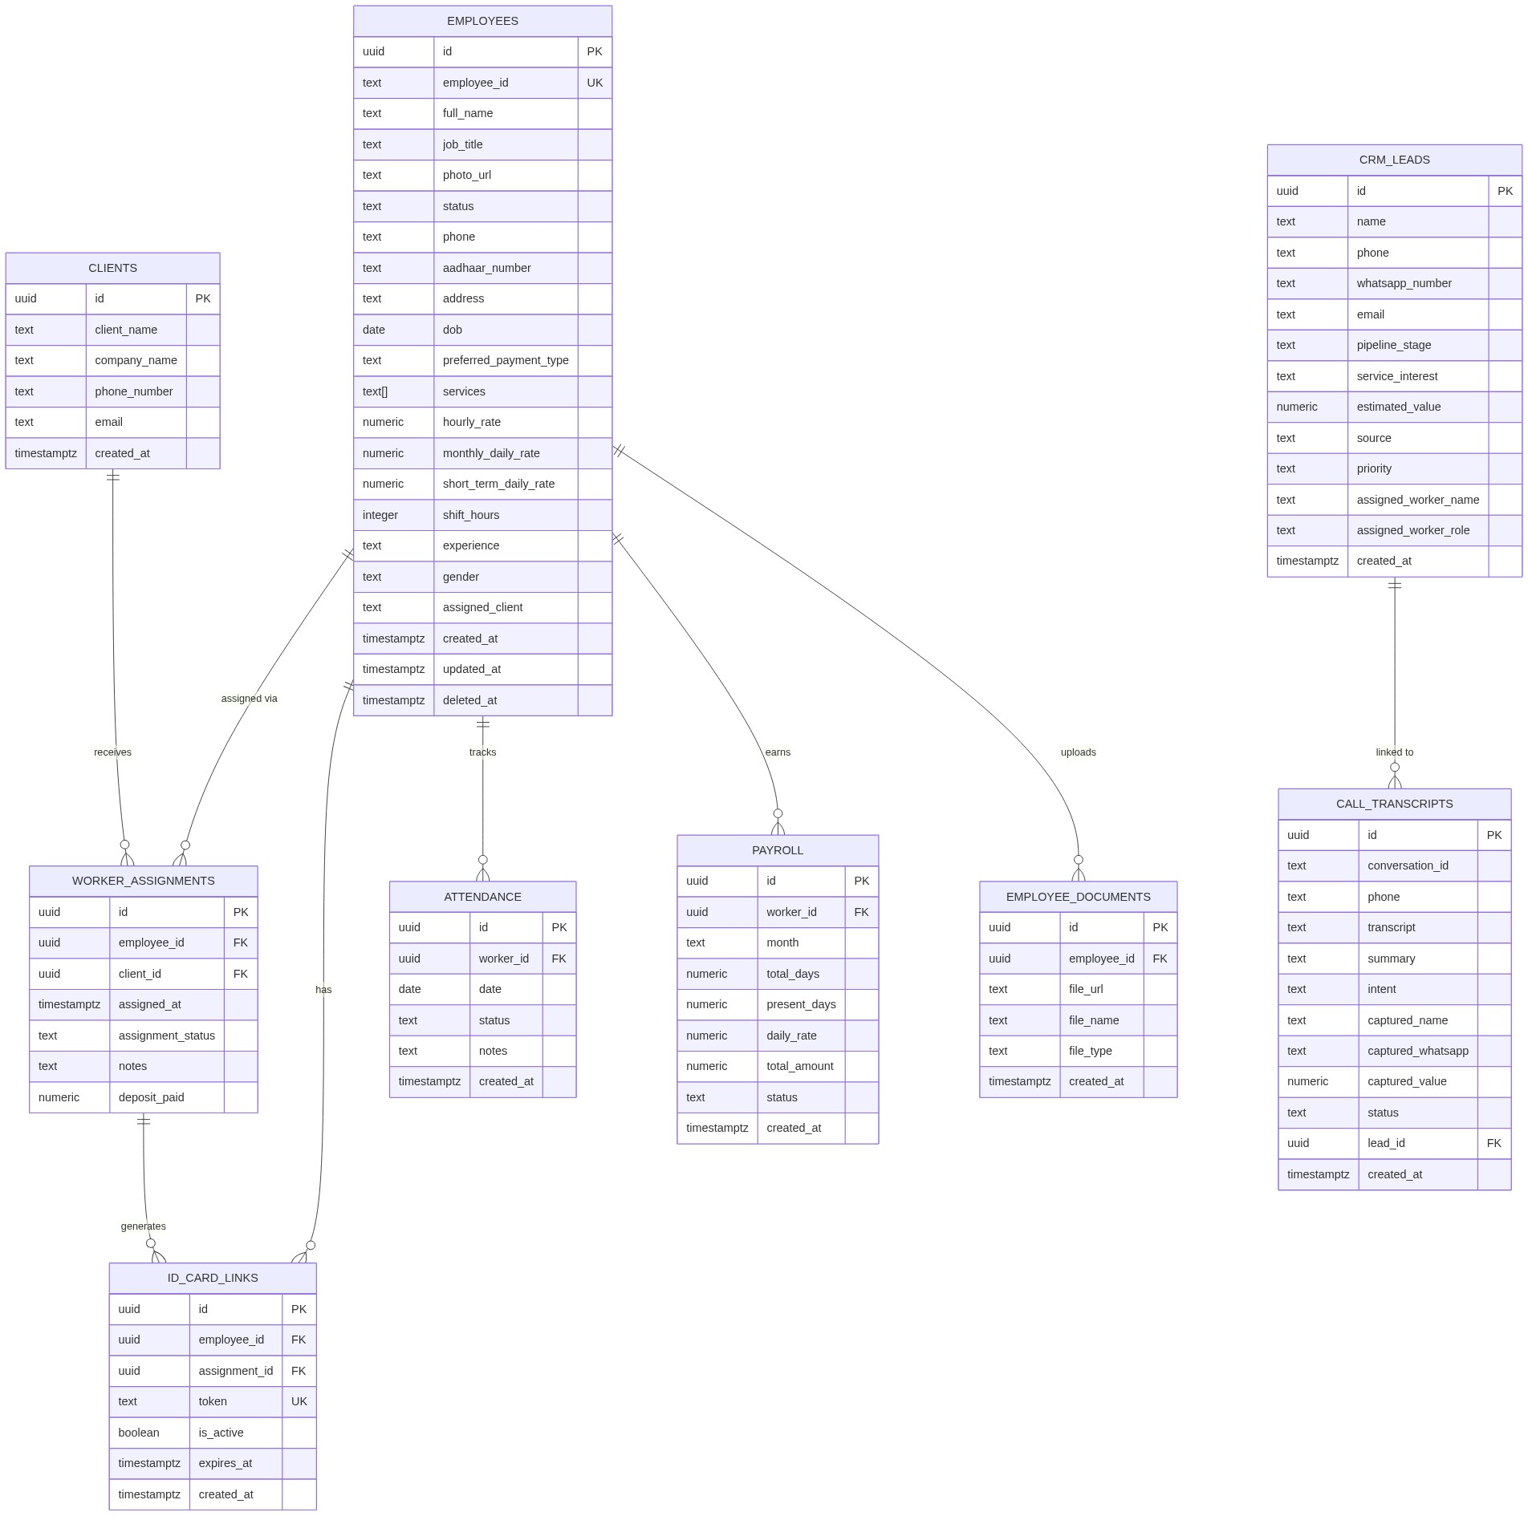

7.5 Use Case Diagram
The use case diagram shows interactions between four actor types and the twenty use cases. Use cases are grouped and colour-coded by the primary actor who initiates them.
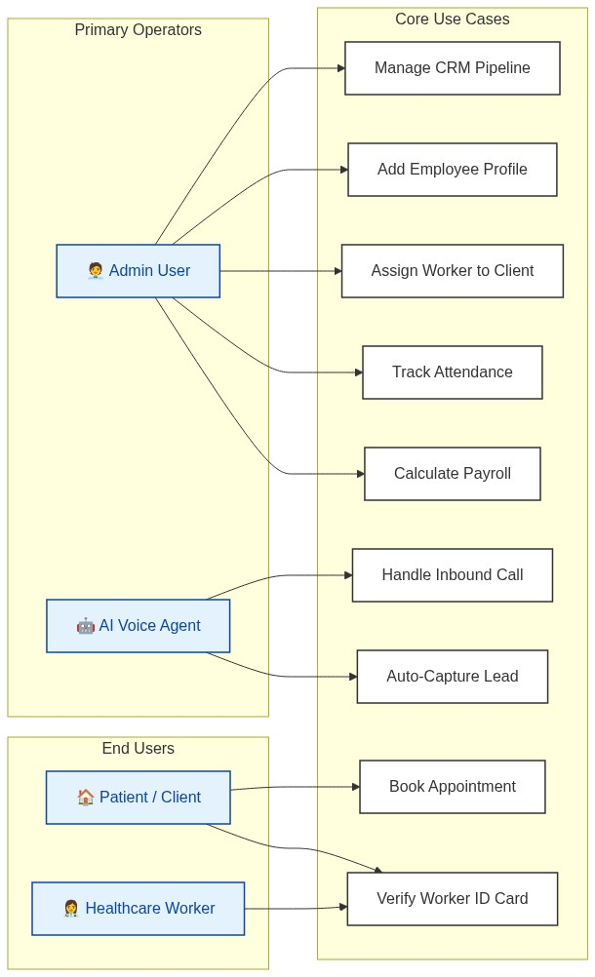
Figure 7.5 — Use Case Diagram showing all actors and their interactions with 99Care OS

7.6 Class Diagram
Eight application-layer classes are shown with attributes, methods, and relationships. Solid arrows = associations; dashed arrows = dependencies.
Figure 7.6 — Class Diagram: eight application-layer classes and their relationships
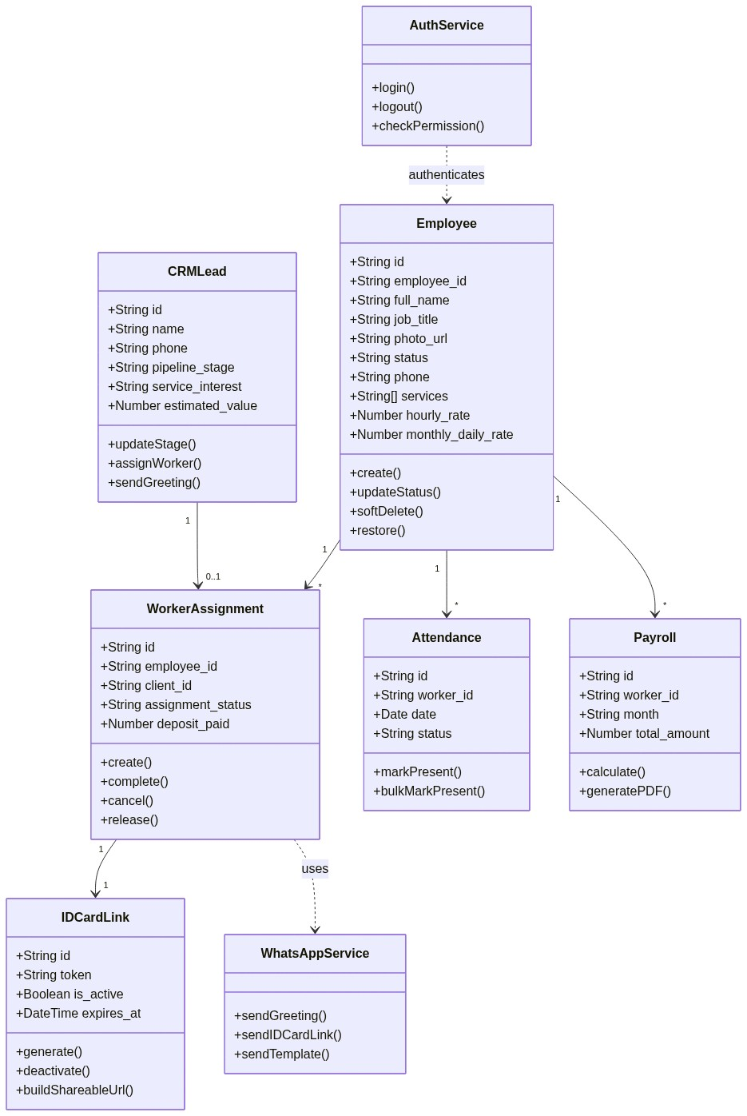

7.7 Sequence Diagram — Lead Intake Flow (AI Voice Call)
This diagram shows the sequence of interactions when a patient calls 99 Care. The AI agent handles the call, extracts lead data, inserts it into the database, and automatically sends a WhatsApp greeting to the caller.
Figure 7.7 — Sequence Diagram: AI voice call lead intake flow (11 steps)
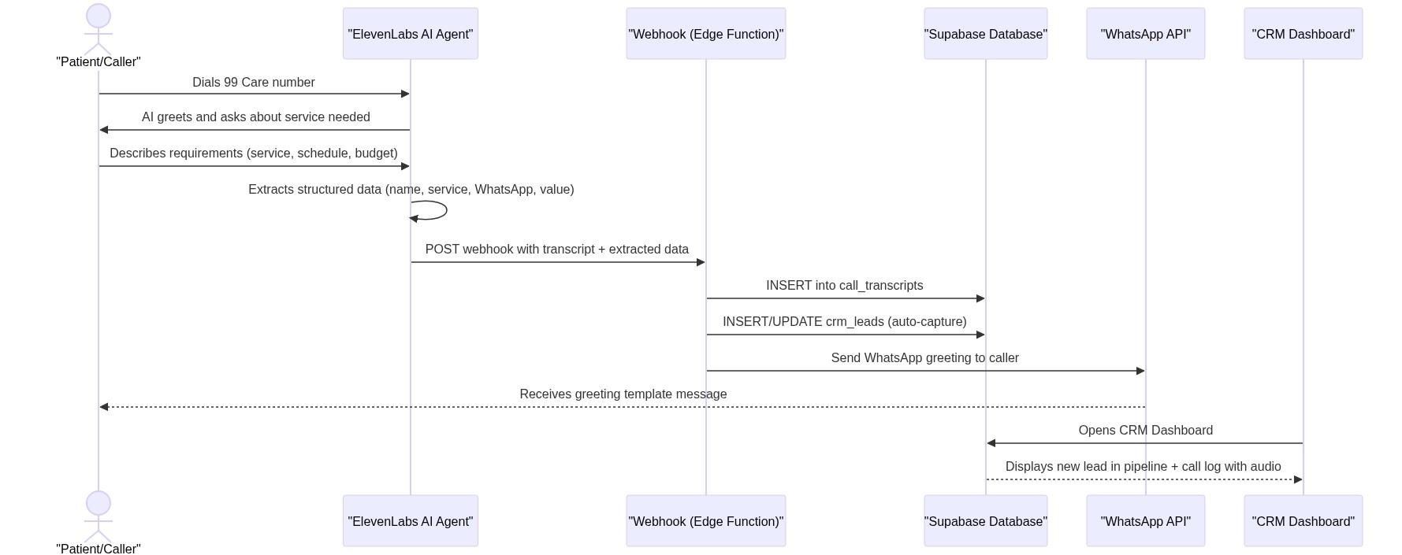

7.8 Sequence Diagram — Worker Assignment Flow
This diagram shows the complete 15-step sequence when an administrator assigns a healthcare worker to a client — from clicking "Assign" through database updates, token generation, and WhatsApp notification delivery.
Figure 7.8 — Sequence Diagram: Worker assignment flow from "Assign" click to WhatsApp notification (15 steps)
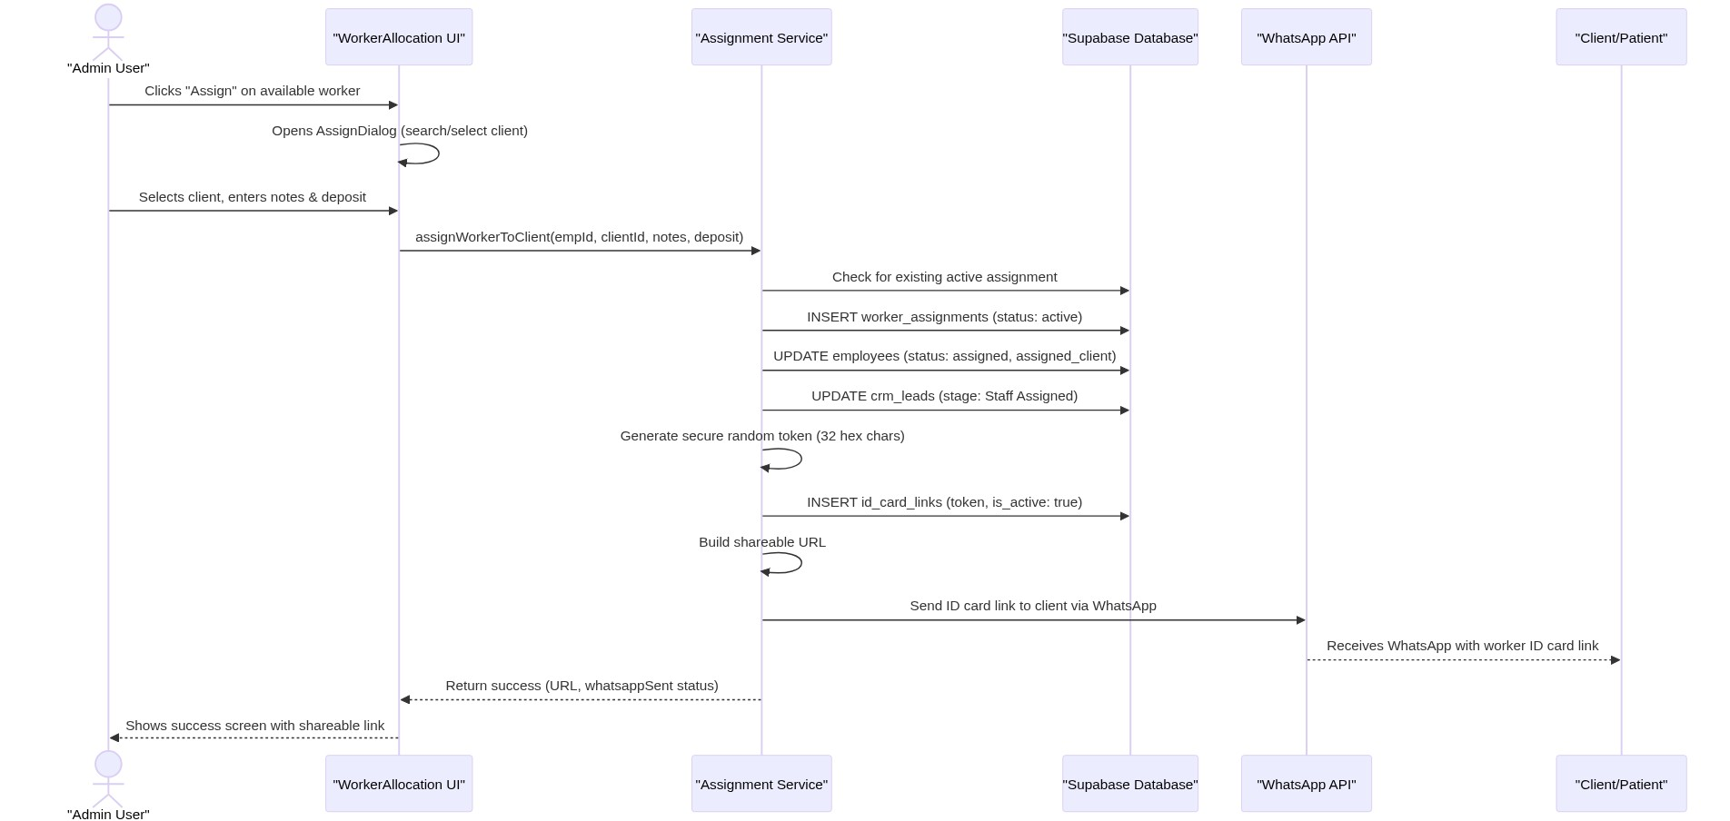

CHAPTER 8: FRONT-END SCREENS
This chapter presents the key user interface screens of the 99Care OS system. Each screen is described with its purpose, key elements, and navigation context.

8.1 Public Website — Home Page
Purpose: The landing page of the 99care.org public website. It serves as the first point of contact for potential clients and provides an overview of 99 Care’s services.
Key Elements:
- Hero section with a prominent call-to-action (“Book Appointment”)
- Service highlights (Elderly Care, Nursing, Baby Care, Physiotherapy, etc.)
- Statistics section (years of experience, happy patients, healthcare workers)
- Testimonials carousel
- WhatsApp chat widget for instant communication
- Responsive navigation with mobile hamburger menu
Navigation: Accessible at the root URL (/). Links to Services, About, Contact, and Appointment pages.
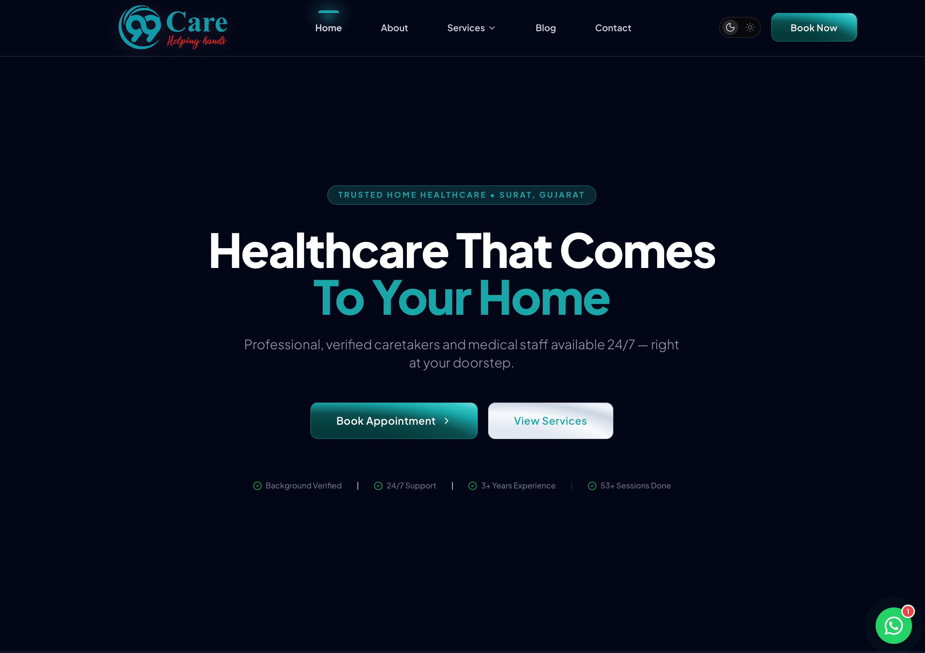
Figure 8.1 — Public Website Home Page (Hero Section)

8.2 Public Website — Services Page
Purpose: Displays all healthcare services offered by 99 Care with descriptions and icons.
Key Elements:
- Grid of service cards with icons, titles, and brief descriptions
- Tabs for Nursing Services and Caretaker Services
- Each card links to a detailed service page with a “Learn more” button
- Animated entrance effects using Framer Motion
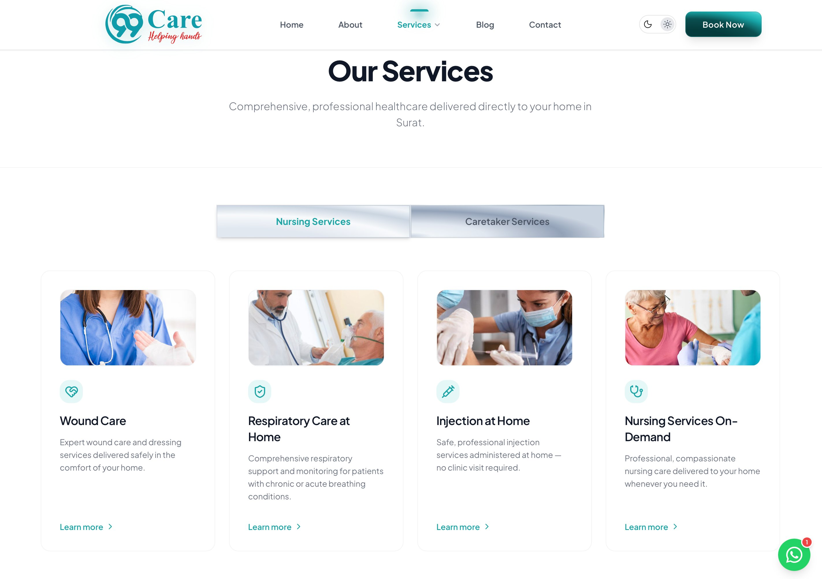
Figure 8.2 — Public Website Services Page

8.3 Public Website — Appointment Booking
Purpose: Allows potential clients to book an appointment online, which automatically creates a lead in the CRM pipeline.
Key Elements:
- Multi-field form: Full Name, Phone Number, Email Address, Service Required, Preferred Date & Time, Location in Surat, Additional Notes
- Form validation with error messages
- Side panel with contact details: phone, email, WhatsApp, business hours, and head office address
- Success confirmation page after submission
- Auto-triggers CRM lead creation via Supabase
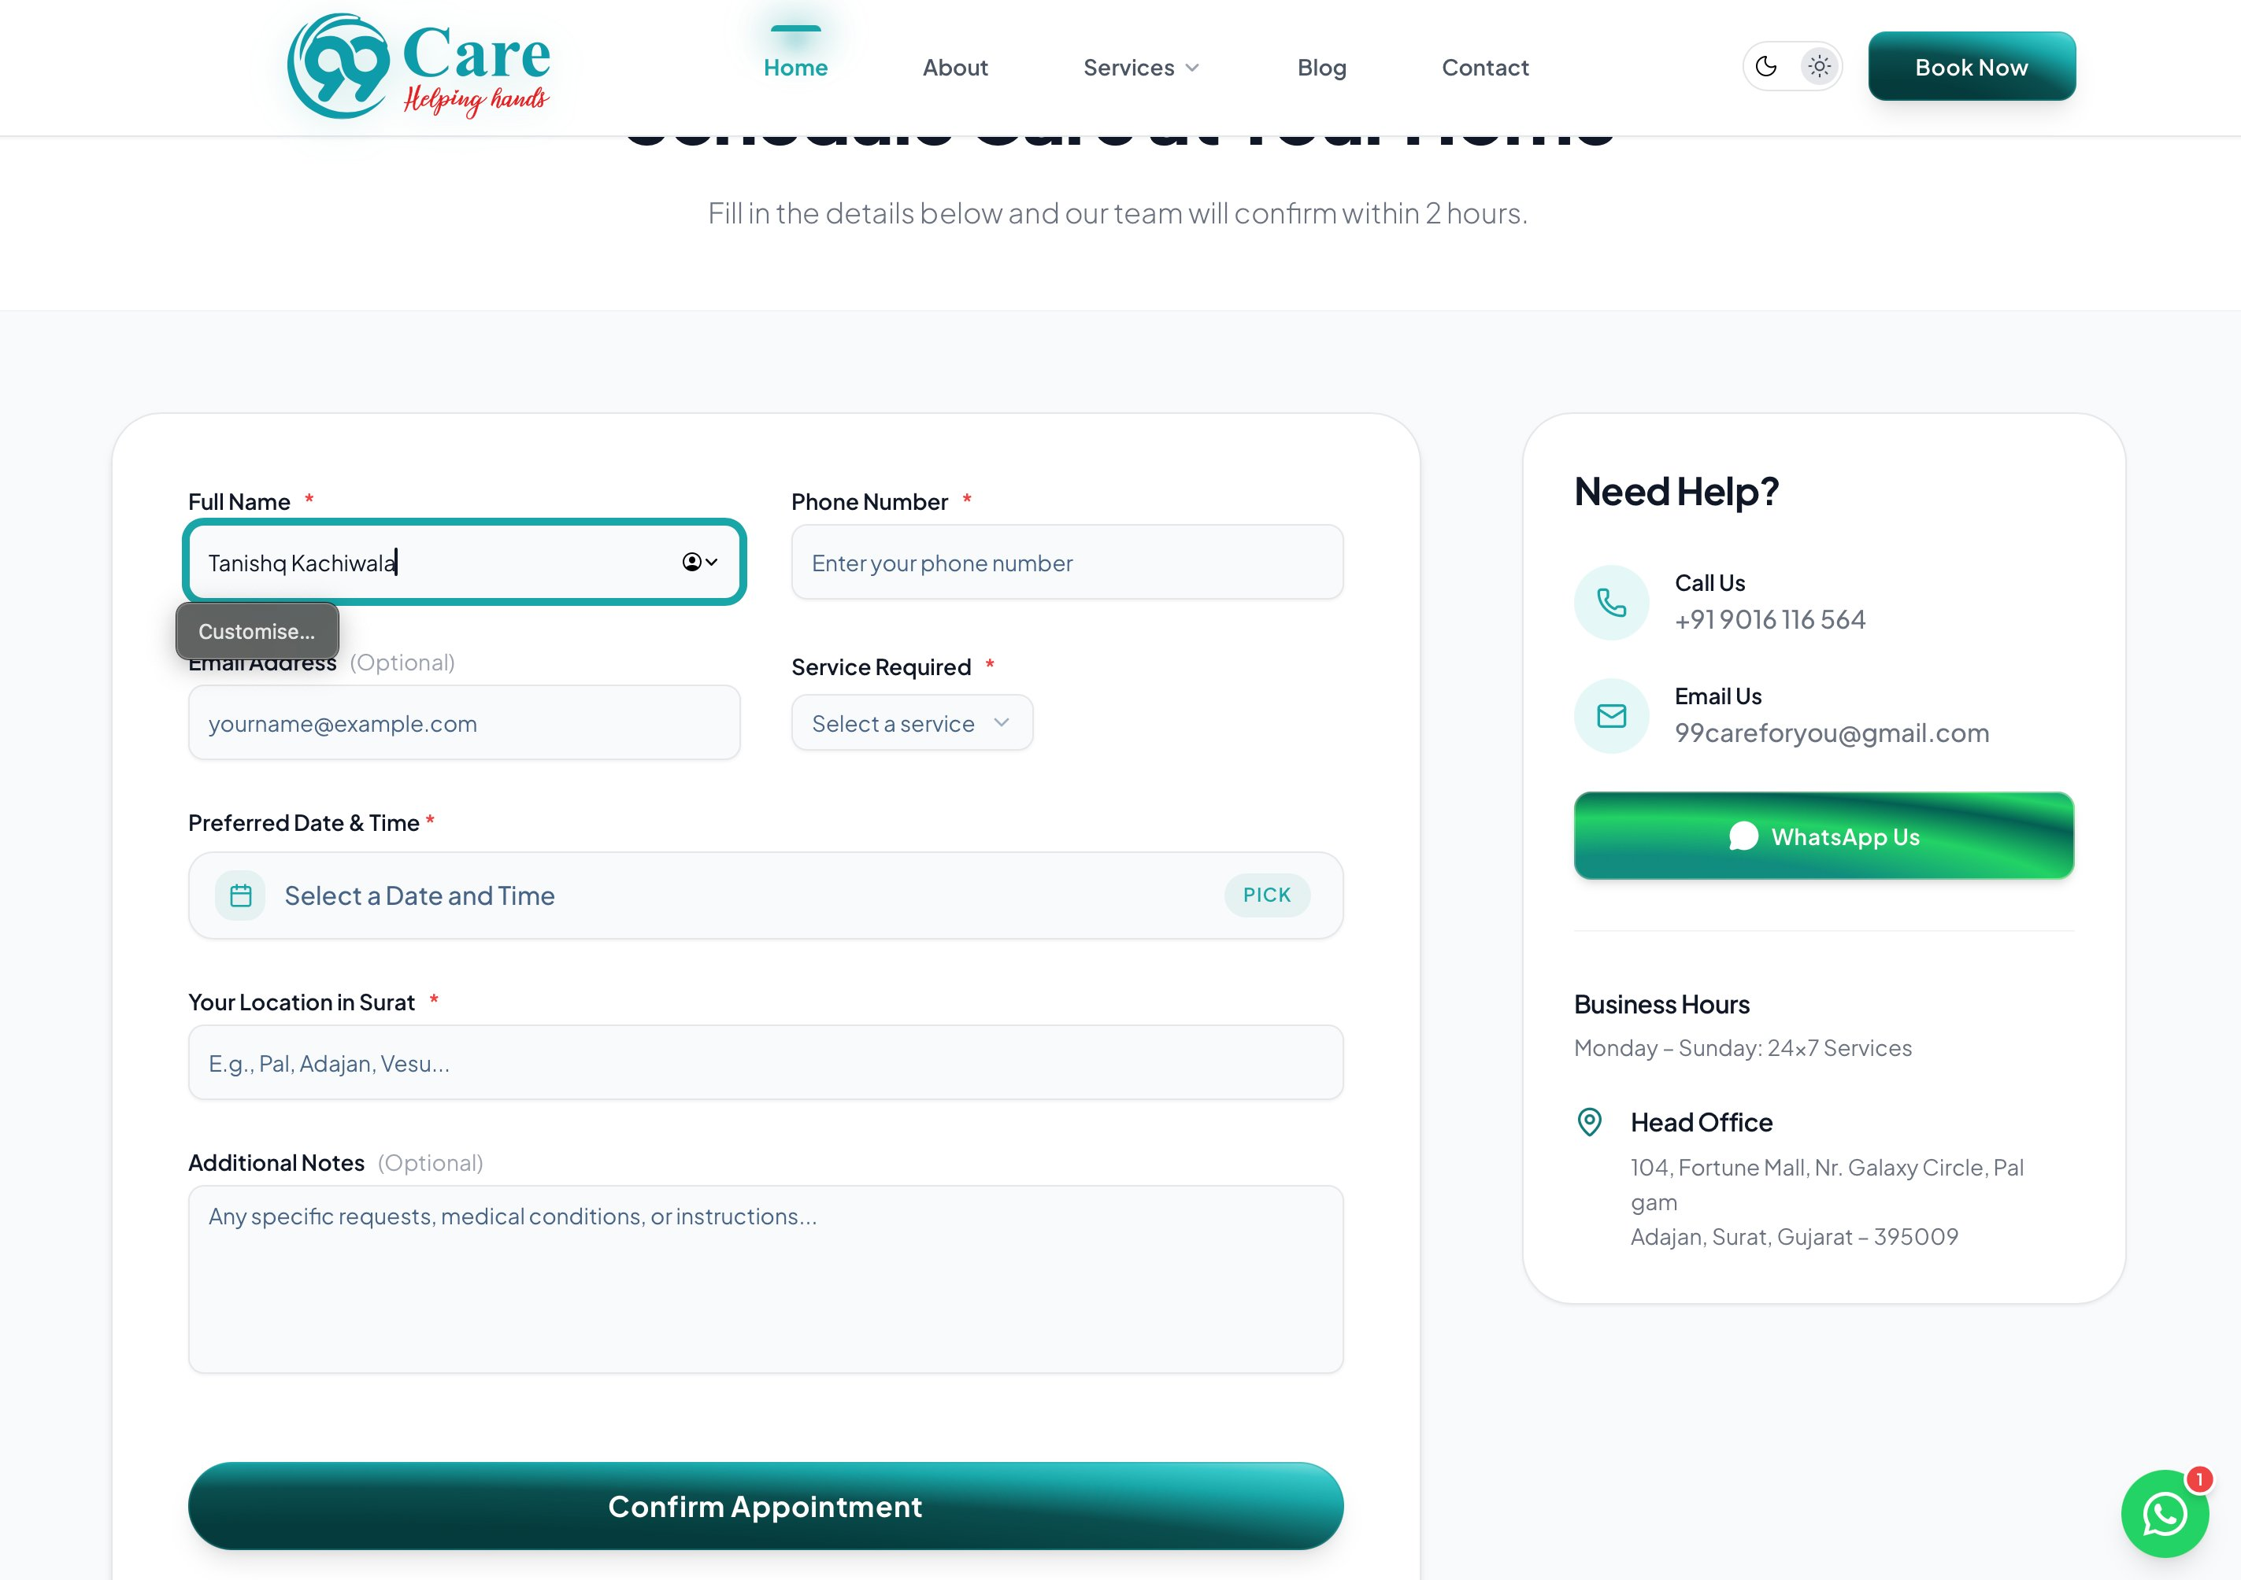
Figure 8.3 — Public Website Appointment Booking Form

8.4 Login Screen
Purpose: Secure authentication gateway for admin and staff users.
Key Elements:
- Clean, centered card design with 99Care logo and branding
- Username and password fields with validation
- Loading state with spinner during authentication
- Error message display for invalid credentials
- “Secured by 99Care OS Authentication” footer label
- Responsive design for mobile and desktop
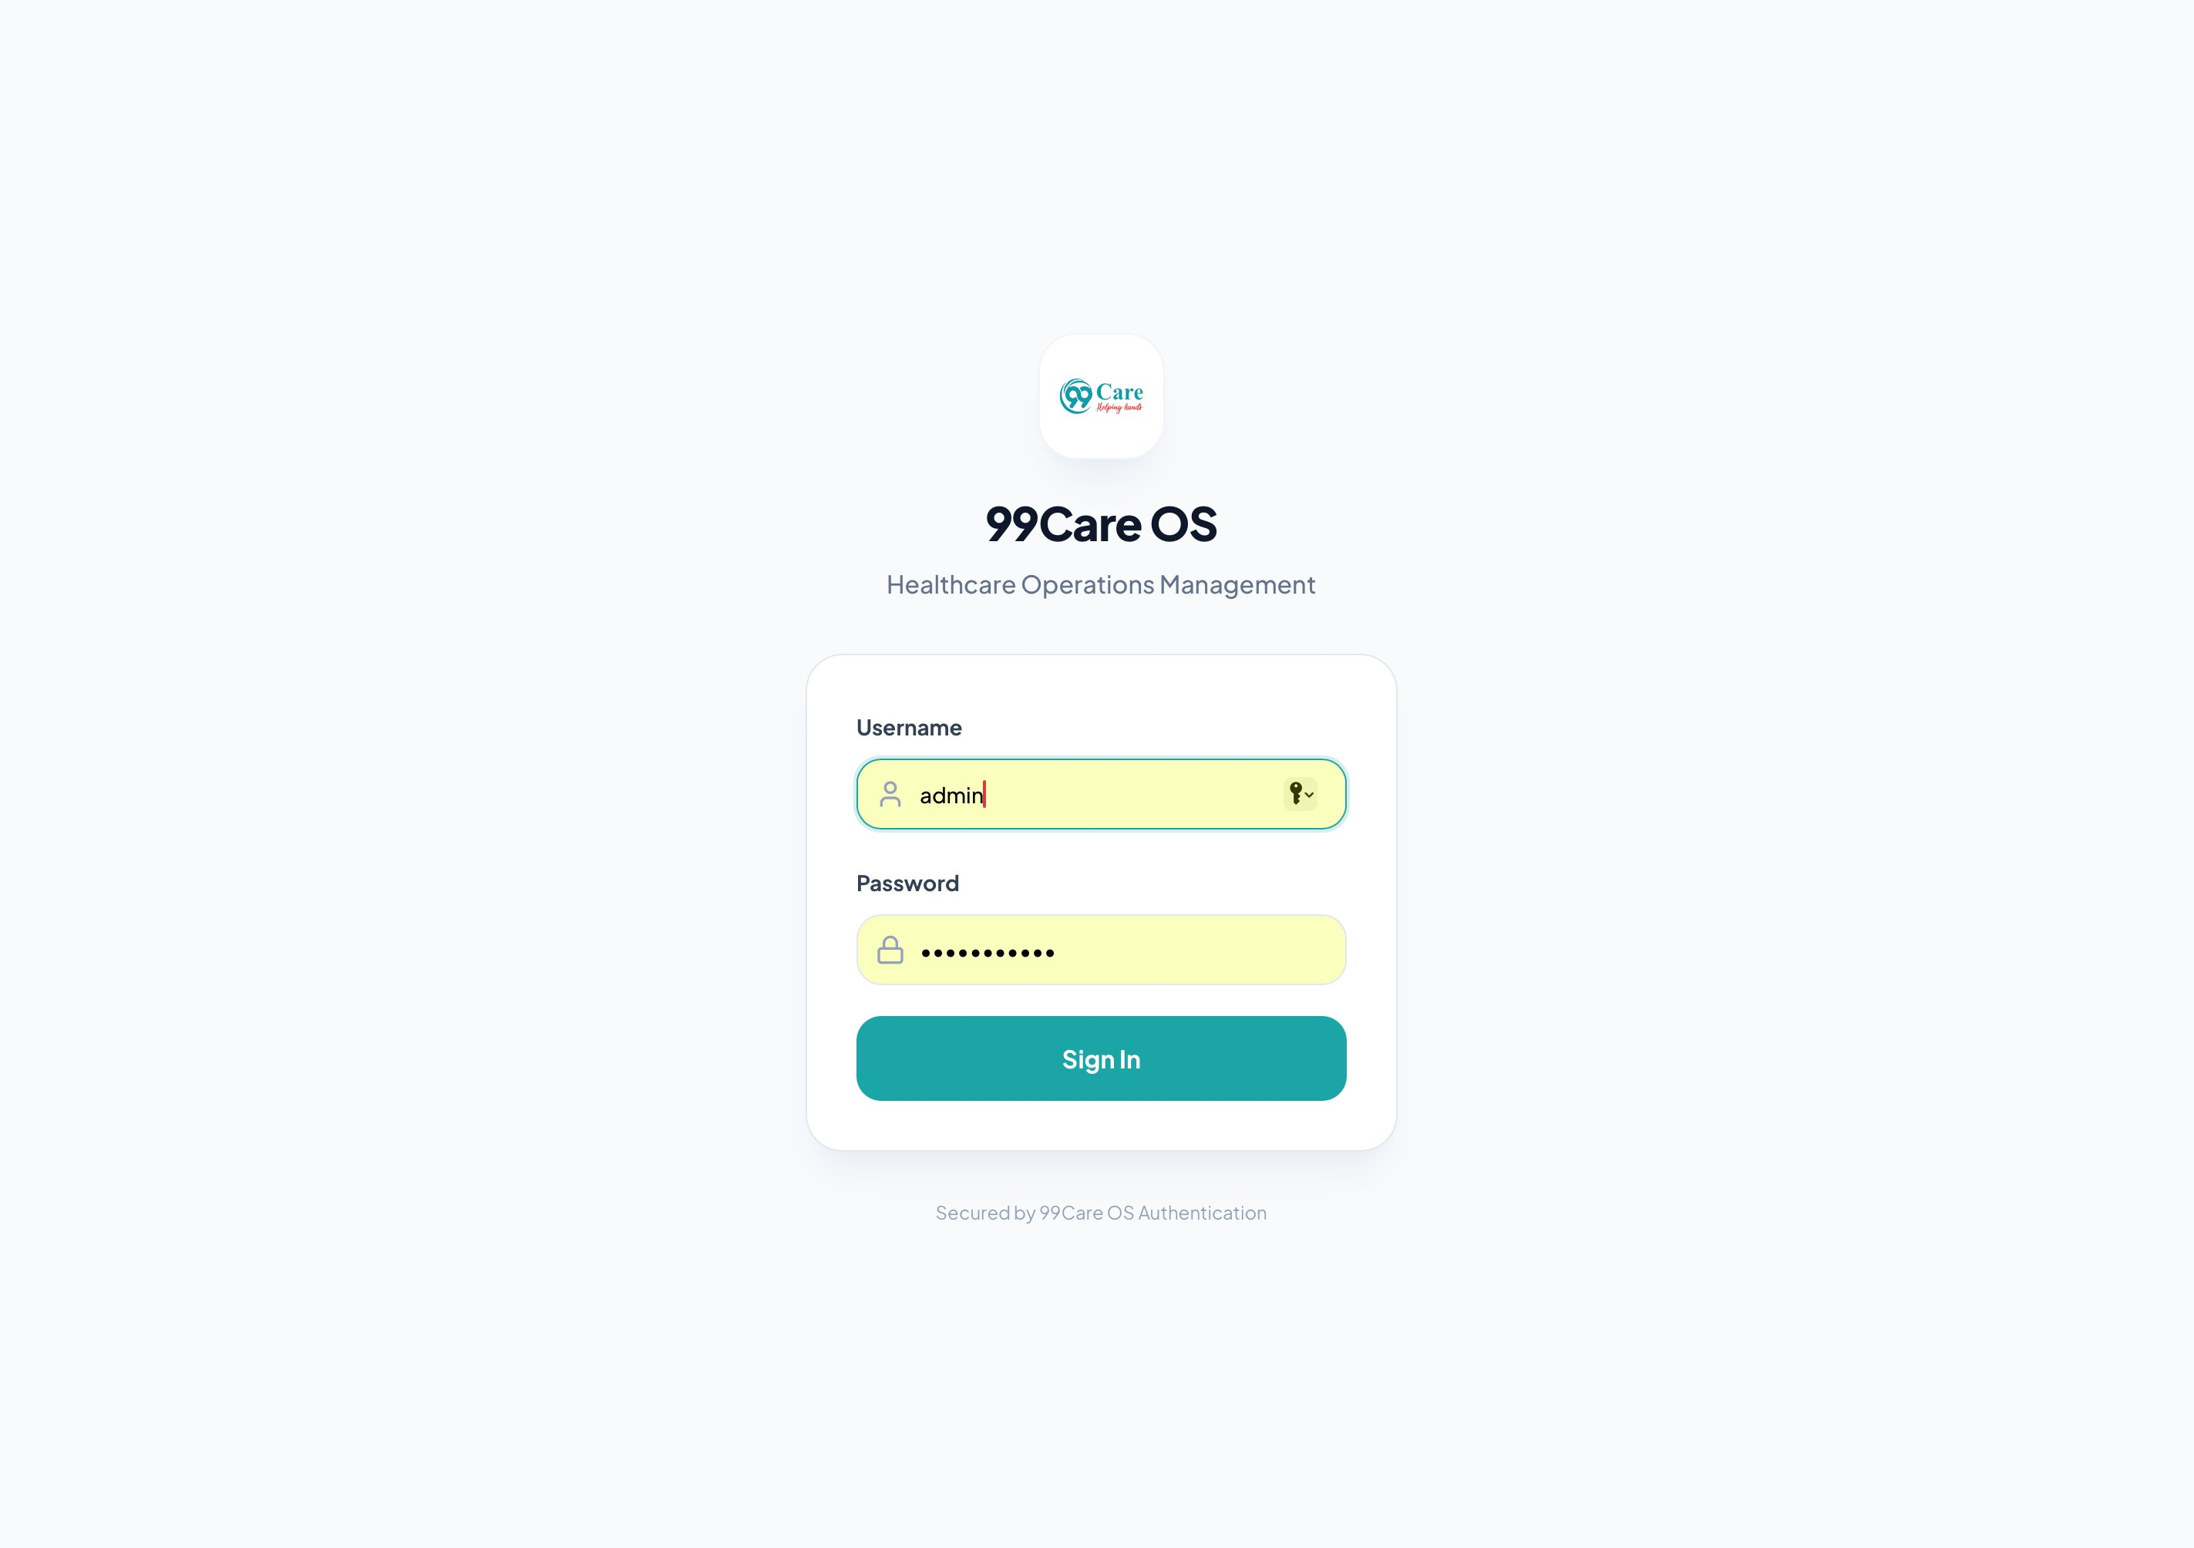
Figure 8.4 — Login Screen (99Care OS Authentication)

8.5 Admin Dashboard
Purpose: The main landing page after login, providing a high-level overview of business metrics.
Key Elements:
- Summary metric cards: Active Leads, Active Deployments, Platform MRR, AI Voice Calls
- Monthly Recurring Revenue (MRR) area chart with projected trajectory
- Recent AI Activity live stream panel
- Sidebar navigation: Dashboard, AI CRM, Clients, AI HR, Finance, Access Control
- Global search bar and View Public Site shortcut in the top bar
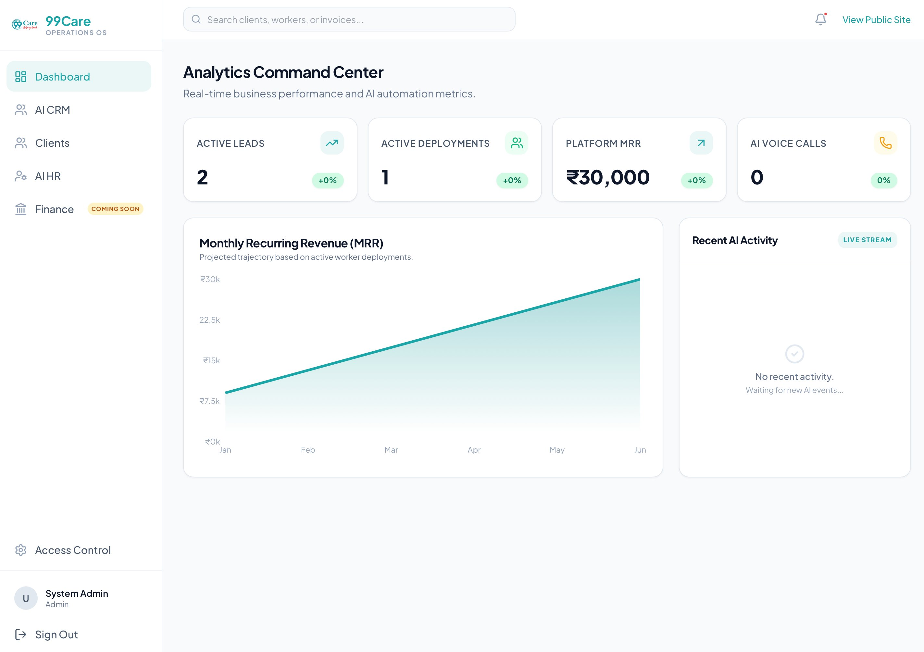
Figure 8.5 — Admin Dashboard (Analytics Command Centre)

8.6 CRM — Kanban Pipeline View
Purpose: Visual pipeline management for tracking leads through various stages.
Key Elements:
- Lead cards organised in collapsible rows by pipeline stage with lead counts per stage
- Stages: New Inquiry → In Discussion → Quotation Sent → Form Submitted → Staff Assigned → Deposit Pending → Active Client
- Each card displays lead name, priority badge (Medium/High), phone number, and time since creation
- Live Sync Active indicator for real-time updates
- Add Lead and Export CSV action buttons in the top bar
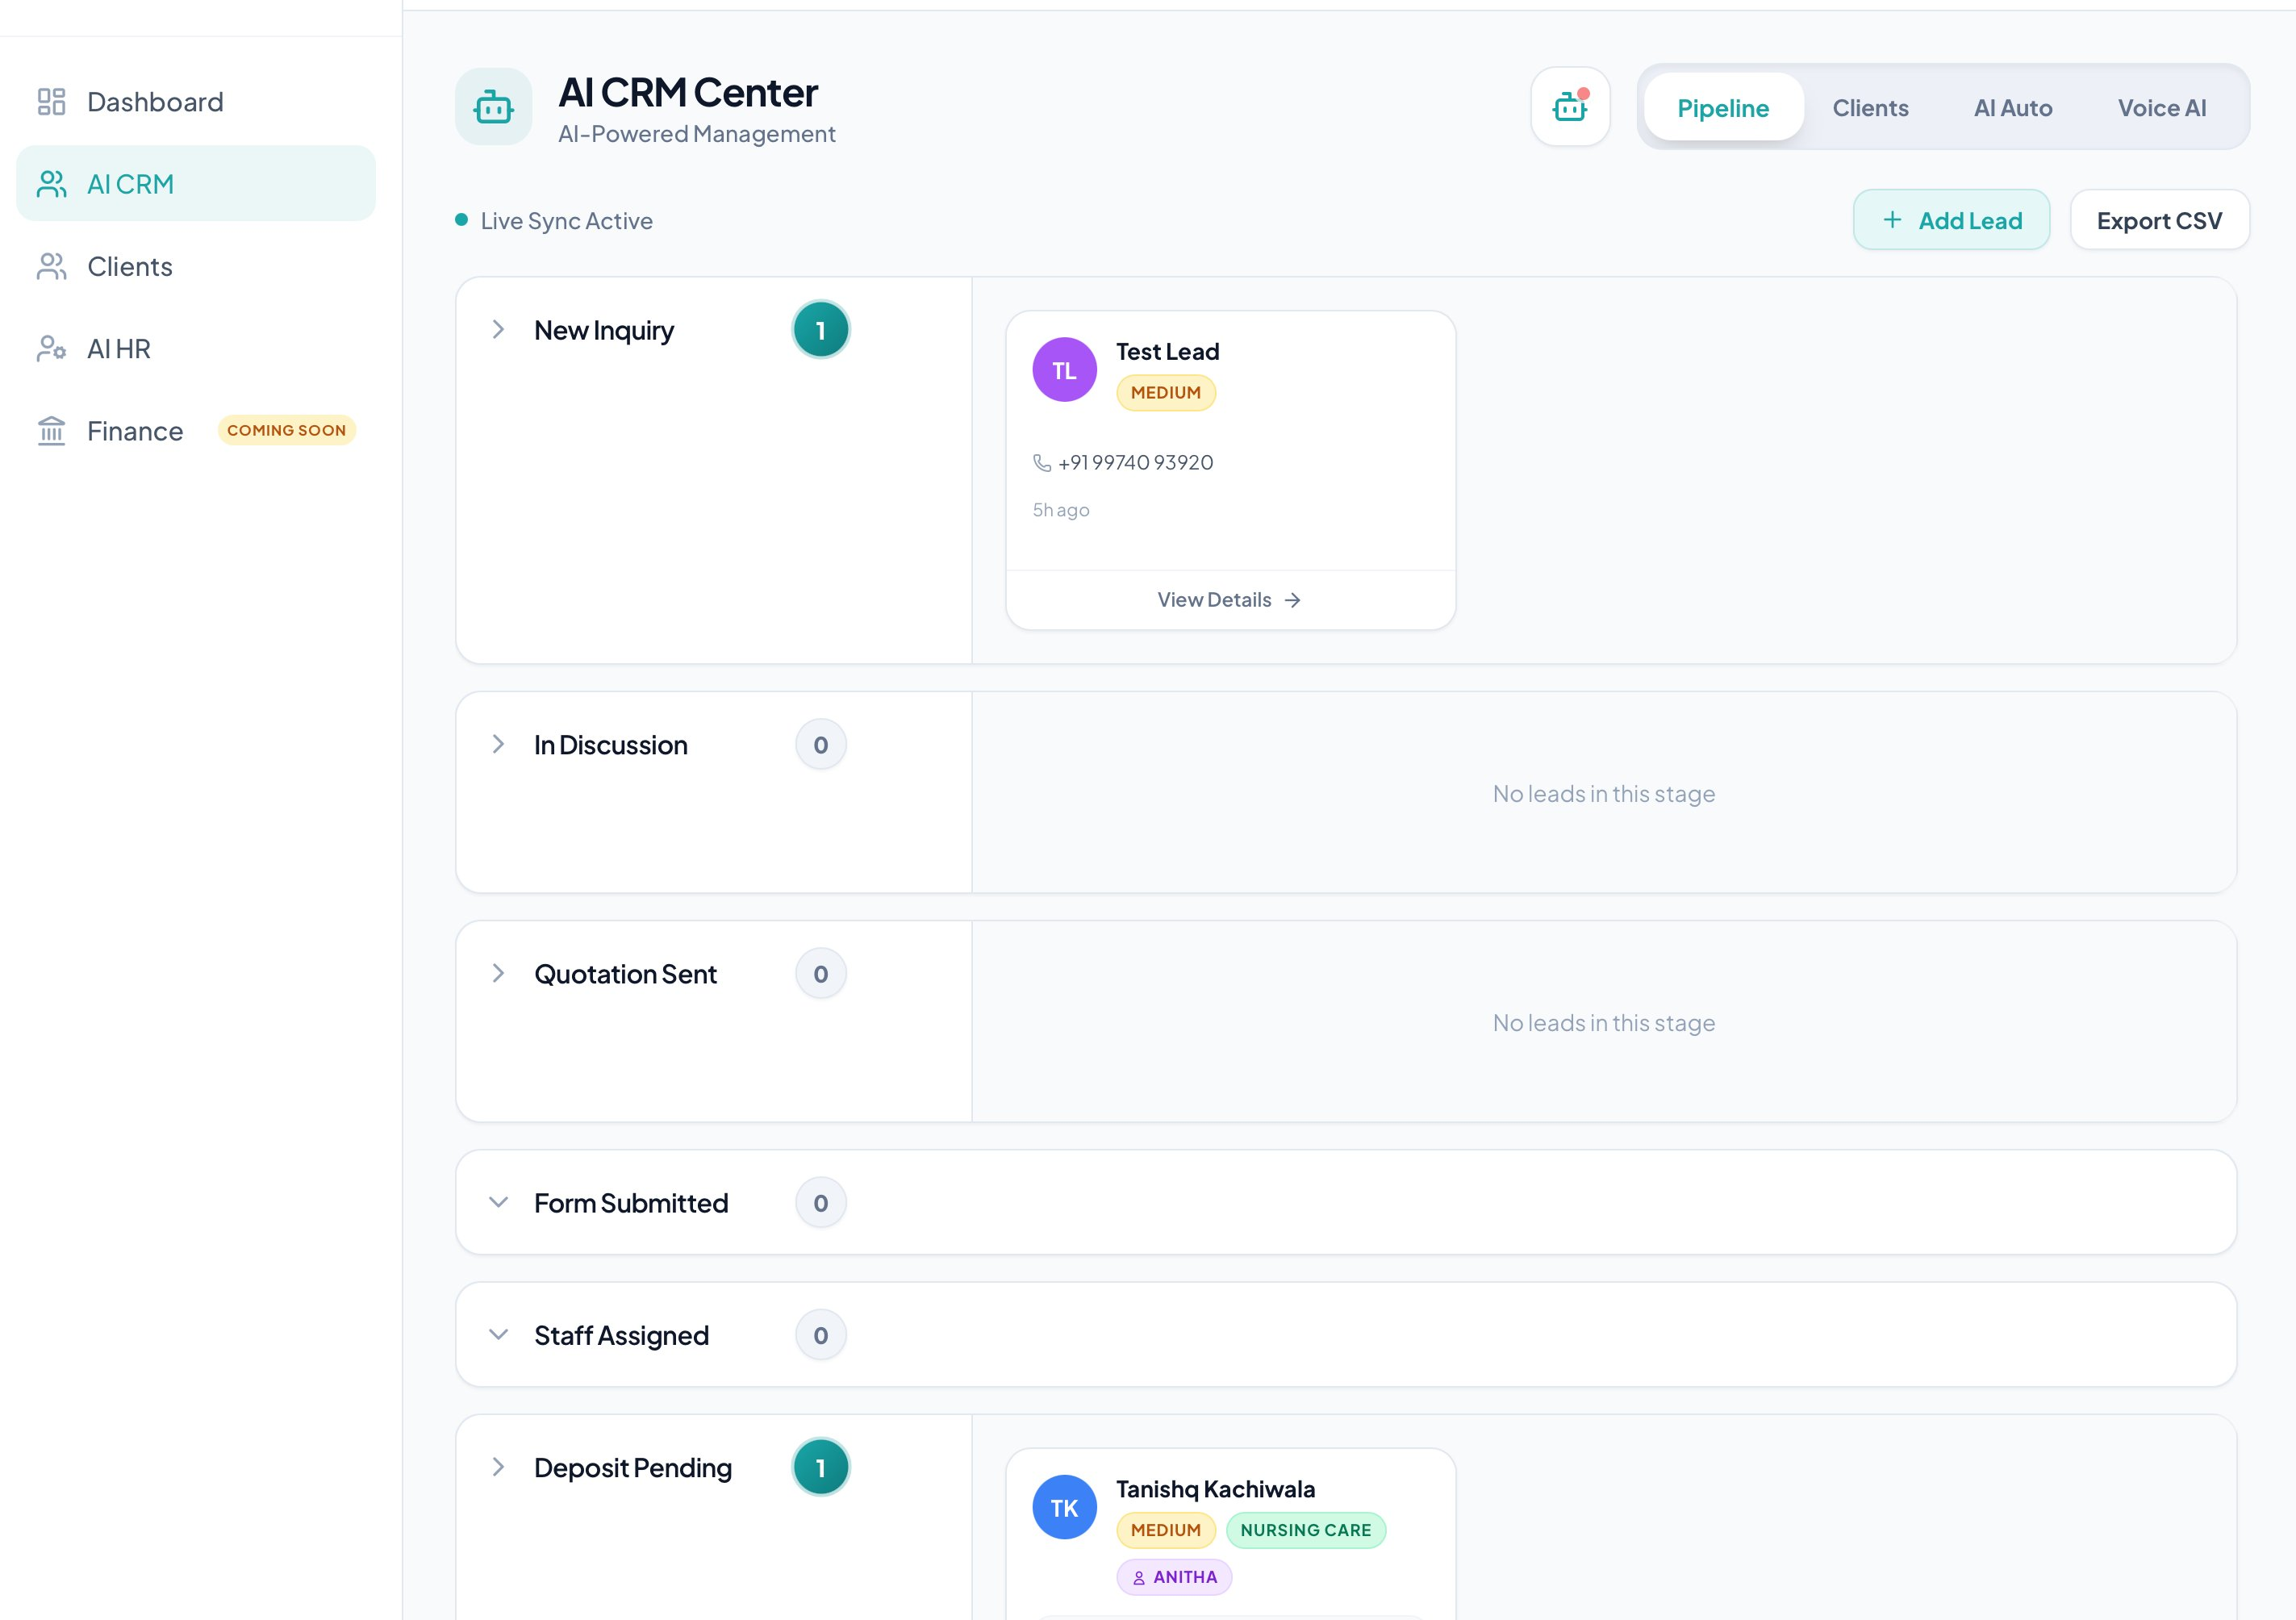
Figure 8.6 — CRM Kanban Pipeline View (AI CRM Centre)

8.7 CRM — Call Logs with AI Summary
Purpose: Displays AI-processed call recordings with transcripts and auto-captured lead data.
Key Elements:
- Summary stats panel: Total AI Calls Today, Leads Captured via Voice, Avg. Call Duration, and Start Web Call button
- Call entries with caller name, call type badge (INBOUND), duration, and date
- Audio player per entry with track ready status indicator
- AI Summary & Intent tag (e.g., New Born Baby Care) and AI-generated call summary
- “Lead Data Captured” panel showing caller name, estimated value, phone, and WhatsApp number
- “Sent (Resend?)” and “+ Add to Pipeline” action buttons
- “View Full Transcript” button to open the complete call transcript modal
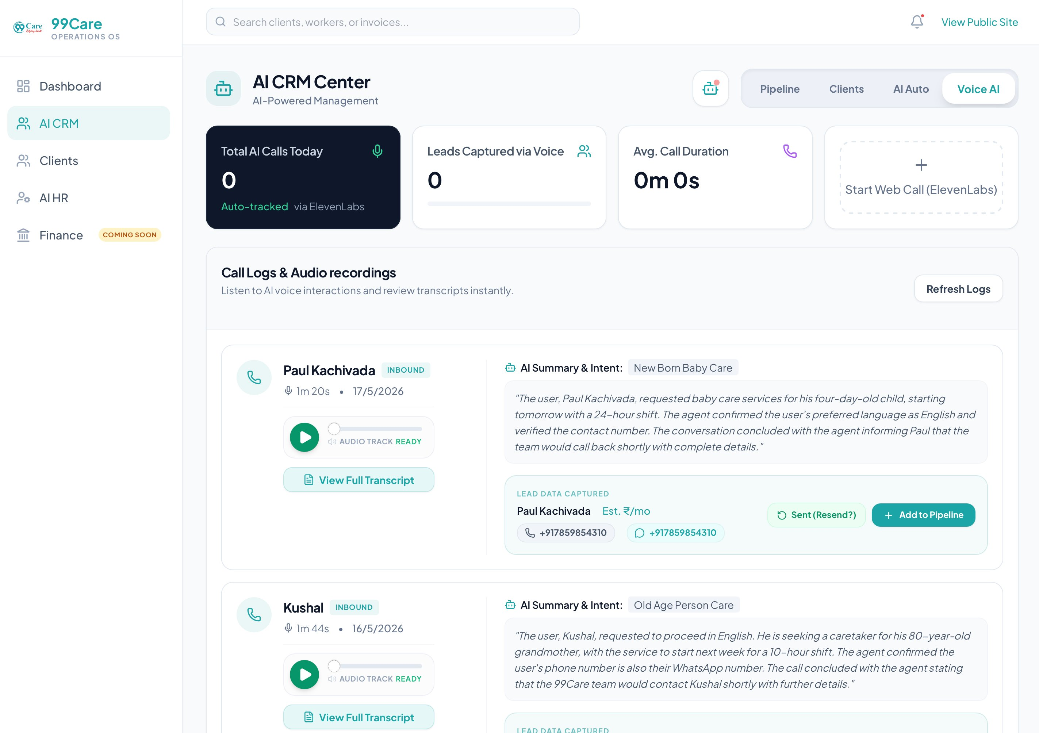
Figure 8.7 — CRM Voice AI: Call Logs and AI Summary Panel

8.8 HR — Available Workers Tab
Purpose: Displays all healthcare workers currently available for assignment.
Key Elements:
- Card-based grid layout with worker photo or avatar, full name, job title, and availability status badge
- Skills, contact number, and join date displayed on each worker card
- “ID Card” and “Assign” action buttons on each card
- Search bar by name, role, or ID with a refresh icon button
- Module tabs: Available Workers, Deployments, Directory, Trash
- Add Employee button in the top-right corner
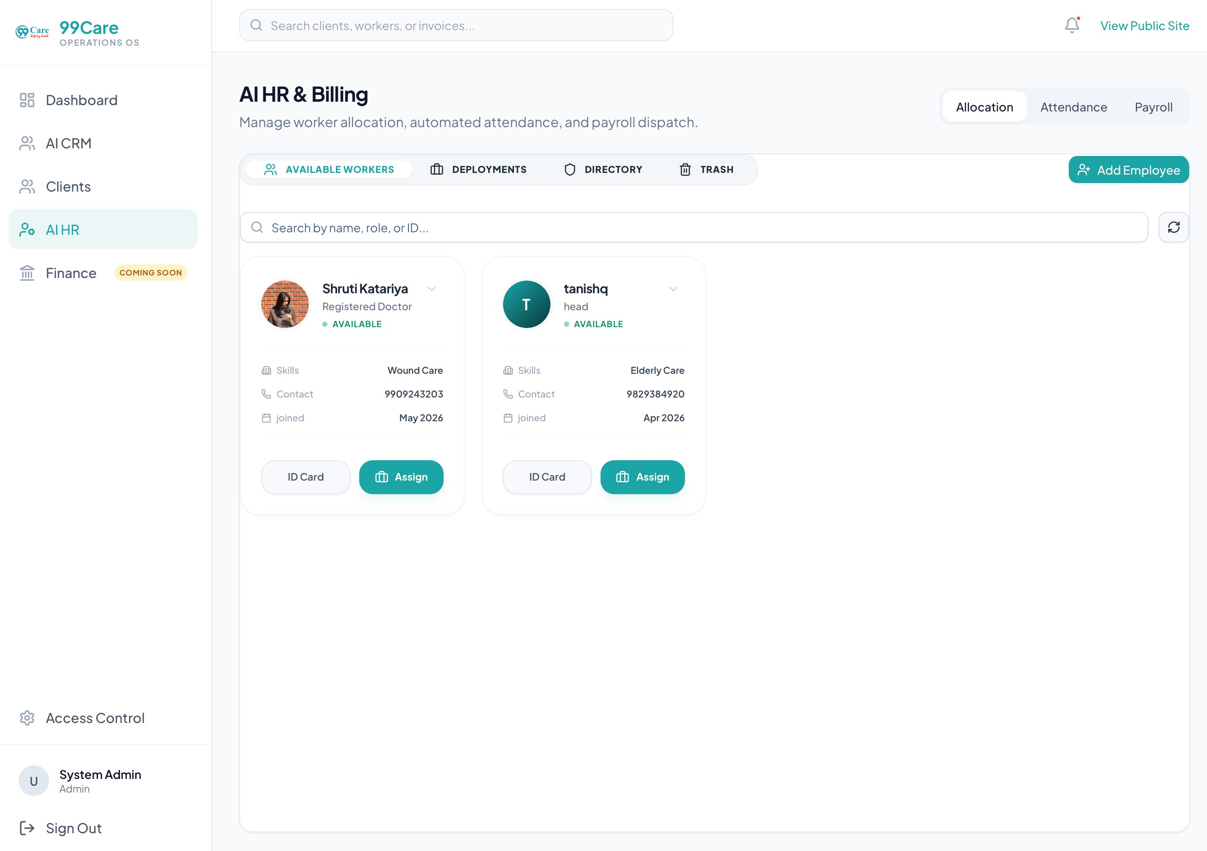
Figure 8.8 — HR Module: Available Workers Tab

8.9 HR — Active Deployments Tab
Purpose: Shows all currently active worker-to-client assignments.
Key Elements:
- Table view with columns: Staff Member, ID No., Client Name, Deployment Date, Auth Link, Deployment Actions
- Client confirmation status badge (e.g., CONFIRMED) shown beneath the client name
- Deployment Actions: ID Card preview, Resend Link via WhatsApp, Release worker, Terminate assignment
- Shareable Auth Link shown in truncated form with copy and external link icon buttons
- Active deployment count badge displayed in the section header
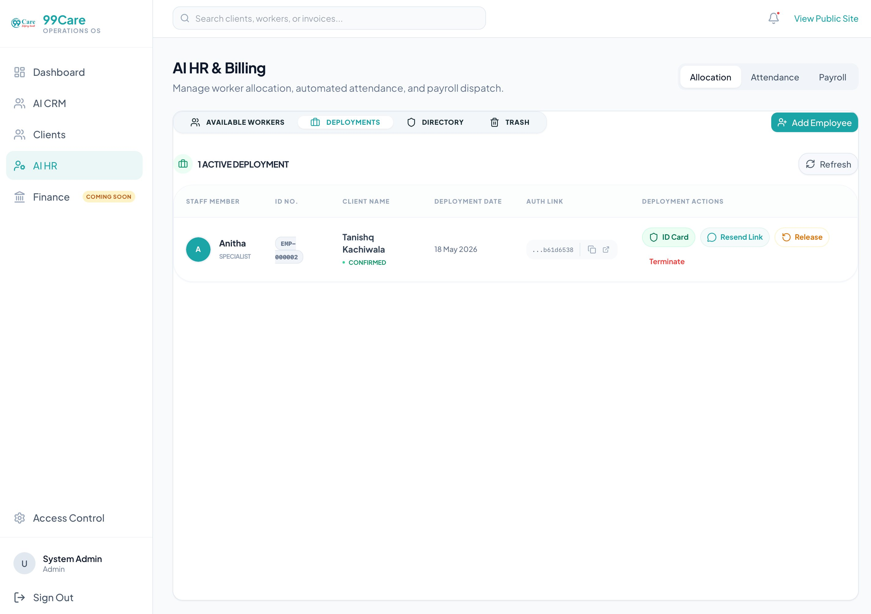
Figure 8.9 — HR Module: Active Deployments Tab

8.10 HR — Employee Directory
Purpose: Complete directory of all employees (available, assigned, inactive) with status management.
Key Elements:
- Table view with Worker Info (avatar, name, employee ID, role), Services & Payment type, Status badge, and Quick Actions
- Status filter tabs at the top right: All, Available, Assigned, Inactive
- Expandable row dropdown for changing a worker’s current status
- Confirmation dialog when moving a worker from “Assigned” to “Available”
- ID Card quick action button on each row
- Directory summary footer showing total staff members and record scope (e.g., 3 Staff Members | All Records)
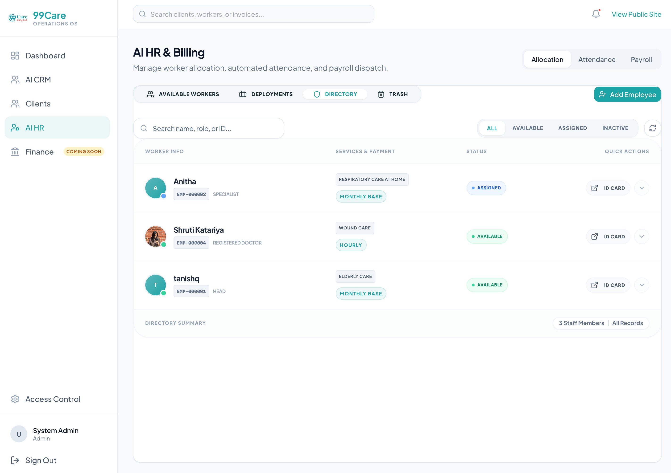
Figure 8.10 — HR Module: Employee Directory Table

8.11 HR — Attendance Matrix
Purpose: Daily attendance tracking for all active and assigned workers, auto-synced with billing.
Key Elements:
- Date picker constrained to today’s date, labelled “Daily Command Matrix”
- Stats bar showing Total, Present, Leaves/Absent, and Pending counts
- Worker rows with name, role, assigned client name, and attendance status buttons
- Per-row status options: Present, Absent, Other (expands to Paid Leave, Unpaid Leave, Half Day, Weekly Off)
- “Bulk Mark Present” button for quick batch operations across all workers
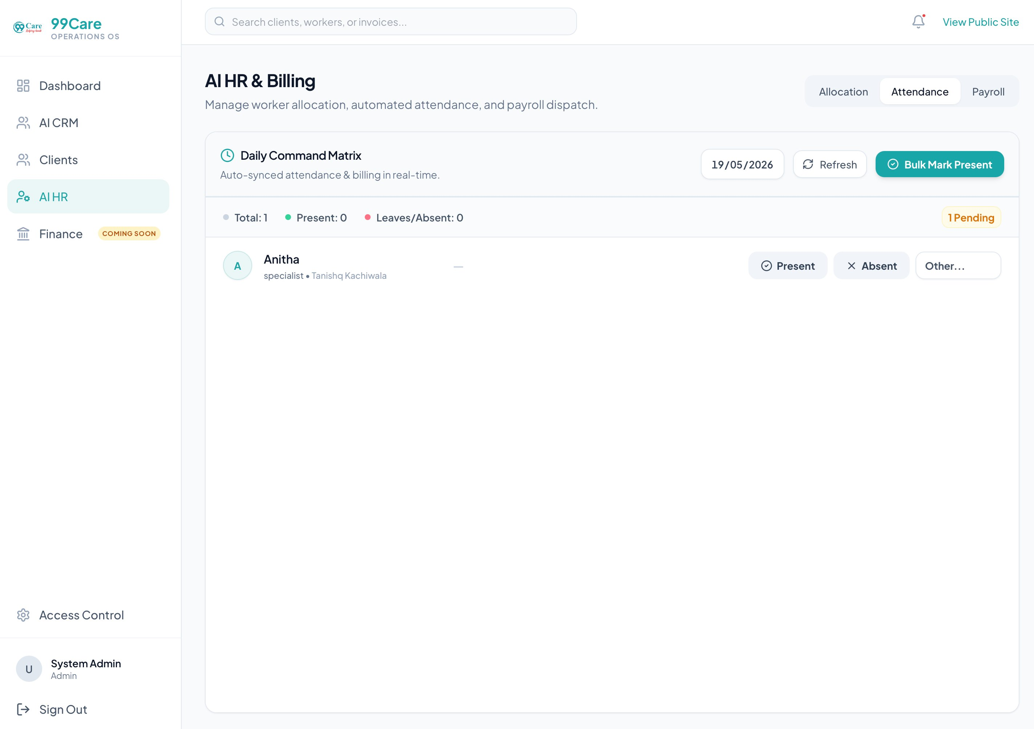
Figure 8.11 — HR Module: Daily Attendance Matrix

8.12 HR — Worker Assignment Dialog
Purpose: Modal dialog for assigning an available healthcare worker to a specific client lead.
Key Elements:
- Modal overlay with context header showing the client name the assignment is being made for
- Available worker cards showing avatar, full name, designation, and availability badge
- Contact phone number listed on each worker card
- “Assign to [Client]” button and a WhatsApp message shortcut icon per worker card
- Close (×) button to dismiss the dialog without assigning
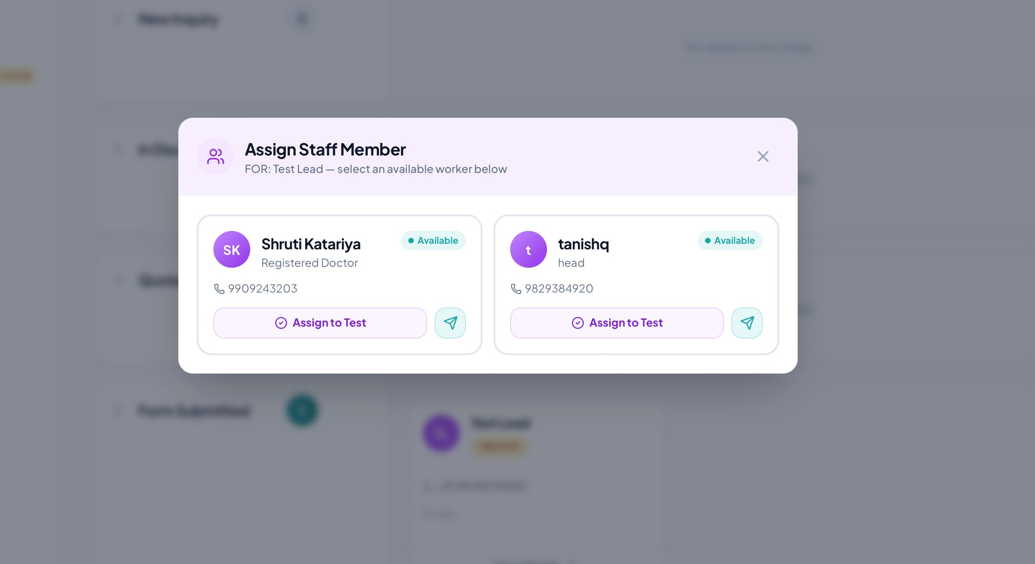
Figure 8.12 — HR Module: Worker Assignment Dialog

8.13 HR — Digital ID Card Preview
Purpose: Preview of the digital employee ID card that is shared with clients via a secure link.
Key Elements:
- Professional card design with 99 Care branding and teal colour scheme
- Employee photo, full name, designation, and employee ID number
- Key details: Duty hours, years of experience, age, gender, and residential address
- “Authorized Personnel Only” label and Active status indicator in the card footer
- “Print / Save” button for generating a downloadable or printable physical copy
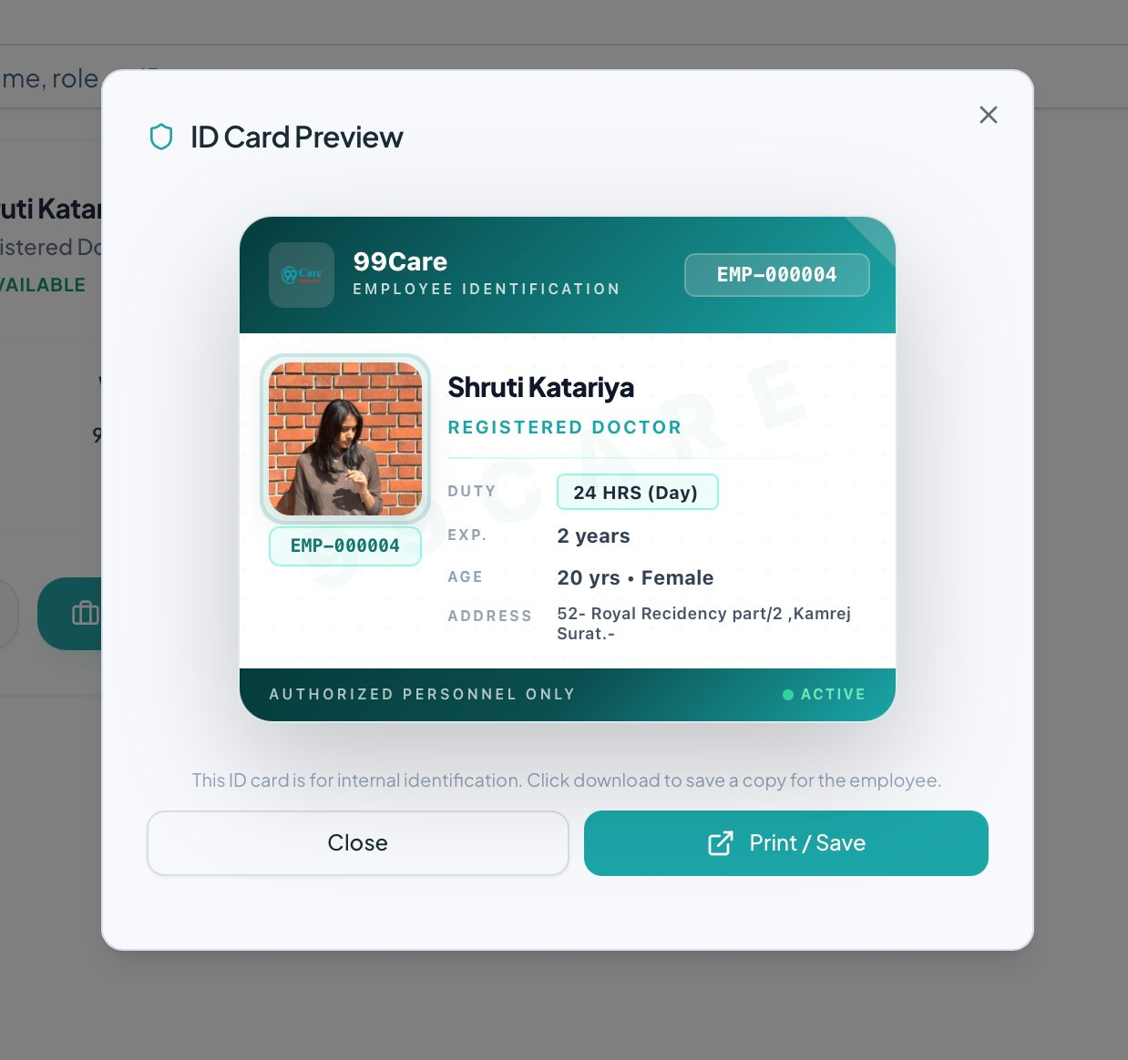
Figure 8.13 — HR Module: Digital Employee ID Card Preview

8.14 Billing Module
Purpose: Financial management including client invoice generation and payroll records.
Key Elements:
- Professional tax invoice layout with 99 Care letterhead, logo, and full contact details
- Bill To section: client name, phone, and address
- Invoice metadata: Invoice number, invoice date, and due date
- Line-item table with service description, HSN/SAC code, and amount
- Total amount in figures and in words (e.g., INR Five Thousand Rupees Only)
- Payment section with UPI QR code, bank account details, and authorised signatory
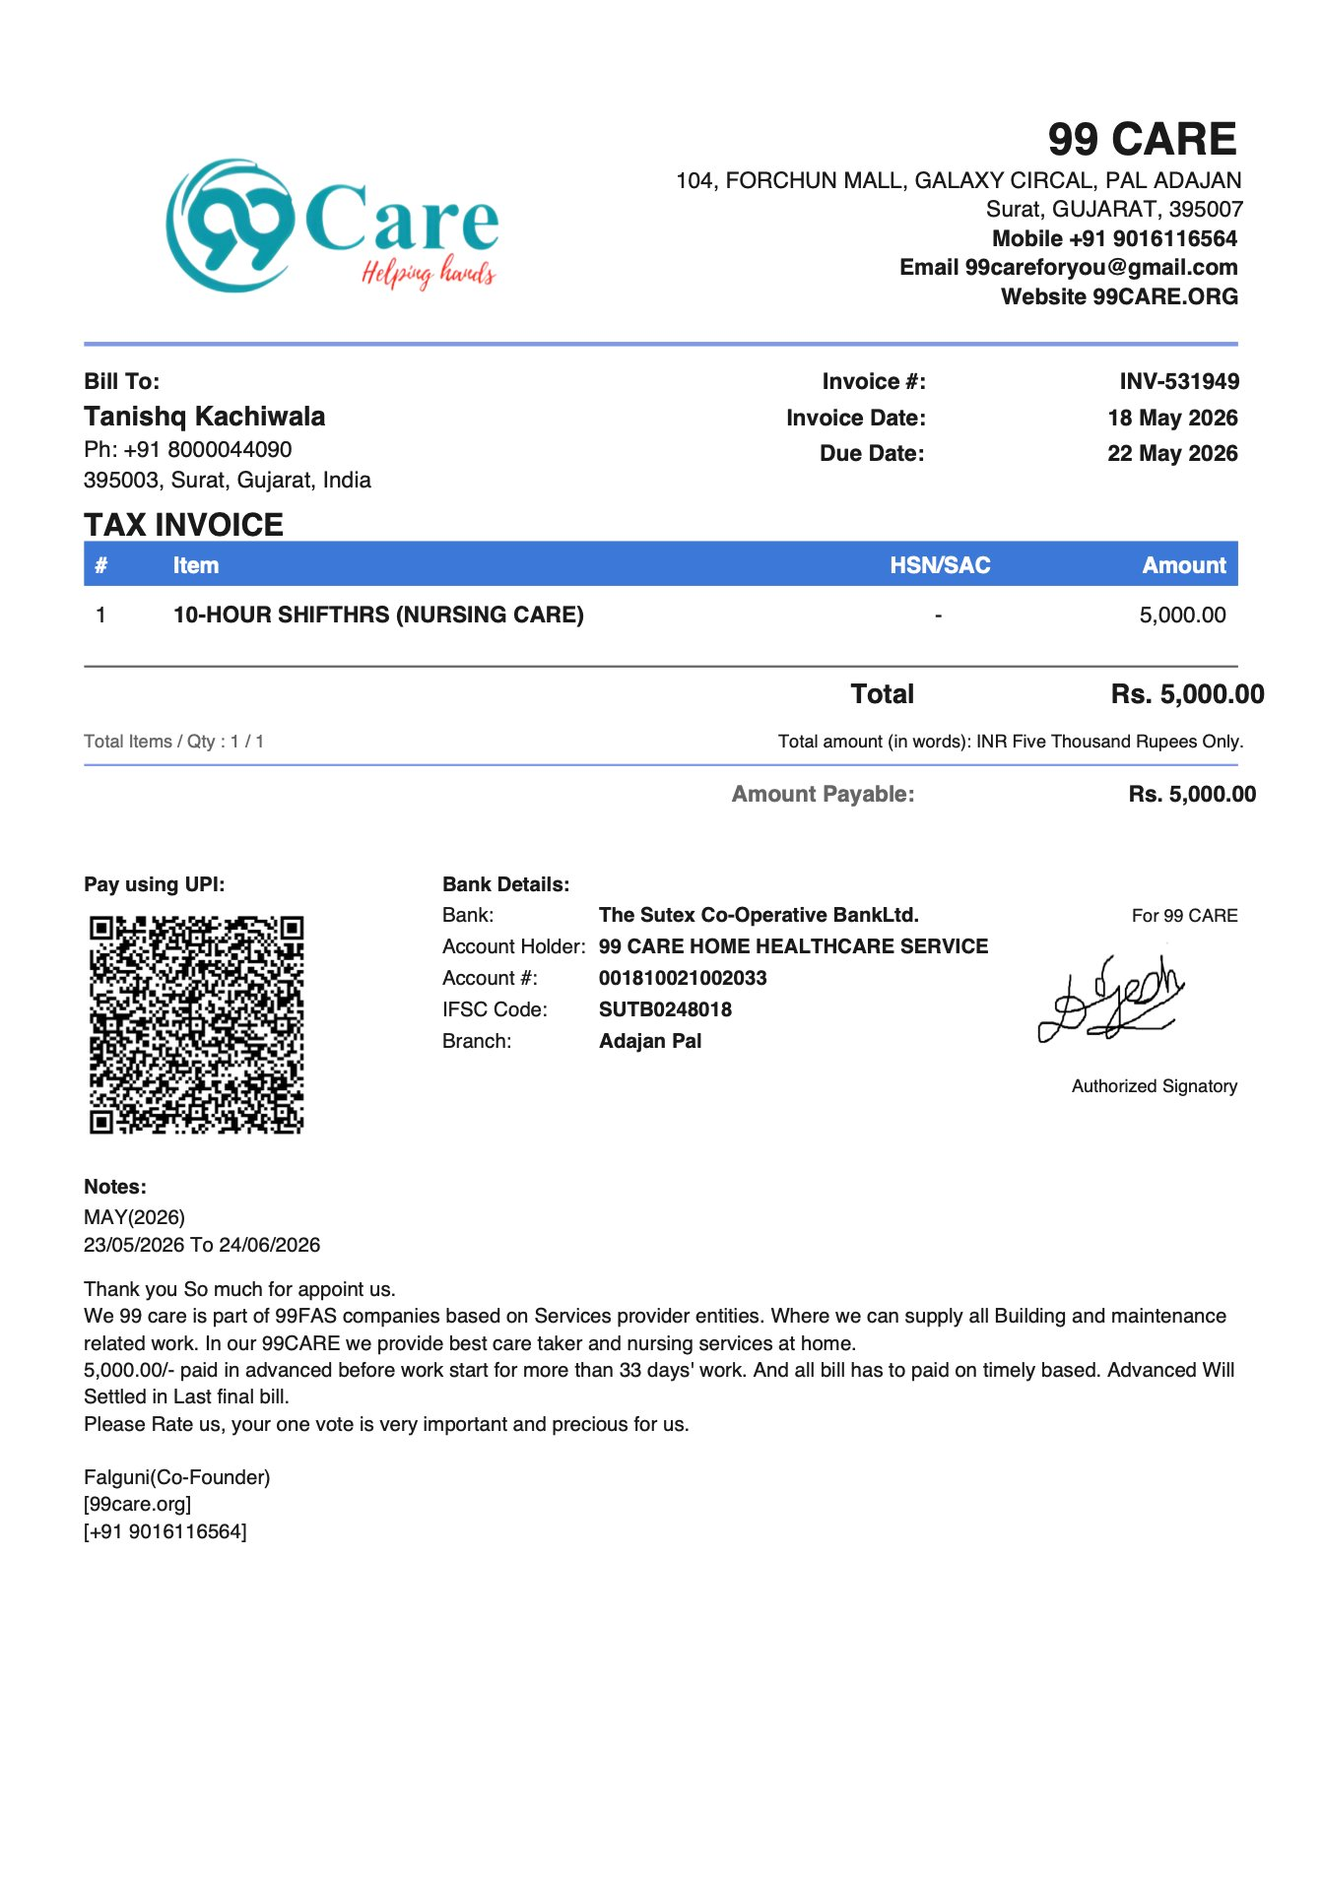
Figure 8.14 — Billing Module: Generated Tax Invoice (PDF View)

8.15 Access Control / Settings
Purpose: Role-based access management for creating and managing staff accounts with granular module permissions.
Key Elements:
- Create New Staff Account form with Full Name, Username, and Password fields
- Module Access Permissions section with individual toggle checkboxes per module
- Available permission modules: Main Dashboard, AI CRM Pipeline, Client Master, AI HR & Workers, Finance & Billing
- Each permission tile shows the module name and a short description of access level granted
- Save Account and Cancel buttons at the bottom of the form
- Existing staff accounts table with User, Username, Access Modules, and Actions columns
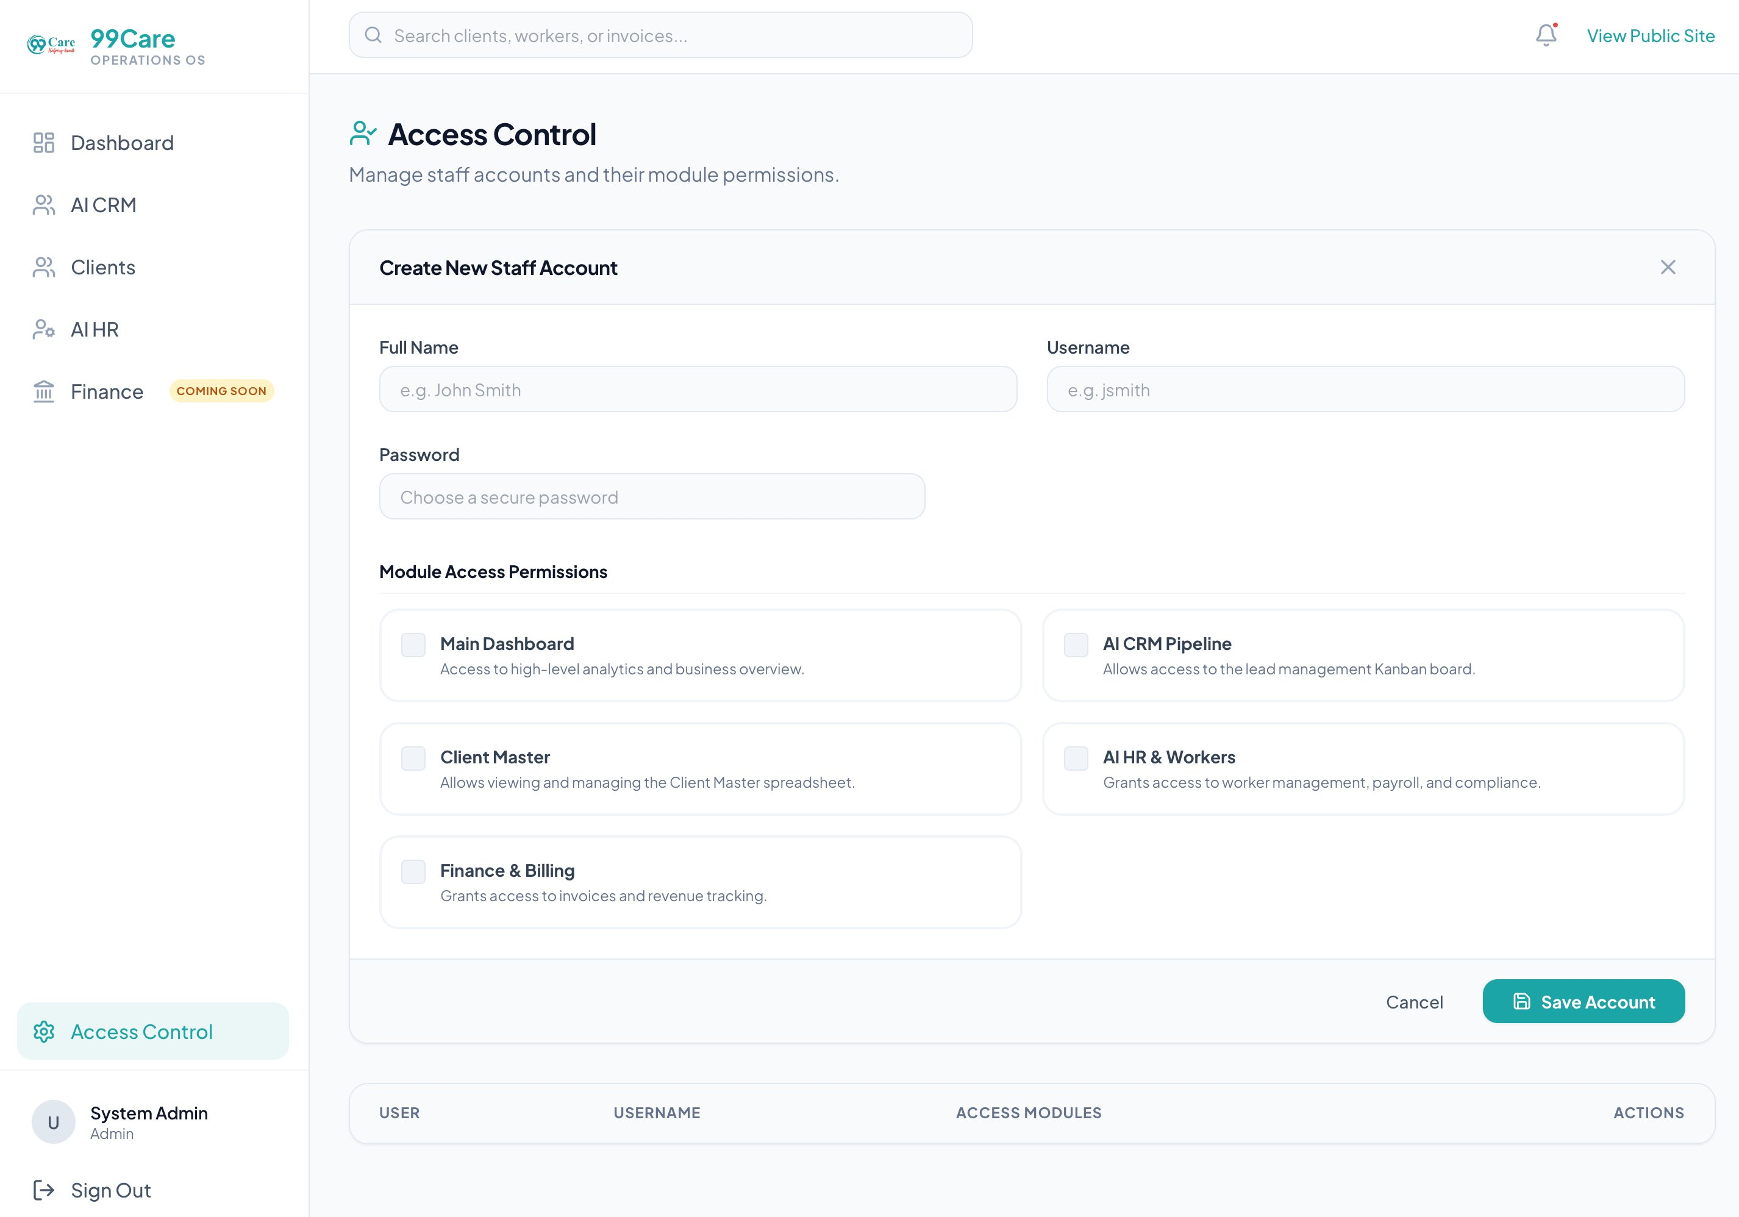
Figure 8.15 — Access Control: Staff Account and Module Permission Management

CHAPTER 9: DATABASE DESIGN

9.1 Overview
The 99Care OS system uses PostgreSQL 15 as its relational database, managed through Supabase. The database is designed around the following core principles:
- UUID Primary Keys: All tables use UUID-based primary keys for globally unique identification and enhanced security.
- Referential Integrity: Foreign key constraints enforce relationships between all related tables.
- Soft Delete: Employee records support soft deletion via a deleted_at timestamp column, enabling data recovery without permanent loss.
- Auto-Generated IDs: Human-readable employee IDs (e.g., EMP-000001) are auto-generated by database triggers upon record insertion.
- Row Level Security (RLS): All tables have RLS policies that restrict data access to authenticated users only.
- Timestamps: All tables include created_at and updated_at fields to maintain complete audit trails for all records.

9.2 List of Database Tables
The database consists of ten primary tables, each responsible for a distinct domain within the system.
# | Table Name | Purpose
1 | employees | Stores healthcare worker profiles and details
2 | crm_leads | Stores lead/prospect information for the CRM pipeline
3 | worker_assignments | Junction table linking employees to clients for job assignments
4 | id_card_links | Stores shareable public-access tokens for digital ID cards
5 | clients | Client records for worker assignment and WhatsApp notifications
6 | attendance | Daily attendance records for healthcare workers
7 | payroll | Monthly payroll calculation records
8 | call_transcripts | AI voice call transcripts and extracted lead data
9 | employee_documents | Uploaded ID proofs and documents for employees
10 | appointments | Online appointment bookings from the public website

9.3 Table Structures
Each table below is described with its column definitions, data types, constraints, and purpose. All tables use UUID primary keys generated via gen_random_uuid() and include a created_at timestamp by default.
Column | Data Type | Constraints | Description
id | UUID | PK, DEFAULT gen_random_uuid() | Primary key
employee_id | TEXT | UNIQUE, NOT NULL | Auto-generated (EMP-000001 format)
full_name | TEXT | NOT NULL | Full name of the employee
job_title | TEXT | NOT NULL | Job title / designation
photo_url | TEXT | — | Supabase Storage URL for profile photo
department | TEXT | — | Department (optional)
status | TEXT | NOT NULL, DEFAULT 'available', CHECK | Status: available, assigned, inactive
phone | TEXT | — | Contact phone number
aadhaar_number | TEXT | — | Aadhaar card number
address | TEXT | — | Residential address
dob | DATE | — | Date of birth
preferred_payment_type | TEXT | DEFAULT 'monthly' | Payment type: hourly, monthly, short_term
services | TEXT[] | — | Array of service skills
hourly_rate | NUMERIC | DEFAULT 0 | Hourly payment rate
monthly_daily_rate | NUMERIC | DEFAULT 0 | Daily rate for monthly workers
short_term_daily_rate | NUMERIC | DEFAULT 0 | Daily rate for short-term workers
shift_hours | INTEGER | — | Shift duration in hours (hourly workers)
rating | NUMERIC | DEFAULT 5.0 | Worker performance rating
gender | TEXT | — | Gender
assigned_client | TEXT | — | Currently assigned client name (denormalized)
username | TEXT | UNIQUE (partial, WHERE NOT NULL) | Optional login username
password_hash | TEXT | — | Hashed password for worker login
deposit_received | NUMERIC | DEFAULT 0 | Deposit amount received
created_at | TIMESTAMPTZ | NOT NULL, DEFAULT now() | Record creation timestamp
updated_at | TIMESTAMPTZ | NOT NULL, DEFAULT now() | Last update timestamp
deleted_at | TIMESTAMPTZ | — | Soft-delete timestamp (NULL = active)
Primary Key: id | Unique Constraints: employee_id, username (partial, WHERE NOT NULL)

Column | Data Type | Constraints | Description
id | UUID | PK | Primary key
name | TEXT | NOT NULL | Lead/prospect name
phone | TEXT | — | Primary phone number
whatsapp_number | TEXT | — | WhatsApp contact number
email | TEXT | — | Email address
pipeline_stage | TEXT | NOT NULL, DEFAULT 'New Inquiry' | Current pipeline stage
service_interest | TEXT | — | Service they are interested in
estimated_value | NUMERIC | — | Estimated monthly value
source | TEXT | — | Lead source: Call, Website, WhatsApp, Manual
priority | TEXT | DEFAULT 'medium' | Lead priority level
notes | TEXT | — | Additional notes
assigned_worker_name | TEXT | — | Denormalized assigned worker name
automation_error | TEXT | — | Automation status/error tracking
created_at | TIMESTAMPTZ | NOT NULL, DEFAULT now() | Record creation timestamp
Column | Data Type | Constraints | Description
id | UUID | PK | Primary key
employee_id | UUID | FK → employees(id), ON DELETE CASCADE | Assigned employee
client_id | UUID | FK → clients(id), ON DELETE CASCADE | Assigned client
assigned_at | TIMESTAMPTZ | NOT NULL, DEFAULT now() | Assignment date and time
assignment_status | TEXT | NOT NULL, DEFAULT 'active', CHECK | Status: active, completed, cancelled
notes | TEXT | — | Assignment notes
deposit_paid | NUMERIC | DEFAULT 0 | Deposit amount paid by client
Column | Data Type | Constraints | Description
id | UUID | PK | Primary key
employee_id | UUID | FK → employees(id), ON DELETE CASCADE | Employee this ID card belongs to
assignment_id | UUID | FK → worker_assignments(id), ON DELETE CASCADE | Related assignment record
token | TEXT | UNIQUE, NOT NULL | Secure random token for public URL
is_active | BOOLEAN | NOT NULL, DEFAULT true | Whether the link is currently active
expires_at | TIMESTAMPTZ | — | Expiration timestamp (NULL = never expires)
created_at | TIMESTAMPTZ | NOT NULL, DEFAULT now() | Link creation timestamp

Column | Data Type | Constraints | Description
id | UUID | PK | Primary key
client_name | TEXT | NOT NULL | Client/patient name
company_name | TEXT | — | Company or facility name
phone_number | TEXT | — | Phone number for WhatsApp notifications
email | TEXT | — | Email address
created_at | TIMESTAMPTZ | NOT NULL, DEFAULT now() | Record creation timestamp
Column | Data Type | Constraints | Description
id | UUID | PK | Primary key
worker_id | UUID | FK → employees(id) | Employee reference
date | DATE | NOT NULL | Attendance date
status | TEXT | NOT NULL | Present, Absent, Paid Leave, Unpaid Leave, Half Day, Weekly Off
notes | TEXT | — | Additional remarks
created_at | TIMESTAMPTZ | DEFAULT now() | Record creation timestamp
Column | Data Type | Constraints | Description
id | UUID | PK | Primary key
worker_id | UUID | FK → employees(id) | Employee reference
month | TEXT | NOT NULL | Pay period (e.g., "2026-04")
total_days | NUMERIC | — | Total working days in the month
present_days | NUMERIC | — | Days marked present
daily_rate | NUMERIC | — | Applicable daily rate for the worker
total_amount | NUMERIC | — | Calculated total payroll amount
status | TEXT | DEFAULT 'pending' | Payroll status: pending, paid
created_at | TIMESTAMPTZ | DEFAULT now() | Record creation timestamp
Column | Data Type | Constraints | Description
id | UUID | PK | Primary key
conversation_id | TEXT | UNIQUE | ElevenLabs conversation ID
phone | TEXT | — | Caller's phone number
transcript | TEXT | — | Full call transcript text
summary | TEXT | — | AI-generated call summary
intent | TEXT | — | Detected service intent from the call
captured_name | TEXT | — | Extracted caller name
captured_whatsapp | TEXT | — | Extracted WhatsApp number
captured_value | NUMERIC | — | Extracted estimated monthly value
status | TEXT | DEFAULT 'New' | Processing status of the transcript
lead_id | UUID | FK → crm_leads(id) | Linked CRM lead record
created_at | TIMESTAMPTZ | DEFAULT now() | Record creation timestamp

9.4 Relationships Summary
The following table summarizes the key relationships between database tables, their cardinality types, and their functional descriptions within the system.
Relationship | Type | Description
employees → worker_assignments | One-to-Many | One employee can have multiple assignments over time
clients → worker_assignments | One-to-Many | One client can have multiple worker assignments
worker_assignments → id_card_links | One-to-Many | Each assignment generates at least one ID card link
employees → id_card_links | One-to-Many | An employee can have multiple ID card links across assignments
employees → attendance | One-to-Many | One employee has daily attendance records
employees → payroll | One-to-Many | One employee has monthly payroll records
employees → employee_documents | One-to-Many | One employee can have multiple uploaded documents
crm_leads → call_transcripts | One-to-Many | A lead can be linked to multiple call transcripts
The schema enforces referential integrity throughout using ON DELETE CASCADE on critical foreign keys. For instance, deleting a worker assignment automatically removes its associated ID card links, preventing orphaned records. The attendance and payroll tables use a soft reference without CASCADE, allowing historical records to be preserved even if the underlying employee record is soft-deleted.
The worker_assignments table acts as the central junction between employees and clients, enabling the system to track full historical deployment data, enforce the single-staff-per-client business rule at the application layer, and link all downstream artifacts — such as digital ID cards and WhatsApp notifications — to a specific assignment context.

CHAPTER 10: BACK-END DESCRIPTION

10.1 Database Structure and Architecture Overview
The backend of 99Care OS is built on Supabase, an open-source Backend-as-a-Service (BaaS) platform that provides a managed PostgreSQL 15 database, authentication, file storage, real-time subscriptions, and serverless edge functions — all accessible through auto-generated REST and GraphQL APIs.
The overall architecture follows a three-tier model. The React-based browser client communicates with the Supabase platform via secure HTTPS REST calls and WebSocket connections for real-time updates. The Supabase platform hosts the PostgreSQL 15 database protected by Row Level Security policies, with file storage through an S3-compatible object store, authentication through the GoTrue service, and business logic through Deno-based Edge Functions. External third-party services — ElevenLabs AI and Meta WhatsApp Cloud API — are integrated via these Edge Functions, which serve as secure intermediaries between the system and external platforms.
Layer | Technology | Responsibility
Client (Browser) | React 19 + TypeScript + Vite | User interface, state management, API calls via Supabase JS client
REST API Layer | PostgREST (via Supabase) | Auto-generated REST endpoints mapped directly to PostgreSQL tables
Authentication | GoTrue (Supabase Auth) | JWT-based session management, virtual email login strategy
File Storage | Supabase Storage (S3-compatible) | Employee photos and scanned ID documents
Database | PostgreSQL 15 | Relational data storage with RLS policies and triggers
Serverless Functions | Supabase Edge Functions (Deno) | Webhook handling, external API integration, automated messaging
AI Voice | ElevenLabs API | Conversational AI phone agent for inbound/outbound call handling
Messaging | Meta WhatsApp Cloud API | Automated template-based WhatsApp notifications to clients
Hosting | Vercel | Global edge deployment of the React frontend with CDN

10.2 Data Storage and Handling

10.2.1 Database (PostgreSQL via Supabase)
All structured data is stored in a PostgreSQL 15 relational database managed by Supabase. The key aspects of data handling are as follows:
- Auto-generated UUIDs: All records use gen_random_uuid() for primary keys, ensuring globally unique and non-sequential identifiers that prevent enumeration-based attacks.
- Database Triggers: Custom PostgreSQL triggers handle automatic operations. The generate_employee_id_trigger auto-generates sequential employee IDs in the format EMP-000001 upon insertion into the employees table. The set_updated_at_trigger automatically updates the updated_at column whenever any record is modified.
- Soft Deletion: Employee records use a deleted_at timestamp column for soft deletion, allowing data recovery from the recycle bin without permanent loss of information.
- Check Constraints: Status fields use CHECK constraints to enforce valid values at the database level, for example restricting the employee status to one of: available, assigned, or inactive.

10.2.2 File Storage (Supabase Storage)
Binary files are stored in Supabase Storage, an S3-compatible object storage service. Two primary storage areas are used:
- employee-photos bucket: Stores employee profile photographs. Files are uploaded with unique randomly generated names under the photos/ directory to prevent filename collisions.
- employee-photos/documents/ path: Stores scanned ID proofs and certificates uploaded during employee onboarding, organized by employee UUID for straightforward retrieval.
- Public URLs: All uploaded files are served via auto-generated public URLs for display within the application interface, accessible without requiring a login.

10.2.3 Authentication Data
User authentication is managed by GoTrue (Supabase Auth) using the following design:
- Virtual Email Strategy: Admin usernames are mapped to virtual email addresses — for example, the username "admin" is stored as "admin@staff.healthcare" — to work with Supabase's email-based authentication system without requiring real email addresses for internal staff accounts.
- JWT Tokens: Successful authentication returns a JSON Web Token (JWT) stored in the browser and attached as a Bearer token to every subsequent API request for stateless, server-side authorization.
- Session Management: The Supabase JS client library handles automatic session refresh and token renewal transparently, maintaining active admin sessions without requiring repeated login.

10.3 Queries and Logic

10.3.1 Supabase Edge Functions
Edge Functions are serverless TypeScript functions that run on the Deno runtime at the edge, geographically close to users. They handle all external API integrations, webhook processing, and automated communication workflows that cannot be performed directly from the client browser. The table below describes each deployed Edge Function:
Edge Function | Purpose | Trigger
elevenlabs-call-webhook | Receives call completion webhooks from ElevenLabs AI; extracts transcript, summary, and structured lead data; inserts into call_transcripts and auto-creates a CRM lead | HTTP POST (webhook from ElevenLabs)
get-elevenlabs-calls | Fetches call history from ElevenLabs API and syncs with the local database; returns enriched call data to the CRM dashboard | HTTP GET (from CRM dashboard)
get-call-audio | Proxies audio file requests to ElevenLabs API; streams call recording audio to the browser's embedded audio player | HTTP GET (from audio player)
meta-whatsapp-outbound | Sends WhatsApp template messages via Meta's Cloud API; handles greeting messages, follow-ups, and assignment notifications to clients | HTTP POST (from CRM module)
send-id-card-link | Sends the digital ID card shareable link to a client via WhatsApp, formatted with the employee name, job title, and public URL | HTTP POST (from assignment service)
send-contact-email | Processes contact form submissions from the public website and dispatches notification emails to the company | HTTP POST (from contact page)
razorpay-webhook | Handles payment confirmation webhooks from the Razorpay gateway for deposit and billing transactions | HTTP POST (webhook from Razorpay)
drip-campaign | Manages scheduled follow-up WhatsApp message sequences for leads currently in the CRM pipeline | Scheduled / HTTP POST
status-engine | Processes automated pipeline stage transitions based on predefined business rules and event triggers | HTTP POST
send-joining-link | Sends onboarding and joining links to newly assigned healthcare workers via WhatsApp | HTTP POST
whatsapp-elevenlabs-bot | Handles inbound WhatsApp messages and routes them to the ElevenLabs AI conversational agent for automated responses | HTTP POST (webhook from Meta)

10.3.2 Key Database Queries
The application communicates with the database through Supabase's JavaScript client library (@supabase/supabase-js), which translates chainable method calls into REST API requests. The most critical multi-step query patterns are described below:
Query Pattern 1: Fetching Available Employees (with Filters)
This query retrieves all active employees whose status is "available", who have no assigned client, and who have not been soft-deleted. Results are ordered alphabetically by full name to support the worker selection interface.
Query Pattern 2: Creating a Worker Assignment (5-Step Sequence)
- INSERT a new record into worker_assignments with status 'active'.
- UPDATE the employee record: set status to 'assigned' and populate the assigned_client field.
- UPDATE the corresponding CRM lead to advance the pipeline stage to 'Staff Assigned'.
- INSERT a new record into id_card_links with a cryptographically secure 32-character hex token.
- INVOKE the send-id-card-link Edge Function to dispatch the ID card WhatsApp message.
If any step fails, compensation logic rolls back all previously completed steps to maintain data consistency.
Query Pattern 3: Releasing a Worker (Full Cleanup Sequence)
- UPDATE id_card_links: set is_active to false to deactivate the public ID card URL immediately.
- UPDATE worker_assignments: set assignment_status to 'cancelled'.
- UPDATE employees: reset status to 'available' and clear the assigned_client field.
- UPDATE crm_leads: clear the assigned_worker_name field.
Query Pattern 4: Attendance Marking (Upsert)
Attendance records are written using an upsert operation against the composite unique constraint (worker_id, date). This ensures that re-marking attendance for the same day updates the existing record rather than creating a duplicate entry.

10.3.3 Row Level Security (RLS)
All tables have Row Level Security policies enabled to enforce data isolation and access control directly at the database engine level, independent of application logic:
- Authenticated users only: All SELECT, INSERT, UPDATE, and DELETE operations on all tables require a valid JWT token. Unauthenticated requests are rejected at the database layer before any data is accessed.
- Public access exception: The id_card_links table permits anonymous SELECT access to support token-based public ID card verification by clients, without requiring any login.
- Service role bypass: Edge Functions authenticate using the Supabase service_role key, which bypasses RLS entirely, allowing Edge Functions to perform system-level operations such as webhook processing and automated lead creation on behalf of the platform.

CHAPTER 11: IMPLEMENTATION

11.1 Module-Wise Explanation
The 99Care OS system is organized into six major modules, each responsible for a distinct area of the healthcare operations workflow. Each module is implemented as a set of React components supported by Supabase database queries and, where required, Edge Function integrations with external services.

Module A: Public Website
The public-facing website serves as the digital storefront for 99 Care. It is built as a set of React pages wrapped in a shared Layout component that provides consistent navigation and footer across all pages.

Key Pages
- HomePage: Hero section, service highlights, key business statistics, client testimonials, and an embedded WhatsApp chat widget for instant inquiries from prospective clients.
- ServicesPage: An animated grid of all available healthcare services with Framer Motion entrance effects on scroll.
- ServiceDetailPage: In-depth service descriptions with a booking call-to-action button that directs users to the appointment page.
- AppointmentPage: A multi-field booking form with Zod schema validation. On successful submission, it inserts a record into the appointments table and auto-triggers a CRM lead creation via a PostgreSQL database trigger.
- ContactPage: A contact form that invokes the send-contact-email Edge Function upon submission to deliver an email notification to the company.
- BlogPage / BlogDetailPage: Blog listing and detail pages supporting SEO content marketing to drive organic website traffic.
- PublicIDCard: A token-authenticated page that displays a worker's digital ID card to clients for identity verification, requiring no user login — accessible only via a unique secure token in the URL.

Technical Highlights
- All pages use Framer Motion for smooth page transitions and scroll-triggered animation effects.
- SEO meta tags are dynamically set per page using the SEOMeta component to ensure proper indexing.
- The website is configured as a Progressive Web App (PWA) with service worker caching for offline access on mobile devices.
- Fully responsive design using TailwindCSS utility classes, tested across mobile, tablet, and desktop screen sizes.

Module B: CRM (Customer Relationship Management)
The CRM module is the lead management hub of the system, integrating AI voice calls and WhatsApp messaging into a unified visual pipeline. It manages the complete lead lifecycle from initial inquiry through to active client conversion.

1. Kanban Pipeline Board
- Visual drag-and-drop interface with six configurable pipeline stages: New Inquiry → Form Submitted → Staff Assigned → Deposit Pending → Trial in Progress → Active Client.
- Each lead card displays the client name, phone number, estimated monthly value, service interest, and an assigned worker badge where applicable.
- A right-side inspector panel allows viewing full lead details, changing the pipeline stage, editing field values, and triggering AI follow-up actions from a single view.

2. Call Logs and Audio Playback
- Call data is fetched from ElevenLabs via the get-elevenlabs-calls Edge Function and displayed in a sortable log table.
- Each entry shows caller name, call type (Inbound or Outbound), call duration, and timestamp.
- An embedded audio player streams call recordings directly via the get-call-audio Edge Function without requiring file downloads.
- AI-generated call summaries and detected service intent are displayed alongside each call log entry for quick review.
- A "View Full Transcript" modal provides access to the complete conversation text for detailed review.

3. AI Lead Capture
- The elevenlabs-call-webhook Edge Function processes all incoming call completion data automatically when a call ends.
- Structured information is extracted from the AI conversation: caller name, service interest, estimated monthly value, and WhatsApp number.
- A CRM lead is automatically created in the pipeline and the call transcript is linked to it for full traceability.

4. WhatsApp Integration
- Automated greeting messages are sent to new leads via the meta-whatsapp-outbound Edge Function immediately upon lead creation.
- All messages are template-based and pre-approved to comply with Meta's WhatsApp Business API policies for business messaging.
- Message delivery status is tracked from Sending → Sent → Error with retry functionality for failed messages.
- Phone number normalization logic handles +91 and 91 prefix variations to ensure consistent and reliable message delivery.

Module C: HR / Workforce Management
The HR module is the largest and most complex module in the system. It handles the complete employee lifecycle — from initial onboarding and daily attendance tracking, through payroll calculation, digital ID card generation, and eventual off-boarding via soft deletion and the recycle bin.

1. Employee Onboarding
The "Add New Employee" dialog provides a multi-field form collecting all required worker profile information:
- Personal details: Full name, job title, phone number, Aadhaar number, residential address, date of birth, and gender.
- Professional details: Experience description and multi-select service skill tags covering Elderly Care, Nursing, Baby Care, Physiotherapy, and others.
- Payment configuration: Selection of Hourly, Monthly, or Short-Term payment type with corresponding rate input fields shown conditionally.
- Document upload: Multiple scanned ID proofs and certificates stored in Supabase Storage, organized by employee UUID.
- Photo upload: Profile photograph with live preview and optional crop functionality before final submission.

2. Available Workers Tab
- Card-based grid displaying all workers with status = 'available' and no current assignment.
- Each card shows the worker's photo, full name, job title, service skill tags, and payment type badge.
- Available card actions: Assign (opens assignment dialog), Preview ID Card, Edit Profile, and Delete (soft).
- A search bar with debounced input enables real-time filtering without triggering excessive API calls.

3. Worker Assignment Flow
The assignment process is executed by the assignWorkerToClient service function, which enforces a strict seven-step sequence with automatic rollback on failure:
- Validate that no existing active assignment exists for the selected client (enforcing the single-staff-per-client business rule).
- INSERT a new record into worker_assignments with status 'active'.
- UPDATE the employee record: set status to 'assigned' and populate the assigned_client field.
- UPDATE the corresponding CRM lead: advance the pipeline stage to 'Staff Assigned'.
- Generate a cryptographically secure token (32 hex characters) using crypto.randomUUID.
- INSERT a new record into id_card_links with the generated token, linked to the current assignment.
- INVOKE the send-id-card-link Edge Function to send the ID card WhatsApp message to the client.
If any step in the sequence fails, compensation logic automatically rolls back all previously completed steps to maintain full data consistency across all affected tables.

4. Active Deployments Tab
- Table view of all active worker-to-client assignments with clearly labelled action buttons per row.
- Available actions: Preview ID Card, Resend WhatsApp Link, Release Worker, and Terminate Assignment.
- The release flow calls deactivateIDCardLink, which executes the full four-step cleanup sequence described in Chapter 10, ensuring no orphaned records or active public links remain after a worker is released.

5. Employee Directory
- Full table view of all non-deleted employees with filter tabs for All, Available, Assigned, and Inactive status categories.
- An inline status-change dropdown is provided per employee row. Changing an assigned worker's status to "Available" displays a safety confirmation dialog that explicitly warns the administrator about the downstream impact on the current client assignment.

6. Attendance Tracking
- A date picker constrained to the current date and past dates only prevents future-date attendance entries.
- All available and assigned workers for the selected date are listed with per-row status selectors.
- Available status options: Present, Absent, Paid Leave, Unpaid Leave, Half Day, and Weekly Off.
- A "Mark All Present" one-click button enables efficient bulk operations for routine daily entries.
- A statistics header shows live counts of: Total Workers, Present, On Leave or Absent, and Pending (not yet marked).

7. Digital ID Cards and Recycle Bin
- Professional ID cards feature 99 Care branding, the worker's photo, full name, designation, and employee ID number in a print-ready layout.
- Cards are shareable via a unique token-based public URL and downloadable as an image file using the html2canvas library.
- Soft-deleted employees appear in the Recycle Bin tab with individual Restore and Permanent Delete options. The "Empty Trash" button enables bulk permanent deletion with full cascade cleanup of all related records across assignments, ID card links, attendance, payroll, and document tables.

Module D: Client Management
- A searchable Client Master Database displaying all registered clients with their contact information.
- Client records are auto-populated from CRM leads at the moment a worker assignment is first created.
- Full assignment history is tracked per client, with links to associated worker records for quick reference.

Module E: Billing & Finance
- Payroll is calculated automatically from attendance records, using the employee's configured payment rate structure (hourly, daily, or short-term daily rates).
- Monthly payroll summaries display a worker-wise breakdown with payment status tracking (pending or paid).
- PDF invoice generation uses the jsPDF library with the autoTable plugin for formatted, printable, and exportable output.

Module F: Access Control & Authentication
- Role-Based Access Control (RBAC) allows administrators to create staff accounts with individually toggleable module-level permissions for CRM, HR, Clients, and Finance.
- Staff usernames are mapped to virtual email addresses (e.g., username@staff.healthcare) to integrate with Supabase Auth without requiring real email addresses.
- Protected routes verify JWT token validity and module-level permissions before rendering any dashboard content, ensuring strict access separation between roles.

11.2 Working of the System
The system follows a client-server architecture where the React frontend communicates with the Supabase backend exclusively through secure REST API calls and WebSocket connections. The end-to-end flow for a typical user interaction proceeds as follows:
- User opens the application: React Router evaluates the current URL and renders the appropriate page component. If the target route is protected, the user is redirected to the login page before access is granted.
- Authentication check: The ProtectedRoute component reads the JWT token from session storage and verifies both its validity and the user's module-level permissions before rendering the requested module content.
- Data fetching: Page components invoke Supabase client library queries to retrieve data from the database. These calls are translated to HTTPS GET requests against the PostgREST API, with the JWT token included in the Authorization header for RLS enforcement.
- User actions: Form submissions and button clicks trigger service functions that orchestrate multi-step database operations with full error handling and compensation rollbacks as required.
- External integrations: Actions requiring third-party communication — WhatsApp messages, email notifications, AI call data retrieval — invoke Supabase Edge Functions via secure HTTPS POST requests. These functions run server-side and interact with external APIs using environment-stored secret credentials that are never exposed to the browser.
- Real-time updates: Supabase Realtime subscriptions maintain a WebSocket connection to the database and push table-level change events to connected clients, keeping the user interface synchronized without requiring manual page refreshes.

11.3 Technologies Used – Summary
Layer | Technology | Role
Frontend | React 19 + TypeScript | Interactive UI components with full type safety
Styling | TailwindCSS 3 | Utility-first CSS framework for rapid responsive design
UI Components | shadcn/ui (Radix) | Accessible, customizable, headless component library
Build Tool | Vite 7 | Fast development server and optimized production bundler
Animations | Framer Motion | Declarative page transitions and scroll-based animations
Backend / BaaS | Supabase | Database, Auth, Storage, Realtime, and Edge Functions
Database | PostgreSQL 15 | Relational data storage with RLS, triggers, and constraints
Serverless | Deno (Edge Functions) | TypeScript runtime for server-side serverless functions
AI Voice | ElevenLabs API | Conversational AI phone agent for automated call handling
Messaging | Meta WhatsApp Cloud API | Automated template-based WhatsApp client notifications
Payments | Razorpay | Payment gateway for deposit and billing transactions
PDF Generation | jsPDF + autoTable | Client-side PDF invoice and payroll report generation
Hosting | Vercel | Global edge deployment with CDN for the React frontend
Version Control | Git + GitHub | Source code management and collaborative development

CHAPTER 12: SOURCE CODE

Non-Disclosure Compliance (NDC) Notice
This project is submitted under Non-Disclosure Compliance (NDC) conditions.
As per the NDC certificate issued by 99 Care (attached at the beginning of this report), the source code of the 99Care OS system contains proprietary and confidential business logic, data structures, API integrations, and trade secrets that cannot be disclosed, reproduced, or published in any part of this project report.

What is Restricted:
- Complete source code listings
- API keys, authentication tokens, and environment configurations
- Proprietary algorithm implementations
- Third-party API integration details (ElevenLabs, Meta WhatsApp Cloud API)
- Database migration scripts containing business logic
- Edge Function implementations

What is Provided Instead:
- Complete Video Demonstration: A comprehensive video walkthrough of the entire system has been prepared, demonstrating all modules, user flows, and features. This video is submitted alongside this report for evaluation purposes.
- System Architecture & Design: Chapters 7 (System Design), 9 (Database Design), and 10 (Back-End Description) provide detailed architectural documentation including flowcharts, DFDs, ERDs, class diagrams, sequence diagrams, and database schema — all without exposing proprietary code.
- Module-Wise Implementation Description: Chapter 11 (Implementation) provides a thorough module-wise explanation of the system's functionality and working.
- Live Demo Availability: A live demonstration of the working system can be arranged upon request during the viva/evaluation session.

Project Statistics (Non-Confidential)
Metric | Value
Total Source Files | 170+
Primary Language | TypeScript / TSX
Frontend Components | 40+ React components
Backend Edge Functions | 12 serverless functions
Database Tables | 10 tables
Database Migrations | 27 migration files
Lines of Code (Frontend) | ~13,500
Version Control | Git (GitHub — private repository)
Deployment | Vercel (dual-deploy: public website + admin portal)

CHAPTER 13: TESTING AND IMPLEMENTATION

13.1 Types of Testing
The 99Care OS system was tested using a combination of testing methodologies to ensure reliability, correctness, and usability across all modules.

13.1.1 Unit Testing
Individual components, service functions, and utility modules were tested in isolation to verify that each unit of code performs its intended function correctly.
Focus Areas:
- Employee service functions (create, update, delete, restore)
- Assignment service functions (assign, deactivate, release)
- Phone number normalization utility
- Token generation and URL building functions
- Form validation schemas (Zod)

13.1.2 Integration Testing
Interactions between connected modules were tested to verify that data flows correctly across system boundaries.
Focus Areas:
- CRM lead creation → Worker assignment → ID card generation → WhatsApp notification (end-to-end assignment flow)
- AI call webhook → Call transcript storage → CRM lead auto-capture
- Appointment booking → CRM lead creation via database trigger
- Employee soft-delete → Recycle bin → Permanent delete with cascade cleanup

13.1.3 System Testing
The complete system was tested as a whole to verify that all modules work together correctly in a production-like environment.
Focus Areas:
- Full user workflows from login to task completion
- Cross-module interactions (CRM → HR → Billing)
- Concurrent user access
- Data consistency across modules

13.1.4 User Acceptance Testing (UAT)
The system was presented to the client (99 Care management) for validation against their real-world operational requirements.
Focus Areas:
- Business workflow accuracy
- UI/UX intuitiveness and ease of use
- Data accuracy (correct calculations, proper status updates)
- WhatsApp message delivery and formatting
- ID card design and content

13.2 Test Case Design
Test Case ID | Description | Input Data | Expected Output | Actual Output | Status
TC-CRM-01 | Add a new lead manually | Name: "Test Patient", Phone: "9876543210", Service: "Elderly Care", Value: 15000 | Lead appears in "New Inquiry" stage of Kanban board | Lead created successfully and displayed in pipeline | Pass
TC-CRM-02 | Move lead between pipeline stages | Drag lead card from "New Inquiry" to "Form Submitted" | Lead card moves to the new column; stage updated in database | Stage updated correctly | Pass
TC-CRM-03 | View AI call log with audio | Navigate to Call Logs tab | Call entries displayed with audio player, AI summary, and transcript button | All call data rendered correctly with working audio playback | Pass
TC-CRM-04 | Auto-capture lead from AI call | AI call completes with caller name "John Doe" | Lead auto-created in pipeline with captured name and details | Lead created with correct data | Pass
TC-CRM-05 | Send WhatsApp greeting | Click "Send Greeting" on a lead with valid phone | Greeting sent; button changes to "Greeting Sent" | Message delivered; status updated | Pass
TC-CRM-06 | Send greeting to invalid phone | Click "Send Greeting" on lead with phone "12345" | Error toast shown; "Retry Greeting" button displayed | Error handled gracefully | Pass
TC-CRM-07 | Display phone and WhatsApp in call logs | View lead data captured section | Both phone number and WhatsApp number shown with icons | Both numbers displayed correctly | Pass

Test Case ID | Description | Input Data | Expected Output | Actual Output | Status
TC-HR-01 | Add new employee | Full name: "Priya Sharma", Job Title: "Nurse", Photo uploaded | Employee created with auto-generated ID (EMP-XXXXXX); appears in Available Workers tab | Employee created; ID generated; displayed in grid | Pass
TC-HR-02 | Assign worker to client | Select available worker → Select client from CRM → Submit | Assignment created; worker status changes to "Assigned"; WhatsApp sent to client with ID card link | All steps completed; WhatsApp delivered | Pass
TC-HR-03 | Assign worker to client with existing assignment | Try to assign when client already has active staff | Error message: "This lead already has a staff member assigned" | Error displayed correctly | Pass
TC-HR-04 | Release worker from assignment | Click "Release" on active deployment → Confirm | Worker status reverts to "Available"; assignment cancelled; ID card link deactivated; CRM lead updated | All cleanup operations completed | Pass
TC-HR-05 | Change assigned worker to available (safety warning) | In Directory, change status of assigned worker to "Available" | Confirmation dialog appears warning about releasing from client | Dialog shown with warning message | Pass
TC-HR-06 | Confirm status change after warning | Click "Yes, Make Available" in confirmation dialog | Worker released, status updated, assignment cancelled | Worker released successfully | Pass
TC-HR-07 | Cancel status change after warning | Click "Cancel" in confirmation dialog | No changes; worker remains "Assigned" | Status unchanged | Pass
TC-HR-08 | Soft-delete employee | Click Delete on an employee → Confirm | Employee hidden from main lists; appears in Recycle Bin | Soft-delete successful; appears in trash | Pass
TC-HR-09 | Restore soft-deleted employee | Click "Restore" in Recycle Bin | Employee reappears in main lists with previous status | Restore successful | Pass
TC-HR-10 | Permanent delete with cascade | Click "Delete Permanently" in Recycle Bin | Employee and all related records permanently removed | Cascade delete successful | Pass
TC-HR-11 | Mark daily attendance | Select date → Mark workers as Present/Absent/Leave | Attendance records created/updated via upsert | Records saved correctly | Pass
TC-HR-12 | Bulk mark all present | Click "Bulk Mark Present" button | All pending workers marked as "Present" for the selected date | All records updated | Pass
TC-HR-13 | Upload employee documents | Add new employee with 2 ID proof photos | Documents uploaded to Supabase Storage; records created in employee_documents table | Files uploaded; records linked | Pass

Test Case ID | Description | Input Data | Expected Output | Actual Output | Status
TC-AUTH-01 | Valid admin login | Username: "admin", Password: "password123" | Redirected to /admin dashboard | Login successful; dashboard loaded | Pass
TC-AUTH-02 | Invalid credentials | Username: "admin", Password: "wrongpass" | Error message: "Invalid username or password" | Error displayed correctly | Pass
TC-AUTH-03 | Empty fields | Submit with empty username and password | Error message: "Please enter both username and password" | Validation error shown | Pass
TC-AUTH-04 | Access protected route without login | Navigate to /admin/hr directly | Redirected to /login page | Redirect to login successful | Pass
TC-AUTH-05 | Staff user without HR access | Login as staff with only CRM permission; navigate to /admin/hr | Access denied or redirected | Module access restricted | Pass
Test Case ID | Description | Input Data | Expected Output | Actual Output | Status
TC-PUB-01 | View public ID card via token | Navigate to /id-card/{valid-token} | Employee ID card displayed with photo, name, designation, and company branding | ID card rendered correctly | Pass
TC-PUB-02 | View expired/invalid ID card token | Navigate to /id-card/{invalid-token} | Error message: "ID card not found or expired" | Error page displayed | Pass
TC-PUB-03 | Submit appointment booking | Fill form with valid data and submit | Confirmation page shown; record created in appointments table; CRM lead auto-created | All steps completed | Pass
TC-PUB-04 | Responsive design on mobile | View website on 375px width screen | All elements properly sized and readable; hamburger menu for navigation | Fully responsive | Pass
TC-PUB-05 | PWA installation | Click "Install App" on supported browser | App installs to home screen; opens in standalone mode | PWA installed successfully | Pass

13.3 Bug Reporting
The following bugs were identified and resolved during the testing phase:
Bug ID | Description | Severity | Resolution
BUG-01 | Duplicate key violation on username column when creating employees without a username | High | Removed username field from the INSERT query; updated unique constraint to be partial (WHERE username IS NOT NULL)
BUG-02 | WhatsApp greeting auto-trigger causing error toasts for call logs with invalid/missing phone numbers | Medium | Added phone number validation (minimum 10 digits) before auto-triggering the greeting
BUG-03 | Assigned workers could be changed to "Available" without releasing their client assignment | High | Added confirmation dialog with safety warning; implemented proper release flow via deactivateIDCardLink
BUG-04 | Phone number and WhatsApp number not displayed in call log lead data section | Low | Added Phone icon with call.phone and WhatsApp icon with call.capturedWhatsapp to the Lead Data Captured section
BUG-05 | Soft-deleted (trashed) workers appearing in the assignment picker dropdown | Medium | Added .is('deleted_at', null) filter to the available workers query

13.4 Implementation Details

Environment Setup
The system operates in two deployment modes:
- Public Website (VITE_APP_MODE=public) — Deployed to Vercel on a custom domain (99care.org). Contains only public-facing pages (Home, Services, Contact, Blog, etc.). SEO-optimized with meta tags and sitemap.
- OS Portal (VITE_APP_MODE=os) — Deployed to Vercel on a separate subdomain. Contains both public pages and protected admin modules. robots.txt set to noindex, nofollow to prevent search engine indexing.

Deployment Steps
- Code pushed to GitHub main branch
- Vercel detects the push and triggers an automatic build
- tsc -b runs TypeScript compilation for type checking
- vite build creates optimized production bundles
- Assets deployed to Vercel's global edge network
- Service worker generated for PWA support
- Application available at the configured domain within ~60 seconds

Database Migrations
Database schema changes are managed through numbered SQL migration files in the supabase/migrations/ directory. Each migration is applied using the Supabase CLI:
This ensures a versioned, reproducible database schema across development and production environments.

CHAPTER 14: RESULTS AND DISCUSSION

14.1 System Outputs
The 99Care OS system has been successfully developed, tested, and deployed. The following results were observed upon completion:

14.1.1 Public Website
- The public website is live and accessible at the configured domain, serving as the primary digital presence for 99 Care.
- The website achieves responsive rendering across all device sizes (320px to 4K).
- Online appointment booking is fully functional, with submissions auto-creating leads in the CRM pipeline.
- The PWA can be installed on mobile devices, providing a near-native experience.

14.1.2 CRM Module
- The Kanban pipeline board provides a clear visual overview of all leads across stages.
- AI voice call integration successfully captures and processes inbound calls, extracting lead data with high accuracy.
- Call audio playback, AI-generated summaries, and full transcripts are available within the CRM interface.
- WhatsApp greeting messages are delivered within 2–5 seconds of triggering, with proper status tracking.
- Leads can be manually created, edited, and moved through pipeline stages.

14.1.3 HR / Workforce Module
- Employee onboarding is streamlined with a comprehensive form supporting photo and document uploads.
- Worker assignment completes the full workflow (assignment creation → status update → ID card generation → WhatsApp notification) within 3–5 seconds.
- Digital ID cards are professional, verifiable, and shareable via unique URLs.
- The attendance matrix supports daily tracking with bulk operations.
- The safety confirmation dialog successfully prevents accidental worker releases.

14.1.4 Billing & Finance
- Payroll calculations are accurate based on attendance records and configured rates.
- PDF invoices are generated client-side using jsPDF, eliminating the need for server-side PDF processing.

14.1.5 Access Control
- Role-based access successfully restricts module visibility based on staff permissions.
- Authentication via virtual email strategy works seamlessly with Supabase Auth.

14.2 Observations
# | Observation | Impact
1 | The AI voice agent (ElevenLabs) accurately extracts lead data (name, service, budget) from natural Hindi and English conversations in approximately 85–90% of cases. | Significantly reduces manual data entry and speeds up lead capture.
2 | WhatsApp template message delivery has a success rate of ~95%, with failures primarily due to unregistered phone numbers. | Reliable for automated client communication.
3 | The worker assignment flow (7-step process) completes within 3–5 seconds, compared to an estimated 15–20 minutes for the manual process. | ~98% reduction in assignment processing time.
4 | The single-page application architecture provides smooth navigation without full page reloads, improving user experience. | Users can switch between modules instantly.
5 | Supabase's auto-generated REST API eliminates the need for writing custom backend routes, significantly reducing development time. | Faster development with fewer bugs.
6 | The dual-deploy architecture (public website + OS portal) from a single codebase ensures consistency while maintaining separation of concerns. | Simplified maintenance and deployment.

14.3 Performance Discussion
Metric | Target | Achieved | Notes
Page Load Time (First Contentful Paint) | < 3 seconds | ~1.5 seconds | Vite's optimized bundling and Vercel's CDN
Assignment Flow (End-to-End) | < 10 seconds | 3–5 seconds | Includes DB writes, token generation, and WhatsApp API call
Build Time (Production Bundle) | < 2 minutes | ~45 seconds | TypeScript compilation + Vite build + PWA generation
Bundle Size (JS) | < 3 MB | ~2.9 MB (gzipped: ~807 KB) | Includes all modules; code-splitting recommended for future
Database Query Response | < 500ms | 50–200ms | Supabase hosted on AWS with low-latency connections
Concurrent Users Supported | 50+ | 50+ (estimated) | Supabase Free/Pro tier capabilities

14.4 Key Achievements
- Real-World Deployment: Unlike a theoretical academic project, 99Care OS is deployed and used by a real healthcare company for daily operations.
- AI Integration: Successfully integrated conversational AI (ElevenLabs) for automated phone call handling — a cutting-edge technology in the healthcare operations space.
- Multi-Channel Communication: The system seamlessly integrates phone calls (ElevenLabs), WhatsApp messaging (Meta API), email (Resend), and web forms into a unified CRM pipeline.
- End-to-End Automation: From lead capture to worker assignment to client notification — the entire workflow can be completed without manual intervention.
- Production-Grade Architecture: The system follows industry best practices including TypeScript for type safety, RLS for data security, soft-delete for data recovery, and compensation logic for multi-step operations.

CHAPTER 15: LIMITATIONS
The 99Care OS system, while fully functional and deployed in production, has the following limitations:

15.1 Current Constraints
# | Limitation | Description | Impact
1 | No Offline Mode for Admin Portal | The admin portal (CRM, HR, Billing) requires an active internet connection. There is no offline data caching or queue system for admin operations. | Staff cannot manage operations during internet outages.
2 | Single-Language AI Agent | The ElevenLabs AI voice agent is configured primarily for Hindi and English. It may not perform accurately for callers speaking in Gujarati or other regional languages. | Some callers may experience difficulty in communication with the AI agent.
3 | No Native Mobile App | While the system is a PWA and works on mobile browsers, it does not have a dedicated native Android or iOS application. | Some mobile-specific features (push notifications, background sync) are limited compared to native apps.
4 | Large JavaScript Bundle | The production JavaScript bundle is approximately 2.9 MB (807 KB gzipped). This is above the recommended 500 KB threshold for optimal performance on slow networks. | Initial load may be slower on 2G/3G connections.
5 | No Multi-Tenancy | The system is designed for a single organization (99 Care). It does not support multiple healthcare companies sharing the same instance. | Cannot be offered as a SaaS product without architectural changes.
6 | Limited Reporting & Analytics | The dashboard provides basic metrics but lacks advanced reporting features such as date-range comparisons, export to Excel, custom report generation, or trend analysis. | Management relies on manual analysis for deeper insights.
7 | No Automated Scheduling | Worker assignments are manual. The system does not suggest optimal worker-client matches based on skills, location, availability, or past ratings. | Assignment optimization relies entirely on admin judgment.
8 | WhatsApp Template Dependency | All WhatsApp messages must use pre-approved Meta templates. Free-form messaging is not supported through the system. | Communication flexibility is limited to approved template formats.
9 | No Payment Gateway for Clients | While the system tracks deposits and billing, clients cannot make online payments directly through the platform. | Payment collection remains a manual or external process.
10 | Single Admin Level | The RBAC system supports module-level permissions but does not have granular action-level permissions (e.g., "can view but not edit" within a module). | All users with module access have full CRUD permissions within that module.

CHAPTER 16: FUTURE ENHANCEMENTS
The following enhancements are planned or recommended for future iterations of the 99Care OS system:

16.1 Possible Improvements
# | Enhancement | Description | Priority
1 | Code Splitting & Lazy Loading | Implement dynamic import() for admin modules (CRM, HR, Billing) to reduce the initial JavaScript bundle size. Each module would be loaded only when the user navigates to it. | High
2 | AI-Powered Worker-Client Matching | Build a recommendation engine that suggests optimal worker assignments based on service type, worker skills, proximity (using geolocation), availability, and past client ratings. | High
3 | Multilingual AI Voice Agent | Extend the ElevenLabs AI agent to support Gujarati and other regional languages, improving accessibility for a broader demographic of callers. | Medium
4 | Online Payment Integration | Integrate Razorpay or UPI payment gateway to allow clients to make deposit payments and monthly service payments directly through the platform. | High
5 | Advanced Reporting Dashboard | Build a comprehensive analytics module with date-range filters, downloadable reports (Excel/PDF), trend charts, conversion funnel analysis, and worker utilization heatmaps. | Medium
6 | Native Mobile Application | Develop a React Native or Flutter mobile app for healthcare workers to view their assignments, check-in for attendance (with GPS verification), and receive push notifications. | Medium

# | Enhancement | Description | Priority
7 | GPS-Based Attendance | Implement geofenced attendance marking where workers can only check in when they are within a specified radius of the client's location. | Medium
8 | Client Feedback & Ratings | Build a client feedback system where patients can rate healthcare workers after service completion, creating a quality feedback loop. | Low
9 | Automated Contract Generation | Generate service agreements and contracts as PDFs with pre-filled client and worker details, digital signature support, and automated email delivery. | Low
10 | Multi-Tenancy / SaaS Model | Restructure the database with tenant isolation to support multiple healthcare companies on a single platform, enabling a SaaS business model. | Low
11 | WhatsApp Chatbot for Clients | Extend the WhatsApp bot to handle client queries such as "When is my worker arriving?", "Can I change my service schedule?", and "Show me my invoice." | Medium
12 | Shift Scheduling & Calendar | Add a visual calendar interface for scheduling worker shifts across multiple clients, with drag-and-drop shift management and conflict detection. | Medium

16.2 Additional Features
- Email Marketing Integration: Connect with email marketing platforms for newsletter campaigns and client engagement.
- Document OCR: Automatic extraction of information from uploaded Aadhaar cards and other documents using OCR technology.
- Audit Log: Comprehensive logging of all admin actions (who did what, when) for compliance and accountability.
- Dark Mode: Theme toggle for users who prefer a dark interface, especially for extended use during night shifts.
- Two-Factor Authentication (2FA): Enhanced security for admin accounts using OTP-based 2FA via SMS or authenticator apps.

CHAPTER 17: CONCLUSION

17.1 Summary of the Project
The 99Care OS — AI-Powered Healthcare Operations Management System was successfully designed, developed, and deployed as a comprehensive solution for managing the day-to-day operations of a home healthcare services provider.
The project addressed a real-world problem faced by 99 Care — the inefficiency and fragmentation of their manual operational processes — by building a unified, cloud-based platform that integrates:
- Customer Relationship Management (CRM) with an AI-powered lead pipeline, voice call integration, and automated WhatsApp messaging
- Human Resource Management (HR) with employee onboarding, workforce allocation, digital ID card generation, attendance tracking, and payroll management
- Billing & Finance with automated payroll calculations and PDF invoice generation
- Public Website with online appointment booking, service showcase, and SEO optimization
- Access Control with role-based permissions for multi-user team management
The system has been deployed to production and is actively used by the 99 Care team for managing their healthcare worker workforce and client pipeline in Surat, Gujarat.

17.2 Learning Outcomes
Through the development of this project, the following key learning outcomes were achieved:

Technical Skills
- Full-Stack Web Development: Gained hands-on experience building a production-grade web application using React 19, TypeScript, and Supabase — from database design to UI implementation to deployment.
- AI Integration: Learned to integrate third-party AI services (ElevenLabs Conversational AI) using webhooks, REST APIs, and serverless functions for real-time data processing.
- API Integration: Successfully integrated Meta's WhatsApp Cloud API for automated business communication, including template message management, phone number formatting, and delivery status tracking.
- Database Design: Designed a normalized relational database schema with 10+ tables, foreign key relationships, check constraints, database triggers, and Row Level Security policies.
- Serverless Architecture: Built 12 serverless edge functions using Deno/TypeScript for handling webhooks, external API communication, and asynchronous business logic.
- PWA Development: Implemented Progressive Web App capabilities including service worker caching, installability, and offline fallback pages.
- Version Control & CI/CD: Used Git/GitHub for version control with automatic deployments through Vercel's CI/CD pipeline.

Problem-Solving Skills
- Compensation Logic: Learned to implement multi-step database operations with manual rollback mechanisms to ensure data consistency when any step in a workflow fails.
- Phone Number Normalization: Solved the practical challenge of handling inconsistent phone number formats (with/without country codes) across multiple systems (WhatsApp, ElevenLabs, database).
- Safety UX Patterns: Implemented confirmation dialogs and safety gates to prevent accidental destructive actions (e.g., releasing an assigned worker without warning).

Professional Skills
- Client Communication: Gained experience working directly with a client (99 Care) to understand business requirements, gather feedback, and iterate on the product.
- Real-World Deployment: Experienced the challenges and considerations of deploying a production application — including environment configuration, domain setup, API key management, and monitoring.
- Documentation: Learned to document system architecture, database schemas, and user workflows for both technical and non-technical stakeholders.

Final Note
This project demonstrates that modern web technologies — when combined with AI services and cloud infrastructure — can create powerful, affordable solutions for small and medium businesses in the healthcare sector. The 99Care OS system has successfully transformed the operational efficiency of a home healthcare company, proving the practical value of the technologies and skills acquired during this project.

CHAPTER 18: BIBLIOGRAPHY / REFERENCES

18.1 Books
# | Author(s) | Title | Publisher | Year
1 | Robin Wieruch | The Road to React | Leanpub | 2024
2 | Boris Cherny | Programming TypeScript | O'Reilly Media | 2019
3 | Craig Walls | Spring in Action (concepts adapted for BaaS) | Manning Publications | 2022
4 | Abraham Silberschatz, Henry Korth, S. Sudarshan | Database System Concepts | McGraw-Hill | 2019

18.2 Websites and Online Documentation
# | Resource | URL | Accessed
1 | React Official Documentation | https://react.dev | February–April 2026
2 | TypeScript Handbook | https://www.typescriptlang.org/docs/ | February–April 2026
3 | Supabase Documentation | https://supabase.com/docs | February–April 2026
4 | Supabase Edge Functions Guide | https://supabase.com/docs/guides/functions | March 2026
5 | PostgreSQL 15 Documentation | https://www.postgresql.org/docs/15/ | March 2026
6 | Vite Documentation | https://vite.dev/guide/ | February 2026
7 | TailwindCSS Documentation | https://tailwindcss.com/docs | February 2026
8 | shadcn/ui Component Library | https://ui.shadcn.com | February 2026
9 | Radix UI Primitives | https://www.radix-ui.com/docs/primitives | February 2026
10 | Lucide Icons | https://lucide.dev | February 2026
11 | Framer Motion Documentation | https://motion.dev | February 2026
12 | React Router v7 Documentation | https://reactrouter.com | February 2026
13 | TanStack React Query | https://tanstack.com/query | March 2026
14 | ElevenLabs API Documentation | https://elevenlabs.io/docs | March 2026
15 | Meta WhatsApp Cloud API | https://developers.facebook.com/docs/whatsapp/cloud-api | March 2026
16 | Vercel Documentation | https://vercel.com/docs | February 2026
17 | Zod Schema Validation | https://zod.dev | March 2026
18 | jsPDF Documentation | https://github.com/parallax/jsPDF | April 2026
19 | Recharts Documentation | https://recharts.org | March 2026
20 | MDN Web Docs | https://developer.mozilla.org | February–April 2026

18.3 Other Sources
# | Source | Description
1 | GitHub Repositories | Referenced open-source projects for design patterns and best practices
2 | Stack Overflow | Problem-solving for specific technical challenges
3 | Supabase Community Discord | Community support for Supabase-specific queries
4 | YouTube Tutorials | Video tutorials for ElevenLabs and WhatsApp API integration

CHAPTER 19: APPENDIX

19.1 Glossary of Terms
Term | Definition
BaaS | Backend as a Service — a cloud service model that provides ready-to-use backend features (database, auth, storage) via APIs.
Edge Function | A serverless function that runs on servers geographically close to the user, reducing latency.
Kanban | A project management methodology that uses visual boards with columns to represent workflow stages.
JWT | JSON Web Token — a compact, URL-safe token format used for securely transmitting authentication information.
RLS | Row Level Security — a PostgreSQL feature that restricts which rows a user can access based on policies.
PWA | Progressive Web App — a web application that uses modern web capabilities to deliver app-like experiences.
Webhook | An HTTP callback that sends real-time data from one application to another when a specific event occurs.
Upsert | A database operation that inserts a new record or updates an existing one if a conflict is detected.
Soft Delete | A deletion strategy where records are marked as deleted (using a timestamp) rather than being physically removed.
Deno | A modern JavaScript/TypeScript runtime (used by Supabase Edge Functions) that is secure by default.
CDN | Content Delivery Network — a network of servers that delivers web content based on the user's geographic location.

19.2 Project File Structure

19.3 Environment Variables
The following environment variables are required for the system (values are confidential and not disclosed):
Variable | Purpose
VITE_SUPABASE_URL | Supabase project URL
VITE_SUPABASE_ANON_KEY | Supabase anonymous/public API key
VITE_APP_MODE | Application mode: 'public' or 'os'
VITE_APP_DOMAIN | Domain identifier for dual-deploy
VITE_APP_URL | Application base URL
SUPABASE_SERVICE_ROLE_KEY | Service role key for edge functions (server-side only)
META_WHATSAPP_TOKEN | Meta WhatsApp Cloud API access token
META_PHONE_NUMBER_ID | Meta WhatsApp phone number ID
ELEVENLABS_API_KEY | ElevenLabs API key
RESEND_API_KEY | Resend email service API key

19.4 Deployment URLs
Environment | URL | Purpose
Public Website | https://99care.org | Customer-facing website
OS Portal | (Confidential subdomain) | Admin operations portal
Supabase Dashboard | https://supabase.com/dashboard | Database and backend management
GitHub Repository | https://github.com/Tanishq4090/HealthCare | Source code (private)

19.5 Video Demonstration
As per the NDC compliance requirement, a comprehensive video demonstration of the 99Care OS system has been prepared. The video covers:
- Public Website — Home page, services, appointment booking, contact form
- Login & Authentication — Admin login flow
- CRM Module — Kanban pipeline, call logs with audio, AI lead capture, WhatsApp greetings
- HR Module — Employee onboarding, available workers, worker assignment, active deployments, directory, attendance, ID cards, recycle bin
- Billing Module — Payroll calculation, invoice generation
- Access Control — Staff account management, permission configuration
- Public ID Card — Token-based public access verification
The video is submitted alongside this report on the designated storage medium (Pen Drive / Google Drive).

