Chapter 7: Software/System Design
7.1 System Flowchart
The system flowchart illustrates the complete flow of the 99Care OS platform, covering user entry and authentication, the public website module, admin dashboard modules, and the worker assignment sub-flow.
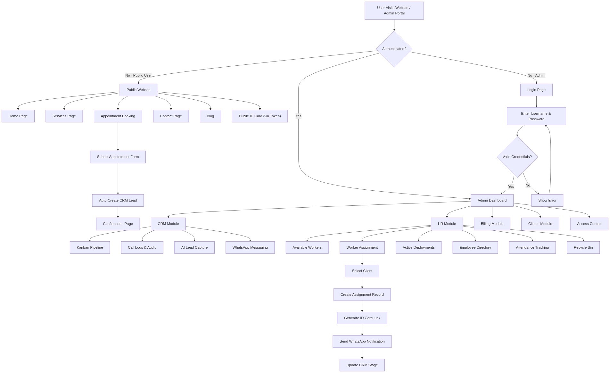
Figure 7.1 — System flowchart of 99Care OS

7.2 Data Flow Diagram — Level 0 (Context Diagram)
The context diagram provides a high-level view of 99Care OS and its interactions with all external entities including patients, admin staff, healthcare workers, the ElevenLabs AI agent, and the WhatsApp Cloud API.
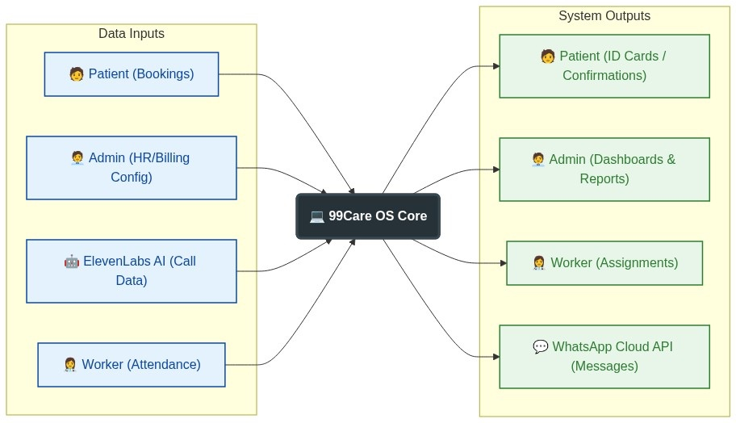
Figure 7.2 — DFD Level 0: Context diagram showing 99Care OS and all external entities

7.3 Data Flow Diagram — Level 1
Six major processes are shown with external entities, data stores, and clearly labelled data flows between them. The processes include Lead Management, Workforce Management, Assignment & ID Cards, Attendance & Payroll, Communication Engine, and Authentication & Access Control.
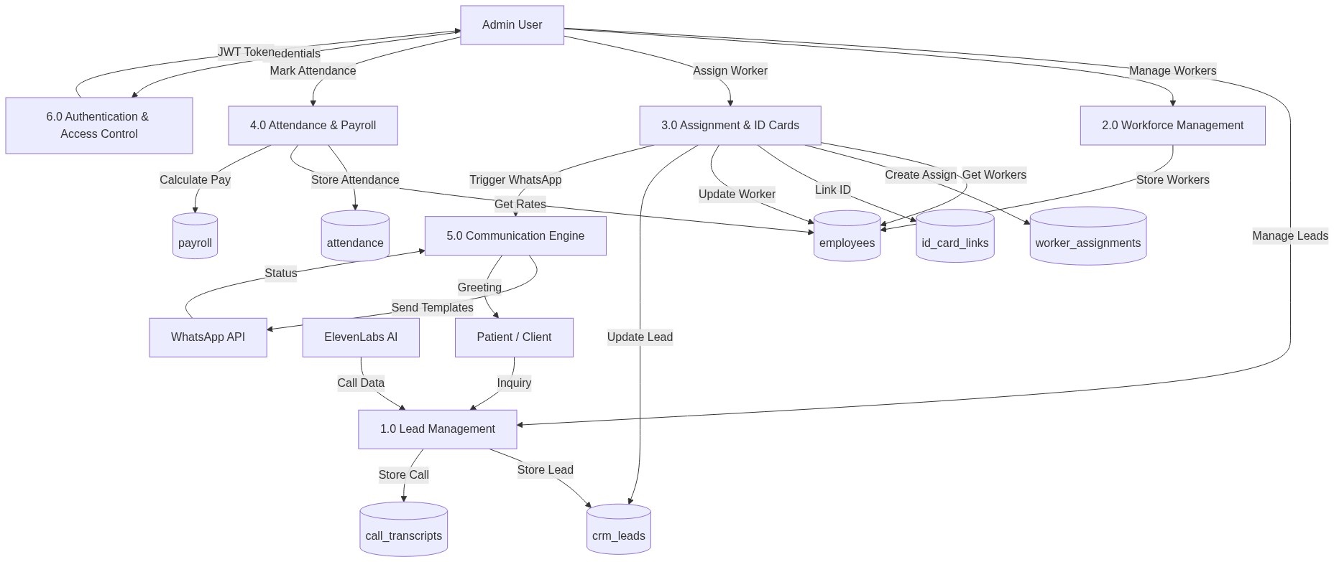
Figure 7.3 — DFD Level 1: Six major processes, external entities, and seven data stores

7.4 Entity Relationship Diagram
The Entity Relationship Diagram depicts all nine database tables and their relationships, including primary keys, foreign keys, and cardinality notations for each association.
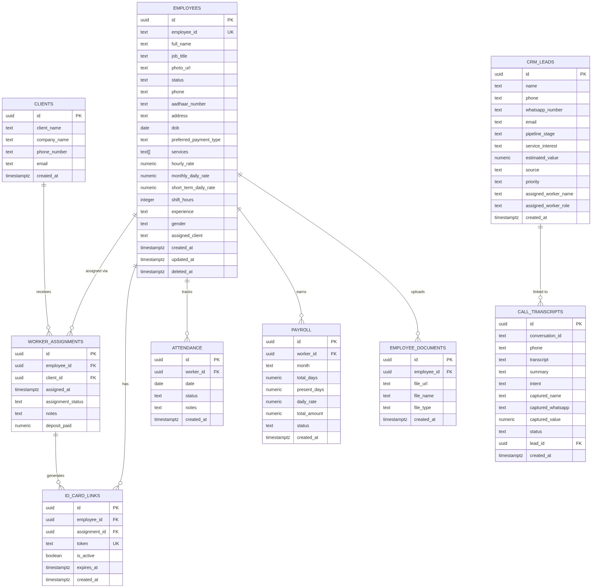
Figure 7.4 — Entity Relationship Diagram showing all nine database tables and their relationships

7.5 Use Case Diagram
The Use Case Diagram identifies all actors interacting with the 99Care OS — Admin User, AI Voice Agent, Patient/Client, and Healthcare Worker — and maps each to the system functions they initiate or participate in.
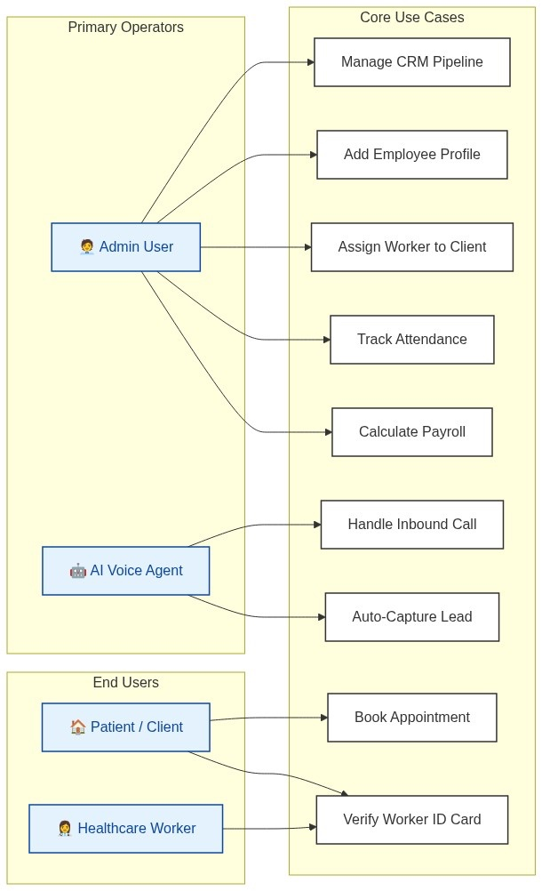
Figure 7.5 — Use Case Diagram showing all actors and their interactions with 99Care OS

7.6 Class Diagram
The Class Diagram presents the eight application-layer classes — Employee, WorkerAssignment, Attendance, Payroll, IDCardLink, CRMLead, AuthService, and WhatsAppService — along with their attributes, methods, and inter-class relationships.
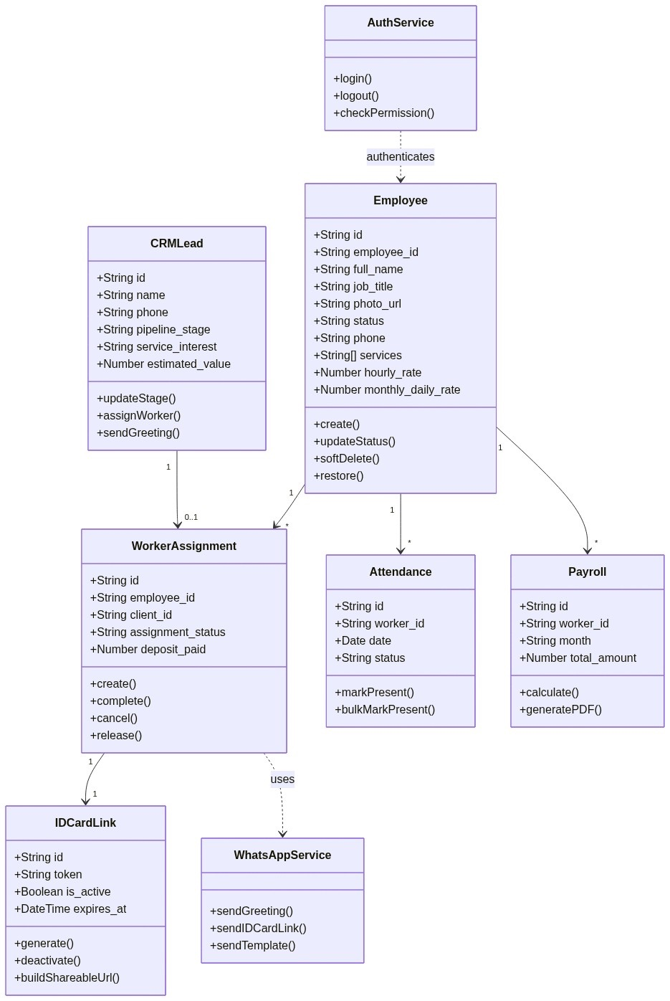
Figure 7.6 — Class Diagram: eight application-layer classes and their relationships

7.7 Sequence Diagram — AI Voice Call Lead Intake
This sequence diagram traces the eleven-step flow initiated when a patient calls the 99Care number, from the AI agent greeting through transcript storage, CRM lead creation, and WhatsApp greeting delivery to the caller.
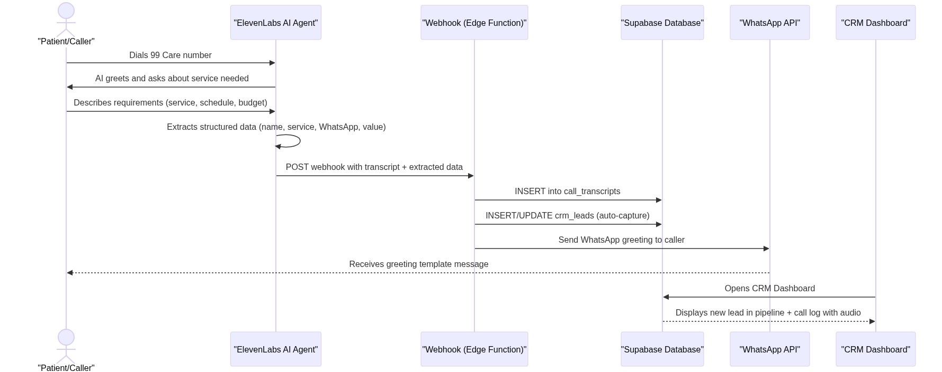
Figure 7.7 — Sequence Diagram: AI voice call lead intake flow (11 steps)

7.8 Sequence Diagram — Worker Assignment Flow
This sequence diagram details the fifteen-step worker assignment process, from the admin clicking “Assign” on an available worker through database updates, secure token generation, and WhatsApp ID card link delivery to the client.
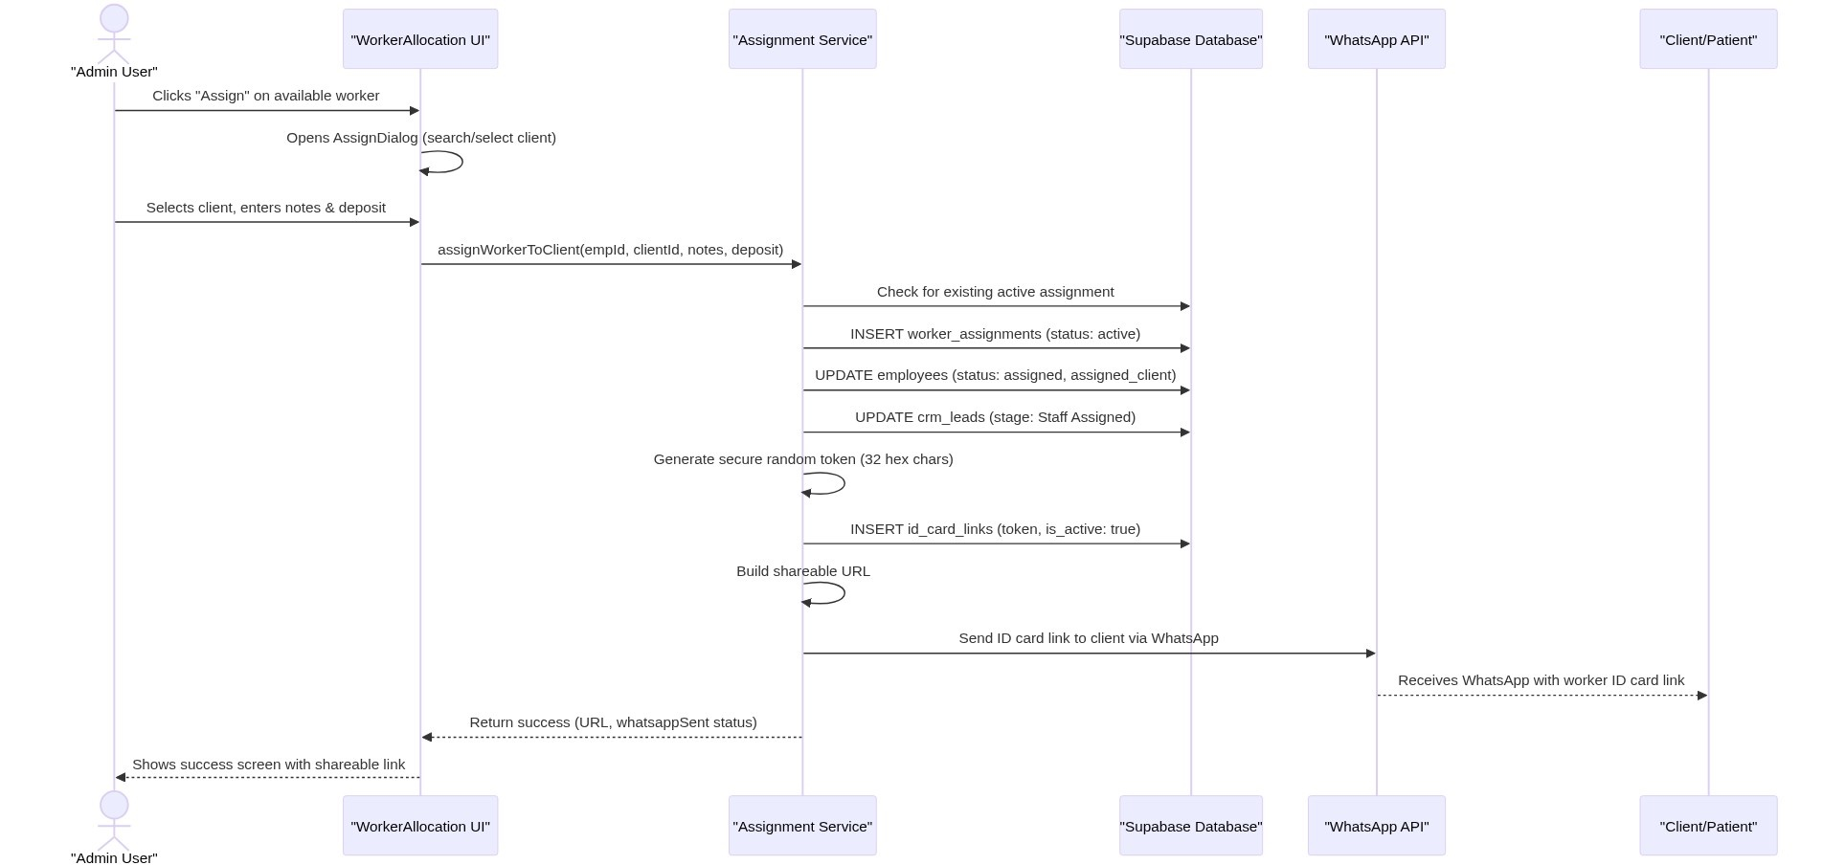
Figure 7.8 — Sequence Diagram: Worker assignment flow from “Assign” click to WhatsApp notification (15 steps)

