LP3 (ISR) – Assignment 3 – Inverted Files (RollNo: 43221)

Input Code:
import java.io.*;
import java.util.*;
public class InvertedFile {
public static void main(String[] args) throws NumberFormatException,
IOException {
String fname = "";
ArrayList<String> invertedData = new ArrayList<String>();
int docno[][] = new int[100][10];
InputStreamReader ins = new InputStreamReader(System.in);
BufferedReader br = new BufferedReader(ins);
System.out.println("\nENTER TOTAL NO OF FILES:");
int no = Integer.parseInt(br.readLine());
int i = 1;
while (i - 1 != no) {
System.out.println("\nENTER FILE " + i + " NAME:");
fname = br.readLine();
indexing(fname, invertedData, docno, i);
i += 1;
}
displayIndex(invertedData, docno);
}
public static void displayIndex(ArrayList<String> invertedData,
int[][] docno) {
int i, j;
for (i = 0; i < invertedData.size(); i++) {
System.out.print(invertedData.get(i) + "\t");
for (j = 1; j <= docno[i][0]; j++)
System.out.print(docno[i][j] + "\t");
System.out.print("\n");
}
}
public static void indexing(String fname, ArrayList<String> invertedData, int[][] docno, int fileno) {
BufferedReader br;
try {
br = new BufferedReader(new FileReader(fname));
String data = "", line = br.readLine();
while (line != null) {
data += line + " ";
line = br.readLine();
}
String[] st = data.split("[ ,.]");
String currenttoken = null;
int i = 0;
while (i < st.length) {
currenttoken = st[i];
int indx = invertedData.indexOf(currenttoken);
if (indx == -1) {
invertedData.add(currenttoken);
indx = invertedData.indexOf(currenttoken);
docno[indx][0] = 1;
docno[indx][1] = fileno;
} else {
docno[indx][docno[indx][0] + 1] = fileno;
docno[indx][0] += 1;
}
i += 1;
}
} catch (Exception e) {
e.printStackTrace();
}
}
}

Output:
Text1.txt:
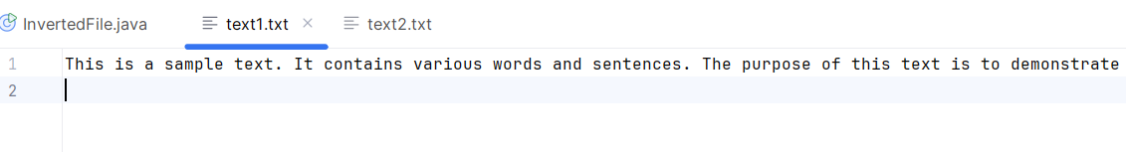
Text2.txt:
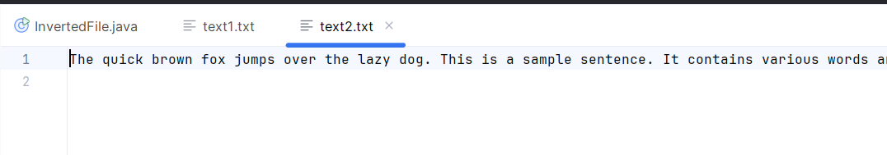

"C:\Program Files\Java\jdk-22\bin\java.exe" "-javaagent:C:\Program Files\JetBrains\IntelliJ IDEA Community Edition 2024.1.4\lib\idea_rt.jar=58044:C:\Program Files\JetBrains\IntelliJ IDEA Community Edition 2024.1.4\bin" -Dfile.encoding=UTF-8 -Dsun.stdout.encoding=UTF-8 -Dsun.stderr.encoding=UTF-8 -classpath F:\BE\LP3\GroupA_Assignment_3_InvertedFiles\out\production\GroupA_Assignment_3_InvertedFiles InvertedFile

ENTER TOTAL NO OF FILES:
2

ENTER FILE 1 NAME:
text1.txt

ENTER FILE 2 NAME:
text2.txt
This 1 2
is 1 1 2
a 1 2
sample 1 2
text 1 1 1 1
1 1 1 1 1 1 1 2 2
It 1 1 2
contains 1 2
various 1 2
words 1 1 2
and 1 1 1 2
sentences 1
The 1 1 2
purpose 1
of 1 1 1
this 1
to 1 1
demonstrate 1
the 1 1 1 1 1 1 2
functionality 1
conflation 1
algorithm 1 1
will 1 1
remove 1 1
stop 1
suffixes 1
count 1
frequency 1
each 1
word 1
provide 1
insights 1
into 1
analysis 1
process 1
Feel 1
free 1
modify 1
observe 1
results 1
quick 2
brown 2
fox 2
jumps 2
over 2
lazy 2
dog 2
sentence 2
punctuation 2
marks 2

Process finished with exit code 0

