**Data Communication and Computer Networks**

**Lab Cat 2**

**Name: Tanishq Tyagi**

**Reg no: 20BIT0192**

**Ques ->**

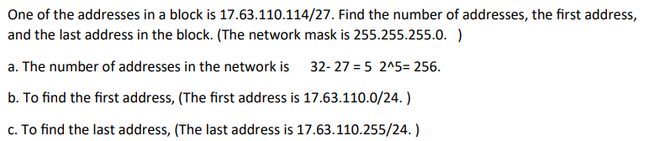

**Code ->**

**Server.py ->**

import socket

localIP = "127.0.0.1"

localPort = 20001

s = socket.socket(family=socket.AF_INET, type = socket.SOCK_DGRAM)

s.bind((localIP, localPort))

print("Server is listening...")

def toDecimal(data):

return int(data, 2)

def calculate(data):

output =""

l = data.split('/')

cidr = l[1]

op1 = pow(2, (32-int(cidr)))

output+=str(op1) + "__"

startbin = ""

lastbin = ""

counter = 0

n=24

for i in range (0, 32):

if(i < n):

startbin+="1"

lastbin+="0"

else:

startbin+="0"

lastbin+="1"

counter = counter + 1

if(counter == 8):

startbin+="."

lastbin+="."

counter = 0

startMask = startbin.split(".")

lastMask = lastbin.split(".")

startMask.pop()

lastMask.pop()

sMask = []

lMask = []

for i in startMask:

sMask.append(toDecimal(i))

for i in lastMask:

lMask.append(toDecimal(i))

startAdd = []

givenAdd = l[0].split('.')

for i in range(0, 4):

startAdd.append(int(givenAdd[i]) & sMask[i])

lastAdd = []

for i in range(0, 4):

lastAdd.append(startAdd[i] + lMask[i])

op2 = ""

for i in range(0,4):

if(i < 3):

op2 += str(startAdd[i]) + "."

else:

op2 += str(startAdd[i])

op2+="/24__"

for i in range(0,4):

if(i < 3):

op2 += str(lastAdd[i]) + "."

else:

op2 += str(lastAdd[i])

op2+="/24"

output += op2

return output

while True:

client = s.recvfrom(1024)

data = client[0]

addr = client[1]

data = data.decode("utf-8")

output = calculate(data)

toSend = str.encode(output)

s.sendto(toSend, addr)

**client.py ->**

import socket

localIP = "127.0.0.1"

localPort = 20001

address = (localIP, localPort)

s = socket.socket(family=socket.AF_INET, type = socket.SOCK_DGRAM)

ip = input("Enter the IP Address: ")

dataToSend = str.encode(ip)

s.sendto(dataToSend, address)

op = s.recvfrom(1024)

output = op[0].decode("utf-8")

ans = output.split("__")

print("Number of Addresses: ",end=" ")

print(ans[0])

print("Start Address: ", end =" ")

print(ans[1])

print("Last Address: ", end =" ")

print(ans[2])

**Server Output Screenshot ->**

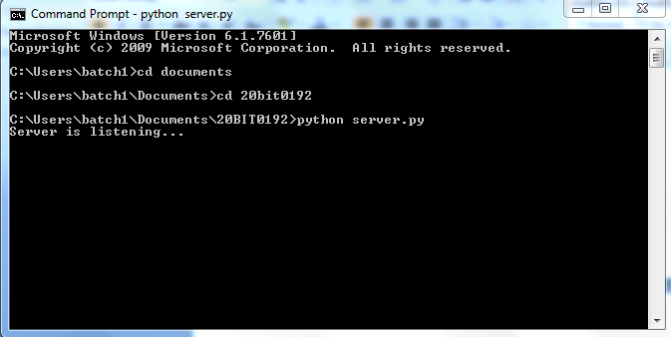

**Client Output Screenshot ->**

