Experiment No. 1

1. Aim

Demonstrate inline, internal, and external JavaScript; use console methods; create a webpage showing user info and a welcome message.

2. Software / Tools Required
- Any text editor (VS Code / Notepad++ / Sublime Text)
- Web Browser (Google Chrome / Mozilla Firefox / Microsoft Edge)
- HTML, CSS, and JavaScript

3. Code

practical1.html

<!DOCTYPE html>

<html lang="en">

<head>

<meta charset="UTF-8">

<meta name="viewport" content="width=device-width, initial-scale=1.0">

<title>College Department</title>

<style>

body {

margin: 0;

min-height: 100vh;

display: flex;

justify-content: center;

align-items: center;

background: linear-gradient(160deg, #eef6ff, #dcecff);

font-family:Cambria, Cochin, Georgia, Times, 'Times New Roman', serif;

}

.container {

width: 100%;

max-width: 700px;

text-align: center;

padding: 20px;

}

h1 {

margin: 0 0 12px;

color: #0f4c81;

font-size: 56px;

letter-spacing: 1px;

}

h2 {

margin: 0 0 18px;

color: #23395b;

font-size: 38px;

}

p {

margin: 0 0 28px;

color: #4b5563;

font-size: 20px;

}

a {

display: inline-block;

text-decoration: none;

background-color: #0f4c81;

color: white;

padding: 12px 22px;

border-radius: 999px;

font-weight: bold;

transition: background-color 0.2s ease;

}

a:hover {

background-color: #0c3d67;

}

@media (max-width: 600px) {

h1 {

font-size: 42px;

}

h2 {

font-size: 28px;

}

p {

font-size: 18px;

}

}

</style>

</head>

<body onload="showExternalAlert()">

<div class="container">

<h1>SIT Nagpur</h1>

<h2>Computer Science Department</h2>

<p>Welcome to the department page.</p>

<a href="student-info.html">Student Info Page</a>

</div>

<script src="practical1.js"></script>

</body>

</html>

practical1.js

function showExternalAlert() {

alert("Welcome to SIT Nagpur");

}

student-info.html

<!DOCTYPE html>

<html lang="en">

<head>

<meta charset="UTF-8">

<meta name="viewport" content="width=device-width, initial-scale=1.0">

<title>Student Info</title>

<style>

body {

font-family:'Gill Sans', 'Gill Sans MT', Calibri, 'Trebuchet MS', sans-serif;

margin: 0;

min-height: 100vh;

display: flex;

justify-content: center;

align-items: center;

background-color: #2b2744;

}

.form-box {

background-color: white;

padding: 30px;

border: 1px solid #ccc;

border-radius: 10px;

width: 320px;

box-shadow: 0 2px 8px rgba(0, 0, 0, 0.1);

}

h1 {

margin-top: 0;

text-align: center;

font-family: 'Gill Sans', 'Gill Sans MT', Calibri, 'Trebuchet MS', sans-serif;

}

label {

display: block;

margin-top: 12px;

}

input,

select {

width: 100%;

padding: 8px;

margin-top: 5px;

box-sizing: border-box;

}

button {

width: 100%;

padding: 10px;

margin-top: 18px;

}

.output-box {

margin-top: 20px;

padding: 12px;

background-color: #f4f4f4;

border-radius: 8px;

display: none;

}

.output-box p {

margin: 6px 0;

}

a {

display: block;

text-align: center;

margin-top: 15px;

padding: 8px;

}

</style>

<script>

function displayStudentInfo() {

document.getElementById("displayName").textContent =

document.getElementById("name").value;

document.getElementById("displayRoll").textContent =

document.getElementById("roll").value;

document.getElementById("displayDepartment").textContent =

document.getElementById("department").value;

document.getElementById("displayYear").textContent =

document.getElementById("year").value;

document.getElementById("displayEmail").textContent =

document.getElementById("email").value;

document.getElementById("outputBox").style.display = "block";

}

</script>

</head>

<body>

<div class="form-box">

<h1>Student Information</h1>

<label for="name">Enter Name:</label>

<input type="text" id="name">

<label for="roll">Enter Roll Number:</label>

<input type="text" id="roll" inputmode="numeric" pattern="[0-9]+" placeholder="24070521015">

<label for="department">Enter Department:</label>

<select id="department">

<option value="">Select Department</option>

<option value="CSE">CSE</option>

<option value="Mechanical">Mechanical</option>

<option value="Civil">Civil</option>

<option value="Electrical">Electrical</option>

<option value="Electronics">Electronics</option>

<option value="IT">IT</option>

</select>

<label for="year">Enter Year:</label>

<select id="year">

<option value="">Select Year</option>

<option value="1st">1st</option>

<option value="2nd">2nd</option>

<option value="3rd">3rd</option>

<option value="4th">4th</option>

</select>

<label for="email">Enter Email:</label>

<input type="email" id="email">

<button type="button" onclick="displayStudentInfo()">Submit</button>

<div class="output-box" id="outputBox">

<p><strong>Name:</strong> <span id="displayName"></span></p>

<p><strong>Roll Number:</strong> <span id="displayRoll"></span></p>

<p><strong>Department:</strong> <span id="displayDepartment"></span></p>

<p><strong>Year:</strong> <span id="displayYear"></span></p>

<p><strong>Email:</strong> <span id="displayEmail"></span></p>

</div>

<a href="practical1.html">Back to Department Page</a>

</div>

</body>

</html>

4. Output

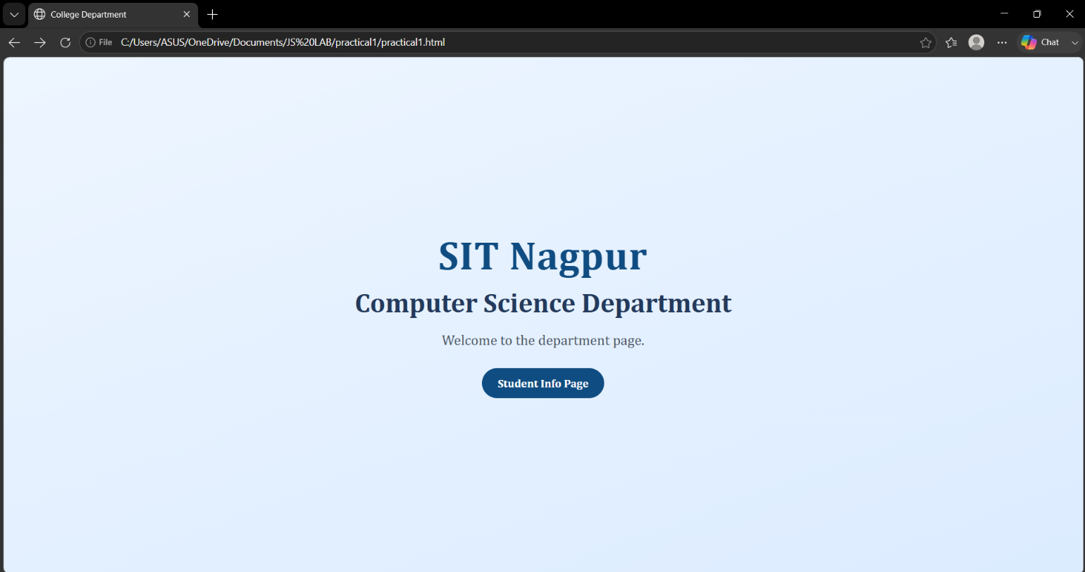
Harshini Bonde
24070521015

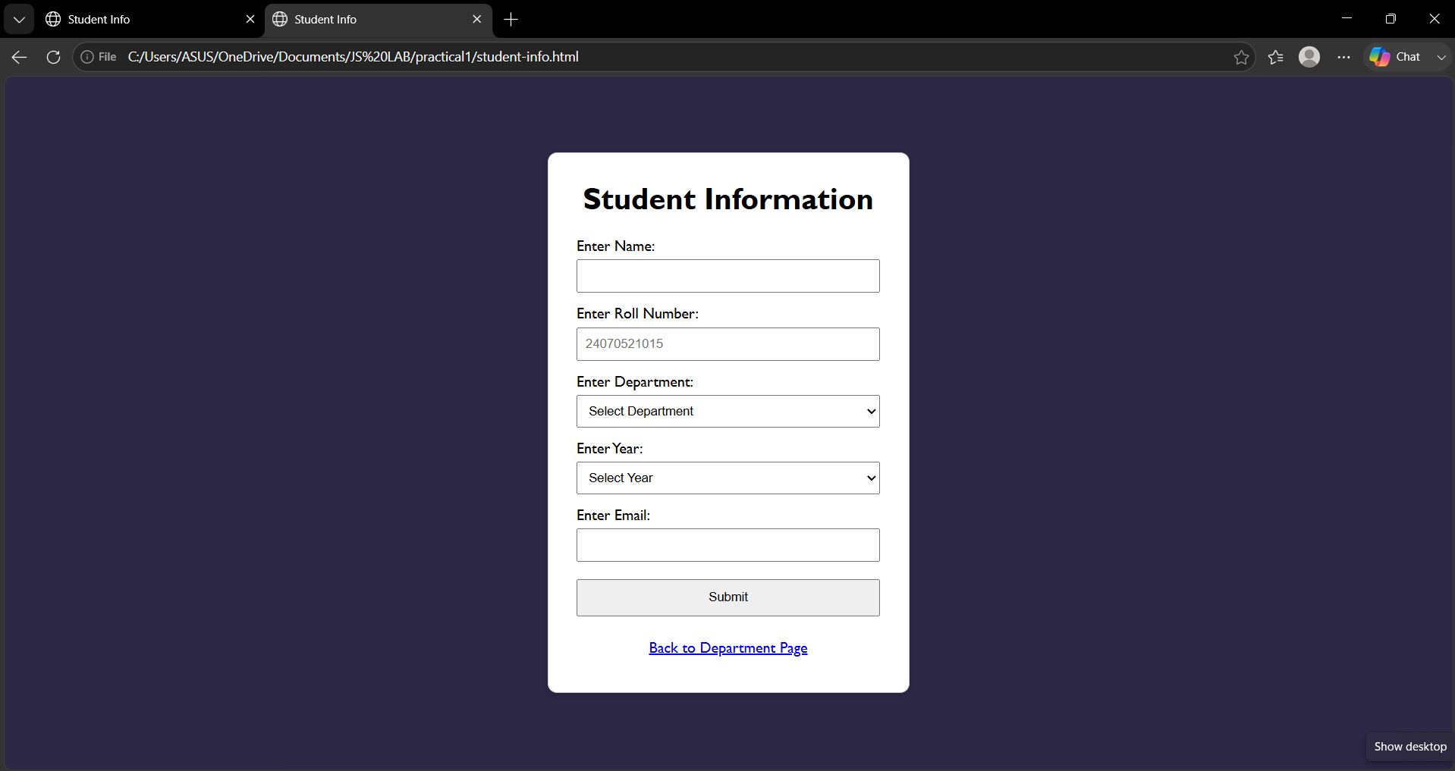
Harshini Bonde
24070521015

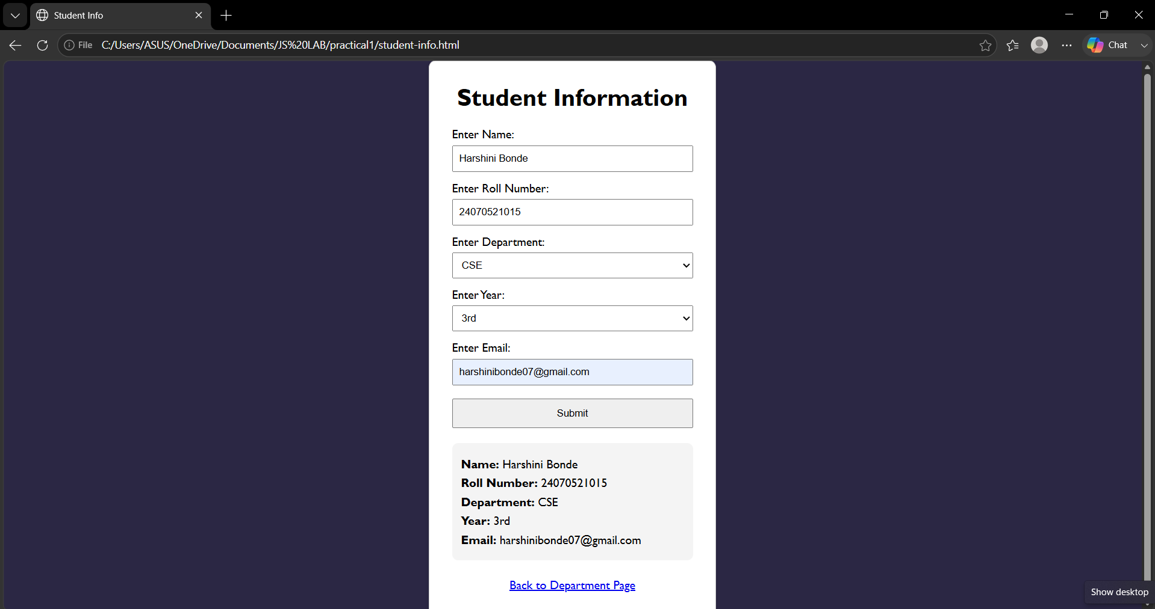
Harshini Bonde
24070521015

5. Case Study

script.js

function greet() {

alert("Welcome to JavaScript Programming!");

console.table([

{

Name: "Sample User",

Course: "JavaScript"

}

]);

console.time("Execution");

console.timeEnd("Execution");

}

Index.html

<!DOCTYPE html>

<html>

<head>

<title>Form</title>

<!-- Internal JavaScript -->

<script>

function showWelcome() {

let name = document.getElementById("name").value;

let age = document.getElementById("age").value;

document.getElementById("output").innerHTML =

"<h2>Welcome, " + name + "</h2>" +

"<p>Your age is: " + age + "</p>";

console.log("User Name: " + name);

console.info("User Age: " + age);

console.warn("This is a warning message");

console.error("This is an error message (Demo purpose)");

}

</script>

</head>

<body>

<h1>User Info</h1>

<label>Enter Name:</label>

<input type="text" id="name" placeholder="Enter name">

<br><br>

<label>Enter Age:</label>

<input type="number" id="age" placeholder="Enter age">

<br><br>

<!-- Inline JavaScript -->

<button onclick="showWelcome(); greet();">

Submit

</button>

<hr>

<div id="output"></div>

<!-- External JavaScript -->

<script src="script.js"></script>

</body>

</html>

6. Case study Output

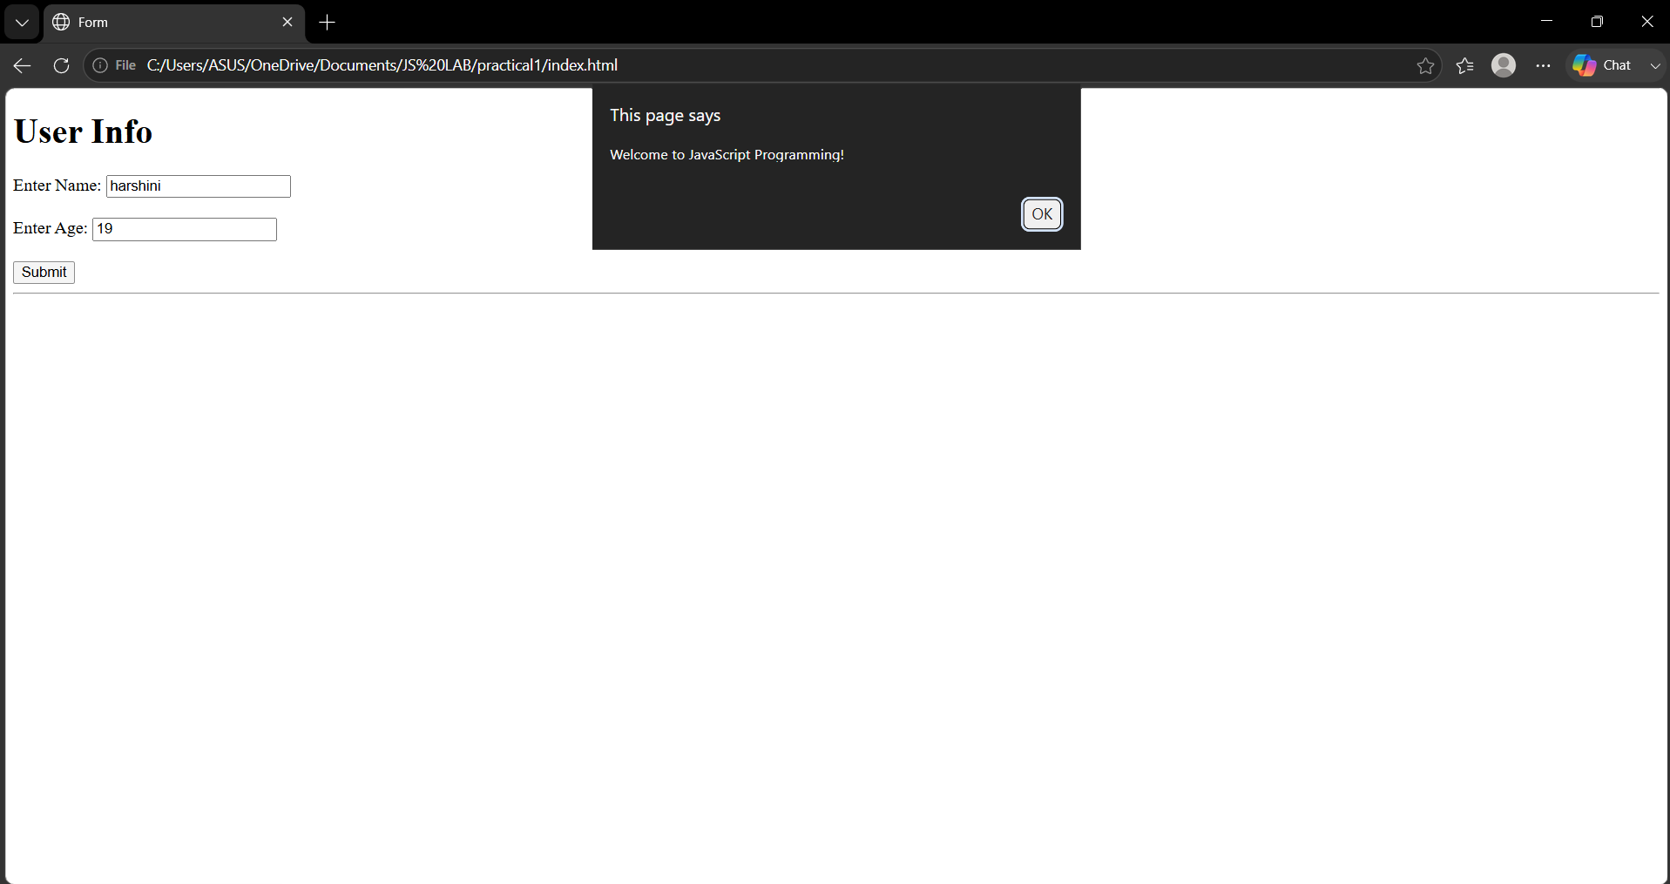
Harshini Bonde
24070521015

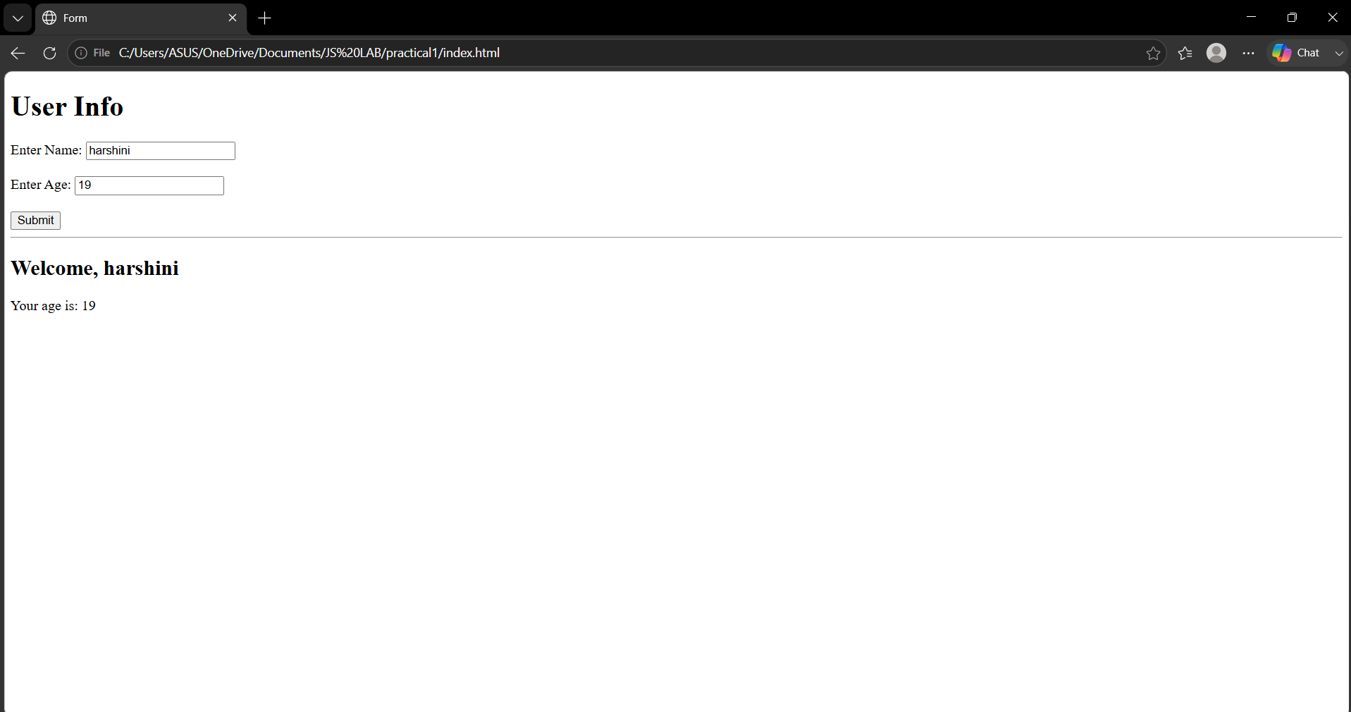
Harshini Bonde
24070521015

