Experiment No. 4

1. Aim

Use function types, scope, and closures; apply try-catch; build a palindrome checker.

2. Software / Tools Required
- Any text editor (VS Code / Notepad++ / Sublime Text)
- Web Browser (Google Chrome / Mozilla Firefox / Microsoft Edge)
- HTML, CSS, and JavaScript

3. Code

index.html

<!DOCTYPE html>

<html lang="en">

<head>

<meta charset="UTF-8">

<title>Vehicle Number Validator</title>

<link rel="stylesheet" href="style.css">

</head>

<body>

<h2>Vehicle Number Validator</h2>

<input type="text" id="vehicleNumber" placeholder="e.g. MH12AB1234" maxlength="10">

<button onclick="checkVehicleNumber()">Validate</button>

<div id="result"></div>

<script src="script.js"></script>

</body>

</html>

script.js

function validation(regNumber) {

try {

if (!regNumber || regNumber.trim() === "") {

throw new Error("Vehicle number cannot be empty");

}

regNumber = regNumber.trim().toUpperCase();

if (regNumber.length !== 10) {

throw new Error("Vehicle number must have exactly 10 characters");

}

const stateCode = regNumber.substring(0, 2);

if (!/^[A-Z]{2}$/.test(stateCode)) {

throw new Error("First 2 characters must be uppercase alphabets (state code)");

}

const districtCode = regNumber.substring(2, 4);

if (!/^[0-9]{2}$/.test(districtCode)) {

throw new Error("Characters 3-4 must be digits (district code)");

}

const series = regNumber.substring(4, 6);

if (!/^[A-Z]{2}$/.test(series)) {

throw new Error("Characters 5-6 must be alphabets (series code)");

}

const vehicleNo = regNumber.substring(6, 10);

if (!/^[0-9]{4}$/.test(vehicleNo)) {

throw new Error("Last 4 characters must be digits (vehicle number)");

}

return { valid: true, message: "Valid vehicle registration number: " + regNumber };

} catch (error) {

return { valid: false, message: error.message };

}

}

function checkVehicleNumber() {

const input = document.getElementById("vehicleNumber").value;

const resultDiv = document.getElementById("result");

const result = validation(input);

if (result.valid) {

resultDiv.textContent = result.message;

resultDiv.className = "valid";

} else {

resultDiv.textContent = "Error: " + result.message;

resultDiv.className = "invalid";

alert(result.message);

}

}

style.css

* {

box-sizing: border-box;

}

body {

margin: 0;

min-height: 100vh;

display: flex;

flex-direction: column;

justify-content: center;

align-items: center;

padding: 32px 20px;

font-family: "Segoe UI", Tahoma, Geneva, Verdana, sans-serif;

text-align: center;

background: linear-gradient(135deg, #eef4ff 0%, #f8fbff 45%, #e8fff4 100%);

color: #1f2937;

}

body::before {

content: "";

position: fixed;

inset: 0;

background:

radial-gradient(circle at top left, rgba(37, 99, 235, 0.14), transparent 32%),

radial-gradient(circle at bottom right, rgba(22, 163, 74, 0.14), transparent 30%);

pointer-events: none;

}

h2,

input,

button,

#result {

position: relative;

z-index: 1;

}

h2 {

margin: 0 0 22px;

padding: 24px 28px 10px;

width: min(100%, 520px);

font-size: clamp(1.7rem, 4vw, 2.2rem);

font-weight: 700;

letter-spacing: 0.03em;

color: #12325f;

background: rgba(255, 255, 255, 0.72);

border: 1px solid rgba(255, 255, 255, 0.7);

border-bottom: none;

border-radius: 24px 24px 0 0;

backdrop-filter: blur(12px);

box-shadow: 0 12px 35px rgba(18, 50, 95, 0.12);

}

input {

width: min(100%, 520px);

padding: 14px 16px;

font-size: 1rem;

text-transform: uppercase;

border: 1px solid #cfd9e8;

border-radius: 0;

outline: none;

background: rgba(255, 255, 255, 0.92);

color: #1f2937;

box-shadow: 0 4px 18px rgba(15, 23, 42, 0.06);

transition: border-color 0.2s ease, box-shadow 0.2s ease, transform 0.2s ease;

}

input::placeholder {

color: #94a3b8;

text-transform: none;

}

input:focus {

border-color: #2563eb;

box-shadow: 0 0 0 4px rgba(37, 99, 235, 0.16);

transform: translateY(-1px);

}

button {

width: min(100%, 520px);

margin-top: 14px;

padding: 14px 18px;

font-size: 1rem;

font-weight: 600;

background: #2563eb;

color: #ffffff;

border: none;

border-radius: 10px;

cursor: pointer;

box-shadow: none;

transition: background-color 0.2s ease;

}

button:hover {

background: #1d4ed8;

}

button:active {

background: #1e40af;

}

#result {

width: min(100%, 520px);

margin-top: 22px;

padding: 16px 18px;

font-weight: 600;

font-size: 1rem;

border-radius: 18px;

background: rgba(255, 255, 255, 0.85);

border: 1px solid rgba(203, 213, 225, 0.75);

box-shadow: 0 12px 26px rgba(15, 23, 42, 0.08);

min-height: 58px;

}

.valid {

color: #166534;

background: rgba(220, 252, 231, 0.9) !important;

border-color: rgba(134, 239, 172, 0.95) !important;

}

.invalid {

color: #b91c1c;

background: rgba(254, 226, 226, 0.92) !important;

border-color: rgba(252, 165, 165, 0.95) !important;

}

@media (max-width: 600px) {

h2 {

padding: 20px 20px 10px;

border-radius: 20px 20px 0 0;

}

button {

border-radius: 10px;

}

#result {

border-radius: 16px;

}

}

4. Output

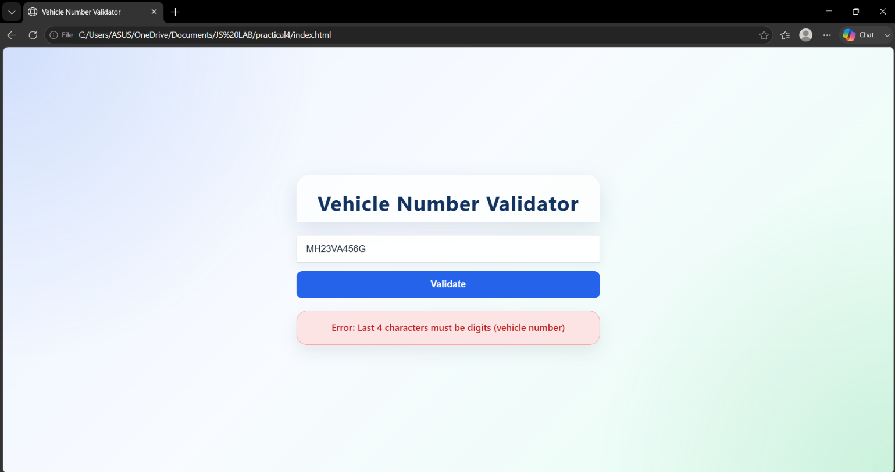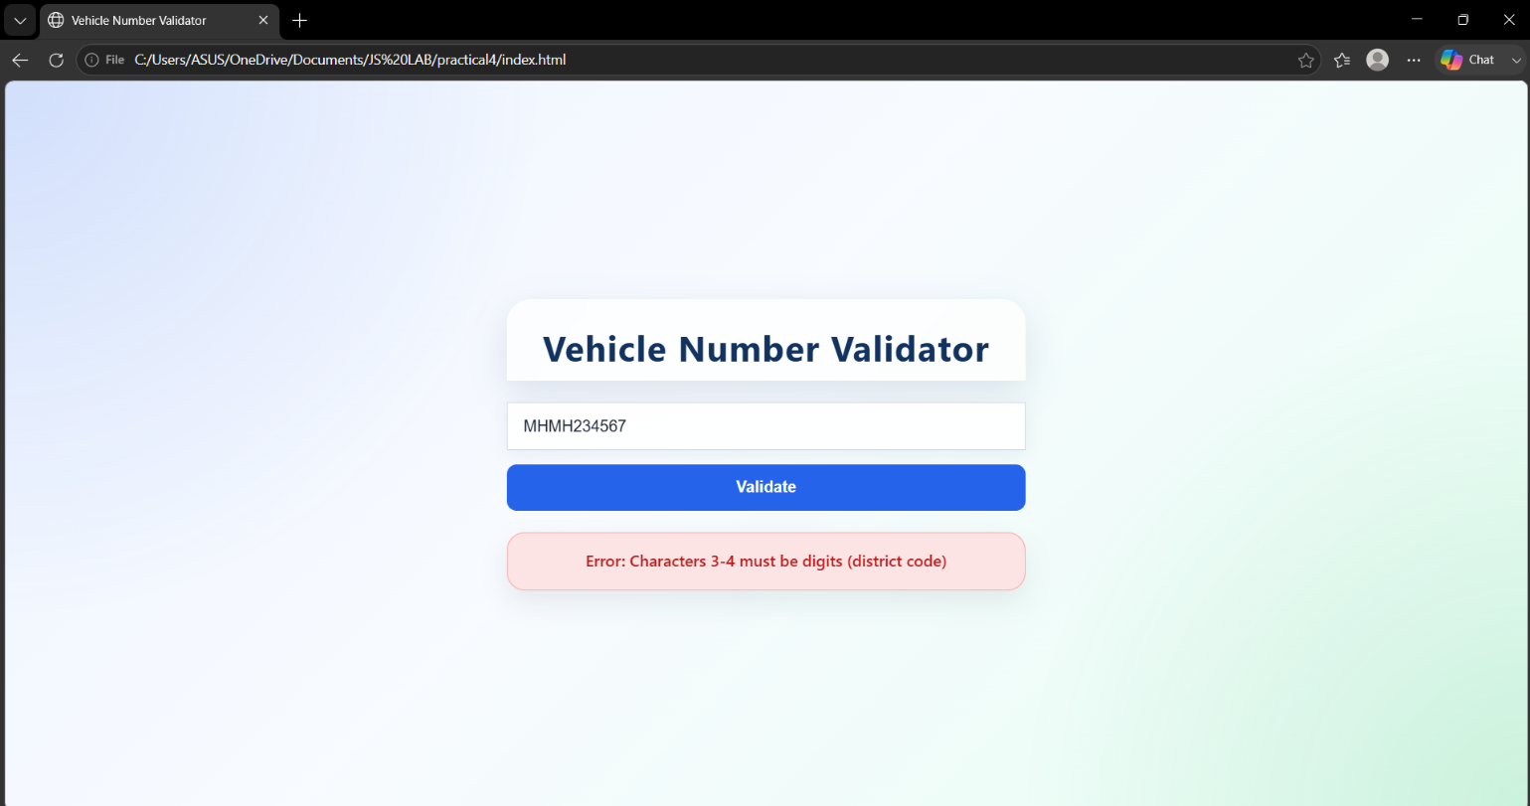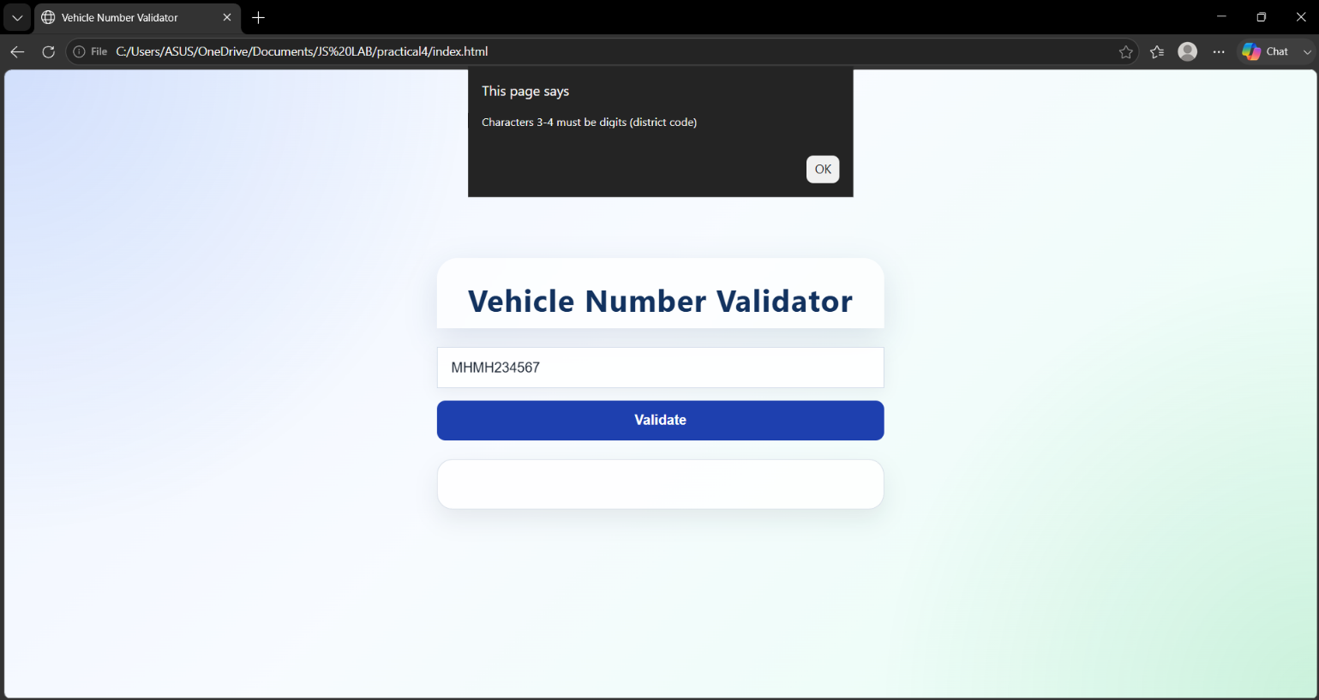
TANSIHQ DODIYA
24070521021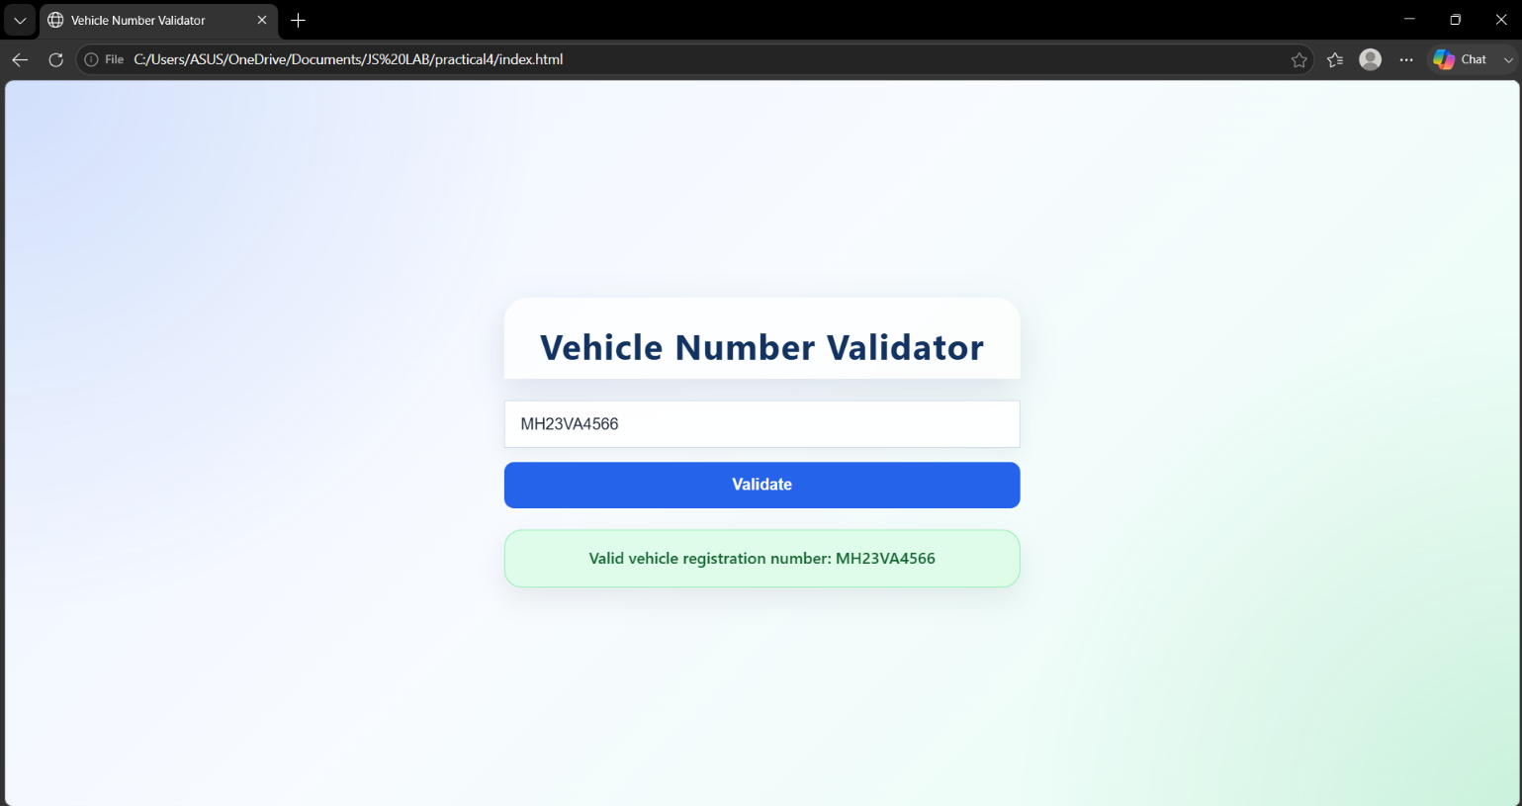
TANSIHQ DODIYA
24070521021
TANSIHQ DODIYA
24070521021
TANSIHQ DODIYA
24070521021

5. Case Study

caseStudy.html

<!DOCTYPE html>

<html>

<head>

<title>Palindrome Checker</title>

<link rel="stylesheet" href="caseStudy.css">

<script src="caseStudy.js"></script>

</head>

<body>

<div class="container">

<h2>Palindrome Checker</h2>

<label for="word">Enter a Word:</label>

<input type="text" id="word" placeholder="e.g. madam">

<input type="button" value="Check Palindrome" onclick="checkPalindrome()">

<div id="result"></div>

</div>

</body>

</html>

caseStudy.css

*{

margin:0;

padding:0;

box-sizing:border-box;

font-family: Arial, Helvetica, sans-serif;

}

body{

background:#f3f7fb;

color:#333;

padding:20px;

}

.container{

width:420px;

max-width:100%;

margin:50px auto;

background:#ffffff;

border:1px solid #d7e4f0;

border-radius:8px;

padding:24px;

}

h2{

text-align:center;

color:#4c6b8a;

margin-bottom:20px;

font-size:24px;

}

label{

font-size:15px;

color:#444;

}

input[type="text"]{

width:100%;

margin-top:8px;

margin-bottom:16px;

padding:10px;

border:1px solid #ccc;

border-radius:4px;

font-size:15px;

}

input[type="text"]:focus{

border-color:#888;

outline:none;

}

input[type="button"]{

width:100%;

padding:10px;

background:#8ba8c4;

color:#fff;

border:none;

border-radius:4px;

font-size:15px;

cursor:pointer;

}

input[type="button"]:hover{

background:#7092b3;

}

#result{

margin-top:18px;

padding:12px;

background:#eef5fb;

border-left:3px solid #8ba8c4;

border-radius:4px;

display:none;

}

#result h3{

color:#222;

margin-bottom:8px;

font-size:18px;

}

#result p{

margin:4px 0;

font-size:14px;

color:#444;

}

caseStudy.js

// Function to reverse a string

function reverseString(str) {

return str.split("").reverse().join("");

}

// Closure

function message() {

let msg = "Palindrome Checker";

function display() {

return msg;

}

return display;

}

// Main Function

function checkPalindrome() {

try {

let word = document.getElementById("word").value.trim();

let resultBox = document.getElementById("result");

if (word === "") {

resultBox.style.display = "none";

throw "Please enter a word.";

}

if (!/^[A-Za-z]+$/.test(word)) {

resultBox.style.display = "none";

throw "Only alphabets are allowed.";

}

if (word.length < 3) {

resultBox.style.display = "none";

throw "Please enter at least 3 characters.";

}

if (word.length > 20) {

resultBox.style.display = "none";

throw "Character limit exceeded (20 characters).";

}

let input = word.toLowerCase();

let reverse = reverseString(input);

let result = "";

if (input === reverse) {

result = "Palindrome";

} else {

result = "Not a Palindrome";

}

resultBox.style.display = "block";

resultBox.innerHTML =

"<h3>" + message()() + "</h3>" +

"<p><strong>Word:</strong> " + word + "</p>" +

"<p><strong>Result:</strong> " + result + "</p>";

} catch (error) {

alert(error);

}

}

5. Case Study Output

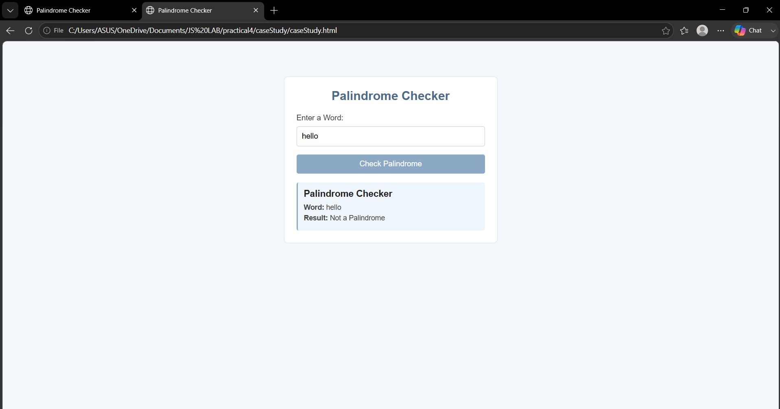
TANSIHQ DODIYA
24070521021

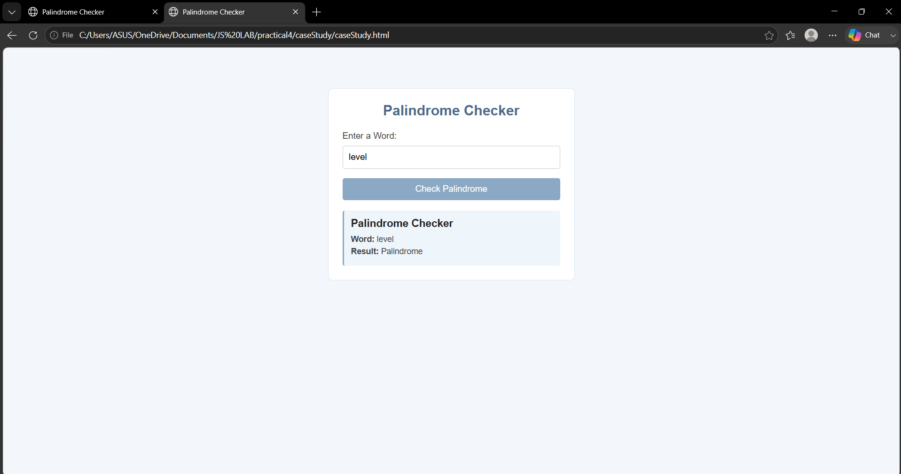
TANSIHQ DODIYA
24070521021

