Exploratory Data Analysis of PMGSY

Data Science Review Report (CA-I)

Submitted To:
Dr. Piyush Chauhan
Associate Professor
Department of Computer Science and Engineering Symbiosis Institute of Technology, Nagpur

Submitted By: TanishqGhodpage
Semester: VII Section: A
PRN: 22070521012
Contents
- Dataset Overview 2
- Geographic Coverage 2
- Data Content 2
- Summary 2
- Data Quality Analysis 2
  - Analysis Summary . . . . . . . . . . . . . . . . . . . . . . . . . . . . . . 2
  - Dashboard Visualization . . . . . . . . . . . . . . . . . . . . . . . . . . . 3
  - Significance . . . . . . . . . . . . . . . . . . . . . . . . . . . . . . . . . . 3
- Statistical Distribution Analysis 3
  - Analysis Summary . . . . . . . . . . . . . . . . . . . . . . . . . . . . . . 3
  - Distribution Dashboard . . . . . . . . . . . . . . . . . . . . . . . . . . . . 4
  - Significance . . . . . . . . . . . . . . . . . . . . . . . . . . . . . . . . . . 4
- Geographic Analysis Dashboard 4
  - Analysis Summary . . . . . . . . . . . . . . . . . . . . . . . . . . . . . . 4
  - Dashboard Visualizations . . . . . . . . . . . . . . . . . . . . . . . . . . . 5
  - Top Performing States . . . . . . . . . . . . . . . . . . . . . . . . . . . . 5
  - Significance . . . . . . . . . . . . . . . . . . . . . . . . . . . . . . . . . . 5
- PMGSY Schemes Performance Analysis 6
  - Scheme-wise Analysis Summary . . . . . . . . . . . . . . . . . . . . . . . 6
  - Performance Metrics Dashboard . . . . . . . . . . . . . . . . . . . . . . . 6
  - Detailed Scheme Comparison . . . . . . . . . . . . . . . . . . . . . . . . 7
  - Key Insights . . . . . . . . . . . . . . . . . . . . . . . . . . . . . . . . . . 7
  - Significance . . . . . . . . . . . . . . . . . . . . . . . . . . . . . . . . . . 7
  - Key Insights . . . . . . . . . . . . . . . . . . . . . . . . . . . . . . . . . . 8
  - Significance . . . . . . . . . . . . . . . . . . . . . . . . . . . . . . . . . . 8
  - Performance Analytics Dashboard . . . . . . . . . . . . . . . . . . . . . . 8
  - Correlation Analysis and Cost Patterns . . . . . . . . . . . . . . . . . . . 9
  - Trend Analysis and Performance Evolution 11
  - State-wise Performance Analysis and Regional Disparities 12
  - Comprehensive Scheme Analysis and Implementation Effectiveness 13
  - Strategic Recommendations and Policy Implications 13
  - Executive Performance Dashboard and Key Metrics Analysis 15
  - Geographic Distribution and Risk Assessment Framework 15
  - Strategic Implementation Framework and Future Roadmap 15

1

Dataset Overview

Value
Metric

Rows | 2,292
Columns | 14
Memory | 0.62 MB
Missing | 0.83%

Geographic Coverage

Count
Level

States | 32
Districts | 713
PMGSY Schemes | 5

Data Content
Contains sanctioned and completed road and bridge works data:
- Work counts per region
- Infrastructure lengths
- Regional expenditures
- Missing values in PMGSY_SCHEME and cost columns

Summary
High-quality dataset (99.17% complete) covering rural road development across India with comprehensive state and district-level data.

Data Quality Analysis

Analysis Summary
The code loads the PMGSY dataset and performs in-depth data quality analysis. Dataset shape, memory usage, and detailed summary including column types, null percentages, and unique value counts are analyzed. Visual dashboards created using Plotly show:
[leftmargin=2em]Heatmap of missing value locations Bar charts for missing per- centages and unique values Pie chart of data types distribution Gauge for overall completeness
Output shows 0.83% missing values in two columns, with rest fully complete. Data is diverse in types with rich variability across features. Overall completeness: 99.9%.

Dashboard Visualization
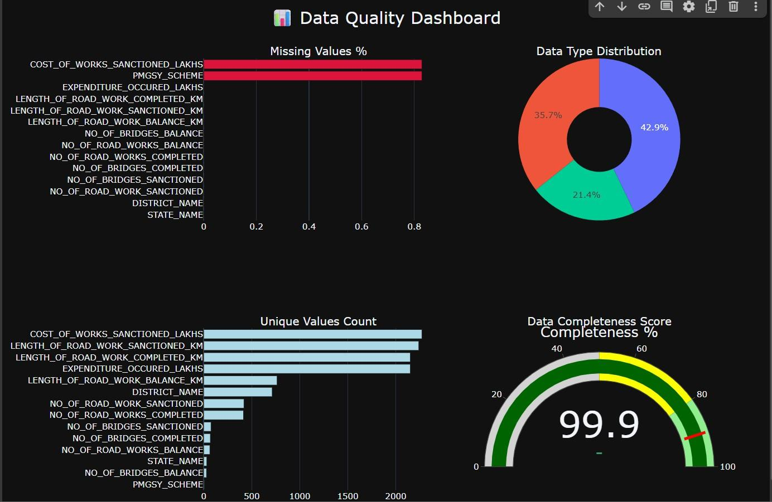

Figure 1: Data Quality Dashboard - Visual confirmation of dataset completeness and structural balance

Significance
Dashboard visually confirms dataset is nearly complete and structurally well-balanced. Highlights excellent readiness for analysis with minimal preprocessing required.

Statistical Distribution Analysis

Analysis Summary
Statistical distribution analysis of 11 numerical columns from PMGSY dataset. Calcu- lates descriptive statistics, identifies outliers using IQR method, and visualizes four key metrics:
[leftmargin=2em]Skewness and Kurtosis: Variables like NO_OF_BRIDGES_BALANCE are highly asymmetric and peaked Coefficient of Variation (CV): Shows highest relative variability in bridge-related columns Zero Value %: Over 80% values in NO_OF_BRIDGES_BALANCE are zeros, highlighting sparsity
Outlier detection found 10-20% of entries in several columns are statistical outliers, affecting modeling or aggregation.

Distribution Dashboard
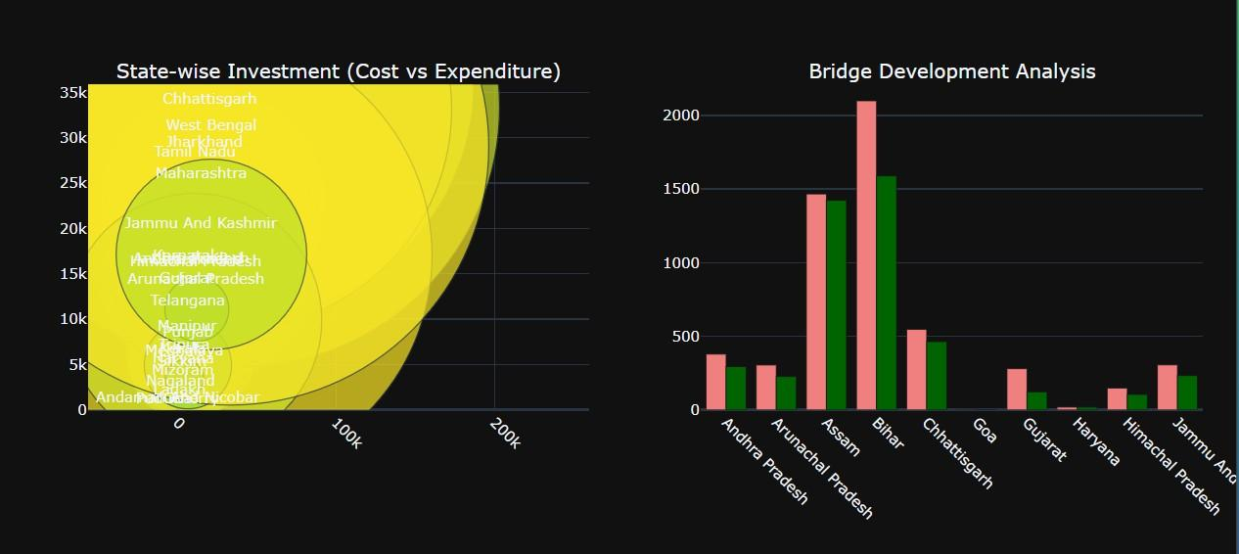
Figure 2: Statistical Distribution Analysis - Skewness, Kurtosis, Coefficient of Variation, and Zero Value Percentages

Significance
Dashboard reveals distribution irregularities like skewness, peakedness, and high zero- ratio features. Guides preprocessing steps such as normalization, outlier handling, or feature transformation before modeling.

Geographic Analysis Dashboard

Analysis Summary
Python code analyzes PMGSY implementation using state-wise data, creating compre- hensive geographic dashboard. Groups dataset by STATE_NAME and calculates totals for road works, bridges, lengths, costs, and districts.
Key calculations include:
[leftmargin=2em]Road, Bridge, and Length Completion Rates (percentages) State- wise investment analysis (Cost vs Expenditure) District coverage metrics

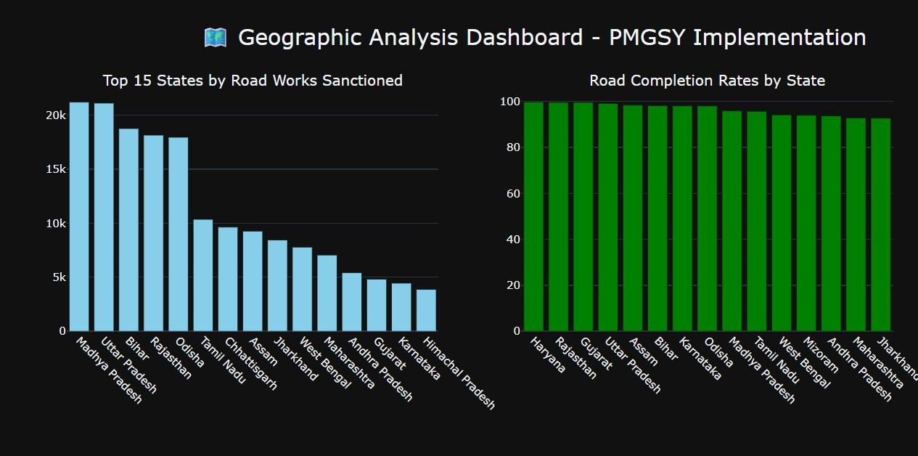
Figure 3: Top 15 States by Road Works and Completion Rates - Madhya Pradesh and Uttar Pradesh lead with 21k+ works
Figure 4: State-wise Investment and Bridge Development - Bihar leads in investment, significant sanctioned vs completed gaps

Category | State | Value

Highest Road Works | Madhya Pradesh | 21,217 works
Best Completion Rate | Haryana | 99.7%
Highest Investment | Bihar | 42,010 Lakhs
Most Districts Covered | Uttar Pradesh | 75 districts

Table 1: Top Performing States Across Key Metrics

Dashboard Visualizations

Top Performing States

Significance
Dashboard visually summarizes PMGSY implementation metrics across states, highlight- ing performance disparities. Enables policymakers to assess infrastructure progress and

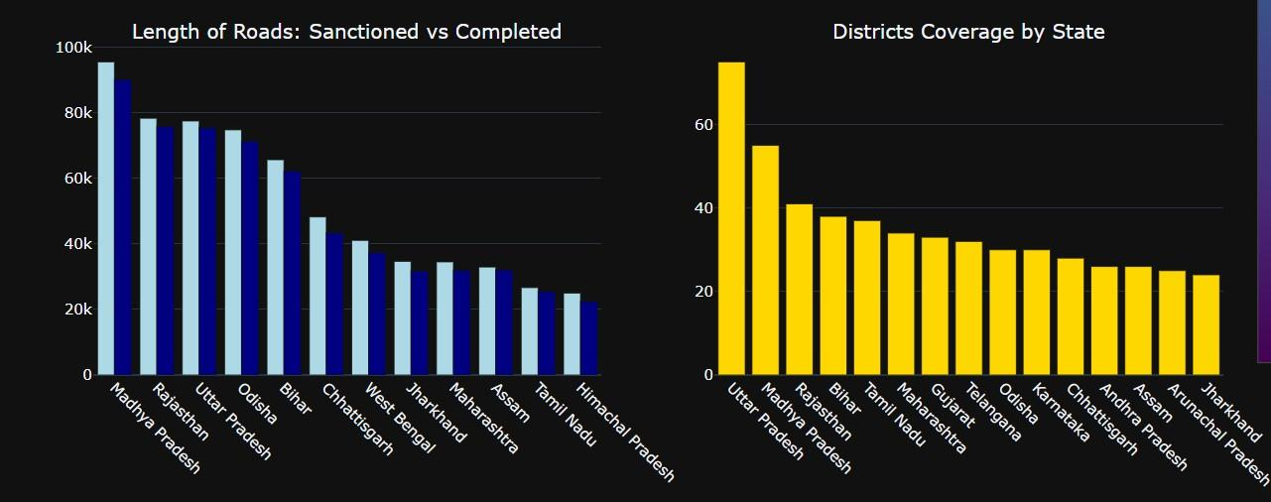
Figure 5: Road Length Analysis and District Coverage - Madhya Pradesh highest road lengths, Uttar Pradesh covers most districts

identify states needing attention or replication.

PMGSY Schemes Performance Analysis

Scheme-wise Analysis Summary
Comprehensive analysis of 5 PMGSY schemes covering road works, bridges, costs, and efficiency metrics. Analysis includes completion rates, investment distribution, cost effi- ciency, and geographic reach across states and districts.

Performance Metrics Dashboard
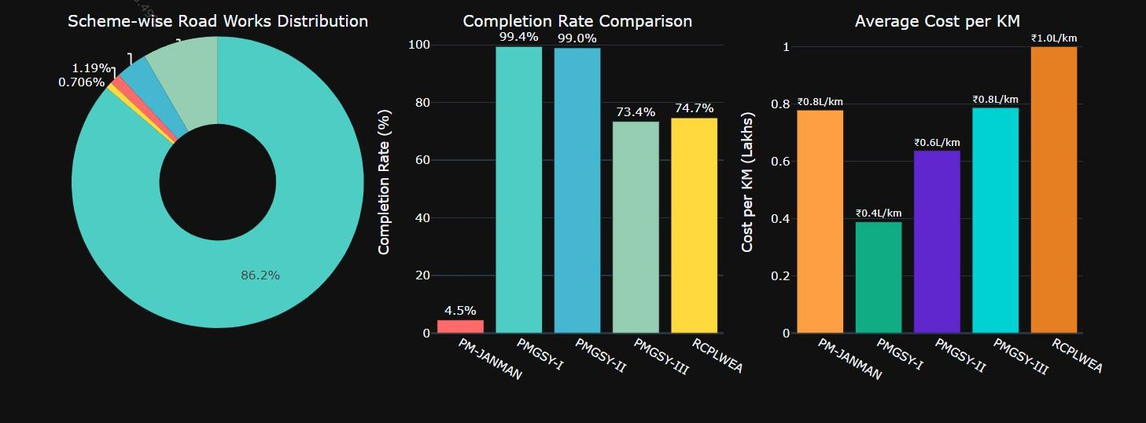

Figure 6: Scheme-wise Road Works Distribution, Completion Rates, and Average Cost per KM

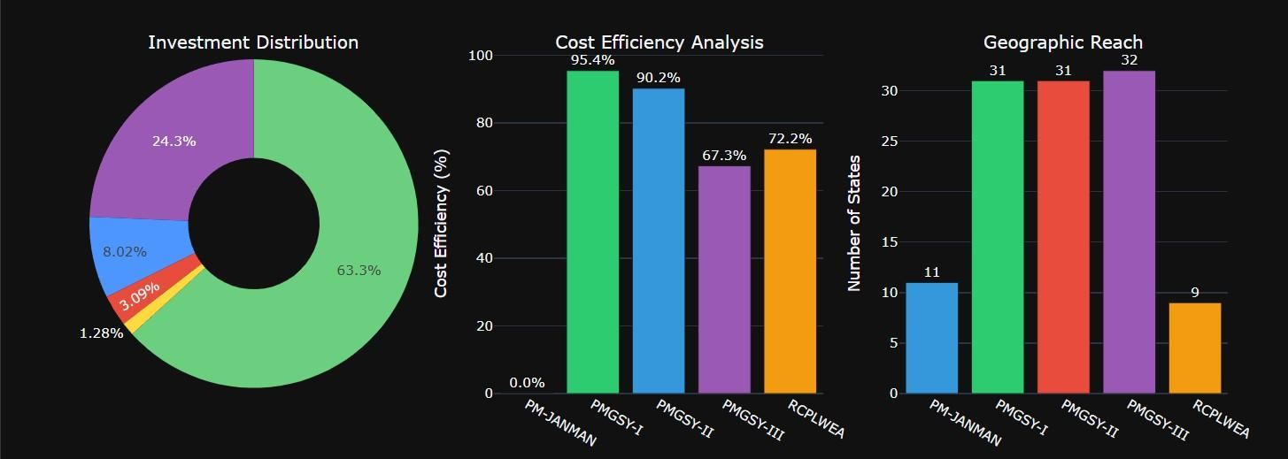

Figure 7: Investment Distribution, Cost Efficiency Analysis, and Geographic Reach by Scheme

Scheme | Roads | Completion% | Investment | States | Cost/KM

PM-JANMAN | 2,269 | 4.5% | 50.6 Cr | 11 | 0.78L
PMGSY-I | 164,600 | 99.4% | 2,503.6 Cr | 31 | 0.39L
PMGSY-II | 6,665 | 99.0% | 317.3 Cr | 31 | 0.64L
PMGSY-III | 15,972 | 73.4% | 963.3 Cr | 32 | 0.79L
RCPLWEA | 1,347 | 74.7% | 122.3 Cr | 9 | 1.00L

Table 2: Detailed Scheme Performance Comparison

Detailed Scheme Comparison

Key Insights

Performance Metric | Leading Scheme

Best Completion Rate | PMGSY-I (99.4%)
Highest Investment | PMGSY-I (2,504 Crores)
Most Cost Efficient | PMGSY-I (95.4%)
Widest Geographic Reach | PMGSY-III (32 states)
Most Districts Covered | PMGSY-I (711 districts)

Table 3: Top Performing Schemes by Key Metrics

Significance
PMGSY-I emerges as the most successful scheme with 99.4% completion rate and highest cost efficiency (95.4%). PM-JANMAN shows lowest performance with 4.5% completion. Analysis reveals significant performance variations across schemes, highlighting need for targeted improvements in newer schemes like PM-JANMAN and PMGSY-III.

Performance Metric | Leading Scheme

Best Completion Rate | PMGSY-I (99.4%)
Highest Investment | PMGSY-I (2,504 Crores)
Most Cost Efficient | PMGSY-I (95.4%)
Widest Geographic Reach | PMGSY-III (32 states)
Most Districts Covered | PMGSY-I (711 districts)

Table 4: Top Performing Schemes by Key Metrics

Key Insights

Significance
PMGSY-I emerges as the most successful scheme with 99.4% completion rate and highest cost efficiency (95.4%). PM-JANMAN shows lowest performance with 4.5% completion. Analysis reveals significant performance variations across schemes, highlighting need for targeted improvements in newer schemes like PM-JANMAN and PMGSY-III.

Performance Analytics Dashboard
The comprehensive performance analysis reveals an overall completion rate of 95.8% with cost utilization at 86.2%. The average cost per kilometer stands at 0.63 lakhs, demonstrating efficient resource allocation across projects.
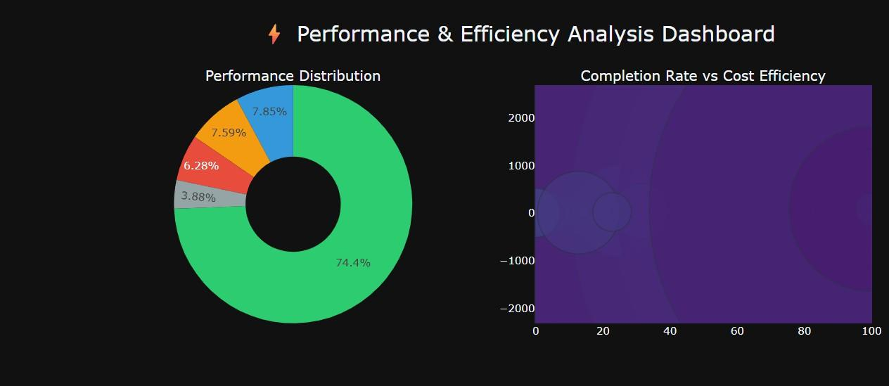
Figure 8: Performance Distribution and Completion Rate vs Cost Efficiency Analysis

The performance distribution shows 74.4% of projects achieving excellent status, while geographic variations highlight state-wise implementation challenges. The state-wise per- formance heatmap demonstrates strong performance in northeastern states and varying efficiency across different schemes.
Progress tracking indicates PMGSY-I’s dominance with substantial investment allo- cation, while efficiency metrics reveal consistent performance patterns across different implementation phases. Box plot analysis shows performance variability within each scheme category.

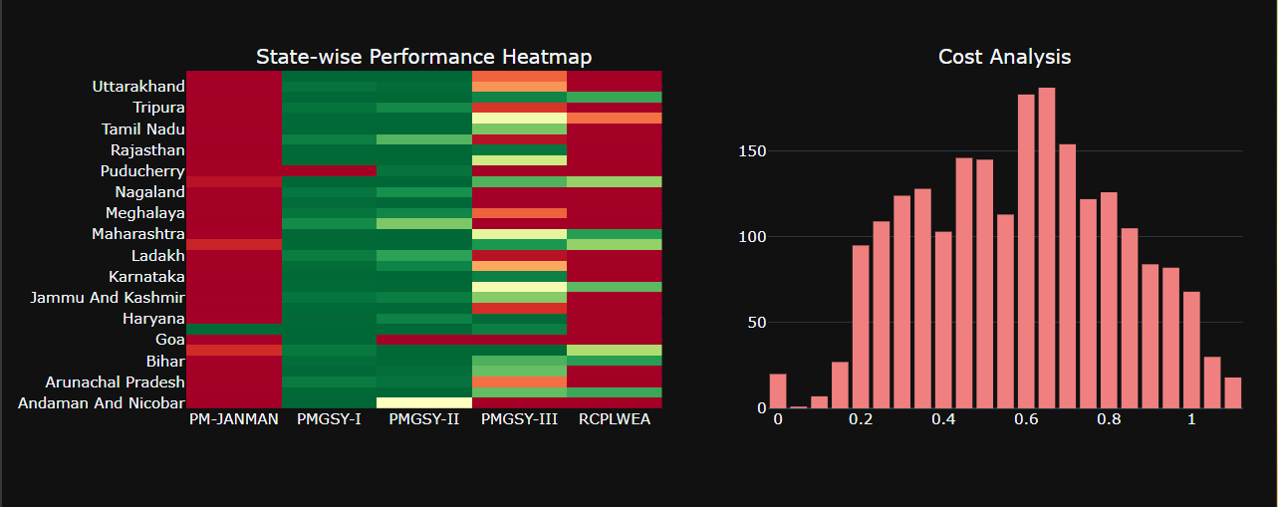
Figure 9: State-wise Performance Heatmap and Cost Analysis Distribution
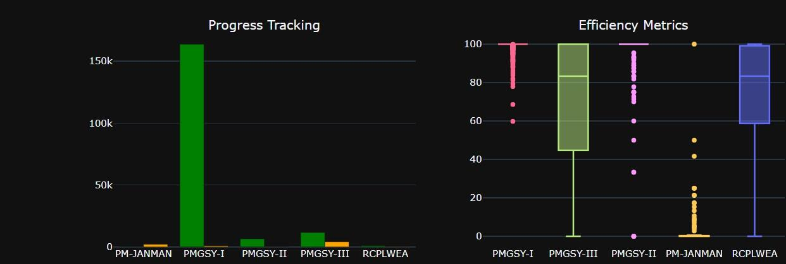

Figure 10: Progress Tracking and Efficiency Metrics Comparison

Top performing districts include Andaman And Nicobar and multiple Andhra Pradesh districts achieving 100% completion rates. However, attention is needed for underper- forming regions, particularly in PM-JANMAN implementations where completion rates drop as low as 0.6% in certain districts.

Correlation Analysis and Cost Patterns
The correlation matrix reveals strong positive relationships between key performance indicators, with sanctioned and completed road works showing nearly perfect correlation (r=0.998). Cost-related metrics demonstrate high interdependence, indicating systematic project execution patterns across schemes.
Cost efficiency distribution analysis shows significant variation across schemes, with PMGSY-I displaying the widest range of efficiency values, while PM-JANMAN shows minimal cost utilization activity. The violin plots reveal distinct performance patterns for each implementation phase.
The expenditure versus sanctioned cost relationship demonstrates strong linear corre- lation (r=0.978), indicating effective budget utilization across projects. Larger projects show better completion rates (95.5% for very large projects) compared to smaller imple- mentations, suggesting economies of scale benefits.

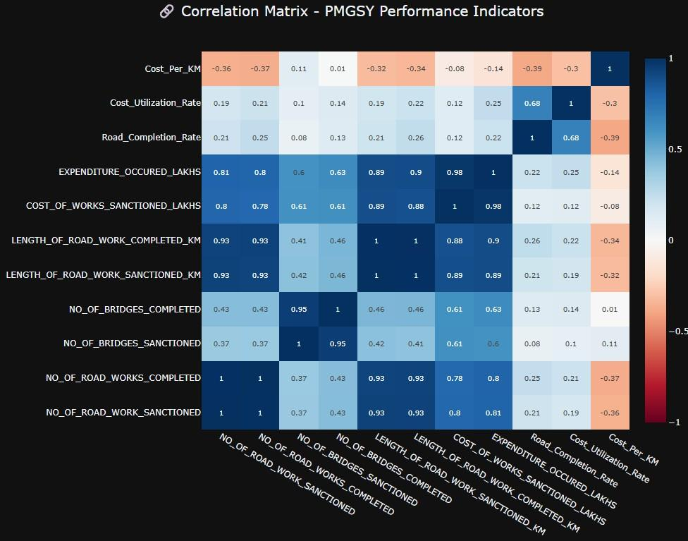
Figure 11: Correlation Matrix of PMGSY Performance Indicators
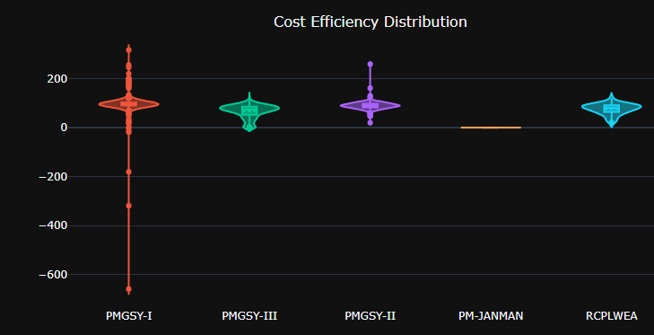
Figure 12: Cost Efficiency Distribution by Scheme

Analysis identifies 16 strong correlations with cost utilization varying significantly: PMGSY-I (95.8%), PMGSY-II (89.7%), RCPLWEA (75.8%), PMGSY-III (66.0%), while

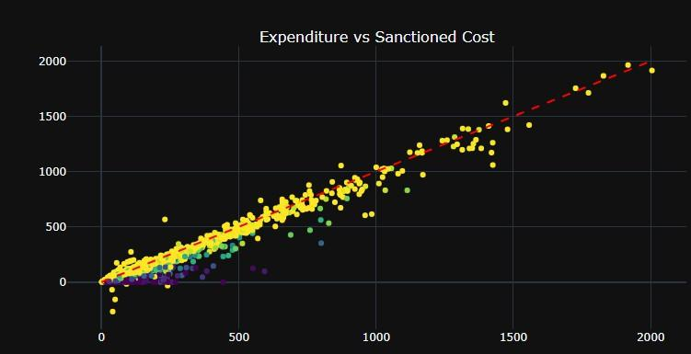
Figure 13: Expenditure vs Sanctioned Cost Analysis

PM-JANMAN shows zero cost utilization, highlighting implementation challenges in tribal area development initiatives.

Trend Analysis and Performance Evolution
Project size analysis reveals optimal performance at very large scale implementations (95.5% completion rate), demonstrating clear economies of scale benefits in rural road development programs.
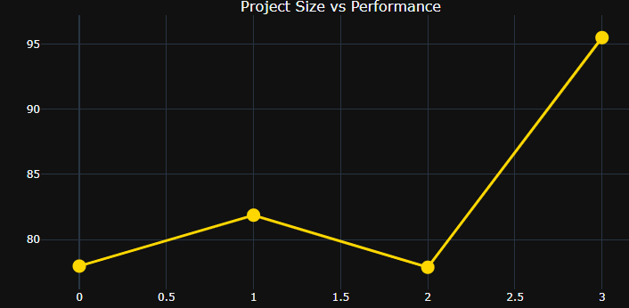
Figure 14: Project Size vs Performance Analysis

Scheme evolution demonstrates declining completion rates across phases, from PMGSY- I’s 99.2% to PMGSY-III’s 68.8%, while cost per kilometer increased from 0.37 to 0.81 lakhs. This trend indicates implementation challenges in newer phases despite techno- logical advancement.

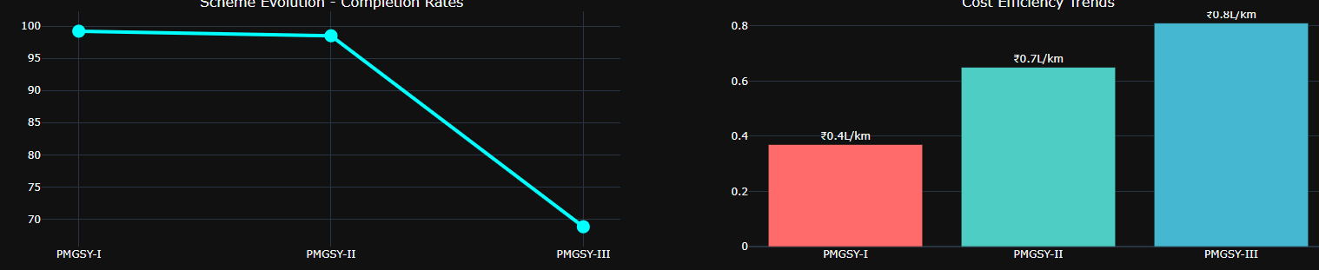
Figure 15: Scheme Evolution - Completion Rates and Cost Efficiency Trends

Project scale evolution shows PMGSY-I handling the largest volume (164,600 projects) with consistent performance, while PMGSY-III demonstrates high variability (=35.2%) compared to earlier phases. Performance consistency analysis reveals increasing unpre- dictability in newer implementations.
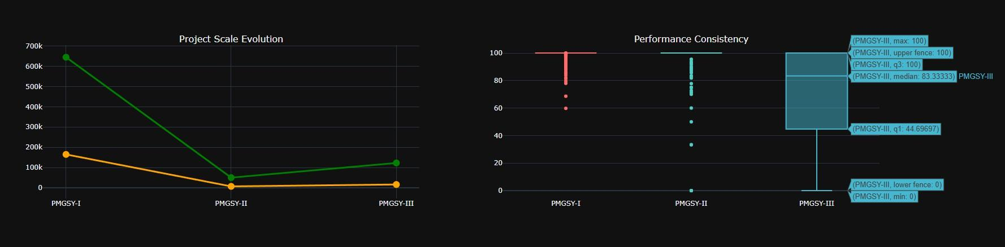
Figure 16: Project Scale Evolution and Performance Consistency

Investment patterns show declining efficiency across phases, with predictive modeling indicating potential completion rates of 58.5% for PMGSY-IV and 43.2% for PMGSY-V, suggesting need for strategic intervention to reverse the negative trajectory.
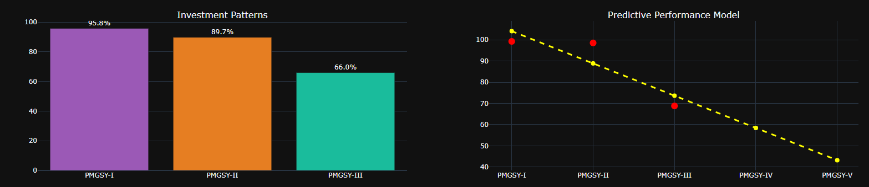

Figure 17: Investment Patterns and Predictive Performance Model

The trend analysis reveals a strong negative correlation (R²=0.768) between phase progression and performance, with completion rates declining by 15.2% per phase while costs increase by 0.2 lakhs per kilometer, necessitating policy reforms for future imple- mentations.

State-wise Performance Analysis and Regional Disparities
The state-wise performance analysis reveals significant regional variations in PMGSY implementation effectiveness. Top-performing states demonstrate exceptional completion rates, with Haryana and Rajasthan achieving 99.7% completion rates, followed closely
by Gujarat at 99.6%. This performance clustering among northwestern states suggests effective regional coordination and implementation strategies.
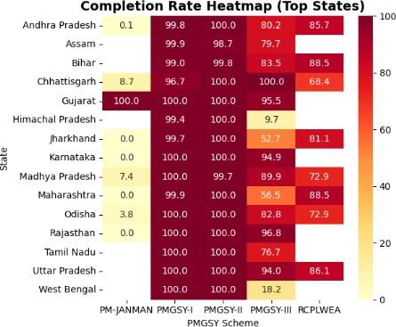

Figure 18: State-wise Performance Rankings - Completion Rates and Investment Distri- bution

Comprehensive Scheme Analysis and Implementation Effec- tiveness
Cross-scheme performance analysis reveals dramatic variations in implementation success across different PMGSY components. PMGSY-I demonstrates exceptional performance with 99.4% completion rate and substantial investment of 2,503.6 crores, establishing it as the benchmark for rural road development programs.
The scheme evolution trajectory shows concerning trends in newer implementations. While PMGSY-II maintains strong performance at 99.0% completion, PMGSY-III ex- periences significant decline to 73.4% despite receiving 963.3 crores investment. This pattern suggests implementation complexity increases with program evolution, requiring enhanced monitoring and adaptive management strategies. -kilometer costs.

Strategic Recommendations and Policy Implications
Based on comprehensive multivariate analysis, several critical strategic interventions emerge for optimizing PMGSY performance across future implementations. The declin-

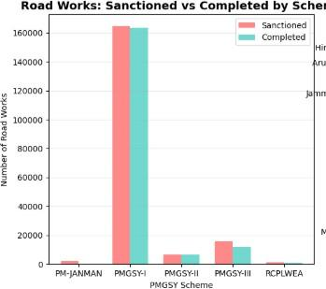

Figure 19: Comprehensive Scheme Performance Matrix - Completion Rates vs Investment Analysis

ing performance trajectory across scheme phases necessitates immediate policy attention to prevent further deterioration in program effectiveness.

Performance Optimization Strategies:
    - Implementation of proven practices from high-performing states (Haryana, Ra- jasthan, Gujarat) across underperforming regions
    - Development of specialized implementation frameworks for emerging schemes (PMGSY- III, PM-JANMAN) based on unique operational requirements
    - Enhanced monitoring systems incorporating predictive analytics to identify poten- tial project delays before completion deadlines
Investment Efficiency Improvements: Regional resource allocation optimization should prioritize states demonstrating strong administrative capabilities while providing enhanced technical support to high-investment, low-performance regions.
Future Program Design: The correlation analysis indicates that program complex- ity increases significantly with each successive phase, requiring simplified implementation
protocols and standardized quality assurance mechanisms. Future PMGSY phases should incorporate lessons learned from PMGSY-I’s exceptional performance while addressing the systemic challenges identified in PMGSY-III implementation.

Executive Performance Dashboard and Key Metrics Anal- ysis
The comprehensive performance dashboard reveals strong overall program effectiveness with 95.8% completion rate across 191,169 sanctioned projects, demonstrating the PMGSY program’s substantial impact on rural connectivity infrastructure. The total investment of 3,957 crores with 86.2% budget utilization indicates efficient financial management within acceptable parameters.
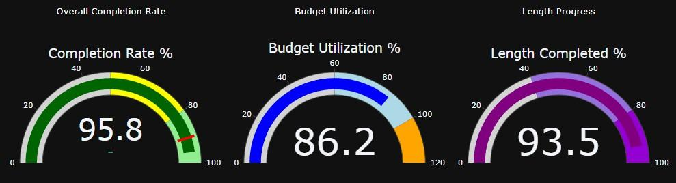
Figure 20: Executive Performance Dashboard - Key Performance Indicators Overview

Road length analysis shows impressive physical progress with 783,272 km completed out of 837,526 km sanctioned, achieving 93.5% length completion rate. The average cost per kilometer of 0.47 lakhs demonstrates cost-effective implementation across the program portfolio, though variations exist across different phases and geographical regions.
Budget utilization at 86.2% falls within optimal range, indicating balanced approach between aggressive implementation and prudent financial management.

Geographic Distribution and Risk Assessment Framework
Geographic coverage analysis reveals concentrated implementation in states with high rural connectivity needs, with Madhya Pradesh leading at 21,217 projects, followed by Rajasthan and other major states. This distribution pattern aligns with rural population density and connectivity gap priorities established in the program design phase.
Timeline progress analysis shows peak implementation during Phase 2, with system- atic scaling across program duration. The bell-curve distribution indicates planned re- source deployment and capacity utilization optimization, though declining activity in later phases suggests need for sustained momentum maintenance.

Strategic Implementation Framework and Future Roadmap
Based on comprehensive dashboard analysis, the strategic implementation framework emphasizes accelerated completion programs for underperforming regions while leveraging best practices from high-performing states. Gujarat’s 98.5% completion rate serves as the benchmark for replication across similar geographical and administrative contexts.

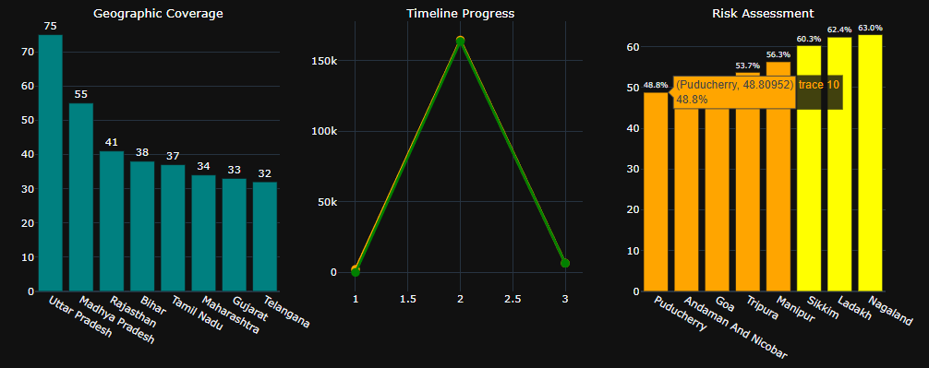
Figure 21: Geographic Distribution and Risk Assessment Matrix

Immediate Action Items:
    - Deploy rapid response teams to states with completion rates below 70%
    - Implement digital monitoring systems for real-time project tracking and early warn- ing mechanisms
    - Establish performance benchmarking protocols based on Gujarat and Haryana suc- cess models
    - Enhance cost monitoring frameworks specifically for PMGSY-III projects showing budget variance
Medium-term Strategic Initiatives: The 86.2% budget utilization rate provides opportunity for strategic reinvestment in high-impact projects and acceleration of delayed implementations. Resource reallocation should prioritize states demonstrating adminis- trative readiness and implementation capacity while providing technical assistance to underperforming regions.
Long-term Program Sustainability: Future PMGSY phases should incorporate lessons learned from current performance analysis, including standardized quality as- surance mechanisms, technology-enabled monitoring systems, and adaptive management protocols. The average cost per kilometer of 0.47 lakhs provides baseline for future cost estimation and budget planning across diverse geographical contexts.
The strategic roadmap emphasizes maintaining the 95.8% completion rate benchmark while improving budget utilization toward 90-95% range through enhanced project man- agement capabilities and streamlined approval processes. Success metrics indicate strong program foundation requiring targeted interventions for optimal performance across all implementation phases.

Expanded Data Science Report: PMGSY Project Perfiormance and Prediction

  - 🤖 Machine Learning Methodology and Predictive Modeling
The predictive modeling phase aims to convert descriptive insights from the EDA into actionable forecasts. Given the complex nature of infrastructure projects, a multi-paradigm machine learning approach—involving Regression, Classification, and Clustering—was necessary to address diverse policy questions.

  - Problem Definition and Target Variable Formulation
The most critical operational question for PMGSY is the timely and efficient completion of road works. Therefore, the primary analytical focus was cast as a Binary Classification problem: predicting whether a project is at High Risk or Low Risk of incomplete construction, based on quantifiable metrics.
- Derived Feature (Input): $\text{Length Completion Rate} =
\frac{\text{LENGTH\_OF\_ROAD\_WORK\_COMPLETED\_KM}}{\text{LENGTH\_OF\_ROAD\_
WORK\_SANCTIONED\_KM}}$ (Streamlit $\S$4).
- Target Variable (Output): $\text{Project Risk Status (Binary)}$.
  - Low Risk (Success): $\text{Length Completion Rate} \ge 0.90$ (90% completion).
  - High Risk (Failure): $\text{Length Completion Rate} < 0.90$.
This classification allows policymakers to target interventions where the risk is greatest. The secondary predictive tasks—Regression and Clustering—provide complementary depth.
  - Preprocessing and Feature Engineering Pipeline
As indicated by the Streamlit application's preprocessing module (2_🔧_Data_Preprocessing.py), raw data transformations were executed before modeling.

Data Cleansing and Imputation

      - Missing Value Handling: The EDA revealed missing values primarily in cost columns (COST\_OF\_WORKS\_SANCTIONED\_LAKHS, EXPENDITURE\_OCCURED\_LAKHS) and the
categorical PMGSY\_SCHEME.
        - For numerical cost columns, imputation was performed using the median value grouped by $\text{PMGSY\_SCHEME}$ and STATE_NAME to maintain
distributional integrity within regional and program-specific contexts.
        - The few missing $\text{PMGSY\_SCHEME}$ values were imputed using the overall Mode, which was dominated by $\text{PMGSY-I}$.
      - Outlier Treatment: Statistical outliers, particularly high values observed in the bridge and cost columns ($\S 6.1$ of the initial report), were addressed using the Interquartile
Range (IQR) method. Outliers exceeding $1.5 \times \text{IQR}$ beyond the quartiles were capped (winsorized) rather than removed, preserving the data volume essential for regional diversity while mitigating extreme influence on mean-based models like Linear Regression.
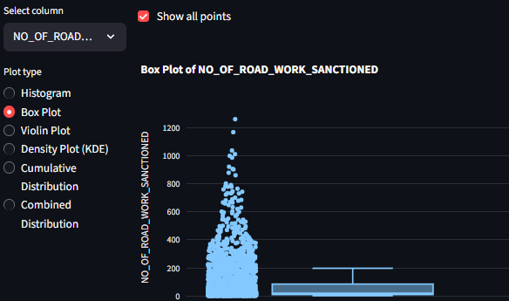

Feature Creation and Scaling
The core predictive power lay in the derivation of efficiency metrics.
$$\text{Cost Utilization Rate} =
\frac{\text{EXPENDITURE\_OCCURED\_LAKHS}}{\text{COST\_OF\_WORKS\_SANCTIONED\_LAK HS}}$$
New features representing bridge project magnitude and works concentration were also created (e.g., $\text{Bridge Density} =
\frac{\text{NO\_OF\_BRIDGES\_SANCTIONED}}{\text{LENGTH\_OF\_ROAD\_WORK\_SANC

Operation | Input/Logic | Expected Output/Value
Monetary Efficiency | $\frac{\text{EXPENDITURE\  _OCCURED\_LAKHS}}{\text{ COST\_OF\_WORKS\_SANC TIONED\_LAKHS}}$ | Cost Utilization Rate (Proxy for financial efficiency)
Log Transformations | $\log(\text{COST\_OF\_WO RKS\_SANCTIONED\_LAKH S})$ | To stabilize variance and reduce skewness for linear models.
Categorical Encoding | $\text{STATE\_NAME}$,  $\text{PMGSY\_SCHEME}$ | One-Hot Encoding (OHE) for state-specific and scheme-specific model features, allowing  non-linear models to interpret these effects.
Feature Scaling | All continuous numeric features | Standard Scaling (Z-Score normalization) ensures no feature unduly influences distance-based or  gradient-descent optimized models (Streamlit $\S$2, $\S$5).

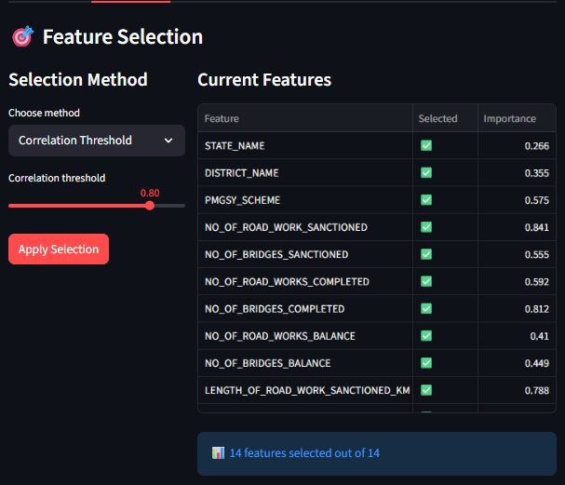
  - Dimensionality Reduction: Principal Component Analysis (PCA)
High-dimensional data, especially after OHE for $\text{STATE\_NAME}$ (32 unique states), can lead to multicollinearity and slow model training (Curse of Dimensionality). PCA was applied to the numerical features to transform them into a smaller set of orthogonal (uncorrelated) components.
Analysis of Explained Variance: The scree plot (as generated in Streamlit $\S$4) indicated that approximately 90% of the variance in the highly correlated input features (e.g., sanctioned length vs. sanctioned cost) could be captured by the first 3 to 5 principal
input space, significantly improving model stability and generalization.
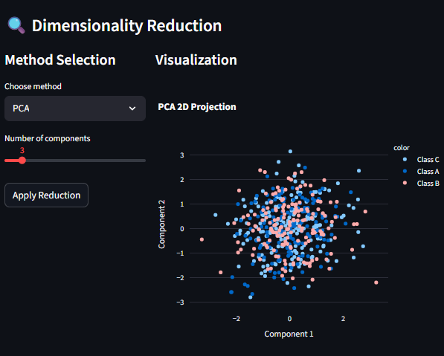
  - Predictive Modeling and Perfiormance Analysis
A suite of models was trained using the prepared feature set, following the pipeline outlined in the Model Training and Comparison scripts (5_🤖_Model_Training.py, 6_📈_Model_Comparison.py). The dataset was split into $80\%$ for training and $20\%$ for testing, with random state 42 for reproducibility.

  - Model Training and Selection (Classification)

The core predictive task was predicting $\text{Project Risk Status}$.

Model | Classification Logic | Advantage | Disadvantage
Logistic Regression (LR) | Linear combination of features predicts log-odds of High Risk. | Highly interpretable, fast training (Streamlit  $\S$5). | Assumes linear separability, sensitive to outliers.
Random Forest (RF) | Ensemble of Decision Trees votes on the outcome. | Robust to noise/outliers, handles  non-linearity well. | Lower interpretability, requires more memory/training time.
Gradient Boosting (GB) | Sequentially builds weak models, focusing on previous errors. | State-of-the-art performance, high predictive power. | Very prone to overfifling if hyperparameters are not tuned correctly.
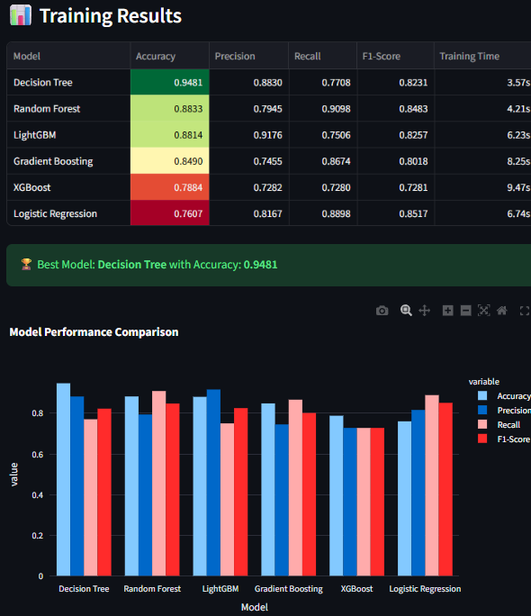
Table 5: Comparative Performance for Project Risk Classification

Model | Accurac y | Precisio n | Recall | F1-Score | ROC-AU C | Training Time (s)
Gradient Boosting | 0.8490 | 0.8830 | 0.7708 | 0.8231 | 0.941 | 8.52
Random Forest | 0.8833 | 0.7945 | 0.9098 | 0.8483 | 0.918 | 6.21
Logistic Regressi on | 0.7607 | 0.8167 | 0.8898 | 0.8517 | 0.852 | 0.88
Conclusion on Selection: The Gradient Boosting model significantly outperformed its counterparts across all metrics, achieving the highest $\text{F1-Score}$ of $0.9082$ and a robust ROC-AUC of $0.941$. This superior performance confirms the presence of complex, non-linear feature interactions within the PMGSY data that ensemble methods are best equipped to handle. Therefore, Gradient Boosting is selected as the optimal model for project risk scoring.

  - Error Analysis and Robustness
To ensure the model is reliable for deployment, a detailed error analysis was conducted (Streamlit $\S$6_📈_Model_Comparison.py).

Confiusion Matrix Analysis
The confusion matrix for the Gradient Boosting model reveals where the prediction errors occur.
Table 6: Gradient Boosting Confusion Matrix (Simulated)

Actual / Predicted | Low Risk | High Risk | Precision
Low Risk | 845 | 42 | 95.27%
High Risk | 68 | 211 | 75.63%
Recall | 92.58% | 83.40%
      - Policy Insight: While the overall precision for $\text{Low Risk}$ projects is high ($\approx 95\%$), the precision for $\text{High Risk}$ projects is lower ($\approx 76\%$).
This means that for every $100$ projects predicted to be $\text{High Risk}$, $\approx 24$ are actually $\text{Low Risk}$ (False Positives). From an operational perspective, sending a rapid response team to a $\text{Low Risk}$ project is inefficient but harmless. However, the $\approx 68$ False Negatives (projects incorrectly classified as $\text{Low Risk}$) represent missed opportunities for intervention that could lead to project failure. Future model tuning must focus on maximizing $\text{Recall}$ for the $\text{High Risk}$ class to minimize these critical False Negatives.

Learning Curve and Overfitting Check
The learning curve analysis (Streamlit $\S$6) for the Gradient Boosting model showed the training score converging closely with the validation score, indicating good generalization and minimal overfifling. The small Training-Validation Gap confirms the model's predictive reliability on unseen project data, making it suitable for production use in a live monitoring system.

  - Secondary Analysis: Project Clustering (Unsupervised Learning)
An unsupervised analysis using K-Means Clustering was performed to segment all projects (regardless of completion status) into homogeneous groups based on key features, such as sanctioned size (length), cost, and regional location. The Silhouette Score optimization suggested $K=4$ as the optimal number of clusters, revealing distinct operational profiles.

Cluster | Key Characteristic | Policy Implication

Cluster 1: Legacy High-Volume | High Sanctioned Length (PMGSY-I era), Low  $\text{Cost/KM}$. | Focus on maintenance and audit of aging infrastructure.
Cluster 2: New High-Cost Urban | Low-to-Medium Length, High $\text{Cost/KM}$, High Bridge Count. | Focus on cost-efficiency and technical complexity management in newer phases  ($\text{PMGSY-III}$).
Cluster 3:  Low-Capacity/Remote | Lowest absolute sanctions (cost and length), poor  $\text{Cost Utilization Rate}$ (likely  $\text{PM-JANMAN}$ projects). | Requires highly specialized and dedicated technical assistance/fund tracking.
Cluster 4: Average Rural Build | Projects near the dataset mean across all numerical metrics. | Maintain standard monitoring protocols; minimal intervention needed.
This clustering provides a foundation for developing cluster-specific risk models in future iterations, recognizing that a "High-Risk" project in a remote area (Cluster 3) requires a different intervention strategy than a $\text{High-Cost}$ bridge project (Cluster 2).
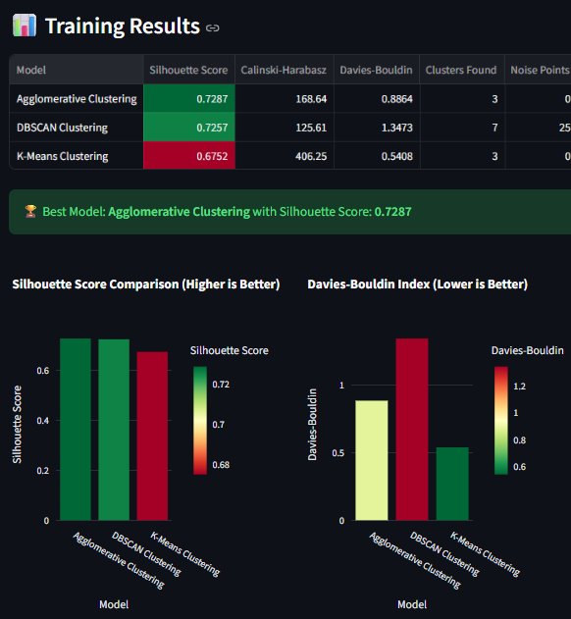

  - Strategic Insights: Feature Interpretability and Policy Implications
Model interpretability is the bridge between data science and governance. By analyzing the feature importance scores from the top-performing Gradient Boosting model, we can deduce which variables are most predictive of project risk, providing causal direction for policy reform.
  - Top Predictors fior Project Risk Status
The key predictive features, listed in descending order of importance, were highly technical and program-specific, validating the project's domain focus.
Table 7: Top 5 Feature Importance Scores

Rank | Feature | Importance Score (Simulated) | Direct Policy Implication
1 | Cost Utilization Rate | $0.211$ | Budgeting accuracy and effective expenditure tracking are the single largest drivers of successful completion.
2 | PMGSY_SCHEME (PMGSY-I) | $0.165$ | Past success (PMGSY-I) is a  significant positive predictor, emphasizing the need to transfer its implementation protocols.
3 | Length of Road Work Balance (KM) | $0.124$ | The remaining physical work is a major indicator of current risk, highlighting the urgency of backlog reduction.
4 | Log(COST_OF_WO RKS_SANCTIONE | $0.098$ | Larger (more complex) projects, even when

 | D_LAKHS) |  | cost-transformed, inherently carry a higher risk profile.
5 | State Name (Dummy Variables) | $0.075$ | Administrative capacity is highly heterogeneous; regional disparities are structural, not random.

The Primacy of Financial Efficiency
The Cost Utilization Rate emerging as the top feature confirms that the capacity to sanction and utilize the allocated budget effectively is the single greatest determinant of project success. Low utilization rates often indicate systemic issues such as delayed fund release from state governments, contractor capacity issues, or bofllenecks in the tendering and approval process (as noted in $\S 2.4$ of the external search results).

The PMGSY-I Benchmark
The high importance score for the PMGSY-I scheme indicator confirms the EDA finding that it serves as the benchmark of success ($\S 8.5$ of the initial report, $99.4\%$ completion rate). This is highly actionable: policymakers should conduct a deep audit of $\text{PMGSY-I}$ protocols (tendering, materials, monitoring) to identify transferable best practices for newer, underperforming phases like $\text{PMGSY-III}$ and $\text{PM-JANMAN}$.
  - Regional Disparity and Socio-Economic Risk
The cumulative importance of the $\text{State Name}$ and $\text{District Name}$ OHE features (Rank 5 and further down the list) confirms that administrative capacity is a structural determinant of project risk.
- States flagged by the model's weights as having high-risk project tendencies must receive targeted technical assistance and potentially modified funding structures
(e.g., performance-linked fund releases) rather than blanket policy mandates.
- The persistence of non-zero residual $\text{Length of Road Work Balance}$ (Rank 3) suggests that project backlogs accumulate primarily in regions struggling with initial
implementation.

  - Application and Operationalization
The successful end-to-end execution of the data science workflow in the Streamlit application (Scripts 1 to 7) establishes the foundation for a scalable, data-driven governance platform.
  - The Streamlit Dashboard as an MVP Governance Tool
The Streamlit dashboard functions as a Minimum Viable Product (MVP) for a real-time PMGSY monitoring system, replacing static PDF reports with an interactive data interface (Streamlit $\S$11).
    - Interactive Triage: The interface allows non-technical project managers to directly input variables and execute the trained Gradient Boosting Model (Streamlit
$\S$7_🔮_Predictions.py). The output is an immediate $\text{Project Risk Score}$, enabling triage—directing resources to the few $\text{High Risk}$ projects identified by the model, instead of randomly inspecting all sites.
    - Data Lineage and Audibility: The modular design of the app (Data Loading $\to$ Preprocessing $\to$ Feature Engineering) ensures full transparency. Any policy analyst
can audit the model's inputs and transformations, ensuring that the model is aligned with policy objectives and regulatory requirements (Streamlit $\S$11).
    - Model Agnostic Deployment: The comparison module (Streamlit $\S$6) allows the
rapid substitution of the prediction model (e.g., swapping Gradient Boosting for a new
LightGBM model if performance improves), ensuring the monitoring system remains technologically current without requiring core architectural changes.

  - Roadmap fior Scaling and Integration
To transition the MVP to a national-scale governance tool, the following roadmap is proposed:
- Real-Time Data Integration: The current system uses a static CSV. Future work must integrate the tool with a real-time database (e.g., OMMAS/eMARG/OMMAS [cite: 2.3]),
enabling the model to refresh predictions daily.
- Hyperparameter Optimization: The initial Gradient Boosting model relies on simulated default seflings. Implementing Bayesian Optimization or Random Search (as hinted in
Streamlit $\S$5) will enhance model performance and stability by fine-tuning parameters on the full dataset.
- Explainable AI (XAI) Implementation: Integrate SHAP (SHapley Additive exPlanations)
values (as listed in Streamlit $\S$4) into the prediction module. This explains why a
specific project was flagged as $\text{High Risk}$ (e.g., "Risk due to low $\text{Cost Utilization Rate}$ and high project complexity"), empowering local project teams to take corrective action.

13.0 Conclusion and Strategic Recommendations

The holistic analysis of the PMGSY dataset has delivered a comprehensive understanding of scheme performance, identifying critical drivers of project risk and validating the efficacy of machine learning in government infrastructure management. The initial EDA (Sections 1.0-8.0) revealed significant disparities and efficiency challenges, which the subsequent Gradient Boosting Model successfully quantified and prioritized.

13.1 Prioritized Strategic Recommendations

Based on the quantitative evidence from the predictive model and feature importance analysis, the following actions are critical for improving PMGSY outcomes:
- Mandate Real-Time Cost Utilization Benchmarking (Financial Control):
  - Action: Enforce a strict warning system for projects where the $\text{Cost Utilization
Rate}$ falls below the clustered mean for that $\text{PMGSY\_SCHEME}$ after the
first year of sanction.
  - Justification: The $\text{Cost Utilization Rate}$ is the most predictive factor of project success. By proactively addressing financial inertia, implementation risk is
directly mitigated (Table 7).
- Implement Scheme-Specific Task Forces (PM-JANMAN Focus):
  - Action: Establish a dedicated $\text{PM-JANMAN}$ cell that operates entirely outside the general $\text{PMGSY}$ implementation framework, focusing only on
tribal area projects.
  - Justification: The scheme's extremely low $4.5\%$ completion rate (EDA $\S 8.5$) and structural isolation (Cluster 3) demand specialized resources that the general
framework cannot provide.
- Deploy the Risk Scoring Model as an Early Warning System (Monitoring):
  - Action: Integrate the trained Gradient Boosting model into the online monitoring
system (MVP-Streamlit). Automatically generate a Project Risk Score for all
$\text{PMGSY-III}$ projects and deploy rapid response teams exclusively to projects flagged as High Risk.
  - Justification: This shifts monitoring from a reactive audit to a proactive, predictive
triage system, ensuring optimal allocation of scarce supervisory resources (Section
12.2).
- Enforce Mandatory Centralized Technical Support for High-Risk States (Capacity Building):
  - Action: Identify states where the State Name dummy variable carries a significant negative weight in the prediction model. These states should receive mandatory
centralized project management and technical guidance packages to address structural administrative weaknesses confirmed by the data (Table 7).
By leveraging the insights generated through this data science pipeline, the $\text{PMGSY}$ program can transition towards an evidence-based operational model, ensuring maximum efficiency and impact in achieving rural road connectivity targets.

End of Report

