ASSIGNMENT 1

1. In your home directory, create sets of empty practice files

* Create 6 files with names of the form songsX.mp3.



* Create 6 files with names of the form snapX.jpg.



* Create 6 files with names of the form filmX.avi.

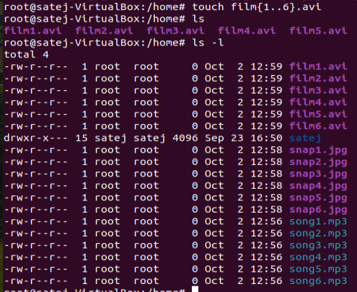

In each set, replace X with the numbers 1 through 6.

2. From your home directory,

* Move songs file into your Music subdirectory.

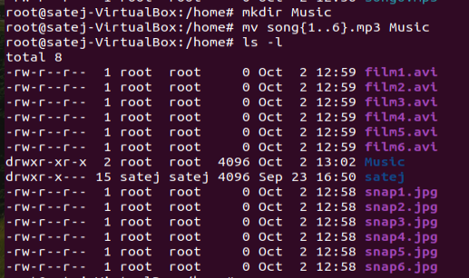

* Move snap file into your Pictures subdirectory.

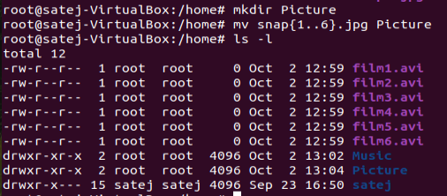

* Move your movie files into Videos subdirectory

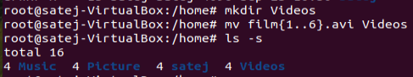

3. Create 3 subdirectories for organizing your files named friends,family,work

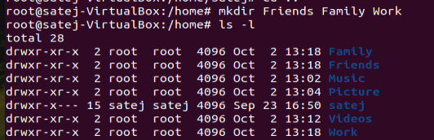

4. Copy files (all types ) containing numbers 1 and 2 to the friends folder.



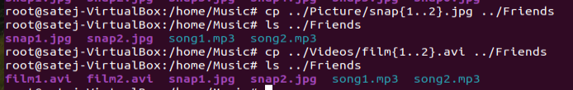

Copy files (all types) containing numbers 3 and 4 to the family folder.

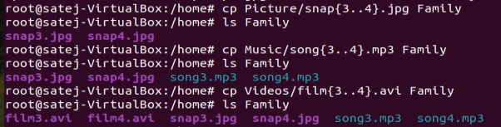

Copy files (all types) containing numbers 5 and 6 to the work folder.

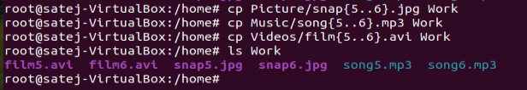

ASSIGNMENT 2

6. Delete all files in family subdirectory.

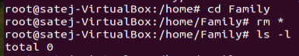

7. Delete friends subdirectory



8. Create user tom , bob , sam , prince

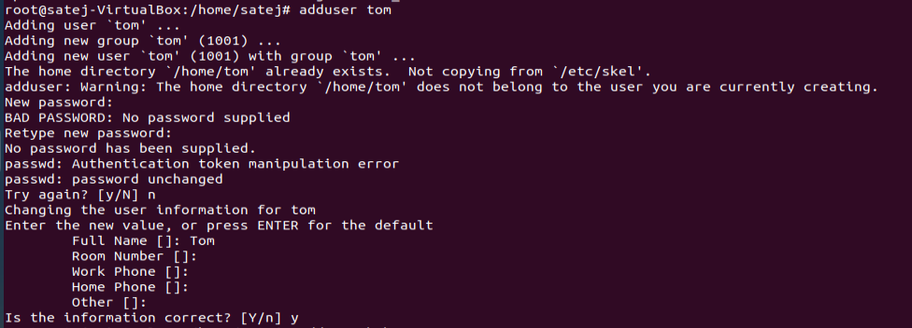

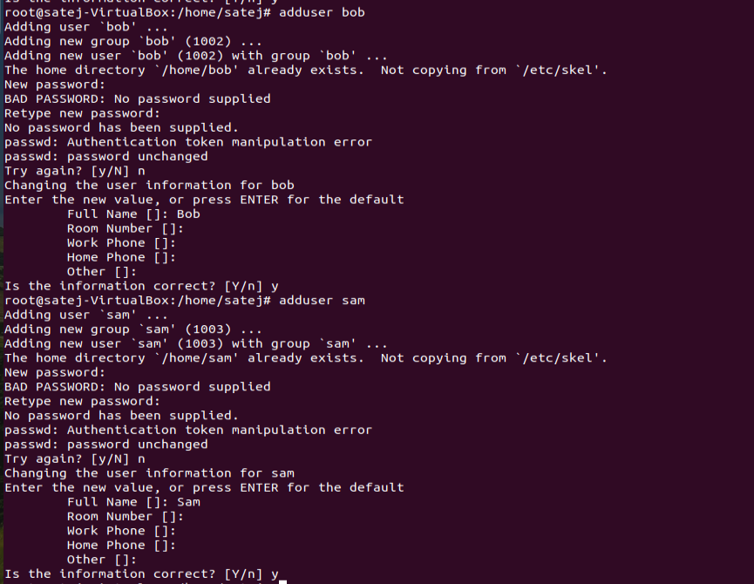

9. Create Group dac , dbda ,ditiss

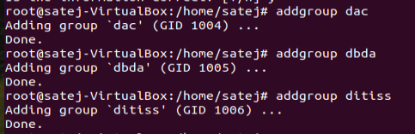

10. add user

Tom in dac

Bob in dbda

Sam in ditiss







11. login as prince and create iacsd directory in /tmp and create 4 files in iacsd with name project-1 project-2 upto 4

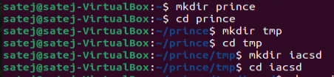



12. assign permissions to project files as below

Project-1 – tom should be owner of this

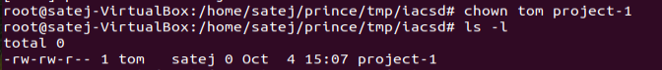

Project-2 – dac should be owner of this

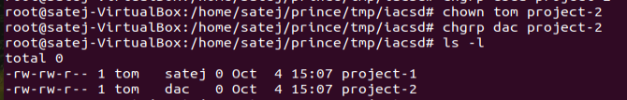

Project-3 --- others should not have any permission but tom should have rw access

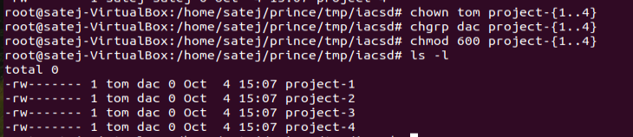

Project-4 – dbda group should have rwx permissions.

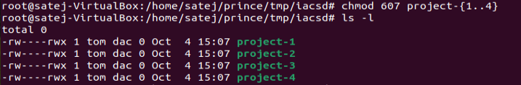

ASS-3

Kindly write any 10 programs.

1. Write a Shell Script to find maximum between two numbers.

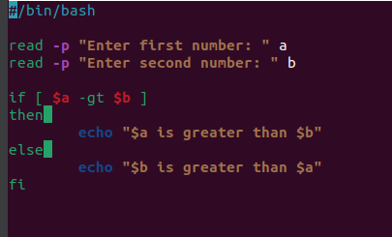

Output:

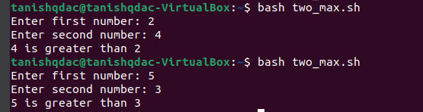

1. Write a Shell Script to find maximum between three numbers.

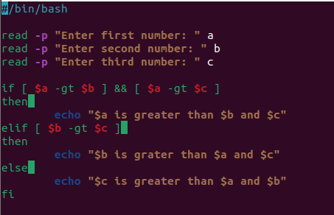

Output:

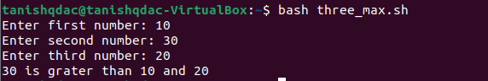

1. Write a Shell Script to check whether a number is negative, positive or zero.

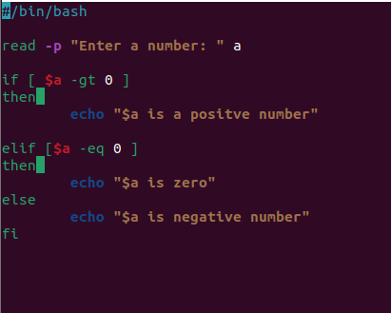

Output:



1. Write a Shell Script to check whether a number is divisible by 5 and 11 or not.

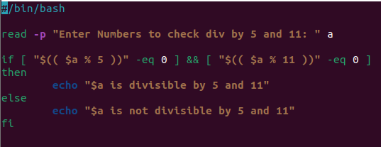

Output:

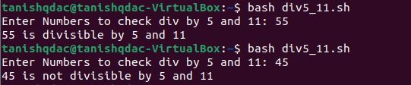

1. Write a Shell Script to check whether a number is even or odd.

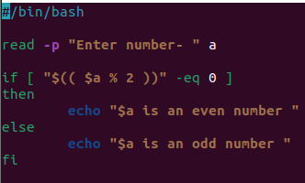

Output:

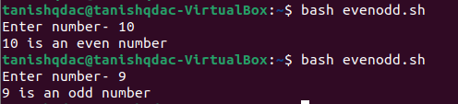

1. Write a Shell Script to check whether a year is leap year or not.

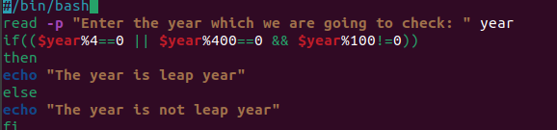

Output:

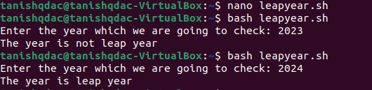

1. Shell Script to print number between 1 to 10 in character format using switch-case.

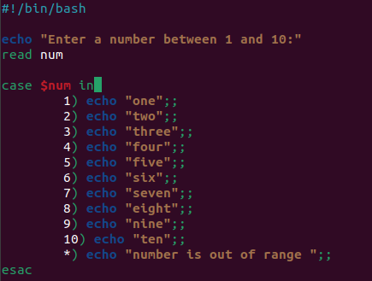

Output:

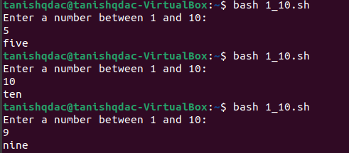

1. Shell Script to accept id from user to confirm department using switch-case.

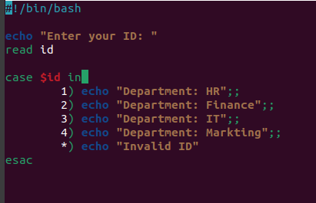

Output:

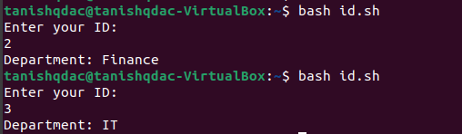

1. Shell Script to check password is correct or incorrect using switch-case.

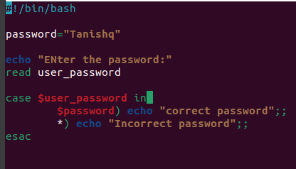

Output:

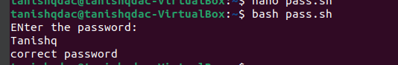

1. Shell Script to print day of week using switch-case.

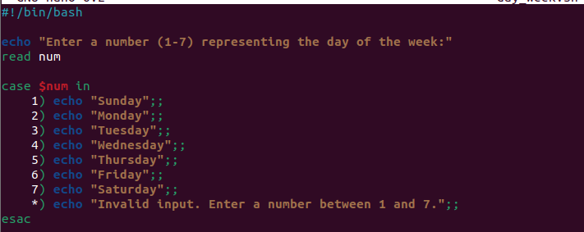

Output:

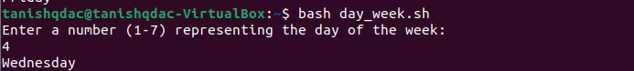

1. Shell Script to create calculator using switch-case.

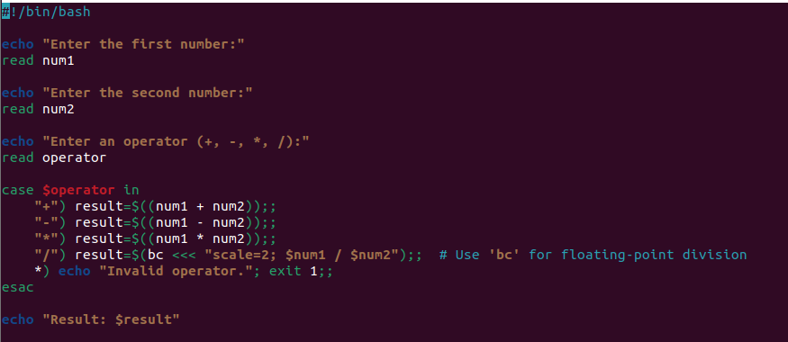

Output:

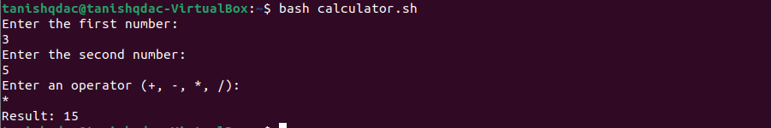

**ASS-4**

1) Write a shell script tp print

* your are logged in as which user
* in which directory you are
* and in which terminal you are working
* total number of files and directories in current directory

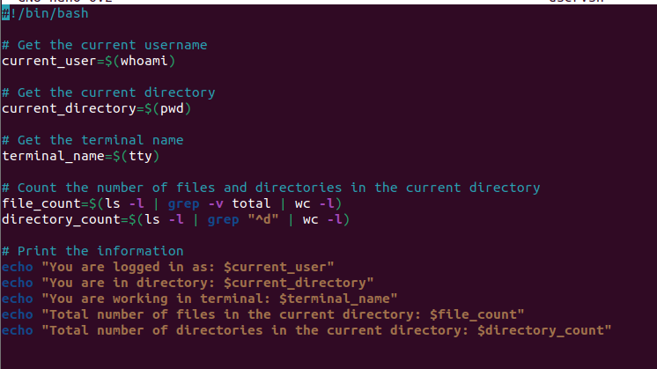

Output:

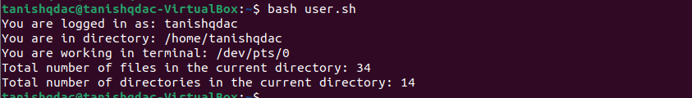

2).Write a shell script to create a menu driven program for adding, deletion or finding a record in a database. Database should have the field like rollno, name, semester and marks of three subjects. Last option of the menu should be to exit the menu.

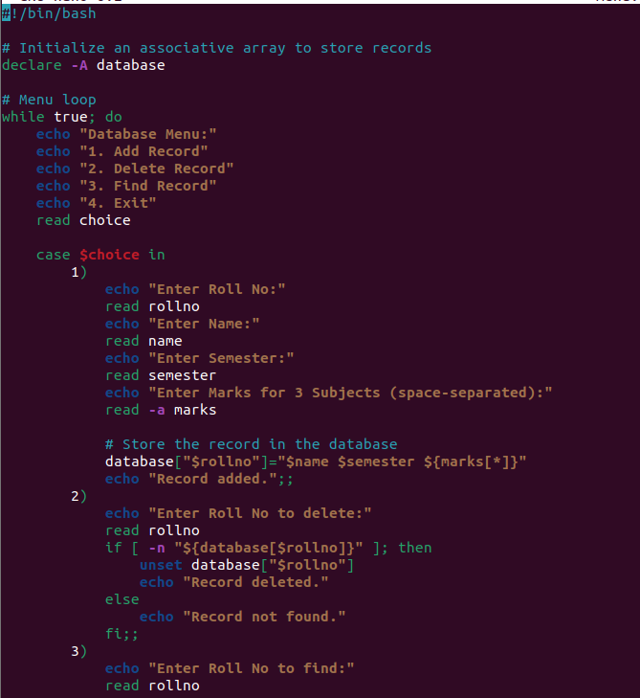

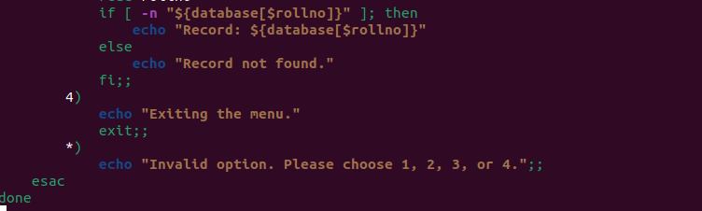

Output:

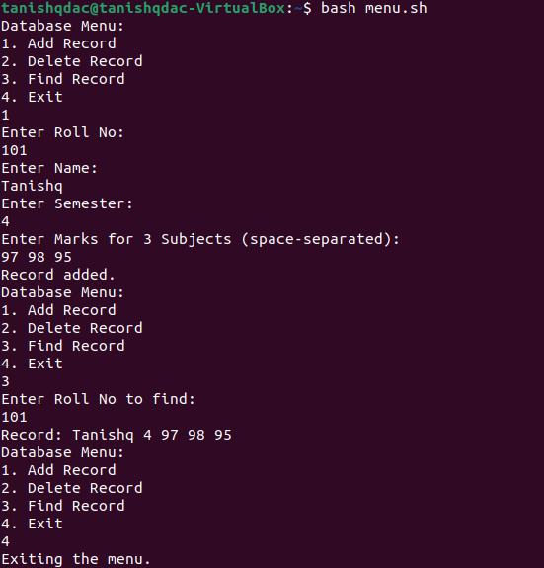

3) Write a Linux shell script to accept 10 number and tell how many are +tive, -tive and zero.

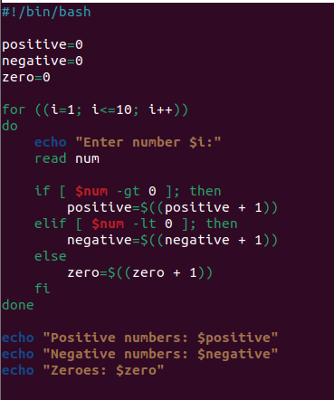

Output:

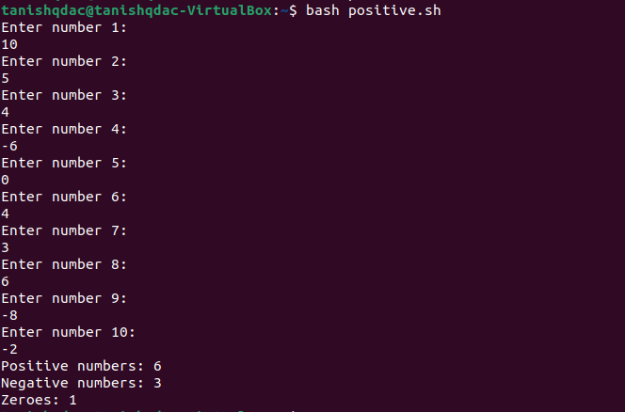

4) Write a shell script to accept five number and display max and min value.

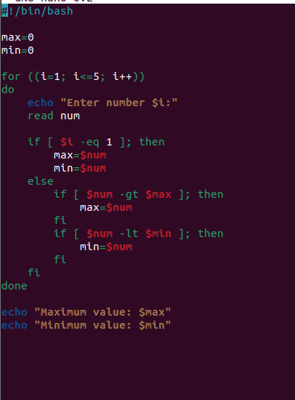

Output:

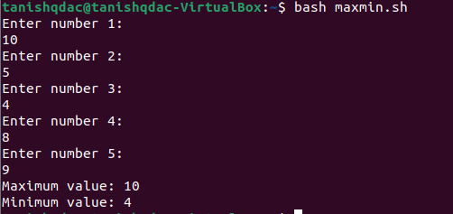

5) Write a script to find out String is palindrome or not.

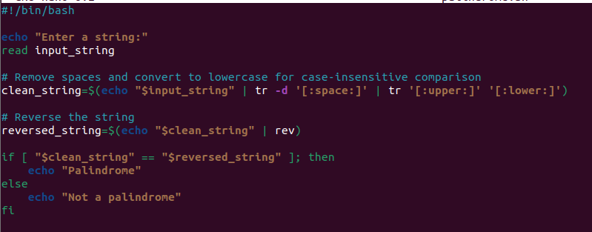

Output:

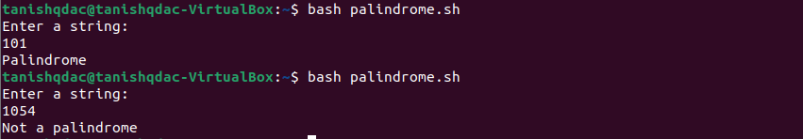

6) Write a shell script to print given number’s sum of all digits (eg. If number is 123, then it’s sum of all digits will be 1+2+3=6)

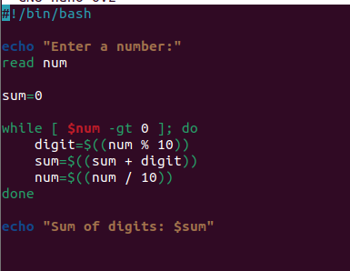

Output:

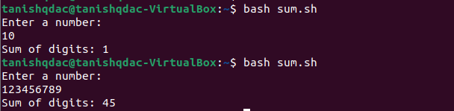

7) Create a script to

Create user , Delete user , Create group , delete Group using case

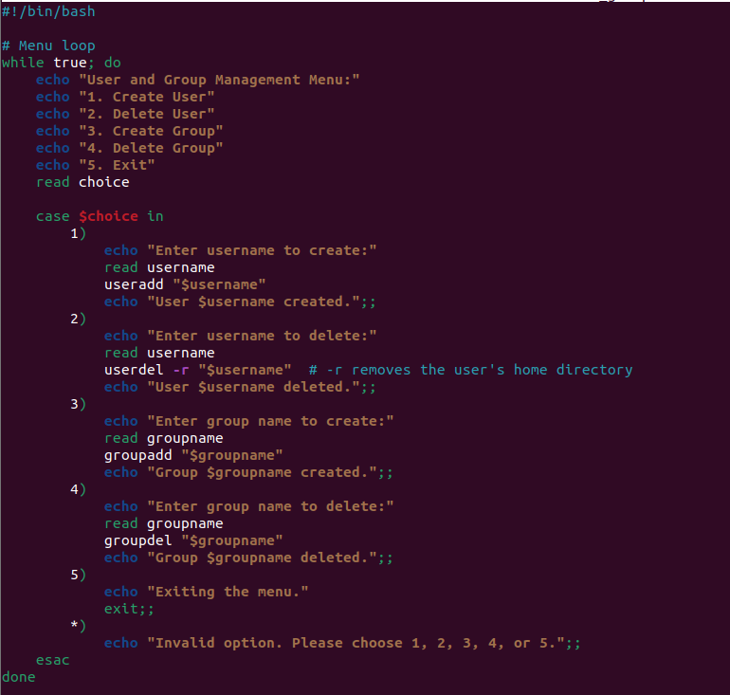

Output:

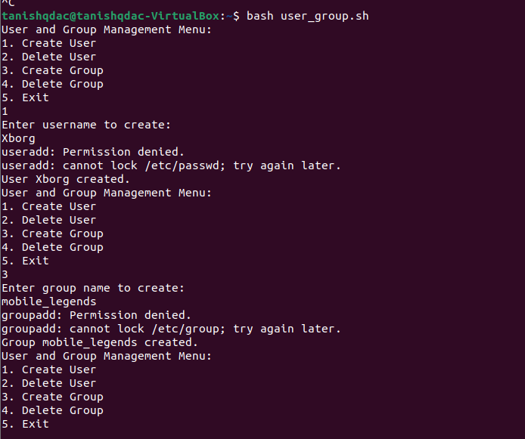

**ASS-5**

1. Shell Script to display the first 10 natural numbers.

Expected Output :

1 2 3 4 5 6 7 8 9 10

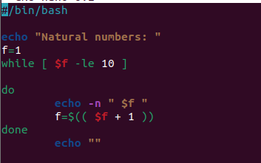

Output:



2. Shell Script to compute the sum of the first 10 natural numbers.

Expected Output :

The first 10 natural number is :

1 2 3 4 5 6 7 8 9 10

The Sum is : 55

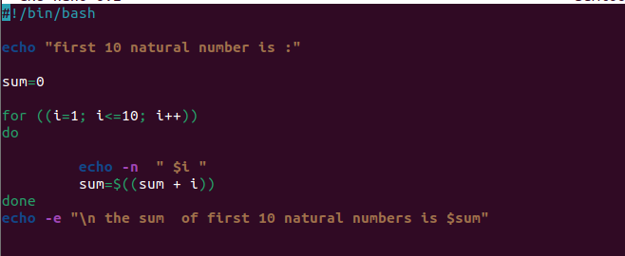

Output:

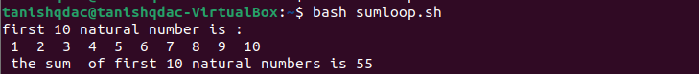

3. Shell Script to display n terms of natural numbers and their sum.

Test Data : 7

Expected Output :

The first 7 natural number is :

1 2 3 4 5 6 7

The Sum of Natural Number upto 7 terms : 28

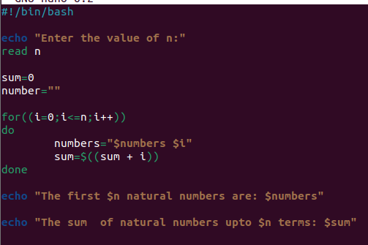

Output:

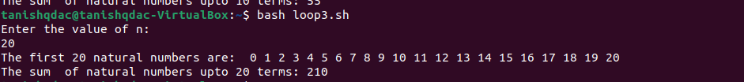

4. Shell Script to read 10 numbers from the keyboard and find their sum and average.

Test Data :

Input the 10 numbers :

Number-1 :2

...

Number-10 :2

Expected Output :

The sum of 10 no is : 55

The Average is : 5.500000

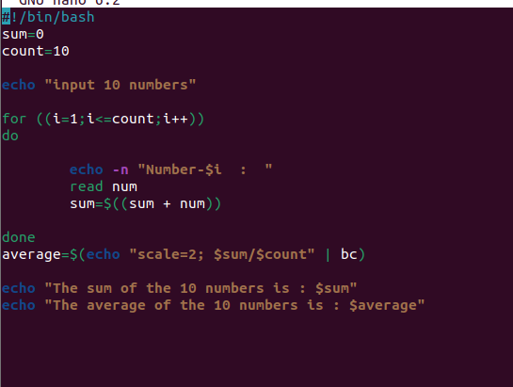

Output:

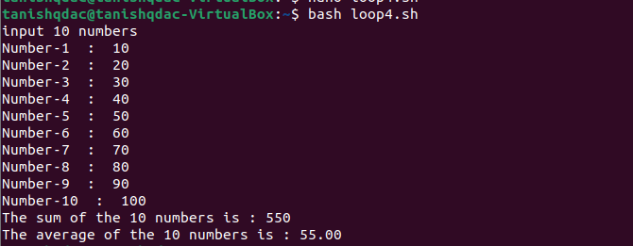

5. Shell Script to display the cube of the number up to an integer.

Test Data :

Input number of terms : 5

Expected Output :

Number is : 1 and cube of the 1 is :1

Number is : 2 and cube of the 2 is :8

Number is : 3 and cube of the 3 is :27

Number is : 4 and cube of the 4 is :64

Number is : 5 and cube of the 5 is :125

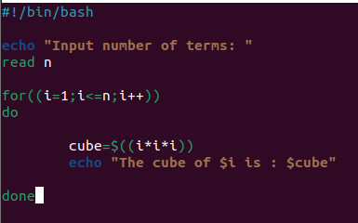

Output:

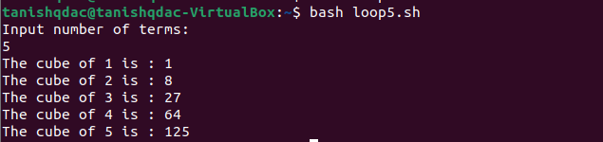

6. Shell Script to display the multiplication table for a given integer.

Test Data :

Input the number (Table to be calculated) : 15

Expected Output :

15 X 1 = 15

...

...

15 X 10 = 150

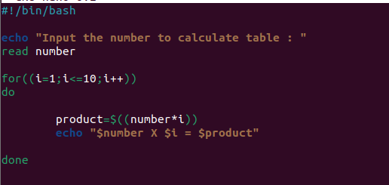

Output:

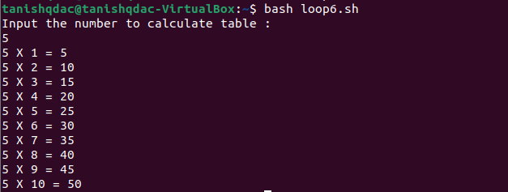

7. Shell Script to display the multiplier table vertically from 1 to n.

Test Data :

Input upto the table number starting from 1 : 8

Expected Output :

Multiplication table from 1 to 8

1x1 = 1, 2x1 = 2, 3x1 = 3, 4x1 = 4, 5x1 = 5, 6x1 = 6, 7x1 = 7, 8x1 = 8

...

1x10 = 10, 2x10 = 20, 3x10 = 30, 4x10 = 40, 5x10 = 50, 6x10 = 60, 7x10 = 70, 8x10 = 80

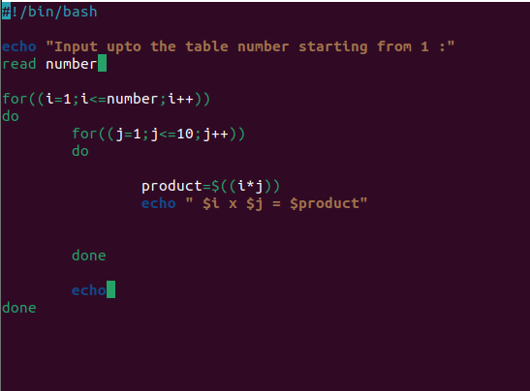

Output:

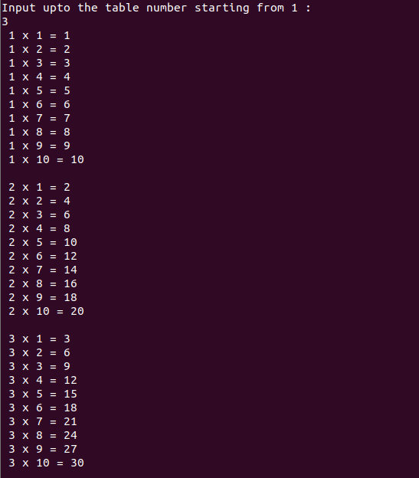

8. Shell Script to display the n terms of odd natural numbers and their sum.

Test Data

Input number of terms : 10

Expected Output :

The odd numbers are :1 3 5 7 9 11 13 15 17 19

The Sum of odd Natural Number upto 10 terms : 100

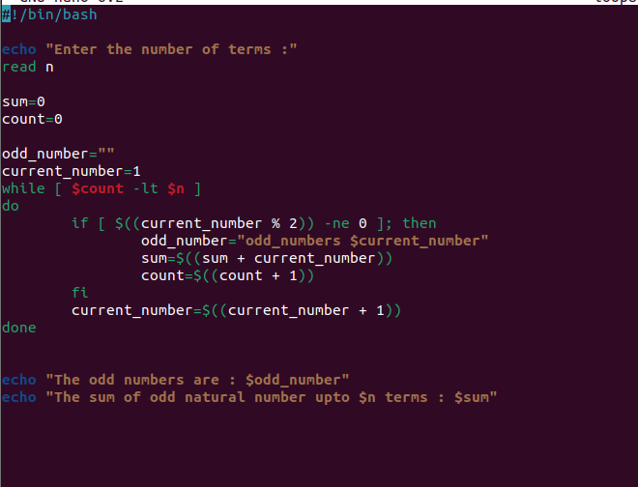

Output:

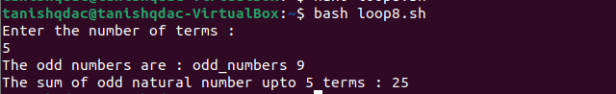

9. Shell Script to display a pattern like a right angle triangle using an asterisk.

The pattern like :

*

**

***

****

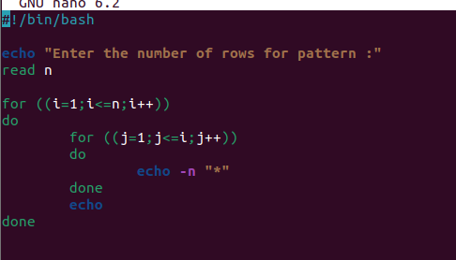

Output:

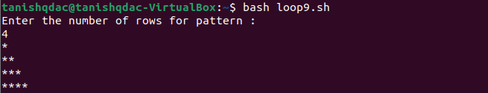

10. Shell Script to display a pattern like a right angle triangle with a number.

The pattern like :

1

12

123

1234

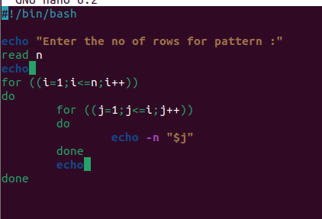Output:

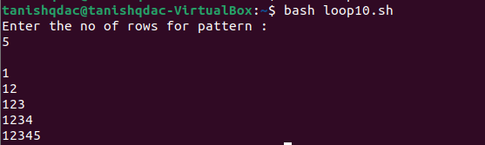

11. Shell Script to make such a pattern like a right angle triangle with a number which will repeat a number in a row.

The pattern like :

1

22

333

4444

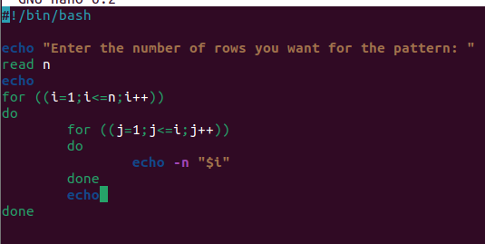

Output:

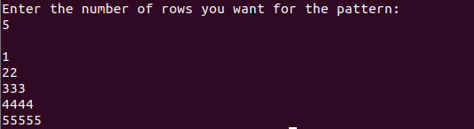

12. Shell Script to make such a pattern like a right angle triangle with the number increased by 1.

The pattern like :

1

2 3

4 5 6

7 8 9 10

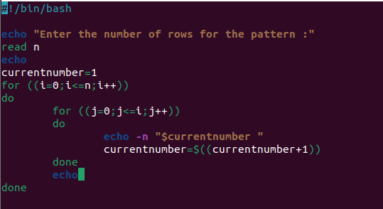

Output:

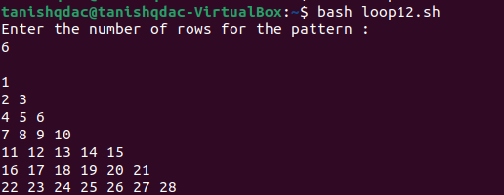

**ASS-6**

**one**

**apple**

**banana**

**cat**

**dog**

**elephant**

**two**

**fish**

**gun**

**horse**

**icecream**

**three**

**jelly**

**kitkat**

**lolipop**

**marshmallow**

**four**

**new**

**oppo**

**vivo**

**china**

**/home -> mkdir EVERYONE**

**Create a file with every user (whoami >> username.txt)**

**oppo -> primary group change -> one**

**vivo -> primary group change -> two**

**jelly,kitkat, lolipop, marshmallow -> add these users to sudo group**

**fish,gun -> add these users to one group as well (secondary group)**

