**Week-3 Entity Framework Core 8.0 (Lab1 : Understanding ORM with a Retail Inventory System)**

Q1. What is ORM?

Ans. **Object-Relational Mapping (ORM)** is a programming technique that allows developers to interact with a database using the programming language’s objects instead of raw SQL. ORMs, like Entity Framework (EF) Core, map C# classes to database tables and map properties to columns. For example, a Product class in C# is represented as a table in the database, and its properties (Id, Name, Stock) become table columns.

Benefits of ORM :

1. Productivity: Developers can focus on C# code instead of writing complex SQL queries.
2. Maintainability: Changes to data models can be managed in one place (C# code) and then migrated to the database.
3. Abstraction from SQL: ORM handles generating the appropriate SQL, reducing SQL syntax errors and making development faster and safer.

Q2.  **EF Core vs. EF Framework (EF6) :**

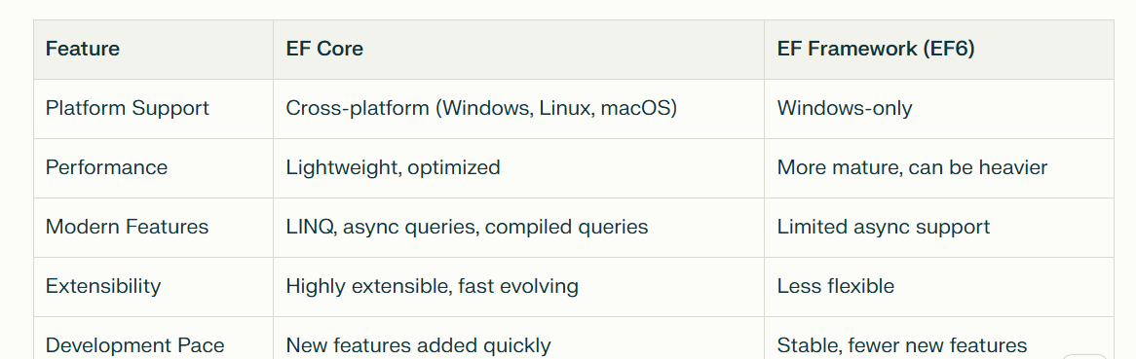

Ans. **EF Core:** Good for modern, cross-platform apps. Includes advanced features like LINQ, async, and optimized performance.

**EF 6:**Preferable for legacy, Windows-based, or very mature environments.

Q3. **EF Core 8.0 Features:**

Ans.

JSON Column Mapping: Store and query JSON data in columns, so you can map .NET objects to JSON fields within a database column.

Improved Performance with Compiled Models: Models can be precompiled for faster startup and query performance.

Interceptors & Better Bulk Operations: Add logic to intercept and handle database operations, and improved methods for efficiently handling large data sets in bulk.