# Assignment 3: Deploying, Backing Up, and Migrating Virtual Machines on Hypervisors

**Name – Tanishq Thuse**

**Roll no – 52**

**PRN – 12310237**

**Sub – Cloud computing**

KVM (Kernel-based Virtual Machine) is a Linux kernel module enabling virtualization.  
VMware ESXi is an enterprise-grade, bare-metal hypervisor from VMware.  
Parallels Desktop is a macOS hypervisor optimized for Windows/macOS integration.  
UTM is a Mac app that uses QEMU for virtualization/emulation, allowing macOS users to run Linux, Windows, and more.

**KVM**:  
- Create VM using virt-manager or virsh commands.  
- Backup using snapshot or copying qcow2 image.  
- Migrate using virsh migrate --live command.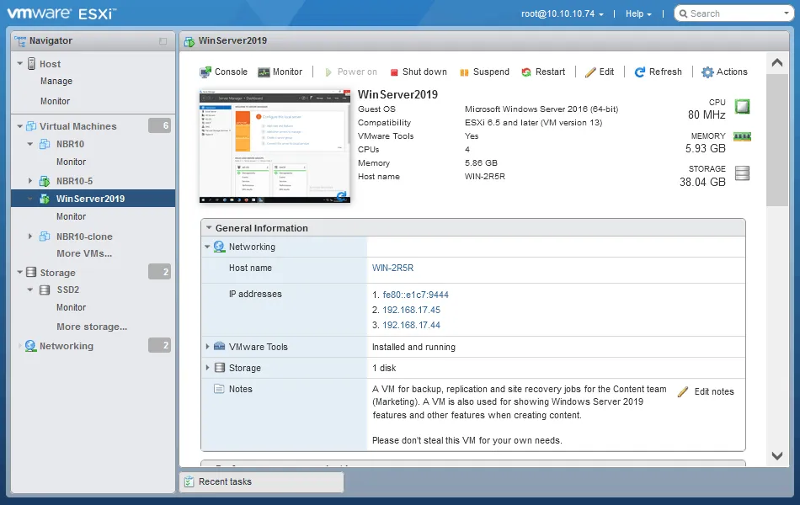

**ESXi**:  
- Create VM from ISO.  
- Backup by exporting OVF/OVA from vSphere Client.  
- Migrate using vMotion in vCenter or manual OVF import/export.

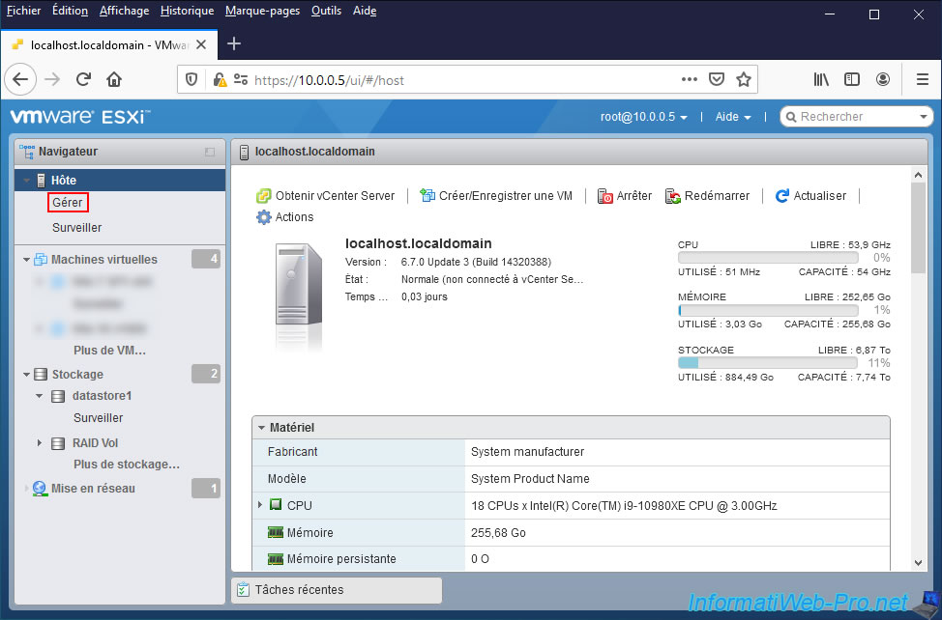

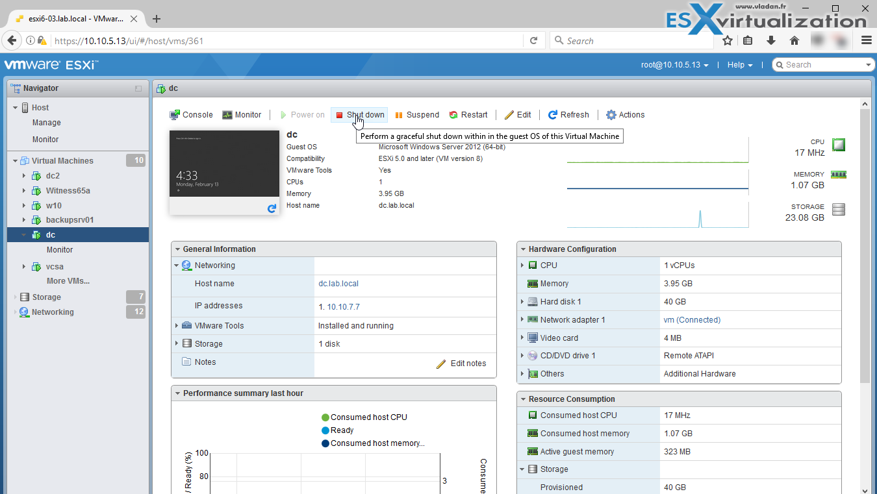

1. **Need a ready VM on Linux/ Ubuntu**

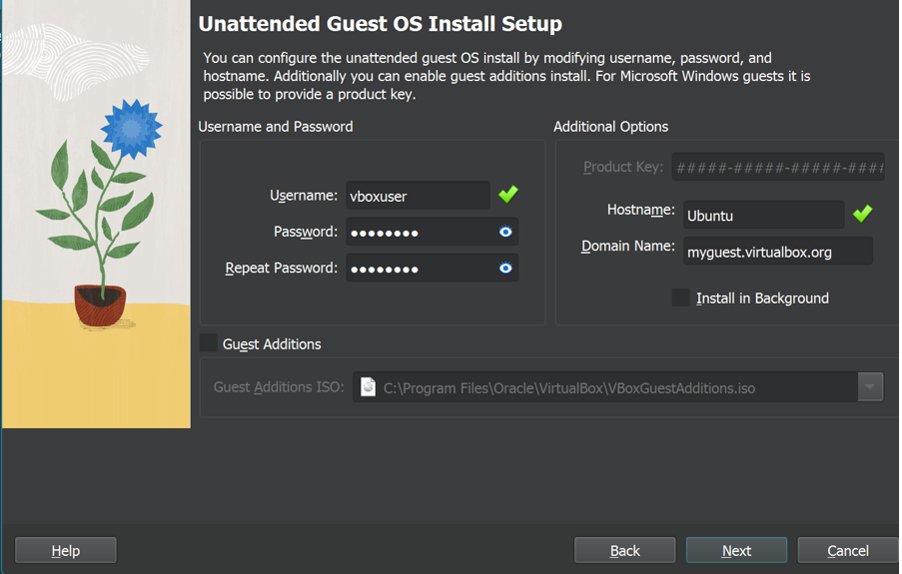

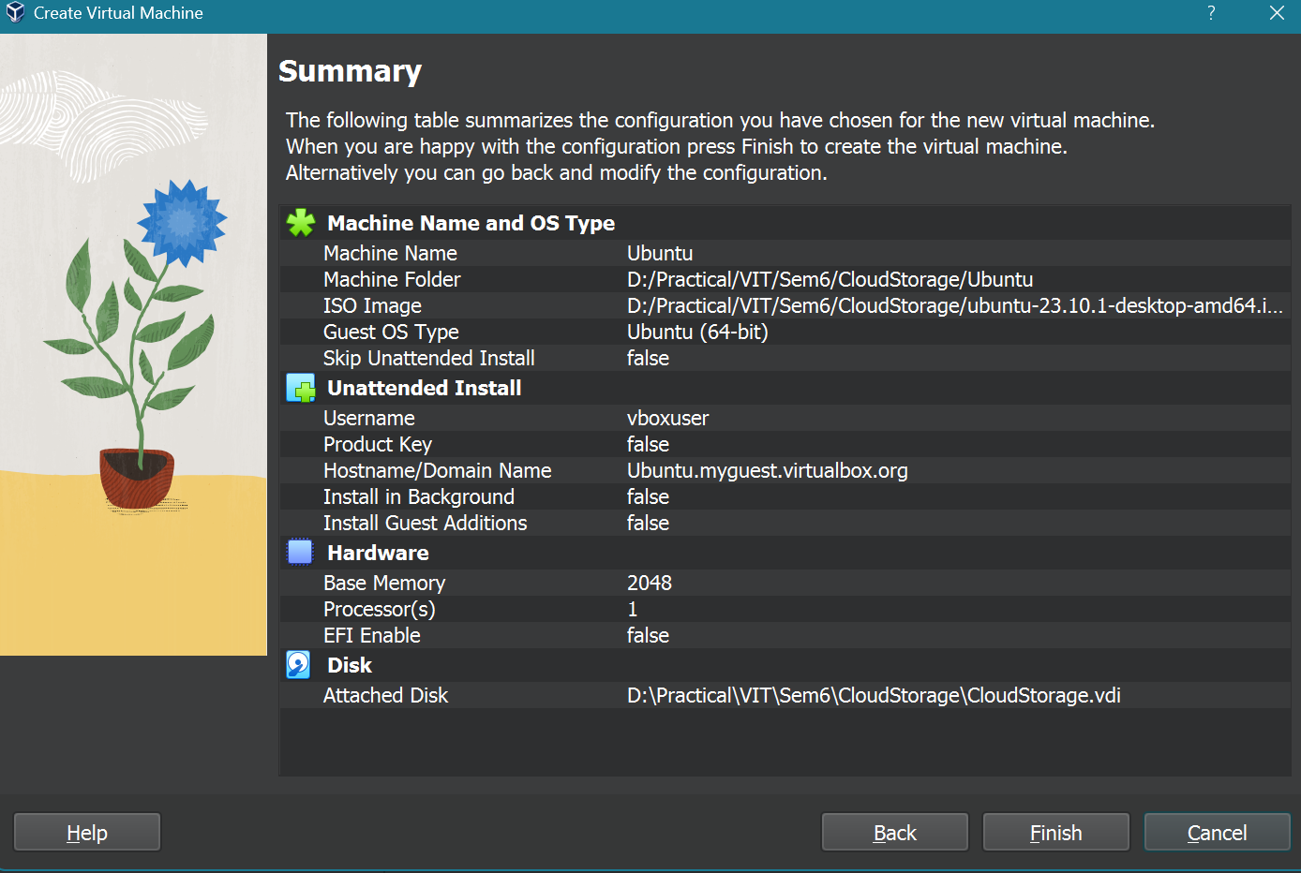

1. **Click on File and select ‘export appliances’. Select the virtual machine you would like to export.**

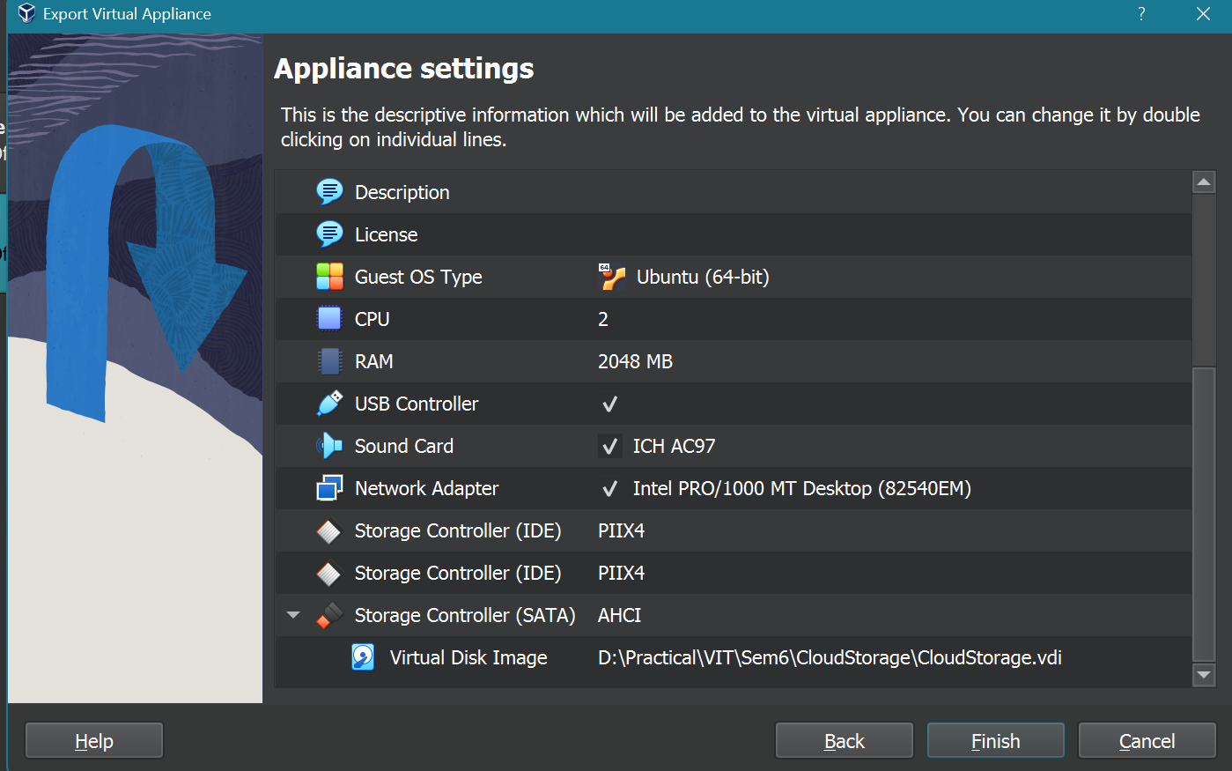

1. **Click on Next till its processing on the default settings(Select a dest folder for your file):**

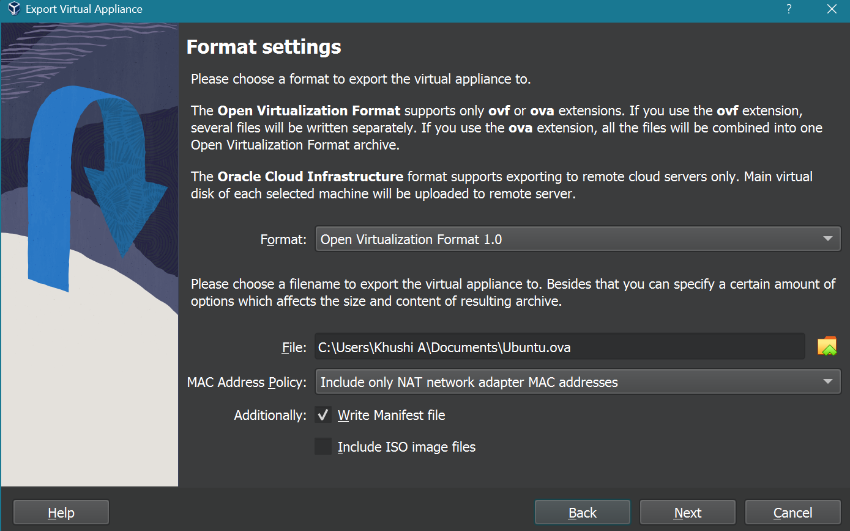

A file would be created which is your backup file.

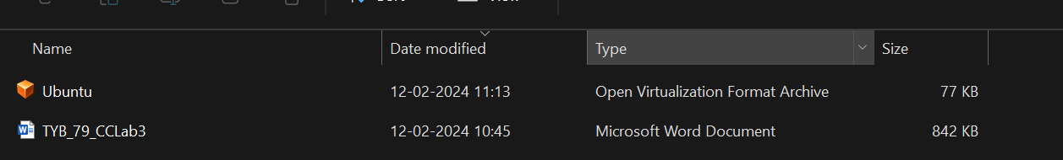

1. **Now go to Virtual Box dashboard to remove the backed up VM**

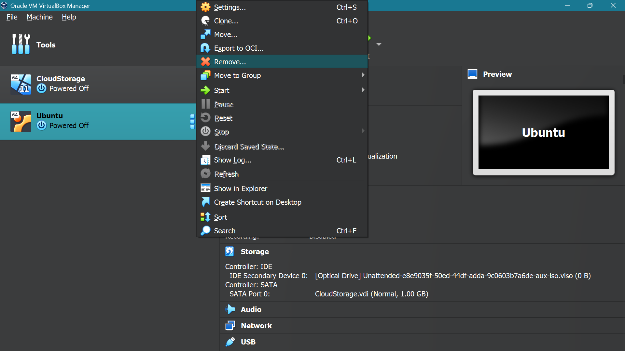

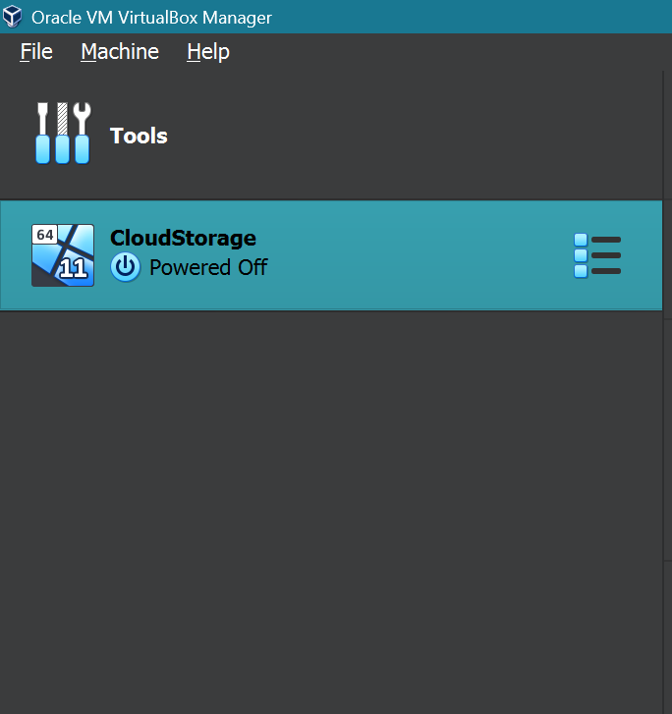

1. **Click on Import Appliances now and select the .ova backup file at your destination which you selected**

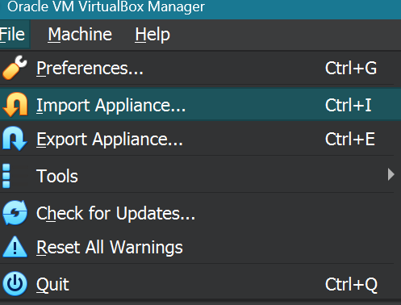

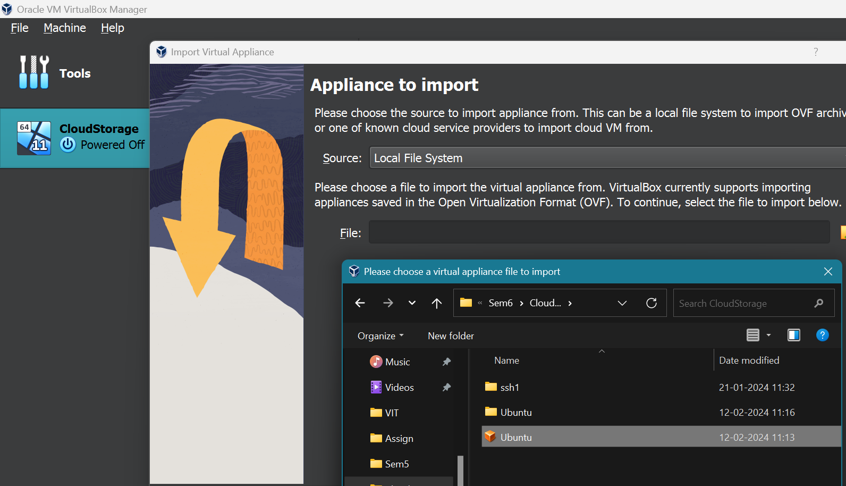

1. **Click on Import with the default settings:**

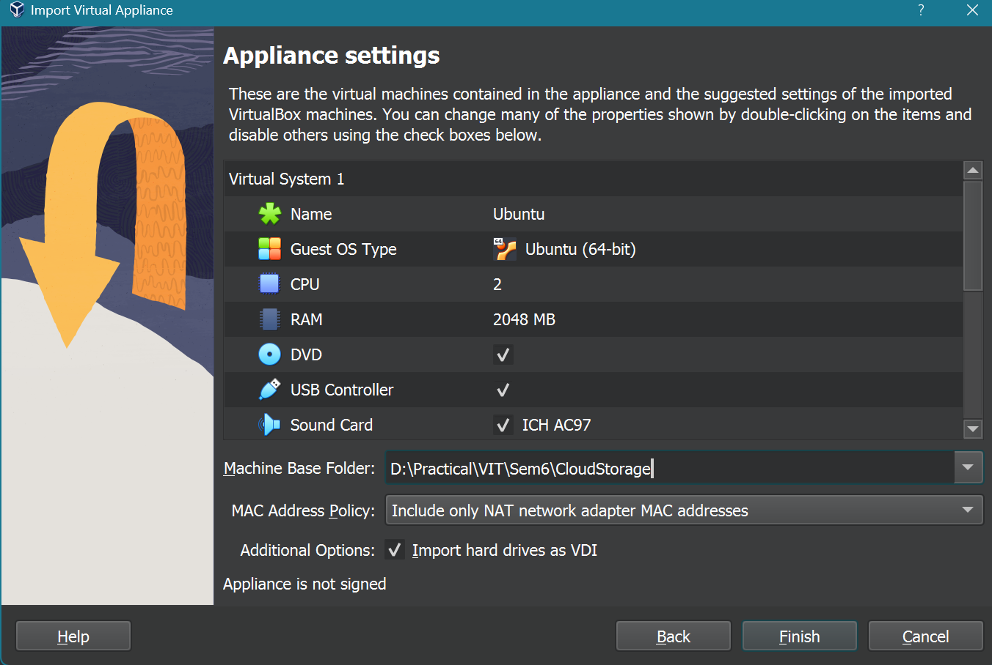

1. **Successfully Backed up and restored the VM using Cold migration:**

