**Name – Tanishq Thuse**

**Branch – CSAI**

**Div – B**

**Roll no. – 52**

**Subject – Computer Network**

**Assignment – 2 : Problem Statement:  
Set up a small network of 2–4 computers using an access point and allow wireless gadgets to connect. Practice commands: ping, pathping, ipconfig/ifconfig, arp, netstat, nbtstat, nslookup, route, traceroute/tracert, nmap.**

**Theory**

**Access Point (AP): Connects wireless devices to a wired network via Wi-Fi, acting as a bridge between clients and LAN.**

**Functions:**

* **Wireless connectivity**
* **Data bridging**
* **Range extension**
* **Security (WPA2/WPA3)**
* **Bandwidth management**

**Working:**

1. **Connect AP to router/switch via Ethernet**
2. **Broadcast SSID**
3. **Devices connect with credentials**
4. **Forward traffic between wireless and wired networks**

**Advantages: Mobility, reduced cabling, scalability  
Standards: IEEE 802.11 a/b/g/n/ac/ax**

**3. Networking Commands**

**3.1 tracert / traceroute – Tracks packet route to destination, showing hops & latency.**

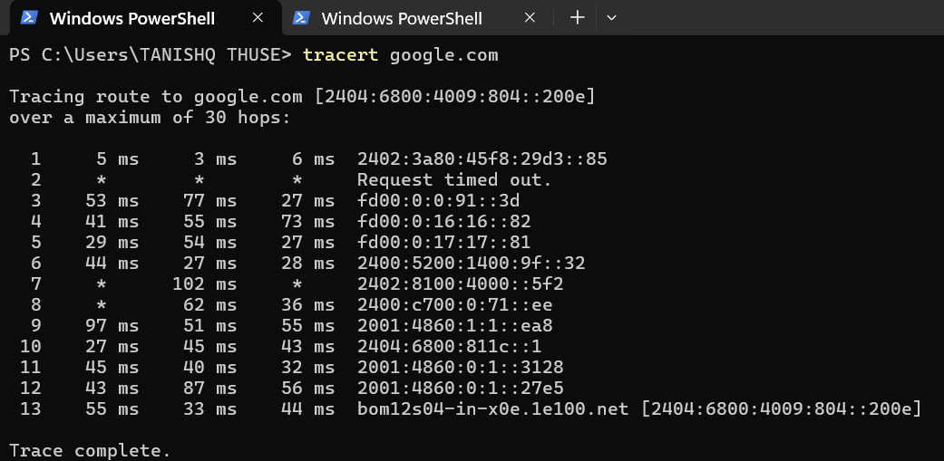

**3.2 pathping – Combines ping & tracert, showing packet loss and latency per hop.**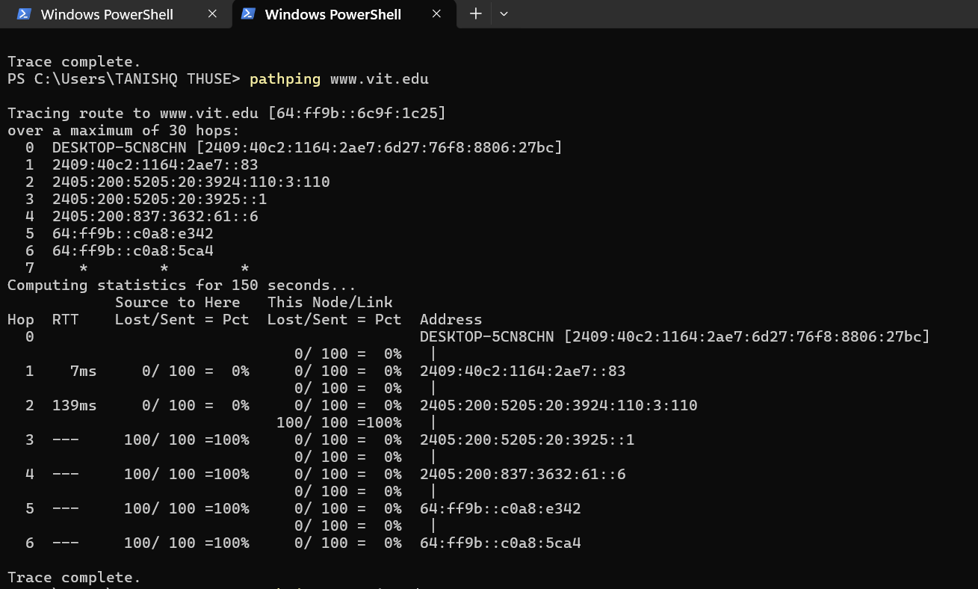

**3.3 ipconfig / ifconfig – Displays and manages network configuration.**

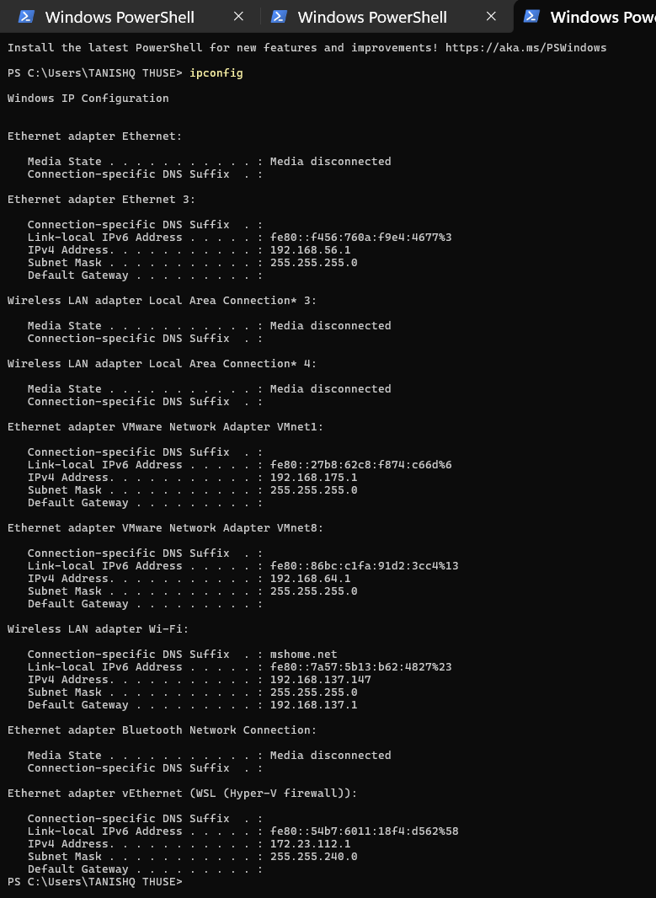

**3.4 arp – Views and manages ARP table (IP–MAC mapping).**

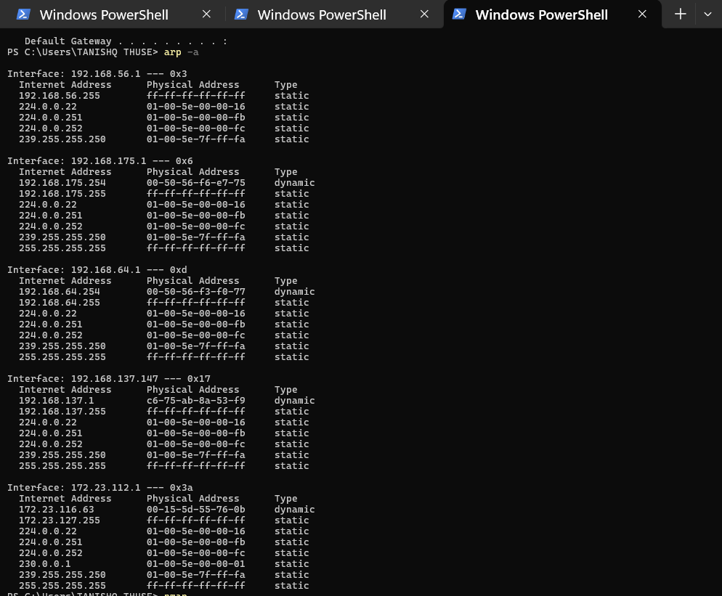

**3.5 netstat – Shows network connections, routing tables, port usage.**

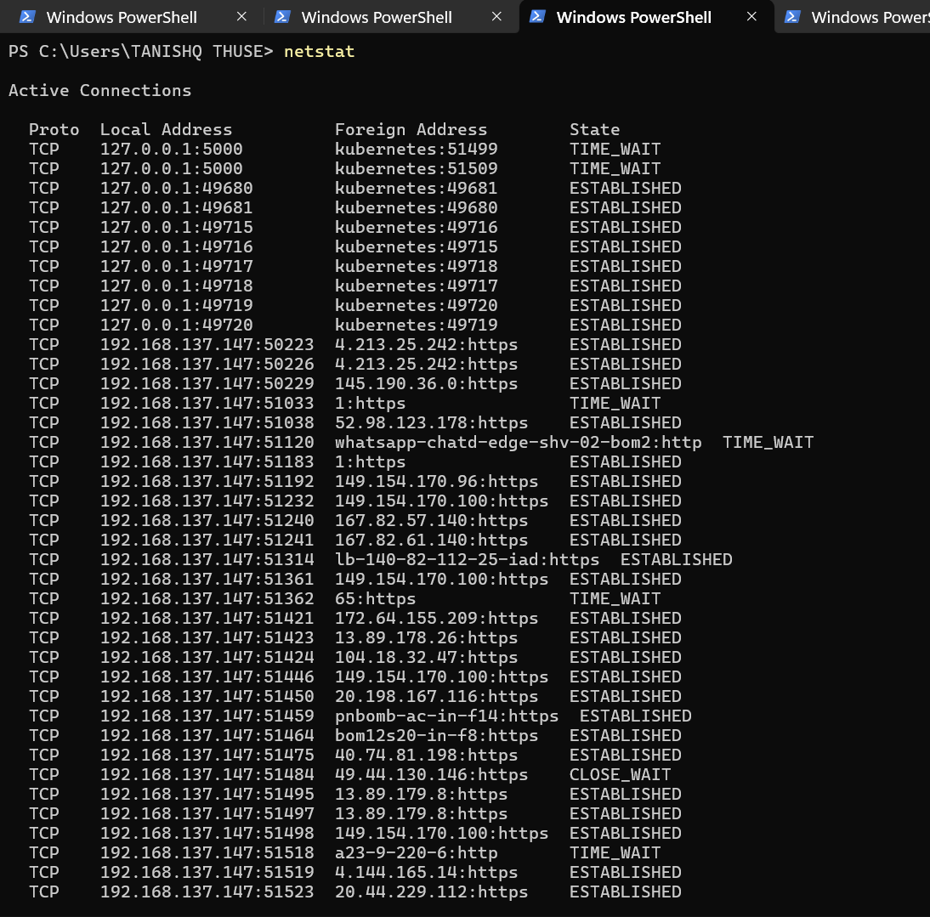

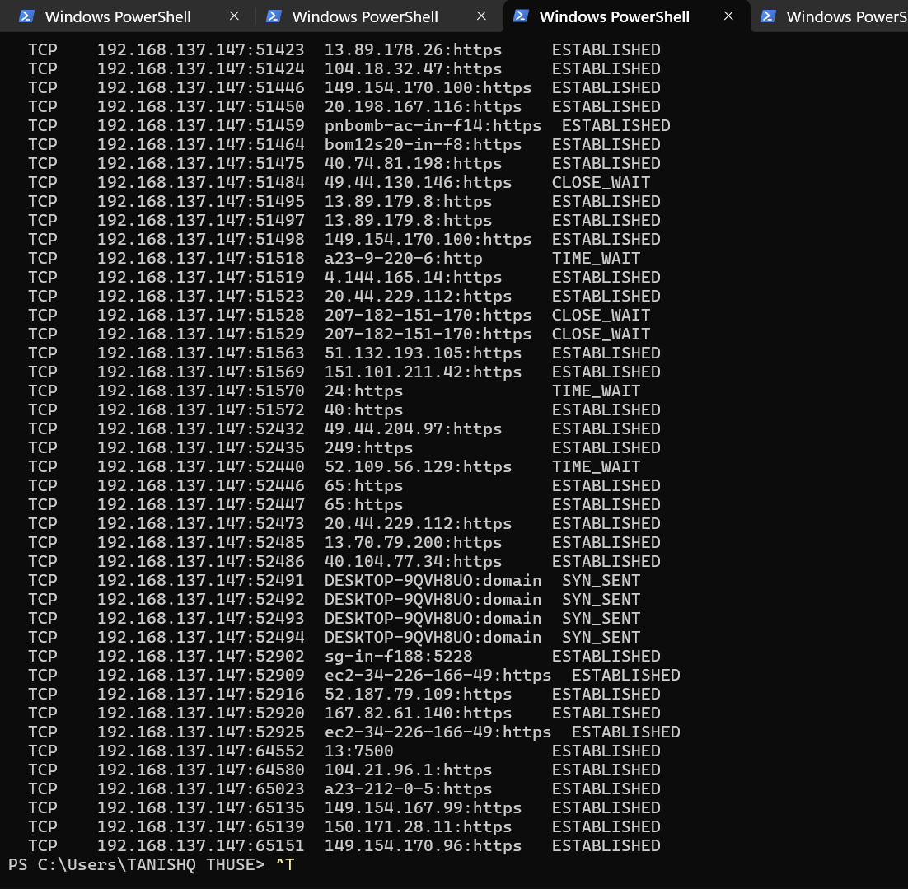

**3.6 nbtstat – Troubleshoots NetBIOS name resolution.**

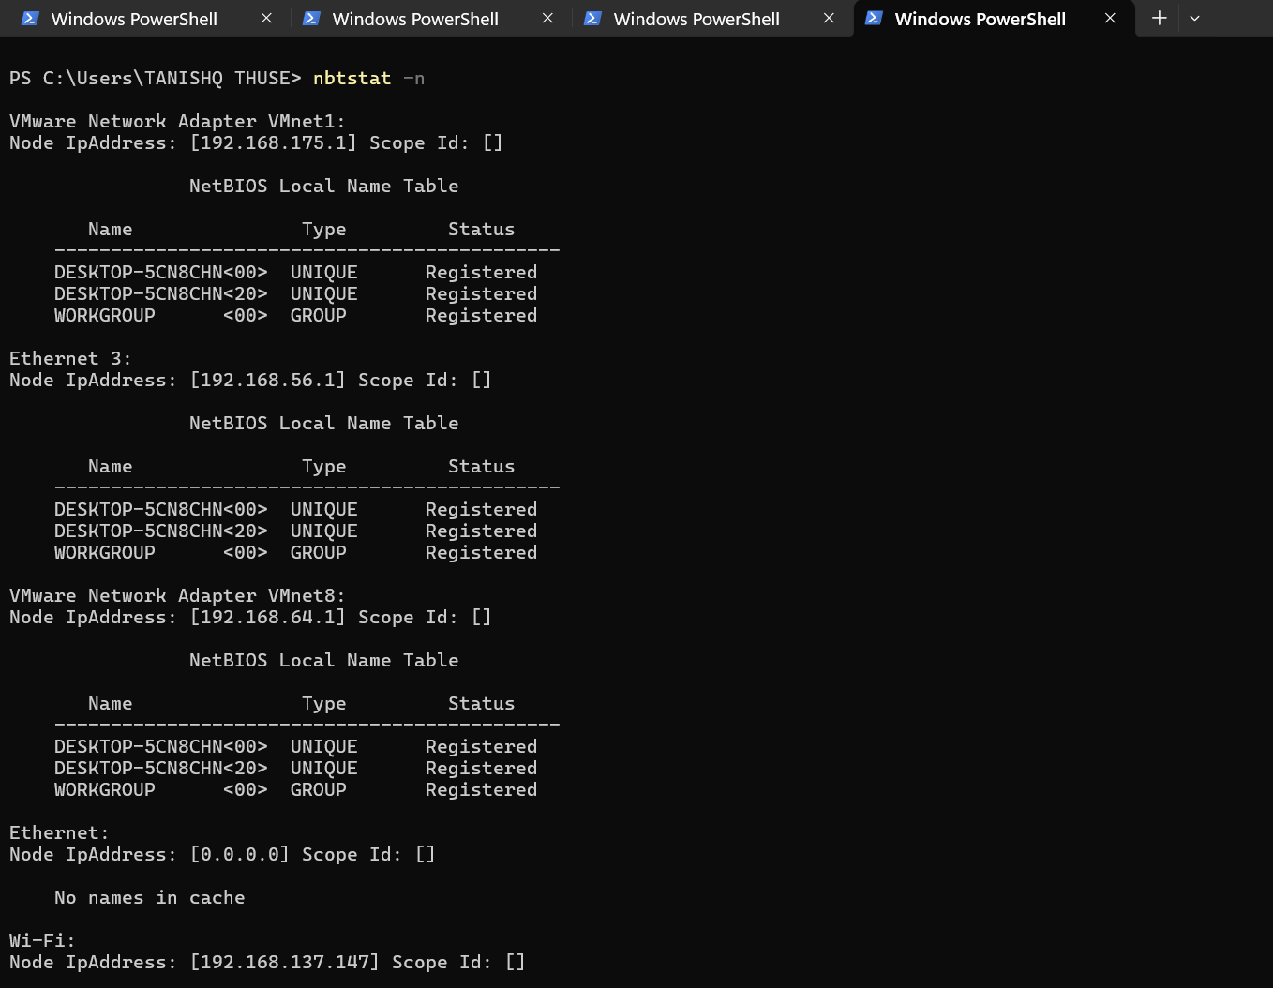

**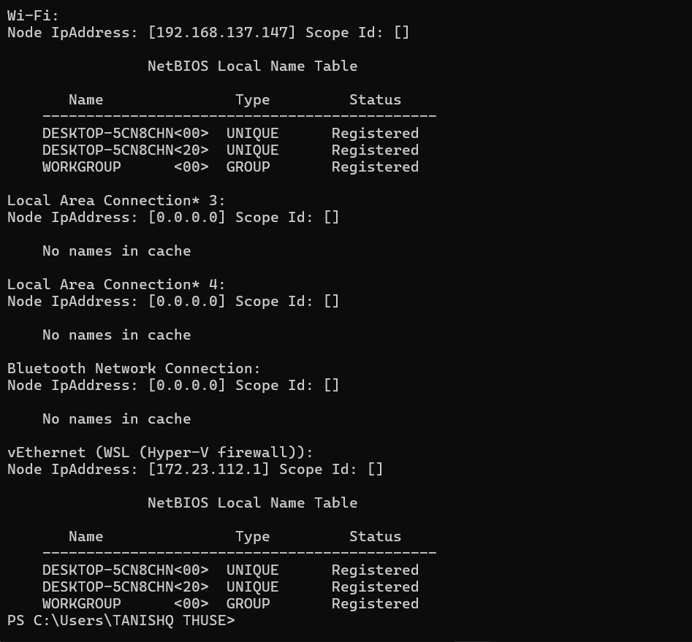  
  
3.7 nslookup – Queries DNS for domain-IP mapping.**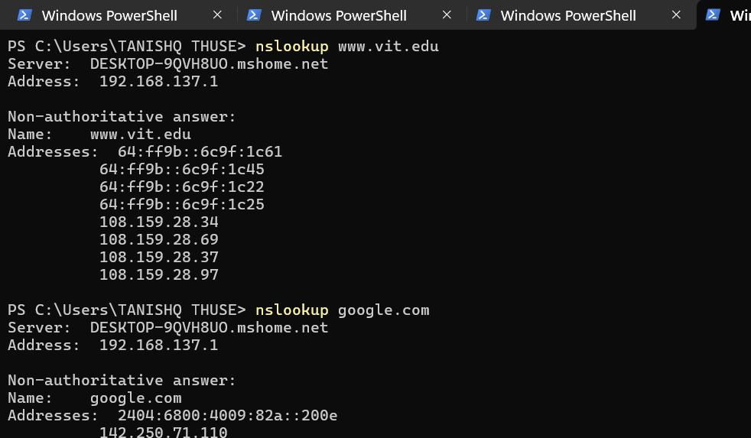

**3.8 route – Views and modifies routing table.**

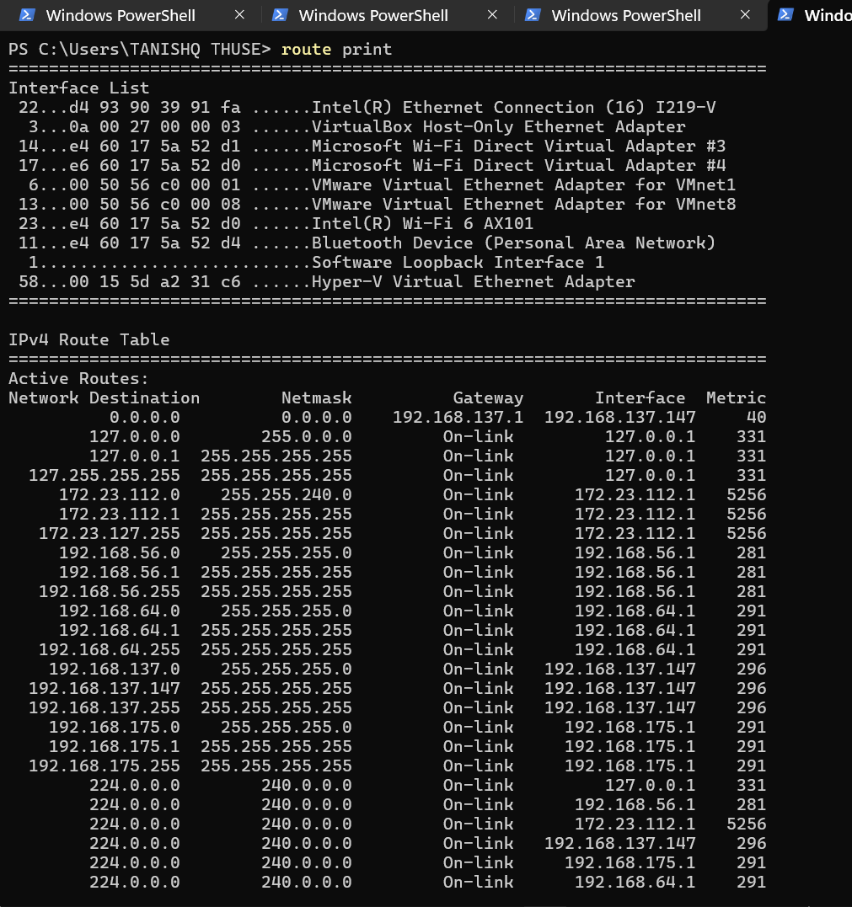

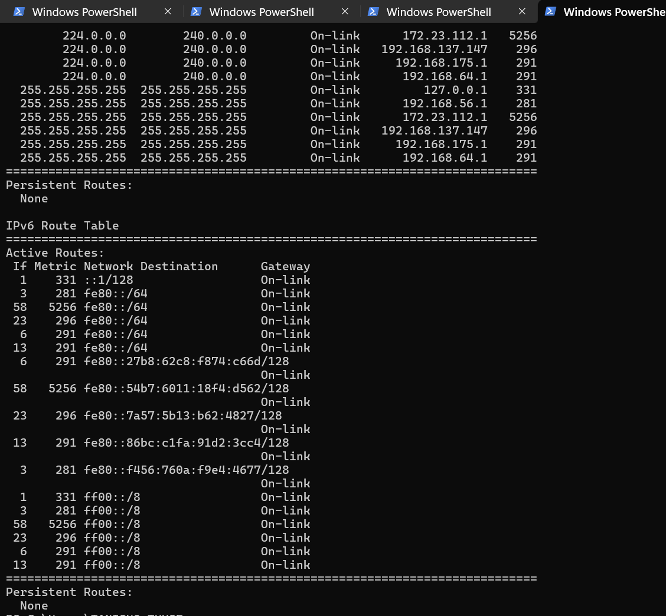

**3.9 nmap – Network scanning tool for host and service discovery.**

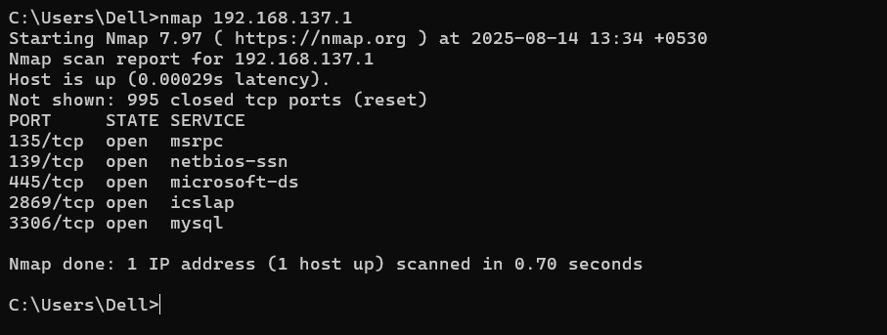

**Procedure**

1. **Connect the access point to the switch/router via Ethernet cable.**
2. **Configure the AP with SSID, security type, and password.**
3. **Connect 2–4 computers to the AP (wired).**
4. **Connect wireless gadgets (phones, laptops) using the configured SSID.**
5. **On each device, run the listed network commands to test connectivity and gather network information.**

**Conclusion**

**A small network was successfully set up using an access point, allowing both wired and wireless connections. Network commands were executed to analyze connectivity, routing, IP configuration, and device communication.**