**Assignment No : 05**

**Name :- Tanishq Thuse**

**Roll No: - 52**

**Class :- CS-AI-B**

**Write the client server programs using UDP Berkeley socket primitives for wired /wireless network for following a. to say Hello to Each other b. Calculator (Trigonometry)**

**A.Say Hello To Each other**

UDPserver.java

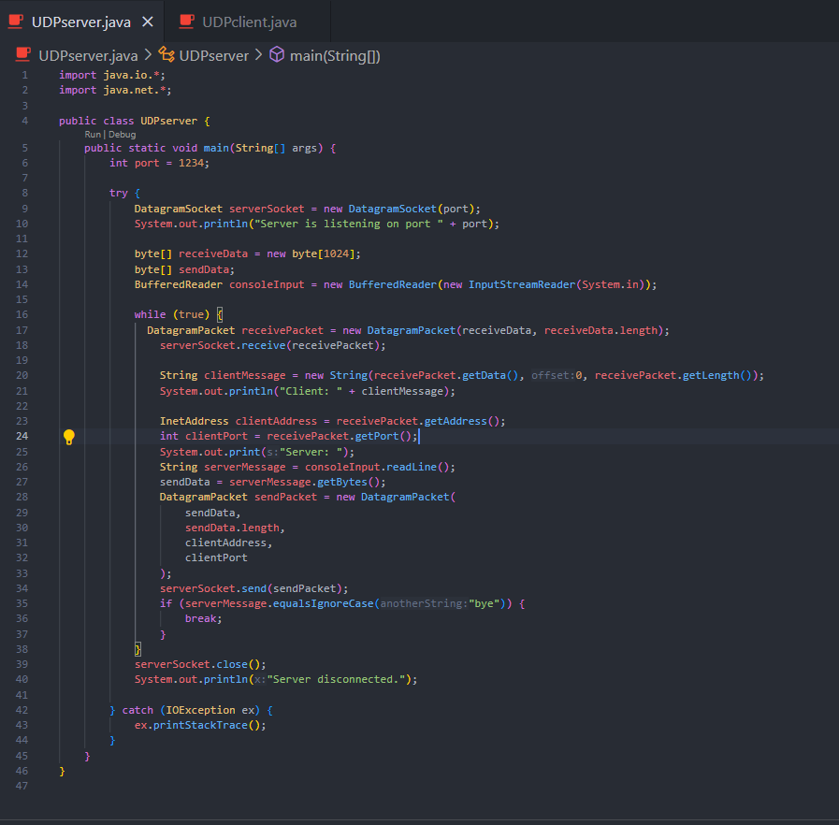

UDPclient.java

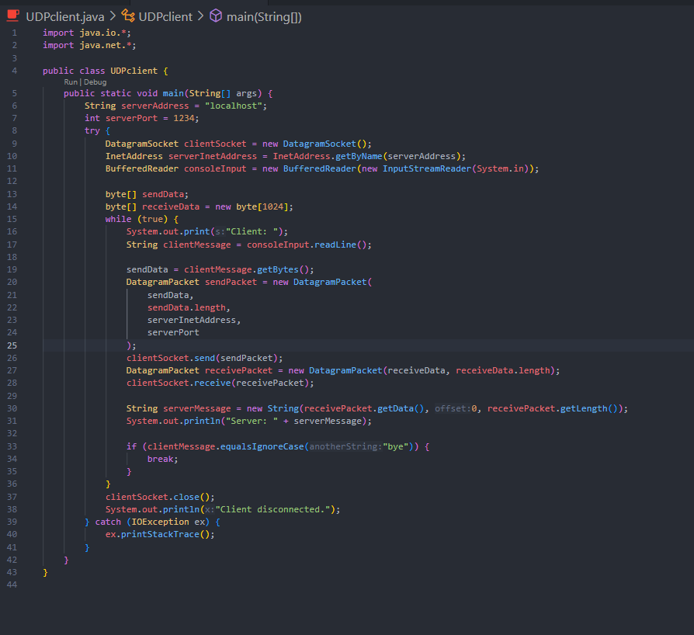

Output : -

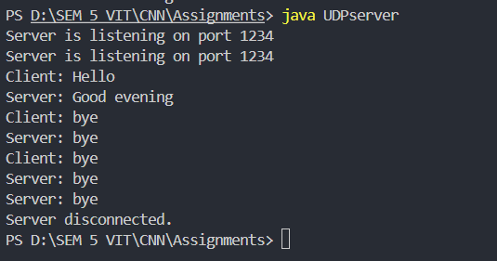

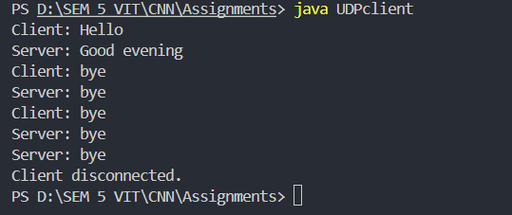

**B. Calculator (Trigonometry)**

TringServer.java

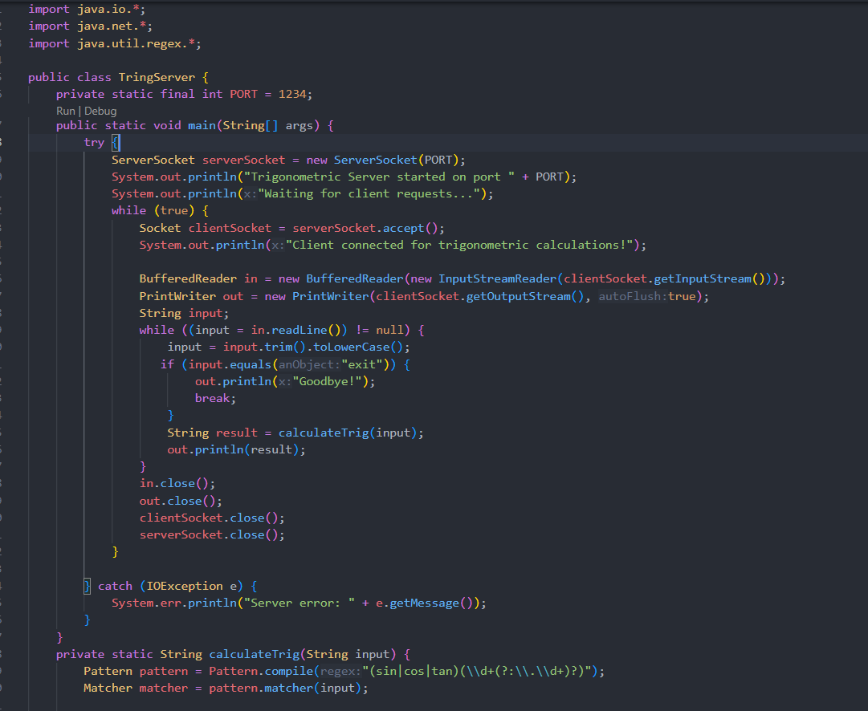

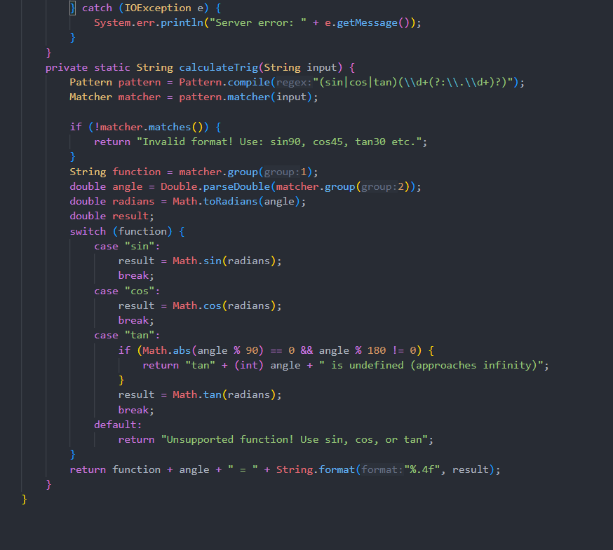

TringClient.java

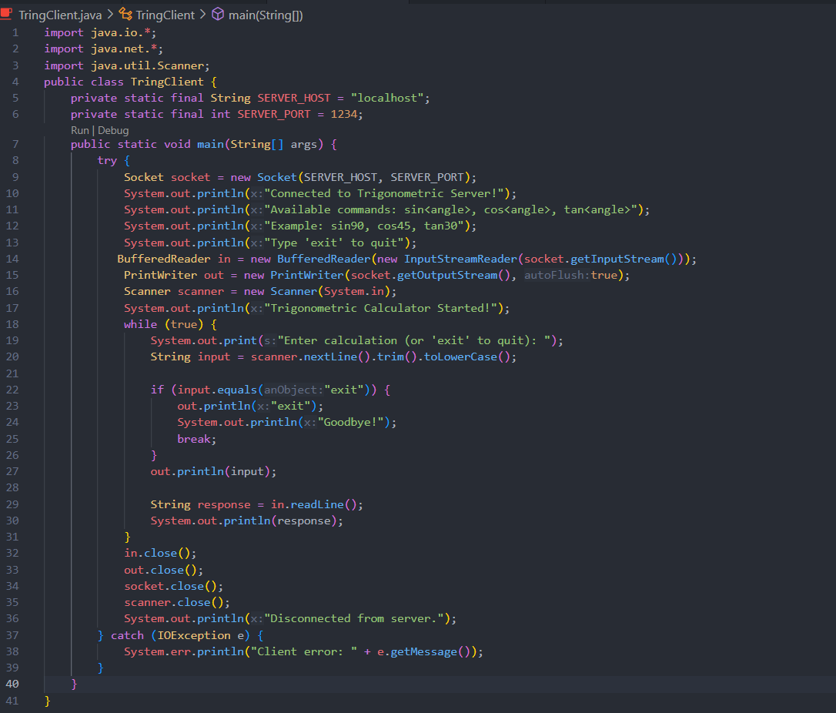

1. Connection Established



1. Perform Operation

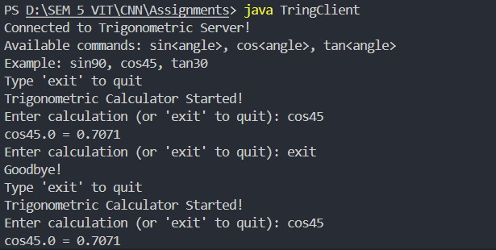

1. Terminate Connection

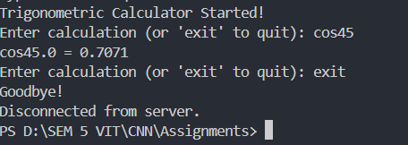

**Conclusion :**

The **UDP (User Datagram Protocol)** provides a simple, connectionless communication In a UDP-based client-server setup, the client transmits data to the server without creating a persistent connection beforehand. The server simply waits for incoming datagram packets and processes them upon arrival. This design is lightweight and works well for quick, low-overhead exchanges, making it ideal for small-scale services like a "Hello" greeting or a trigonometric calculator. By implementing the calculator as **TringServer.java** and **TringClient.java** with a separate port (1235), the two applications can operate independently. This separation not only prevents conflicts but also highlights the adaptability and scalability of the architecture, as multiple services can run simultaneously without interfering with each other.