Assignment No: 4
Name: Tanishq Thuse
Roll No: 60
PRN: 12310237
Div: CS (AI) - B
Title: To install docker on window/linux and build docker image from docker hub.

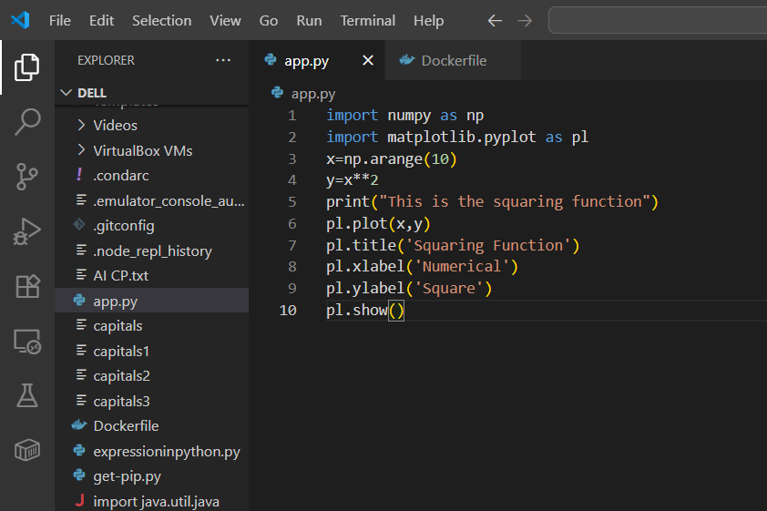

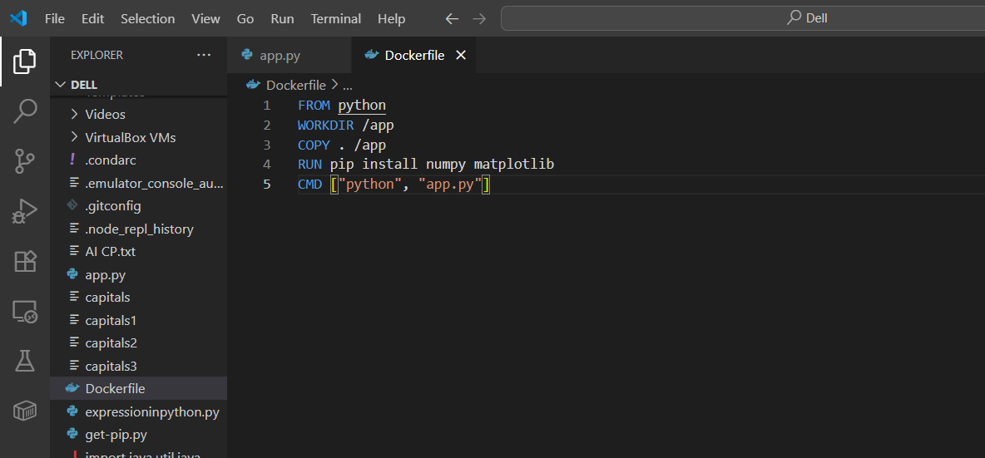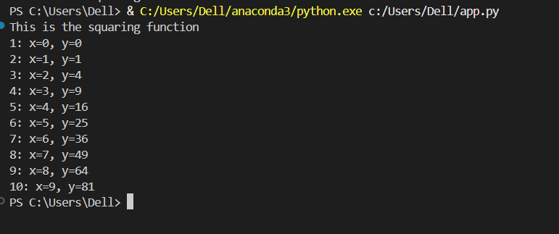

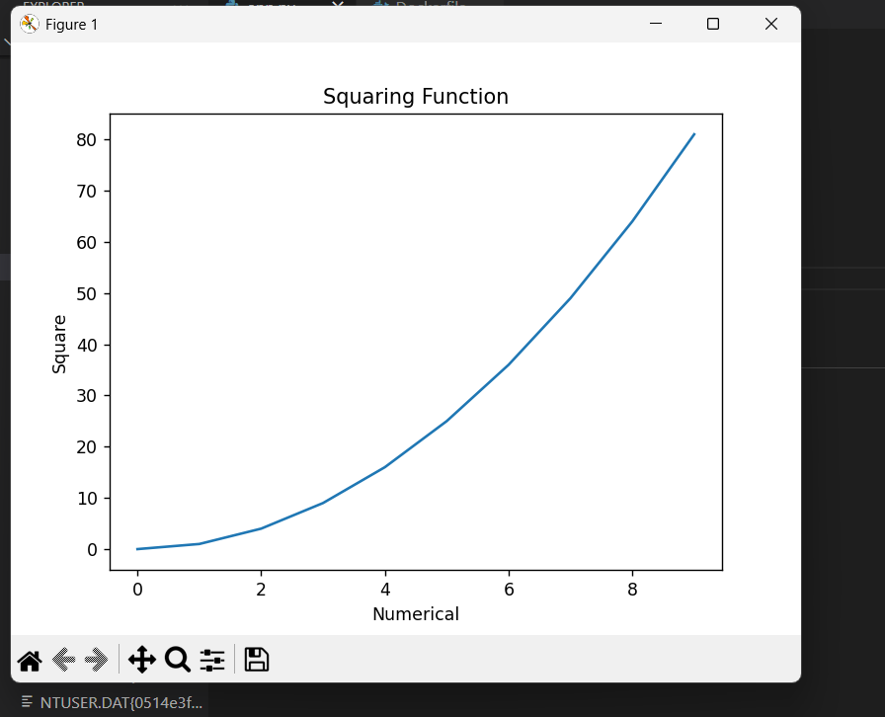
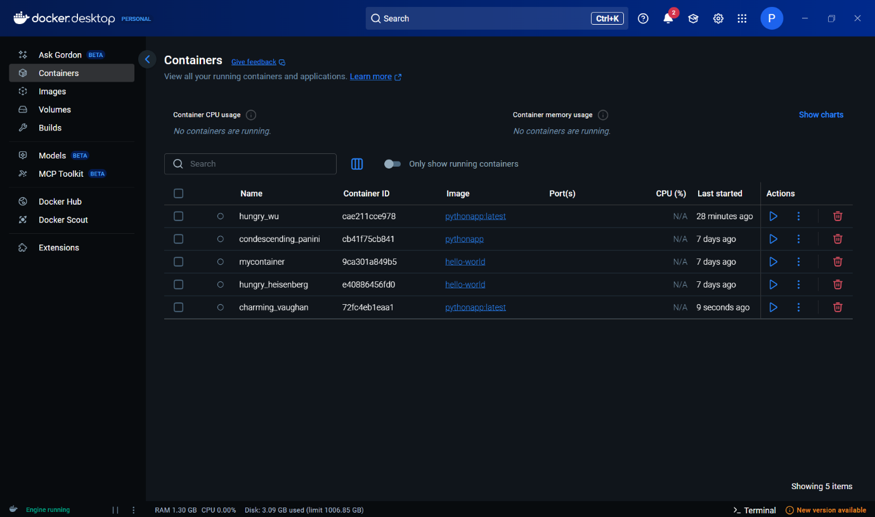

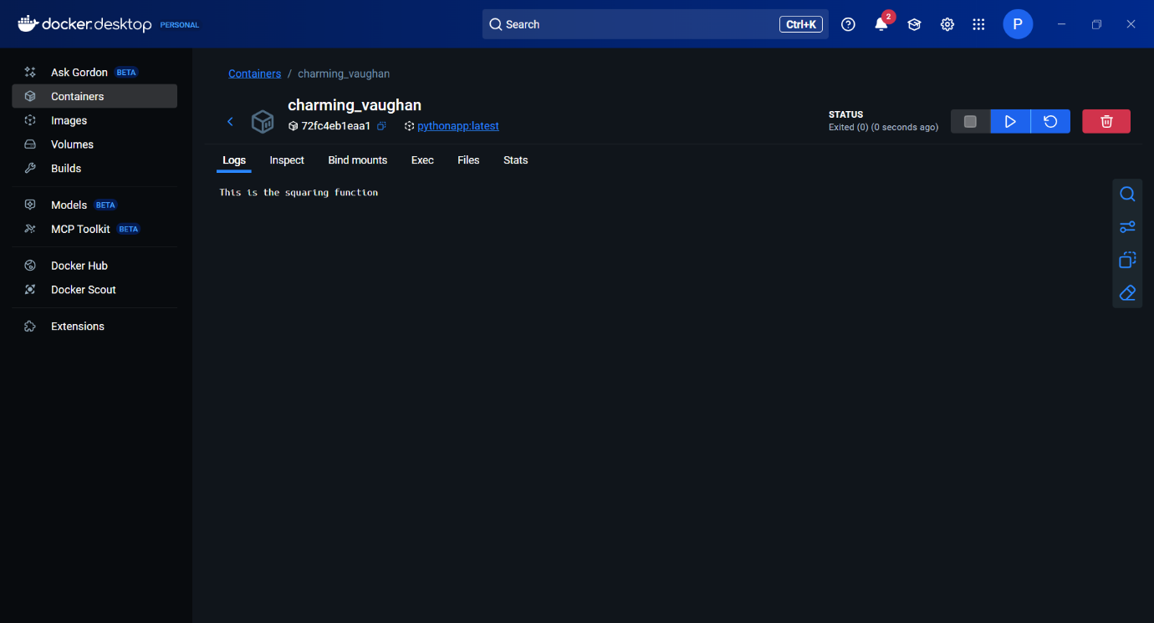

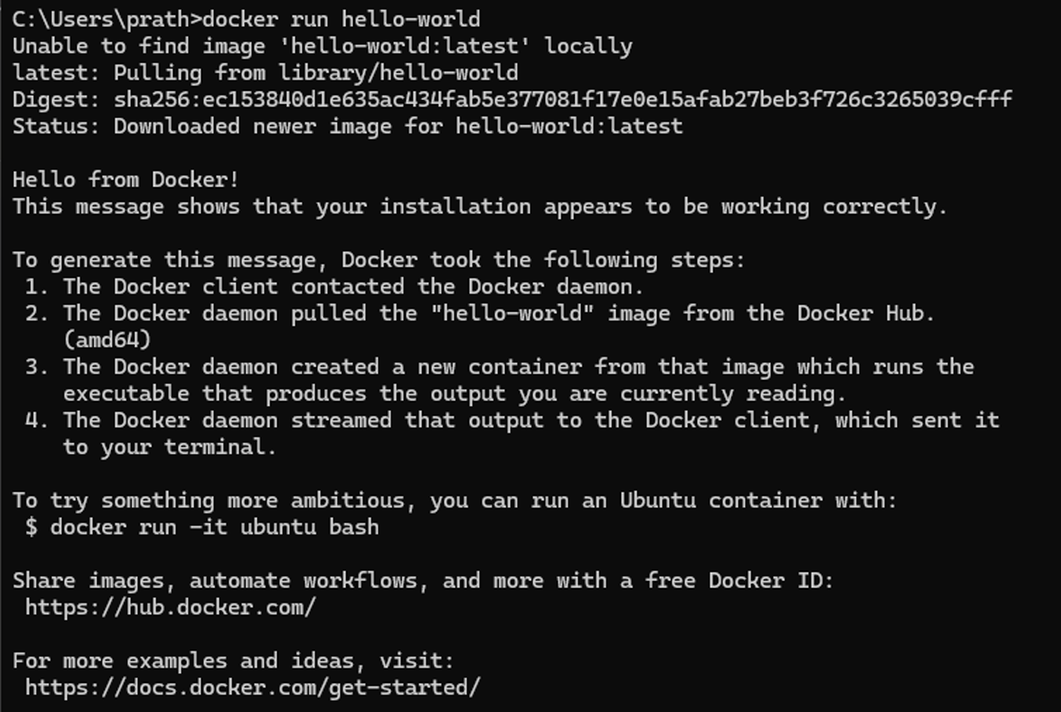

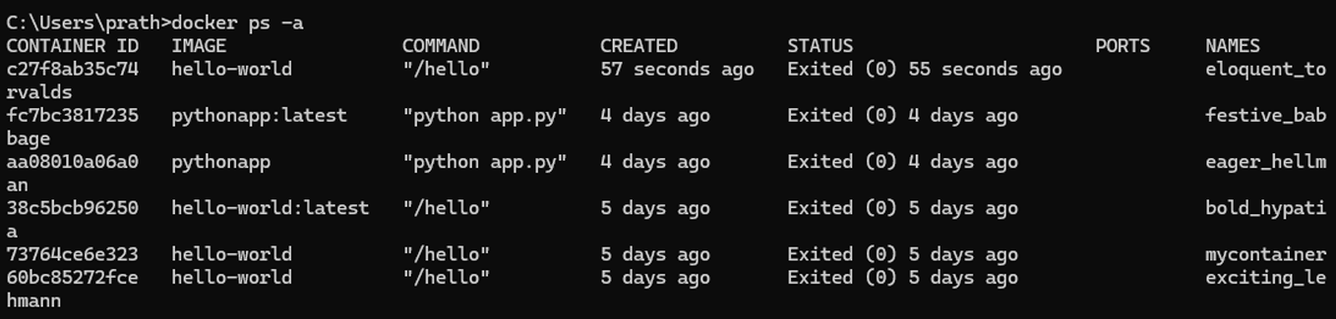
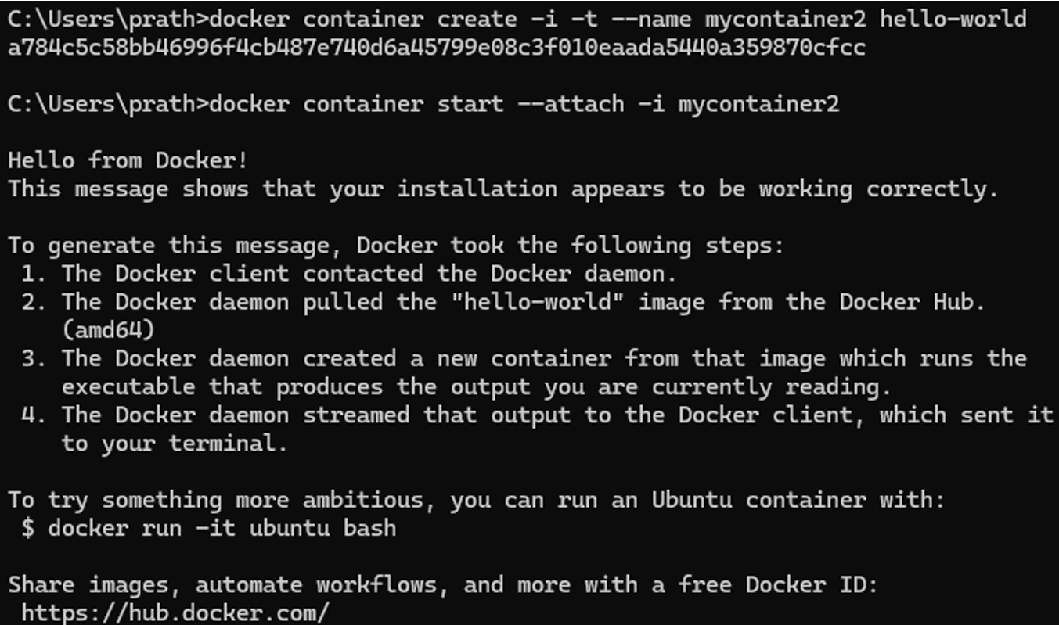
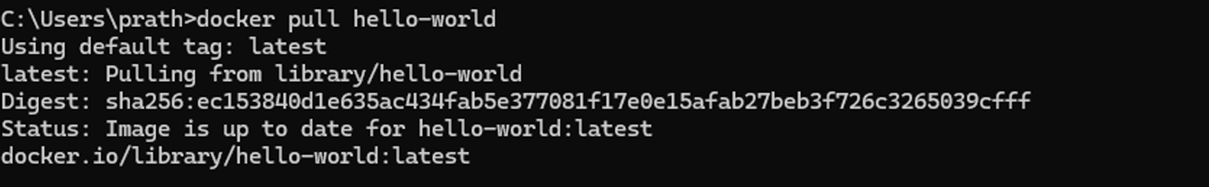
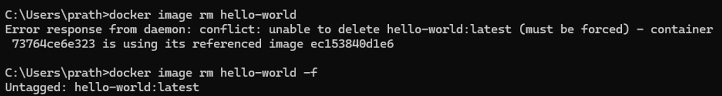

Insights:
In this experiment, I learned how to install Docker on Windows or Linux and build Docker images from Docker Hub. Docker is a platform for creating, running, and managing containers, which package applications with all dependencies to run consistently across environments. I explored the Docker architecture, including the client, daemon, and registries like Docker Hub. I ran basic Docker commands like pulling the "hello-world" image, creating and starting containers, and removing images. I also built a simple Python application container by writing a Dockerfile, installing required libraries, building the image, and running the container. This experience showed me how Docker simplifies application deployment and scaling by using lightweight, isolated containers.

