**Case Study Introduction :**

**IMDB Movie Analysis**

The dataset offers a detailed overview of movies, capturing key aspects such as movie titles, genres, languages, release years, and directors. It includes cast details, IMDb scores, financial data (budget and gross), and social media engagement (Facebook likes). With this information, it’s possible to analyze trends in movie genres, financial success, critical reception, and social media influence. This dataset is ideal for gaining insights into the factors impacting a movie’s popularity and success.

**Data Loading and Preparation:**

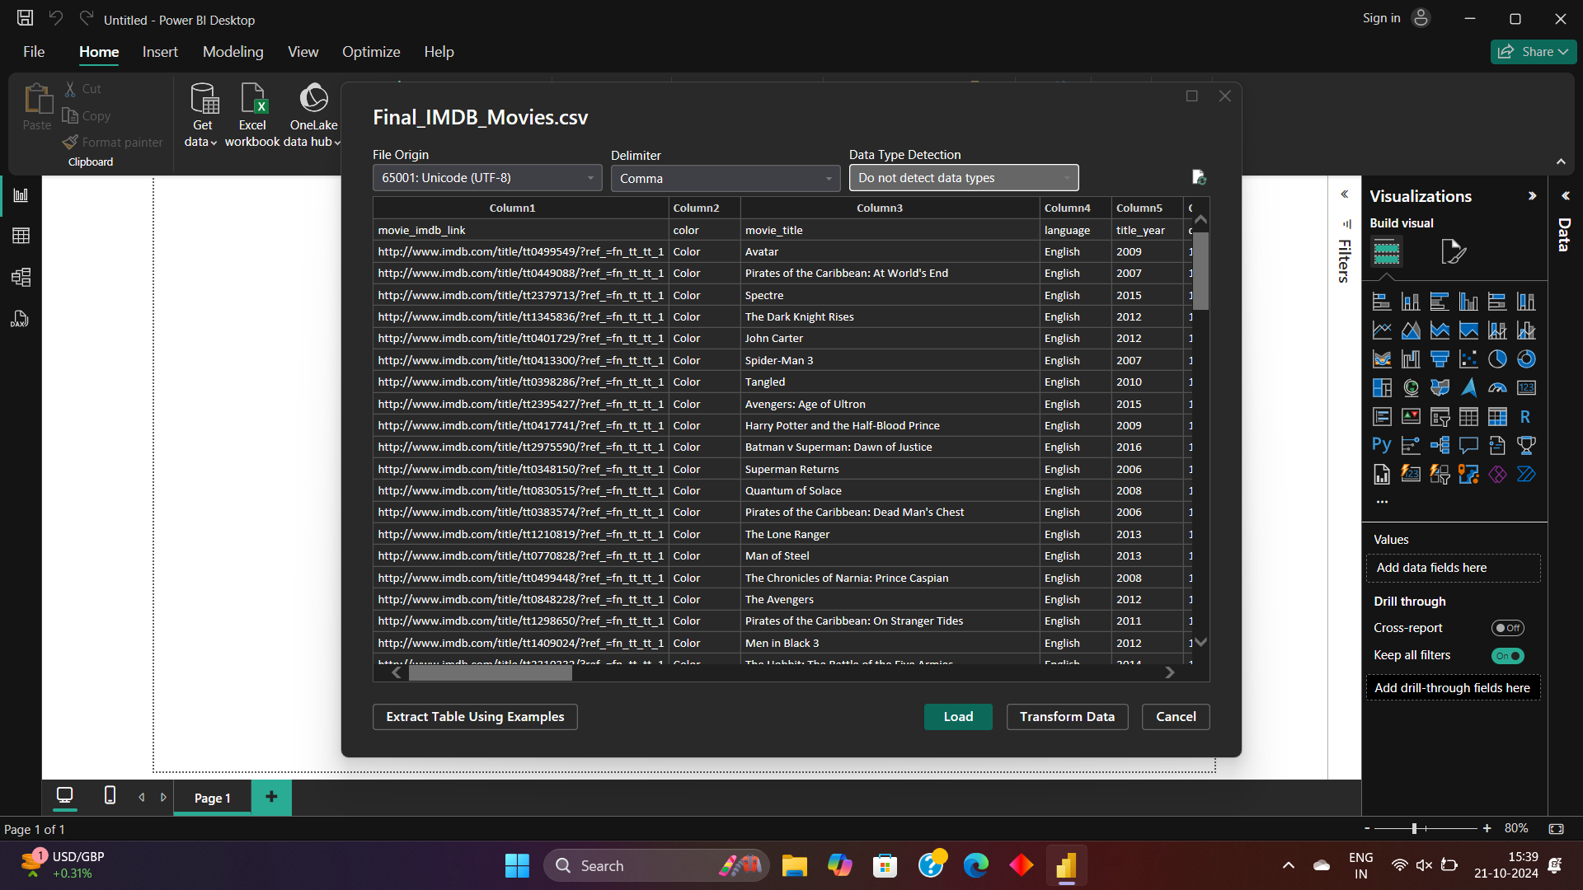

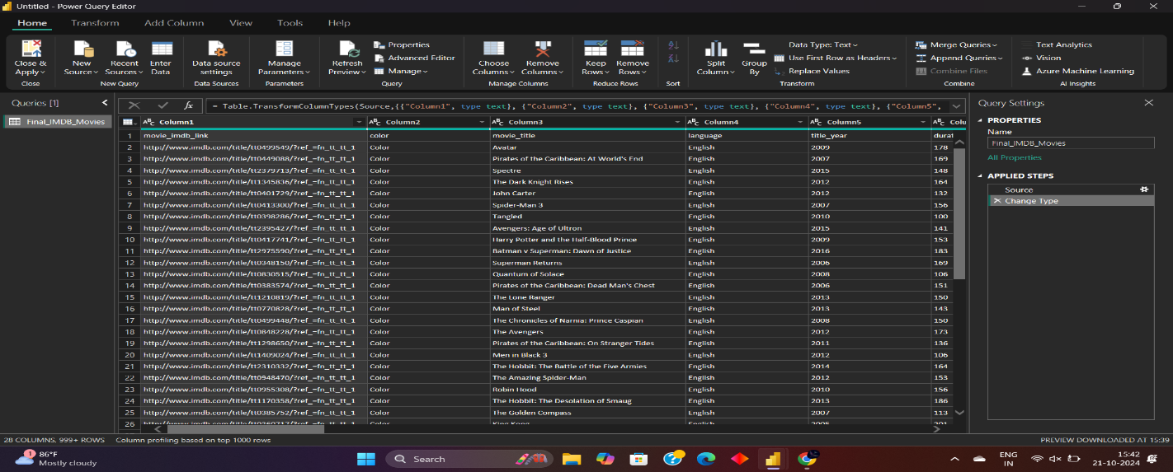

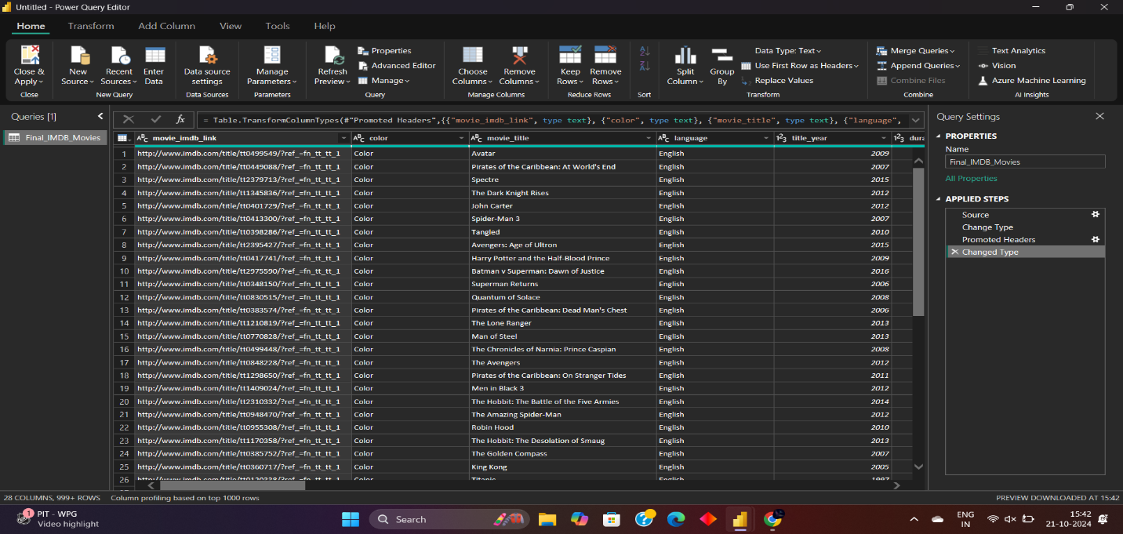

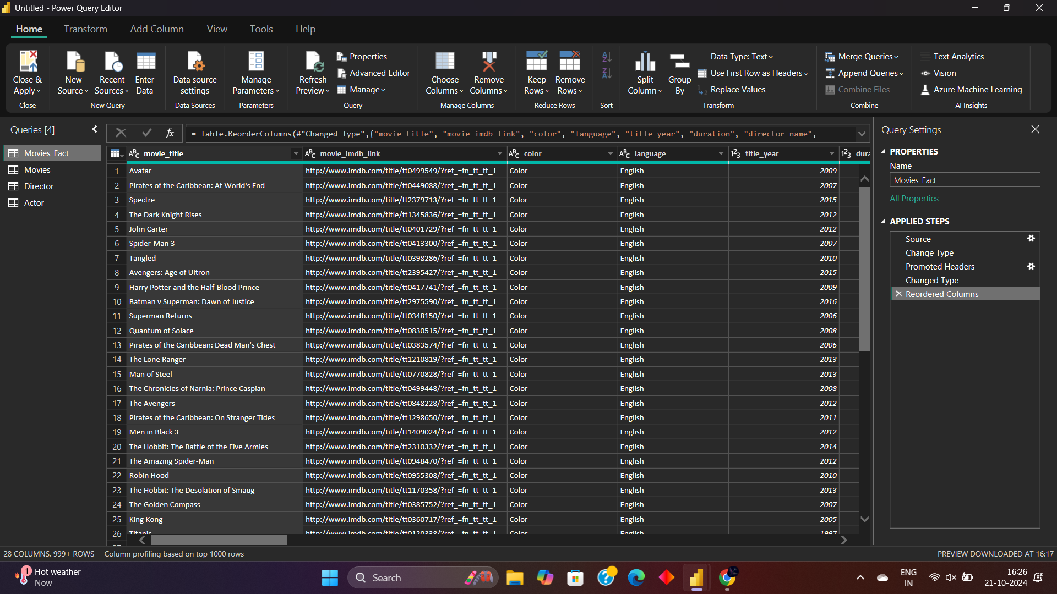

**Data Transformation :**

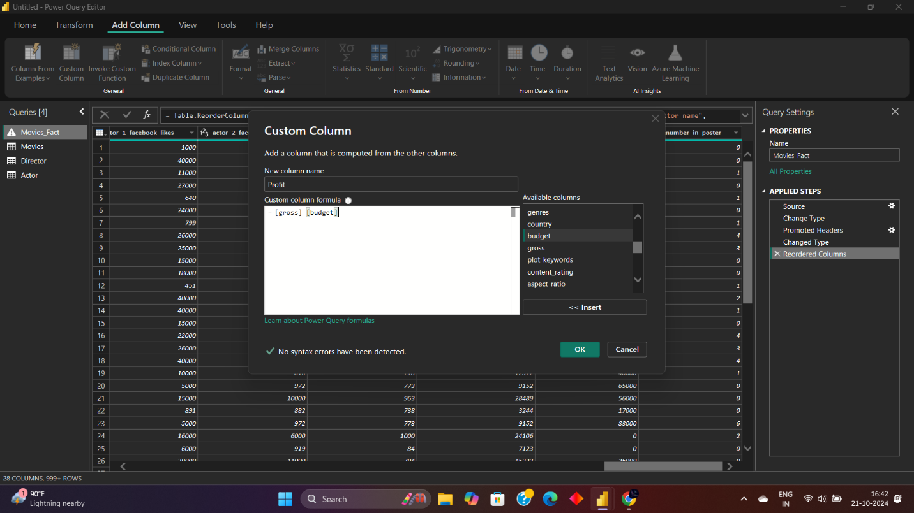

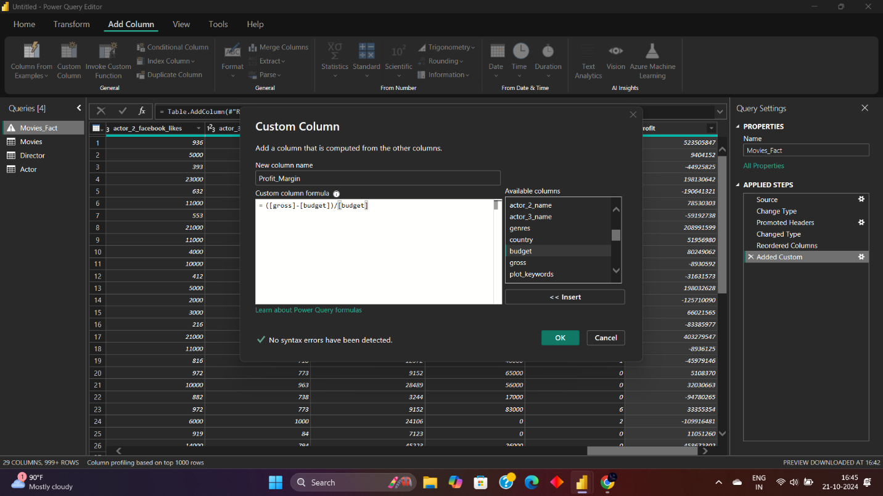

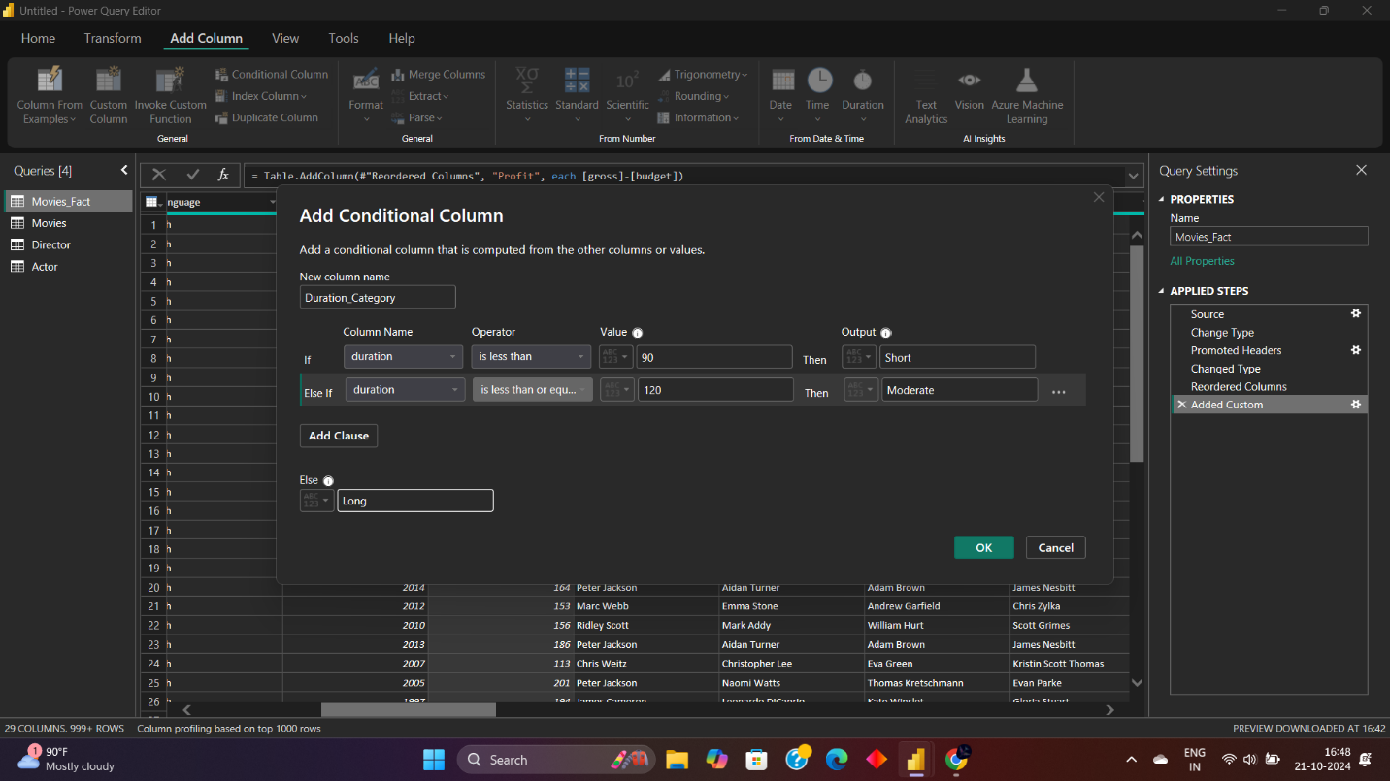

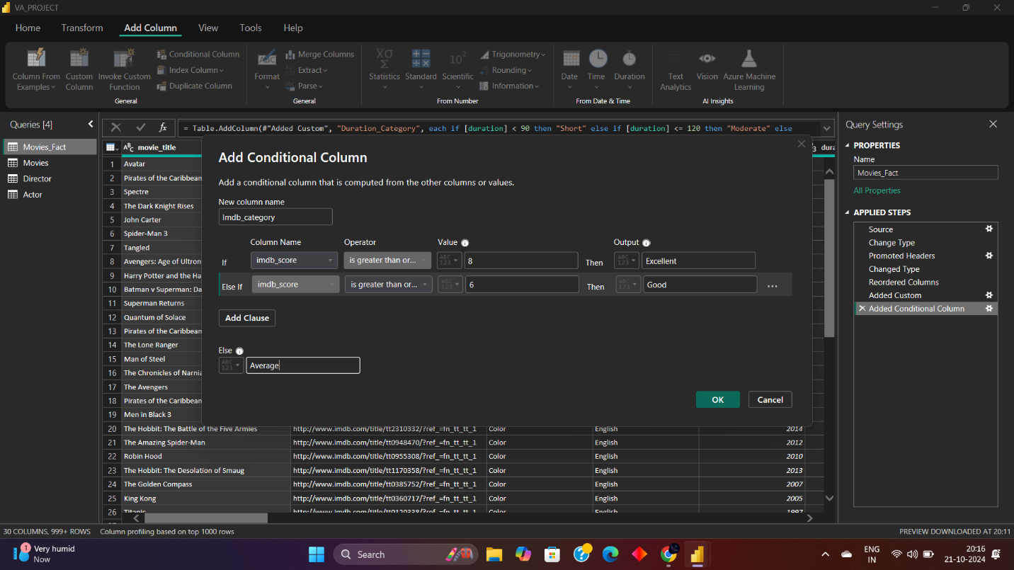

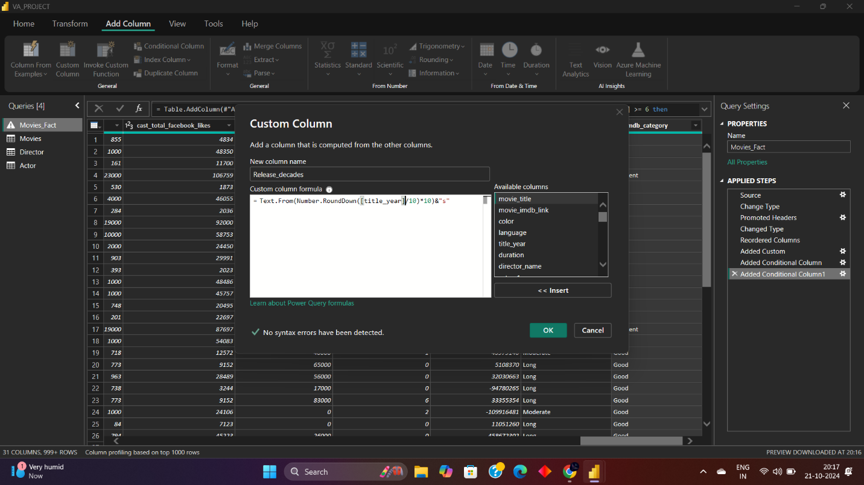

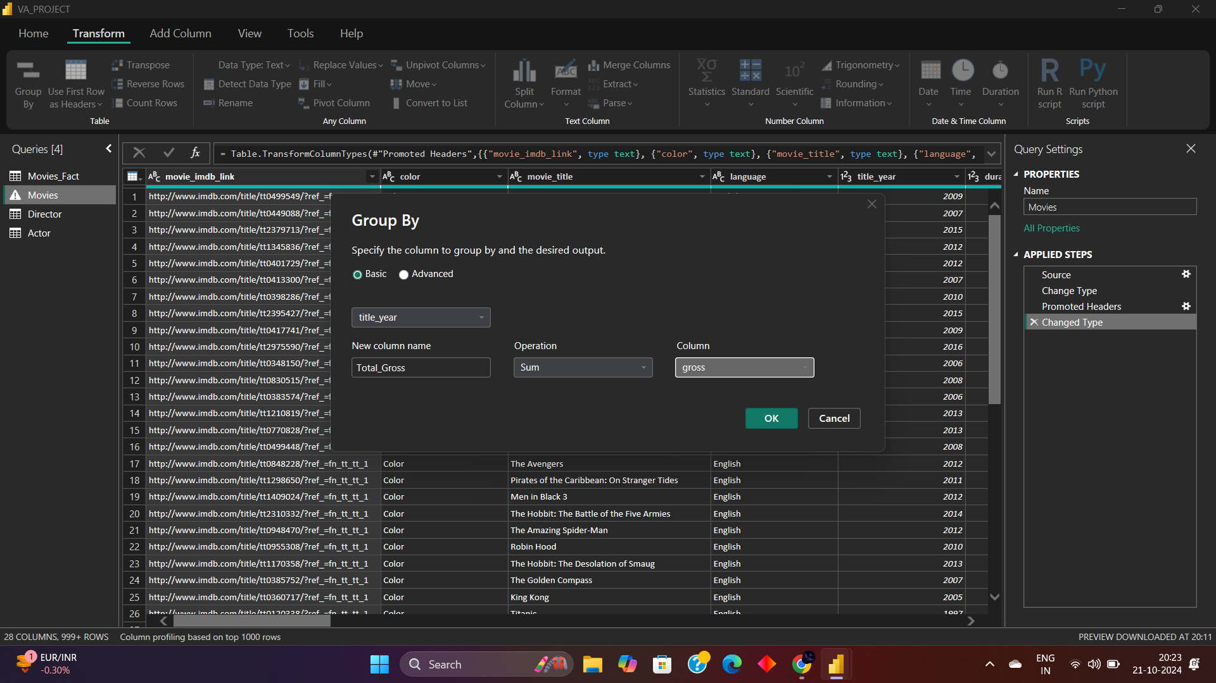

**Creating Relationships and Data Modeling**

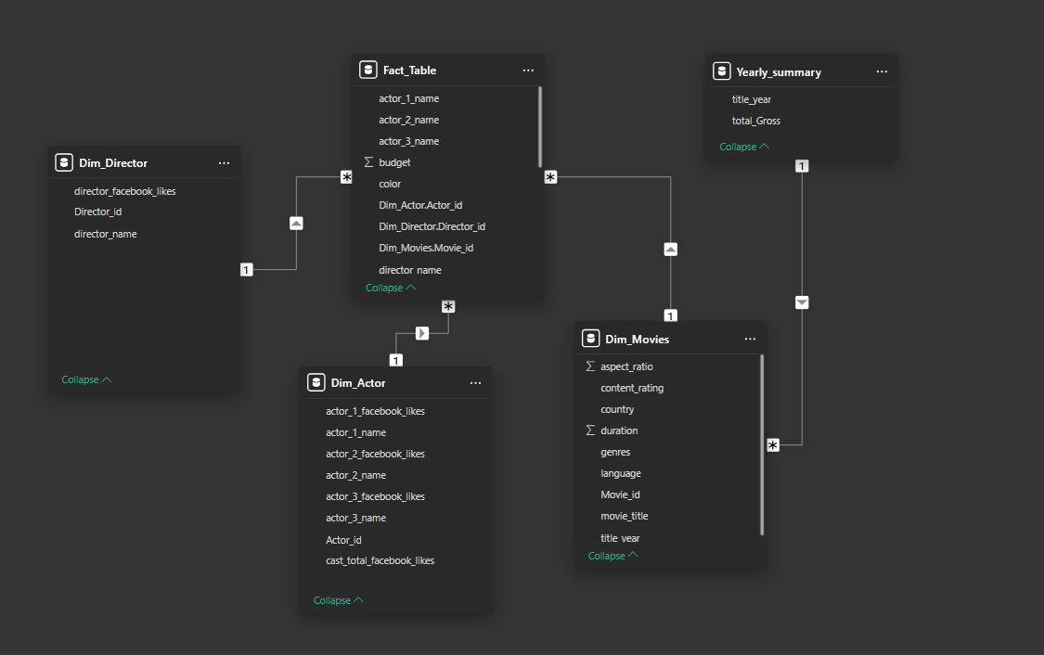

**DAX Calculations :**

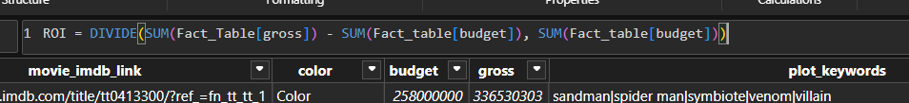

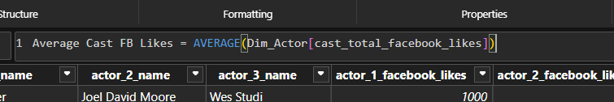

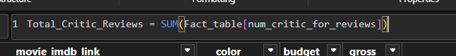

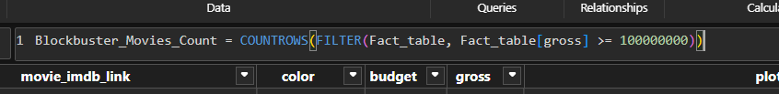

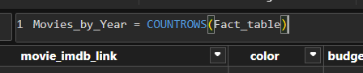

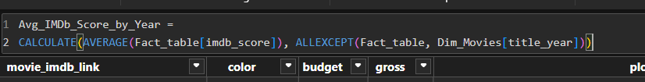

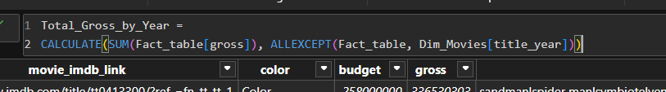

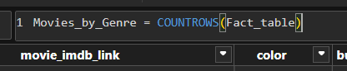

**Data Visualization**



