As we see, as lambda grows turnaround time also grows as expected. Reason: more entities arrive to the system and more they spend more time in the queues waiting.

We can see number of servers grow and turn around time decreases but then it roughly changes. So adding more servers to the system reduces turn around time till it reaches a threshold(for ex. 9 or 10).

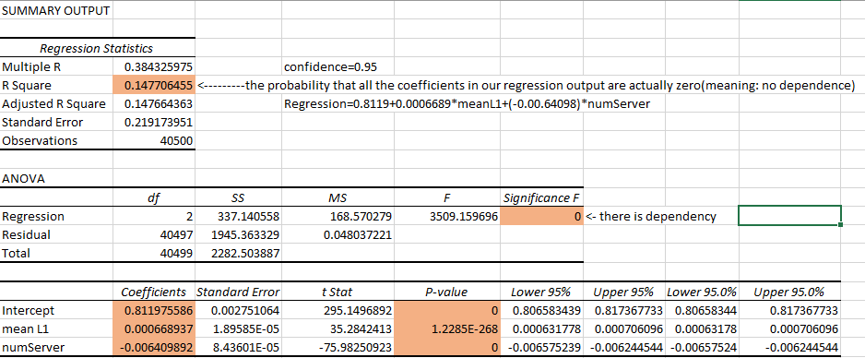
2 var regression with X1=mean service time of layer 1 servers, X2=number of servers of layer 1, Y=mean block time of servers of layer 0 with confidence = 0.95 and alpha=0.05

The chart above shows the fact that we can reduce utilization time by adding more servers to the layer.

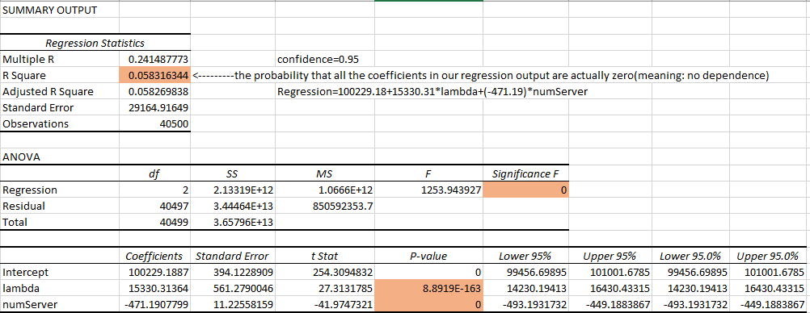
2Var regression with X1=lambda,X2=number of servers of layer 1, Y=TAT(turnaround time), alpha=0.05

As we see, as queue size of layer 1 grows, block time of layer 0 decreases as expected. Because there will be more servers in layer 1 to serve the entities so less number of entities will be in layer 1 queue and the amount of blocked time of layer 0 servers will be lower.

as we see, as queue size of layer 2 increases, turnaround time does not change a lot. The reason is that the number of entities arriving the system is much more that max queue size mentioned above($\sim$1600).

