1)

2)

3)

4)

5)

6)

As we see in diagrams above(1-6), time is growing as the degree of polynomials increase. This means Simpson takes more time to calculate polynomials with higher degree. Also we see that diagrams with lower h value have increased with a faster rate than the diagrams with higher h. this shows that Simpson takes more time to calculate the same polynomials with smaller values of h. in addition, we can see that diagrams with same h but different interval are behaving in almost the same way. For example, diagram 1 with h=0.001 in the (0,30) interval takes 1/3 of diagram 4 with h=0.001 in the (0,90) interval. this shows that time of calculation is dependent of the interval we consider.

7)

8)

9)

10)

11)

12)

As we see in diagrams above (7-12), time is growing as the degree of polynomials increase. This means that mc takes more time to calculate polynomials with higher degree. Also, we see that diagrams with higher n value have increased with a faster rate than the diagrams with lower n. this shows that mc takes more time to calculate the same polynomials with bigger values of n. in addition, we can see that diagrams with same n and different intervals are almost similar, this shows that time is not dependent of the interval we consider.

13)

14)

15)

As we see in diagrams above (13-15), error is growing exponentially as the degree of polynomials increase. And if we consider using a smaller h value, then the graph will show more exponential behavior than higher h values. Also, we can see that if we consider using smaller h values then the error will be so much smaller.

16)

17)

18)

As we see in diagrams above (16-18), error is growing as the degree of polynomials increase. But we can see that if we consider using smaller h values then the error will be so much smaller.

19)

20)

21)

We can see in above diagrams(19-21) that error is increasing as the degree of polynomial increases. Also it’s obvious that if we use more points, MC will have a better estimate.

22)

23)

24)

We can see in above diagrams(22-24) that error is increasing as the degree of polynomial increases. Also it’s obvious that if we use more points, MC will have a better estimate.
In addition, we can see(in diagrams 19-24) that it seems like error is not dependent on the interval we consider for integrating.

25)

it seems like, if we consider using smaller values of h then Simpson will take more time but the values 1>h>=0.2 do not affect the time so much.
27)

This diagram shows that error increases as we choose higher values for h. also, it’s clear that choosing a smaller h haven’t always given smaller error, that is why we see so many bounces in the graph.

26)

it seems like, if we consider using smaller values of h then Simpson will take more time but the values 1>h>=0.2 do not affect the time so much.

28)

This diagram shows that error increases as we choose higher values for h. also, it’s clear that choosing a smaller h haven’t always given smaller error, that is why we see so many bounces in the graph.

Also we can see in the diagrams above(25-28), that time is independent of polynomial degree but error depends on it (in the way that the diagram with higher degree(28) shows more error that the one with smaller degree(27).).
29)

30)

As we can see in the two diagrams above(29-30), time is dependent on polynomial degree in MC. We can see that diagram 30 shows higher values for time than diagram number 29.
31)
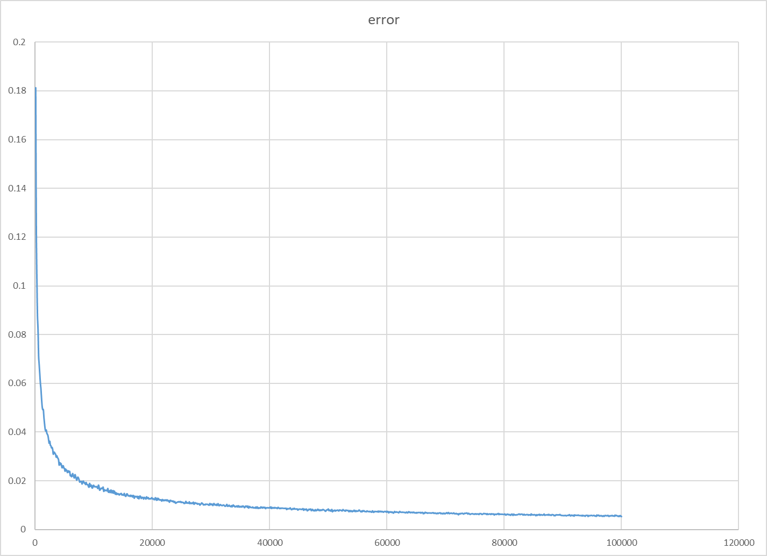

32)

We can see in the two diagrams above(31-32), that error is dependent on polynomial degree and MC can calculate a better estimation when calculating polynomials with smaller degree.

