

**Submitted By:**

Tanjela Rahman Rosni

(2020-1-60-018)

**Submitted To:**

**Dr. Mohammad Arifuzzaman**

Associate Professor

Department of Computer Science and Engineering

**Introduction:**

In this SQL exercise, we aim to manipulate data from tables named Loan, Account, and Employee_details. Through SQL queries, we will extract specific information such as the lowest loan amount, highest account balance, average loan amount, and more. Furthermore, we'll engage with the Employee_details table, tackling tasks like identifying the highest/lowest IDs and salaries, computing averages, and conducting project-related analyses. By completing these exercises, we'll gain proficiency in SQL querying for extracting insights from relational databases, covering tasks like finding extreme values, computing averages, and performing project-specific analyses.

# Task: 1

CREATE TABLE Loan (

Loan_no int(10), Amount int(100),

Branch_name VARCHAR(10)

);

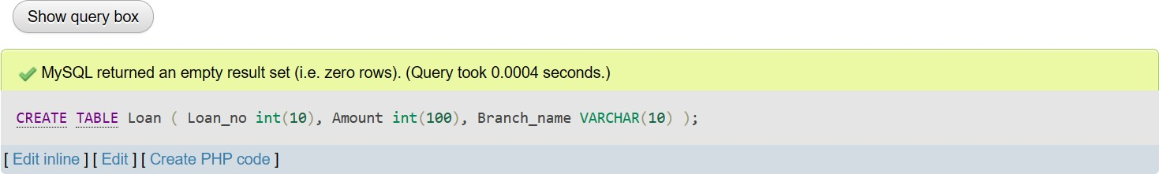

INSERT INTO Loan VALUES (245, 12000 ,'Banani'),(310, 15000, 'Gulshan'),(350, 10000,

'Gulshan'),(450, 8000, 'Uttara');

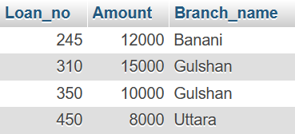

CREATE TABLE Account ( Acct_no int(10), Balance int(100),

Branch_name VARCHAR(10)

);

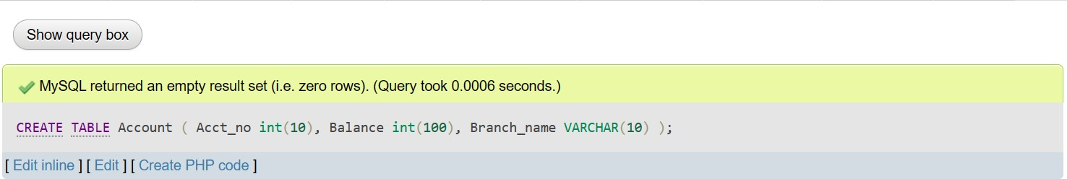

INSERT INTO Account VALUES (101, 20000, 'Gulshan'),(203, 50000, 'Uttara'),(306, 30000,

'Banani');

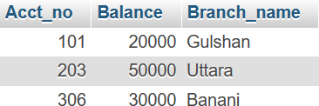

CREATE TABLE Employee_details ( Empid int(10),

EmpName varchar(10), ProjectName VARCHAR(10), Salary int(10)

);

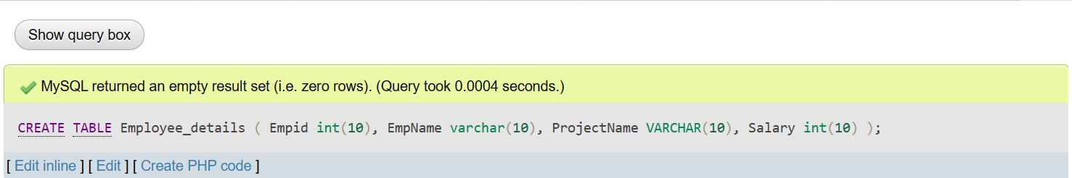

INSERT INTO employee_details VALUES (602,'Asif', 'CloudService', 15000),(925,'Bob', 'CloudService', 13000),(564, 'Charlie', 'ITDevelop',17000),(345,'Suzan','CloudService',10000), (276 ,'Alex' ,'ITDevelop',8000);

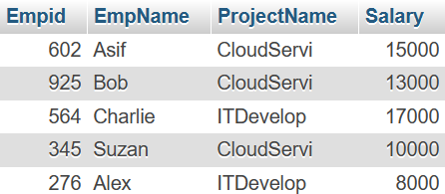

# Task-2:

select loan_no from loan where amount=(select MIN(amount) from loan)



# Task-3:

select MAX(balance) as max_balance from account



# Task-4:

select branch_name from account where balance=(select MAX(balance) from account)



# Task-5:

select AVG(amount) as avg_amount from loan



# Task-6:

select COUNT(acct_no) as No_of_acc from account



## Exercise:

1. **Create the following Employee table and insert the values into it.**

CREATE TABLE Employee_details ( Empid int(10),

EmpName varchar(10), ProjectName VARCHAR(10), Salary int(10)

);



INSERT INTO employee_details VALUES

(602,'Asif', 'CloudService', 15000),(925,'Bob', 'CloudService', 13000),(564, 'Charlie', 'ITDevelop',17000),(345,'Suzan','CloudService',10000), (276 ,'Alex' ,'ITDevelop',8000);

## Show the highest ID.

SELECT MAX(Empid) AS Highest_Empid FROM Employee_details;



## Show the lowest salary.

SELECT MIN(Salary) AS Lowest_Salary FROM Employee_details;



## Show the highest salary.

SELECT MAX(Salary) AS Highest_Salary FROM Employee_details;



## Show the average salary.

SELECT AVG(Salary) AS Average_Salary FROM Employee_details;



## Show the total number of employees.

SELECT COUNT(*) AS Total_Employees FROM Employee_details;



## Show the highest salary of project CloudService.

SELECT MAX(Salary) AS Highest_Salary_CloudService FROM Employee_details

WHERE ProjectName = 'CloudService';



## Show the lowest salary of project ITDevelop.

SELECT MIN(Salary) AS Lowest_Salary_ITDevelop

FROM Employee_details WHERE ProjectName = 'ITDevelop';



## Show the average salary of project ITDevelop.

SELECT AVG(Salary) AS Average_Salary_ITDevelop

FROM Employee_details WHERE ProjectName = 'ITDevelop';



## Show the name of the employee whose salary is highest.

SELECT EmpName FROM Employee_details WHERE Salary = (

SELECT MAX(Salary)

FROM Employee_details

);



## Show the name of the employee whose salary is more than average salary.

SELECT EmpName FROM Employee_details WHERE Salary > (

SELECT AVG(Salary)

FROM Employee_details

);

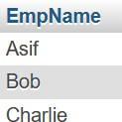

## Show the employee name whose ID is lowest.

SELECT EmpName FROM Employee_details WHERE Empid = (

SELECT MIN(Empid)

FROM Employee_details

);



## Find the total salary expense for the ITDevelop project?

SELECT SUM(Salary) AS Total_Salary_Expense_ITDevelop FROM Employee_details

WHERE ProjectName = 'ITDevelop';



## Calculate the average salary of employees working on the CloudService project.

SELECT AVG(Salary) AS Average_Salary_CloudService FROM Employee_details

WHERE ProjectName = 'CloudService';



## Find the number of employees in the CloudService project.

SELECT COUNT(*) AS Total_Employees_CloudService FROM Employee_details

WHERE ProjectName = 'CloudService';

