

**Submitted By:**

**Tanjela Rahman Rosni**

**(2020-1-60-018)**

**Submitted To:**

**Dr. Mohammad Arifuzzaman Associate Professor**

**Department of Computer Science and Engineering East West University**

**Introduction:**

In SQL, wildcard characters like % and _ are used with the LIKE operator to match patterns in string data. For instance, % represents any sequence of characters, while _ matches a single character.The ORDER BY keyword sorts query results based on specified columns, arranging them in ascending or descending order. This functionality enhances data presentation and analysis in SQL queries.

**Task-1:**

CREATE TABLE employee ( ename VARCHAR(10),

street VARCHAR(5), city VARCHAR(15)

);

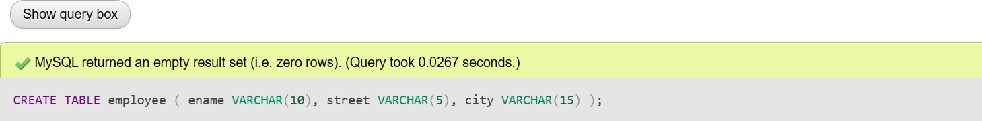

INSERT INTO employee (ename, street, city) VALUES ('Rahim', 'X', 'Dhaka'),

('Mitu', 'Y', 'Sylhet'),

('Sabbir', 'Z', 'Ctg'),

('Babu', 'P', 'Dhaka'),

('Toma', 'X', 'Bogra'),

('Jabbar', 'X', 'Comilla');

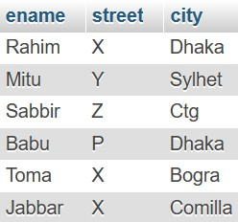

CREATE TABLE works ( Ename VARCHAR(10), Cname VARCHAR(15),

Salary INT

);

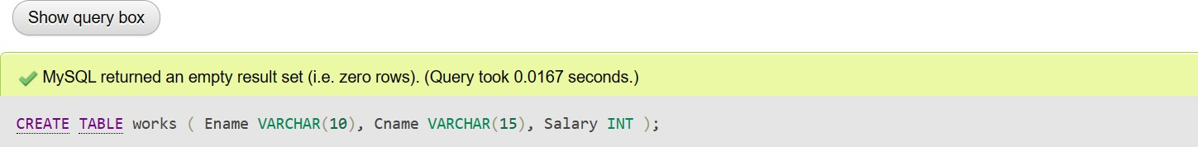

INSERT INTO works (Ename, Cname, Salary) VALUES ('Rahim', 'Samsung', 20000),

('Mitu', 'GP', 30000),

('Sabbir', 'Robi', 40000),

('Babu', 'GP', 50000),

('Toma', 'Robi', 35000),

('Jabbar', 'Samsung', 15000);

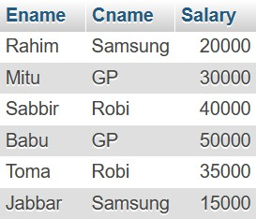

# Task-2: Find out the cname with exactly 2 characters.

SELECT cname FROM works WHERE LENGTH(cname) = 2;

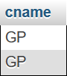

# Task-3: Find out the ename with at least six characters.

SELECT ename FROM employee WHERE LENGTH(ename) >= 6;

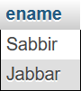

# Task-4: Find out the ename start with ‘S’.

SELECT * FROM employee WHERE ename LIKE 'S%';

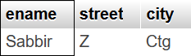

# Task-5: Find out the ename ends with ‘m’.

SELECT * FROM employee WHERE ename LIKE '%m';

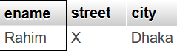

# Task-6: Find out the ename start with ‘R’and end with ‘m’.

SELECT * FROM employee WHERE ename LIKE 'R%m';

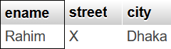

# Task-7: Find out the ename that contains ‘b’.

SELECT * FROM employee WHERE ename LIKE '%b%';

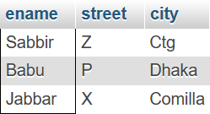

# Task-8: Find all info of the ename order by their salary in ascending order.

SELECT * FROM works ORDER BY salary ASC;

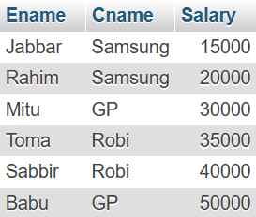

# Task-9: Find all info of the ename order by their salary in descending order.

SELECT * FROM works ORDER BY salary DESC;

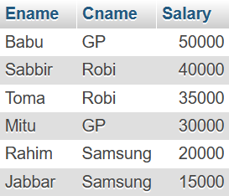

# Task-10: Find all info of the ename order by their salary in ascending order and name in descending order.

SELECT * FROM works ORDER BY salary ASC, ename DESC;

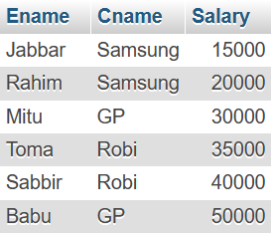

**Exercise:**

CREATE TABLE Author (

Author_id INT,

Author_name VARCHAR(15), Address VARCHAR(25)

);



INSERT INTO Author VALUES

(519, 'John', 'Bangladesh'),

(4825, 'Alex', 'England'),

(316, 'Devid', 'Italy'),

(9621, 'Ana', 'Canada');

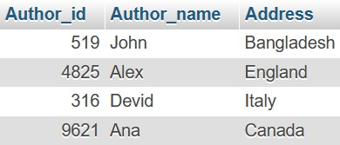

CREATE TABLE Book (

Isbn INT,

Title VARCHAR(25),

Price INT, Publisher_id INT

);

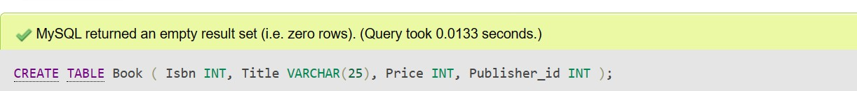

INSERT INTO Book (Isbn, Title, Price, Publisher_id) VALUES (7436, 'Python', 550, 1),

(7412, 'Database', 450, 3),

(3256, 'Networking', 400, 2),

(4125, 'Math', 378, 1),

(2654, 'Physics', 600, 2);

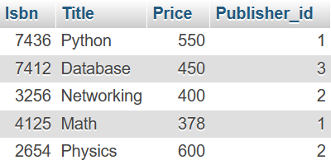

# Find out the author's address with exactly 5 characters.

SELECT * FROM author WHERE LENGTH(address) = 5;



# Find out the author's address with at least 6 characters.

SELECT * FROM author WHERE LENGTH(address) >= 6;

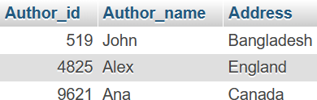

# Find out the author name start with ‘a’.

SELECT * FROM author WHERE Author_name LIKE 'a%';

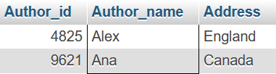

# Find out the author's name starting with ‘a’ and end with ‘a’.

SELECT * FROM author WHERE Author_name LIKE 'a%a';

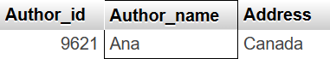

* **Find out the author's name ends with ‘n’.**

**SELECT * FROM author WHERE Author_name LIKE '%n';**

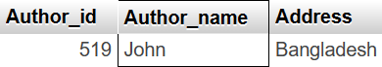

* **Find out the author's address starting with ‘e’.**

SELECT * FROM author WHERE address LIKE 'e%';



# Show the isbn in ascending order.

SELECT * FROM Book ORDER BY Isbn ASC;

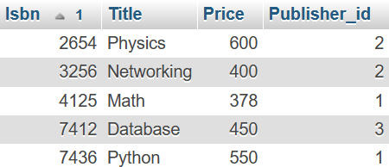

# Show the isbn in descending order.

SELECT * FROM Book ORDER BY Isbn DESC;

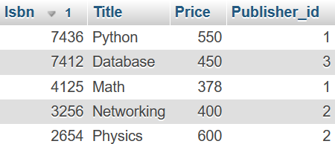

# Show the price in ascending order and the isbn in descending order.

SELECT * FROM Book ORDER BY Price ASC, Isbn DESC;

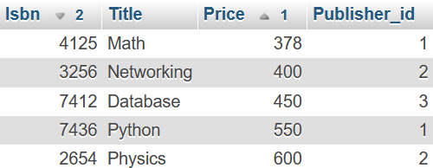

# Find out the book title with exactly 4 characters.

SELECT * FROM Book WHERE LENGTH(Title) = 4;

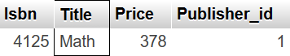

# Find out the book title starts with ‘d’, ends with ‘e’ and has ‘b’ in 5th position.

SELECT * FROM Book WHERE Title LIKE 'd_b e';

