PMHD Consultancy Training

Ecotron
Ecotrons represent a pioneering approach in ecological research, providing a sophisticated platform for studying complex environmental interactions and ecosystem dynamics under controlled conditions. These experimental facilities simulate natural ecosystems, allowing scientists to manipulate variables such as ambient temperature, relative humidity, carbon dioxide (CO₂) levels, nutrient availability, soil temperature and moisture. By creating these carefully controlled environments, ecotrons can facilitate an in-depth investigation of responses of ecosystems to climate change. Ecotrons are leading the way in innovative ecological research, bridging the gap between laboratory studies and field observations, and paving the path for actionable solutions to environmental challenges.

Ecosystem climate change experiments, in which ecotrons are used to simulate plausible future climates, are one of the key instruments to study the response of ecosystems to a change in climate. More specifically, by perturbation of climate variables (e.g., air temperature, precipitation, CO₂ concentration, nitrogen deposition, methane, etc.) projections for future climates can be made.

The UHasselt Ecotron, located at the Hoge Kempen National Park, is an ecotron infrastructure consisting of replicated experimental units in which ecosystems are confined in enclosures. By allowing the simultaneous control of environmental conditions and the online measurement of ecosystem processes, the ecotrons units are suited for experiments with highly controlled climate change manipulation of large intact parts of the ecosystem. The infrastructure allows intensive monitoring and control of key abiotic parameters, separately within 12 large-scale ecosystem replicas.

Project
You are being contacted by Professor Pyrus and his team to help them setup an experiment studying the impact of climate change interventions on fruit production in Belgium. As the impact of climate change is becoming increasingly clear, the agricultural sector faces significant challenges in maintaining the quantity, quality and sustainability of food production.

Professor Pyrus and his team will provide pear plants for the experiment. Two pear varieties from the common pear species are available: Conference and Doyenne du Comice. The Conference species currently has harvest season in October/beginning of November, whereas the Doyenne Du Comice has harvest season in late September until second week of October. Pear cultivation, in particular, is influenced by a multitude of environmental factors, including temperature fluctuations, water availability, and soil health.

In this project several possible future climate scenarios will be investigated. All of these scenarios are projections of mathematical models of how climate variables (e.g., air temperature, precipitation, CO₂ concentration, nitrogen deposition, methane, etc.) would change by specific climate interventions such as actively removing CO2; energy transition (from fossil fuel bans to increase renewable energy sources); investment in sustainable public transport; degrowth of economies; protection and regrowth of forests; reflect sunlight; encourage vegan diets.

The following 4 climates scenarios will be considered in the study. These climates represent possible scenarios in 2070:
- Climate scenario 1: Climate variables in the Ecotron are set according to the projected climate in 2070 without major interventions
- Climate scenario 2: Climate variables in the Ecotron are set according to climate interventions mainly focusing on actively removing CO2
- Climate scenario 3: Climate variables in the Ecotron are set according to climate interventions mainly focusing on more sustainable energy production
- Climate scenario 4: Climate variables in the Ecotron are set according to climate interventions mainly focusing on transportation

This study aims to assess which is the best scenario for pear quality in the future. The pear trees are planted in September of year X and climate conditions are immediately applied in year X. In year X+2 it is expected that pears can be harvested. There is a standard process in place for pollination of the trees.

If we do not have enough Ecotrons at UHasselt, we can use another 12 Ecotrons at CNRS France.

With your knowledge on statistics and design of experiments they expect you to setup a well-designed and efficient study.
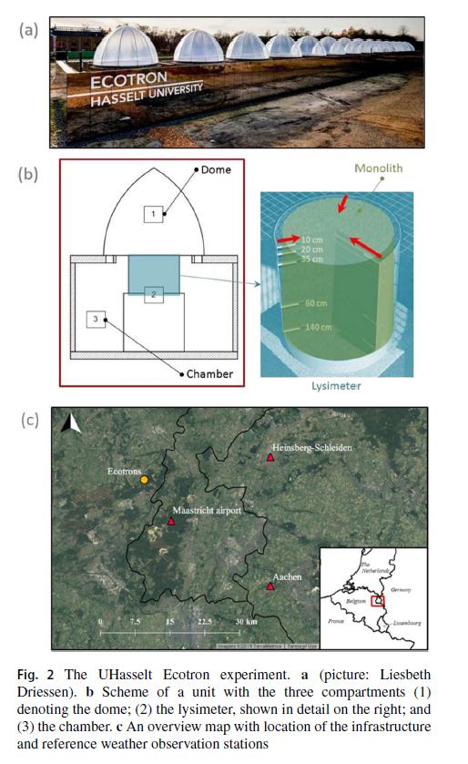
https://doi.org/10.1007/s00484-020-01951-8

