Dashboard-01:

IPL Power BI Dashboard (2008-2024)

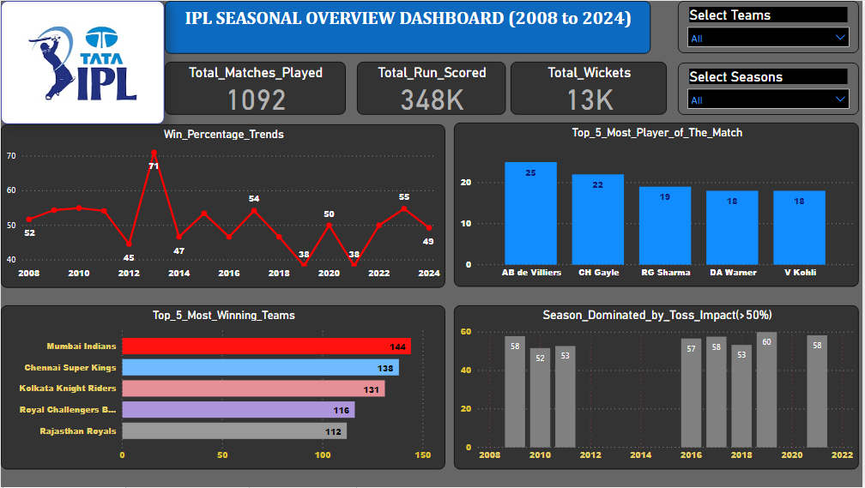

DAX FORMULA(Measures):-

***Total_Matches = DISTINCTCOUNT(Match_Teams[MatchID])

***Total_Run_Scored = SUM(deliveries[total_runs])

***Total_Wickets = COUNTROWS(FILTER(deliveries,deliveries[is_wicket]=1))

***Win_Percentage = DIVIDE(

COUNTROWS(FILTER(matches,matches[winner]=matches[team1])),

COUNTROWS(matches)

)*100

***Total_Awards = COUNTROWS(FILTER(matches,NOT(ISBLANK(matches[player_of_match]))))

***Total_Wins =

VAR Selectedteam=

SELECTEDVALUE(Team_Names[Teams])

RETURN

IF(

ISBLANK(Selectedteam),

COUNTROWS(matches),

CALCULATE(

COUNTROWS(matches),

matches[winner]=Selectedteam

)

)

***Toss_Impact_Percentage = DIVIDE(

[Toss_Impact_Matches],

COUNTROWS(matches)

)*100

Dashboard-02:  
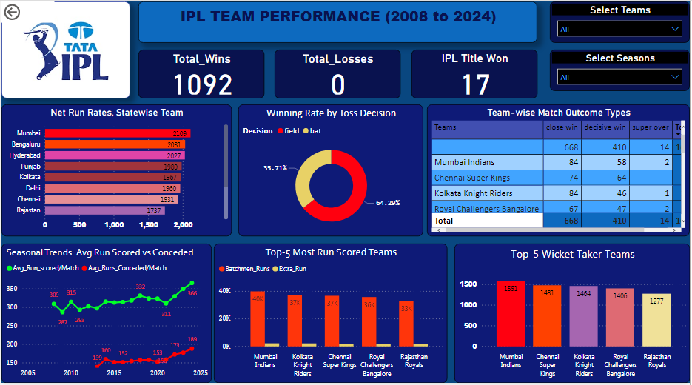  
DAX FORMULA(Measures):-  
*** Total_Wins =

VAR Selectedteam=

SELECTEDVALUE(Team_Names[Teams])

RETURN

IF(

ISBLANK(Selectedteam),

COUNTROWS(matches),

CALCULATE(

COUNTROWS(matches),

matches[winner]=Selectedteam

)

)  
  
*** Total_Losses = [Total_Matches]-[Total_Wins]

*** IPL_Titles =

VAR FinalMatches=

CALCULATE(

COUNTROWS(matches),

FILTER(matches,matches[match_type]="Final" && matches[winner]=Team_Names[Teams])

)

RETURN

IF(ISBLANK(FinalMatches),0,FinalMatches)

*** State_Group =

SWITCH(

TRUE(),

Team_Names[Teams]="Chennai Super Kings","Chennai",

Team_Names[Teams]="Kolkata Knight Riders","Kolkata",

Team_Names[Teams]="Delhi Daredevils","Delhi",

Team_Names[Teams]="Royal Challengers Bangalore","Bengaluru",

Team_Names[Teams]="Rajasthan Royals","Rajastan",

Team_Names[Teams]="Kings XI Punjab","Punjab",

Team_Names[Teams]="Deccan Chargers","Hyderabad",

Team_Names[Teams]="Delhi Capitals","Delhi",

Team_Names[Teams]="Gujarat Lions","Gujarat",

Team_Names[Teams]="Gujarat Titans","Gujarat",

Team_Names[Teams]="Kochi Tuskers Kerala","Kerala",

Team_Names[Teams]="Lucknow Super Giants","Lucknow",

Team_Names[Teams]="Mumbai Indians","Mumbai",

Team_Names[Teams]="Pune Warriors","Pune",

Team_Names[Teams]="NA","Unknown",

Team_Names[Teams]="Punjab Kings","Punjab",

Team_Names[Teams]="Pune Warriors","Pune",

Team_Names[Teams]="Rising Pune Supergiant","Pune",

Team_Names[Teams]="Rising Pune Supergiants","Pune",

Team_Names[Teams]="Royal Challengers Bengaluru","Bengaluru",

Team_Names[Teams]="Sunrisers Hyderabad","Hyderabad",

"Unknown"

)

*** Net_Run_Rate_By_State =

VAR RunsFor =

CALCULATE(

SUM(deliveries[total_runs]),

TREATAS(VALUES(Team_Names[Teams]), deliveries[batting_team])

)

VAR OversFor =

CALCULATE(

DISTINCTCOUNT(deliveries[over]),

TREATAS(VALUES(Team_Names[Teams]), deliveries[batting_team])

)

VAR RunsAgainst =

CALCULATE(

SUM(deliveries[total_runs]),

TREATAS(VALUES(Team_Names[Teams]), deliveries[bowling_team])

)

VAR OversAgainst =

CALCULATE(

DISTINCTCOUNT(deliveries[over]),

TREATAS(VALUES(Team_Names[Teams]), deliveries[bowling_team])

)

RETURN

DIVIDE(RunsFor, OversFor, 0) - DIVIDE(RunsAgainst, OversAgainst, 0)

***toss_impact = IF(matches[toss_winner]= matches[winner], "Toss Winner Won", "Toss Winner Lost")  
  
*** match_outcome = IF(

matches[super_over]="Y",

"super over",

IF(matches[result_margin]<10,"close win","decisive win"))

*** Avg_Run_scored/Match =

VAR TotalRuns =

SUM(deliveries[total_runs])

VAR TotalMatches =

CALCULATE(

DISTINCTCOUNT(deliveries[match_id])

)

RETURN

DIVIDE(TotalRuns, TotalMatches)

*** Avg_Runs_Conceded/Match =

VAR SelectedTeam =

MAX(Team_Names[Teams])

VAR MatchesPlayed =

CALCULATETABLE(

DISTINCT(deliveries[match_id]),

deliveries[bowling_team]=SelectedTeam

)

VAR MatchCount =

COUNTROWS(MatchesPlayed)

VAR RunConceded =

CALCULATE(

SUM(deliveries[total_runs]),

deliveries, deliveries[bowling_team]=SelectedTeam

)

RETURN

IF(MatchCount >0, DIVIDE(RunConceded,MatchCount), BLANK())

*** Batchmen_Runs = SUM(deliveries[batsman_runs])

*** Extra_Run = [Total_Run_Scored]-[Batchmen_Runs]

*** Bowling_Wickets = CALCULATE(

COUNT(deliveries[dismissal_kind]),

deliveries[dismissal_kind] IN

{"bowled", "caught", "caught and bowled", "hit wicket", "lbw", "obstructing the field", "retired out", "retired hurt",

"run out", "stumped"}

)

Dashboard-03:  
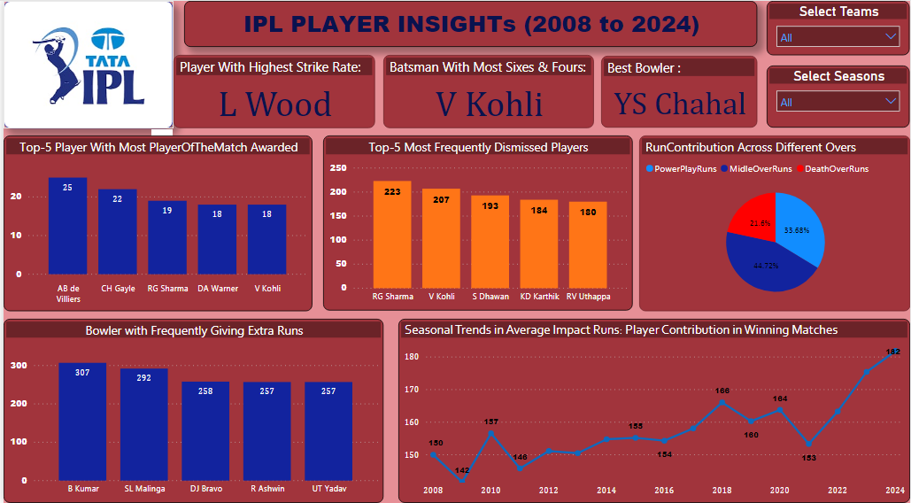

DAX FORMULA(Measures):-  
*** StrikeRateLeader =

VAR TopPlayer =

TOPN(

1,

SUMMARIZE(

deliveries,

deliveries[batter],

"@StrikeRate",

DIVIDE(

SUM(deliveries[batsman_runs]),

COUNT(deliveries[ball])

)*100

),

[@StrikeRate],DESC

)

RETURN

CONCATENATEX(

TopPlayer,

deliveries[batter],

",")

**\*\*\*** TopBoundaryBatsman =

VAR TopPlayer =

TOPN(

1,

SUMMARIZE(

deliveries,

deliveries[batter],

"@BoundaryCount",

SUMX(

deliveries,

IF(deliveries[batsman_runs]=4||deliveries[batsman_runs]=6,1,0)

)

),

[@BoundaryCount],

DESC

)

RETURN

CONCATENATEX(

TopPlayer,

deliveries[batter],

","

)

**\*\*\*** TopBowler =

VAR TopPlayer=

TOPN(

1,

SUMMARIZE(

deliveries,

deliveries[bowler],

"@wicketCount",

COUNTROWS(

FILTER(deliveries,deliveries[is_wicket]=1&& NOT(ISBLANK(deliveries[bowler])))

)

),

[@wicketCount],

DESC

)

RETURN

CONCATENATEX(

TopPlayer,

deliveries[bowler],

","

)

**\*\*\*** PlayerOfMatch = COUNT(matches[player_of_match])

**\*\*\*** DismissalCount = COUNT(deliveries[player_dismissed])

**\*\*\*** PowerPlayRuns =

SUMX(

FILTER(deliveries,deliveries[over]<=6),

deliveries[batsman_runs])

**\*\*\*** MidleOverRuns = SUMX(

FILTER(deliveries,deliveries[over]>6 && deliveries[over]<=15),

deliveries[batsman_runs]

)

**\*\*\*** DeathOverRuns = SUMX(

FILTER(deliveries,deliveries[over]>15),

deliveries[batsman_runs])

**\*\*\*** TotalExtras = SUMX(

FILTER(

deliveries,

NOT(ISBLANK(deliveries[bowler]))

),

deliveries[extra_runs]

)

**\*\*\*** ImpactRuns = DIVIDE(

SUMX(

FILTER(

deliveries,

LOOKUPVALUE(matches[winner],matches[id],deliveries[match_id])=deliveries[batting_team]

),

deliveries[batsman_runs]

),

COUNT(matches[id])

)

DAX FORMULA that CREATE TABLES & COLUMN:-  
***Team_Names:  
*** Team_Names = DATATABLE("Teams",STRING,

{

{"Chennai Super Kings"},

{"Deccan Chargers"},

{"Delhi Capitals"},

{"Delhi Daredevils"},

{"Gujarat Lions"},

{"Gujarat Titans"},

{"Kings XI Punjab"},

{"Kochi Tuskers Kerala"},

{"Kolkata Knight Riders"},

{"Lucknow Super Giants"},

{"Mumbai Indians"},

{"Pune Warriors"},

{"Punjab Kings"},

{"Rajasthan Royals"},

{"Rising Pune Supergiants"},

{"Rising Pune Supergiant"},

{"Royal Challengers Bangalore"},

{"Royal Challengers Bengaluru"},

{"Sunrisers Hyderabad"},

{"NA"}

}

)

**State_Group =

SWITCH(

TRUE(),

Team_Names[Teams]="Chennai Super Kings","Chennai",

Team_Names[Teams]="Kolkata Knight Riders","Kolkata",

Team_Names[Teams]="Delhi Daredevils","Delhi",

Team_Names[Teams]="Royal Challengers Bangalore","Bengaluru",

Team_Names[Teams]="Rajasthan Royals","Rajastan",

Team_Names[Teams]="Kings XI Punjab","Punjab",

Team_Names[Teams]="Deccan Chargers","Hyderabad",

Team_Names[Teams]="Delhi Capitals","Delhi",

Team_Names[Teams]="Gujarat Lions","Gujarat",

Team_Names[Teams]="Gujarat Titans","Gujarat",

Team_Names[Teams]="Kochi Tuskers Kerala","Kerala",

Team_Names[Teams]="Lucknow Super Giants","Lucknow",

Team_Names[Teams]="Mumbai Indians","Mumbai",

Team_Names[Teams]="Pune Warriors","Pune",

Team_Names[Teams]="NA","Unknown",

Team_Names[Teams]="Punjab Kings","Punjab",

Team_Names[Teams]="Pune Warriors","Pune",

Team_Names[Teams]="Rising Pune Supergiant","Pune",

Team_Names[Teams]="Rising Pune Supergiants","Pune",

Team_Names[Teams]="Royal Challengers Bengaluru","Bengaluru",

Team_Names[Teams]="Sunrisers Hyderabad","Hyderabad",

"Unknown"

)

**IPL_Titles =

VAR FinalMatches=

CALCULATE(

COUNTROWS(matches),

FILTER(matches,matches[match_type]="Final" && matches[winner]=Team_Names[Teams])

)

RETURN

IF(ISBLANK(FinalMatches),0,FinalMatches)

***Match_Teams:  
***Match_Teams =

SELECTCOLUMNS(

UNION(

SELECTCOLUMNS(matches, "match_id", matches[id], "season",matches[season], "Team", matches[team1]),

SELECTCOLUMNS(matches, "match_id", matches[id], "season",matches[season], "Team", matches[team2])

),

"MatchID", [match_id],

"Season",[season],

"Team",[Team]

)