**Results**

**Demographic characteristics of the participants**

A total of 704 respondents participated in the study, of which 153 (22%) were male and 551 (78%) were female. Parents’ ages were classified into four categories: < 25, 25–35, 36–45, and greater than 45 years (approximately 1.8%, 54%, 38%, and 6.7%, respectively). The educational status of parents was diverse; most parents had com pleted higher secondary education (54%), followed by postgraduate (25%), undergraduate (16%), and primary education (5%). Among the respondents, 71.5% were unemployed, and 28.5% were employees. Most participants belonged to nuclear families (53%), followed by single-parent families (26%) and extended families (21%), while the majority (58%) belonged to middle-income families. Of the total respondents, 54% had female children, while the rest of the participants in the study had male children; 60% of parents had only two children, 25% had only one, and 15% had more than two children. Approximately 89% of parents reported that the mother was the leading caregiver of the child at home. In the case of disease treatment, 65% said that their child’s grandparents were not involved in decision making, whereas 35% reported that they were involved in decision making when their child was ill (Table 1).

| **Characteristic** | **N = 704***1* |
| --- | --- |
| Parent’s age (years) |  |
| < 25 | 13 (1.8%) |
| > 45 | 47 (6.7%) |
| 25–35 | 377 (54%) |
| 36–45 | 267 (38%) |
| Parent’s sex |  |
| Female | 551 (78%) |
| Male | 153 (22%) |
| Parent’s education level |  |
| Postgraduate | 175 (25%) |
| Primary | 35 (5.0%) |
| Secondary | 381 (54%) |
| Undergraduate | 113 (16%) |
| Employment status |  |
| Employed | 95 (13%) |
| Not employed | 503 (71%) |
| Self employed | 106 (15%) |
| Family type |  |
| Extended family | 147 (21%) |
| Nuclear family | 372 (53%) |
| Single parent family | 185 (26%) |
| Your average household income per month (BDT) |  |
| High (greater than 50000 BDT) | 139 (20%) |
| Low (less than 30000 BDT) | 160 (23%) |
| Middle (less than 50000 BDT) | 405 (58%) |
| Child’s sex |  |
| Female | 379 (54%) |
| Male | 325 (46%) |
| Child’s age (years) |  |
| < 5 | 1 (0.1%) |
| < 5 | 37 (5.3%) |
| > 10 | 313 (44%) |
| 5–9 | 353 (50%) |
| Number of children |  |
| >= 3 | 104 (15%) |
| 1 | 176 (25%) |
| 2 | 424 (60%) |
| Who is the leading child caregiver at home? |  |
| Father | 54 (7.7%) |
| Grandmother | 16 (2.3%) |
| Mother | 629 (89%) |
| Others | 5 (0.7%) |
| Are grandparents at home involved in treatment decisions when your child is ill? |  |
| Always | 34 (4.8%) |
| Never | 459 (65%) |
| Often | 54 (7.7%) |
| Sometimes | 157 (22%) |
| *1*n (%) | |

**Table 1: Demographic characteristics of the participants**

**Distribution of knowledge regarding antibiotic resistance**

Figure 1 provides the distribution of knowledge regarding antibiotics, a significant proportion of the participants showed a lack of knowledge in recognizing the basic antibiotics of which 63% and 56% did not know that amoxicillin and azithromycin were antibiotics, respectively, while 79% knew that paracetamol was not an antibiotic. Of most participants, 75% knew that the misuse of antibiotics could lead to AR, and approximately 47% believed that antibiotic-resistant bacteria are difficult to treat.

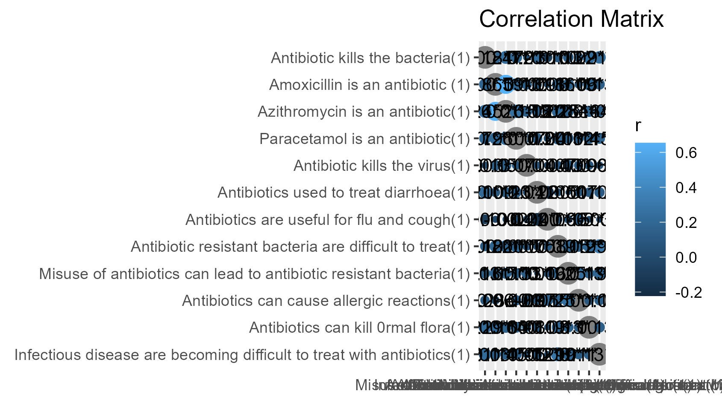

**Figure 1: Distribution of knowledge regarding antibiotic resistance**

**Attitude towards misuse of antibiotics**

Figure 2 shows the distribution of parents’ attitudes toward the misuse of antibiotics. More than 80% had a positive attitude toward non-antibiotic prescriptions and were satisfied with the doctor’s prescription. In contrast, 75% disagreed with the provision of antibiotics to their children without indication. The majority of parents (approximately 63%) believed that antibiotics could be used for fever and cold improvement. Additionally, some parents 26% were ready to stop administering antibiotics to their children when there were improvements and 27% reused the same antibiotics for similar symptoms.

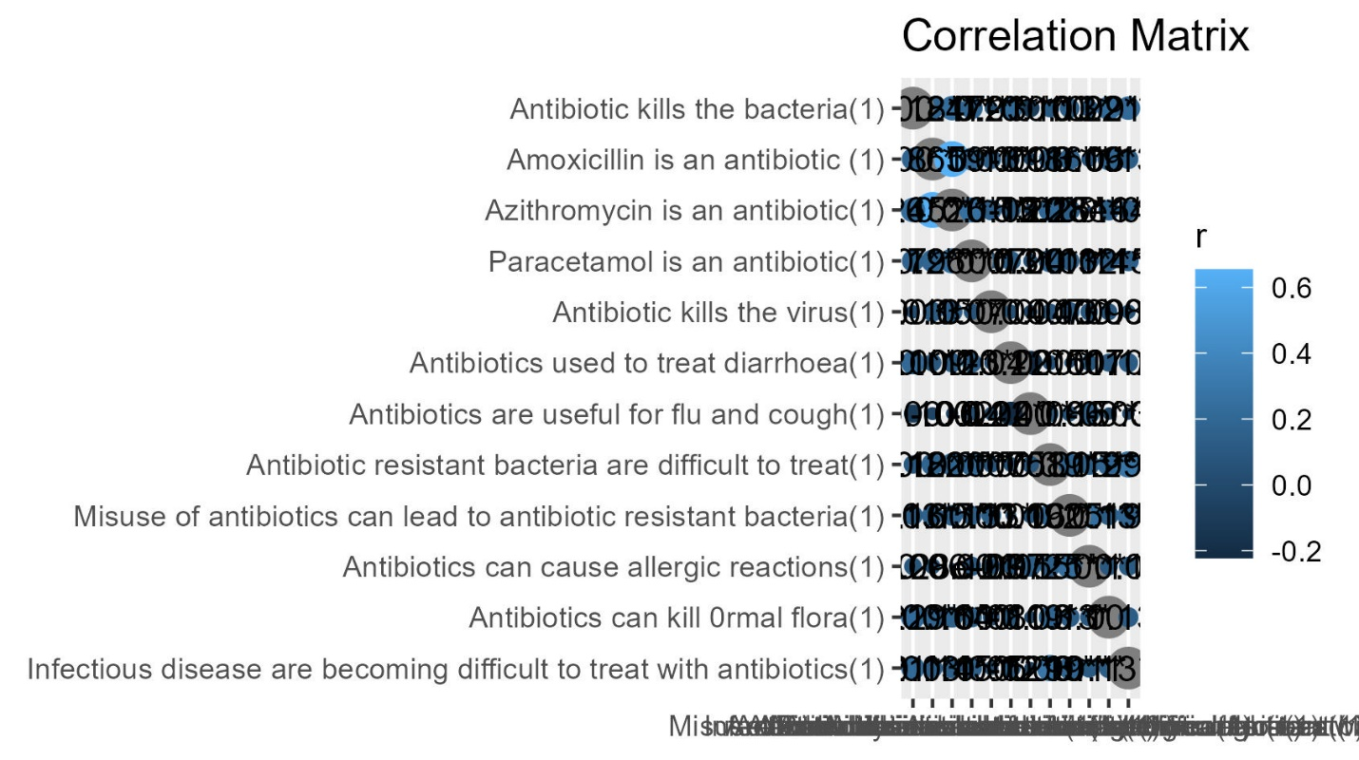

**Figure 2: Attitude towards misuse of antibiotics**

**Practices regarding the use of antibiotics**

The majority (58%) of respondents gave antibiotics to their children without consulting a doctor, and 36% liked taking antibiotics from pharmacies rather than from doctors. Approximately 51% of the parents gave antibiotics to their children when they had a cough. Regarding the expiry date, 24% reported that they did not check the expiration date of antibiotics before giving them to their children (Fig. 3).

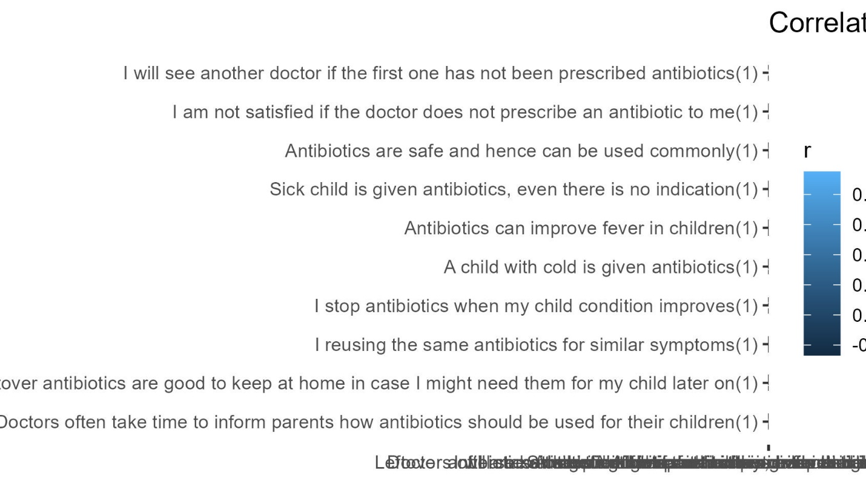

**Figure 3: Practices regarding the use of antibiotics**

**Major sources of information regarding antibiotics**

Most parents obtained their information from prescribers (86%), followed by dispensers (36%) and the Internet (30%). Few parents obtained information about antibiotics from social media (23%), pharmaceutical companies (11%), or other sources (23%) including colleagues, nurses, and university courses. (Table 2).

| **Characteristic** | **N = 704***1* |
| --- | --- |
| Information provided by pharmaceutical companies leaflet | 78 (11%) |
| Information from prescribers | 607 (86%) |
| Information from dispensers | 252 (36%) |
| Information from nurses | 22 (3.1%) |
| Information given by a colleague | 34 (4.8%) |
| Information from University courses | 16 (2.3%) |
| Internet | 213 (30%) |
| Social media | 165 (23%) |
| Others...55 | 89 (13%) |
| *1*n (%) | |

**Table 2: Major sources of information regarding antibiotics**

**Level of knowledge, attitudes, and practices regarding antibiotic resistance**

Overall, the level of knowledge, attitudes, and practices regarding rational use of antibiotics in children. Of the 704 parents assessed on the KAP, 17% (n = 122) had good and 45% (n = 314) had moderate knowledge, 30% (n = 209) had a positive attitude, and 36% (n = 250) had good practices on rational antibiotic use in children (Table 3).

| **Characteristic** | **N = 704***1* |
| --- | --- |
| knowledge_Level |  |
| Poor | 268 (38%) |
| Moderate | 314 (45%) |
| Good | 122 (17%) |
| Attitude_Level |  |
| Poor | 59 (8.4%) |
| Moderate | 155 (22%) |
| Good | 490 (70%) |
| Practice_level |  |
| Poor | 127 (18%) |
| Good | 577 (82%) |
| *1*n (%) | |

**Table 3: Level of knowledge, attitudes, and practices regarding antibiotic resistance**

| **Characteristic** | **N** | **OR***1* | **95% CI***1* | **p-value** |
| --- | --- | --- | --- | --- |
| Parent’s age (years) | 704 |  |  |  |
| < 25 |  | — | — |  |
| > 45 |  | 6.46 | 1.70, 32.0 | **0.010** |
| 25–35 |  | 4.67 | 1.40, 21.1 | **0.021** |
| 36–45 |  | 7.14 | 2.12, 32.4 | **0.003** |
| Parent’s sex | 704 |  |  |  |
| Female |  | — | — |  |
| Male |  | 2.08 | 1.40, 3.14 | **<0.001** |
| Parent’s education level | 704 |  |  |  |
| Postgraduate |  | — | — |  |
| Primary |  | 0.14 | 0.06, 0.30 | **<0.001** |
| Secondary |  | 0.37 | 0.24, 0.55 | **<0.001** |
| Undergraduate |  | 0.85 | 0.49, 1.47 | 0.5 |
| Employment status | 704 |  |  |  |
| Employed |  | — | — |  |
| Not employed |  | 0.51 | 0.31, 0.81 | **0.005** |
| Self employed |  | 1.71 | 0.89, 3.34 | 0.11 |
| Family type | 704 |  |  |  |
| Extended family |  | — | — |  |
| Nuclear family |  | 0.95 | 0.63, 1.40 | 0.8 |
| Single parent family |  | 0.81 | 0.52, 1.26 | 0.4 |
| Your average household income per month (BDT) | 704 |  |  |  |
| High (greater than 50000 BDT) |  | — | — |  |
| Low (less than 30000 BDT) |  | 0.32 | 0.20, 0.52 | **<0.001** |
| Middle (less than 50000 BDT) |  | 0.68 | 0.44, 1.04 | 0.077 |
| Child’s sex | 704 |  |  |  |
| Female |  | — | — |  |
| Male |  | 1.04 | 0.77, 1.42 | 0.8 |
| Child’s age (years) | 704 |  |  |  |
| < 5 |  | — | — |  |
| < 5 |  | 0.00 |  | >0.9 |
| > 10 |  | 0.00 |  | >0.9 |
| 5–9 |  | 0.00 |  | >0.9 |
| Number of children | 704 |  |  |  |
| >= 3 |  | — | — |  |
| 1 |  | 1.03 | 0.63, 1.70 | 0.9 |
| 2 |  | 1.08 | 0.70, 1.68 | 0.7 |
| *1*OR = Odds Ratio, CI = Confidence Interval | | | | |
| **Table 4.** Factors associated with the level of knowledge among parents of school-going children (N = 704). OR odds ratio, CI confidence interval. *p-value ˂ 0.05 was considered statistically significant. Significant values are in bold. | | | | |

| **Characteristic** | **N** | **OR***1* | **95% CI***1* | **p-value** |
| --- | --- | --- | --- | --- |
| Parent’s age (years) | 704 |  |  |  |
| < 25 |  | — | — |  |
| > 45 |  | 2.67 | 0.32, 18.1 | 0.3 |
| 25–35 |  | 2.18 | 0.33, 8.64 | 0.3 |
| 36–45 |  | 1.76 | 0.26, 7.04 | 0.5 |
| Parent’s sex | 704 |  |  |  |
| Female |  | — | — |  |
| Male |  | 1.10 | 0.58, 2.21 | 0.8 |
| Parent’s education level | 704 |  |  |  |
| Postgraduate |  | — | — |  |
| Primary |  | 0.44 | 0.12, 2.14 | 0.3 |
| Secondary |  | 0.33 | 0.13, 0.70 | **0.008** |
| Undergraduate |  | 0.74 | 0.24, 2.36 | 0.6 |
| Employment status | 704 |  |  |  |
| Employed |  | — | — |  |
| Not employed |  | 0.74 | 0.28, 1.67 | 0.5 |
| Self employed |  | 0.58 | 0.19, 1.60 | 0.3 |
| Family type | 704 |  |  |  |
| Extended family |  | — | — |  |
| Nuclear family |  | 0.32 | 0.11, 0.76 | **0.019** |
| Single parent family |  | 0.35 | 0.11, 0.90 | **0.043** |
| Your average household income per month (BDT) | 704 |  |  |  |
| High (greater than 50000 BDT) |  | — | — |  |
| Low (less than 30000 BDT) |  | 0.22 | 0.07, 0.56 | **0.003** |
| Middle (less than 50000 BDT) |  | 0.45 | 0.15, 1.09 | 0.10 |
| Child’s sex | 704 |  |  |  |
| Female |  | — | — |  |
| Male |  | 1.10 | 0.64, 1.89 | 0.7 |
| Child’s age (years) | 704 |  |  |  |
| < 5 |  | — | — |  |
| < 5 |  | 0.00 |  | >0.9 |
| > 10 |  | 0.00 |  | >0.9 |
| 5–9 |  | 0.00 |  | >0.9 |
| Number of children | 704 |  |  |  |
| >= 3 |  | — | — |  |
| 1 |  | 0.83 | 0.33, 1.97 | 0.7 |
| 2 |  | 0.93 | 0.39, 1.97 | 0.9 |
| *1*OR = Odds Ratio, CI = Confidence Interval | | | | |

**Table 5.** Factors associated with the level of attitudes towards antibiotic resistance among parents of school going children (N = 704). OR odds ratio, CI confidence interval. *p-value ˂ 0.05 was considered statistically significant. Significant values are in bold.

| **Characteristic** | **N** | **OR***1* | **95% CI***1* | **p-value** |
| --- | --- | --- | --- | --- |
| Parent’s age (years) | 704 |  |  |  |
| < 25 |  | — | — |  |
| > 45 |  | 1.11 | 0.22, 4.50 | 0.9 |
| 25–35 |  | 1.96 | 0.43, 6.67 | 0.3 |
| 36–45 |  | 0.95 | 0.21, 3.22 | >0.9 |
| Parent’s sex | 704 |  |  |  |
| Female |  | — | — |  |
| Male |  | 0.71 | 0.46, 1.12 | 0.13 |
| Parent’s education level | 704 |  |  |  |
| Postgraduate |  | — | — |  |
| Primary |  | 0.12 | 0.05, 0.29 | **<0.001** |
| Secondary |  | 0.31 | 0.16, 0.56 | **<0.001** |
| Undergraduate |  | 0.33 | 0.16, 0.68 | **0.003** |
| Employment status | 704 |  |  |  |
| Employed |  | — | — |  |
| Not employed |  | 1.48 | 0.85, 2.50 | 0.2 |
| Self employed |  | 0.92 | 0.47, 1.78 | 0.8 |
| Family type | 704 |  |  |  |
| Extended family |  | — | — |  |
| Nuclear family |  | 0.20 | 0.09, 0.40 | **<0.001** |
| Single parent family |  | 0.25 | 0.10, 0.52 | **<0.001** |
| Your average household income per month (BDT) | 704 |  |  |  |
| High (greater than 50000 BDT) |  | — | — |  |
| Low (less than 30000 BDT) |  | 0.33 | 0.16, 0.64 | **0.001** |
| Middle (less than 50000 BDT) |  | 0.45 | 0.23, 0.81 | **0.011** |
| Child’s sex | 704 |  |  |  |
| Female |  | — | — |  |
| Male |  | 0.88 | 0.60, 1.29 | 0.5 |
| Child’s age (years) | 704 |  |  |  |
| < 5 |  | — | — |  |
| < 5 |  | 0.00 |  | >0.9 |
| > 10 |  | 0.00 |  | >0.9 |
| 5–9 |  | 0.00 |  | >0.9 |
| Number of children | 704 |  |  |  |
| >= 3 |  | — | — |  |
| 1 |  | 1.54 | 0.84, 2.80 | 0.2 |
| 2 |  | 1.55 | 0.91, 2.57 | 0.10 |
| *1*OR = Odds Ratio, CI = Confidence Interval | | | | |

**Table 6.** Factors associated with the level of practices regarding antibiotic resistance among parents of school going children (N = 704). OR odds ratio, CI confidence interval. *p value ˂ 0.05 was considered statistically significant. Significant values are in bold.