**CHAPTER: 6**

**SYSTEM DESIGN**

**6.1 Use Case Diagram**

A use case diagram is used to represent the dynamic behavior of a system. It encapsulates the system's functionality by incorporating use cases, actors, and their relationships.

It models the tasks, services, and functions required by a system/subsystem of an application. It depicts the high-level functionality of a system and also tells how the user handles a system.

* **Purpose of Use Case Diagrams**

The main purpose of a use case diagram is to portray the dynamic aspect of a system. It accumulates the system's requirement, which includes both internal as well as external influences. It invokes persons, use cases, and several things that invoke the actors and elements accountable for the implementation of use case diagrams.

* + It gathers the system's needs.
  + It depicts the external view of the system.
  + It recognizes the internal as well as external factors that influence the system.
  + It represents the interaction between the actors.

**Symbols used in Use case:**

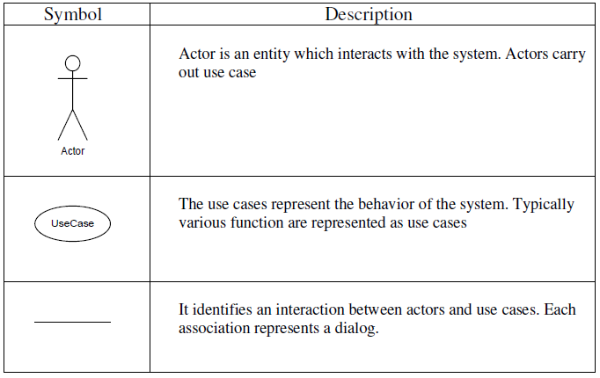

* + 1. **Use case Diagram for Admin :-**

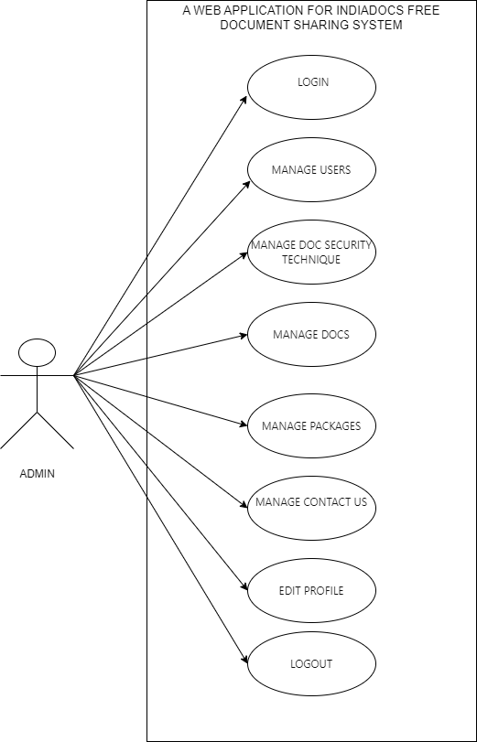

**Figure 6.2.1 Use Case diagram**

**6.2.2Use case Diagram for User :-**

1. 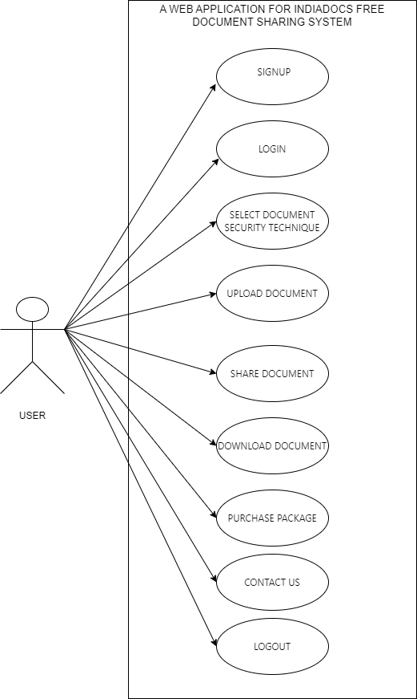

**Figure 6.2.2 Use Case diagram**

**6.2 Class Diagram**