First impression: data is set to “object” – because of empty entry. 923 of 4898 are duplicates.
With those observations delete dupe first.
Deleted duplicate entries: The purpose of the task is to categorise its white wine samples at a winery. Duplicates would be detrimental.

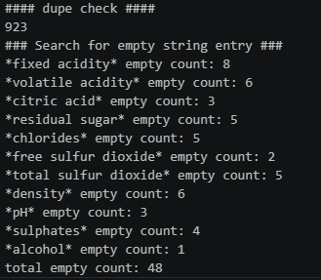

The data was graphed for its distribution and outlier identification. Some examples include:
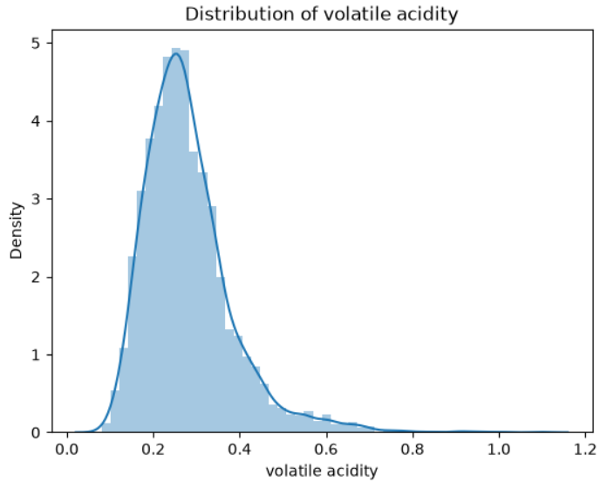
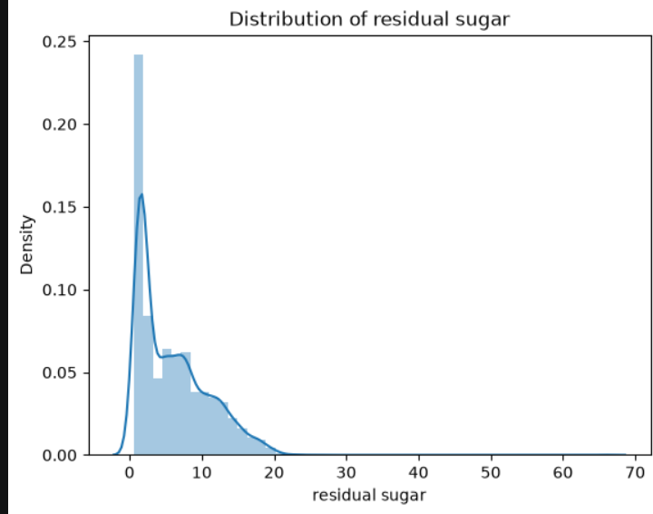
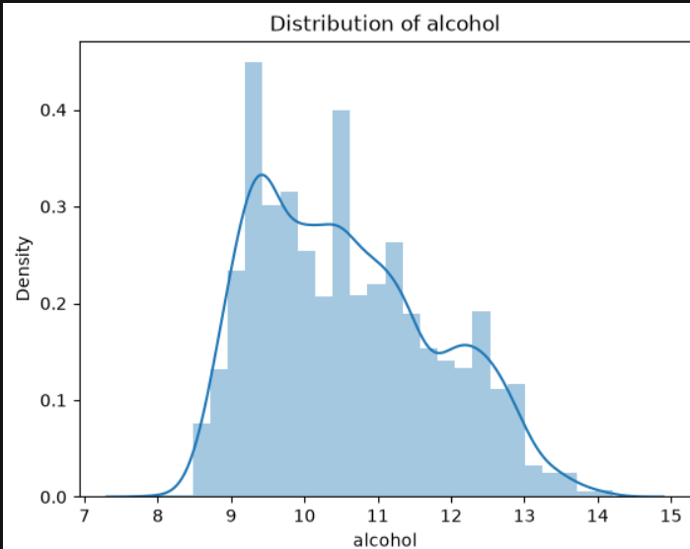
Seemed to have deviation and right skewedness, to minimise noise median value was chosen.

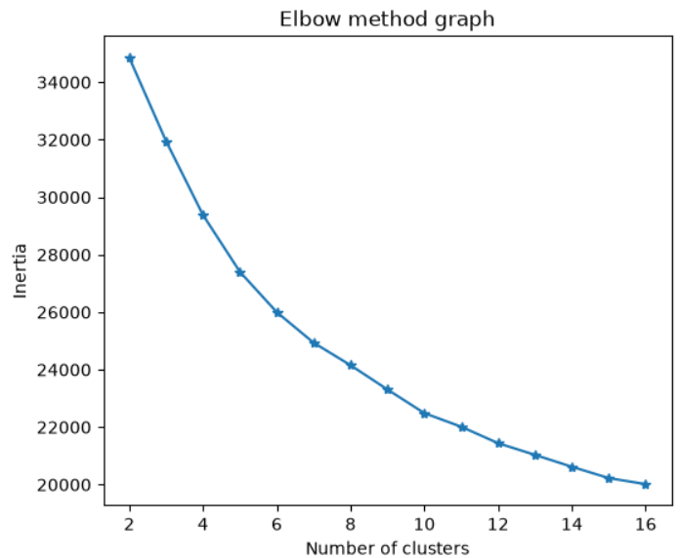

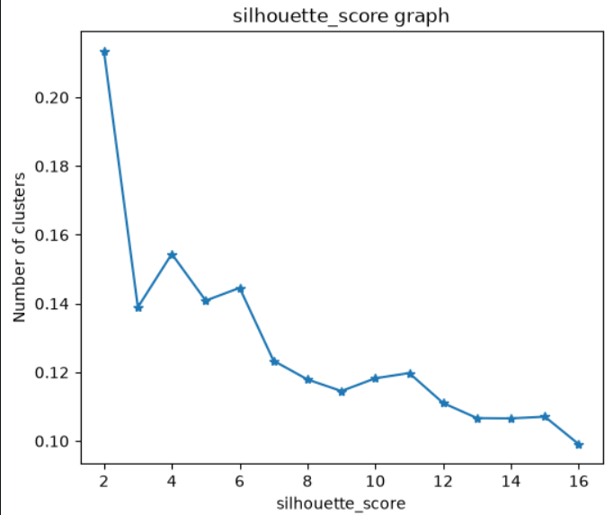

K = 6 was selected.

