**Assignment2**

Name: Meng Nan

UID: 3030036376

(i) Show the $E(y(n))$

$$E\left(y\left(n\right)\right)=E\left[\sum_{j=1}^{J}{w_{j}x_{j}\left(n\right)}\right]=\sum_{j=1}^{J}{w_{j}E[x_{j}\left(n\right)]}=w^{T}E\left[x\left(n\right)\right]=w^{T}μ_{x}$$

(ii) Show the $var(y\left(n\right))$

$$var\left(y\left(n\right)\right)=E\left({\left(y\left(n\right)-E\left(y\left(n\right)\right)\right)}^{2}\right)=E\left(y^{2}\left(n\right)-2y\left(n\right)E\left(y\left(n\right)\right)+E^{2}\left(y\left(n\right)\right)\right)$$

$=E({\left(w^{T}x\left(n\right)\right)}^{2}-2(w^{T}x\left(n\right)μ_{x}w)+{(w^{T}μ_{x})}^{2})$

$=w^{T}E\left({\left(x\left(n\right){-μ}_{x}\right)}^{2}\right)w=w^{T}E\left[\overline{x}\left(n\right){\overline{x}\left(n\right)}^{T}\right]w=w^{T}C_{xx}w$

(iii) Show the optimum weight vector $w^{*}$

$$L\left(w,λ_{1},λ_{2}\right)=\frac{1}{2}w^{T}C_{xx}w-λ_{1}\left(w^{T}1_{J}-1\right)-λ_{2}\left(w^{T}μ_{x}-t\right)$$

The derivation of the L is:

$$\frac{∂L\left(w,λ_{1},λ_{2}\right)}{∂w}=w^{T}C_{xx}-λ_{1}{1_{J}}^{T}-λ_{2}{μ_{x}}^{T}=0$$

$C_{xx}w=λ_{1}1_{J}+λ_{2}μ_{x}$**(1)**

**So:**

$$w^{*}={C_{xx}^{-1}(λ}_{1}1_{J}+λ_{2}μ_{x})$$

For the equation (1), we can get:

$w=λ_{1}{C_{xx}^{-1}1}_{J}+λ_{2}{C_{xx}^{-1}μ}_{x}$**(2)**

We multiply $1_{J}^{T}$ on the both side of the equation (2):

$$1_{J}^{T}w=λ_{1}{{1_{J}^{T}C}_{xx}^{-1}1}_{J}+λ_{2}{{1_{J}^{T}C}_{xx}^{-1}μ}_{x}$$

$1=λ_{1}a+λ_{2}b$**(3)**

We multiply $μ_{x}^{T}$ on the both side of the equation (2):

$$μ_{x}^{T} w=λ_{1}{{μ_{x}^{T} C}_{xx}^{-1}1}_{J}+λ_{2}{{μ_{x}^{T} C}_{xx}^{-1}μ}_{x}$$

Then we can get:

$t=λ_{1}b+λ_{2}c$**(4)**

From the equation (3) and (4), we can easily get the result:

$$\left\{\begin{aligned}1=λ_{1}a+λ_{2}b (3) \\ t=λ_{1}b+λ_{2}c (4)\end{aligned}\right.$$

$a\left(4\right)-b\left(3\right)$:

$$λ_{2}^{*}=\frac{at-b}{ac-b^{2}}$$

$c\left(3\right)-b\left(4\right)$:

$$λ_{1}^{*}=\frac{c-bt}{ac-b^{2}}$$

**Part 2**

(i) The graph is shown as follows:

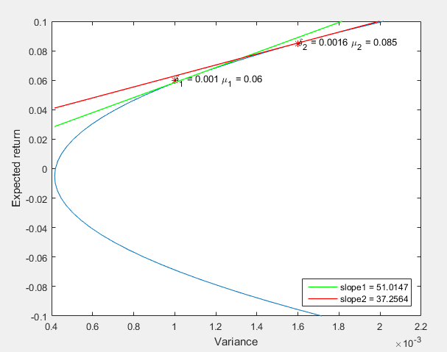

From the graph, we can easily know that:

The best expected return $μ_{1}=0.06$ when the standard deviation of the portfolio is $σ_{1}={10}^{-3}$

The best expected return $μ_{2}=0.085$ when the standard deviation of the portfolio is $σ_{2}=1.6×{10}^{-3}$

(ii) From the graph, we can easily know that $(μ_{1},σ_{1})$ gives a better portfolio, since the slope at that point is larger than the slope at the point $(μ_{2},σ_{2})$

**Appendix**

ass2.m

clear all;

close all;

addpath('ARMAX_GARCH_K_Toolbox');

% Reset random stream for reproducibility.

rng(0,'twister');

JAssets = 10; % desired number of assets

% Generate means of returns between -0.02 and 0.05.

a = -0.01; b = 0.05;

mean_return = a + (b-a).*rand(JAssets,1);

% Generate standard deviations of returns between 0.008 and 0.006.

a = 0.08; b = 0.06;

stdDev_return = a + (b-a).*rand(JAssets,1);

%%

Ntime=200;

%% X: Each row is a time-instant. Each Column is an asset.

X=zeros(Ntime,JAssets);

for j=1:JAssets

X(:,j)=mean_return(j)+stdDev_return(j)*randn(Ntime,1);

end

%%

%% MF: mean forecast

%% VF: forecast of variance

MFpred=zeros(JAssets,1);

VFpred=zeros(JAssets);

for j=1:JAssets

%% For each of the variables, fit the ARMA(1,1)-GARCH(1,1) model

[parameters, stderrors, LLF, ht, resids, summary] = garch(X(:,j),'GARCH', 'GAUSSIAN',1,1,0,1,1,0,[]);

%% 1-step ahead Prediction of the mean and covariance of return

[MFpred(j), VFpred(j,j), ~, ~] = garchfor2(X(:,j), resids, ht, parameters, 'GARCH', 'GAUSSIAN',1,1,1,1,1);

end

a=ones(JAssets,1)'*(VFpred\ones(JAssets,1));

b=ones(JAssets,1)'*(VFpred\MFpred);

c=MFpred'*(VFpred\MFpred);

target=[-.1:5e-3:.1]';

risk=zeros(length(target),1);

for j=1:length(target)

delta=a*c-b^2;

lambda1=(c-b*target(j))/delta;

lambda2=(a*target(j)-b)/delta;

w=VFpred\(lambda1*ones(JAssets,1)+lambda2*MFpred);

risk(j)=w'*VFpred*w;

end

plot(risk,target);

ylabel('Expected return')

xlabel('Variance')

%% Write your own code;

Delta = 4*10^-5;

delta1 = 10^-3;

index1 = find(abs(risk - delta1) < Delta);

mu_1 = max(target(index1));

delta2 = 1.6 * 10^-3;

index2 = find(abs(risk - delta2) < Delta);

mu_2 = max(target(index2));

hold on

plot([delta1,delta2],[mu_1,mu_2],'r*')

text(delta1,mu_1,['\delta_1 = ' num2str(delta1) ' \mu_1 = ' num2str(mu_1)])

text(delta2,mu_2,['\delta_2 = ' num2str(delta2) ' \mu_2 = ' num2str(mu_2)])

%% find the better one

index_1 = find(target == mu_1)

index_2 = find(target == mu_2)

Y1 = mu_1;

X1 = risk(index_1);

Y2 = mu_2;

X2 = risk(index_2);

Y1_1 = target(index_1 + 1);

X1_1 = risk(index_1 + 1);

Y2_1 = target(index_2 + 1);

X2_1 = risk(index_2 + 1);

slope_1 = ((Y1_1+Y1)/2 - Y1) / ((X1_1+X1)/2 - X1);

slope_2 = ((Y2_1+Y2)/2 - Y2) / ((X2_1+X2)/2 - X2);

RangeX = max(risk) - min(risk);

X1_start = min(risk);

Y1_start = Y1 + slope_1*(X1_start - X1);

X1_end = max(risk);

Y1_end = Y1 + slope_1*(X1_end - X1);

X2_start = min(risk);

Y2_start = Y2 + slope_2*(X2_start - X2);

X2_end = max(risk);

Y2_end = Y2 + slope_2*(X2_end - X2);

a = plot([X1_start,X1_end],[Y1_start,Y1_end],'g-','LineWidth',1);

b = plot([X2_start,X2_end],[Y2_start,Y2_end],'r-','LineWidth',1);

axis([0.4*10^-3, 2.2*10^-3, -0.1, 0.1])

L1 = ['slope1 = ' num2str(slope_1)];

L2 = ['slope2 = ' num2str(slope_2)];

legend([a,b],L1,L2,'Location','southeast');