[1]

New Method in Evaluation of Similarity Measures for Brain Image Registration

Q. R. Razlighi[2], N. Kehtarnavaz[3], S. Yousefi[4], A. Klein[5]

*Abstract*—Evaluation of similarity measures (SM) for image registration, in general, is a nontrivial problem due to complex involvement of the SM in the optimization cost function. A new evaluation protocol is proposed to examine the effectiveness of the SMs for brain image registration in which the optimization effects are eliminated. This evaluation is based on four performance metrics of robustness, accuracy, consistency and computational complexity. Robustness, for the first time, is quantified as part of the proposed evaluation procedure and accuracy is quantified as the tolerance of the SM in registering degraded images. Also a new similarity metrics, normalized spatial mutual information (NSMI) for 3D brain image registration is introduced in this study. Experimental examination is carried out based on five different modalities of simulated 3D brain images for which the ground truths are known. It is shown that *NSMI* are more robust and accurate than the existing SMs. In addition, they provide more consistent outcome for inter-modality medical image registration with no increase in the order of their computational complexity.

*Index Terms*—Image Registration, Similarity Measures, Spatial Mutual Information, Quadrilateral Markov Random Field, Normalized Spatial Mutual Information.

# INTRODUCTION

One may consider image registration as the most fundamental problem in human brain image analysis. Medical diagnosis, functional localization, brain parcelation/labeling and in general any morphological image analyses are often require an accurate image registration. Human brain images are variant due to natural biological variations, different types of biological information (e.g., structural versus functional), modality specific image degradations, patient positioning in the scanners, and patient related changes over time, which are either the consequence of aging, the progress of disease, or effects of therapy. Image registration is the process of determining the correspondence between objects in two images, by convention between the source and the target image. To determine correspondences it is necessary to find the geometrical or spatial transformation applied to the source image so that it aligns with the target.

In the past, registration methods have mostly relied on matching corresponding features in the images to be registered, but more recently, interests have been directed to measures of global correspondence obtained directly from image intensities, the so-called similarity measures (SM). In this case, the performance of image registration technique becomes directly related to the effectiveness of the SM in measuring the images similarities. Brain image registration techniques, based on intensity based SMs, have been reviewed in a number of surveys [1], [12], [13] in which many different SM has been utilized. However evaluation of SM as an independent/separate component of the image registration process has been not been covered in these surveys. In [18], a new protocol is proposed to evaluate the effectiveness of SMs for rigid-body registrations, however the proposed protocol is not applicable to non-rigid brain image registration. Elastix [20] is a new toolkit which allows the components of a registration process to be replaced. Different SMs can be plugged into Elastix and for a given optimization strategy they can be evaluated. The same approach is used in [19] to evaluate the SMs utilized in ANTS package for affine and non-rigid registration under the framework of ANTS in which it is possible to evaluate a single component of the processing stream while holding all other aspects constant. However, isolating the effect of optimization strategy from similarity measure in the registration results is quite challenging if not impossible.

Here we present a method for a quantitative, optimization-independent, systematic and statistical evaluation of the similarity measures. We examine the SM effectiveness under a framework that totally eliminates the optimization process. In this case, given the images to be registered, the outcome of a registration task only depends on the similarity measure and the spatial transformation model. The evaluation method here is in the reverse order the registration process to be able to assess only the effectiveness of different SM in quantifying the similarity between two brain images. This quantification is done by definition of a new metric called robustness and is purely through simulation of the rigid, affine and non-rigid transformation applied to an image to obtain the source image. The severity of the mis-registration is controlled by the transformation parameter. Then the behavior of each SM is studied under such controlled environment.

After presenting the evaluation method in the next section, a comprehensive review, including an explanation of theoretical basis of the SMs, is provided. Intensity based SMs are categorized here in three categories of statistical measures, probabilistic measures, and spatial dependency measures based on their theoretical origin. A normalized version of newly defined SM, named Spatial Mutual Information (SMI) [25], is introduced in this section and it is extended to 3D for its compatibility to brain MR images. Section 4 gives the details of the dataset used for the evaluation. This dataset consists of the widely utilized simulated magnetic resonance (MR) brain images of the *BrainWeb* database (www.bic.mni.mcgill.ca/brainweb/). In section 5, the robustness of the listed SMs are evaluated and the relationship between robustness and image degradation is studied. It is also shown that robust SMs perform much better in intermodal brain image registration. Also computational complexities of the selected SMs are compared at the end of section 5. Finally, the paper is concluded in section 6.

# Evaluation Method

In this section, a new comparison method is proposed for a systematic evaluation of SMs in brain image registration. The objective here is to demonstrate how effectively a SM can measure the similarity between two brain images independent on the registration process. This method makes the examination of each SM possible by a single performance metric of *robustness*. The thrust of this paper is on brain image registration, so our examination is done only for five different modalities of 3D brain MR images. However, the developed method in this section is of general purpose in the sense that they are applicable to any image registration problem.

Brain image registration is usually constructed by five components of transformation model, regularization, cost function, optimization, and interpolation. The complex interdependency of these components makes the evaluation of SM a challenging task. As it will be described later in this section, there is no need for regularization in this examination. We also use bicubic interpolation throughout this paper for all the examinations. Therefore, Image registration is simplified here, without a lost in generality, as a problem to find the best global spatial transformation that maximize the cost function between a source and target image. Source and target images can be represented by **X**: ℜ3→ℜ and **Y**: ℜ3→ℜ, which associate scalar intensity values to points described by *X*=(*x*,*y*,*z*)*t* in three-dimensional vector spaces ℜ3. The target image is fixed and the source image undergoes a spatial vector transformation of the form *T*(***μ***): ℜ3→ℜ3 with ***μ***denoting a set of its parameters. The accuracy of such a mapping is defined based on correspondences between the two images, which can be quantified by a cost function of the form

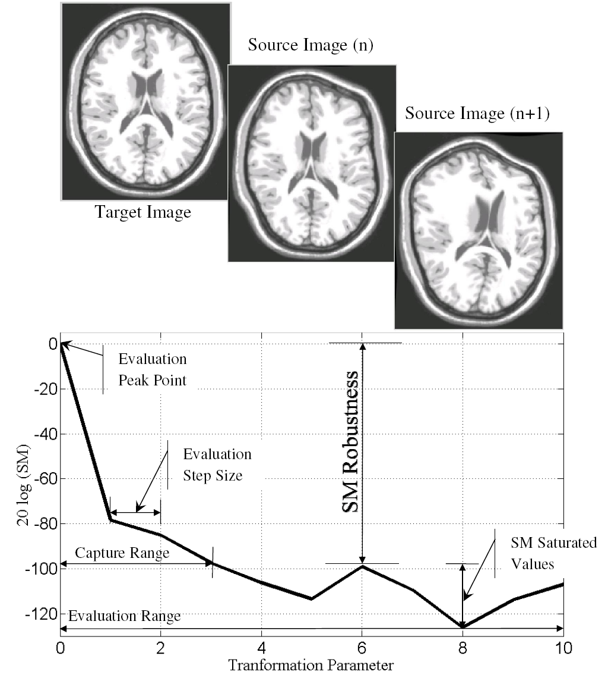

Fig. 1. Evaluation method and corresponding transformation parameters.

|  |  |  |
| --- | --- | --- |
|  |  | (1) |

where *T*(***μ***)denotes the set of admissible transformation functions with the parameters ***μ***, and *C*(.) is the cost function which utilizes the SM to measure the image correspondence level. An optimization process is performed to maximize the cost function, that is

|  |  |  |
| --- | --- | --- |
|  |  | (2) |

where *Topt*(***μ****opt*) denotes the solution to the registration problem, and ℑ is the set of all arbitrary transformations. For any image pair, optimization method, regularization, transformation and interpolation, If **X** and **Y** are intentionally chosen to be the same then *Topt*(***μ****opt*) is already known (*Topt* has to be unit matrix **I** and ***μ****opt* is equal to zero). In this case, small deviation of ***μ*** from this optimal point, for any image pair, and any transformation, reduces the cost function *C*(.) and the related SM value. The range of ***μ***in which SM value monotonically decreases is called here *capture range* and the difference of SM values in the beginning and end of the capture range is defined here as *robustness*. Capture range is the range of ***μ*** in which the SM is capable of measuring the image similarities for a given type of *T*. Outside this range the computed SM value is mostly a random value and meaningless. Obviously such random value cannot guide the optimization process. Robustness is defined inside the capture range, and it is a measure of SM effectiveness in computing image similarities. Empirical examination in section 4 shows that SMs with higher robustness are more prone to the image degradation. Also they outperform the SMs with lower robustness in intermodal image registration.

The proposed evaluation protocol is meant to examine SMs effectiveness without involving the other components of image registration. Regularization is utilized in image registration to increase the capture range of a SM. Since we are evaluating the SMs, based on their robustness and capture range, it makes perfect sense to eliminate the regularization in our examination. We eliminate the optimization simply by utilizing the transformed version of the target image as the source image. We also control the parameter set of the transformation to adjust the severity of the mis-registration to our favor. Next we describe the evaluation method step by step.

A source image **X** is created by applying a controlled spatial vector transformation *T*(***μ***) to the target image **Y**. When a source image is perfectly aligned and matched to a target image (that is to say when both images are the same), the computed SMs for the image pair (**X**,**Y**) should have their maximum values. The magnitude of the transformation parameters ***µ*** is usually zero at this stage since there is no change in the transformed image. Here, this point is referred to as the evaluation *peak point*, see Fig. 1. Next the severity of the misalignment is increased by increasing the transformation parameters ***µ*** by a small step size which is called the evaluation *step size* here. The SMs are then computed between the target image and the new transformed source image. Prospectively, the computed SMs at this point are less than their peak values. This process is continued iteratively by increasing the magnitude of the transformation parameters ***µ*** by one step size which results in a more severe mis-registration in the source image, followed by recomputing the SMs for the new image pair. Consequently, the SMs get settled into their minimum values or range of values at the end, as shown in Fig. 1. This range of values is named as *saturated values*. When a SM reaches its saturated value, it means that the SM is not able to detect any correlation between the corresponding images. The difference between SM peak value and the maximum saturated value is defined here as the SM *robustness*, as shown in Fig. 1.

(18)

Robustness provides a metric of the SM strength or capability in identifying image correspondences. In this paper, robustness, for the first time, is formulated in terms of the outcome of the evaluation procedure. Quantifying the SM robustness makes the comparison of the SM effectiveness more feasible. As it will be shown in section 5, the robust SMs will be more reliable in registering degraded image. It is also shown how they outperform the SMs with low robustness in intermodal image registration. To be able to show such results a number of existing SMs are reviewed in the next section and a new normalized SM is also introduced.

# Similarity Measures Review

In this section, an overview of the similarity measures (SMs) used in image registration is presented. In general, intensity-based similarity measures can be categorized into three groups: statistical measures, probablistic measures and those measures in which the spatial dependency of neighboring pixels/voxels are taken into account. Hereafter, these measures are called spatial dependency measures. It should be realized that the emphasis here is not to include an exhaustive list of similarity measures rather to cover the major or representative similarity measures in each group. However, all SMs utilized in widely used brain image registration software packages, such as AFNI, SPM, and FSL are included in this study. Below, a review of these measures is provided.

## Statistical Measures

Statistically there are different measures for reflecting the departure of two random variables (*X*,*Y*) from independence. The best known is *Pearson Correlation Coefficient* (*PCC*) which was first introduced by Galton and is defined as [13]

|  |  |  |
| --- | --- | --- |
|  |  | (3) |

where *xi* and *yi* denote realizations of random variables *X* and *Y*, *N* the number of the available sample pairs, *µx*  the mean of *X*, *µy*  the mean of *Y*,  *σx* the standard deviation of *X*, and *σy* the standard deviation of *Y*. Although *PCC* is often used as a similarity measure in image registration, there are a number of other measures which are based on *PCC* including 1-|*PCC*| and the nonlinear average of *PCC* over local neighborhoods or so called *PCClpc* and 1-|*PCClpc*|, where | . | indicates absolute value.

*Spearman Correlation Coefficient* (*SCC*) is another correlation measure which is not as popular as *PCC* [14]. This measure is defined as

|  |  |  |
| --- | --- | --- |
|  |  | (4) |

where *xi*, *yi*, and *N* are the same as in (3). There exist some measures that are based on *SCC*, e.g. 1-|*SCC*|.

*Mean Square Differences* (*MSD*) is a measure which denotes the sum of squared discrepancies between intensity pairs divided by the total number of sample pairs [15]. That is,

|  |  |  |
| --- | --- | --- |
|  |  | (5) |

where *xi*, *yi*, and *N* are the same as in (3). Often, *MSD* is considered without averaging and sometimes with the square root.

*Hellinger Distance* (*HD*) was originally introduced as a difference measure between two pdfs, and has been applied to image registration [16]. This measure is given by

|  |  |  |
| --- | --- | --- |
|  |  | (6) |

where *xi*, *yi*, and *N* are the same as in (1).

## Probabilistic Measures

These measures were first defined by Shannon in the field of communication, later they were considered for image registration by Viola [17], and Maes [18]. Under the independency assumption, the statistical characteristics of image **X** is given by individual random variable of this image, for instance *X*. Likewise, mutual information of two images **X** and **Y** is given by the mutual information of two random variables *X*, *Y* as following,

|  |  |  |
| --- | --- | --- |
|  |  | (7) |

where *pX*(*x*) and *pY*(*y*), respectively, denote the one-dimensional pdfs of the image **X** and **Y** represented by their normalized histograms and *pX,Y*(*x,y*) is the two-dimensional joint pdf of the image pair (**X**,**Y**) represented by their normalized joint histogram all under the pixel/voxel independency assumption.  is the finite discrete label set, which reflects the intensity values that exist in the image histogram bins.

There exist a number of other similarity measures which are derived from *MI* including *Joint Entropy* (*JE*) [19], and *Normalized MI* (*NMI*) [20]. *NMI* is a popular similarity measure in the literature for medical image registration, and also an effective one when performing multimodal medical image registration. This measure is stated as

|  |  |  |
| --- | --- | --- |
|  |  | (8) |

where *pX*(*x*), *pY*(*y*), *pX,Y*(*x,y*), and  are the same as in (7), *H*(*X*) and *H*(*Y*) are the entropies of random variables *X* and *Y*, respectively, and *H*(*X,Y*) or *JE* is the joint entropy of the corresponding pair (*X*,*Y*) under the pixel/voxel independency assumption.

*Entropy Correlation Coefficient* (*ECC*) is another measure which is defined in [18]

|  |  |  |
| --- | --- | --- |
|  |  | (9) |

where *I*(*X*,*Y*) is given by (7) and *H*(*X*) and *H*(*Y*) are given by (8).

*Kullback-Leibler Distance* (*KLD*) is also a popular similarity measure defined as [21]

|  |  |  |
| --- | --- | --- |
|  |  | (10) |

where *pX*(*x*), *pY*(*y*), and  are the same as in (7). In fact, *KLD* provides a statistical distance measure between two pdfs.

## Spatial Dependency Measures

The attempt to incorporate spatial information into the computation of *MI* started by Studholme *et al.* [22] in 1996, a year after introducing *MI* as a new SM for image registration by Viola [17] and Maes *et al.* [18]. In other word, the lack of MI in capturing image spatial information reduces its effectiveness as a SM and such disadvantage has been recognized by researchers for the early stage. The second-order *MI* introduced by Rueckert *et al.* [2] was supposed to overcome this shortcoming.

*Second Order Mutual Information* (*SOMI*) involves the utilization of the co-occurrence matrix or Aura matrix to estimate the four-dimensional joint pdf of an image pair which is introduced in [2]. This measure is given by

|  |  |  |
| --- | --- | --- |
|  |  | (11) |

where  denotes a finite discrete label set, *pX*(*x*,*x’*) the probability that *x* and *x’* are adjacent in image **X**, *pY*(*y*,*y’*) the probability that *y* and *y’* are adjacent in image **Y**, *pX,Y*(*x,x’,y,y’*) the joint probability that (*x*,*x’*) are adjacent in image **X** and (*y*,*y’*) are adjacent in mage **Y**, and (*x*,*y*) denoting the corresponding pixels/voxels in the image pair. Unfortunately, the four-dimensional joint histogram for estimating *pX,Y*(*x,x’,y,y’*) becomes so sparse in practice since there is not sufficient data in a typical brain image to adequately fill out all its histogram bins. In [2], Rueckert addressed this issue by reducing the number of the discrete label set to 16. However, such reduction has an adverse effect on the effectiveness of *SOMI* as a similarity measure. This drawback is thoroughly studied by Gao in [24] for the classical *MI*, and also in [25] for the *SOMI*.

*Gradient Mutual Information* (*GMI*) is a spatial similarity measure which is formed by combining *MI* and a gradient measure [3]. *GMI* is formulated as follows:



Fig. 2. Structure of neighboring voxels for a pair of 3D image volume.

|  |  |  |
| --- | --- | --- |
|  |  | (12) |

|  |
| --- |
|  |

where *G*(*X*,*Y*) is the gradient part of the SM contributing to the spatial information, |*∇x*(*σ*)| denotes the magnitude of the gradient vector of image **X** at point *x* with the scale of *σ*, and |*∇y*(*σ*)| the magnitude of the gradient vector of image **Y** at point *y* with the scale of *σ*, and *I*(*X*,*Y*) is given by (5). The registration outcome when using this similarity measure has shown some improvement for the multimodal and rigid registration problem in [3].

The recently introduced Quadrilateral MRF model is utilized in computing Spatial Mutual Information (SMI) to overcome the dimensionality problem. Utilization of the QMRF in [37] gives the following equation for *SMI*

|  |  |  |
| --- | --- | --- |
|  |  | (13) |

where *mxn* is the image size which is the same in both images, *H*(*X,Y*) is the joint entropy of the site *X* in image **X** with the corresponding site in image **Y**, *H*(*Y,Xu*) is the joint entropy of the site *Y* in image **Y** with the upper neighbor of its corresponding site in image **X**, *H*(*Yl,Xu*) is the joint entropy of the left neighbor of site *Y* in image **Y** with the upper neighbor of the corresponding site *X* in image **X**, *H*(*Yr,Xu*) is the joint entropy of the right neighbor of site *Y* in image **Y** with the upper neighbor of the corresponding site *X* in image **X**, *H*(*Xr,Y*) is the joint entropy of the site *Y* in image **Y** with the right neighbor of its corresponding site *X* in image **X**, and finally *H*(*Xl,Y*) is the joint entropy of the site *Y* in image **Y** with the left neighbor of its corresponding site *X* in image **X**.

It is easy to show that Equation (13) is not symmetric in the sense that *I*(**X**,**Y**)=*I*(**Y,X**). Such symmetric property is enforced in [34] by adding the symmetric counterpart of the joint entropy components of Equation (13) which results in the following equation for *SMIsym*

|  |
| --- |
| (14) |

where *mxn* is the image size which is the same in both images, *H*(*a*,*b*)’s are the same as in (13), and their symmetric counterparts. It should be noted that *H*(*Xl*,*Y*) and its symmetric counterpart *H*(*X*,*Yl*) is omitted from Equation (14) since *H*(*Xl*,*Y*) = *H*(*Xr*,*Y*) from a computational standpoint (see figure 4 in [32]).

## Normalization and 3D extension of SMI

In general, *NMI* is shown to be more effective than *MI* [20]. The same resemblance is utilized here to define *NSMI* from the definition of SMI under the new constraint of QMRF. This can be simply formulated as follows:

|  |  |  |
| --- | --- | --- |
|  |  | (15) |

where *H*(**X**), and *H*(**Y**) are given by [34]

|  |
| --- |
| (16) |

and *I*(**X**,**Y**) is the *SMI* given by (13) or (14). *NSMI* can be obtained from both *SMI* and *SMIsym*. The two new similarity measures introduced here *NSMI*, and *NSMIsym* will be evaluated in section VI.

So far all reviewed SMs are defined based on 2D images, whereas the brain images are, in fact, 3D volumes. The interesting point here is that computing SMs over each set of brain image slices results to the same value except for *SMI* and *NSMI*. This is another evidence proving that the voxel interdependency is discarded in all these SMs except for *SMI* and *NSMI*. The extension of these two SMs to 3D brain image is discussed next.

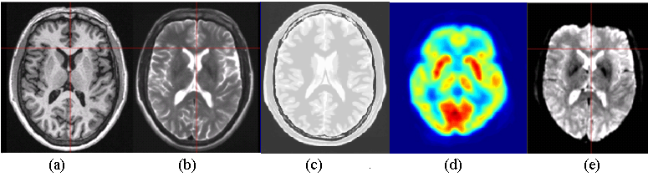

Fig. 3. Sample simulated brain images: (a) T1w, (b) T2w, (c) PD, (d) PET, (e) EPI functional.

Computation of the *SMI*, *SMIsym*, *NSMI*, and *NSMIsym* for 3D images, based on the method given in [12], requires having an extension of the Markovianity constraint to 3D volumes. Even though the definition of Markovianity can be simply extended to multidimensional spaces, a comprehensive and systematic formulation for 3D volume currently does not exist. Therefore, an alternative approach has been adopted here to extend the applicability of these SMs to 3D images. The idea is to consider a 3D image as a composition of its 2D slices, noting that the slicing can be done in three different ways along three axes. In medical imaging in general and in brain imaging in particular, such slices are named transverse, sagittal and coronal, see Fig. 2. Hence, the product of the resulting 3 SMs can be used to serve as a 3D SM, that is

|  |  |  |
| --- | --- | --- |
|  |  | (17) |

where *SMTran* is the SM computed on the transverse slices, *SMSagi* the SM computed on the sagittal slices and *SMCoro* the SM computed on the coronal slices. It can easily be inferred from Equation (17) that the above 3D *SMI* and *NSMI* take into account all the dependencies in the 3D neighboring voxels, even though they cannot mathematically be regarded as mutual information any more. Next we describe the dataset that we utilized in our evaluation.

# Human Brain Image Dataset

In order to evaluate and compare the performance of the listed SMs for 3D brain image registration, various modalities of 3D brain images are considered. Digital brain phantom images of the *BrainWeb* database gives three simulated structural MR images, i.e. T1-weighted (T1w), T2-weighted (T2w) and Proton Density (PD). To have a thorough experimental evaluation, it is also desired to include some functional brain images into the dataset. We used the methods described in [47] and [48] to generate simulated Echo Planar Imaging (EPI), and Positron Emission Tomography (PET) functional images, respectively, derived from the *Brainweb* image. The *BrainWeb* images have been extensively used to study the performance of anatomical brain mapping techniques such as non-linear co-registration, cortical surface extraction, or tissue classification [49]. The main advantages of using this database are: (i) the answer is known prior to experiments, and (ii) imaging parameters can be controlled independently. Since the source for simulation of the functional images is the same digital phantom one gets a systematic means of establishing the gold standard, and controlled level of image degradation for all the modalities.

T1w, T2w and PD brain images with 1 mm isometric resolution and with different levels of image degradation (noise and intensity non-uniformity) were obtained from the *BrainWeb* database. The simulations were done based on all the 8-bit quantized anatomical image sets.

For the simulation of the EPI functional brain images, a typical EPI size of 64×64×36 was selected. Comparing this resolution to the original resolution of the PD MR images generated the slice thickness of (5.03×2.83×3.39 mm) along the three axes. A local deformation intensity fading was applied to a small region in the anterior and inferior part of the prefrontal cortex and temporal lobes to partially simulate the effect of signal loss artifacts. Then, the EPI images were resampled using rigid registration to the high resolution anatomical image [47].

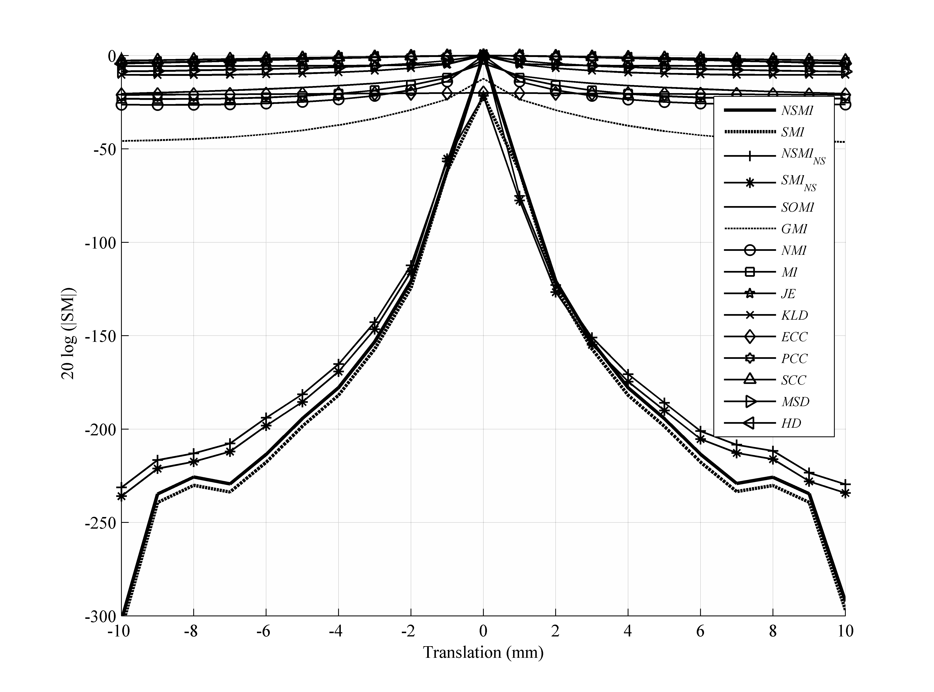

Fig. 4. Averaged evaluation outcome for 2D translations with step size of 1 mm and evaluation range of [-10 +10] mm.

PET brain images were also simulated from the structural MR brain images. First, the structural MR brain images were segmented into regions of different tissue types (gray matter, white matter, cerebral spinal fluid) and structures (skull, skin, and fat). Then, the 3D distributions of the tracer concentration and tissue attenuation coefficient were assigned throughout the segmented brain images. Projected data through these distributions were generated according to the acquisition geometry of PET tomography. Physical effects associated with data acquisition were incorporated into the projections (i.e., photon attenuation, scatter, random, and statistical noise). Finally, a set of projections were reconstructed into the images using the filtered back projection algorithm [48].

Consequently, our dataset consists of three volumes of structural and two volumes of functional MR images. Fig. 3 shows samples of simulated brain images in the dataset that are utilized for the experimental examination in the next section.

# Experimental Results

In this section, the evaluation method described in section II is applied to the dataset images given in section IV to examine the effectiveness of the listed SM’s in section III under the performance metric of robustness. Next, it is shown that the SMs with higher robustness are more prone to image degradations. It is also shown that SMs with less robustness are more likely to fail in intermodal image registration. Finally, the computational complexities of the SMs are discussed at the end of this section.

* 1. Robustness

As it was mentioned before, SM robustness is only depends on the transformation type and the image itself. In this section, SM robustness is computed separately for all different types of affine spatial transformation (translation, rotation, scaling). Some of the common non-rigid transformations in medical imaging are reviewed in [51, 52]. Here, only the *B-spline* model was considered as a representative for this type of transformations. Due to the statistical nature of the process, the computed robustness’s are obtained from five different modalities of human brain images and the average are reported.

*5.1.1 Translation*

To study the behavior of the SMs under translational transformation, a rigid-body shift is utilized to create the required source images. The evaluation range for this evaluation was [-10 10] mm with the evaluation step size of 1 mm. The final outcome was obtained by averaging the evaluation result over all the images in the database. Fig. 4 shows the averaged outcome of this evaluation. To be able to exhibit these results more clearly, the logarithmic scale (20log(|.|)) was used for the vertical axis, and all the SM values were normalized to the range [0 1] in order to have a fair comparison. The details of each SM normalization are presented in Appendix A. Noting that drawing all 15 SMs in one figure makes its readability cumbersome, Table I is provided to list the SMs in the order of their robustness from top to bottom in each category.

It is also a common practice to report the standard deviation, median, and Min/Max values of the results, since more than one experiment is carried out. This statistical criterion is also included in Table I.

Due to the fact that the measures in each category behaved almost similarly, for the rest of the paper, only the best performing SM from the statistical and probabilistic categories and two SM with spatial dependency are selected and compared for the sake of figure clarity. *MSD* was selected from the statistical measures, *NMI* from probabilistic measures and *GMI,* *SOMI*, and our newly defined *NSMI* from the spatial dependency measures. As can be seen from Table I, the robustness of *NSMI* was obtained to be 224 db outperforming *NMI* by 196 db, *GMI* by 188 db, *SOMI* by 208db, *MSD* by 216 db and so on.

Fig. 4 also shows the difference between Symmetric *SMI/NSMI* and Non-Symmetric *SMINS/NSMINS*. One can see that Symmetric *SMI/NSMI* performed just a little better than Non-Symmetric ones. On the other hand, Symmetric *SMI/NSMI* is more desirable to be utilized in the cost function of the optimization process. Subsequently, only Symmetric *NSMI* is selected for comparison with the other selected SMs (*SOMI,* *GMI, NMI*, and *MSD*).

Table I. Robustness of various similarity measures corresponding to Fig. 4.

|  |  |  |  |  |  |  |
| --- | --- | --- | --- | --- | --- | --- |
| **Category** | **SM** | **Min** | **Max** | **Mean** | **Median** | **STD** |
| **Spatial Dependency** | *NSMI* | 206.7567 | 252.4327 | **223.9779** | 212.7444 | 19.8237 |
| *SMI* | 189.7415 | 235.4791 | **206.9949** | 195.7641 | 19.8512 |
| *NSMINS* | 210.5436 | 222.2237 | **214.6814** | 211.2769 | 6.5421 |
| *SMINS* | 193.4968 | 205.1221 | **197.6466** | 198.3209 | 6.4871 |
| *GMI* | 33.8490 | 37.7770 | **35.7892** | 35.7418 | 1.9645 |
| *SOMI* | 15.9340 | 16.6321 | **16.2621** | 16.2201 | 0.3509 |
| **Information Theoretic** | *NMI* | 26.4328 | 29.3838 | **28.1118** | 28.5189 | 1.5170 |
| *MI* | 20.8711 | 23.6658 | **22.4699** | 22.8728 | 1.4403 |
| *ECC* | 10.4084 | 11.8266 | **11.2147** | 11.4090 | 0.7288 |
| *JE* | 5.6808 | 5.7559 | **5.7267** | 5.7433 | 0.0402 |
| *KLD* | 0.9918 | 1.0798 | **1.0328** | 1.0268 | 0.0443 |
| **Statistical** | *MSD* | 7.3750 | 8.7681 | **8.2504** | 8.6081 | 0.7623 |
| *HD* | 4.0283 | 4.6910 | **4.3578** | 4.3540 | 0.3313 |
| *PCC* | 2.7923 | 5.3083 | **3.9935** | 3.8800 | 1.2618 |
| *SCC* | 2.7300 | 3.3860 | **3.0872** | 3.1455 | 0.3319 |

*5.1.2 Rotation*

For rotation, a step size of 0.5 degree and an evaluation range of [0 +5] degrees were considered. Since the selected SMs (*NSMI*, *GMI*, *SOMI, NMI*, and *MSD*) have almost symmetric behavior around the peak point, the same behavior is expected in the evaluation range of [-5 0] degrees. It is worth mentioning that rotation changed the size of a rectangular image, however since the extra triangular areas added to the sides of a rectangular source image were not part of it, they were truncated. In other words, both the target and source images were cropped to smaller sizes to exclude the triangular areas.

The final outcome shown in Fig. 5 is the average of all the results from different images in the database. As can be inferred from Fig. 5, the robustness of *NSMI* was higher than *NMI* by 170.9 db, *GMI* by 170.67 db, SOMI by 180.57 and *MSD* by 186.79 db. As listed in Table I, the deviation of the SM robustness from their mean value is negligible with respect to the scale of each SM. Hence, for the remainder of the paper, for the sake of figures clarity, only the averaged value is reported in the figures.

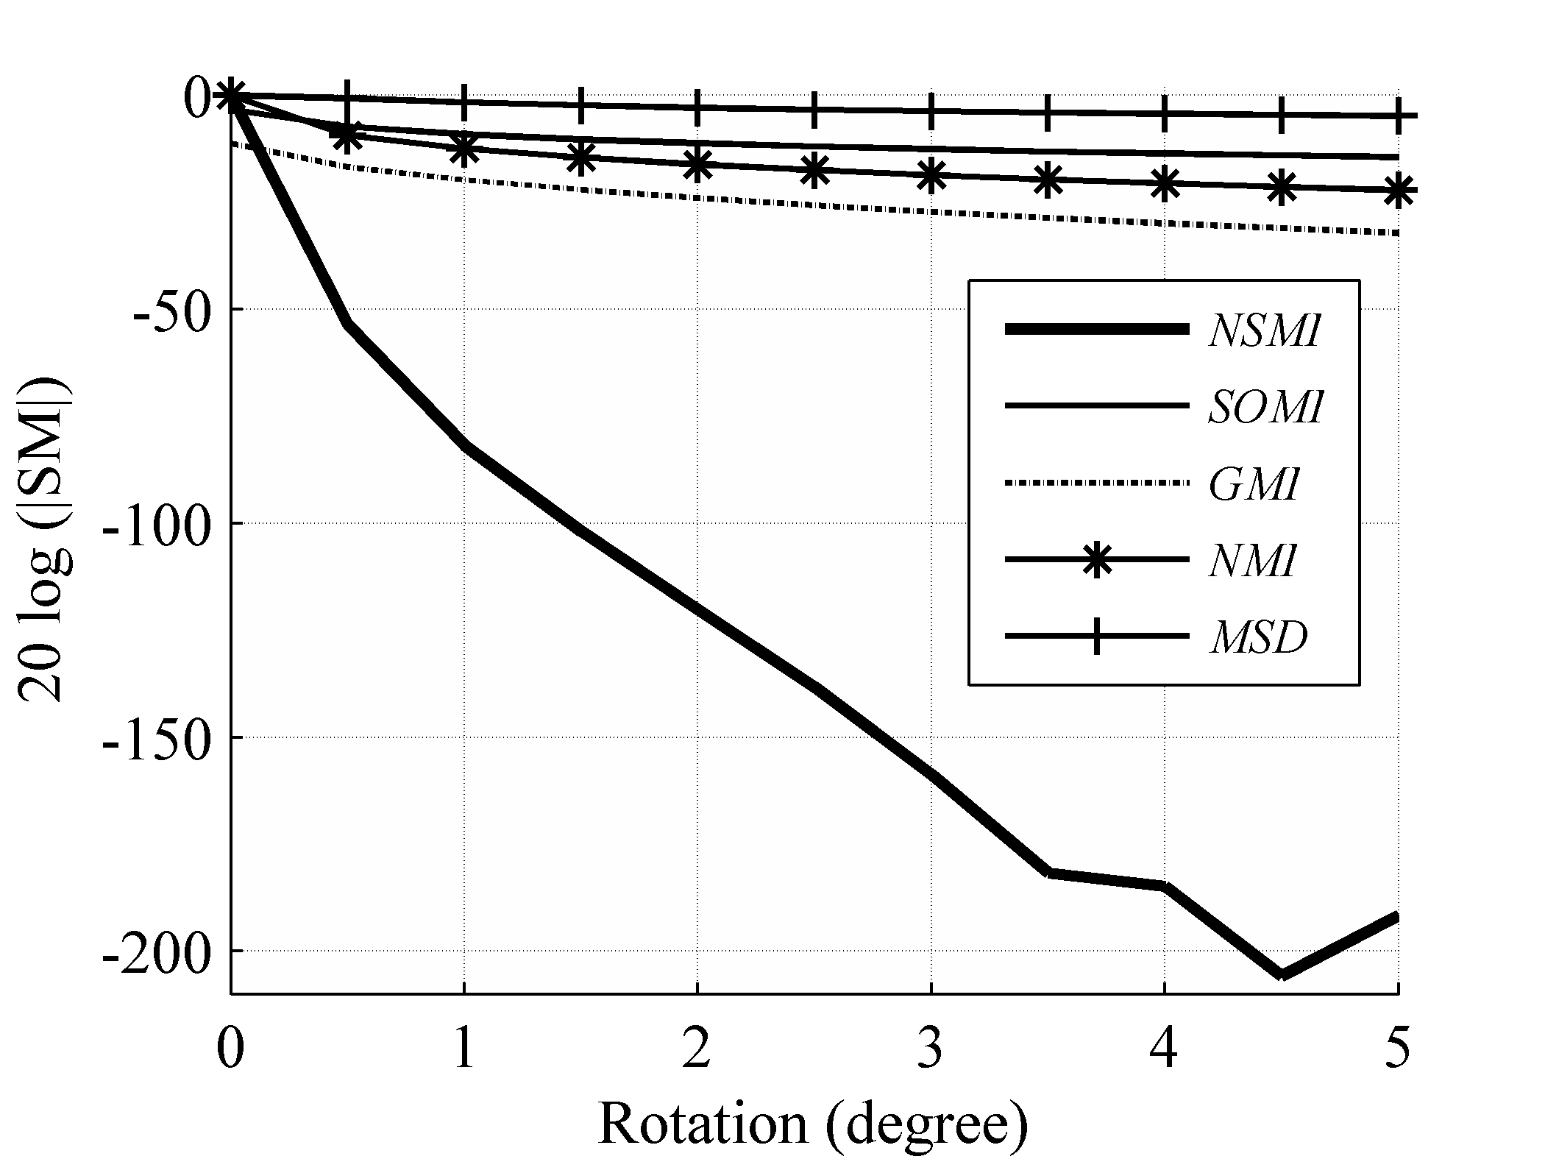

Fig. 5. Averaged evaluation outcome for rotation with step size of 0.5 degree and evaluation range of [0 +5] degrees.

*5.1.3 Scaling*

Unlike the other two rigid transformations (translation and rotation), scaling takes place along all three axes at the same time. The main issue with scaling is that up and down scaling (stretching and shrinking) have different effect on source images and thus they are discussed separately. When a 3D image scales up (scale factor larger than 1), no loss of image information occurs, while scaling down (scale factor smaller than 1) leads to loss of image information. To be able to compute the SMs, it was required to have both images with the same resolution or size.

When the scale factor was larger than 1, the source image stretched. Resizing the target image to match the source image size caused no significant change in any of the SMs over the evaluation range. Therefore, the stretched image (source image) was cropped so that it got fitted into the target image size. Fig. 6 shows the evaluation outcome for scaling over the evaluation range [1 1.5]. As shown in Fig. 6, the robustness of *NSMI* outperformed the robustness of *GMI* by 265.76 db, *SOMI* by 266.59 db, *NMI* by 274.99 db, and *MSD* by 292.24 db.

When the scale factor was smaller than 1, then the resulting image shrank. To prevent any aliasing, antialiasing was applied and the smaller source image was resized to match the target image size. This situation is similar to the registration of a low resolution image to a high resolution one, for example when registering functional MR with anatomical MR images. Fig. 7 shows the evaluation outcome for shrinking over the evaluation range [0.5 1] and step size of 0.05. As shown in Fig. 9, *NSMI* outperformed *NMI* by 54.69 db, *GMI* by 58.97 db, *SOMI* by 63.23 and *MSD* by 64.23 db. It should be noted that no significant change in *MSD* occurred in this experiment.

*5.1.4 Free Form Deformation*

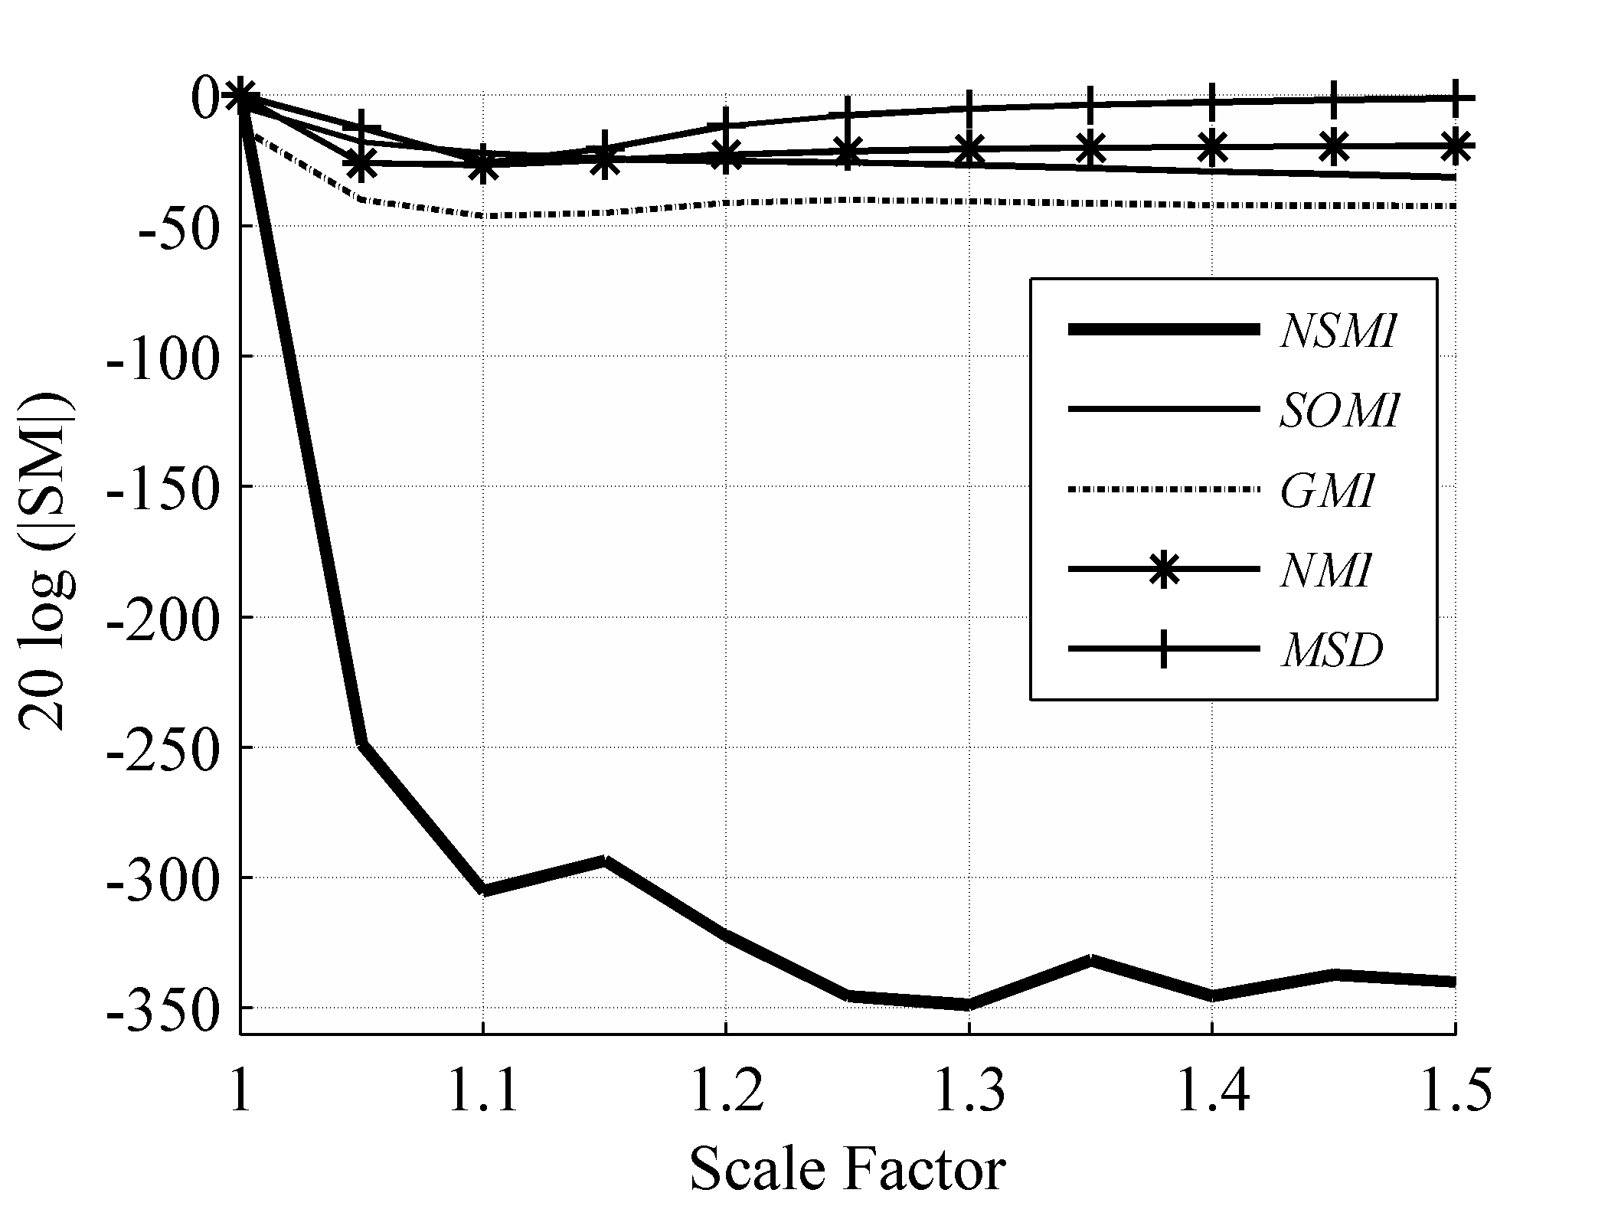

Fig. 6. Averaged evaluation outcome for stretching with step size of 0.05 and evaluation range of [1 1.5].

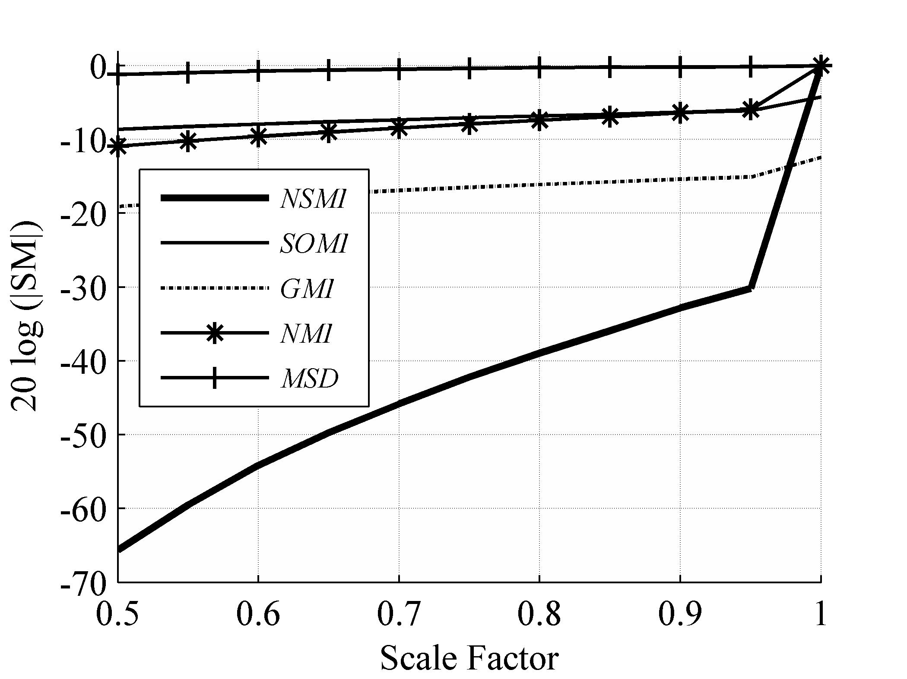

Fig. 7. Averaged evaluation outcome for shrinking with step size of 0.05 and evaluation range of [0.5 1].

For non-rigid transformations, the problem becomes more challenging. The issue is the degree of freedom in the parameters of the non-rigid transformation which can be three times of the image size. In addition to the huge number of control parameters, there is also the choice associated with the transformation function. *B-spline* is the most widely used transformation function in non-rigid image registration [51], and shown to be optimal as an approximation function [53,54]. It is also to be noted that the theory and methods for object modeling using *B-spline* are well developed and discussed in [55].

The Free Form Deformation (FFD) model based on the cubic *B-spline* was considered here due to its use by many researchers in medical imaging, e.g. in [56] for heart modeling, in [57] for 3D object modeling, in [58] for registering SPECT cardiac images, in [59] for registering dynamic contrast enhanced MR breast images. In this experiment, a uniform spacing grid with a spacing size of δ=30 mm was selected to serve as the FFD control points. The source images obtained from the *BrainWeb* phantom with the size of 217×181×181 were truncated to the size of 210×180×180 for simplicity. This made the size of the control mesh 10×9×9. The formulation of the FFD model based on the cubic *B-spline* is thoroughly covered in [59,52], thus not repeated here. For this experiment, there were 3×10×9×9=2430 degrees of freedom. It is easy to see that examining the behavior of the SMs for deviations of all these control points is practically not feasible. Hence, a small set of control points (10~100) were randomly selected from the FFD mesh. These random points were made to deviate along all three directions. For evaluation purposes, it was required to control the severity of the deformation, but deviating all the control points along the same direction produces a uniform deformation throughout the image. Instead, the directions of the deviations in the selected control points were chosen randomly while their magnitudes were kept under the control of the evaluation procedure. Fig. 8 shows the evaluation outcome for the FFD transformation over the evaluation range [0 3] mm and the step size of 0.2 mm. As can be seen from Fig. 8, *NSMI* outperformed *GMI* by 65.0 db, *SOMI* by 70 db, *NMI* by 51.61 db, and *MSD* by 75.2 db. In the next section, the correlation between our newly defined robustness metric with the actual robustness of the SM to image degradation is presented.

* 1. Robustness to image degradation

Table II. Registration error for registering T1w target image to degraded and spatially transformed (rigid, affine, non-rigid) source image using *NMI* and *NSMI*.

|  |  |  |  |  |  |  |  |  |
| --- | --- | --- | --- | --- | --- | --- | --- | --- |
|  | *NMI* | | | | *NSMI* | | | |
| Degradation | Translation | Rotation | Scaling | Deformation | Translation | Rotation | Scaling | Deformation |
| 20% INU | **pass** | **pass** | **pass** | **pass** | **pass** | **pass** | **pass** | **pass** |
| 40% INU | **pass** | **pass** | **pass** | **pass** | **pass** | **pass** | **pass** | **pass** |
| 60% INU | **pass** | **pass** | **pass** | fail | **pass** | **pass** | **pass** | fail |
| 5% Noise | fail | fail | fail | fail | **pass** | **pass** | **pass** | **pass** |
| 10% Noise | fail | fail | fail | fail | **pass** | **pass** | **pass** | **pass** |
| 20% Noise | fail | fail | fail | fail | **pass** | **pass** | **pass** | fail |
| 40% Noise | fail | fail | fail | fail | **pass** | fail | **pass** | fail |
| 5% noise & 40% INU | fail | fail | fail | fail | **pass** | **pass** | **pass** | **pass** |
| 10% noise & 20% INU | fail | fail | fail | fail | **pass** | **pass** | **pass** | fail |
| 20% noise & 40% INU | fail | fail | fail | fail | **pass** | **pass** | **pass** | fail |
| 40% noise & 60% INU | fail | fail | fail | fail | **pass** | fail | **pass** | fail |

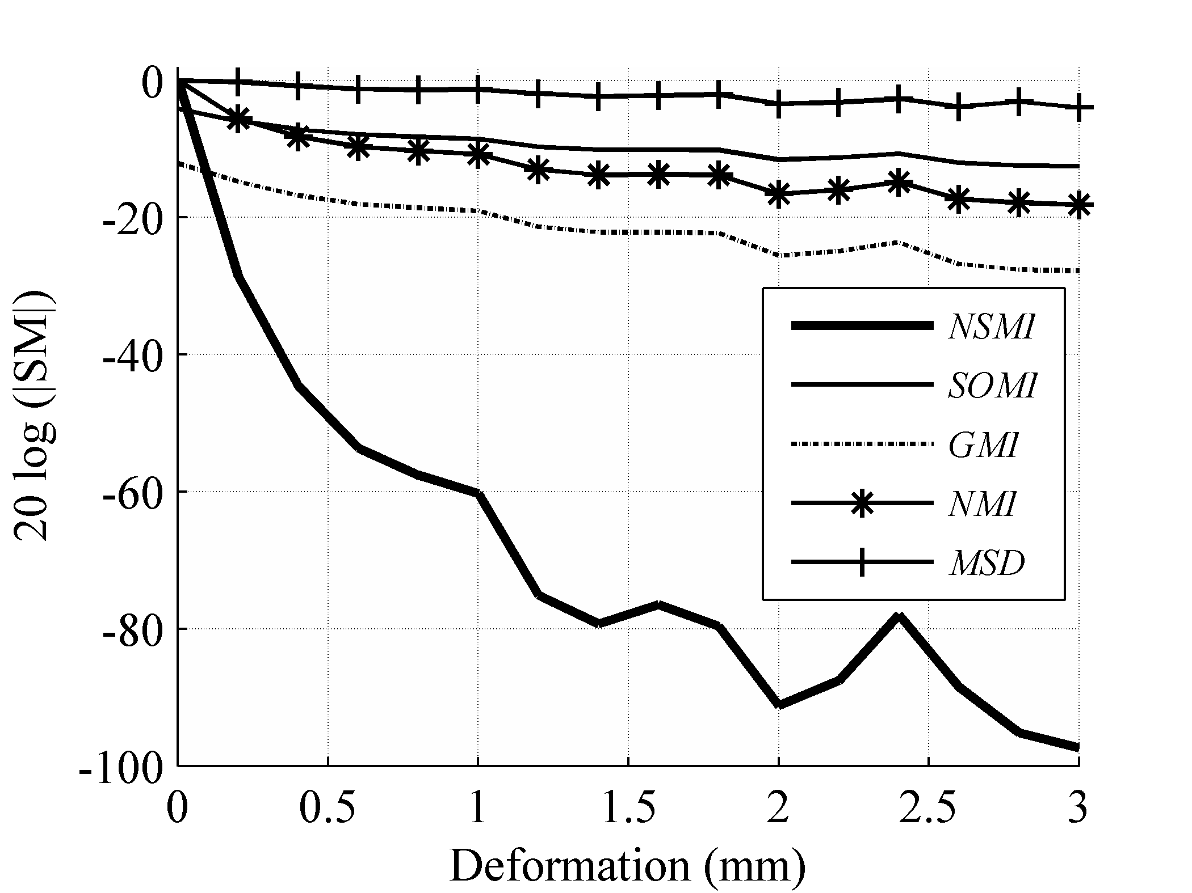

Fig. 8. Averaged evaluation outcome for FFD transformation with step size of 0.2 and evaluation range of [0 3].

The simulated source and target images for computing SM robustness intentionally did not contain any kind of image degradation to be able to compute the maximum possible robustness. Image degradation is one of the main causes of registration failure in single modal image registration problems. Therefore, evaluating SMs robustness requires adding a controlled level of image degradation to the source image. Increasing the level of image degradation on source images eventually causes any SM to fail in registering the images. However, the level of image degradation that causes each SM to fail is different.

In the literature, it is common practice to report the registration validity in terms of the parameter set of the spatial vector transformation ***μ***, even though this seems applicable for translational and rotational vector transformations (translational mis-registration as the magnitude of the error and rotational mis-registration as the phase of the error), it is not certain how to quantify the validity in terms of affine and non–rigid transformation parameters. There are a number of other issues in validating the accuracy of a registration problem which are briefly discussed in chapter 26 of [50]. These issues make the validation of registration accuracy very difficult.

Here the SM validation is considered as a *Boolean* function with pass and fail outcome and it is computed separately for all the registration types and with the controlled level of image degradation. Registration failure happens when the SM peak deviates from the gold standard at least for half of an evaluation step size. Fortunately, the *BrainWeb* database allows one to add a controlled level of simulated noise and Intensity Non-Uniformity (INU) as distortion to a source image. Thus, in this experiment, different levels of noise (5%, 10%, 20%, 40%) and INU (20%, 40%, 60%), and also different combinations of them are added to the target image (T1w) to obtain the degraded source images. Then, the evaluations of all three registrations types (rigid, affine, and non-rigid) are carried out utilizing the most effective SMs (*NSMI*, *NMI*).

Based on the result reported in the previous subsection, *NSMI* is shown to be the most effective existing SM especially for non-rigid registrations. It outperforms *NMI* by 196 db for translation, by 170 db for rotation, by 274 db for scaling, and by 51 db for FFD. As it can seen in Table II, *NMSI* successfully registers all the degraded images for translation and scaling in which its robustness outperform the *NMI* by more than 200 db. It fails in couple of sever situations for rotation in which it robustness is just 150 degree higher than *NMI*. For FFD it only performs successful registration in three more situations when its robustness only differs by 51 db. This clearly show the relationship between the defined robustness and the stability of the SMs to the image degradation. Table II also summarizes the outcome of this experiment. There are in total 44 experiments in which *NSMI* failed registering in only 8 cases while *NMI* failed in 33 cases. One can say that *NSMI* provides approximately 57% better accuracy than *NMI*. Next we discuss the consistency aspect of the SMs.

## Robustness to intermodal registration

In general, a consistent SM is considered to be the one that performs satisfactory registration for all brain image modalities. So far we have shown the superiority of the *NSMI* as compared to the existing SMs from the robustness point of view and we have validated the results by adding the image degradation. In this section, registration between five different brain image modalities is considered to demonstrate the consistency aspect. Three structural (T1w, T2w, and PD) brain MR images were obtained directly from the *BrainWeb* database, and two functional (EPI, and PET) brain images were obtained through simulation as described in section 4. The availability of the gold standard for these images made it possible to validate the intermodal image registration by the robustness of their SMs. Table III shows the result of this experiment. To be able to quantify consistency and establish a comparison, the resulting robustness is reported here. Any of the transformation discussed in this paper can be utilized for this evaluation, however spatial vector translation is used for this examination. It should be noted that values in bold correspond to *NSMI* and values in italic font to *NMI*. The values along the diagonal of the table indicate the robustness of *NSMI* and *NMI* for registering an image with itself, considering that this examination are done based on 2D *NSMI* computation. As can be seen from this table, *NSMI* exhibited a superior performance to *NMI* for inter-modality image registration. A simple way of evaluating SM consistency is to average the robustness of *NSMI* and *NMI* in all 25 experiments (robustness of a failed experiment is considered to be zero). This way the result for *NSMI* is 35 and for *NMI* 12. This indicates roughly a 200% improvement.

## Computational Complexity

Optimization process often requires a large number of iterations to find an optimum solution. In other words, the computational complexity of every SM plays a key role in its practical usability. In this subsection, the complexity of the selected SMs are compared. The complexity of *MSD* is in of the order of *O*(*m*×*n*×*q*), where *m*×*n*×*q* is the dimension of the image volume. On the other hand, the complexity of *MI* or *NMI* is of the order of *O*(*m*×*n*×*q*) + *O*(*l2*) + *O*(*l*) , which is almost the same as *O*(*m*×*n*×*q*) + *O*(*l2*), where *l* is the number of quantization levels in the image. It should be noted that these orders are derived based on the commonly used estimation of the image pdf by its histogram, naturally utilizing a kernel density estimation would alter these orders accordingly.

*GMI* has a higher computational complexity since it computes image gradient together with *MI*. Image gradient has the complexity of *O*(*m*×*n*×*q*×*i*×*j*), where *i* and *j* denote the sizes of a gradient filter. This order once added to the *MI* computation increases the complexity to the order of *O*(*m*×*n*×*q*×*i*×*j*) + *O*(*m*×*n*×*q*) + *O*(*l2*) or equivalently to *O*(*m*×*n*×*q*×*i*×*j*) + *O*(*l2*). Equation (15) reflects that *SMI* from a computational standpoint is a summation of 6 joint entropies. Therefore, the computational complexity of *SMI* or *NSMI* is equal to the complexity of *MI* or *NMI*, respectively. In other words, the computational complexity of *SMI/NSMI* does not exceed that of the conventional *MI/NMI*.

Table III. Robustness (db) of **NS*MI*** and *NMI* for inter-modality image registration.

|  |  |  |  |  |  |  |
| --- | --- | --- | --- | --- | --- | --- |
|  |  | **Source Image** | | | | |
|  |  | T1W | T2W | PD | PET | EPI |
| **Target Image** | T1W | **83.97** , *26.43* | **64.86 ,** *12.61* | **59.94** , *14.22* | **13.52** , *6.67* | **11.22** , *Failed* |
| T2W | **64.50** , *13.79* | **86.86** , *28.52* | **66.76** , *18.97* | **57.23** , *12.76* | **11.59** , *0.92* |
| PD | **61.08** , *12.04* | **66.02** , *17.93* | **92.07**  , *29.24* | **14.62** , *12.49* | **10.90** , *0.98* |
| PET | **13.61** , *3.13* | **51.57** , *5.3* | **14.69** , *5.89* | **78.99** , *24.28* | **11.88** , *1.02* |
| EPI | **11.13** , *Failed* | **12.25** , *3.0* | **10.81** , *3.25* | **34.50** , *24.24* | **89.76** , *18.63* |

# Conclusion

A new similarity measure NSMI has been introduced in this paper for brain image registration. This new similarity measure uses the second order Quadrilateral Markov Random Field to capture the image pixel/voxel dependency. An evaluation method has been proposed for comparing the effectiveness of the newly defined SMs with the existing ones in terms of four performance aspects: robustness, accuracy, consistency and computational complexity. It has been shown that the newly introduced similarity measure *NSMI* generated, on average, 145 db higher robustness than the best performing SM among the existing SMs. It has also been shown that the accuracy of *NSMI* was higher as it failed in registering 18% of the cases while the conventional *NMI* failed in 75% of the cases. In addition, it has been demonstrated that the introduced SMs provided more consistent outcome across different image modalities with no addition to the order of its computational complexity.

Appendix A

Normalization of the Similarity Measures

This appendix covers the normalization or rescaling done on all the similarity measures so that they fall in the range [0 1]. *PCC* and *SCC* are by default between the range [0 1]. *NMI* and *NSMI* are both between the range [1 2], therefore they are normalized simply by subtracting one from them. *MSD* is by default in the range [0 2562], however due to the [0 100] range observed in the experiments, it is down scaled by 100 to place it in the range [0 1]. Since the *MSD* peak point is a minimum, it is normalized by subtracting one from it after down scaling. The experiments showed that *HD* is in this range [0 25], thus it is down scaled by 25 and subtracted from one. *ECC* is already in the normalized range [0 1]. JE is down scaled by min (*H*(*X*),*H*(*Y*)) and then is inversed to be in the range [0 1]. *MI* is always between 0 and 8 for 8-bit quantized images, thus down scaling it by 8 places it in the range [0 1]. The same rescaling is done for *SOMI* and *GMI*. For *SMI,* the down scaling is more involved since the number of random variables in the image volume is the same as the image size. Hence, it is required to down scale *SMI* by the image size first and then by 8 to map it to the range [0 1]. *KLD* is normalized simply by adding one.

# References

1. C. E. Shannon, “A mathematical theory of communication,” *Bell System Technical Journal*, vol. 27, pp. 379-423, 623-656, Oct. 1948.
2. D. Rueckert, M. J. Clarkson, D. L. G. Hill, and D. J. Hawkes,“Non-rigid registration using higher-order mutual information,” in *Proc. SPIE Conf. Medical Imaging: Image Processing*, K. M. Hanson, Ed., vol. 3979, pp. 438–447, 2000.
3. J. P. W. Pluim, J. B. A. Maintz, and M. A. Viergever, “Image registration by maximization of combined mutual information and gradient information,” *IEEE Trans. Med. Imag*., vol. 19, no. 8, pp. 809–814, Aug. 2000.
4. J. P. W. Pluim, J. B. A. Maintz, A. Viergever, “Mutual-Information-Based Registration of Medical Images: A Survey,” *IEEE Trans. on Med. Imag.*, vol. 22, no. 8, Aug. 2003
5. A. Gholipour, N. Kehtarnavaz, R. Briggs, M. Devous, K. Gopinath, “Brain functional localization: A survey of image registration techniques,” *IEEE Trans. on Med. Imag.*, vol. 26, pp. 427-451, 2007.
6. Stan.Z. Li. *Markov Random Field Modeling in Image Analysis* (3rd Edition). Series: Advances in Pattern Recognition. Springer. 2009.
7. G. Winkler, *Image Analysis, Random Fields and Markov Chain Monte Carlo Methods*. A Mathematical Introduction. Second Edition. Springer Verlag, New York, 2003.
8. J. M. Hammersley and P. E. Clifford, “Markov fields on finite graphs and lattices,” unpublished manuscript, available online at: "http://www.statslab.cam.ac.uk/~grg/books/hammfest/hamm-cliff.pdf", 1971.
9. J. E. Besag, “Spatial interaction and the statistical analysis of lattice systems (with discussion),” *J. Roy. Statist. Soc. B*, vol. 36, no. 2, pp. 192–236, 1974.
10. A. Gray, J. Kay, and D. Titterington, “An empirical study of the simulation of various models used for images,” *IEEE Trans. Pattern Anal. Machine Intell.*, vol. 16, pp. 507–513, May 1994.
11. K. Abend, T. J. Harley, and L. N. Kanal, “Classification of binary random pattems,” IEEE Trans. Inform. Theory, vol. IT-4, pp. 538-544, 1965.
12. R. Razlighi, N. Kehtarnavaz, and A. Nosratinia,"Computation of image spatial entropy using quadrilateral Markov random field", *IEEE Transactions on Image Processing*, vol. 18, no. 12, Dec. 2009
13. J. L. Rodgers and W. A. Nicewander, "Thirteen ways to look at the correlation coefficient," *The American Statistician*, vol 42, issue 1, pp 59–66, Feb 1988.
14. M. C. Dutton, R. A. Hayashi, K. M. Toga, A. W. Lopez, O. L. Aizenstein, H. J. Becker, J. T. Thompson, "Fluid registration of medical images using Jensen-Renyi divergence reveals 3D profile of brain atrophy in HIV/AIDS", *Proceedings of 3rd IEEE International Symposium on Biomedical Imaging: Nano to Macro*, pp 193-196, April 2006.
15. K. J. Friston, J. Ashburner, C. D. Frith, J.B. Poline, J. D. Heather, and R. S. J. Frackowiak, “Spatial registration and normalization of images,” *Human Brain Mapping*, vol. 2, pp. 165–189, 1995.
16. J.P.W Pluim, J.B.A Maintz, M.A. Viergever, "f-information measures in medical image registration", *IEEE Transactions on Medical Imaging*, vol. 23, issue 12, pp 1508-1516, Dec. 2004.
17. P.A. Viola, “Alignment by maximization of mutual information,” Ph.D. Thesis, MIT, Cambridge, MA 1995.
18. F. Maes, A. Colligon, D. Vandermeulen, G. Marchal, and P. Suetens, “Multimodality image registration by maximization of mutual information,” *IEEE Trans. Med. Imag*., vol. 16, no. 2, pp. 187–198, 1997.
19. A. Collignon, F. Maes, D. Delaere, D. Vandermeulen, P. Suetens, and G. Marchal, “Automated multi-modality image registration based on information theory,” in *Proc. Inf. Processing in Med. Imag. Conf.*, B. Y. , Ed., pp. 263–274, 1995.
20. C. Studholme, D. L. Hill, and D. J. Hawkes, “An overlap invariant entropy measure of 3D medical image alignment,” *Pattern Recogn*., vol. 32, pp. 71–86, 1999.
21. A. C. S. Chung, W. M. Wells, III, A. Norbash, and W. E. L. Grimson, *Multi-modal image registration by minimizing Kullback-Leibler distance*. Berlin, Germany: Springer-Verlag, vol. 2489, pp. 525–532, 2002.
22. C. Studholme, D. L. G. Hill, and D. J. Hawkes, "Incorporating connected region labelling into automated image registration using mutual information," *Mathematical Methods in Biomedical Image Analysis*, A. A. Amini, F. L. Bookstein, and D. C.Wilson, Eds. Los Alamitos, CA: IEEE Computer Soc. Press, pp. 23-31, 1996.
23. C. E. Rodríguez-Carranza and M. H. Loew, "A weighted and deterministic entropy measure for image registration using mutual information," *Proc. SPIE Conf. Medical Imaging: Image Processing,* K. M. Hanson, Ed., 1998, vol. 3338, pp. 155-166.
24. Y. Guo and C. Lu, “Multi-modality image registration using mutual information based on gradient vector flow,”  *Proc. 18th ICPR*, Hong Kong, pp. 697–700, 2006.
25. C. Beijing, L. JunLi, C. Gang, “Study of Medical Image Registration Based on Second-order Mutual Information”, *Proceedings of IEEE International Conference on Multimedia & Expo(ICBBE07)*, WuHan, July 7-9, China, 2007.
26. R. Shams, P. Sadeghi and R. A. Kennedy, "Gradient Intensity: A New Mutual Information-Based Registration Method", *Proceedings of IEEE Conference on Computer Vision and Pattern Recognition*, page(s): 1-8, June 2007.
27. R. Gan and A. C. Chung, *Multi-Dimensional Mutual Information Based Robust Image Registration Using Maximum Distance Gradient- Magnitude*, ser. Lecture Notes in Computer Science. Berlin, Germany: Springer-Verlag, vol. 3565, pp. 210-221, 2005.
28. D. Shen, C. Davatzikos,"HAMMER: Hierarchical Attribute Matching Mechanism for Elastic Registration,” *IEEE Transactions on Medical Imaging*, vol.12, no.11, Nov. 2002.
29. D. B. Russakoff, C. Tomasi, T. Rohlfing, and C. R. Maurer, Jr., *Image Similarity Using Mutual Information of Regions*, ser. Lecture Notes in Computer Science. Berlin, Germany: Springer-Verlag, vol. 3023, pp. 596-607, 2004
30. C. Yang, T. Jiang, J. Wang, and L. Zheng, *A Neighborhood Incorporated Method in Image Registration*,G.-Z. Yang et al. (Eds.): MIAR 2006, LNCS 4091, pp. 244 – 251,Springer-Verlag Berlin Heidelberg 2006.
31. A. Bardera , M. Feixas , I. Boada and M. Sbert, *High-Dimensional Normalized Mutual Information for Image Registration Using Random Lines*, J.P.W. Pluim, B. Likar, and F.A. Gerritsen (Eds.): WBIR 2006, LNCS 4057, pp. 264–271, Springer-Verlag Berlin Heidelberg, 2006.
32. D. Tomazevic, B. Linkar, and F. Pernus, "Multifeature mutual information," *Proc. SPIE Med. Imag*., J. M. Fitzpatrick and M. Sonka, Eds., vol. 5370, pp. 143-154, May 2004.
33. M. Holden, L. D. Griffin, N. Saeed, and D. L. G. Hill, *Multi-channel Mutual Information Using Scale Space*, C. Barillot, D.R. Haynor, and P. Hellier (Eds.): MICCAI 2004, LNCS 3216, pp. 797–804, Springer-Verlag Berlin Heidelberg 2004.
34. J. Chappelow, A. Madabhushi,M. Rosen,J. Tomaszeweski, M. Feldman, "A Combined Feature Ensemble based Mutual Information Scheme for robust Inter-Modal, Inter-Protocol Image Registration," *Proceedings of 4th IEEE International Symposium on Biomedical Imaging: From Nano to Macro*, page(s): 644-647, April 2007.
35. T. Butz, J. P. Thiran, *Affine Registration with Feature Space Mutual Information*,W. Niessen and M. Viergever (Eds.): MICCAI 2001, LNCS 2208, pp. 549–556, Springer-Verlag Berlin Heidelberg 2001.
36. A. Hero, B. Ma, O. Michel, and J. Gorman, “Applications of entropic spanning graphs,” *IEEE Signal Processing Magazine*, vol. 19, no. 5, pp. 85 – 95, 2002.
37. H. Neemuchwala and A. Hero, *Entropic Graphs for Registration*, ser. Signal Processing and Communications. New York: CRC Press, ch. 6, pp. 185 – 235, 2005.
38. H. F. Neemuchwala, A. Hero, and P. Carson, “Image matching using alpha-entropy measures and entropic graphs,” *Signal Processing*, vol. 85, no. 2, pp. 277 – 296, 2005.
39. E. Oubel, A. F. Frangi, and A. Hero, “Complex wavelets for registration of tagged MRI sequences,” *Proceedings of IEEE International Symposium on Biomedical Imaging (ISBI)*, pp. 622 – 625, 2006.
40. M. R. Sabuncu and P. J. Ramadge, *Spatial Information in Entropy-Based Image Registration*, ser. Lecture Notes in Computer Science. Berlin, Germany: Springer-Verlag, vol. 2717, pp. 132-141, 2003.
41. E. Oubel, M. de Craene, M. Gazzola, A. Hero, and A. Frangi, “Multiview registration of cardiac tagging MRI sequences,” *Proceedings of IEEE International Symposium on Biomedical Imaging (ISBI),* Arlington, VA, USA, pp. 388 – 391, 2007.
42. Staring, M; van der Heide, A.; Klein, S; Viergever, A.; Pluim, P. W., "Registration of Cervical MRI Using Multifeature Mutual Information", to appear in *IEEE Transactions on Medical Imaging*, 2009.
43. H. Luan, F. Qi, and D. Shen, *Multi-Modal Image Registration by Quantitative- Qualitative Measure of Mutual Information (Q-MI),* ser. Lecture Notes in Computer Science. Berlin, Germany: Springer-Verlag, vol. 3765, pp. 378-387, 2005.
44. H. Luan, F. Qi, Z. Xue, L. Chen, D. Shen, "Multimodality image registration by maximization of quantitative-qualitative measure of mutual information", *Pattern Recognition*, vol. 41, Issue 1, Pages 285-298, 2008.
45. T. Kadir, M. Brady, "Saliency, scale and image descriptions",*Journal International Journal of Computer Vision*, vol. 45, Num. 2, Pages 83-105, Nov. 2001.
46. Q. Razlighi and N. Kehtarnavaz, “A comparison study of image spatial entropy” , *Proceedings of SPIE Conference on Visual Communications and Image Processing,* San Jose 2009.
47. A. Gholipour, N. Kehtarnavaz, R. Briggs, K. Gopinath, et al., “Validation of non-rigid registration between functional and anatomical magnetic resonance brain images,” *IEEE Trans. on Biomed. Eng.,* vol. 55, pp. 563-571, 2008.
48. Ma, Y., M. Kamber, and A. C. Evans, "3d simulation of PET brain images using segmented MRI data and positron tomograph characteristics," *Comput Med Imaging Graph*, vol. 17 no. (4-5), pp. 365–71, 1993.
49. D.L. Collins, A.P. Zijdenbos, V. Kollokian, J.G. Sled, N.J. Kabani, C.J. Holmes, and A.C. Evans, “Design and Construction of a Realistic Digital Brain Phantom,” *IEEE Trans. Med. Imag.,* vol. 17, pp. 463-468, June 1998.
50. A. Bovik, *Handbook of Image and Video Processing*. New York: Academic, 2000.
51. L. Zagorchev and A. Goshtasby, “A comparative study of transformation functions for nonrigid image registration,” *IEEE Trans. Image Process.,* vol. 15, no. 3, pp. 529–538, Mar. 2006.
52. M. Holden, "A review of geometric transformations for nonrigid body registration," *IEEE Trans Med Imaging*, vol. 27, no. 1, pp. 111-128, 2008.
53. M. Unser, A. Aldroubi, and M. Eden, “B-spline signal processing: Part I—Theory,” *IEEE Trans. Signal Process*., vol. 41, no. 2, pp. 821–833, Feb. 1993
54. P. Thevanaz, T. Blu, and M. Unser, “Interpolation revisited,” *IEEE Trans. Med. Imag.*, vol. 19, no. 7, pp. 739–758, Jul. 2000.
55. J. H. Gallier, *Curves and surfaces in geometric modeling: Theory and Algorithms*. San Francisco, CA: Morgan Kaufmann, 1999.
56. E. Bardinet, L. D. Cohen, and N. Ayache, “A parametric deformable model to fit unstructured 3D data,” *Comput. Vision Image Understand.,* vol. 71, no. 1, pp. 39–54, Jul. 1998.
57. M. W. Hsu, J. F. Hughes, and H. Kaufman, “Direct manipulation of free-form deformations,” in *Proc. SIGGRAPH*, vol. 26, pp.177–184., 1992.
58. J. M. Declerck, J. Feldmar, M. L. Goris, and F. Betting, “Automatic registration and alignment on a template of cardiac stress and rest reoriented SPECT images,” *IEEE Trans. Med. Imag*., vol. 16, no. 6, pp. 727–737, Dec. 1997.
59. D. Rueckert, L. I. Sonoda, C. Hayes, D. L. G. Hill, M. O. Leach, and D. J. Hawkes, “Nonrigid registration using free-form deformations: Application to breast MR images,” *IEEE Trans. Med. Imag*., vol. 18, no. 8, pp. 712–721, Aug. 1999.

1.
2. Q. R. Razlighi is a postdoctoral research scientist with Molecular Imaging and neuropathology division of Columbia University, NYC, NY 10032 USA (e-mail: razlighi@gmail.com).
3. N. Kehtarnavaz is a professor with the Department of Electrical Engineering, University of Texas at Dallas, Richardson, TX 75080 USA (e-mail: [kehtar@utdallas.edu](mailto:kehtar@utdallas.edu)).
4. S. Yousefi is a PhD student with the Department of Electrical Engineering, University of Texas at Dallas, Richardson, TX, 75080 USA (e-mail: syousefi@yahoo.com).
5. A. Klein is a assistant professor with Molecular Imaging and neuropathology division of Columbia University, NYC, NY 10032 USA (e-mail: ak2104@columbia.edu)