研究生课程考试成绩单
（试卷封面）

院 系 | 计算机科学与工程学院 | 专业 |  | 电子信息
学生姓名 | 邹刘文 | 学号 |  | 212099
课程名称 | Web数据管理技术
授课时间 | 2022 年 3月至 2022年 6月 |  | 周学时 | 2 | 学分 | 2
简
要
评
语
考核论题
总评成绩
（含平时成绩）
备注
任课教师签名：
日期：
注：1. 以论文或大作业为考核方式的课程必须填此表，综合考试可不填。“简要评语”栏缺填无效。
2. 任课教师填写后与试卷一起送院系研究生秘书处。
3. 学位课总评成绩以百分制计分。
目录

1 Problem Definition 3
2 Basic Idea 3
3 Method 3
3.1 Algorithm Description 3
3.1.1 Basic Rule 3
3.1.2 The Bad Character Rule 3
3.1.2 The Good Character Rule1 3
3.1.2 The Good Character Rule2 3
3.2 Implementation Consideration 3
3.2.0 Implementation Overview 3
3.2.1 Construction of the Suffix Function 3
3.2.2 The purpose and method of using suffix function 12
3.2.3 The Use of the Suffix Function for Good Suffix Rule 1 12
3.2.4 The Use of the Suffix Function for Good Suffix Rule 2 14
3.2.5 The Overall Pipeline 16
4 Performance Analysis & Experiments 17
4.1 Implementations By Java 17
4.2 Experiments 20
4.3 Performance Analysis 21
5 Conclusions 22
6 References 22

1 Problem Definition
此部分为茅伟龙同学撰写

2 Basic Idea
此部分为茅伟龙同学撰写

3 Method

3.1 Algorithm Description
此部分为茅伟龙同学撰写

3.1.1 Basic Rule

3.1.2 The Bad Character Rule

3.1.2 The Good Character Rule1

3.1.2 The Good Character Rule2

3.2 Implementation Consideration

3.2.0 Implementation Overview
As described above, the BP^{[1]} (Boyer and Moore) algorithm and the KMP algorithm have many similarities in terms of the concept and principle, so does their specific implementation. Firstly, we carry out a review of the prefix function, which is particularly important in better understanding the mechanism of KMP, and then naturally introduce the suffix function including its definition and construction strategy; secondly, we demonstrate how to use the calculated values of suffix function for the pattern string to obtain corresponding information required by good suffix rule 1 and good suffix rule 2; last, we summary the overall pipeline combing the good suffix rule 1,2 and bad character rule.

3.2.1 Construction of the Suffix Function
- Comparison between the Prefix Function and Suffix Function
The Prefix Function and Suffix Function have two commonalities: they are performed on the pattern string instead of text string for preprocessing; they both search the maximum matched number of characters between prefix and suffix of a specific string (i.e., a character array), but the matched prefix or suffix cannot be the whole string.
Their differences lie in the range to be matched and the returned value. For clarity, denote the prefix function as P, the suffix function as S. The length of pattern string is m, and the index starts from zero (i.e., we have p [0...m-1]). As shown in Fig. 1, P(i) calculates and returns the maximum matched number of substring p[0…i-1] while S(i) calculates the maximum matched number of substring p[i+1 …. m-1] and returns the index right before the maximum matched suffix.
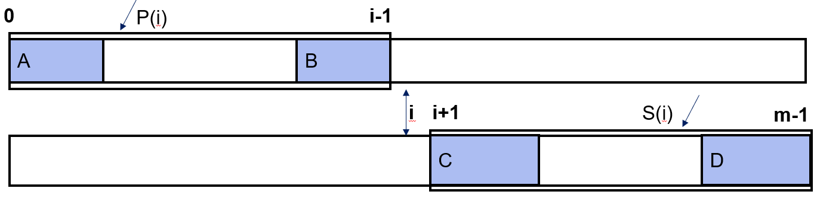
Fig. 1. The range to be matched and the returned value of prefix function and suffix function on position i.
- Three Implementation Strategies for Prefix Function
Three strategies are commonly adopted for the implementation of prefix function^{[2]}. Before diving into details, we have to clearly formulate the prefix function shown below. The pattern string is 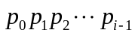and the corresponding next array is 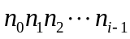(i.e., the length of pattern string is i and the character array indexes from zero), and for position j its value of prefix function is:
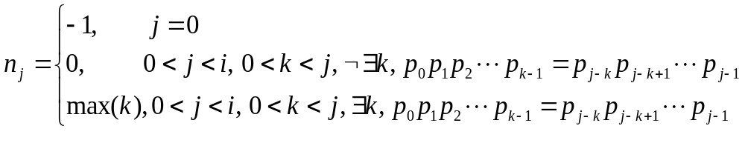
- Method One
The first belongs to the so-called brute force method. We first hypothesize that the maximum matched number is equal to the length of the substring to be studied minus 1, and then validate whether it holds by directly comparing the prefix and suffix of that length of the substring; if it holds we obtain the answer immediately, otherwise we reduce the hypothesized value by one; we repeat the validation process until we find a hypothesized value that satisfy the matching condition or the hypothesized value is reduced to zero which means no matched prefix and suffix exist in this substring. It is noteworthy that when j equals to zero, the substring is empty and therefore returns -1.
The correctness of the method is obvious for it strictly follows the definition, but the time complexity is relatively high: in best cases, only j times of character comparison are needed; in worst cases, (1+2+…+j) = j * (j + 1) / 2 times of character comparison are needed; so, on the average the complexity in calculation is of O(n²) order.
Fig. 2 is an example of the steps. First, we initialize k = j – 1 = 5 - 1 = 4, and compare p[1…j][1:k] = ‘ABCD’ and p[1…j][-k:] = ‘BCDA’, since ‘ABCD’ is unequal to ‘BCDA’, we let k = k – 1 = 3; we continue to compare p[1…j][1:k] = ‘ABC’ and p[1…j][-k:] = ‘CDA’, since ‘ABC’ is unequal to ‘CDA’, we let k = k – 1 = 2; we continue to compare p[1…j][1:k] = ‘AB’ and p[1…j][-k:] = ‘DA’, since ‘AB’ is unequal to ‘DA’, we let k = k – 1 = 1; we continue to compare p[1…j][1:k] = ‘A’ and p[1…j][-k:] = ‘A’, since ‘A’ is equal to ‘A’, we set next[j] = next[5] = 1.
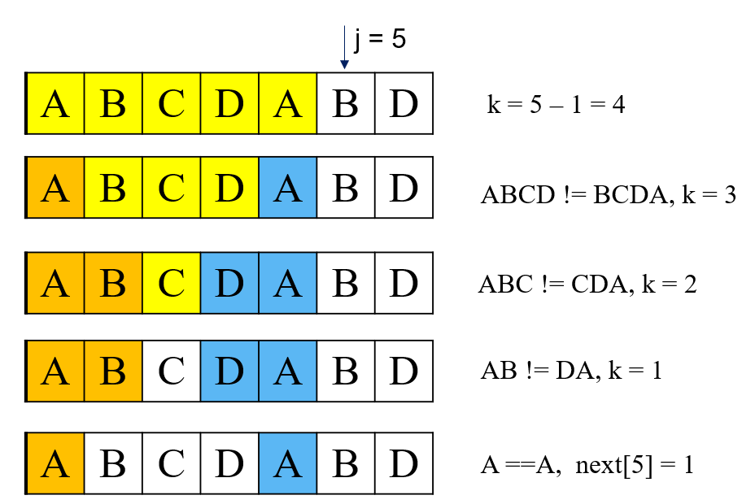
Fig. 2. The example of brute force method in prefix function implementation.
- Method Two
The second refers to recursive method, meaning we try to obtain next[j] by using already calculated next[0, 1, 2, …, j-1]. The basis for this recursion is the fact that next[0] = -1, and then three types of scenarios are in a need for separate discussion.
In case one (displayed in Fig. 3), j equals to one, so p[0…j – 1] is undoubtedly corresponding to the first character of the pattern string and has no non-empty true substrings, thus next[j] = 0.
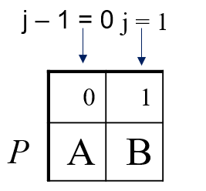
Fig. 3. The case 1 in recursive method (j = 1).
In case two (displayed in Fig. 4), if P[j-1] == P[next[j-1]], then next[j] = next[j-1] +1. The proof of it can be as follows:
- next[j - 1] = k has been known, then we have:
P[0… k-1] = P[j-2-(k-1) …j-2];
if P[j-1] == P[next[j-1]] (P[k]), then we have:
P[0…k-1] + P[k] = P[j-2-(k-1)…j-2] + P[j-1]
P[0…k] = P[j-2-(k-1)…j-1]
P[0…k] = P[j-1-(k+1-1)…j-1]
- next[j] > k+1 is impossible:
we can suppose next[j] = k + 2, then we have:
P[0…k+1] = P[j-1-(k+2-1)…j-1]
P[0…k+1][:k+1] = P[j-1-(k+2-1)…j-1][:k+1]
P[0…k] = P[j-1-(k+2-1)…j-2]
P[0…k] = P[j-2-(k-1)-1…j-2]
so next[j-1] = k + 1, this is a conflict
so next[j] <=k+1 , next[j] = k + 1 = next[j-1] +1
In the concrete example in Fig. 4, j equals to 10, P[j-1] = P[9] = ‘D’, P[next[j-1]] = P[3] = ‘D’, P[j-1] = P[next[j-1]], so next[j] = next[j-1] = 1 + 3 = 4. Intuitively speaking，
prefix ‘ABC’+ ‘D’ equals to suffix ‘ABC’+ ‘D’.
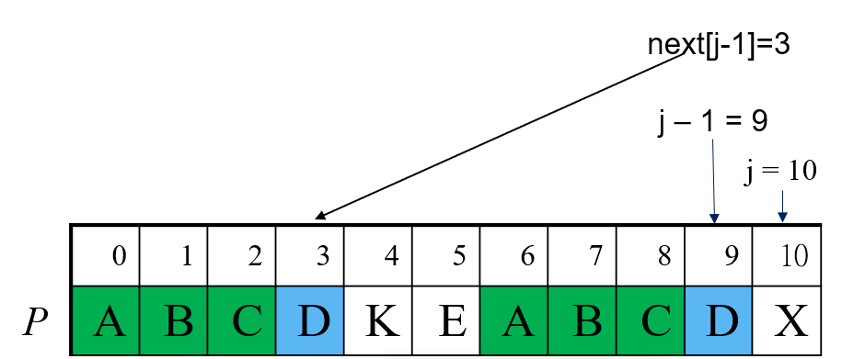
Fig. 4. The case 2 in recursive method.
In case three (displayed in Fig. 4), if P[j-1] != P[next[j-1]], we recursively calculate the value of suffix fuction of next[j-1], if P[j-1] == P[next[next[j-1]], then next[j-1] = next[next[j-1]] +1, otherwise repeat the recursive process of suffix function until the value of suffix function is -1 or the equation is satisfied.
In the example here:
Because P[0…6] = P[10…16] And P[7] != P[17]:
we have next[18] != 8 (7+1);
Since
P[0…2] = P[4…6]
P[4…6] = P[0…6][-3:]
= P[10…16][-3:]
= P[14…16]
So P[0…2] = P[14…16]
Because P[3] != P[17], we have next[18] != 4(3+1);
Since
P[0] = P[2]
P[2] = P[0...2][-1:]
= P[14…16][-1:] = P[16]
so P[0] = P[16]
Because P[1] == P[17], we have next[18] = 2(1+1).
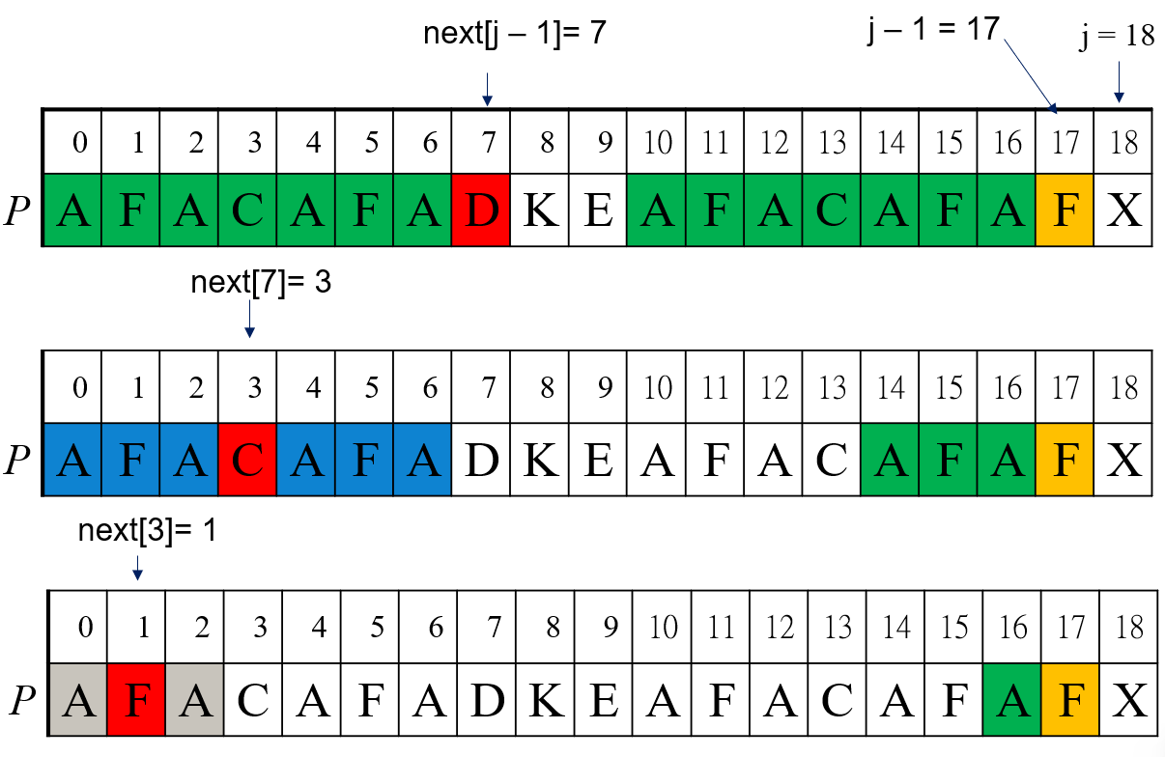
Fig 5. The case 3 in recursive method.
- Method III
The third refers to recursive unfold. It is actually the non-recursive implementation of the recursive method. It has the same time complexity of O(n) as Method II, but the procedure is less clear and more difficult to understand.
- The procedure of the construction of Suffix Function
Suffix function also has three strategies to be implemented, but we just describe the best one with least time complexity: recursive method. For simplicity, suppose the pattern string is p₁p₂p₃…p_{m}, the suffix function can then be formulated as:
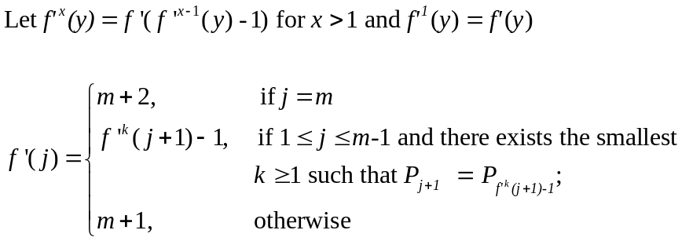
x here means the number of recursions to call the suffix function. The explanation of each of the three cases in the formula is as follows:
- Case 1: when j = m, f’(j) = m + 2.
We can see the empty substring p[m+1:] as two empty characters. Then the empty character on position m + 1 and m + 2 can be seen as equal prefix and suffix, so return the first position of the suffix, i.e., m + 2.
The value of + 2 in fact also helps this recursive process start from the penultimate position rather than the third-to-last position.
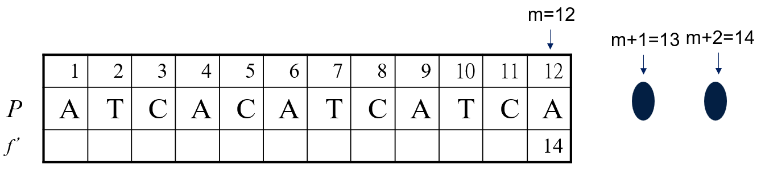
Fig 6. Example for the case 1 in recursive method for suffix function implementation.
- Case 2: f’(j) = f’^{(k’)}(j+1) – 1, if 1<=j<=m-1 and there exists the smallest integer k>= 1 such that P[j+1] = P[f’^{(k)}(j+1)-1].
We prove this by directly using the example:

Because P[5…9] = P[8…12] and P[4] != P[7]:
we have f’(3) != 7 ( 8 – 1);

Because f’⁽²⁾(j+1) = f’( f’(j+1) – 1 )
= f’( 8 – 1 )
= f’( 7 )
= 11
we have P[11…12] = P[8…9]
= P[8…12][:2]
= P[5…9][:2]
= P[5…6]
Also because P[4] != P[10], we have:
f’(3) != 10 (11-1)

f’⁽³⁾(j+1) = f’( f’⁽²⁾(j+1) – 1 )
= f’( 11 – 1 )
= f’( 10 )
= 13
Because P[4] == P[13-1], i.e.
P[j+1] == P[f’⁽³⁾(j+1)-1]
we have:
f’(3) = f’⁽³⁾(j+1)-1 = 12。

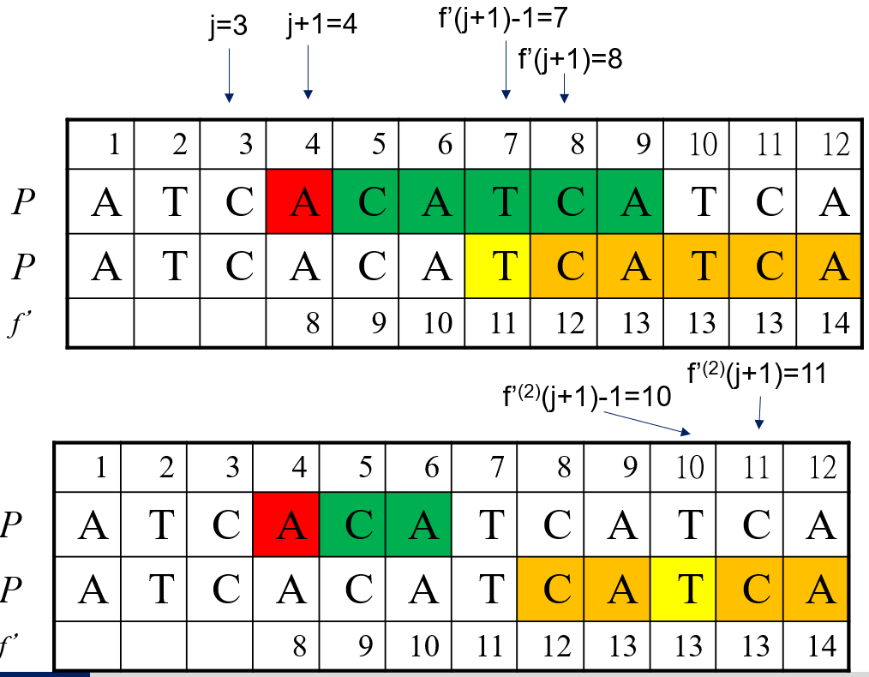
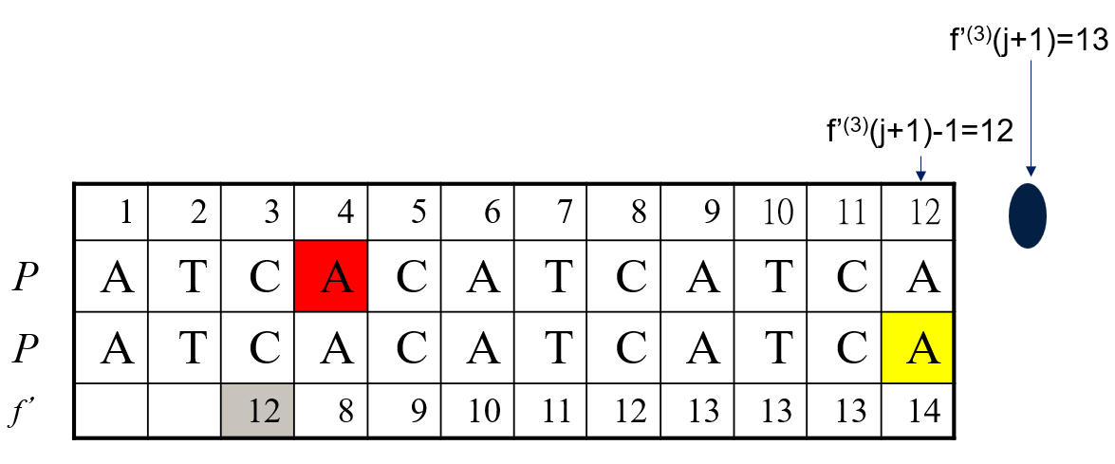
Fig 7. Example for the case 2 in recursive method for suffix function implementation.
- Case 3: otherwise f’(j) = m + 1
We prove this by directly using two examples.
Proof for example 1:
Because f’(j+1) = m+2 = 14,
P[j+1] = ‘A’.
P[f’(j+1) -1] =P[13] not exist

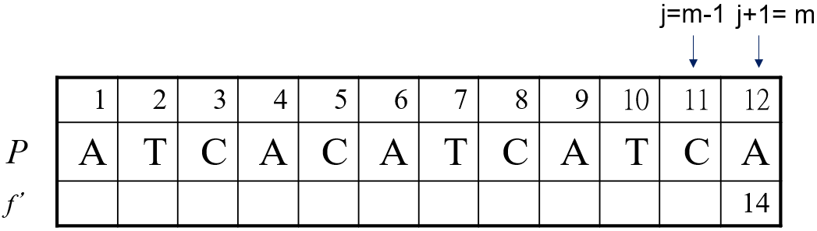
Fig 8. Example 1 for the case 3 in recursive method for suffix function implementation.
Proof for example 2:

We have :
f’(j+1) = 13,

f’⁽²⁾(j+1) = f’(12)=14
P[j+1] = ‘T’.
P[f’(j+1) -1] =P[12]= ‘A’
So P[j+1] != P[f’(j+1) -1],
P[f’⁽²⁾(j+1) – 1] = P[13] not exist

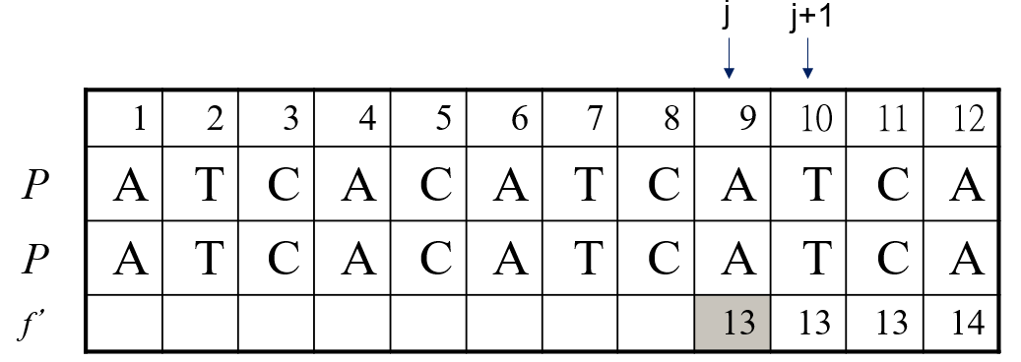
Fig 9. Example 2 for the case 3 in recursive method for suffix function implementation.
The case 3 has many types of scenarios. Two examples here both belong to the type: position j + 1 has no corresponding matched prefix and suffix, in which type the result can also have two types. As shown in Fig. 10 (a), if P[f’(j+1)-1] = P[m] = b is unequal to P[j+1], then f’(j) = m + 1; as shown in Fig. 10 (b), if P[f’(j+1)-1] = P[m] = b is equal to P[j+1], the f’(j) = 1, the counterfactual method can prove that f’(j) can not be greater than 1.

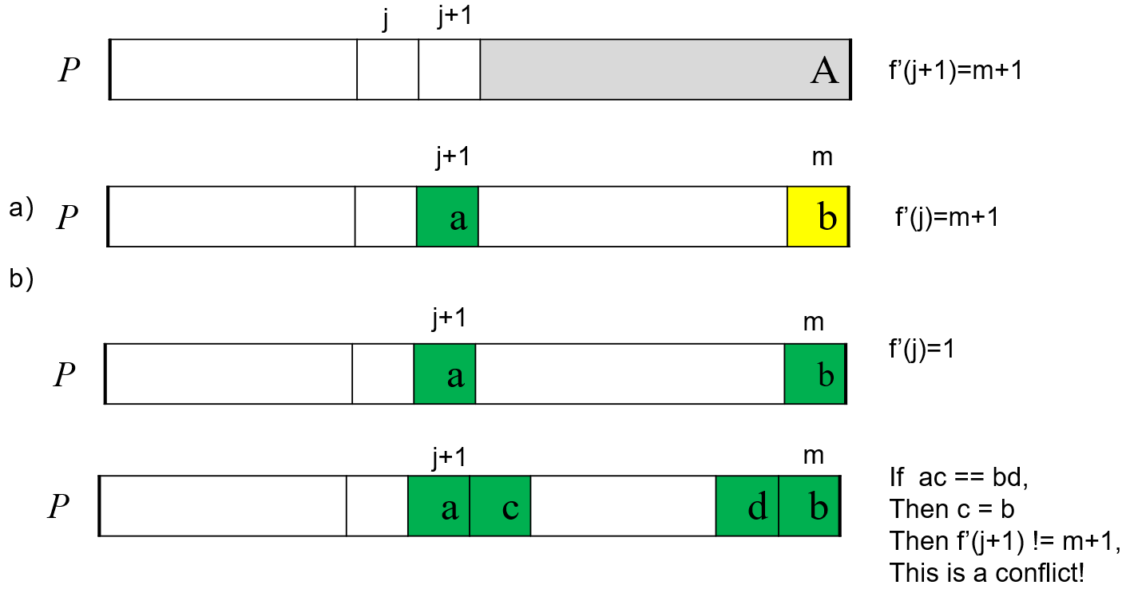
Fig 10. Two types of f’(j) when f’(j+1) = m + 1.

The purpose and method of using suffix function
The purpose is to apply good suffix rule1 and good suffix rule2 at the same time. Let G’(j), 1≦j≦m, to be the largest number of shifts by good suffix rules. First, we set G’(j) to zeros as their initializations; then, use the suffix function to get good suffix rule1 info(gs1) and corresponding G’ (m – gs1); and finally, use the suffix function to get good suffix rule2 info(gs2) and corresponding G’ (m – gs2).

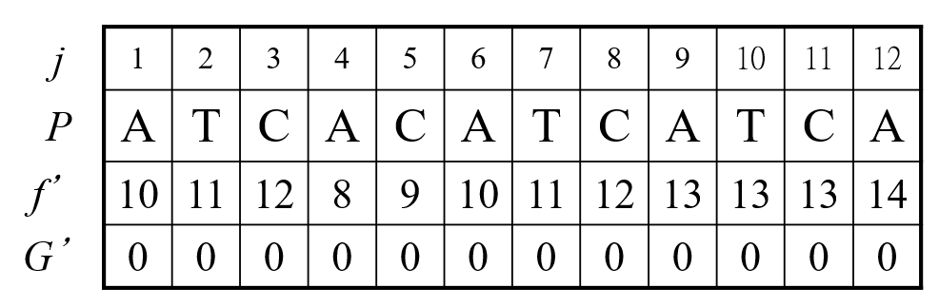
Fig 11. The initializations of G’ for pattern string.

3.2.3 The Use of the Suffix Function for Good Suffix Rule 1
Method Description:
Scan the string from right to left. For position j, denote f’(j) – 1 as t, if P[j] != P[t] and gs1(t) not assigned, then we could have:
gs1(t) = j + (m – t ) = j + (m – (f’(j) – 1)) = j + m – f’(j) + 1
G’(t) = m – max{gs1(t), gs2(t)} = m – gs1(t) = f’(j) – 1 - j.

Proof:
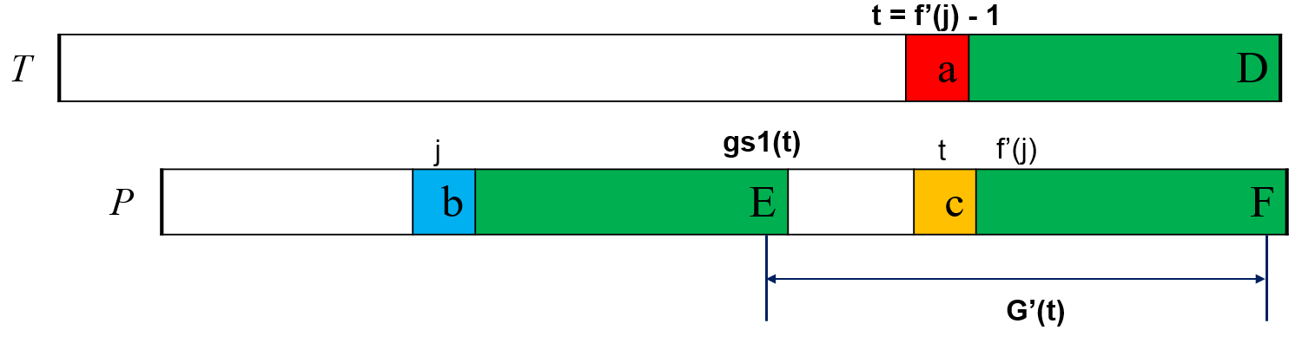
- The calculation of gs1(t).
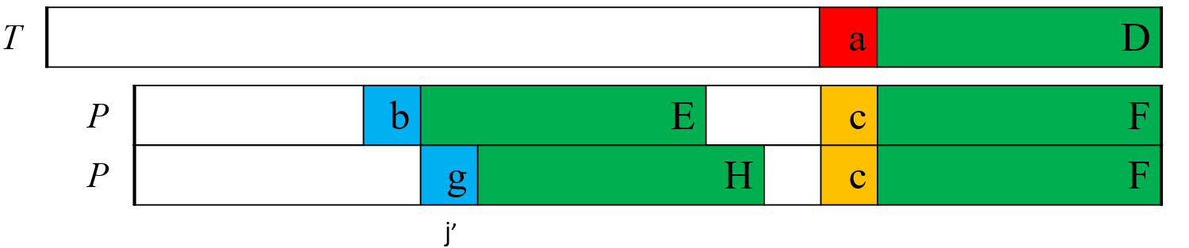
- The hypothesis if there is a righter position that matches D.
Fig 12. The illustration for the proof.
- First, we prove that gs1(t) is equal to the end position of the prefix E:
When text string T and pattern string P are mismatched at t,
we have: D = F, a!=c;
if P[j] != P[t], then b != c;
according to the meaning of f’ function, we have E = F;
D = F , E = F, then we have E = D;
We have to ensure the end of E is the most right position in P that matches the suffix D, we can suppose there is a righter position that matches D (shown in Fig. (b)): the end of H, but since we scan from right to left, if H exists, the gs1(t) must has been assigned, so this is a conflict.
- Then we prove gs1(t) >= gs2(t):
gs1(t) means we could find full matched suffix,
gs2(t) means we can only find partially matched suffix,
so gs1(t) >= gs2(t);
thus for those t whose gs1(t) have been assigned, there is no need to update its G’(t).

Example:
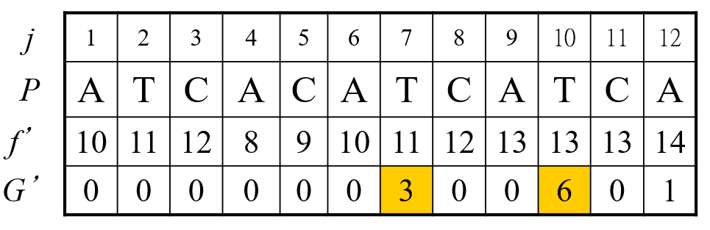
Fig. 10. An example of getting G’ using gs1 info obtained from suffix funtion f’.

As shown in Fig. 10, when j=12, t=13 > m; when j=11, t=12, Since P₁₁=‘C’≠ ‘A’= P₁₂, G’(t) = m – max{gs₁(t), gs₂(t)} = m – gs₁(t) = f’(j) – 1 – j, => G’(12)=13-1-11= 1; when j=10, t=12, since P₁₀=‘T’≠‘A’ =P₁₂ , G’(12) ≠0; when j=9, t=12, P₉ = ‘A’ =P₁₂; When j=8, t=11, P₈ = ‘C’ =P₁₁; when j=7, t=10, P₇ = ‘T’ =P₁₀ ; when j=6, t=9, P₆ = ‘A’ =P₉; when j=5, t=8, P₅ = ‘C’ =P₈; when j=4, t=7, since P₄ = ‘A’ ≠ P₇ = ‘T’, G’(7) = 8 – 1 – 4= 3, besides, t = f’⁽²⁾(4) – 1=f’(f’(4) – 1) – 1=10. since P₄ = ‘A’≠P₁₀ = ‘T’, G’(10) =f’(7) – 1 – j= 11 – 1 – 4 = 6; when j=3, t=11. P₃=‘C’=P₁₁; when j=2, t=10. P₂=‘T’=P₁₀; when j=1, t=9. P₁=‘A’=P₉.

3.2.4 The Use of the Suffix Function for Good Suffix Rule 2
Step 1 Description:
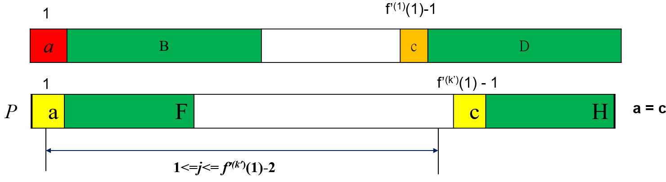
Fig. 11. Step 1 in getting gs2 info from suffix funtion f’.
Find smallest k in {1,2, …, m} such that P[1] = P[f’^{(k)}(1)-1] as k’; if G’(j) is not determined in the first scan and 1<=j<= f’^{(k’)}(1)-2, thus, in the second scan, we set G’(j)=m - max{gs₁(j), gs₂(j)}= m - gs₂(j)= f’^{(k’)}(1) – 2, if no such k exists, set each undetermined value of G to m in the second scan.

Step 1 Proof: satisfy the definition of good suffix rule2; it is indeed the subarray with maximum length

Step 1 Example:
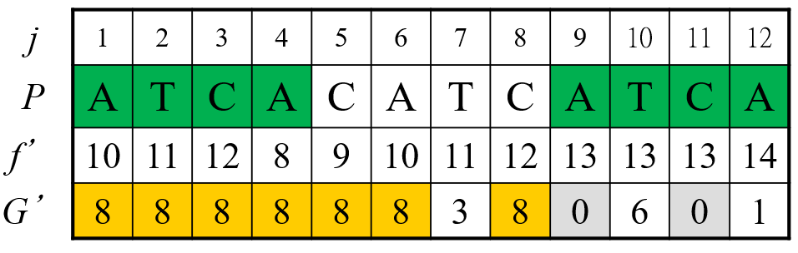
Fig. 12. An example for step 1 in getting gs2 info from suffix funtion f’.

k’=1, since P_{f’(1)-1}=P₉=“A”=P₁, we set G’(j)=f’ (1)-2 for j=1,2,3,4,5,6,8.

Step 2 Description:
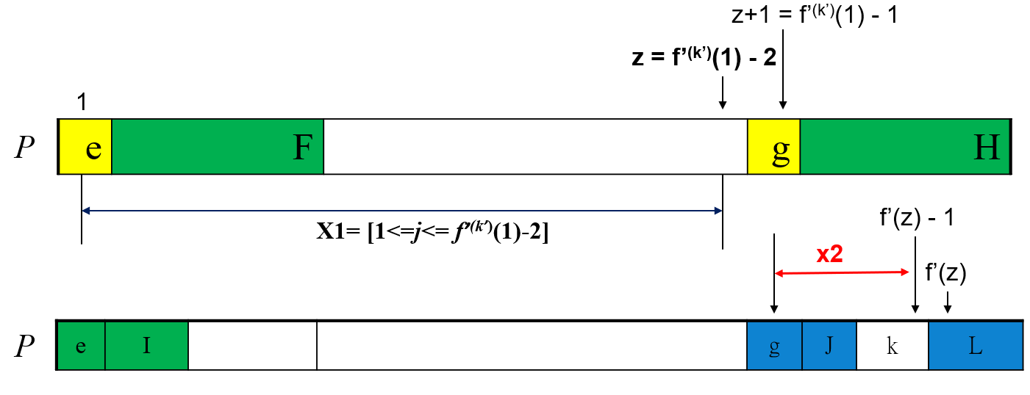
Fig. 13. Step 2 in getting gs2 info from suffix funtion f’.
Let z be f’^{(k’)}(1)-2. Let k’’ be the largest value k such that f’’^{(k)}(z)-1<=m. Then we set G’(j) = m - gs₂(j) = m - (m - f’’^{(i)}(z) - 1) = f’’^{(i)}(z) - 1, where 1<=i<=k’’ and f’’^{(i-1)}(z) < j <= f’’^{(i)}(z)-1 and f’’⁽⁰⁾(z) = z.

Step 2 Proof:
e + I = g + J, g + J = L, so e + I = L
So for z+1 <=j <= f’(z) -1,
gs2(j) = e + I = m – (f’(z) – 1),
G’(j) = m –gs1(j) = f’(z) -1

Step 2 Example:
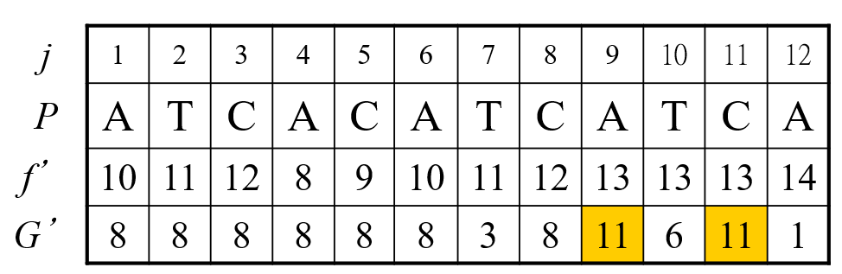
Fig. 14. An example for step 2 in getting gs2 info from suffix funtion f’.

z=8 : k=1, f’’⁽¹⁾(8)-1=11≦m=12;
k=2, f’’⁽²⁾(8)-1=12≦m=12=> k’’=2;
i=1, f’’⁽⁰⁾(8)=8 < j ≦ f’’⁽¹⁾(8)-1=11;
i=2, f’’⁽¹⁾(8)-1 =11< j ≦ f’’⁽²⁾(8)-1=12.
So, we set G(9) and G(11)= f’’⁽¹⁾(8) – 1= 12-1 = 11.

3.2.5 The Overall Pipeline
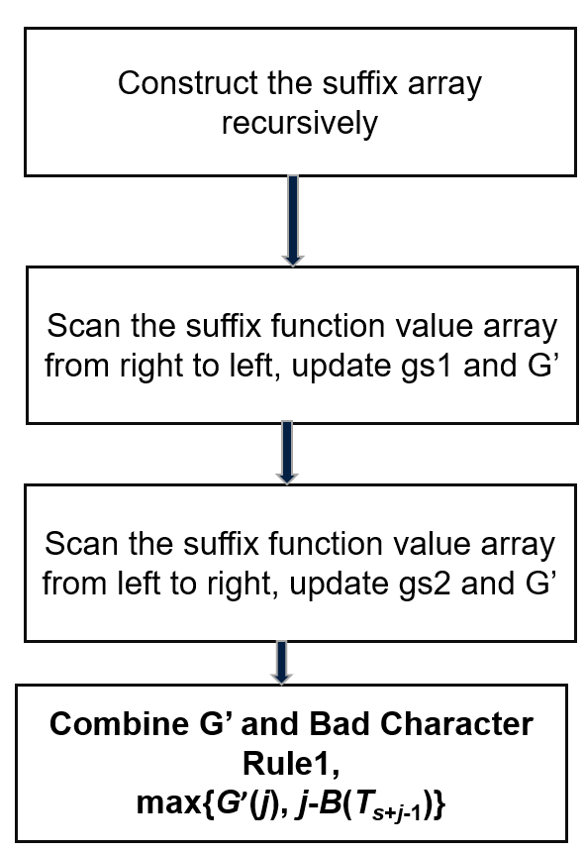
Fig. 15. The overall pipeline for bm algorithm.
The bm algorithm tries to move as many as possible steps when a mismatch occurs, so when bad character rule and good suffix rule give different steps, choose the bigger one.

4 Performance Analysis & Experiments

4.1 Implementations By Java
We implement bm and kmp by simple java class.
The bm class is:
- public class BM {
- // BM算法匹配字符串，匹配成功返回P在S中的首字符下标，匹配失败返回-1
- public static int indexOf(String source, String pattern) {
- char[] src = source.toCharArray();
- char[] ptn = pattern.toCharArray();
- int sLen = src.length;
- int pLen = ptn.length;

- // 模式串为空字符串，返回0
- if (pLen == 0) {
- return 0;
- }
- // 主串长度小于模式串长度，返回-1
- if (sLen < pLen) {
- return -1;
- }

- int[] BC = buildBadCharacter(ptn);
- int[] GS = buildGoodSuffix(ptn);

- // 从尾部开始匹配，其中i指向主串，j指向模式串
- for (int i = pLen - 1; i < sLen; ) {
- int j = pLen - 1;
- for (; src[i] == ptn[j]; i--, j--) {
- if (j == 0) { // 匹配成功返回首字符下标
- return i;
- }
- }

- // 每次后移“坏字符规则”和“好后缀规则”两者的较大值
- // 注意此时i（坏字符）已经向前移动，所以并非真正意义上的规则
- i += Math.max(BC[src[i]], GS[pLen - 1 - j]);
- }

- return -1;
- }

- // 坏字符规则表
- private static int[] buildBadCharacter(char[] pattern) {
- int pLen = pattern.length;
- final int CHARACTER_SIZE = 256; // 英文字符的种类，2^8
- int[] BC = new int[CHARACTER_SIZE]; // 记录坏字符出现时后移位数

- Arrays.fill(BC, pLen); // 默认后移整个模式串长度
- for (int i = 0; i < pLen - 1; i++) {
- int ascii = pattern[i]; // 当前字符对应的ASCII值
- BC[ascii] = pLen - 1 - i; // 对应的后移位数，若重复则以最右边为准
- }

- return BC;
- }

- // 非真正意义上的好字符规则表，后移位数还加上了当前好后缀的最大长度
- private static int[] buildGoodSuffix(char[] pattern) {
- int pLen = pattern.length;
- int[] GS = new int[pLen]; // 记录好后缀出现时后移位数
- int lastPrefixPos = pLen; // 好后缀的首字符位置

- for (int i = pLen - 1; i >= 0; i--) {
- // 判断当前位置（不含）之后是否是好后缀，空字符也是好后缀
- if (isPrefix(pattern, i + 1)) {
- lastPrefixPos = i + 1;
- }
- // 如果是好后缀，则GS=pLen，否则依次为pLen+1、pLen+2、...
- GS[pLen - 1 - i] = lastPrefixPos - i + pLen - 1;
- }

- // 上面在比较好后缀时，是从模式串的首字符开始的，但实际上好后缀可能出现在模式串中间。
- // 比如模式串EXAMPXA，假设主串指针在比较P时发现是坏字符，那么XA就是好后缀，
- // 虽然它的首字符X与模式串的首字符E并不相等。此时suffixLen=2表示将主串指针后移至模式串末尾，
- // pLen-1-i=4表示真正的好字符规则，同样主串指针后移，使得模式串前面的XA对齐主串的XA
- for (int i = 0; i < pLen - 1; i++) {
- int suffixLen = suffixLength(pattern, i);
- GS[suffixLen] = pLen - 1 - i + suffixLen;
- }

- return GS;
- }

- // 判断是否是好后缀，即模式串begin（含）之后的子串是否匹配模式串的前缀
- private static boolean isPrefix(char[] pattern, int begin) {
- for (int i = begin, j = 0; i < pattern.length; i++, j++) {
- if (pattern[i] != pattern[j]) {
- return false;
- }
- }

- return true;
- }

- // 返回模式串中以pattern[begin]（含）结尾的后缀子串的最大长度
- private static int suffixLength(char[] pattern, int begin) {
- int suffixLen = 0;

- int i = begin;
- int j = pattern.length - 1;
- while (i >= 0 && pattern[i] == pattern[j]) {
- suffixLen++;
- i--;
- j--;
- }

- return suffixLen;
- }
- }

The kmp class is:
- public class KMP {
- public int indexOf(String source, String pattern) {
- int i = 0, j = 0;
- char[] src = source.toCharArray();
- char[] ptn = pattern.toCharArray();
- int sLen = src.length;
- int pLen = ptn.length;
- int[] next = getNext(ptn);
- while (i < sLen && j < pLen) {
- // 如果j = -1,或者当前字符匹配成功(src[i] = ptn[j]),都让i++,j++
- if (j == -1 || src[i] == ptn[j]) {
- i++;
- j++;
- } else {
- // 如果j!=-1且当前字符匹配失败,则令i不变,j=next[j],即让pattern模式串右移j-next[j]个单位
- j = next[j];
- }
- }
- if (j == pLen)
- return i - j;
- return -1;
- }

- public int[] getNext(char[] p) {
- // 已知next[j] = k,利用递归的思想求出next[j+1]的值
- // 如果已知next[j] = k,如何求出next[j+1]呢?具体算法如下:
- // 1. 如果p[j] = p[k], 则next[j+1] = next[k] + 1;
- // 2. 如果p[j] != p[k], 则令k=next[k],如果此时p[j]==p[k],则next[j+1]=k+1,
- // 如果不相等,则继续递归前缀索引,令 k=next[k],继续判断,直至k=-1(即k=next[0])或者p[j]=p[k]为止
- int pLen = p.length;
- int[] next = new int[pLen];
- int k = -1;
- int j = 0;
- next[0] = -1; // next数组中next[0]为-1
- while (j < pLen - 1) {
- if (k == -1 || p[j] == p[k]) {
- k++;
- j++;
- next[j] = k;
- } else {
- k = next[k];
- }
- }
- return next;
- }
- }

4.2 Experiments
We select five pairs of pattern string and text string to test the running time of the kmp and bm algorithms (in nanoseconds). The experiment code is as follows:
- public class BMTest {
- public static void main(String[] args) throws java.lang.Exception {
- KMP kmp = new KMP();
- // String a = "QWERQWR";
- // String b = "WWE QWERQW QWERQWERQWRT";

- // String a = "CABABA";
- // String b = "XXXXAABABAXXXXAABABA";

- // String a = "aaaaaab";
- // String b = "bbbbb";

- String a = "ATCACATCATCA";
- String b = "GATCGATCACATATCACATCATCA";

- int[] next = kmp.getNext(a.toCharArray());
- for (int i = 0; i < next.length; i++) {
- System.out.println(a.charAt(i) + " " + next[i]);
- }
- long start1 = System.nanoTime();
- int res = kmp.indexOf(b, a);
- long end1 = System.nanoTime();
- System.out.println(res);
- System.out.println((end1 - start1) + "ns");

- BM bm = new BM();
- long start2 = System.nanoTime();
- int res2 = bm.indexOf(b,a);
- long end2 = System.nanoTime();
- System.out.println(res2);
- System.out.println((end2 - start2) + "ns");
- }
- }

4.3 Performance Analysis
The experiment results is displayed in the below table I:

Pattern String P | Text String T | KMP running time | BM running time
“QWERQWR” | "WWE QWERQW QWERQWERQWRT" | 6100ns | 36300ns
"CABABA" | "XXXXAABABAXXXXAABABA" | 9700ns | 65000ns
"aaaaaab" | "bbbbb" | 9900ns | 5100ns
"ATCACATCATCA" | "GATCGATCACATATCACATCATCA" | 10800ns | 77100ns
Table I. The experiment results of kmp and bm.

The experiment results are in accordance with the theoretical analysis^{[3]}.
The preprocessing time of the BM algorithm is O(m+ASIZE). The worst matching time is O(mn), citing the example of the paper (e.g., pattern = "CABABA," and string = "XXXXAABABAXXXXXXAABABABA") in which you can only move at most 2 steps at a time with the operation (n-m)/2*(m-2) (i.e., O(mn)). The best case is pattern string:a^{m-1}b, text string: b^{n}, which is (n-m)/m (i.e., O(n/m)). For acyclic pattern strings, the time complexity does not exceed 3n.
The preprocessing time of KMP is O(m), and the matching time is a relatively constant O(n), which could be proved as follows:
The "j = N[j];" statement in the loop body cannot be executed more than n times. Otherwise, since "j = N[j]; "each execution necessarily decreases j (at least by 1) and the only operation that increases j is "j++", then, if "j = N[j];" is executed more than n times, the final result is necessarily makes j a negative number much smaller than -1. This is not possible (j is sometimes -1, but soon +1 returns to 0).

The BM algorithm tends to be more efficient in practice, and there is an improved Turbo-BM algorithm that brings the worst case of the BM algorithm down to 2n^{[4]}.

5 Conclusions
We come to three important conclusions for the bm algorithm: a) BM executes matching from right to left, which is the fundamental reason for the acceleration of matching procedure; b) the BM applies bad character rule with the help of B array and applies the good suffix rule 1 and good suffix rule 2 with the help of suffix function array; c) the BM algorithm tends to be more efficient for the combination use of good suffix rule and bad character rule.

6 References
[1]Boyer, R. S., & Moore, J. S. (1977). A fast string searching algorithm. Communications of the ACM, 20(10), 762-772.
[2]wzhang1117. KMP算法求next数组[EB/OL]. [2022-07-20]. https://www.zybuluo.com/wzhang1117/note/27431.
[3]tcfellow. C++字符串与KMP算法和BM算法时间复杂度 [EB/OL]. [2022-07-20]. https://juejin.cn/post/6844903635101417485.
[4]igm. Turbo-BM algorithm [EB/OL]. [2022-07-20]. http://www-igm.univ-mlv.fr/~lecroq/string/node15.html#SECTION00150

