BABYFUND THAILAND | CASE STUDY
Family Savings Coordination Platform
STAKEHOLDER ANALYSIS MATRIX
Document Title | Stakeholder Analysis Matrix
Project Name | BabyFund Thailand — Family Savings Coordination Platform
Document Version | Portfolio edition
Status | Simulated BA case study — unvalidated design
Date | October 2026
Prepared By | Tankhun Luengchaicharn, Junior IT Business Analyst
Approved By | Not approved — simulated case study

1. Purpose
This proposed map identifies parties who could have an interest in, or influence over, a future BabyFund service. No stakeholder interviews or partnerships have occurred. It looks at how much each stakeholder cares about the project and how much power they have over it, groups them using a Power/Interest Grid, and sets a clear plan for how to communicate with each group. This helps the project team spend the right amount of time and effort on the right people, instead of treating every stakeholder the same way.

2. Stakeholder Identification & Analysis
The table below lists the originally listed twenty-one stakeholder roles, how they relate to the project, and how much interest and power each one has. This combination decides which Power/Interest quadrant they belong to.
Stakeholder | Category | Interest Level | Power / Influence | Quadrant
CEO / Founder | Internal — Executive | High | High | Manage Closely
Product Manager | Internal — Management | High | High | Manage Closely
Compliance Officer | Internal — Management | High | High | Manage Closely
Thai SEC | External — Regulator | High | High | Manage Closely
Thai PDPA Officer | Internal — Management | High | High | Manage Closely
Bank of Thailand (BOT) | External — Regulator | High | High | Manage Closely
AMLO | External — Regulator | High | High | Manage Closely
PDPC | External — Regulator | High | High | Manage Closely
Licensed Broker Partner (Custodian) | External — Core Partner | High | High | Manage Closely
Possible invite channel (unselected) (Platform Partner) | External — Core Partner | High | High | Manage Closely
Potential payment providers (KBank, SCB, Bangkok Bank) | External — Candidate provider | Low | High | Keep Satisfied
External Auditor | External — Service Provider | Low | High | Keep Satisfied
Provider-designated custodian / depository | External — Infrastructure | Low | High | Keep Satisfied
App Stores (Apple, Google) | External — Platform Owner | Low | High | Keep Satisfied
IT Development Team | Internal — Delivery Team | High | Medium | Keep Informed
UI/UX Designer | Internal — Delivery Team | High | Medium | Keep Informed
Thai Parents (Primary Users) | External — End User | High | Low | Keep Informed
Marketing Team | Internal — Delivery Team | High | Medium | Keep Informed
Customer Support Team | Internal — Delivery Team | High | Low | Keep Informed
Invited Contributors (Relatives or Others) | External — End User | Low | Low | Monitor
Children Age 13–20 (Future Users) | External — End User | Low | Low | Monitor

3. Power / Interest Grid
The diagram below plots the originally listed twenty-one stakeholder roles by how much power they hold and how much interest they have in the project. This illustrates a proposed prioritisation, not measured interest or influence, as explained in Section 4.
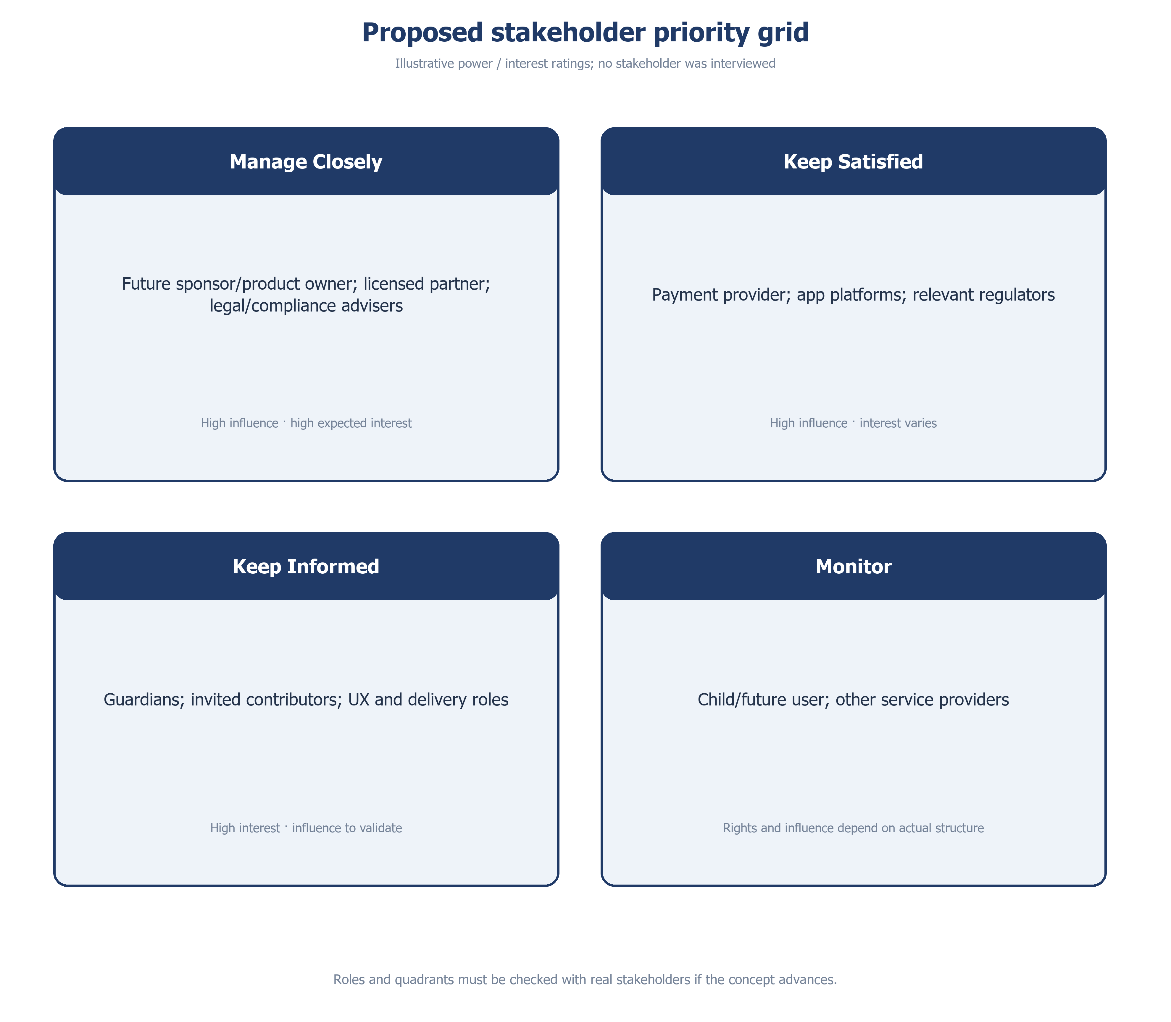
Figure 1: Proposed stakeholder priority grid — BabyFund Thailand

4. Stakeholder Engagement Strategy by Quadrant

4.1 Manage Closely (High Power / High Interest)
These stakeholders can approve, block, or strongly shape the project, and they care closely about the outcome. They need the most attention: regular direct contact, fast answers to their questions, and early warning of any problems.
- CEO / Founder, Product Manager, Compliance Officer, Thai PDPA Officer — would review major decisions if a sponsor team existed.
- Thai SEC, Bank of Thailand, AMLO, PDPC — would be consulted through the applicable regulatory process; no filing or review has occurred.
- Licensed Broker Partner (Custodian) — would define responsibilities and service levels if a partnership were agreed, since this partnership is now the foundation the whole business depends on.
- Possible invite channel (unselected) — would be assessed as a platform dependency, not just routine technical contact, since login, invites and notifications may rely on one channel if alternatives are not designed.

4.2 Keep Satisfied (High Power / Low Interest)
These partners can affect the project a great deal, especially if something goes wrong, but they are not following daily progress closely. They need clear, well-timed updates that keep their confidence without asking too much of their time.
- Potential payment providers, External Auditor, Custodian/Depository, and App Stores — engaged through scheduled reviews and compliance checks at each project milestone, not constant contact.

4.3 Keep Informed (Low Power / High Interest)
These stakeholders care a great deal about the outcome but do not make final decisions. They are kept informed to gather their input and keep their trust.
- IT Development Team, UI/UX Designer, Marketing Team, and Customer Support Team — engaged through daily stand-ups, sprint reviews, and internal demos.
- Thai Parents (Primary Users) — engaged through user research, beta testing, and in-app feedback.

4.4 Monitor (Low Power / Low Interest)
These stakeholders are affected by the project but have little power over it and little daily involvement. Only light, occasional communication is needed.
- Invited contributors may be relatives or other people chosen by the parent. The proposed guest journey avoids a BabyFund account, but payer identity, bank controls and link forwarding remain validation questions. Their interest level is a hypothesis, not a research finding.
- Children Age 13–20 — engaged through age-appropriate app content and BabyFund Academy; a possible age-20 handover remains subject to partner and legal review.

5. Communication Plan Summary
The table below summarizes the communication channel, how often contact happens, and who owns each relationship.
Stakeholder | Channel | Frequency | Owner
CEO / Founder | Steering committee meeting | Weekly | Product Manager
Product Manager | Sprint planning & steering committee | Weekly | Product Manager
Compliance Officer | Compliance review meeting | Bi-weekly | Compliance Officer
Thai SEC | Determine required regulatory contact after legal-role review | Only if applicable | Compliance Officer
Thai PDPA Officer | Data protection review | Bi-weekly | Compliance Officer
Bank of Thailand (BOT) | Determine if any filing or contact applies | To be determined | Compliance Officer
AMLO | Determine reporting owner and duty | To be determined | Compliance Officer
PDPC | Determine applicable notification duty | To be determined | PDPA Officer
Licensed Broker Partner (Custodian) | Proposed partner terms and SLA discussion | Weekly | Product Manager
Possible invite channel (unselected) | Possible channel feasibility review | Monthly | IT Development Team
Potential payment providers | Possible provider feasibility review | Monthly | IT Development Team
External Auditor | Audit engagement | Annual | Compliance Officer
Provider-designated custodian / depository | Proposed reconciliation-role review | Quarterly | Compliance Officer
App Stores (Apple, Google) | Policy compliance check | Before each release | IT Development Team
IT Development Team | Daily stand-up & sprint review | Daily / Bi-weekly | Product Manager
UI/UX Designer | Design review workshop | Weekly | Product Manager
Thai Parents (Primary Users) | User research & in-app feedback | Ongoing | Marketing Team
Marketing Team | Campaign planning meeting | Bi-weekly | Product Manager
Customer Support Team | Support readiness training | Monthly | Customer Support Lead
Invited Contributors | Private invite journey (no BabyFund account proposed) | As needed | Marketing Team
Children Age 13–20 | In-app educational content | As needed | Product Manager

Stakeholder responsibilities to validate
Guardian: creates a child portfolio and planning goals, chooses private invite recipients, reviews unpaid gift intents and sets a voluntary monthly plan. Invited guests can be non-relatives without BabyFund accounts; provider payer checks may still apply.
Licensed investment partner: prospective owner of product suitability, execution, custody and confirmed account value. Payment provider: prospective owner of approved rails, payer checks, confirmation and exceptions. Neither is selected or engaged.
Child: beneficiary of goal planning; access, legal ownership and handover must be determined separately. Named banks, LINE and regulators are examples or dependencies, not confirmed project partners.

Engagement status and accountability
All named providers and channels are examples. No broker, payment provider, bank, LINE team or regulator has joined the case study. Any meeting cadence, SLA, filing or sign-off elsewhere in this matrix is a proposed future activity, not an event that occurred.
A future partner decision record must name who opens and owns the account, checks payer and suitability, accepts and returns funds, invests and holds assets, provides valuation, handles disputes, approves withdrawal and confirms age-20 title transfer. BabyFund’s own privacy, marketing and regulated-role responsibilities require separate review.

