BABYFUND THAILAND | CASE STUDY
Family Savings Coordination Platform
PROCESS FLOW DIAGRAMS
Document Title | Process Flow Diagrams
Project Name | BabyFund Thailand — Family Savings Coordination Platform
Document Version | Portfolio edition
Status | Simulated BA case study — unvalidated design
Date | October 2026
Prepared By | Tankhun Luengchaicharn, Junior IT Business Analyst
Approved By | Not approved — simulated case study

1. Purpose
This document shows, step by step, how three of the most important processes work inside BabyFund Thailand. The revised diagrams show proposed actors, decisions and provider validation gates as labelled steps. Exception outcomes are described in the boxes and walkthrough. A plain-language walkthrough and a list of linked requirements follow each diagram.

2. Flow 1 — Parent Onboarding & KYC Verification
This flow shows proposed guardian setup, the child-age gate, planning-profile creation, and conditional partner identity and eligibility checks. A planning profile is not an investment account.
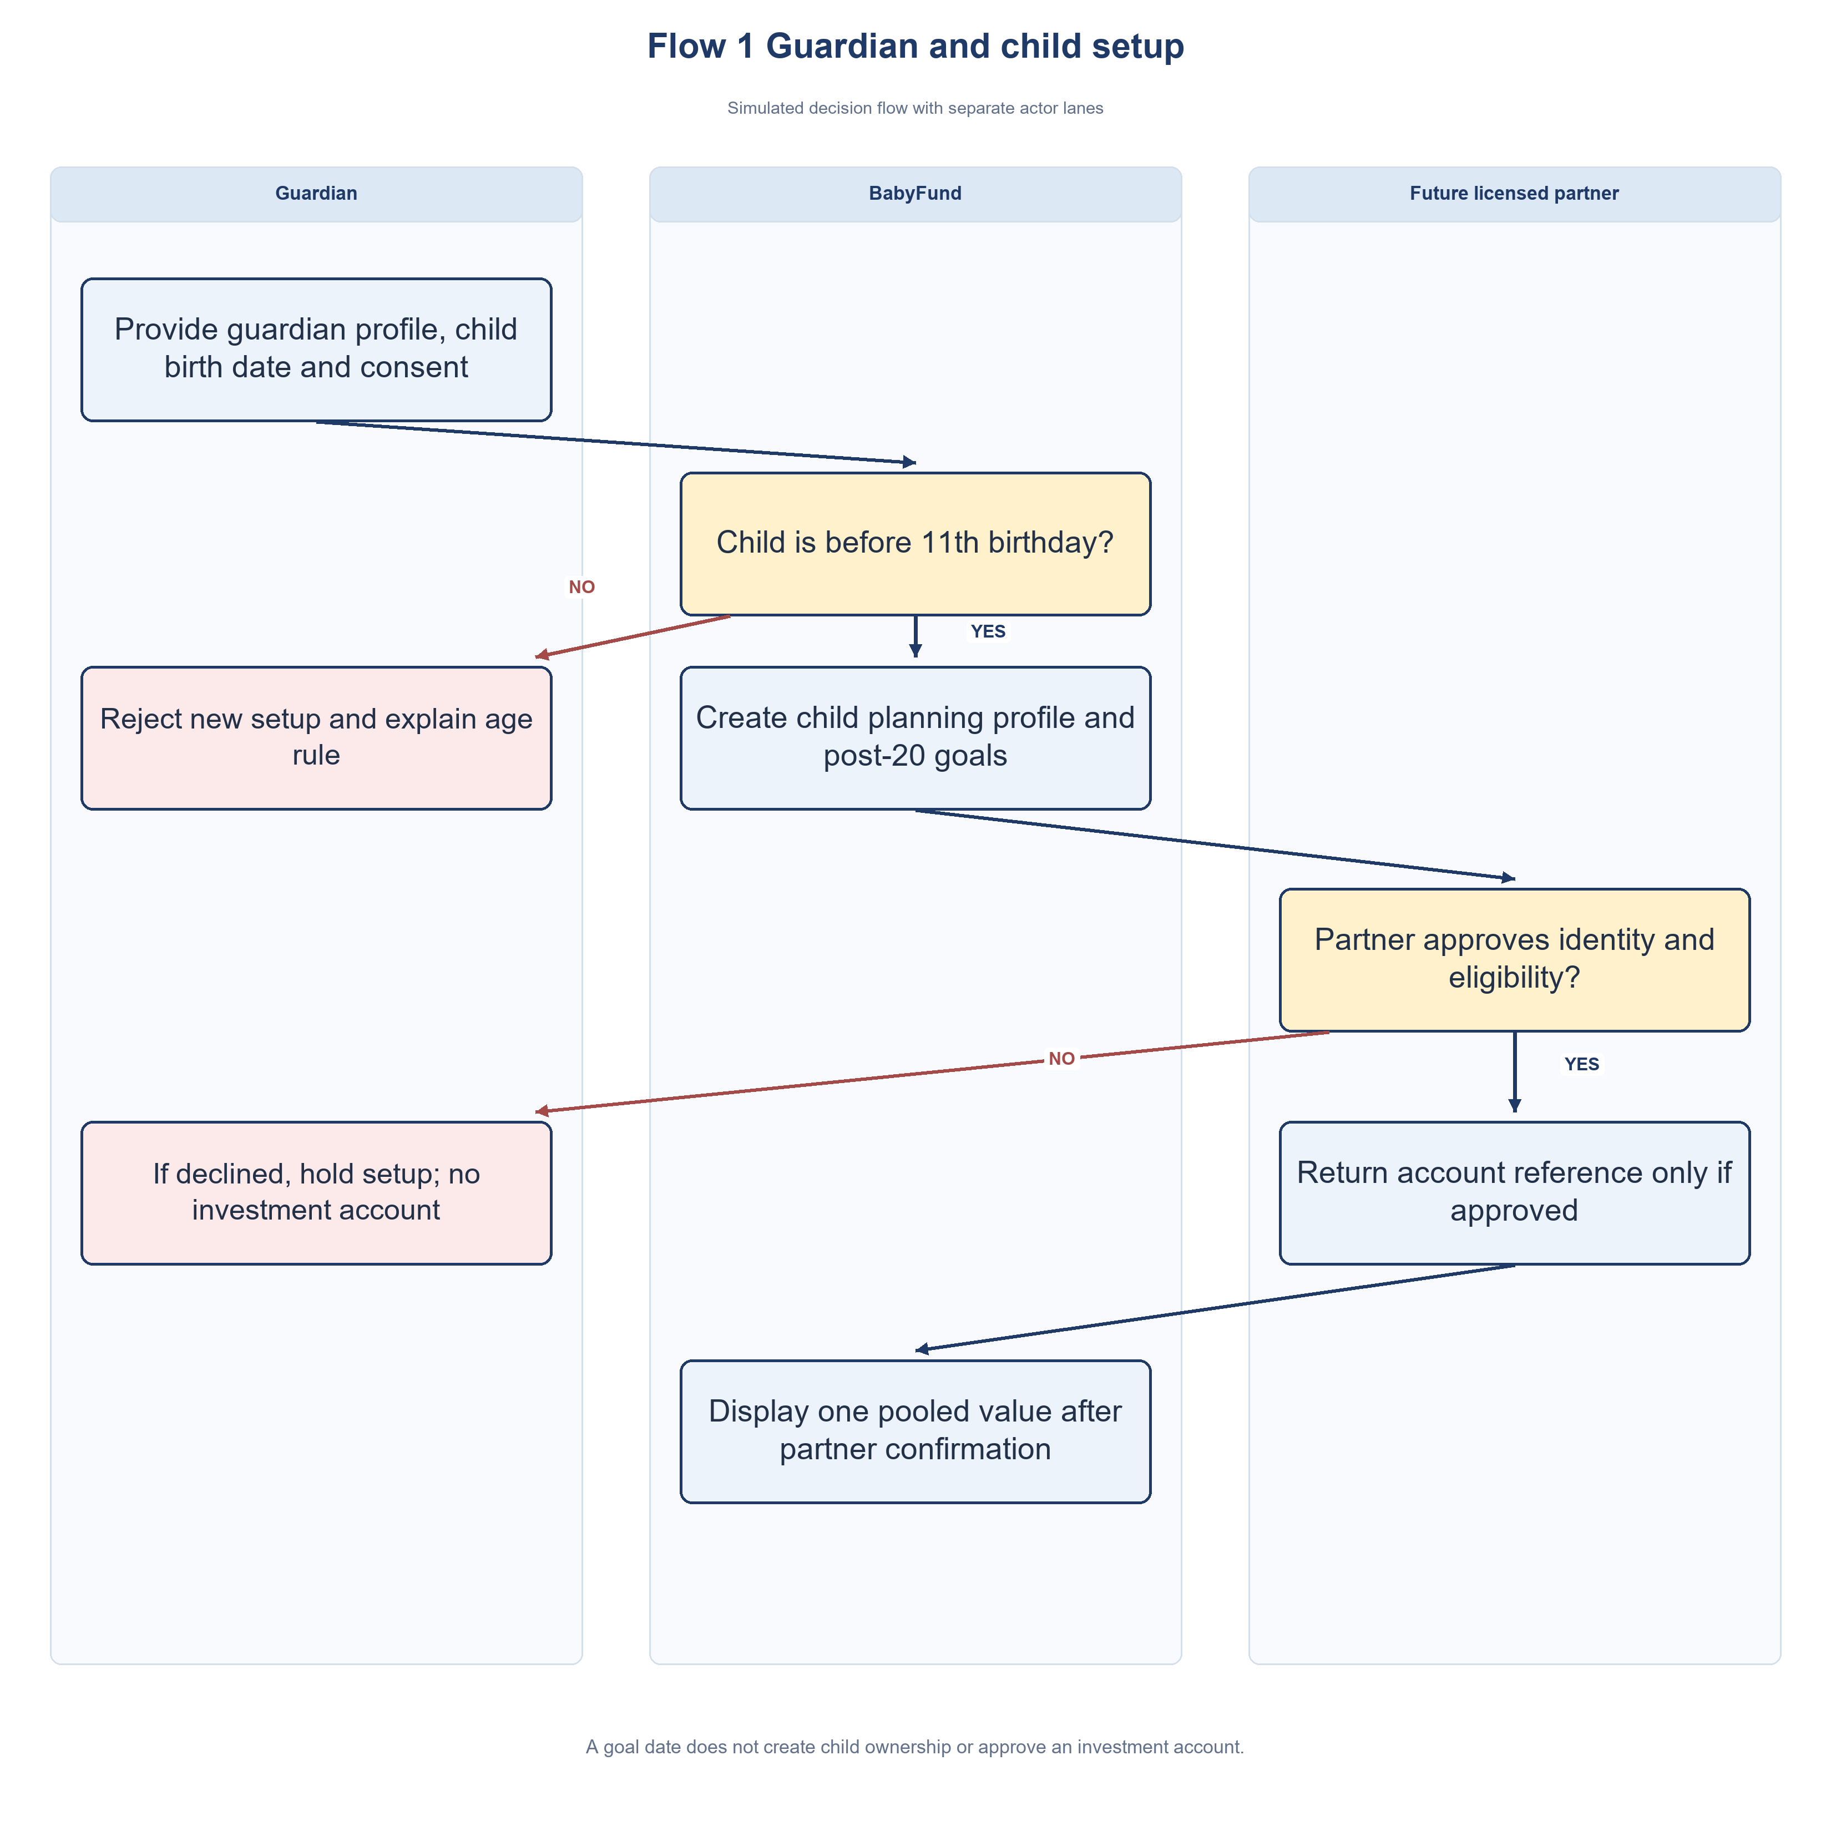
Figure 1: Guardian onboarding and child goal — proposed

Step-by-Step Walkthrough
1. The guardian provides a profile, child birth date and required consent. If consent is withheld, setup stops.
2. BabyFund checks whether the child is before the 11th birthday. At or after that birthday, new setup stops and the age rule is explained.
3. For an eligible child, BabyFund creates a planning profile with goals due on or after the 20th birthday. This does not establish child ownership.
4. A proposed licensed partner determines the identity and eligibility checks needed for any investment account. No live integration or agreed KYC process exists.
5. If the partner declines or cannot confirm eligibility, the case is held without an investment account or invested value.
6. Only after partner approval does BabyFund record the partner-supplied account reference, subject to the confirmed account and custody structure.
7. BabyFund shows one pooled child value only after partner confirmation, separately from planning goals and pending intents.
Linked Requirements: FR-001, FR-005, RULE-01

3. Flow 2 — Invited Guest Contribution & Investment Process
This flow follows an invited guest from gift intent to partner-confirmed S&P 500-linked investment and the parent seeing an updated balance.
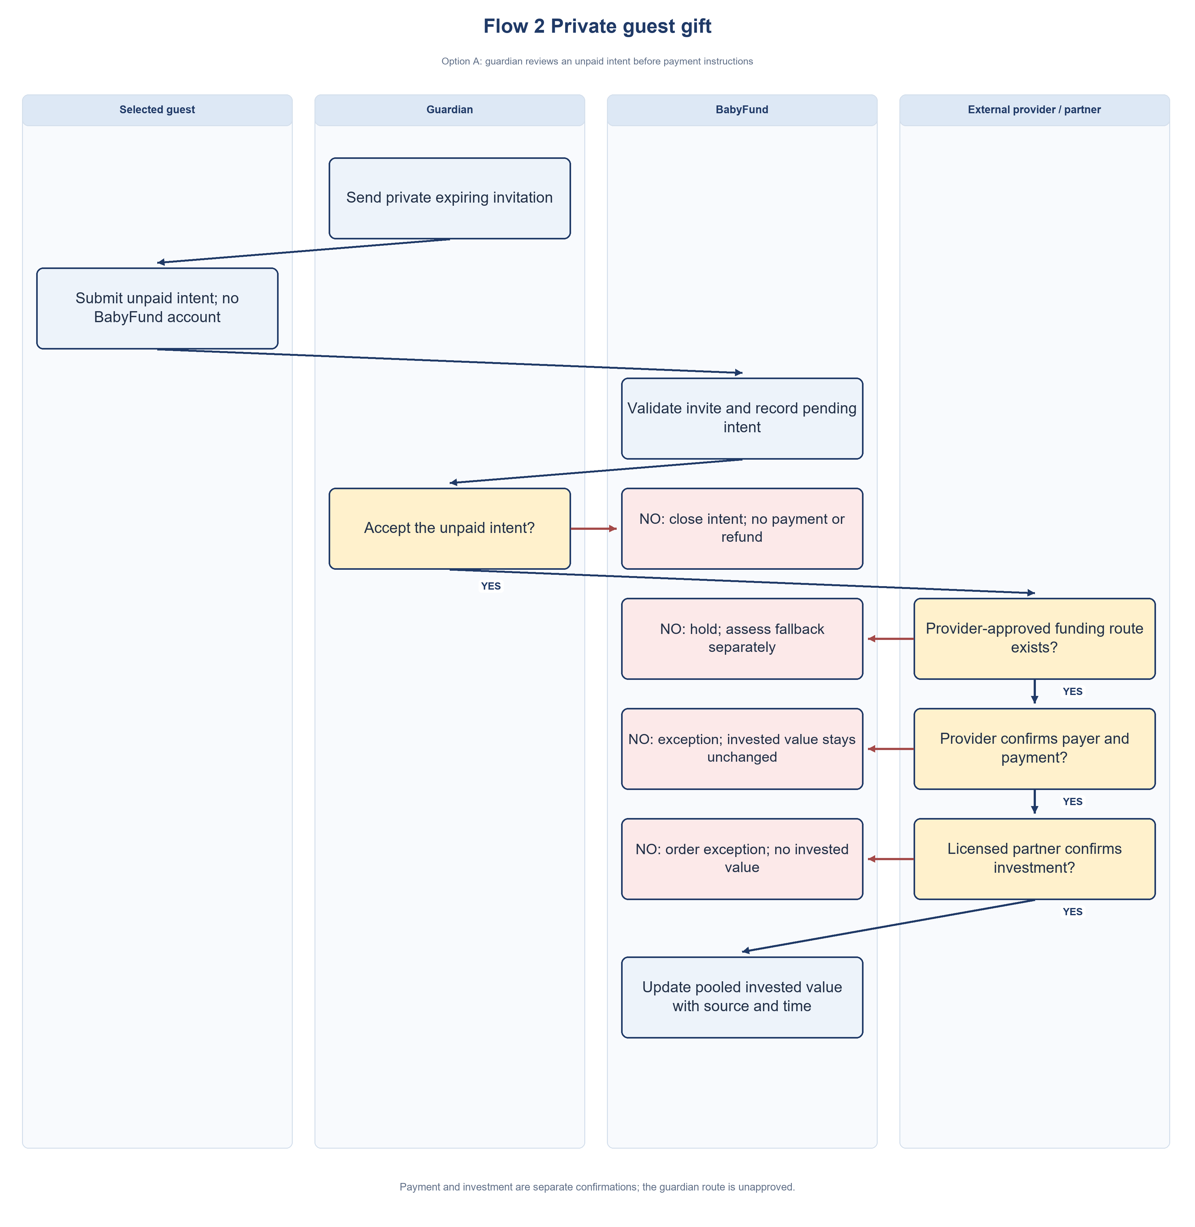
Figure 2: Invited guest contribution — owner-selected Option A, subject to provider validation

Step-by-Step Walkthrough
1. A selected guest opens an unexpired private invite and submits an unpaid gift intent. Parent deposits and recurring instructions are separate paths.
2. BabyFund asks the guardian to accept or decline the intent and records the decision and time. No payment instruction is shown while review is pending.
3. If declined or expired, the unpaid intent closes. If accepted, a provider-approved payment route may be shown; BabyFund never holds client money.
4. The responsible provider checks payer eligibility and payment reference. A mismatch, failure, timeout or duplicate enters exception review without increasing invested value.
5. BabyFund displays payment received only after provider confirmation, with source and time. Any required FX rate and fee come from the responsible provider.
6. The licensed partner alone decides eligibility, custody and execution of a suitable S&P 500-linked product; vehicle and suitability rules are not agreed.
7. BabyFund displays invested status/value only after licensed-partner confirmation, separately from accepted intent and payment received, with source and as-of time.
8. A milestone notice may follow only after partner-confirmed invested value crosses the threshold; pending gifts never trigger it.
Linked Requirements: BR-008, RULE-03; FR-010 to FR-013, FR-017, FR-022, FR-027

4. Flow 3 — Withdrawal request and conditional age-20 handover
This flow replaces the original "hard lock until age 18" design. It shows two separate paths: the normal path, where a possible age-20 handover is requested, and the early withdrawal path, where a parent can request funds before then under clear conditions.
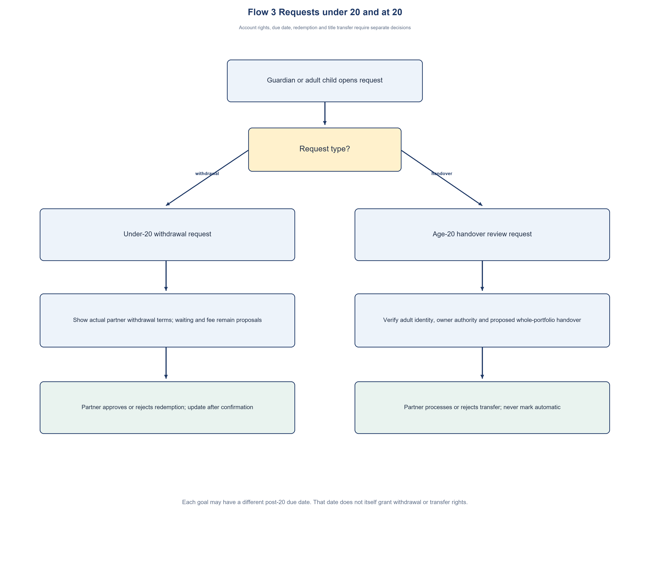
Figure 3: Withdrawal and possible age-20 handover — conditional

Step-by-Step Walkthrough
1. A guardian or adult child opens the relevant request; BabyFund distinguishes an under-20 withdrawal request from an age-20 handover review.
2. Path A — Child Turns 20: the child completes their own identity verification. If verification succeeds, the partner reviews whether and how ownership can be transferred; no automatic transfer is assumed. If not, the current partner-confirmed legal ownership and access remain unchanged.
3. Path B — Early Withdrawal Request: the parent submits a request with a documented reason. Eligibility follows the partner's confirmed terms; BabyFund does not decide legal withdrawal rights.
4. If the partner accepts the request, the app displays any partner-approved waiting period and fee before confirmation.
5. The guardian confirms only if the partner's actual terms require a further step; otherwise the provider processes or rejects the request.
6. When all required steps are met, the partner processes or rejects the request under its confirmed rules and reports the outcome.
Linked Requirements: FR-020, FR-021, FR-026, RULE-02

Flow control notes
Flow 1 checks the child-age gate before proposed partner identity and eligibility checks: before the 11th birthday continues; the 11th birthday or older stops new setup. Each goal due date must be on or after the 20th birthday. A declined or unconfirmed partner application creates no investment account or invested value.
Flow 2 branches on guardian accept or decline before payment. Accepted intent proceeds only if a provider-approved route exists. Payment failure, expiry, duplicate reference or partner rejection enters exception review and never counts as invested value. The guardian-mediated fallback is a separate route pending provider review.
Flow 3 separates an under-20 withdrawal request from an age-20 handover request. The actual owner’s rights and partner decision control both; a goal due date does not trigger automatic transfer.

Decision points missing from a real operating flow
The diagrams show a proposed sequence only. Before any live payment path, a partner/provider must answer: third-party payer allowed? payer matching method? route expiry? failed/duplicate/late payment owner? refund or return path? investment rejection handling? The answer determines the actual branches.
For multiple goals, a private invitation carries invite_id and child_id. After partner confirmation, the mock ledger assigns the event once. Later goal edits affect only planning views. Valuation loss, real partial withdrawal and any age-20 partial handover need partner rules and tests before implementation.
If the selected partner disallows direct guest funding, Option C is a separate proposal requiring approval. Guest-to-guardian payment and guardian-to-partner investment are two events, with no implied custody or automatic trace.

