BABYFUND THAILAND | CASE STUDY
Family Savings Coordination Platform
USE CASE DIAGRAM & DESCRIPTIONS
Document Title | Use Case Diagram & Descriptions
Project Name | BabyFund Thailand — Family Savings Coordination Platform
Document Version | Portfolio edition
Status | Simulated BA case study — unvalidated design
Date | October 2026
Prepared By | Tankhun Luengchaicharn, Junior IT Business Analyst
Approved By | Not approved — simulated case study

1. Purpose
This document presents the overall Use Case Diagram for BabyFund Thailand, showing the core actors and selected use cases in the simulated scope, followed by detailed step-by-step descriptions for the five most important use cases. A brief summary table covers the remaining use cases for completeness.

2. Use Case Diagram
The revised map groups the core guardian, invited guest, licensed-provider and future-child interactions. It is a scope map, not formal UML; external capabilities remain proposed.
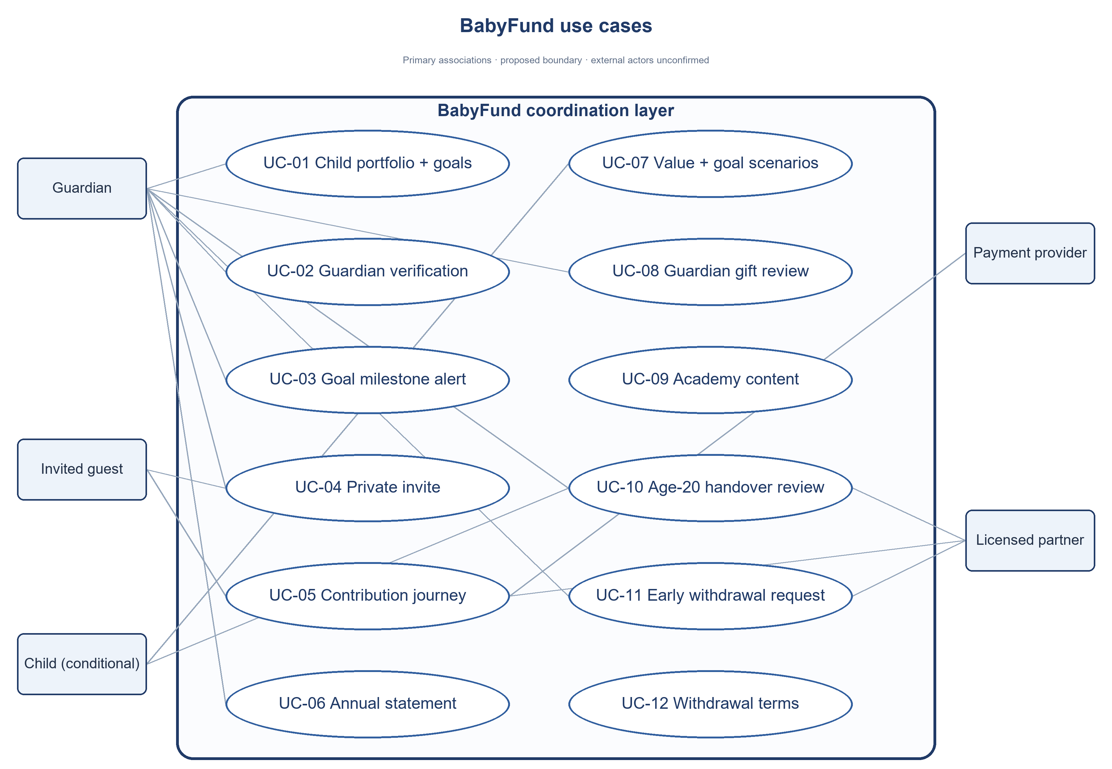
Figure 1: Proposed use case map — BabyFund Thailand

3. Detailed Use Case Descriptions

3.1 UC-01: Open Child Account & Set Dream Board
Actor(s) | Parent (primary); KYC Verification Service (supporting)
Description | Allows a verified guardian to request one child portfolio for a child younger than 11 and set several planning goals with dates on or after age 20. Legal account creation remains partner-dependent.
Preconditions | The parent has completed identity verification (KYC) and holds a verified profile.
Main Flow
1. Parent selects "Add Child" from the home dashboard.
2. Parent uploads the child's birth certificate.
3. System validates the birth certificate details.
4. Guardian creates one or more goals, each with a target and due date at or after the 20th birthday.
5. System records the child profile and planning goals; any investment account reference is added only after partner confirmation.
6. System displays the new account on the parent's home dashboard.
Alternative / Exception Flow
If evidence is missing, setup stays pending. On or after the 11th birthday, a new child portfolio is rejected. A goal date before the 20th birthday is rejected.
Postconditions: An eligible child profile and one or more planning goals are recorded; this alone does not create an investment account or change legal ownership.
Linked Requirements: FR-002, FR-003, FR-019; BR-002; RULE-01, RULE-14

3.2 UC-05: Make a Contribution
Actor(s) | Guardian, Invited Contributor; Licensed Partner (proposed)
Description | Allows money to be added to a child's fund, either as a one-time deposit, a recurring monthly deposit, or an occasion-tagged gift from a selected contributor.
Preconditions | The child account exists. For family contributions, a gift link or QR code has been generated by the parent.
Main Flow
1. An invited guest submits an unpaid intent from a valid private invite; a parent deposit follows its own funding path.
2. BabyFund records the guest intent as awaiting guardian review and shows no payment instruction.
3. The guardian accepts or declines. Decline closes the unpaid intent; acceptance permits only a provider-approved payment step.
4. The provider checks payer eligibility and reference, then reports confirmed payment or an exception. BabyFund never holds the guest's money.
5. The licensed partner checks suitability and eligibility, reports any required FX rate/fee, and alone confirms an eligible investment order.
6. BabyFund separates review, accepted-awaiting-payment, paid, exception and invested states, with provider source and as-of time.
Alternative / Exception Flow
If payment fails, times out or cannot be matched, the app shows an exception and does not increase invested value.
If the guardian declines before payment, the app closes the unpaid intent without showing payment instructions. A later post-payment dispute follows the responsible provider's process.
Postconditions: The app shows invested value only after partner confirmation; declined or failed intents do not increase it.
Linked Requirements: FR-006 to FR-009, FR-011 to FR-013; BR-004 to BR-006, BR-023; RULE-03, RULE-04, RULE-09, RULE-10

3.3 UC-07: View Portfolio Growth & Projections
Actor(s) | Parent; Child read-only view from age 13 (roadmap, conditional)
Description | Allows the parent, or the child in read-only mode, to view the current fund balance, growth history, and a projected future value.
Preconditions | The child account has been created and has at least one recorded balance.
Main Flow
1. User opens the child's account detail screen.
2. System displays the partner-confirmed child value in Thai Baht separately from pending items, and shows each goal planning view once.
3. System displays a growth chart showing how the balance has changed over time.
4. User opens the Growth Projector tool and enters a monthly contribution amount.
5. System calculates per-goal scenarios through that goal’s due date using its pooled value and remaining months.
Alternative / Exception Flow
A child view is disabled until access, consent and partner rules are approved; a proposed age-13 threshold is not a live entitlement.
Postconditions: The user has a timestamped view of the latest partner-sourced value, growth history, and projected future value.
Linked Requirements: FR-022, FR-023, FR-025; BR-013, BR-014, BR-016; RULE-07

3.4 UC-04: Invite Selected Contributor
Actor(s) | Parent; optional invite channel (supporting)
Description | Allows a parent to generate a private child-portfolio invitation that lets a selected person propose an unpaid gift without creating a BabyFund account.
Preconditions | The child account exists and the parent is logged in.
Main Flow
1. Parent opens the Family Fund Circle screen.
2. Parent selects "Invite Contributor."
3. System generates a QR code and a LINE-shareable link tied to the specific child's account.
4. Parent shares the link through LINE.
5. The selected person opens the private, expiring link without a BabyFund account and submits an unpaid intent. Payment instructions appear only after guardian acceptance and provider checks.
6. The provider performs required payer checks; a QR scan is not proof of identity.
Alternative / Exception Flow
If a payment route expires or payment is not confirmed, no invested amount is recorded. Any intent expiry follows its own configured rule; no BabyFund account is created for the guest.
Postconditions: A private gift invitation is active for the selected child portfolio, and any resulting contribution is recorded as tracked under the selected contribution status.
Linked Requirements: FR-010, FR-012; BR-007; RULE-10

3.5 UC-10: Request Possible Age-20 Handover
Actor(s) | Child (age 20); KYC Verification Service (supporting)
Description | Requests a possible age-20 handover for partner and legal review; age and KYC alone do not change ownership. This use case replaces the original "hard lock until 18" design. See also UC-11 (Request Early Withdrawal) for the separate early-withdrawal path.
Preconditions | The child has reached 20 years of age; transfer eligibility, scope and steps remain partner decisions.
Main Flow
1. At age 20, the guardian or child may request a handover review under partner rules.
2. The partner specifies required identity, consent and ownership evidence.
3. BabyFund forwards only authorised information through an approved process.
4. Upon successful verification, the licensed partner assesses and, if permitted, completes a documented handover.
5. Child receives only the access confirmed by the partner, under the confirmed account terms.
Alternative / Exception Flow
If requirements are not met or no transfer route exists, the existing legal ownership and access remain unchanged.
Postconditions: Ownership changes only after all legal, consent and partner steps are completed; otherwise existing ownership continues.
Linked Requirements: FR-026; RULE-01, RULE-07

4. Summary of Remaining Use Cases
The following use cases appear in the diagram but are not detailed above. They are summarized here for completeness.
ID | Name | Actor(s) | Brief Description
UC-02 | Register & Verify Identity (KYC) | Parent, KYC Service | Confirms a parent's identity using their Thai national ID card before any account can be created.
UC-03 | Receive Milestone Notifications | Parent, optional notification channel | Sends an in-app and LINE alert when a child's fund reaches a savings target.
UC-06 | Export Annual Statement | Parent | Generates a downloadable Thai-language PDF summarizing a year of account activity.
UC-08 | Review Invited Contribution | Parent | Lets a parent approve or decline a gift intent from an invited person before any payment instruction is shown.
UC-09 | Access BabyFund Academy | Parent, Child | Provides Thai-language financial education content within the app.
UC-11 | Request Early Withdrawal | Parent, Licensed Broker Partner | Lets a guardian request a withdrawal under the licensed partner's confirmed rights, evidence and fee terms.
UC-12 | Withdrawal Terms Disclosure | (Included by UC-11) | Shows the partner's applicable waiting period or fee only if its approved terms require them.

Use case identifiers and boundaries
The existing IDs are preserved: UC-01 child portfolio and goals; UC-02 guardian verification; UC-03 goal milestone alert; UC-04 private invite; UC-05 contribution journey; UC-06 annual statement; UC-07 invested value and per-goal scenarios; UC-08 guardian gift review; UC-09 Academy; UC-10 age-20 handover review; UC-11 early withdrawal request; UC-12 withdrawal terms.
The diagram uses each of the existing twelve identifiers once. The Child actor links to UC-07 and UC-10 only as conditional access; it does not imply ownership. The payment provider links to UC-05, while the proposed licensed partner links to UC-05, UC-10 and UC-11. BabyFund records and displays states; external providers decide payment, product eligibility, execution, custody and transfer under their confirmed rules. No participant is a confirmed partner.

Use case boundary corrections
UC-04 invitation is selected-person and child-portfolio-linked, not a public fundraising QR. UC-05 guest intent is unpaid. UC-08 guardian review occurs before any provider payment instruction, not merely before investment. UC-07 invested value requires partner confirmation. UC-10 age-20 handover remains a request and partner decision.
Child read-only access from age 13 and Academy are roadmap proposals. They do not create child ownership or demonstrated production functionality.

UC-07 extension for all-goals view
The guardian may switch between one-goal sensitivity and an all-goals illustration. The all-goals view starts from one partner-confirmed child value, applies one monthly plan until age 20, and deducts hypothetical uses in due-date/priority order. It shows shortfall and residual by goal. It does not place a sell order or change the adult child’s legal rights. Links: BR-031, FR-039, US-21, UAT-21/UAT-22.

