BABYFUND THAILAND | CASE STUDY
Family Savings Coordination Platform
WIREFRAMES
Document Title | Wireframes
Project Name | BabyFund Thailand — Family Savings Coordination Platform
Document Version | Portfolio edition
Status | Simulated BA case study — unvalidated design
Date | October 2026
Prepared By | Tankhun Luengchaicharn, Junior IT Business Analyst
Approved By | Not approved — simulated case study

1. Purpose
This document records owner-supplied captures of the BabyFund Thailand Base44 prototype as a simulated BA portfolio artifact. The 38 images below show 13 screen groups supplied on 12 October 2026. They illustrate proposed behaviour, not a working investment, payment, identity or broker integration. The guardian-review set ends before the last on-screen note because the owner chose to use the available captures.

2. Prototype Screen Captures

Figures 01–13: latest owner-supplied Base44 prototype captures, grouped by screen. Each page shows one readable image segment; adjacent segments belong to the same scrolling screen. All values and statuses are simulated.

Screen 01 Guardian home (1/2)
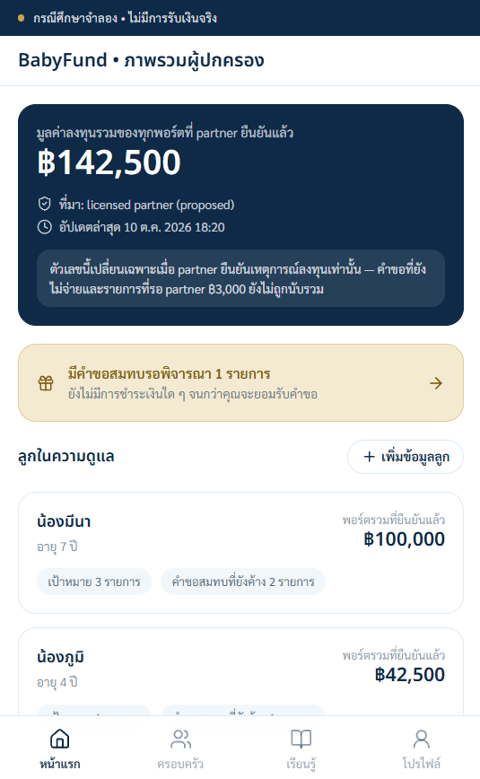

Screen 01 Guardian home (2/2)
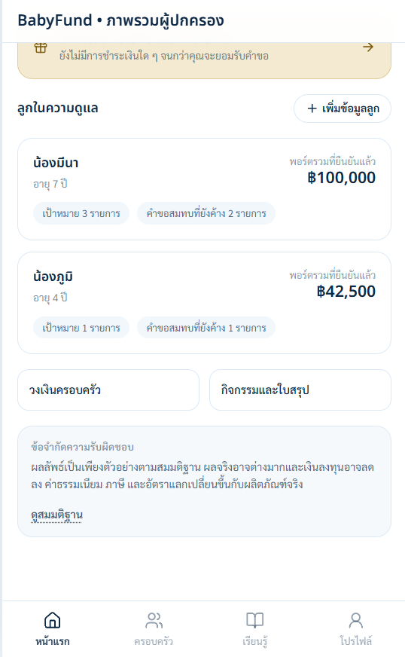

Screen 02 Child portfolio (1/3)
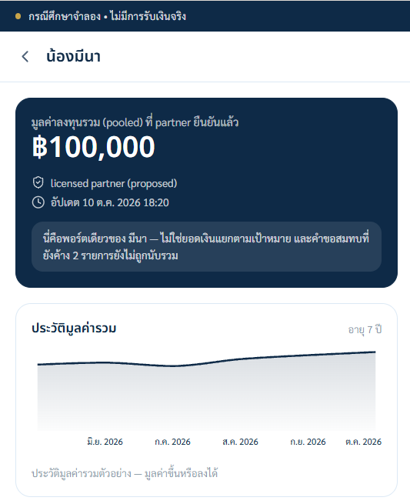

Screen 02 Child portfolio (2/3)
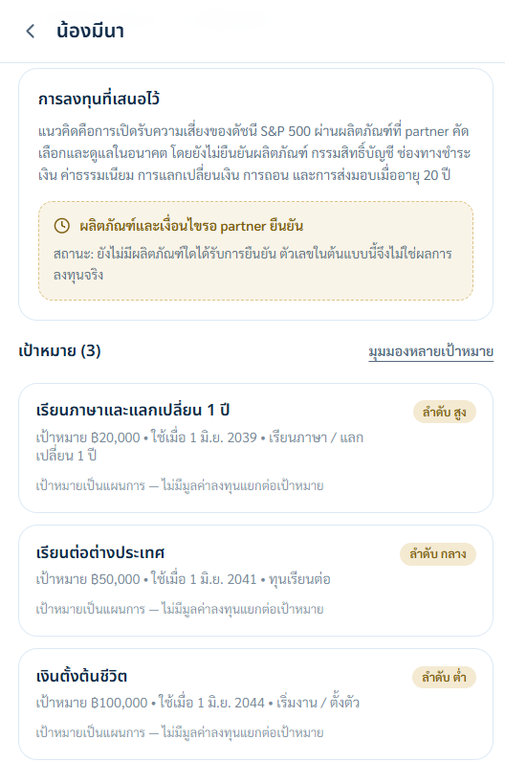

Screen 02 Child portfolio (3/3)


Screen 03 Multiple goals (1/3)
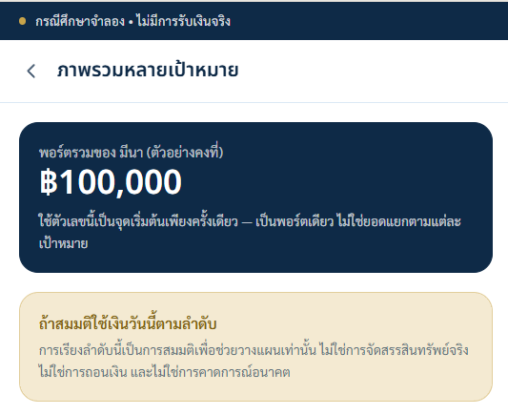

Screen 03 Multiple goals (2/3)
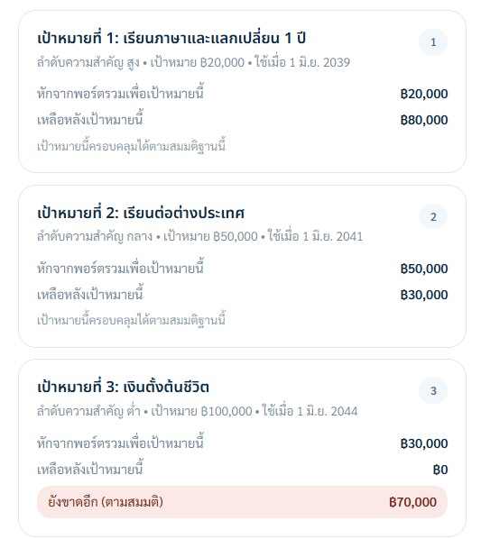

Screen 03 Multiple goals (3/3)


Screen 04 Guardian contribution (1/2)
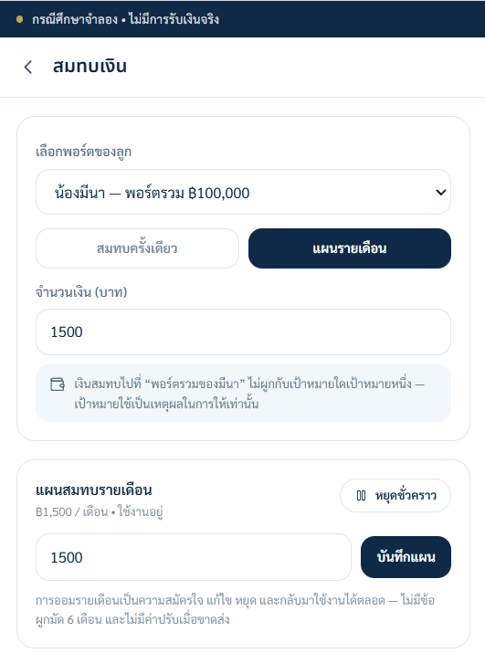

Screen 04 Guardian contribution (2/2)
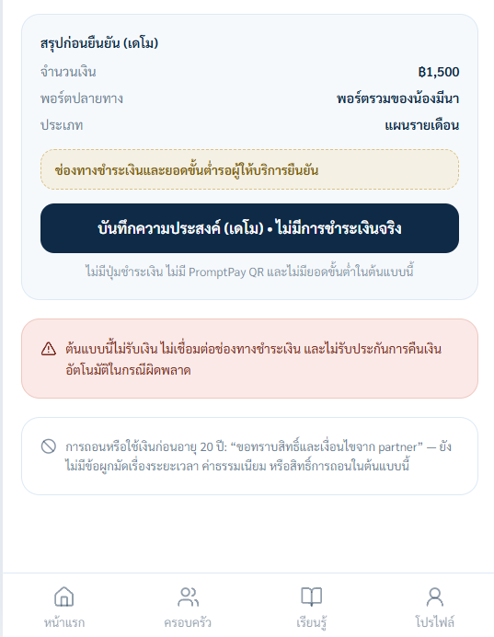

Screen 05 One goal projector (1/5)
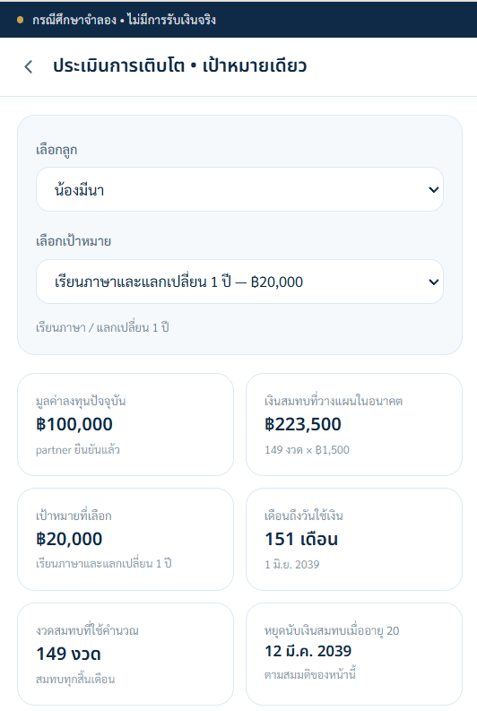

Screen 05 One goal projector (2/5)


Screen 05 One goal projector (3/5)
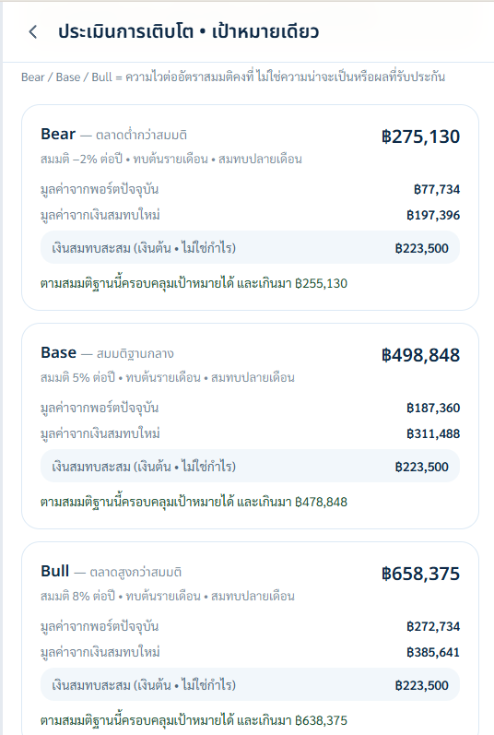

Screen 05 One goal projector (4/5)
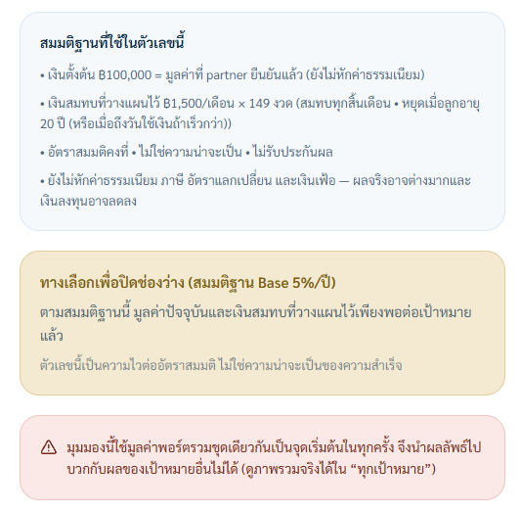

Screen 05 One goal projector (5/5)
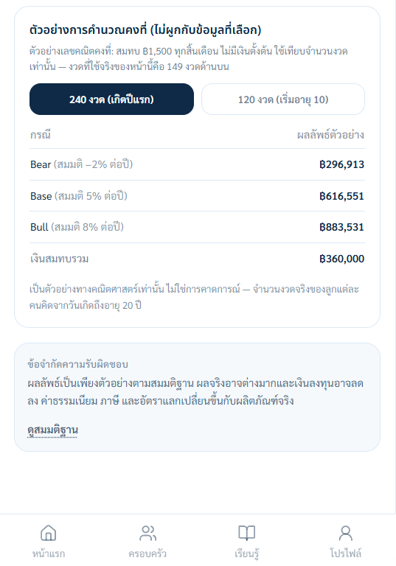

Screen 06 All goals projector (1/4)
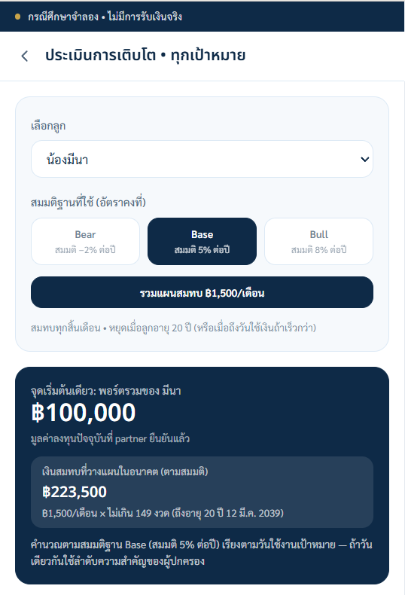

Screen 06 All goals projector (2/4)
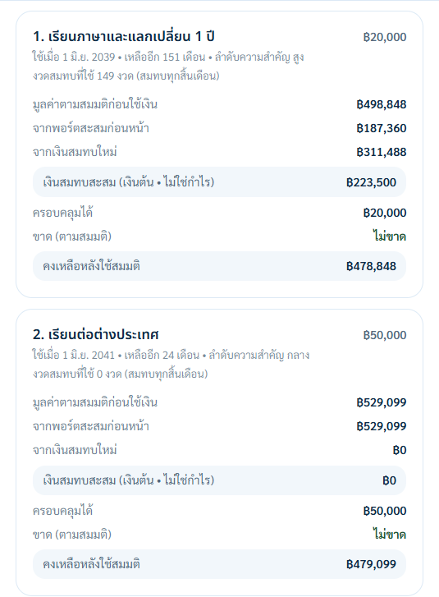

Screen 06 All goals projector (3/4)
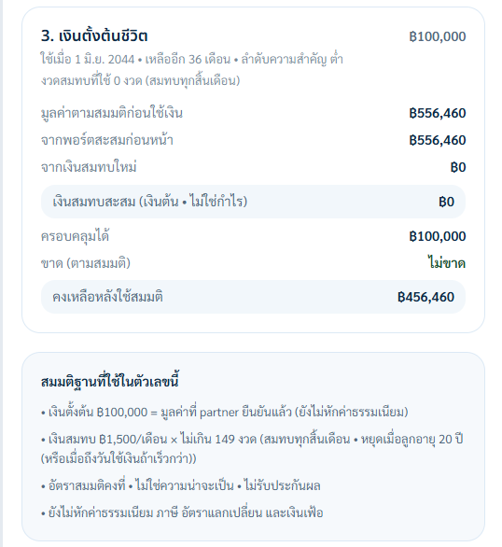

Screen 06 All goals projector (4/4)


Screen 07 Family Circle (1/3)
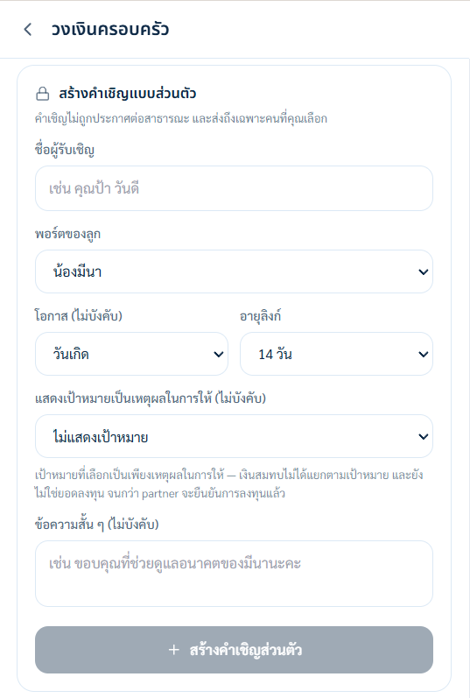

Screen 07 Family Circle (2/3)


Screen 07 Family Circle (3/3)
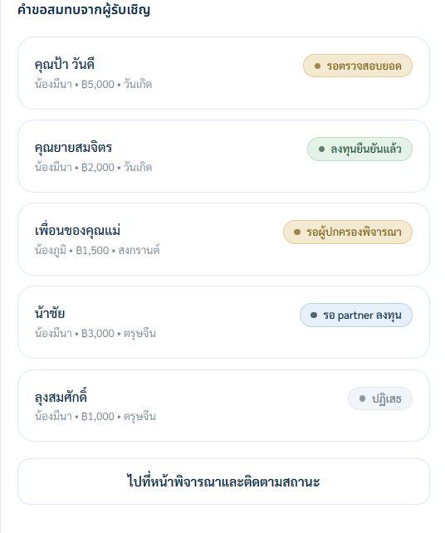

Screen 08 Active private invitation and QR (1/3)


Screen 08 Active private invitation and QR (2/3)
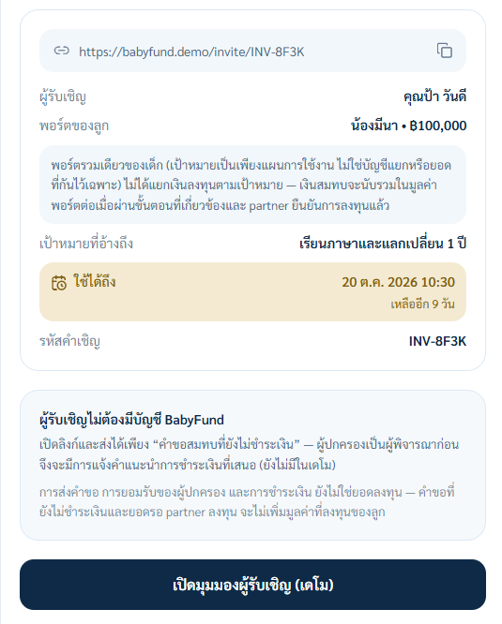

Screen 08 Active private invitation and QR (3/3)


Screen 09 Cancelled invitation state (1/3)
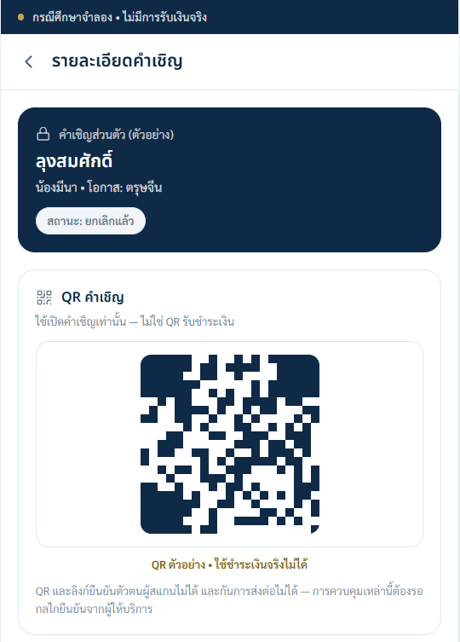

Screen 09 Cancelled invitation state (2/3)
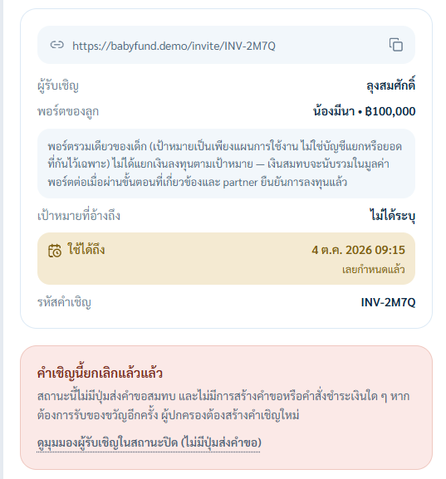

Screen 09 Cancelled invitation state (3/3)
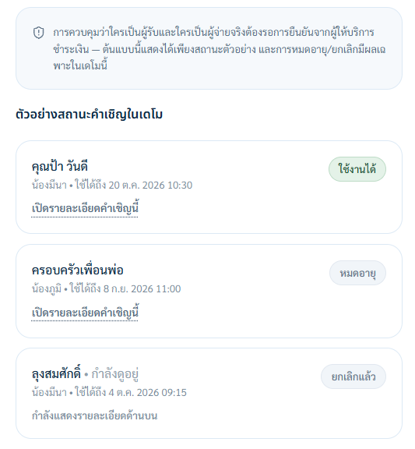

Screen 10 Guest view (1/2)


Screen 10 Guest view (2/2)
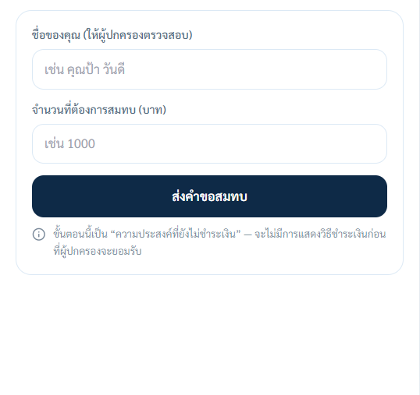

Screen 11 Guardian review and statuses (1/3)
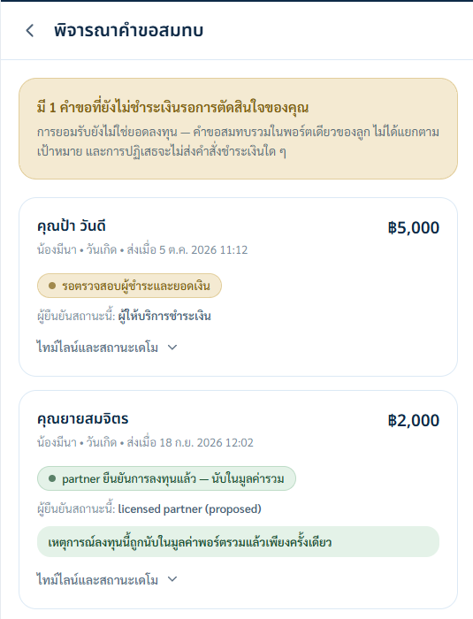

Screen 11 Guardian review and statuses (2/3)
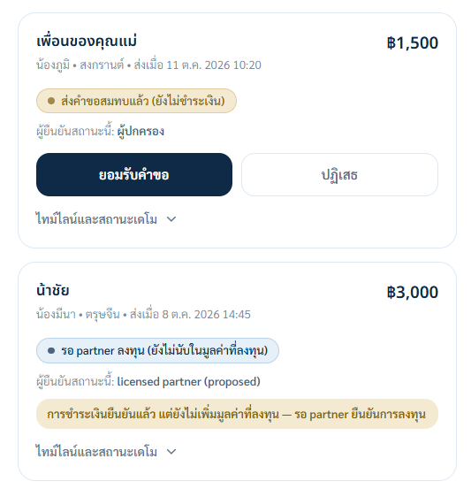

Screen 11 Guardian review and statuses (3/3)
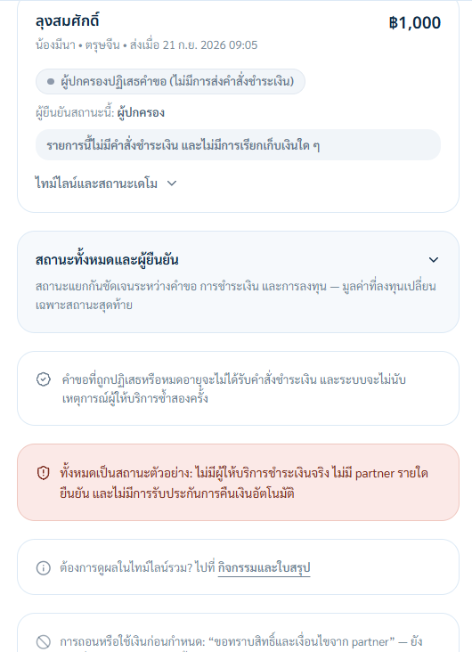

Screen 12 Academy (1/3)


Screen 12 Academy (2/3)


Screen 12 Academy (3/3)


Screen 13 Add child and goals (1/2)
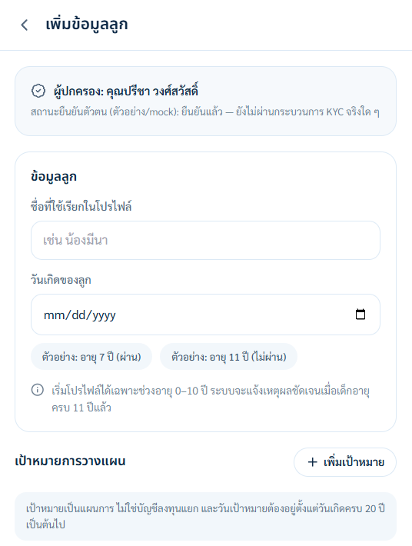

Screen 13 Add child and goals (2/2)
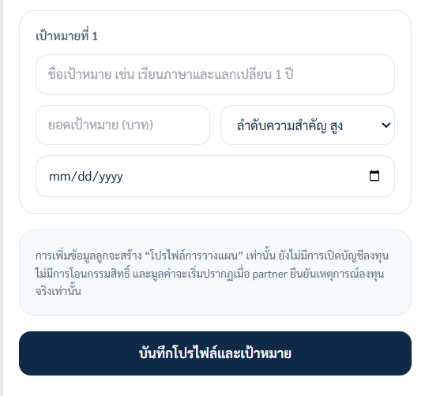

3. Screen Descriptions and Requirement Links

3.1 Screen 1: Guardian Home
The captured home shows the illustrative partner-confirmed family total, a separate pending request, child cards and source/update time. These are synthetic values in a prototype; there is no connected partner.
• The total and each child card show partner-confirmed value as a simulated status, not real holdings.
• Pending intents and amounts awaiting a partner remain outside the invested value.
• “Add Child” opens a planning-profile form with an age 0–10 eligibility rule.
• A bottom navigation bar for Home, Family Circle, Academy, and Profile.
Linked Requirements: FR-004, FR-022; BR-013

3.2 Screen 2: Child Portfolio and Multiple Goals
The child page shows one pooled child value. The separate multi-goal view applies a priority-based today-only illustration; goals do not hold separate invested balances.
• The example child value is displayed once in THB with a proposed source and as-of time; the prototype does not show a secondary USD value.
• The history chart is labelled illustrative. No actual valuation feed or performance history exists.
• Goal cards carry targets, dates and priority. The affordability view deducts each hypothetical use before the next.
• S&P 500 exposure is described as a concept awaiting product, ownership, fee, FX and suitability decisions from a future partner.
• The child page has “สมทบเงิน” and “ใบสรุปตัวอย่าง” shortcuts; neither sends a real transaction.
Linked Requirements: FR-017, FR-018, FR-022, FR-023; BR-010, BR-013

3.3 Screen 3: Add Money
The guardian can record a one-time intent or maintain a voluntary monthly plan. The prototype does not collect money or show a live payment method.
• One-time and monthly-plan choices are visible; the plan can be edited or paused without a BabyFund penalty.
• An amount entry field showing the value in Thai Baht.
• The payment route and minimum amount are explicitly pending provider confirmation.
• A demo summary names the amount and pooled child destination before saving an intent.
• No real PromptPay QR, provider-approved minimum or money-transfer button appears in this prototype.
Linked Requirements: FR-006, FR-007, FR-009; BR-004, BR-005; RULE-04

3.4 Screen 4: Growth Projector
The current one-goal projector shows current pooled value, selected target/date, remaining months, optional monthly plan and three fixed-rate sensitivities. The screenshot labels 149 end-of-month deposits before age 20 and then two growth-only months to the selected goal date.
• The monthly amount uses a numeric input; it is not a slider in the captured prototype.
• Bear, Base and Bull are sensitivity inputs, not success probabilities or market forecasts.
For a post-20 goal, the current prototype counts planned monthly contributions only until the child turns 20, then compounds the illustrative balance until the goal date. It does not assume payments continue beyond age 20.
• A clear disclaimer that every scenario is an illustration; S&P 500 equity and FX risks could leave the value below total contributions.
Birth-to-20 arithmetic example only: FV = 1,500 × ((1+r/12)^240 − 1)/(r/12), end-of-month gifts. The app recalculates n from the selected child and goal dates. At r = −2%, 5%, 8% nominal, the values round to ฿296,913, ฿616,551, ฿883,531. Principal is ฿360,000. Rates are sensitivity inputs, not probabilities or S&P 500 forecasts; fees, tax and FX are excluded.
Linked Requirements: FR-023; BR-014

3.5 Screens 07–11: Family Circle, Invitations, Guest Intent and Guardian Review
The guardian creates a private invitation for a selected person and child portfolio. The invited guest can propose an unpaid gift without a BabyFund account; guardian review comes before any provider-approved payment route.
• Screens 07–09 show the private invitation form, an active sample QR and a cancelled invitation. The QR opens an invitation; it is not a payment instruction or identity check.
• The captured guest page shows an account-free unpaid-intent form and explicitly says no payment method is shown before guardian acceptance.
• The review screen separates unpaid intent, payer/payment checks and partner investment. Only the final partner-confirmed event may affect invested value.
• The visible statuses are synthetic. Payer validation, payment reconciliation, investment, reversals and refunds remain partner/provider questions.
Linked Requirements: FR-010 to FR-014; BR-007 to BR-009, BR-023; RULE-03

3.6 Screens 12–13: BabyFund Academy and Child Eligibility
The Academy page contains sample Thai lesson cards and labels the wider library as roadmap. The Add Child form displays age-7 eligible and age-11 ineligible examples for the proposed 0–10 entry rule; the screenshots do not show an executed form submission.
• The prototype shows example lessons, not a working video library or completed-lesson tracking.
• Child read-only access from age 13 and age-20 handover remain conditional proposals, not present ownership rights.

Updated screen behaviour and arithmetic
Home and child screens distinguish partner-confirmed child value, pending gifts and planning goals. Example: pooled value ฿100,000 and goal costs ฿20,000, ฿50,000 and ฿100,000. A simple priority view shows ฿80,000 remaining after the first, ฿30,000 after the second and ฿70,000 short for the third if all were purchased today; it is not a forecast.
Each goal card shows target, due date and optional priority, not an invested balance. The child portfolio value appears once. An affordability view subtracts earlier items from the illustrative pool and never shows the full ฿100,000 as available to each goal at the same time.
The projector chooses a goal, uses months to its due date and shows bear/base/bull amounts and the entered monthly contribution. A 10-year-old planning for age 20 has roughly 120 monthly payments, not the 240-payment birth example. Explicit inputs govern exact month count.
The UI separates invitation, unpaid intent, guardian review and synthetic payment/investment status labels. No provider payment or partner investment was executed. Academy remains sample and roadmap content, not a delivered lesson library.

Display contract for a multi-goal screen
Portfolio value must have a partner source and as-of time and appears once per child. Goal cards show targets and dates, while a separate priority-based illustration shows what the pooled value could cover in order. No card has a real invested balance.
A standalone goal projector shows the pooled current value, monthly plan, assumed rate and payment timing. Planned payments stop at age 20; any later due date adds growth months without new payments. It warns that this is one goal at a time; the all-goals view deducts earlier hypothetical uses chronologically before later goals. Bear/base/bull are illustrations, not probabilities. Show exclusions for fees, tax, FX and inflation.
A private invite is associated with the selected child portfolio, not a separately funded goal. The guest may see a family goal as motivation; the QR is an invitation token, not proof of payment, identity or earmarking.

All-goals projector state
The current prototype offers separate “One goal” and “All goals” projector routes. The all-goals view has one pooled value at the top and a row for each dated goal: before-use value, target, illustrative amount covered, shortfall and residual. Same-date rows follow guardian priority. A pending gift remains outside invested value.
Separate workbook example, with inputs different from the Base44 screenshots: ฿100,000 now; ฿500/month until age 20; goals ฿20,000/฿50,000/฿100,000 at ages 20/21/25. Under constant −2%, the third goal has ฿59,054 available and ฿40,946 short; under 5% and 8% it has no shortfall. All figures are hypothetical and exclude fees, tax, FX conversion and inflation. No automatic redemption is implied.

4. Visual Review and Limits
QA-01 — The current captures use ‘เรียนภาษาและแลกเปลี่ยน 1 ปี’ for the sample child goal in the child, projector and invitation views. The wording seen in the earlier build is no longer the evidence shown here.
QA-02 — The current one-goal capture shows 149 deposits of ฿1,500 before age 20, followed by two growth-only months to the selected due date. At nominal −2%, 5% and 8% annual rates divided by 12, its illustrative totals round to ฿275,130, ฿498,848 and ฿658,375. The 240-deposit example is separate from this child's selected dates.
Layout observation — The explanatory block in Screen 07 is dense in two columns on a mobile-width screen. This is a prototype readability issue; the captures are retained as supplied rather than presented as a polished production interface.
QA-03 — The active invitation capture displays a sample QR and expiry. The cancelled invitation is shown separately as an exception state. Its QR is a visual example, not a payment QR or proof of identity. Payment, token security and provider controls have not been tested.
The owner-supplied latest captures describe gifts as entering one pooled child portfolio only after the relevant provider and partner confirmation. Screen 11 stops before the last note at the bottom of that page, as accepted by the owner. These are UI screenshots, not executed UAT or evidence that a broker, payment provider or partner has approved or implemented the flow.

